-- **QUESTION 1**

*Create a database named employee, then import data_science_team.csv proj_table.csv*

*and emp_record_table.csv into the employee database from the given resources.*

create database rdbms_assignment;

use rdbms_assignment;

CREATE TABLE emp_record_table(

EMP_ID varchar(50),

FIRST_NAME varchar(50),

LAST_NAME varchar(50),

GENDER varchar(1),

ROLE varchar(50),

DEPT varchar(55),

EXP int,

COUNTRY varchar(55),

CONTINENT varchar(58),

SALARY int,

EMP_RATING int,

MANAGER_ID varchar(50),

PROJ_ID varchar(50) references Proj_table(PROJECT_ID)

);

CREATE TABLE Proj_table(

PROJECT_ID varchar(50) primary key,

PROJ_Name varchar(50),

DOMAIN varchar(50),

START_DATE date,

CLOSURE_DATE date,

DEV_QTR varchar(50),

STATUS varchar(50)

);

CREATE TABLE Data_science_team

(

EMP_ID varchar(20); primary key,

FIRST_NAME varchar(250),

LAST_NAME varchar(50),

GENDER varchar(5),

ROLE varchar(500),

DEPT varchar(30),

EXP int,

COUNTRY varchar(30),

CONTINENT varchar(30)

);

**– QUESTION 2**

Create an ER diagram for the given employee database.

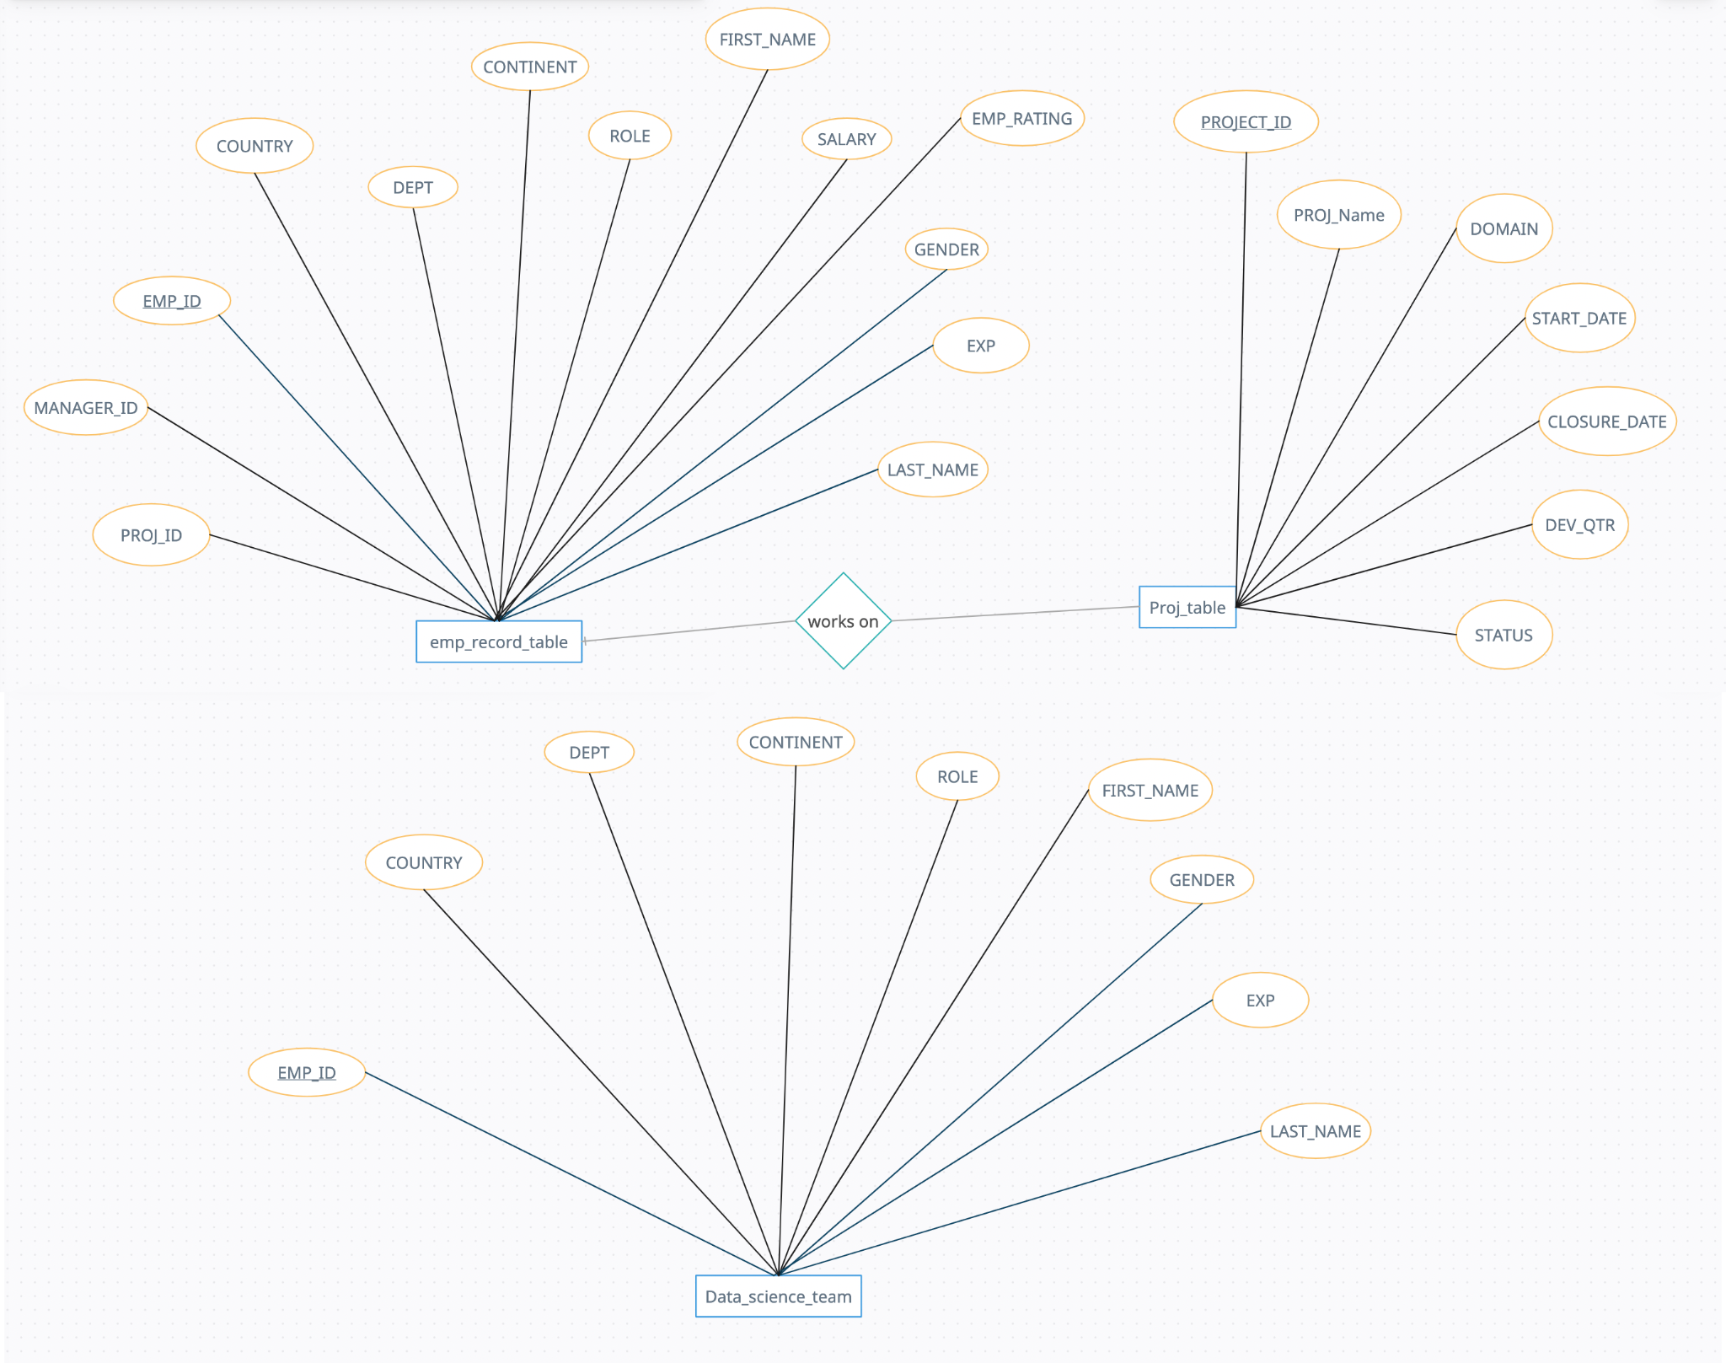

**-- QUESTION 3**

*Write a query to fetch EMP_ID, FIRST_NAME, LAST_NAME, GENDER, and DEPARTMENT*

*from the employee record table, and make a list of employees and details of their*

*department.*

SELECT EMP_ID, FIRST_NAME,LAST_NAME,GENDER,DEPT DEPARTMENT

FROM EMP_RECORD_TABLE

**-- QUESTION 4**

*4. Write a query to fetch EMP_ID, FIRST_NAME, LAST_NAME, GENDER, DEPARTMENT,*

*and EMP_RATING if the EMP_RATING is:*

*● less than two*

*● greater than four*

*● between two and four*

SELECT EMP_ID, FIRST_NAME, LAST_NAME, GENDER, DEPT DEPARTMENT

FROM emp_record_table

WHERE EMP_RATING <2

SELECT EMP_ID, FIRST_NAME, LAST_NAME, GENDER, DEPT DEPARTMENT

FROM emp_record_table

WHERE EMP_RATING >4

SELECT EMP_ID, FIRST_NAME, LAST_NAME, GENDER, DEPT DEPARTMENT

FROM emp_record_table

WHERE EMP_RATING BETWEEN 2 AND 4

**-- QUESTION 5**

Write a query to concatenate the FIRST_NAME and the LAST_NAME of employees in the

Finance department from the employee table and then give the resultant column alias as

NAME.

SELECT CONCAT(FIRST_NAME,LAST_NAME) NAME

FROM EMP_RECORD_TABLE

WHERE DEPT='FINANCE'

**-- QUESTION 6**

Write a query to list only those employees who have someone reporting to them. Also, show

the number of reporters (including the President);.

SELECT E1.EMP_ID,COUNT(E1.EMP_ID)

FROM EMP_RECORD_TABLE E1,EMP_RECORD_TABLE E2

WHERE E1.EMP_ID=E2.MANAGER_ID

GROUP BY E1.EMP_ID

**-- QUESTION 7**

Write a query to list down all the employees from the healthcare and finance departments

using union. Take data from the employee record table.

SELECT *

FROM EMP_RECORD_TABLE

WHERE DEPT IN ('HEALTHCARE', 'FINANCE');

**-- QUESTION 8**

8. Write a query to list down employee details such as EMP_ID, FIRST_NAME, LAST_NAME,

ROLE, DEPARTMENT, and EMP_RATING grouped by dept. Also include the respective

employee rating along with the max emp rating for the department.

SELECT EMP_ID,FIRST_NAME,LAST_NAME,ROLE,DEPT,EMP_RATING,

(SELECT MAX(EMP_RATING) FROM EMP_RECORD_TABLE WHERE DEPT=E1.DEPT)

MAX_RATING

FROM EMP_RECORD_TABLE E1

ORDER BY DEPT

**-- QUESTION 9**

Write a query to calculate the minimum and the maximum salary of the employees in each

role. Take data from the employee record table.

SELECT DEPT,MAX(SALARY),MIN(SALARY)

FROM EMP_RECORD_TABLE

GROUP BY DEPT

**-- QUESTION 10**

Write a query to assign ranks to each employee based on their experience. Take data from

the employee record table.

SELECT EMP_ID, FIRST_NAME,LAST_NAME ,EXP

FROM EMP_RECORD_TABLE

ORDER BY EXP DESC

**-- QUESTION 11**

Write a query to create a view that displays employees in various countries whose salary is

more than six thousand. Take data from the employee record table.

CREATE OR REPLACE VIEW SAL_VIEW AS

SELECT * FROM EMP_RECORD_TABLE

WHERE SALARY>6000

SELECT * FROM SAL_VIEW

**-- QUESTION 12**

Write a nested query to find employees with experience of more than ten years. Take data

from the employee record table

SELECT *

FROM EMP_RECORD_TABLE

WHERE EXP IN

(SELECT EXP FROM EMP_RECORD_TABLE WHERE EXP>10);

**-- QUESTION 13**

Write a query to create a stored procedure to retrieve the details of the employees whose

experience is more than three years. Take data from the employee record table.

DELIMITER $$

CREATE PROCEDURE STORE()

BEGIN

SELECT *

FROM EMP_RECORD_TABLE

WHERE EXP>3;

END $$

CALL STORE();

**-- QUESTION 14**

Write a query using stored functions in the project table to check whether the job profile

assigned to each employee in the data science team matches the organization’s set

standard.

The standard being:

For an employee with experience less than or equal to 2 years assign 'JUNIOR DATA SCIENTIST',

For an employee with the experience of 2 to 5 years assign 'ASSOCIATE DATA SCIENTIST',

For an employee with the experience of 5 to 10 years assign 'SENIOR DATA SCIENTIST',

For an employee with the experience of 10 to 12 years assign 'LEAD DATA SCIENTIST',

For an employee with the experience of 12 to 16 years assign 'MANAGER'.

CREATE DEFINER=`root`@`localhost` FUNCTION `ROLE_CHECK`( EMP_ID_TMP VARCHAR(20)) RETURNS tinyint(1)

DETERMINISTIC

BEGIN

DECLARE ROLE_TMP VARCHAR(30);

DECLARE EXP_TMP INT;

DECLARE FLAG BOOL;

SET FLAG=FALSE;

SELECT EXP INTO EXP_TMP

FROM EMP_RECORD_TABLE

WHERE EMP_ID=EMP_ID_TMP;

SELECT ROLE INTO ROLE_TMP

FROM EMP_RECORD_TABLE

WHERE EMP_ID=EMP_ID_TMP;

IF(EXP_TMP<=2 AND ROLE_TMP='JUNIOR DATA SCIENTIST') THEN

SET FLAG=TRUE;

END IF;

IF(EXP_TMP>2 AND EXP_TMP<=5 AND ROLE_TMP='ASSOCIATE DATA SCIENTIST')

THEN

SET FLAG=TRUE;

END IF;

IF(EXP_TMP>5 AND EXP_TMP<=10 AND ROLE_TMP='SENIOR DATA SCIENTIST') THEN

SET FLAG=TRUE;

END IF;

IF(EXP_TMP>10 AND EXP_TMP<=12 AND ROLE_TMP='LEAD DATA SCIENTIST') THEN

SET FLAG=TRUE;

END IF;

IF(EXP_TMP>12 AND EXP_TMP<=16 AND ROLE_TMP='MANAGER') THEN

SET FLAG=TRUE;

END IF;

RETURN FLAG;

END

$$

-- procedure to check all members with the help of role_check function

DELIMITER $$

CREATE PROCEDURE ALL_CHECK()

BEGIN

SELECT EMP_ID, ROLE_CHECK(EMP_ID) FROM Data_science_team;

end

$$

call ALL_CHECK()

**--Question 15**

15. Create an index to improve the cost and performance of the query to find the employee

whose FIRST_NAME is ‘Eric’ in the employee table after checking the execution plan.

CREATE INDEX IDX

ON EMP_RECORD_TABLE(FIRST_NAME)

SELECT *

FROM EMP_RECORD_TABLE

WHERE FIRST_NAME='Eric'

**-- Question 16**

16. Write a query to calculate the bonus for all the employees, based on their ratings and

salaries (Use the formula: 5% of salary * employee rating);.

SELECT EMP_ID, (.05*SALARY*EMP_RATING)

BONUS, SALARY,EMP_RATING

FROM EMP_RECORD_TABLE

**– Question 17**

17. Write a query to calculate the average salary distribution based on the continent and country.

Take data from the employee record table.

SELECT COUNTRY, AVG(SALARY)

FROM EMP_RECORD_TABLE

GROUP BY COUNTRY

SELECT CONTINENT,AVG(SALARY)

FROM EMP_RECORD_TABLE

GROUP BY CONTINENT