DAY-4 ASSIGNMENT

Ec2 Instances Created : 2 (same configuration)

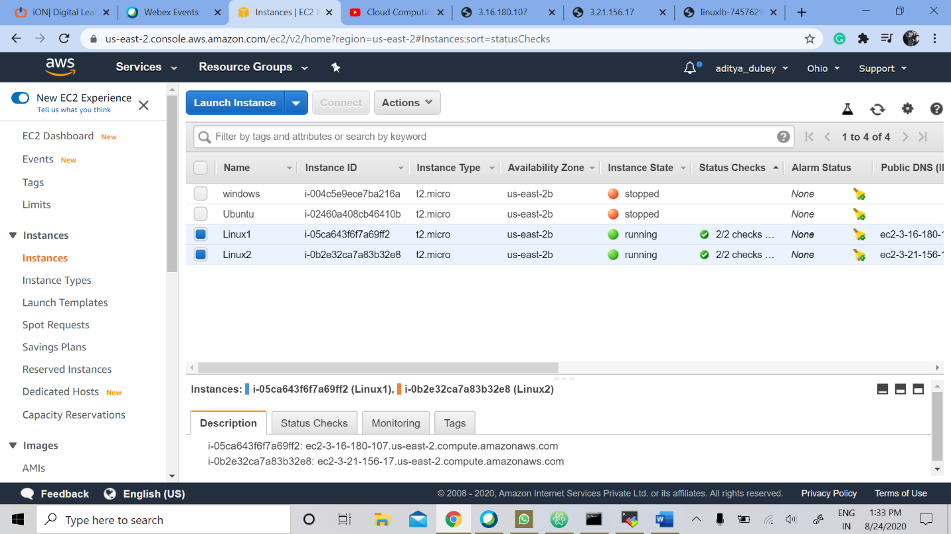

Our Load Balancer : linuxLB (named)

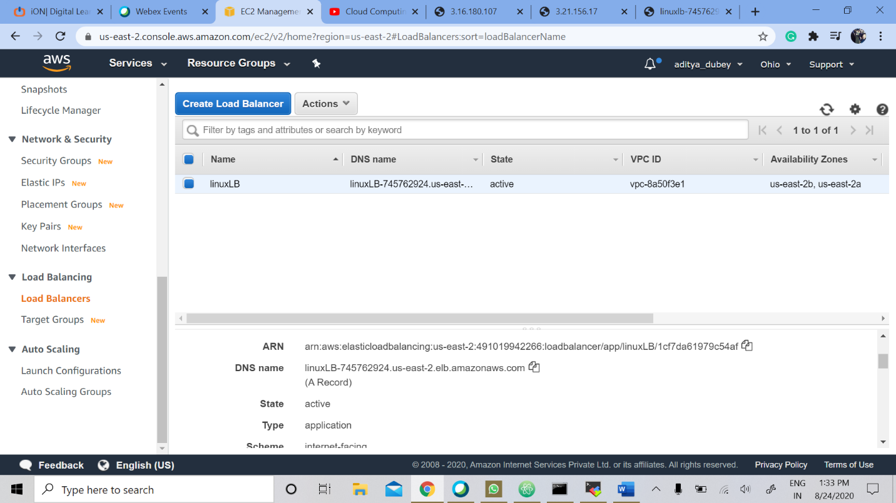

LINUX 1 IP : <http://3.16.180.107/>

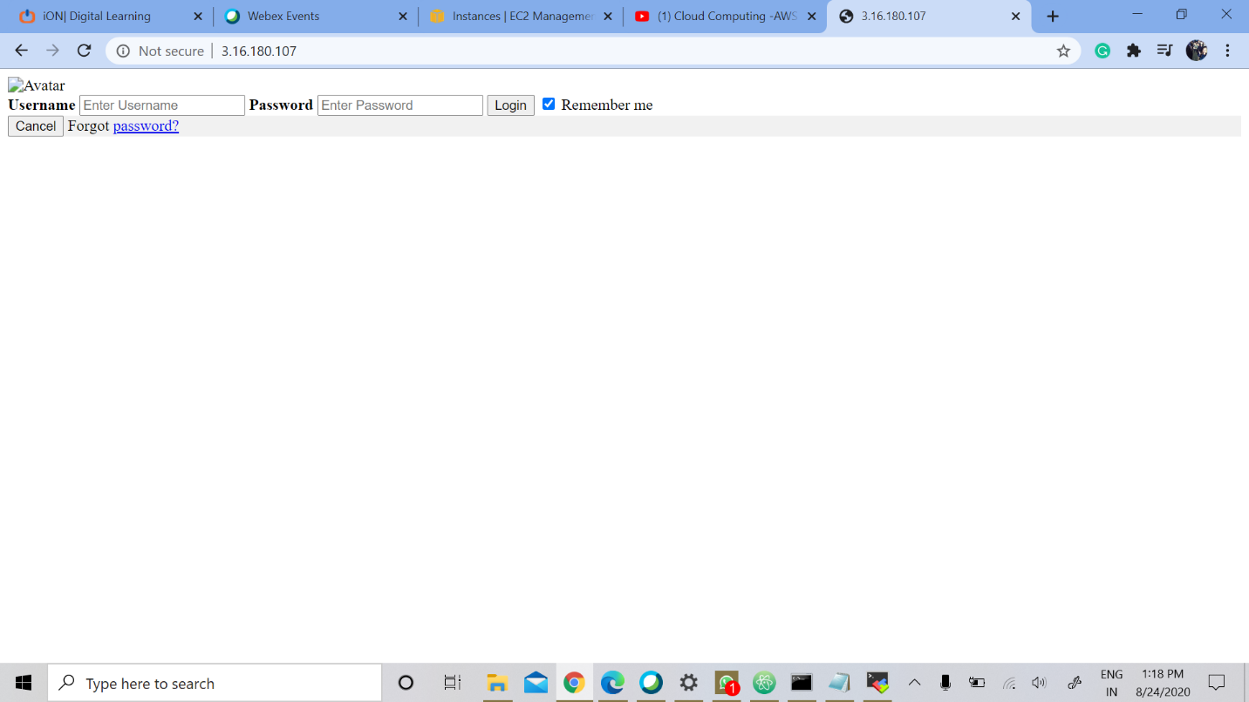

LINUX 2 IP : <http://3.21.156.17/>

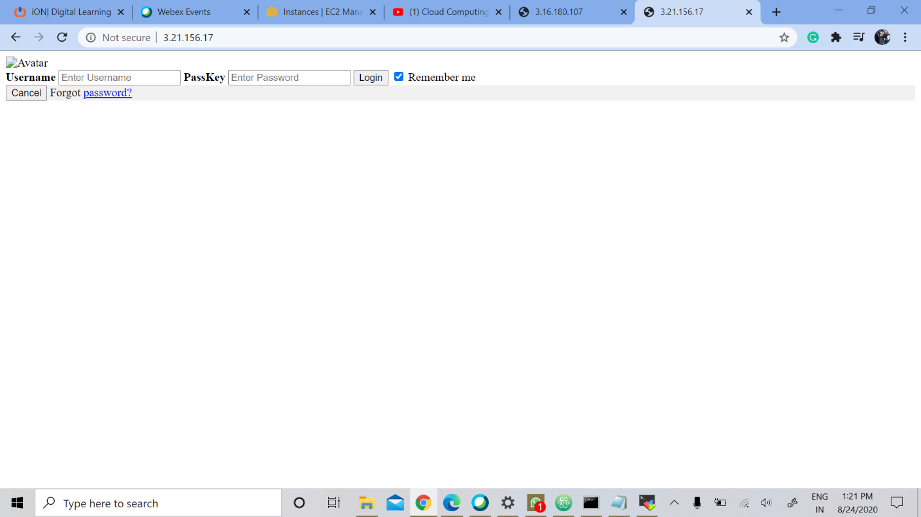

THE DNS LINK : <http://linuxlb-745762924.us-east-2.elb.amazonaws.com/>

The subsequent 2 slides will show how the Load balancer distributed the requests to both the Linux instances that we created

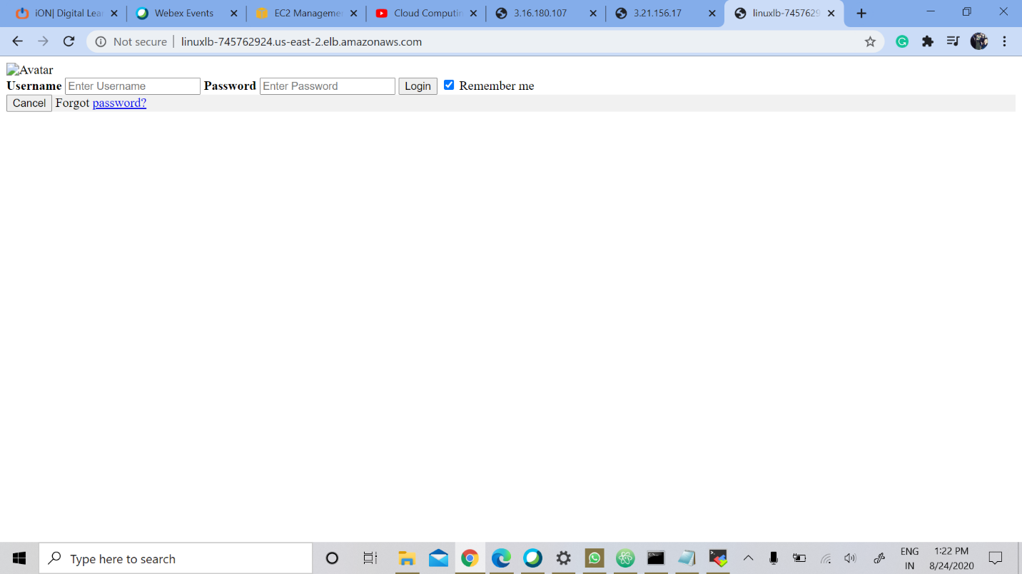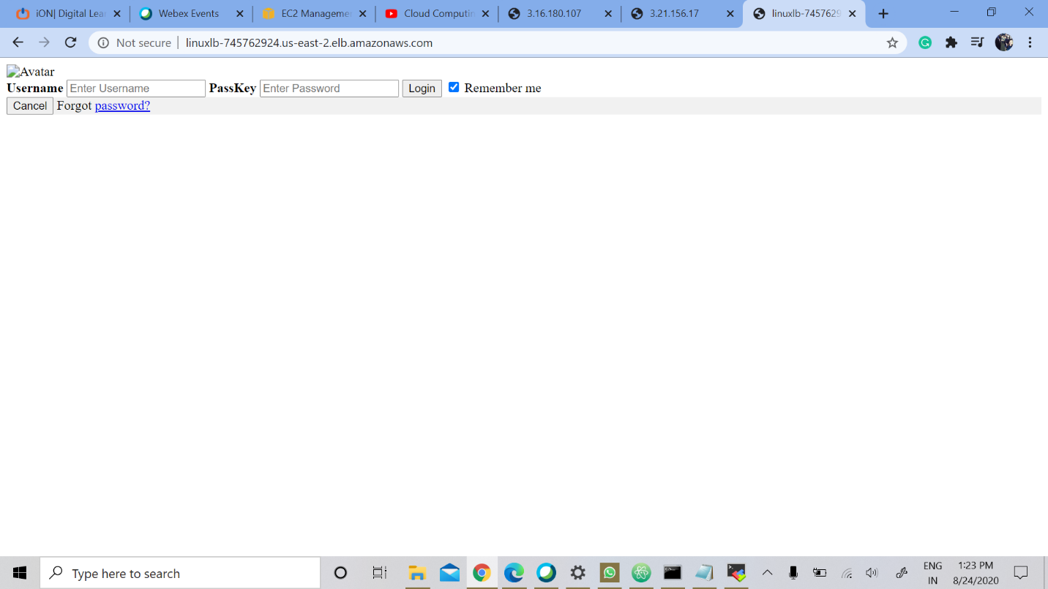

We have made slight changes in the html document see where the request is hitting !(OR on which Instance)