**PROJECT 1**

**Statement : Deploying a web server in Windows instance**

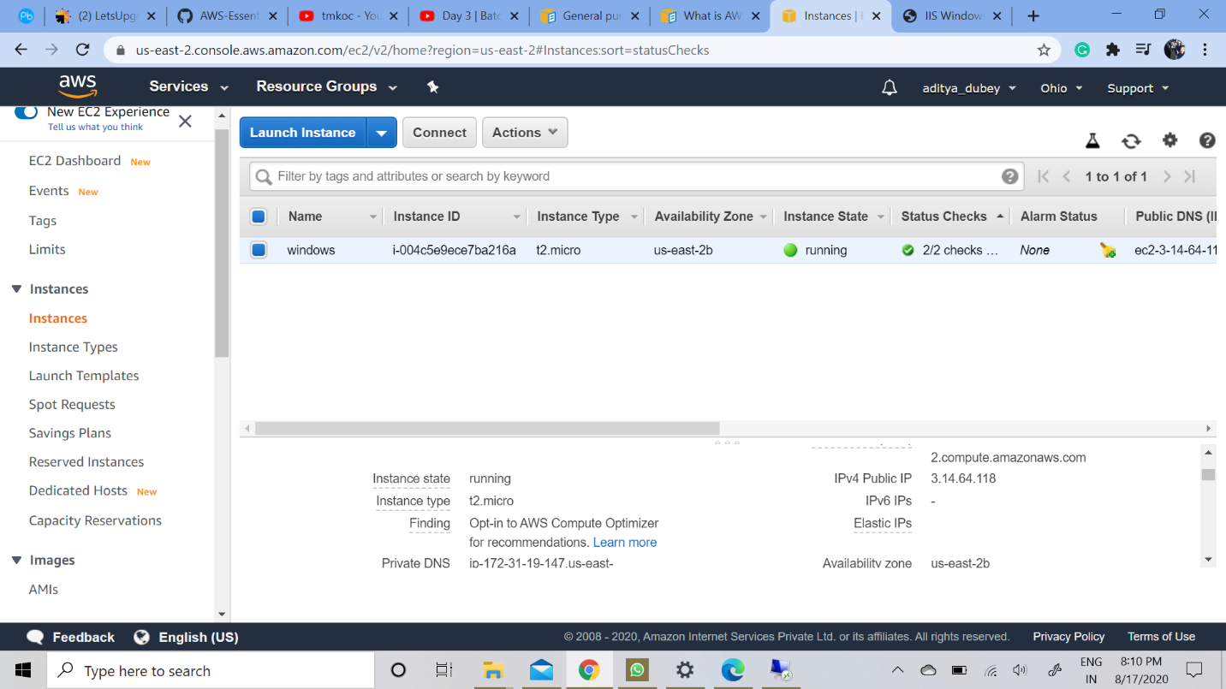

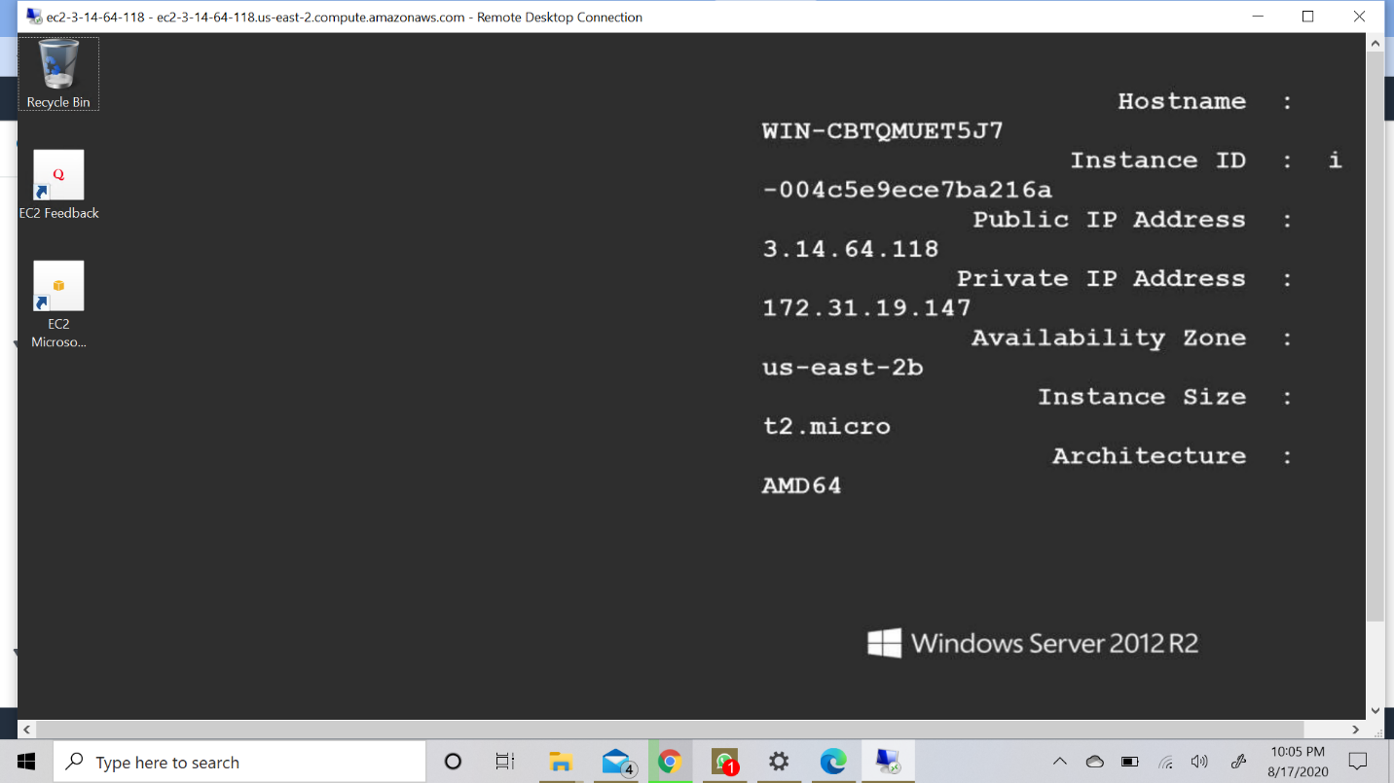

**After Installing the Server :- We just need to paste the public IP on the browser..**

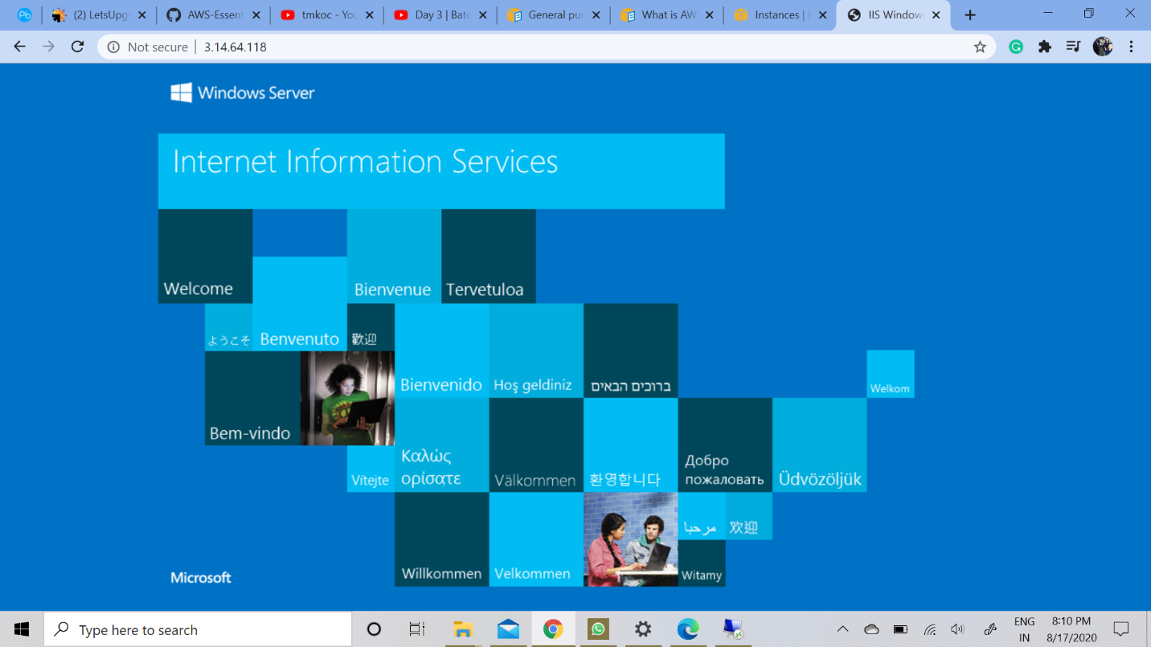

**PROJECT 2**

**Statement : Deploying a web server in Ubuntu instance**

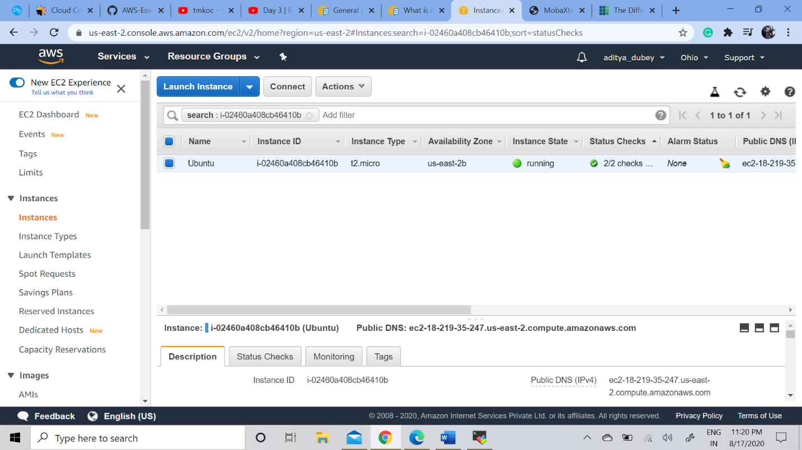

----**Using MobaXterm for launching..**

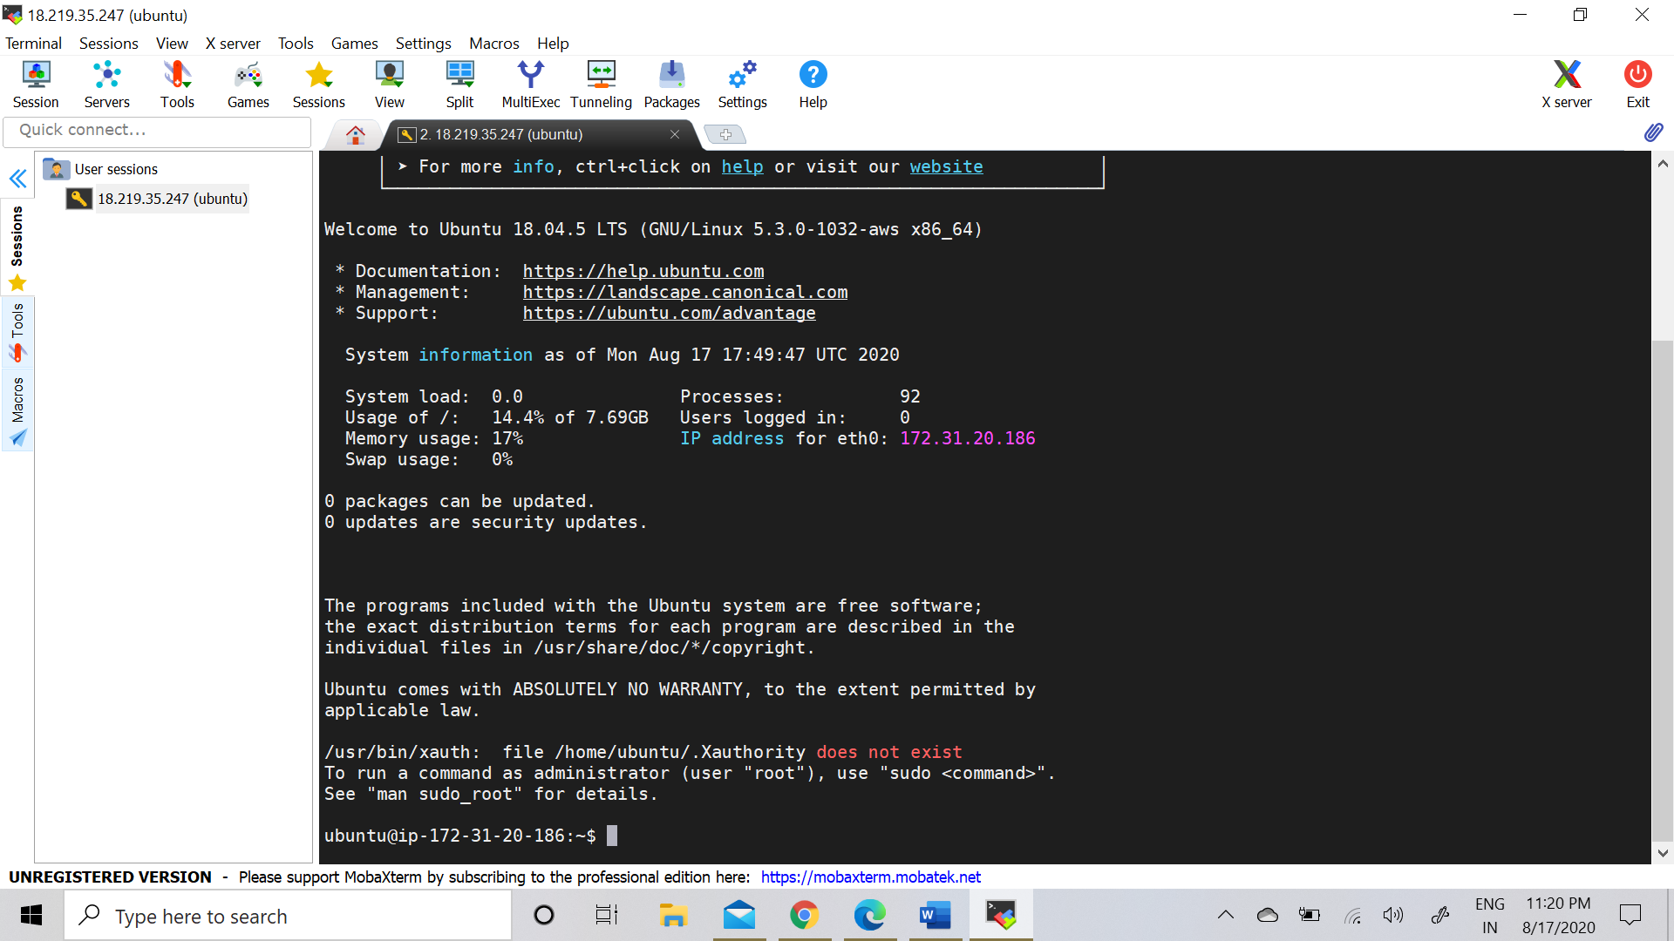

**--After sudo apt-get -y update**

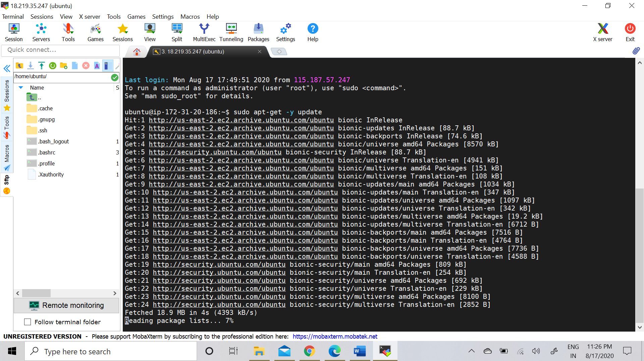

**--After sudo apt-get -y install nginx**

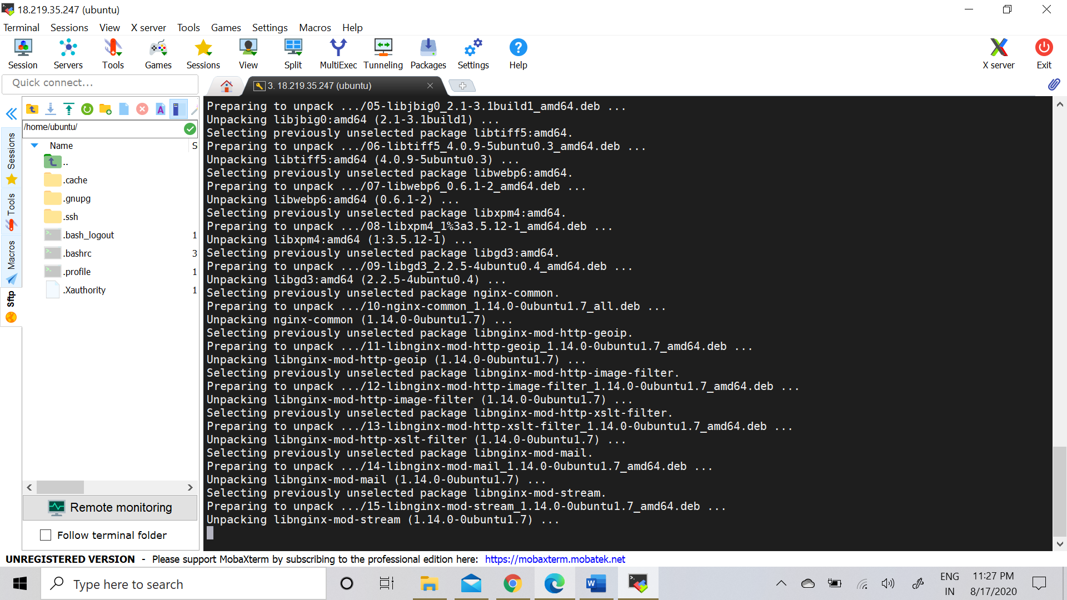

**---Now for checking we just need to paste the public IP on the browser..**

