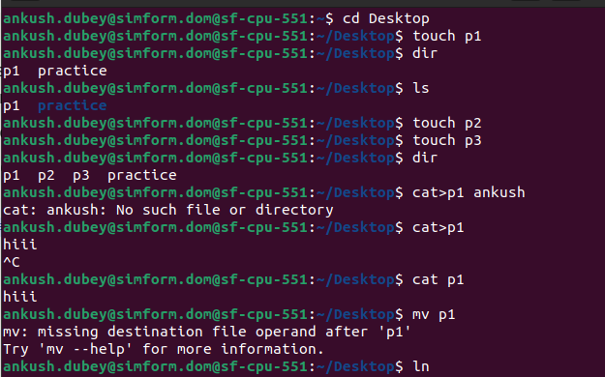
1.Manipulating Files and Directories

Basic commands for files and directories are:-

cp-copy
mv-move/rename
mkdir-make directory
rm-remove
touch-create file
cat-inserting any text

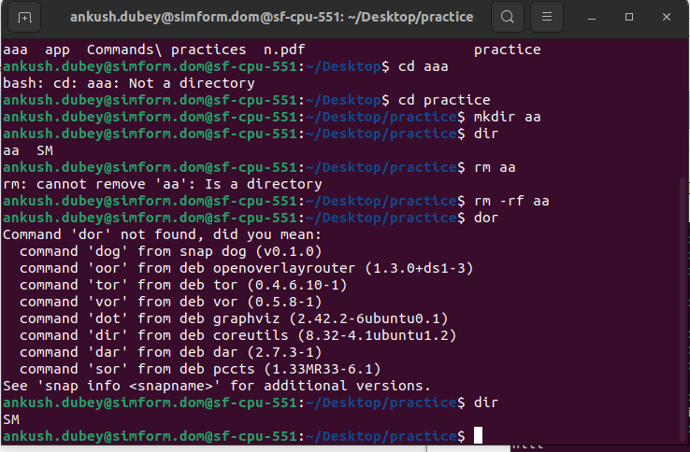

2.List all file permissions with example
Read – Can view or copy file contents
Write – Can modify file content
Execute – Can run the file (if its executable)
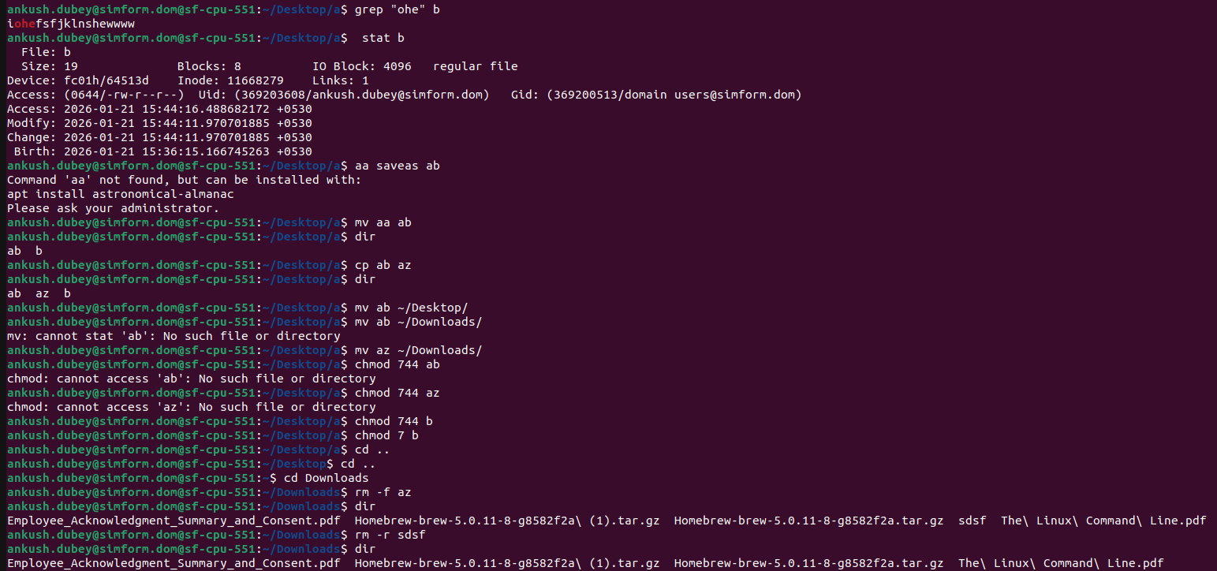

3.List all running process
command:-
ps(currently running processes).
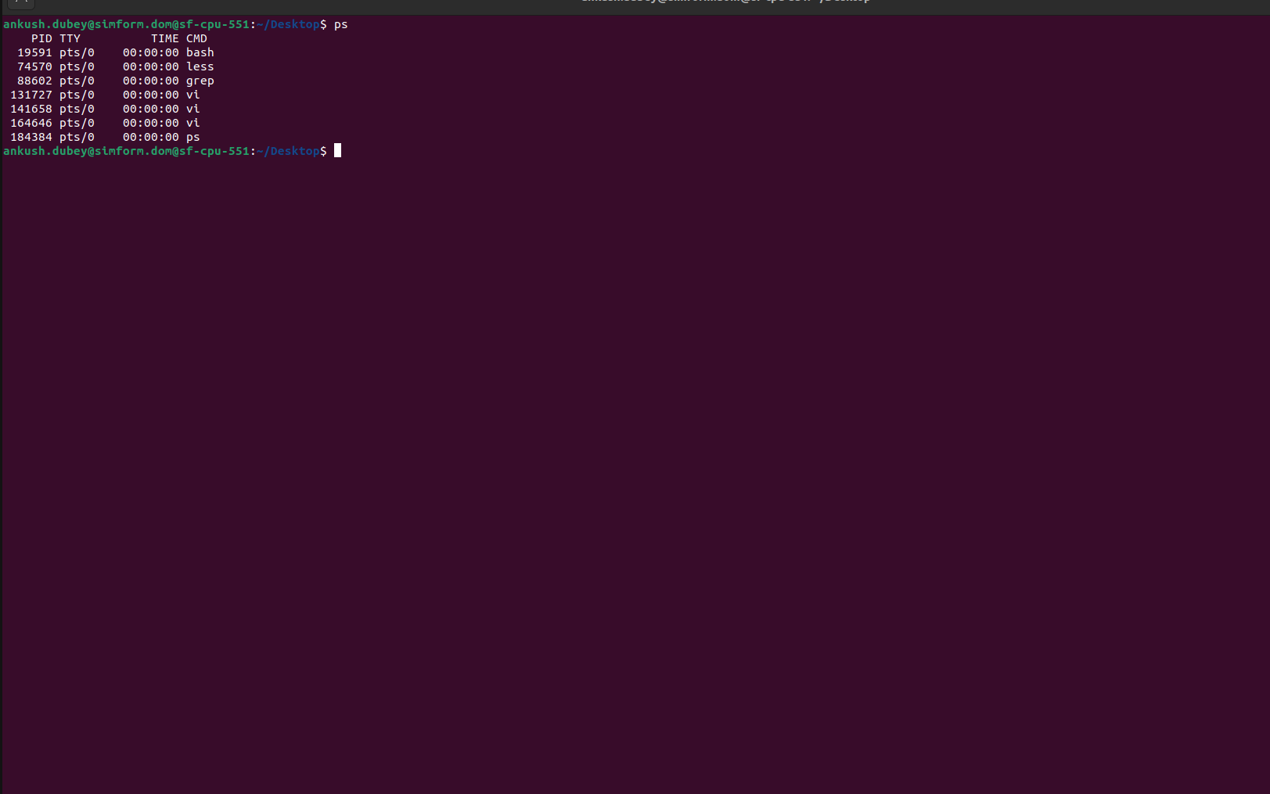
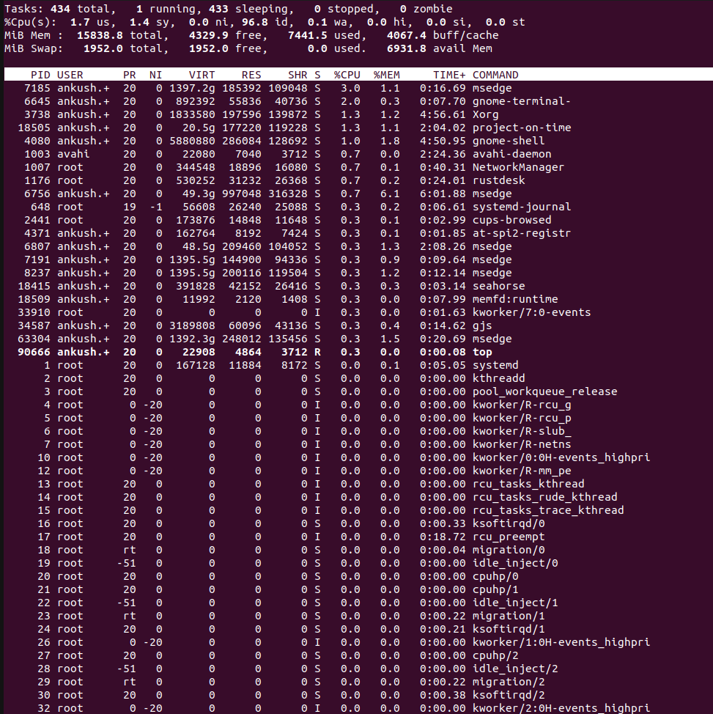
command :top( all tasks)
4.Find particular process by it's name

5. How to kill any particular process

Command: kill process_id

forcefully: kill -9 processs_id
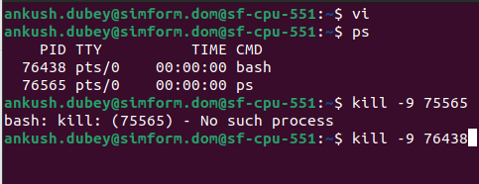

6. Vi or Vim for file editing

Vi file_name → For creating a file
i→ insert text
dd-delete texts
yy-copy
:wq → save and exit
:q! → exit without save
/ → search
:q → quit
%s/replacer/replacing/y → for substituete

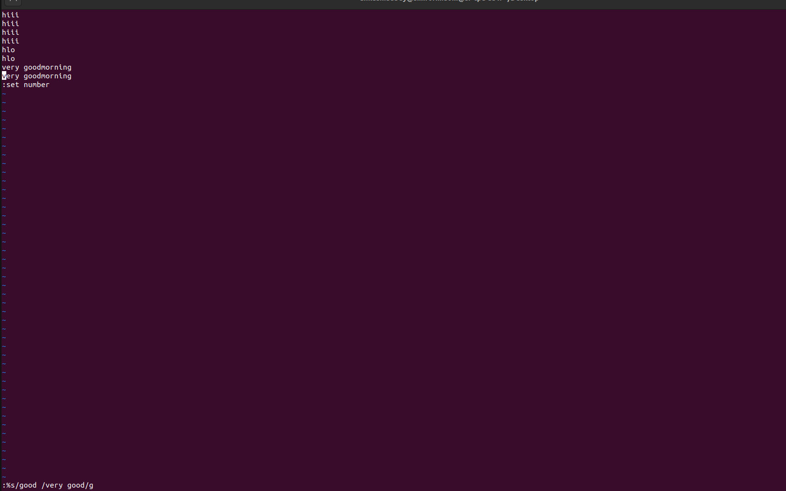

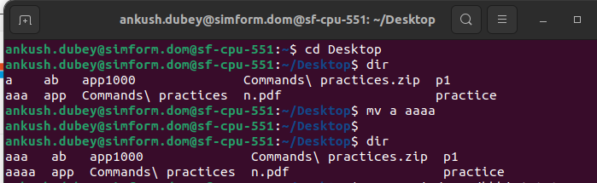
7 . Moving and Renaming Files

command- mv file1 file2

8. Remove Files and Directories

command:- rm file_name(removes file)
rm -r dir_name(remove dir)
rm -f file_name(remove file)

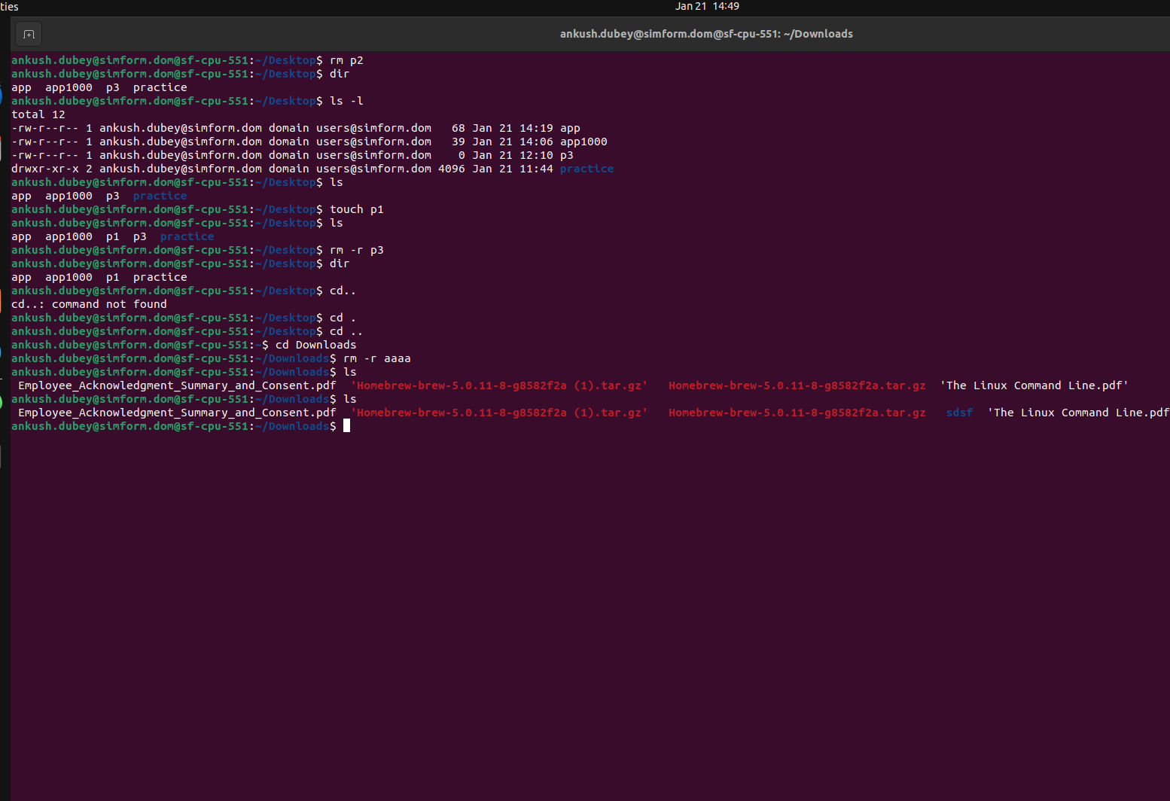

9. List the directory contents

command:- dir

10.How I can get the path of working directory.

Command: pwd(provides path of working directory)

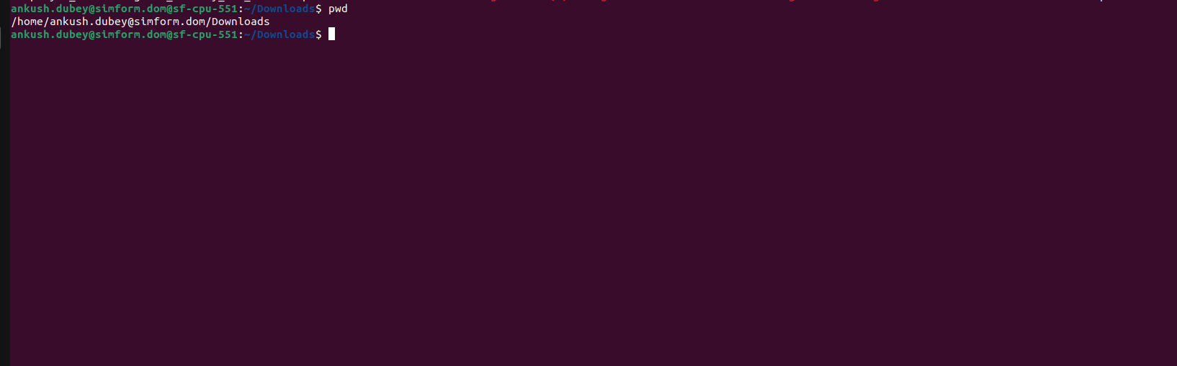

11.How to Search in Vim/Vi

command: /
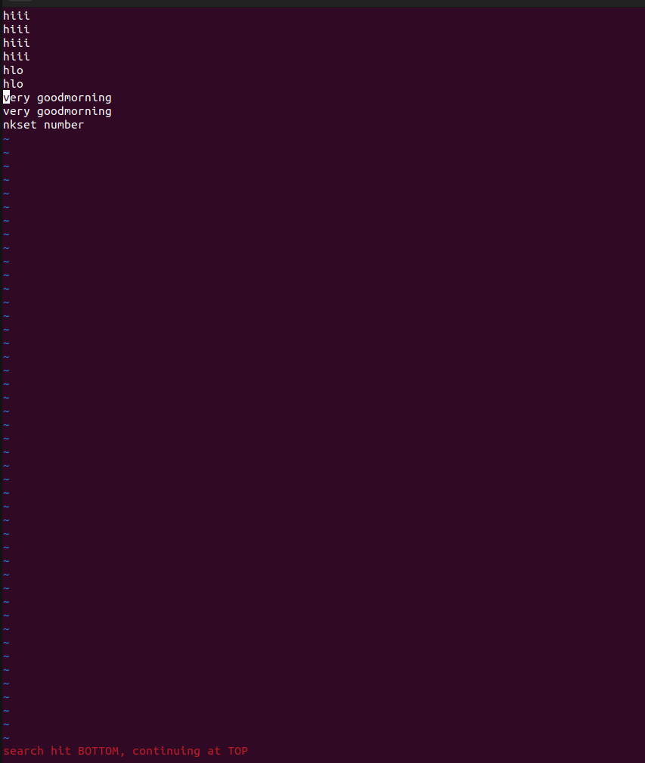

12.How Do You Do A Search And Replace in Vim/Vi

Command : - %s/replacer/replacement/y

13.How we can save and exit from Vim/Vi file.

Command:- :wq-Save and exit
:q-exit
:q! Exit without save

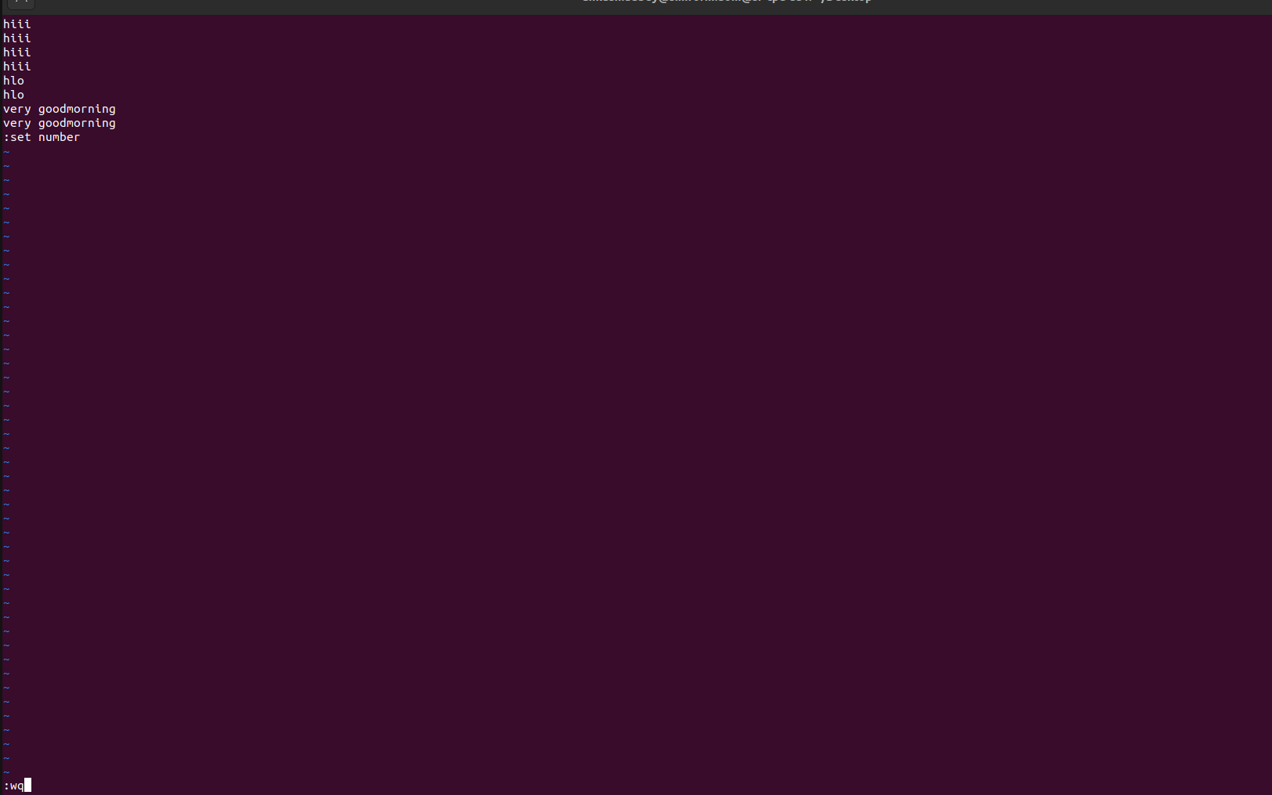

14. Change file owner and group.

Command: sudo useadd username
sudo chown name file_name
sudo groupadd group_name
sudo chown :mygroup file_name

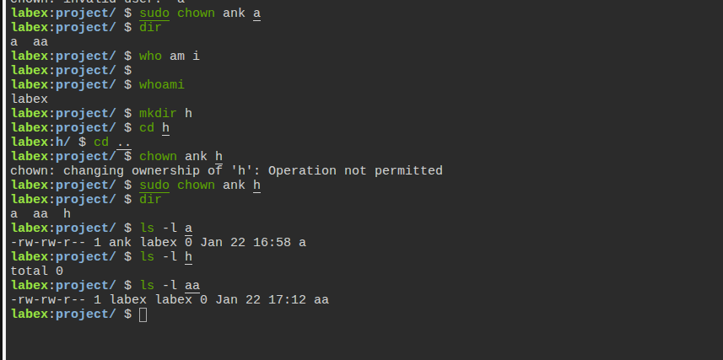
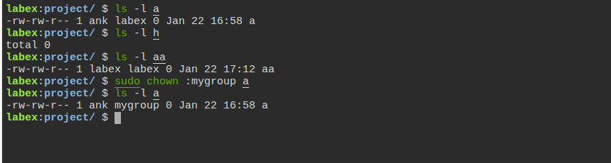

15. Change group ownership

command:- chgrp groupname file_name

