- write a command to create new folder.
Command: mkdir(this command will create anew folder.)
Output:-
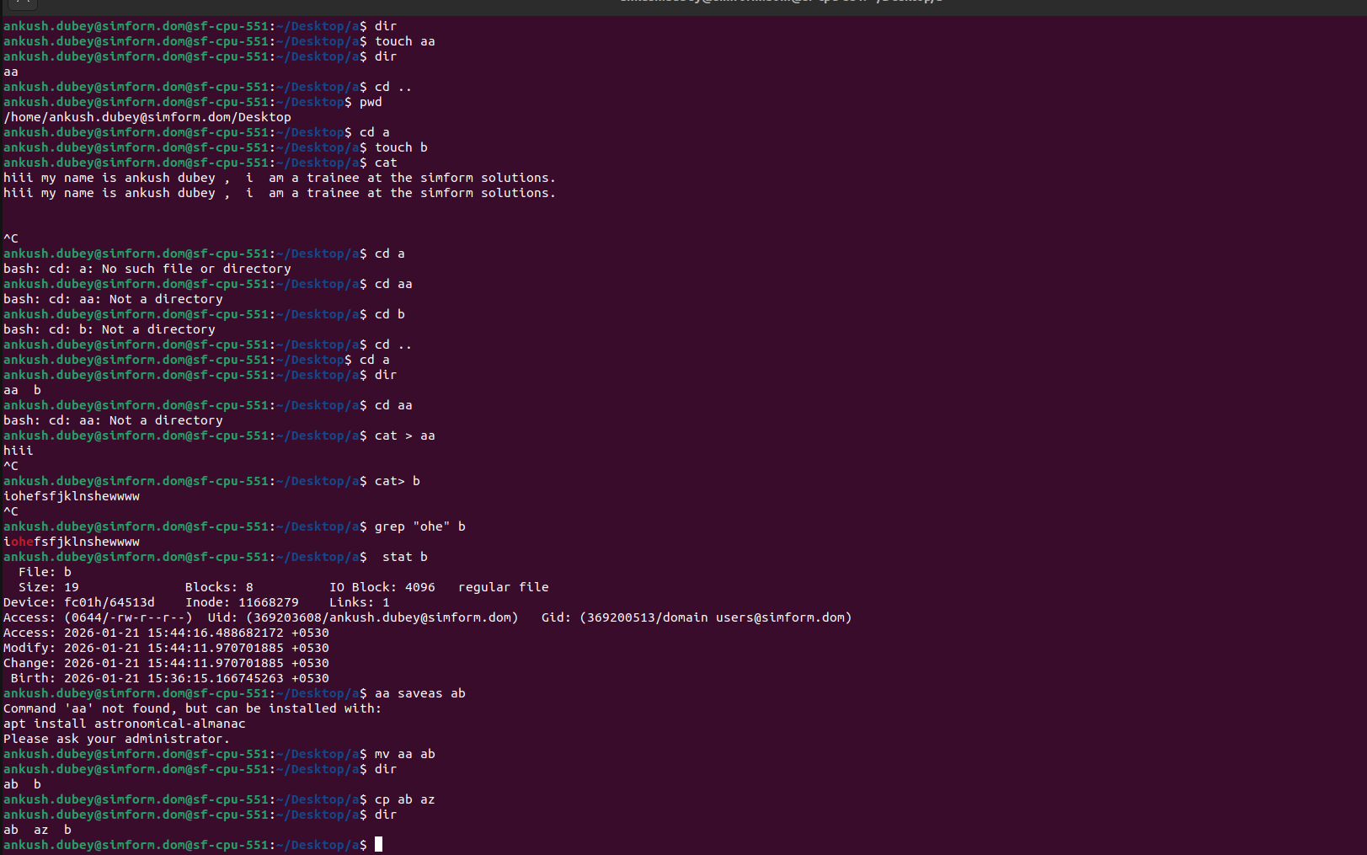

2.write a command to find the current path of the folder

Command:-pwd
Output:-

3.write a command to move into new created folder.

Command :-> cd new_folder_name

Output:-
4.write a command to create new file.

command: touch file_name

Output:-

5.write a command to add some content in a file.
Command -> cat > file_name

Output:-

6.write a command to find a specific word from a file.

Command -> grep word file_name

Output:-

7.write a command to find the size of a file.

Command:- stat file_name
Output:-

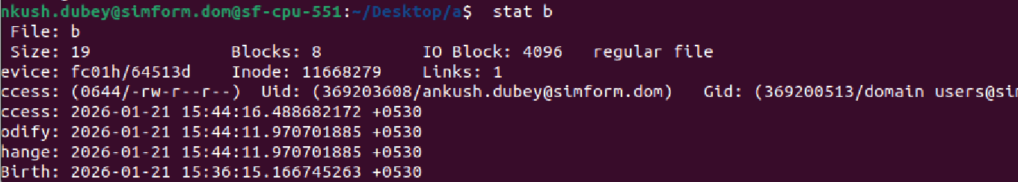

8.write a command to rename that file

command ->mv file1 file2

Output:-

9.write a command to make a copy of a file with another name.

Command:- cp file1 file2
Output:-

10.Write a command to show the list of files in folder.

Command-> dir
Output :-

11. write a command to move that file to desktop.

Command:-> mv filename ~/Desktop/

Output:-

12.write a command to change permissions of the file.
Command:-> chmod 744 az
chmod 744 b
chmod 7 b

output:->

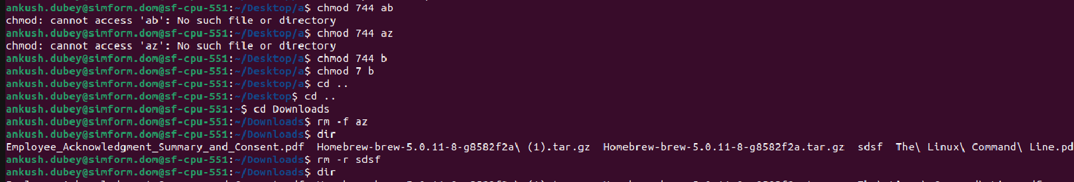

13. write a command to delete file

command:-> rm -r dir (delete directory )
rm -f file_name(delete file)

output:->

14. Write a command to delete created folder.
Command:-rm -r dir (delete directory dir).

Output:-

15.write a command to command to find a any file on local machine.
Command:-find . -type f -name “file_name”

Output:-

16.write a command to create a zip of files from specific path on local machine.

Command:-zip -r filename current_Path

Output:->
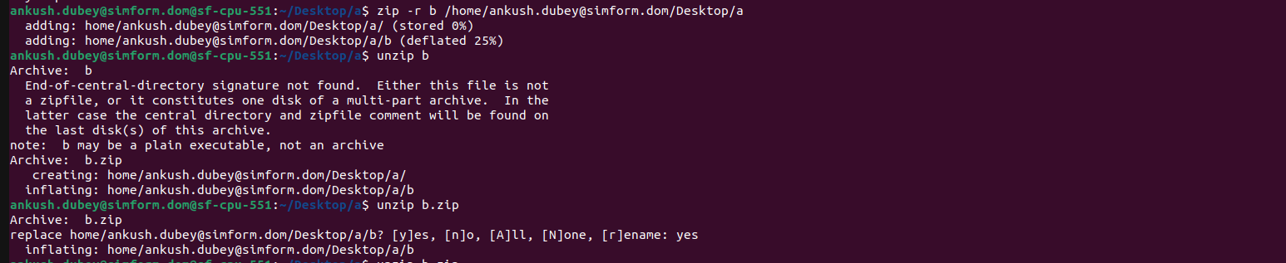

17.write a command to unzip.
Command:-unzip file_name

Output:->

18. Write a command to download file from specific location on the internet.

Command:-wget link/path/to/file.zip

Output:-

19. Write command to see last 10 lines of a file.
Command:-> tail filename

Output:-
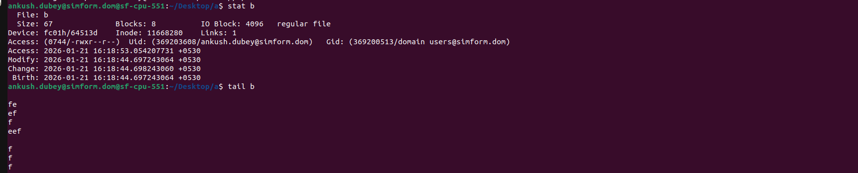
s
20.Write command to see history of a file.
Command-> stat filename
Output:-

