Requirement Analysis and Clarification – Online Banking Application

Application: Indian Net Bank – A Banking Project (Case Study)

Table of Contents
1. Document History 3
1. Introduction 4
2. Actors 4
3. Use Cases 4
UC1: Customer Registration 4
UC2: Login & Home Page 4
UC3: Account Management (Savings & Current) 5
UC4: Statements 5
UC5: Cheque Deposits 5
UC6: Reconciliation Report 6
UC7: Bill Payments 6
UC8: Money Transfer 6
UC9: Security 7
4. Use-Case Diagram 7
5. Functional Requirements 8
6. Non-Functional Requirements 8
8. Clarification Questions 8
Functional 8
Non-Functional 10
9. Success Criteria and Milestones 12
10. Future roadmap 12
11. Appendix 12

Document History
Version No. | Date | Author | Status | Comments
1.0 | 20-Jan-2026 | Uttam Bhatia | Draft

  - Contributors
Contributor | Role
Omprakash Pandey | Product Manager
Manish Dubey | Technical Lead
Uttam Bhatia | IT SME
Navhin | IT SME
Sandhya | IT SME
Vishal | IT SME
Saipriya | IT SME
Sudhir | IT SME

  - Reviewer / Signoff
Reviewer | Date of Signoff | Document version
Omprakash/Manish

1. Introduction
This document presents the requirement analysis for the Online Banking Application. It outlines the key actors, use cases, functional and non-functional requirements, and areas requiring clarification. The purpose is to ensure a shared understanding between business stakeholders and the technical team before proceeding to architecture and implementation. The case-study document is attached in Appendix section.

2. Actors
• Customer (End User): Registers, logs in, performs banking operations.
• Bank Staff (Approver/Admin): Approves registrations, manages cheque clearance, configures limits.
• System (iNB Application): Provides UI, processes transactions, enforces rules.

3. Use Cases

UC1: Customer Registration
• Actors: Customer, Bank Staff, System
• Preconditions: Customer has access to the iNB portal.
• Main Flow:
- - Customer fills registration form (account type, personal details).
- - Request sent to bank staff for approval.
- - Bank staff approves → account created.
- - Customer notified (letter/email/SMS).
- - Customer can log in after approval.
• Clarifications Needed:
- - Should approval be manual only or automated workflow?
- - Notification method (postal letter, email, SMS)?
- - Any KYC/document upload required?

UC2: Login & Home Page
• Actors: Customer, Bank Staff, System
• Preconditions: Customer account approved.
• Main Flow:
- - Customer enters username/password.
- - System validates credentials.
- - Home page displays account balance and summary.
• Clarifications Needed:
- - Should home page show only balance or also recent transactions, alerts, offers?
- - Should login support multi-factor authentication?
- - Mobile/responsive design required?

UC3: Account Management (Savings & Current)
• Actors: Customer, Bank Staff, System
• Preconditions: Customer has an active account.
• Main Flow:
- - Savings Account: Interest applied monthly, withdrawal limits enforced, min balance required.
- - Current Account: Zero balance allowed overdraft facility with daily interest charges.
• Clarifications Needed:
- - Are withdrawal limits/min balance global or per-customer configurable?
- - Should overdraft charges trigger daily notifications?
- - Interest rate changes — who manages configuration?

UC4: Statements
• Actors: Customer, Bank Staff, System
• Preconditions: Customer is logged in.
• Main Flow:
- - Mini statement: last 5 transactions.
- - Detailed statement: user-defined date range.
• Clarifications Needed:
- - Should statements include pending transactions?
- - Export options (PDF, Excel)?

UC5: Cheque Deposits
• Actors: Customer, Bank Staff, System
• Preconditions: Customer has a cheque to deposit.
• Main Flow:
- - Customer fills online slip, prints, attaches to cheque, sends to bank.
- - Bank staff updates status: Not Received → Sent for Clearance → Cleared/Bounced.
- - Customer checks status online.
• Clarifications Needed:
- - Should customers be notified of status changes via email/SMS?
- - Bounced cheque fine — fixed or configurable?
- - SLA for cheque clearance (always 3 days or configurable)?

UC6: Reconciliation Report
• Actors: Customer, Bank Staff, System
• Preconditions: Bank staff is logged in.
• Main Flow:
- - Generate report of cheques received, cleared, bounced, pending.
• Clarifications Needed:
- - Who consumes reports (staff, auditors, customers)?
- - Export formats required (PDF, Excel)?
- - Frequency of report generation?

UC7: Bill Payments
• Actors: Customer, Bank Staff, System
• Preconditions: Customer is logged in.
• Main Flow:
- - Customer pays utility bills immediately or schedules for later.
• Clarifications Needed:
- - Should recurring payments be supported?
- - Integration with external biller APIs?
- - Real-time vs batch processing?

UC8: Money Transfer
• Actors: Customer, Bank Staff, System
• Preconditions: Customer is logged in.
• Main Flow:
- - Customer transfers money to another iNB account.
• Clarifications Needed:
- - Should transfers to external banks be supported?
- - Real-time confirmation required?
- - Transaction limits configurable?

UC9: Security
• Actors: Customer, Bank Staff, System
• Preconditions: Customer attempts login.
• Main Flow:
- - After 3 failed login attempts, account locked → manual reactivation.
• Clarifications Needed:
- - Should system support two-factor authentication?
- - Encryption standards for data at rest/in transit?
- - Audit logging requirements?

4. Use-Case Diagram
[Use-Case Diagram Placeholder: UML diagram showing Customer, Bank Staff, and System interacting with UC1–UC9]
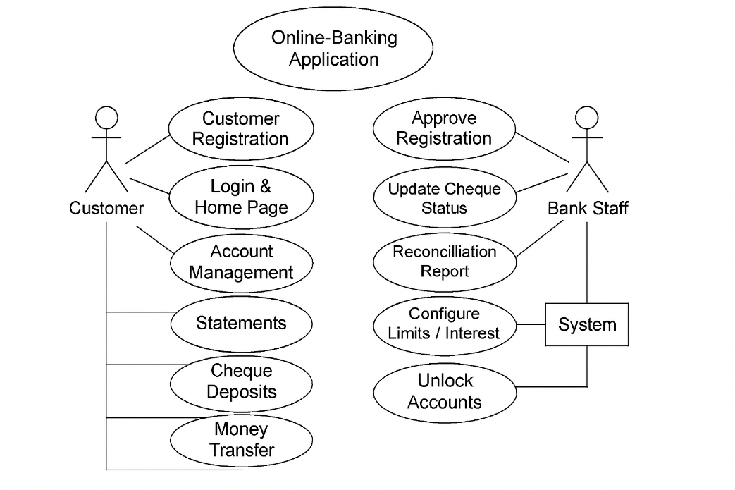

5. Functional Requirements
• Customer registration and approval workflow.
• Login and home page with account summary.
• Savings and Current account management with interest, limits, overdraft.
• Mini and detailed account statements.
• Cheque deposit tracking and status updates.
• Reconciliation reports for cheques.
• Bill payment (immediate and scheduled).
• Money transfer between accounts.
• Security features like login lockout and manual reactivation.

6. Non-Functional Requirements
• Performance: Fast response times under load.
• Scalability: Support for growing number of users and transactions.
• Usability: Intuitive UI with minimal clicks and consistent design.
• Configurability: Admin-configurable limits, interest rates, charges.
• Reliability: Accurate processing of transactions and cheque statuses.
• Deployment: Must run on IIS.
• Security: Data encryption, login lockout, audit logging, optional 2FA.

8. Clarification Questions

Functional
# | Requirement Area | Question | Response (Example) | Owner | Status
 | Registration | Should approval be manual only or automated workflow?
 | Registration | Notification method (postal letter, email, SMS)?
 | Registration | Any KYC/document upload required?
 | Login & Home Page | Should home page show only balance or also recent transactions, alerts?
 | Account Management | Are withdrawal limits/min balance global or per-customer configurable?
 | Account Management | Should overdraft charges trigger daily notifications?
 | Account Management | Interest rate changes — who manages configuration?
 | Account Management | Overdraft limit rules (eligibility criteria, Interest rate and grace period)
 | Statements | Should statements include pending transactions?
 | Cheque Deposits | Bounced cheque fine — fixed or configurable?
 | Cheque Deposits | SLA for cheque clearance (always 3 days or configurable)?
 | Reports | Who consumes reports (staff, auditors, customers)?
 | Reports | Frequency of report generation?
 | Bill Payments | Should recurring payments be supported?
 | Money Transfer/Transactions | Should transfers to external banks be supported?
 | Money Transfer/Transactions | Transaction limits configurable?
 | Money Transfer/Transactions | Type of transactions supported initially (Deposit, Withdrawal, transfer)
 | Money Transfer/Transactions | Preferred payment gateway if any?
 | Good to have - Additional features/services | Additional features/services i.e. FD, RD, Instant Loans etc.
 | Reports/Statements | Export options (PDF, Excel)?
 | Notifications | Should customers be notified of status changes via email/SMS?
 | Integration | Integration with external biller APIs?

Non-Functional
# | Requirement Area | Question | Response (Example) | Owner | Status
 | Security | Should login support multi-factor authentication?
 | Security | User’s authorization and session policy – preferred identity provider if any?
 | Security | Encryption standards for data at rest/in transit?
 | Security | Audit logging requirements?
 | Security | User fraud-detection?
 | Performance | Real-time vs batch processing?
 | Performance | Real-time confirmation required?
 | Availability | Application uptime?  Disaster recovery – RTO, RPO
 | Scalability | Volume of transactions supported – peak concurrent transactions?
 | Usability | Mobile/responsive design required?
 | Compliance | Any compliance & Legal hold requirement i.e. SOX, Legal hold requirement, RBI etc.
 | Compliance | Data residency compliance i.e. GDPR etc.
 | Compliance | User consent and privacy policy
 | Compliance | Data backup & application log retention and access policy
 | I18n | Multi-lingual supports?
 | Observability
 | Maintainability

9. Success Criteria and Milestones
- How will success be measured?
- Key KPIs after go-live?
- Go-Live timelines and milestones?

10. Future roadmap
- Cloud migration – Hybrid

11. Appendix

