GTM Strategy
Structured Notes & Reference
How to structure a sales & marketing case, the metrics that matter, and the deployment / coverage model toolkit
Compiled from handwritten case notes and the supporting decks:
S&M Internal Training Deck • RTM & Sales Deployment • CE Value Roadmap • GTM Integrated DD

Contents
- 1. How to structure a GTM / S&M case (the master tree)
- 2. Revenue side — sources of growth and the revenue bridge
- 3. Cost side — S&M spend anatomy
- 4. Productivity — SPC framework, Magic Number, Rule of 40
- 5. Sales capacity — Strategy / Systems / People
- 6. Deployment model — coverage, roles, motions, ratios
- 7. KPI cheat sheet — every metric you should be able to define
- 8. How to actually run the analysis — the 15-topic playbook
- 9. Glossary of abbreviations

1. How to structure a GTM / S&M case
The core idea: every commercial case ultimately bottoms out in two questions — can the company sell more (revenue) and is the spend behind that revenue efficient (cost). This is the first split on the page; everything else hangs off it.
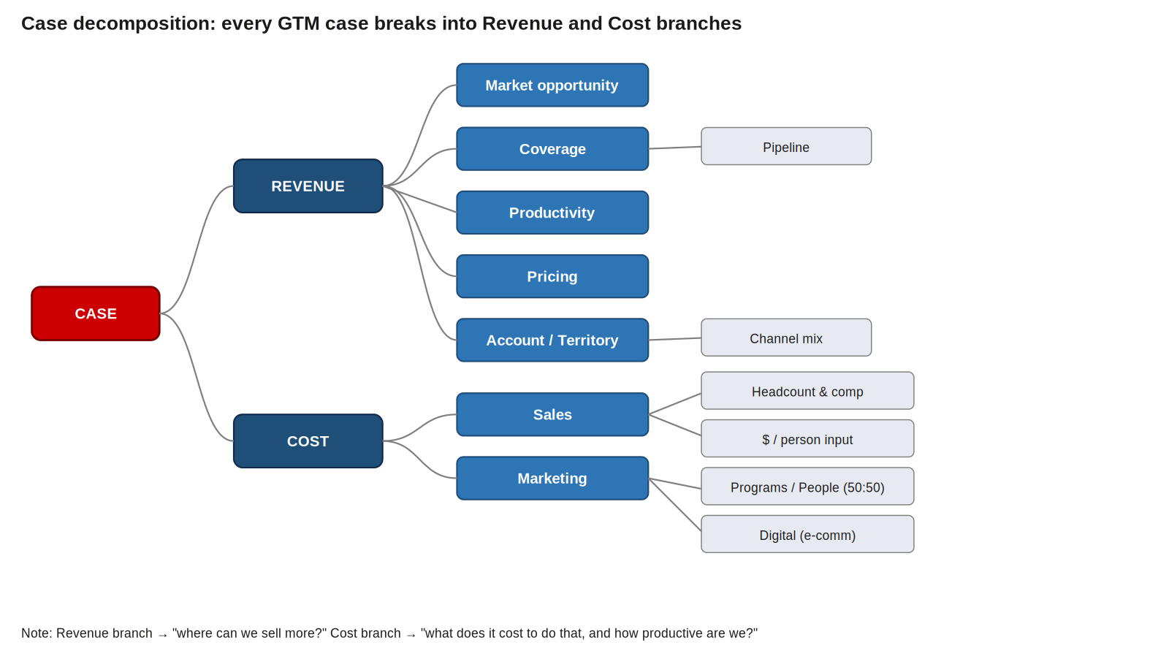
Master decomposition — Revenue (where can we grow?) vs Cost (what does that growth cost?)

Revenue branch — five places growth comes from
Lever | What to dig into
Market opportunity | Is the TAM big enough? Where is opportunity densest? (MoneyMap / CORO can size this.)
Coverage | Are we reaching the customers we should — by geo, segment, channel? Pipeline health rolls up here.
Productivity | Of the reps & dollars we have, how much output? Win rate, SOW, NRR/GRR all live here.
Pricing | Is there discounting leakage? Is there pricing power left on the table? (Often a fast EBITDA win.)
Account / Territory / Channel | How are accounts sliced and assigned? Direct vs channel mix?

Cost branch — split Sales vs Marketing
Cost decomposes neatly into Sales and Marketing. Both then split into compensation (people) and non-compensation (programs, tools, travel, events).
- Sales: frontline reps + support roles (BDR, CSM, RevOps, Pre-sales, SE). Watch headcount, $/rep input, and productivity output.
- Marketing: usually ~50:50 people-vs-program split. Programs = demand-gen, brand, events, content, MarTech. People = the marketing FTEs themselves.
- Digital marketing (e-comm): often pulled out as its own bucket — Bain runs this through the FRWD digital practice; outbound digital sits with the DDA team under CORO.

SHORTHAND TO REMEMBER
• Case → Revenue + Cost
• Revenue → Market opp, Coverage, Productivity, Pricing, Account/Territory/Channel
• Cost → Sales (comp + non-comp) and Marketing (comp + non-comp; programs ~50% of marketing $)
• Data needed: revenue cuts, headcount, comp, pipeline, retention metrics, S&M spend lines

2. Revenue side — sources of growth and the bridge
Pull the revenue file and cut it by every meaningful dimension: region, BU, industry, customer segment, product. Then run a Pareto on top accounts (the 20% generating 80%). Finally — and this is the crucial one — build the revenue bridge: how did you get from last year's revenue to this year's?
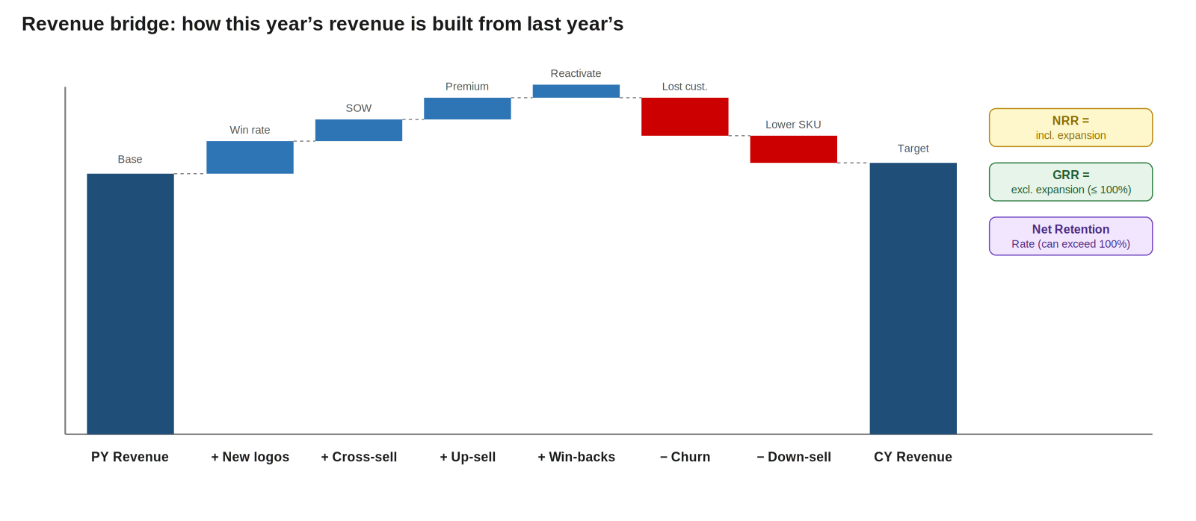
The revenue bridge — every dollar of CY revenue traceable to a transaction type

The seven transaction types in a bridge
Type | Definition
New logos | Brand-new client acquisitions. Driven by pipeline volume × win rate.
Up-sell | Selling premium / higher-priced product to an existing customer (same product, more / better).
Cross-sell | Selling a different / additional product to an existing customer. Often measured as share-of-wallet (SOW) expansion.
Win-backs | Reactivating a customer who previously churned. Often a quick-win lever.
Renewals | Renewing existing contracts at same terms. Foundation of recurring revenue.
Down-sell | Existing customer moves to a lower-priced SKU. Shrinks bridge.
Churn | Existing customer leaves entirely (current revenue = 0). Shrinks bridge.

Three retention metrics that summarize the bridge
Critically: NRR and GRR answer different questions. Get them straight.
Metric | Formula and read
Customer Retention Rate | 1 − customer churn rate. Counts customers, not dollars.
GRR (Gross Retention) | (BoP ARR − Churn ARR − Downsell ARR) / BoP ARR. Excludes expansion. CAPPED at 100%. Reads as: "of the revenue I started the year with, how much did I keep?"
NRR (Net Retention) | (BoP ARR + Upsell + Cross-sell − Churn − Downsell) / BoP ARR. INCLUDES expansion. Can exceed 100%. Reads as: "net change in revenue from existing customers."

THE NUANCE THAT TRIPS PEOPLE UP
• NRR = includes expansion (upsell + cross-sell). Can be >100%. A "growth" metric.
• GRR = excludes expansion. Capped at 100%. A "leakage" metric.
• If NRR is great but GRR is poor → you're backfilling churn with expansion (bad foundation).
• If both are high → durable, expanding base (the goal).

3. Cost side — S&M spend anatomy
Total S&M spend always splits the same way. Get the breakdown early — it tells you where to look for inefficiency.
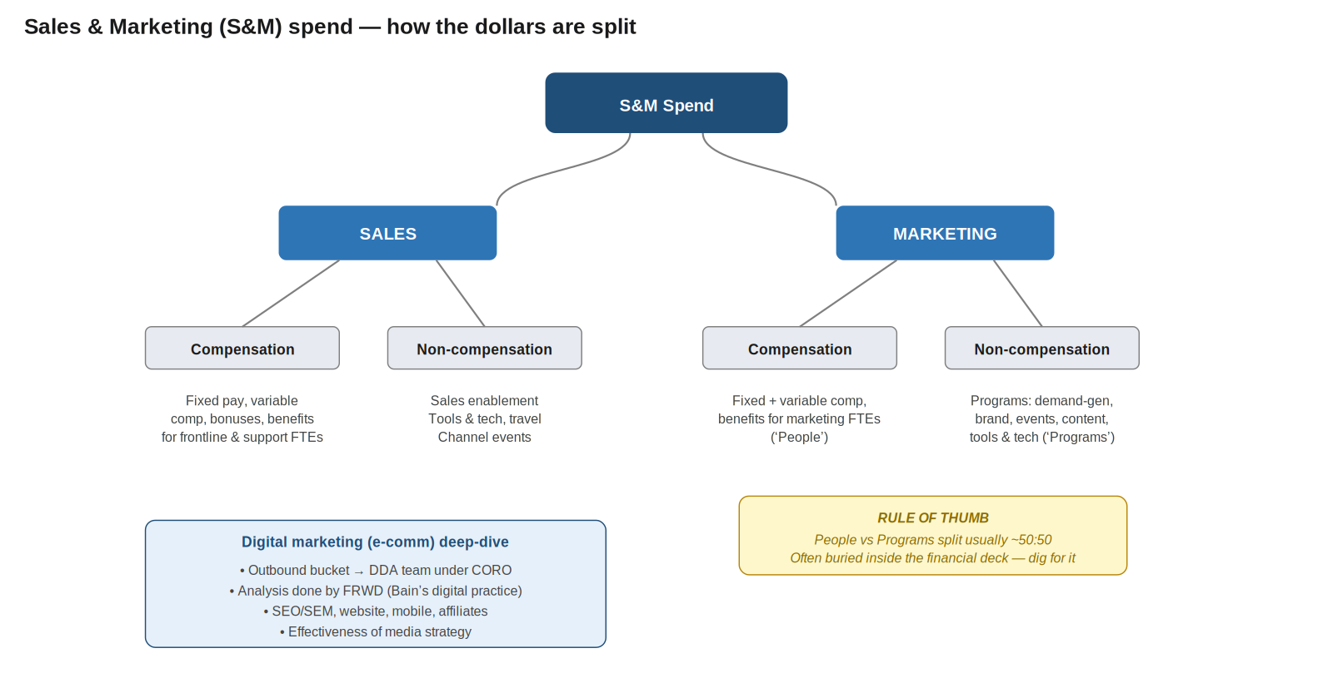
S&M spend always breaks Sales vs Marketing, each into compensation and non-compensation

Sales spend
- Compensation: fixed pay, variable comp, bonuses, benefits — for frontline sales AND sales-support FTEs.
- Non-compensation: sales enablement, sales tools & technology, sales travel, channel sales events.

Marketing spend
- Compensation: fixed + variable comp, benefits for marketing FTEs (the "people" half).
- Non-compensation (programs): demand generation, brand awareness campaigns, marketing tools & technology, external marketing/events, website/content/blogs.
- Rule of thumb: the people-vs-programs split inside marketing is usually around 50:50. If it's heavily skewed, ask why.
- Data location: the people/programs detail is often buried in the financial deck rather than the S&M deck — dig.

Digital marketing (e-commerce)
- Treated as its own outbound bucket — separates from traditional marketing.
- DDA team sits under CORO; analysis usually done by FRWD (Bain's digital practice).
- What to look at: digital experience across mobile/website/affiliate, effectiveness of media strategy, SEO/SEM approach, MarTech stack.

4. Productivity — the SPC framework
The big question: "For every $1 I put into my commercial engine, how much do I get back?" A Sustained Productivity Creator (SPC) is a company that delivered top-quartile productivity growth in 3 out of 4 time periods. Identifying SPCs in an industry tells you what "good" looks like.
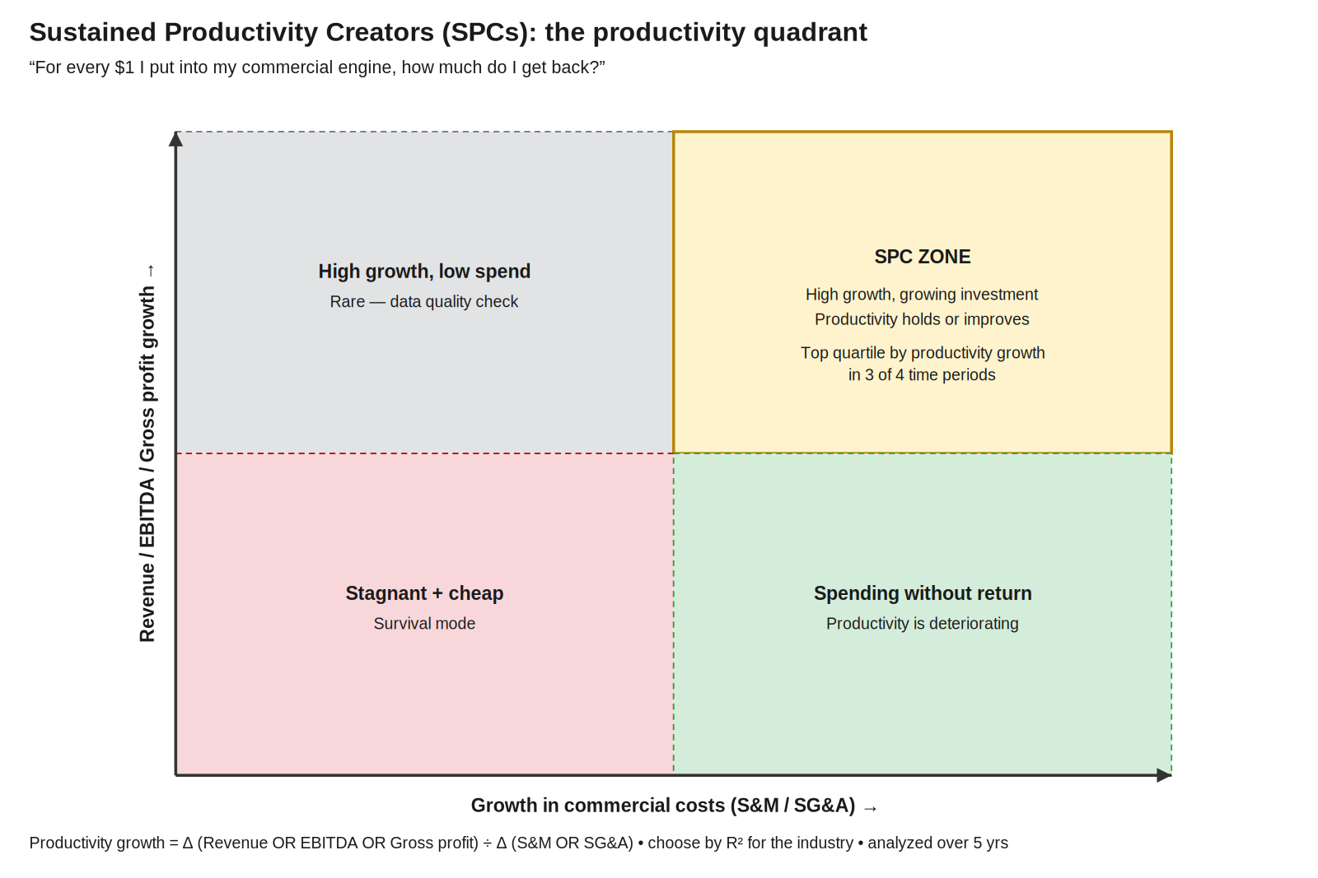
SPC quadrant — productivity = output growth (revenue / EBITDA / gross profit) ÷ input growth (S&M or SG&A)

How productivity growth is calculated
Component | Detail
Numerator (output) | Revenue growth OR EBITDA growth OR Gross profit growth — pick whichever has highest R² in the industry
Denominator (input) | Growth in commercial costs — S&M (for SaaS) or SG&A (for traditional industries)
Time window | 5-year rolling, broken into time periods
SPC threshold | Top quartile by productivity growth in 3 out of 4 time periods

Two related productivity tests

Magic Number (sales & marketing efficiency)
Formula: (Revenue growth current year vs prior year) ÷ S&M expense prior year
Range | Read
< 0.5 → Inefficient | Reactive, not enough collaboration between Sales & Marketing, potential structural issue
0.5 – 1.0 → Balanced | Optimized, proactive, minimum conflict between teams
> 1.0 → Too safe | Under-investing, leaving market opportunity uncaptured, should be taking more chances

Rule of 40 (SaaS-specific)
Formula: 5-year revenue CAGR + median EBITDA margin % ≥ 40%
Captures the trade-off between investing in growth and short-term profitability. Originally a VC heuristic for fast-growing companies. Hard to sustain consistently.

5. Sales capacity — Strategy / Systems / People
Any sales force has three pillars that need to hang together. The X-ray view will tell you which one is broken.
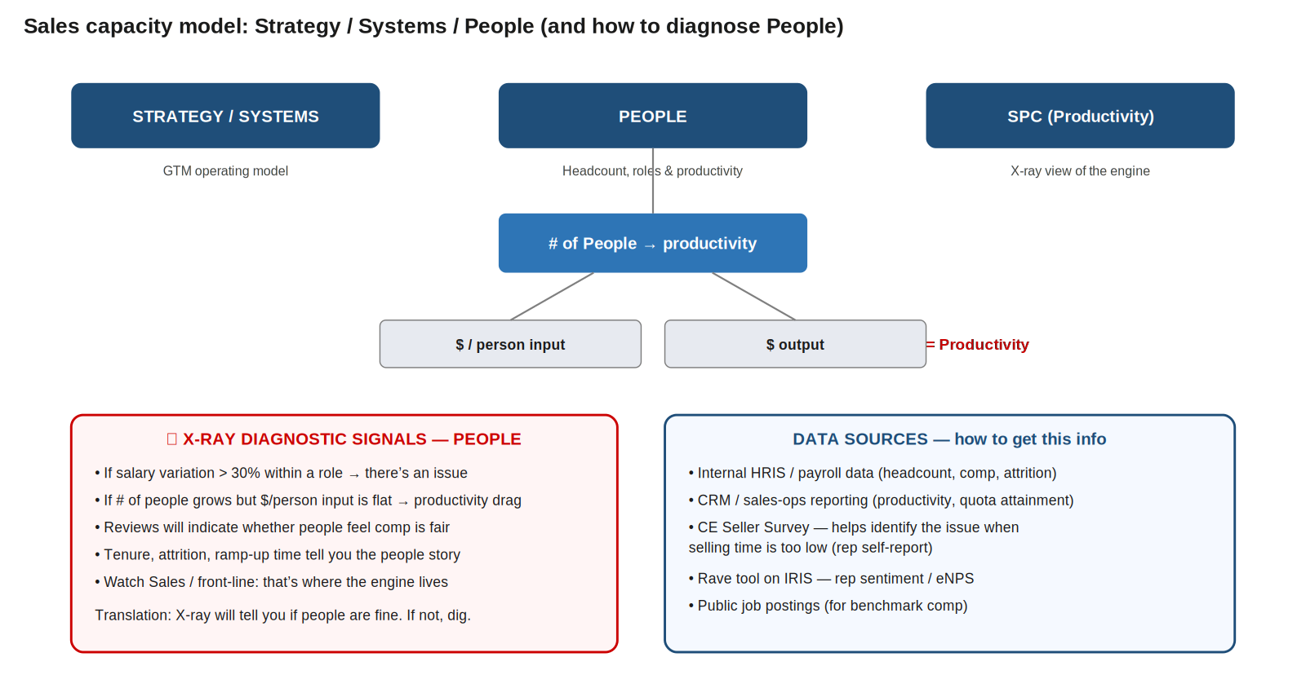
Capacity model — diagnose People dimension by checking # of people, $/person input, and $ output (= productivity)

How to diagnose the People dimension
The math: # of people × $/person input = total spend. $ output ÷ total spend = productivity.
Walk through the X-ray in this order:
- 1. Has # of people grown? Has revenue per person grown with it? If not → productivity drag.
- 2. Is $/person input (comp) reasonable vs benchmark?
- 3. What's the output per person? (Quota attainment, deals closed, revenue produced.)

RED-FLAG TRIGGERS — when the People dimension has a problem
• Salary variation within a role > 30% → there's an issue (inconsistent leveling, equity problems, or hidden roles)
• # of people grew but $/person input is flat → undervaluing capacity, or hiring junior
• Sentiment review surfaces comp complaints → fairness perception broken
• High attrition concentrated in tenured reps → comp / progression issue
• Selling time too low (per CE Seller Survey) → roles overloaded with non-selling work

Where to get the data
- Internal HRIS / payroll — headcount, comp, tenure, attrition by role
- CRM / sales-ops reporting — productivity, quota attainment, win rate, deal velocity
- CE Seller Survey — the canonical Bain seller-side data source; gives you "selling time too low" diagnostic + identifies issue area
- Rave tool on IRIS — rep sentiment / eNPS / qualitative themes
- Public job postings — for benchmarking OTE and role design vs market

6. Deployment model — coverage, roles, motions, ratios
Once strategy is set, deployment answers: How do I actually deploy the sales force? Five sub-questions hang off the deployment model, and they decompose into two parallel choices: what kind of roles and what kind of motions / coverage.
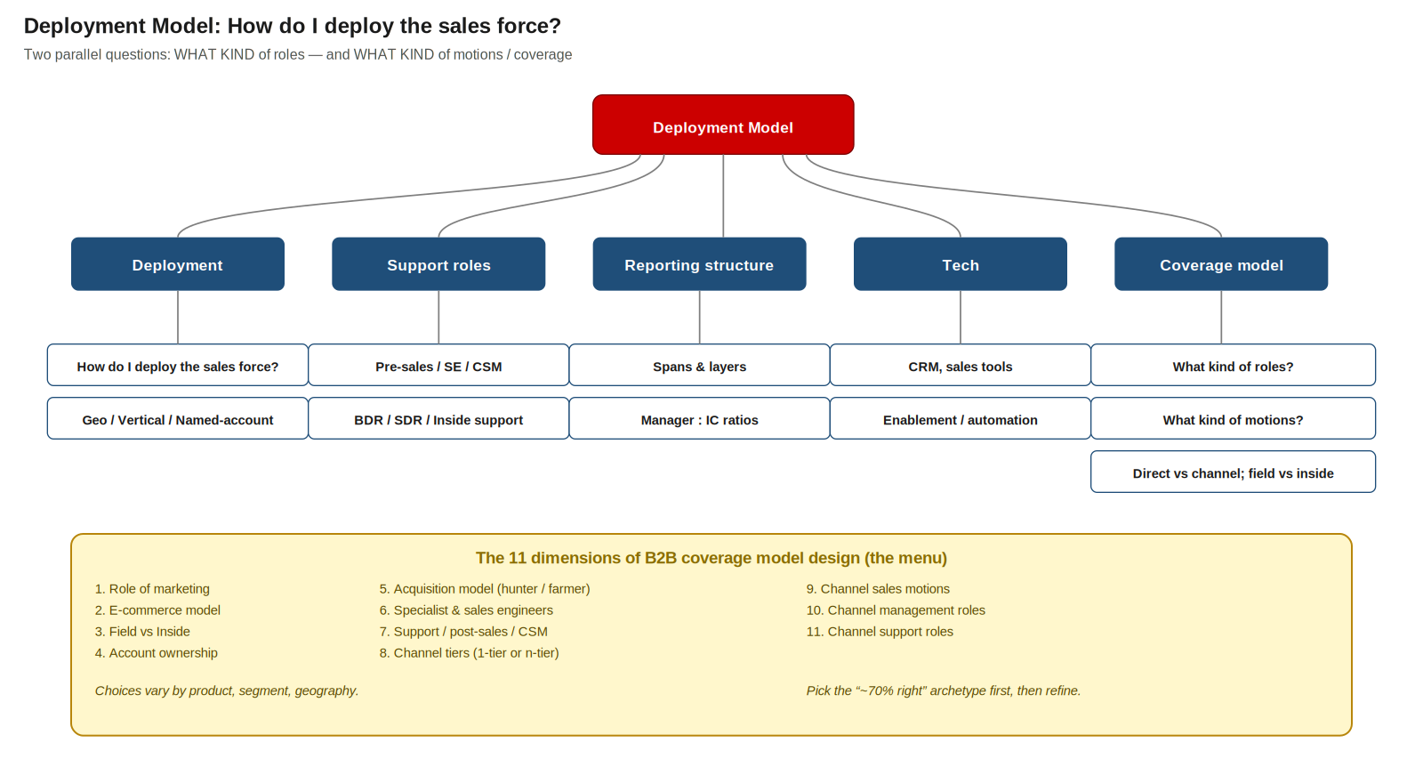
Deployment model — 5 sub-decisions, and the 11 dimensions of B2B coverage model design

The five deployment sub-questions
Sub-question | What you decide
1. Deployment | How to assign reps — by geography, vertical, named account, or hybrid
2. Support roles | Pre-sales, SE, CSM, BDR/SDR, RevOps — what mix, what ratios
3. Reporting structure | Spans & layers — how many ICs per manager, how many layers deep
4. Tech | CRM, sales tools, enablement platforms, automation
5. Coverage model | WHAT kind of roles + WHAT kind of motions (direct vs channel, field vs inside, etc.)

Coverage model: the 11 dimensions (the menu)
There's a Bain menu of 11 dimensions; you pick the "~70% right" archetype first, then refine for product / segment / geography.
Direct role choices (pick one per segment):
- Field vs Inside — do customers expect physical meetings, or can you sell virtually?
- Account ownership — who owns the account end-to-end?
- Acquisition model — hunter → farmer handoff, or single relationship-owner?
- Specialist & sales engineers — what technical expertise is required to sell?
- Support / post-sales / CSM — what additional roles support customers and reps?
Role of marketing & e-commerce:
- Role of marketing — best way to generate leads and excite customers?
- E-commerce offering — what e-commerce model do customers expect?
Channel choices (multiple possible):
- Channel tiers — can you reach customers through 1-tier channels, or are more required?
- Channel sales motions — collaborate with partners, or have them work independently?
- Channel management roles — how to manage channel partners effectively?
- Channel support roles — what supports channel managers and partners?

North Star coverage ratios
Once roles are set, define benchmark coverage ratios — both for sanity checks and as aspirational targets.
- Frontline Sales : BDR/SDR
- Frontline Sales : Customer Success
- Frontline Sales : Pre-sales / Sales Engineers
- Frontline Sales : Revenue Operations
- Manager : IC (span of control) — sanity-check spans & layers
Operational sanity test: # of selling days per account per year = (# annual visits/calls per account) × (days per visit). Multiply by # accounts in segment to validate the rep math.

7. KPI cheat sheet
Every metric you should be able to define on demand — with formula and how to read it.
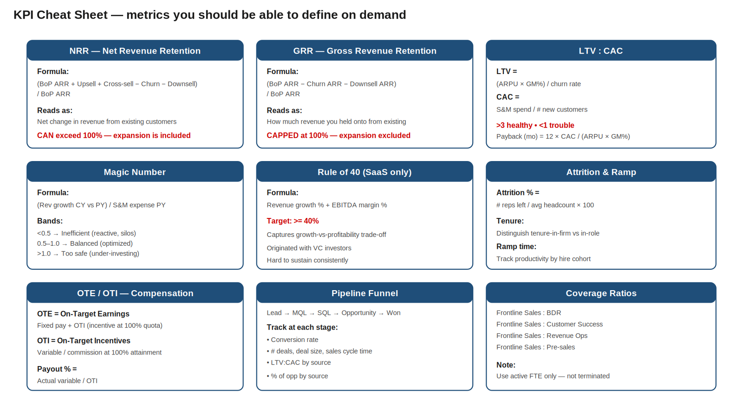
KPI cheat sheet — formulas, bands, and how to interpret

Detailed definitions
Metric | Formula / definition / band
NRR (Net Retention) | (BoP ARR + Upsell + Cross-sell − Churn − Downsell) / BoP ARR. Can exceed 100%. Measures net expansion from existing base.
GRR (Gross Retention) | (BoP ARR − Churn ARR − Downsell ARR) / BoP ARR. Capped at 100%. Measures revenue leakage.
Customer Retention Rate | 1 − (customers lost / customers at start of period). Customer count, not revenue.
LTV | (ARPU × Gross Margin %) / Customer churn rate. Lifetime value of a customer.
CAC | S&M spend / # new customers acquired in period.
LTV : CAC | Ratio. >3 = healthy. <1 = serious retention or acquisition cost problem.
CAC Payback (months) | 12 × CAC / (ARPU × Gross Margin %). How long to recover CAC.
Magic Number | (CY Revenue − PY Revenue) / PY S&M expense. <0.5 inefficient, 0.5–1 balanced, >1 too safe.
Rule of 40 | Revenue growth % + EBITDA margin % ≥ 40%. SaaS only.
Attrition % | # reps left during year / average # reps during year × 100. Active FTEs only.
Tenure | Time in firm vs time in role — distinguish. Use only active reps.
Ramp time | Time from hire to full productivity. Track by cohort (e.g. all 2020 hires).
OTE | On-Target Earnings = Fixed pay + OTI at 100% quota attainment.
OTI | On-Target Incentives = variable / commission earned at 100% attainment.
Payout % | Actual variable comp / OTI. Tells you whether quotas are realistic.
Win rate | Closed-won opportunities / Total closed opportunities. By stage, source, segment.
SOW (Share of Wallet) | Your revenue from account / total addressable spend at that account.
Pipeline coverage | Open pipeline value / quota target. Often 3–4× is healthy.
MQL → SQL → Opp → Won | Funnel conversion at each stage. Track by source.
Span | # direct reports per manager. Watch for very small spans (signals over-layering).
Layers | # of management levels from top to most junior. More layers = wasted effort.

8. The 15-topic GTM diagnostic playbook
When running an integrated GTM DD or CE diagnostic, the Bain playbook covers 15 topics. Memorize the structure — it's the table of contents for any case.

Group A — Where is revenue coming from? (Topics 1–3)
Topic | What you analyze
1. Sources of revenue growth | Revenue cuts by geo, BU, segment, product. Pareto on top accounts. Revenue bridge by transaction type.
2. GTM productivity metrics | Revenue growth vs S&M growth, S&M as % of revenue, Magic Number, Rule of 40 (SaaS), retention metrics (GRR/NRR).
3. GTM capability assessment | Qualitative scoring across 11 capabilities and 49 best practices vs industry peers.

Group B — Sales engine: capacity, roles, comp (Topics 4–8)
Topic | What you analyze
4. Sales capacity | Sales roles, deployment, sales motions. GTM headcount by role.
5. RTM design | Coverage ratios (Sales : Support FTEs) vs benchmark. Productivity by sales & support roles.
6. Roles & channel | Sales process, handoffs, alignment with buying personas. Direct vs indirect channel mix by revenue, by account size.
7. Compensation & sentiment | Tenure, attrition, comp design (fixed vs variable), OTE benchmarks, rep sentiment themes.
8. Productivity & quota | Variability in productivity by rep/role, quota setting & attainment, ramp time, attrition drivers.

Group C — Demand engine: marketing & pipeline (Topics 9–11)
Topic | What you analyze
9. Marketing — digital discoverability | Digital experience, media strategy, SEO/SEM. (FRWD handles digital diagnostics.)
10. Marketing spend | Overall spend, people vs programs split, breakdown by program type, MarTech tooling.
11. Sales pipeline | Pipeline sources & funnel performance, deal metrics (count, size, cycle), LTV:CAC by source, conversion rates MQL→SQL→Opp→Won, pipeline health.

Group D — Pricing & synthesis (Topics 12–15)
Topic | What you analyze
12. Pricing | Pricing-power rapid valuation, unjustified discounting variability, EBITDA upside from pricing.
13. Future resourcing model | Projected headcount aligned to best-in-class coverage ratios. Sales capacity model output.
14. Executive summary & roadmap | Prioritized CE initiatives over short/medium/long term (12–24 months). Upside by lever.
15. Financial integration | Investment required to close gaps. Integration with deal model. Underwritable upside.

9. Glossary of abbreviations
Term | Definition
ARR | Annual Recurring Revenue
BDR / SDR | Business Development Rep / Sales Development Rep (top-of-funnel prospecting)
BoP | Beginning of Period
CAC | Customer Acquisition Cost
CE | Commercial Excellence (Bain practice)
CORO | Bain customer/CE platform & toolkit; houses MoneyMap and other GTM tools
CSM | Customer Success Manager
DDA | Digital Demand Acceleration (Bain team for digital outbound)
DD | Due Diligence
eNPS | Employee Net Promoter Score
FRWD | Bain's digital practice (formerly FRWD); runs digital marketing diagnostics
FTE | Full-Time Employee
GRR | Gross Revenue Retention
GTM | Go-To-Market
IRIS | Bain internal data platform
ISR | Inside Sales Rep
LTV | Customer Lifetime Value
MQL | Marketing Qualified Lead
NRR | Net Revenue Retention
OTE | On-Target Earnings (fixed + incentive at 100% attainment)
OTI | On-Target Incentives (variable comp at 100% attainment)
PY / CY | Prior Year / Current Year
Rave | Bain sentiment / employee-feedback analysis tool on IRIS
RevOps | Revenue Operations
RTM | Route To Market
S&M | Sales & Marketing
SE | Sales Engineer
SG&A | Selling, General & Administrative expenses
SOW | Share of Wallet
SPC | Sustained Productivity Creator
SQL | Sales Qualified Lead
TAM | Total Addressable Market
WACC | Weighted Average Cost of Capital

— End of notes —

