WEEK 1 DATA SCIENCE PROJECT
Data Acquisition, Cleaning & Exploratory Data Analysis
Titanic Dataset
Python • Pandas • NumPy • Matplotlib
Original dataset: 891 rows × 12 columns

1. Introduction
This project simulates the data preparation process used in a typical data science workflow. It covers dataset acquisition, data understanding, cleaning, preprocessing and exploratory data analysis (EDA) using Python.
The Titanic dataset was selected because it contains numerical and categorical variables, missing values and meaningful relationships that can be explored through statistics and visualizations.

1.1 Objectives
- Acquire and inspect a publicly available dataset.
- Identify missing values, duplicate records and data-quality issues.
- Clean and preprocess the dataset using Pandas.
- Perform exploratory analysis using summary statistics.
- Create visualizations to identify patterns and relationships.
- Document the methodology, cleaning decisions and insights.

2. Data Acquisition and Understanding
The Titanic dataset was loaded from the provided CSV file using Pandas. It contains passenger-level information such as survival status, passenger class, name, sex, age, family-related variables, fare, cabin and embarkation port.
The original dataset contains 891 rows and 12 columns.
df = pd.read_csv("titanic.csv")
df.head()
print(df.shape)
df.info()
df.describe()
print(df.isnull().sum())
print("Duplicate rows:", df.duplicated().sum())

3. Data Cleaning and Preprocessing

3.1 Missing Values
Missing-value analysis showed missing data in Age, Cabin and Embarked. Cabin had the highest level of missingness.
Column | Missing Count | Missing %
Cabin | 687 | 77.10%
Age | 177 | 19.87%
Embarked | 2 | 0.22%
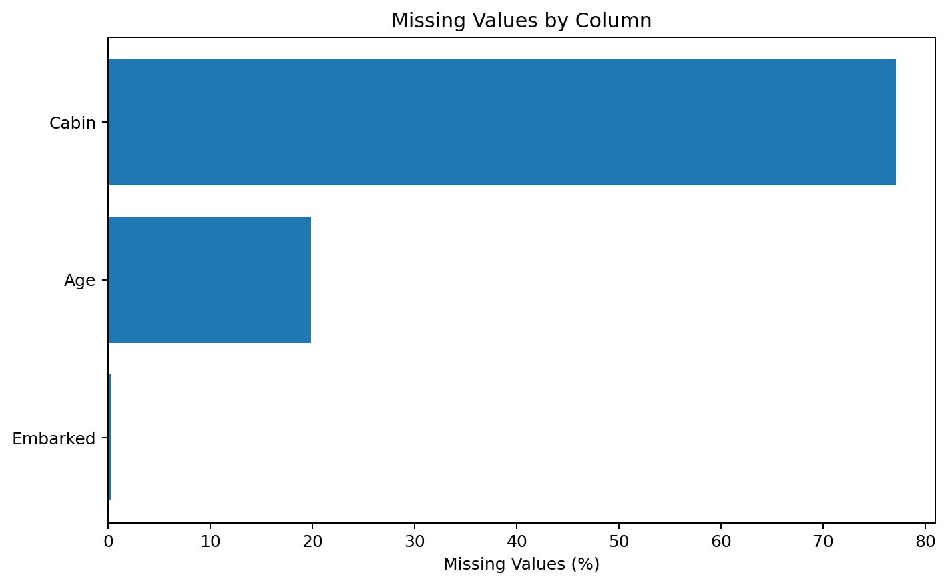
Figure 1. Missing values in the original dataset.

3.2 Cleaning Decisions and Rationale
Age: 177 values were missing (19.87%). Median imputation was used, with a median of 28 years, because the median is less sensitive to extreme values than the mean.
Embarked: 2 values were missing. They were replaced with the mode, 'S', because Embarked is categorical and only two values were missing.
Cabin: 687 values were missing (77.10%). The original Cabin column was removed because its very high missingness would make direct analysis of the raw values unreliable.
Duplicates: 0 duplicate rows were found, so no duplicate records were removed.
cleaned_df = df.copy()
cleaned_df["Age"] = cleaned_df["Age"].fillna(cleaned_df["Age"].median())
cleaned_df["Embarked"] = cleaned_df["Embarked"].fillna(cleaned_df["Embarked"].mode()[0])
cleaned_df = cleaned_df.drop(columns=["Cabin"])
print(cleaned_df.isnull().sum())
print("Duplicates:", cleaned_df.duplicated().sum())

3.3 Cleaning Validation
After cleaning, the dataset contains 891 rows and 11 columns. The retained columns contain no missing values, and duplicate rows remain at 0.
print("Original shape:", df.shape)
print("Cleaned shape:", cleaned_df.shape)
print(cleaned_df.isnull().sum())
cleaned_df.to_csv("titanic_cleaned.csv", index=False)

4. Exploratory Data Analysis
EDA was used to understand distributions and investigate relationships between passenger characteristics and survival.

4.1 Survival Distribution
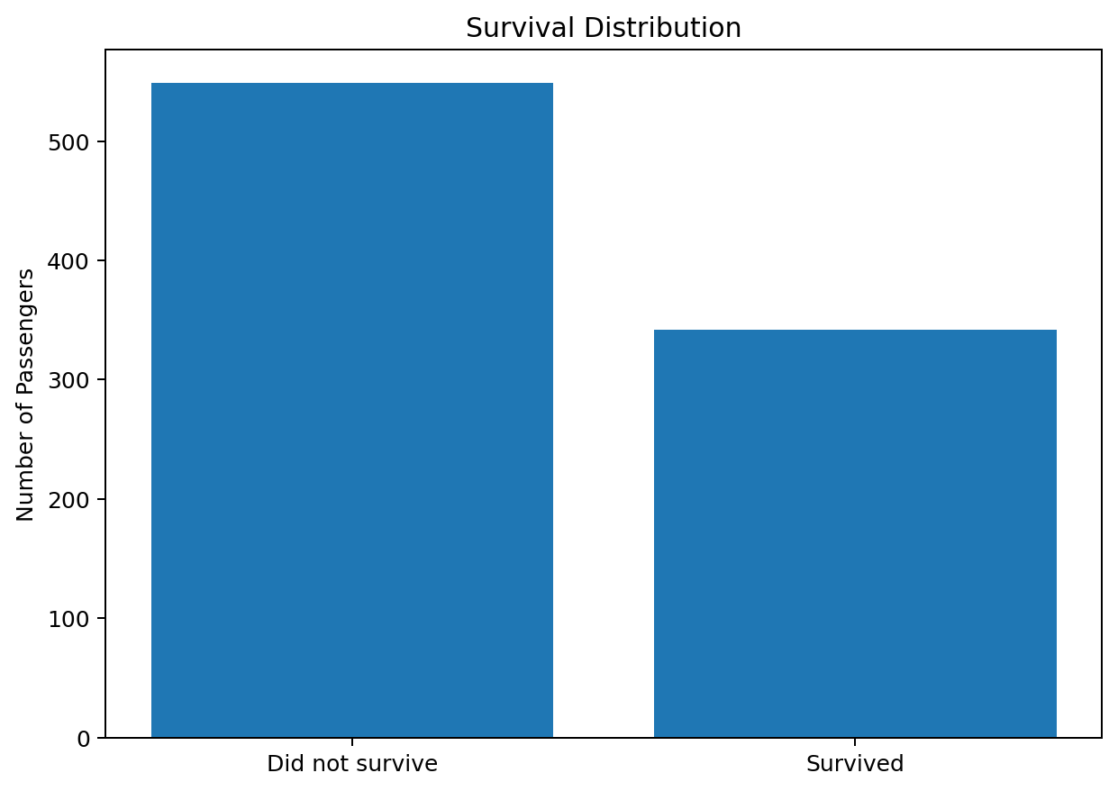
Figure 2. Distribution of passengers by survival status.
cleaned_df["Survived"].value_counts()

4.2 Age Distribution
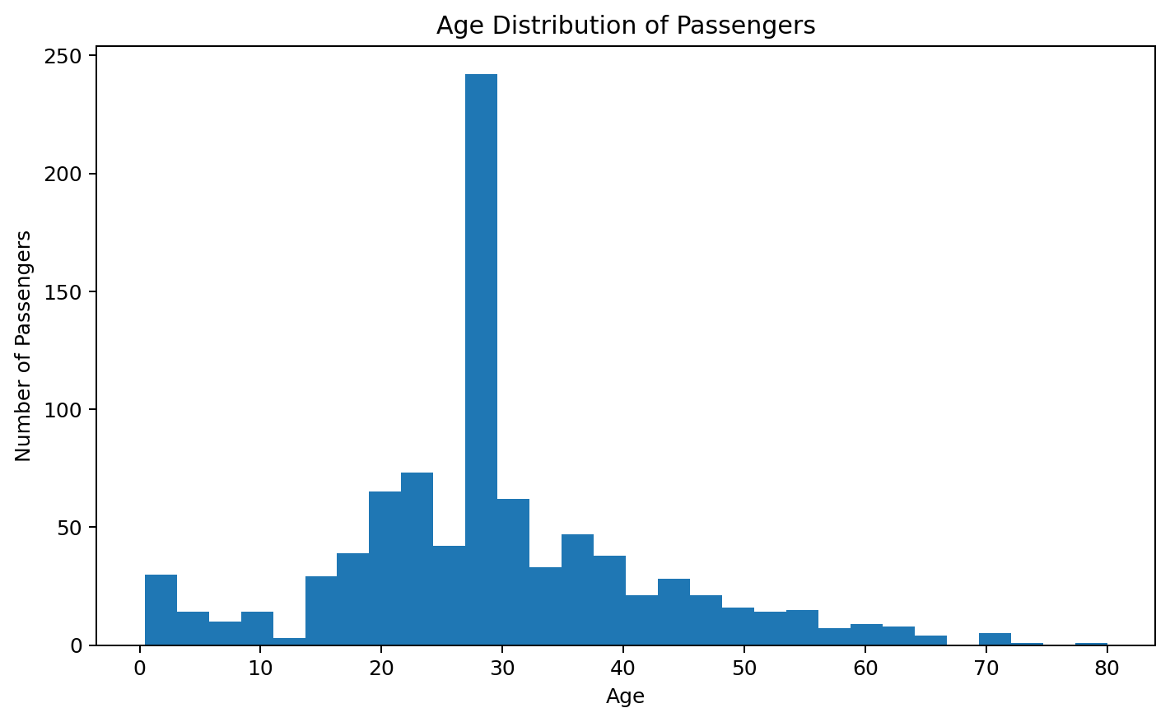
Figure 3. Age distribution of passengers.
plt.hist(cleaned_df["Age"], bins=30)

4.3 Survival by Gender
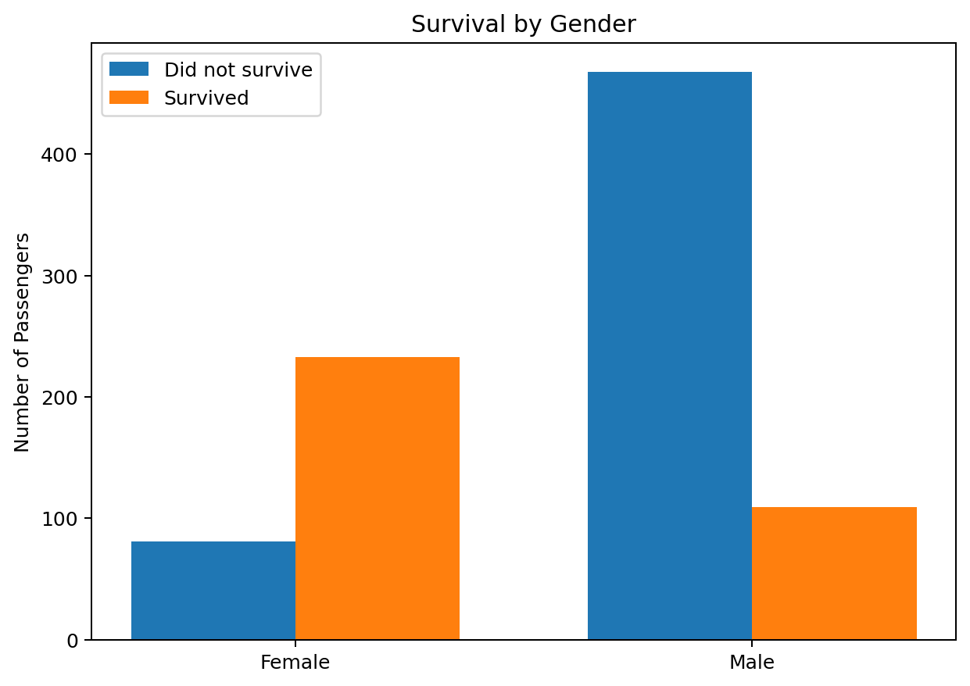
Figure 4. Survival outcomes by gender.
cleaned_df.groupby(["Sex","Survived"]).size()

4.4 Survival by Passenger Class
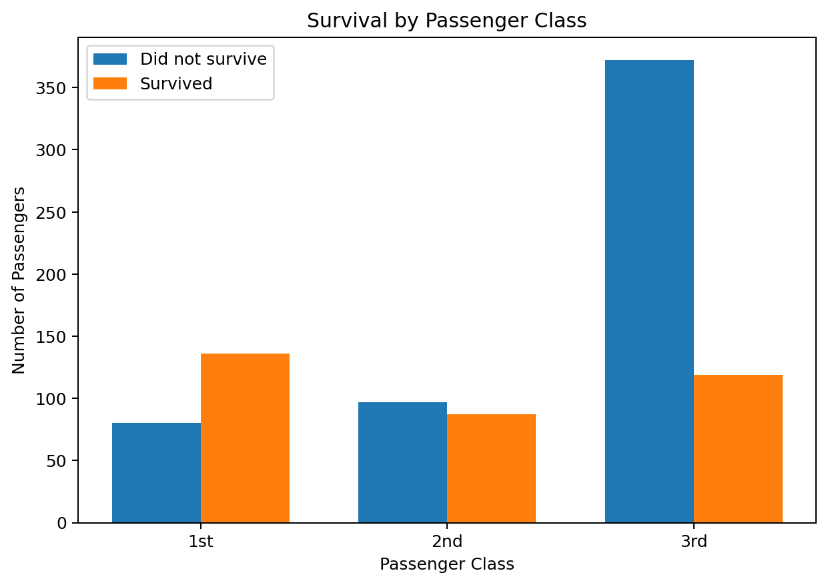
Figure 5. Survival outcomes by passenger class.
cleaned_df.groupby(["Pclass","Survived"]).size()

4.5 Correlation Analysis
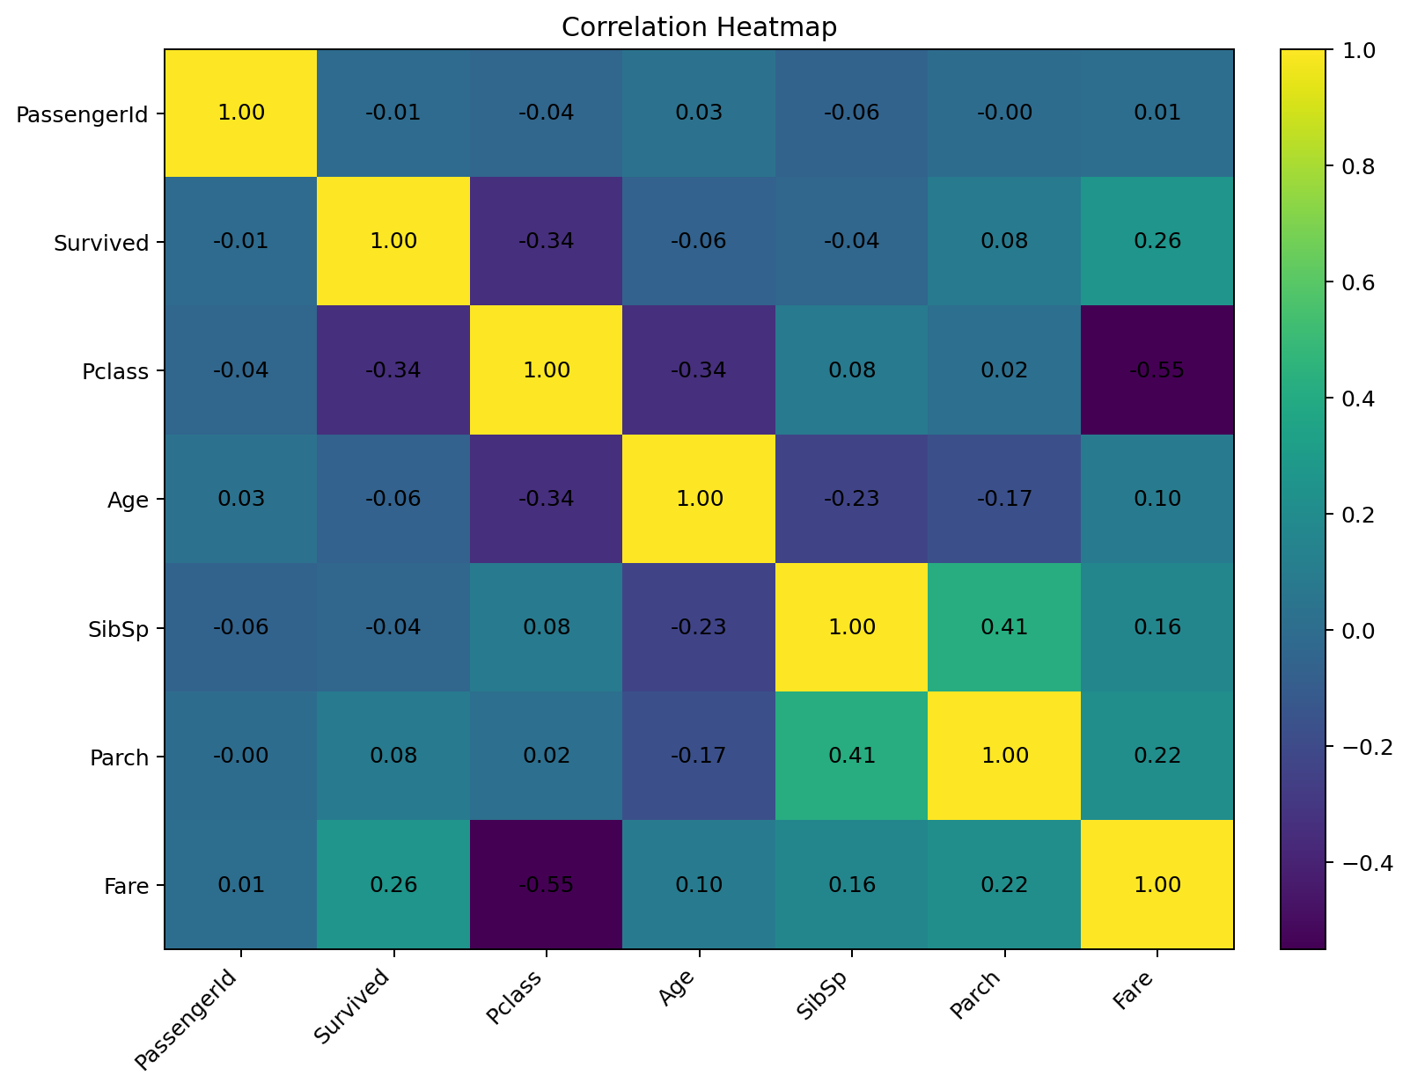
Figure 6. Correlation matrix for numerical variables.
cleaned_df.select_dtypes(include="number").corr()

5. Summary Statistics and Key Insights
The overall survival rate was 38.38%. The mean passenger age was 29.36 years and the median was 28 years.

5.1 Gender-wise Survival Rate
Gender | Survival Rate
Female | 74.20%
Male | 18.89%

5.2 Class-wise Survival Rate
Passenger Class | Survival Rate
Class 1 | 62.96%
Class 2 | 47.28%
Class 3 | 24.24%

5.3 Key Insights
- The overall survival rate was approximately 38.38%, so fewer than half of the passengers survived.
- Female passengers had a survival rate of approximately 74.20%, compared with 18.89% for male passengers.
- Survival varied by passenger class: 62.96% for first class, 47.28% for second class and 24.24% for third class.
- The mean passenger age was 29.36 years and the median was 28 years.
- Passenger class had a correlation of -0.34 with survival, while Fare had a correlation of 0.26.
- Correlation describes association, not causation; further analysis would be required to understand combined effects.

6. Potential Areas for Further Analysis
- Compare survival using combinations of gender and passenger class.
- Investigate whether family size variables (SibSp and Parch) are associated with survival.
- Analyze fare distributions across passenger classes.
- Create age groups and compare survival rates.
- Develop a classification model to predict survival.
- Apply feature engineering and evaluate predictive models using suitable validation metrics.

7. Conclusion
This project demonstrated a complete introductory data preparation and EDA workflow. The Titanic dataset was inspected for structure, missing values and duplicates. Missing Age values were handled using median imputation, missing Embarked values were filled with the mode, and the highly incomplete Cabin column was removed.
The exploratory analysis revealed clear differences in observed survival rates across gender and passenger class. The resulting cleaned dataset and analytical findings provide a foundation for more advanced statistical analysis or predictive modeling.

8. Reproducibility
The project uses Python, Pandas, NumPy and Matplotlib. The cleaned dataset was exported as titanic_cleaned.csv. The code snippets in this report can be combined into a Jupyter Notebook or Python script to reproduce the analysis.

Appendix: Core Python Code
import pandas as pd
import numpy as np
import matplotlib.pyplot as plt
df = pd.read_csv("titanic.csv")
# Inspection
print(df.shape)
df.info()
print(df.describe())
print(df.isnull().sum())
print(df.duplicated().sum())
# Cleaning
cleaned_df = df.copy()
cleaned_df["Age"] = cleaned_df["Age"].fillna(cleaned_df["Age"].median())
cleaned_df["Embarked"] = cleaned_df["Embarked"].fillna(cleaned_df["Embarked"].mode()[0])
cleaned_df = cleaned_df.drop(columns=["Cabin"])
# EDA
plt.hist(cleaned_df["Age"], bins=30)
plt.show()
# Survival rates
print(cleaned_df.groupby("Sex")["Survived"].mean() * 100)
print(cleaned_df.groupby("Pclass")["Survived"].mean() * 100)
# Correlation
print(cleaned_df.select_dtypes(include="number").corr())
# Export
cleaned_df.to_csv("titanic_cleaned.csv", index=False)

End of Report

