**Step 2: Data Analysis: summarization**

I have uploaded the data on Github as I’m working with google-Colab for smooth working.

So, lets see

**Working with match data:**

Shape of data: (756, 18)

Null value in data:

Column count

city 7

winner 4

player_of_match 4

umpire1 2

umpire2 2

umpire3 637

so here is much null values in data I have drop column umpire 3 as it has large values and for rest I have just remove **na** values after this we have data: (743, 17)

data Stats:

id season dl_applied win_by_runs win_by_wickets

count 743.000000 743.000000 743.000000 743.000000 743.000000

mean 1786.578735 2013.418573 0.025572 13.460296 3.375505

std 3455.045846 3.378787 0.157961 23.626205 3.393397

min 1.000000 2008.000000 0.000000 0.000000 0.000000

25% 187.500000 2011.000000 0.000000 0.000000 0.000000

50% 374.000000 2013.000000 0.000000 0.000000 4.000000

75% 567.500000 2016.000000 0.000000 19.000000 6.000000

max 11415.000000 2019.000000 1.000000 146.000000 10.000000

unique values in each column:

id 743

season 12

city 32

date 538

team1 15

team2 15

toss_winner 15

toss_decision 2

result 2

dl_applied 2

winner 15

win_by_runs 89

win_by_wickets 11

player_of_match 226

venue 40

umpire1 61

umpire2 65

**data column with data we have:**

id int64

season int64

city object

date object

team1 object

team2 object

toss_winner object

toss_decision object

result object

dl_applied int64

winner object

win_by_runs int64

win_by_wickets int64

player_of_match object

venue object

umpire1 object

umpire2 object

**corelation in data**

**here its corelation matrix tells about relation among data**

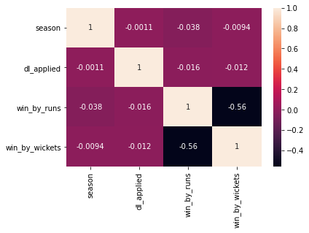

**Distribution of data of [“win by runs”] column data:**

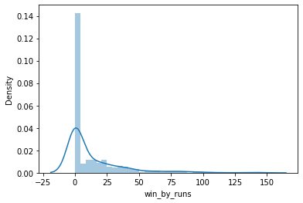

Distribution of data of [“win by wickets”] column data:

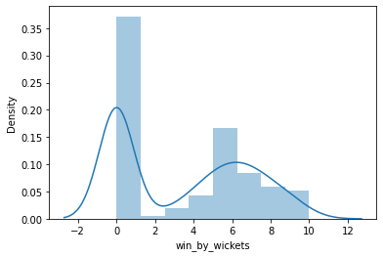

Outliers in data [“win by run”] column data:

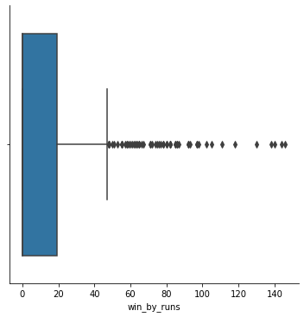

**Teams Numbers of times wins:**

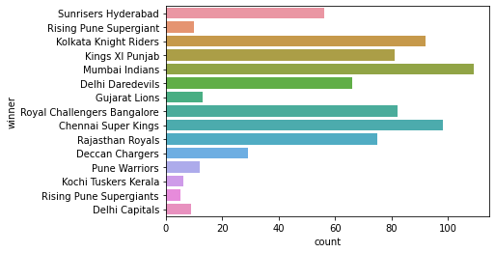

**Matches Played Per year:**

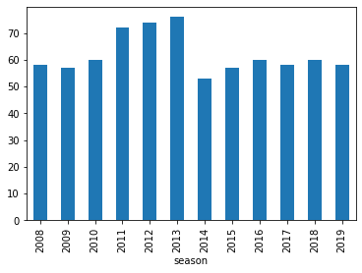

**Cities where matches played**

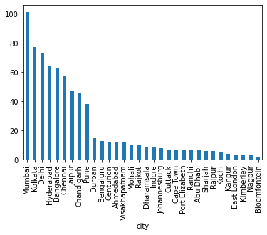

**Top 5 city are :**

City matches

Mumbai 101

Kolkata 77

Delhi 73

Hyderabad 64

Bangalore 63

**Top 5 stadiums are :**

**Stadium**

eden garden

Wankhede

Chinnaswami

Firoz shah kotla

Rajiv Gandhi international stdm.

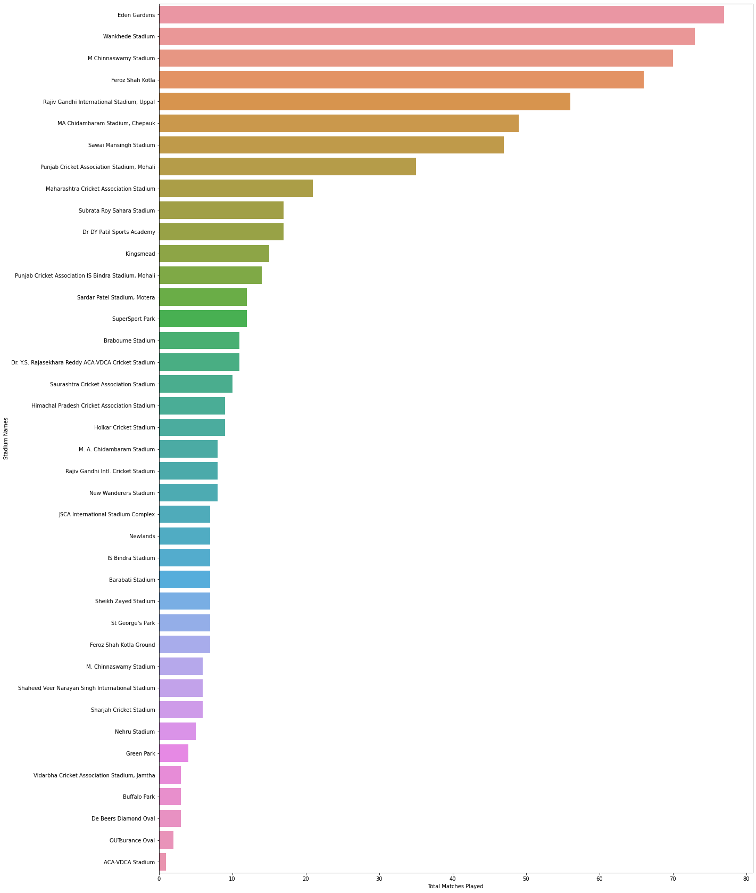**List of top Stadiums where match played**

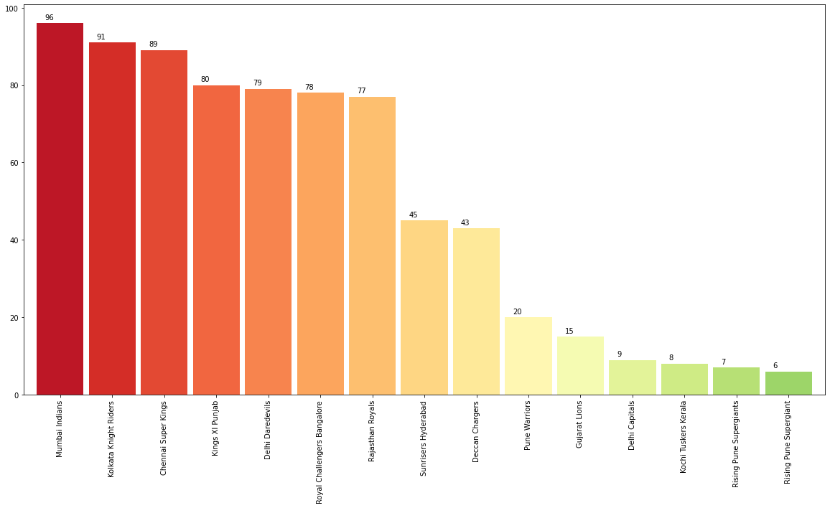**Toss winner percentages**

**most of the time chasing is simple in IPL matches. So if you choose the Filed first time then your chance of winning match get increases near about 50%**

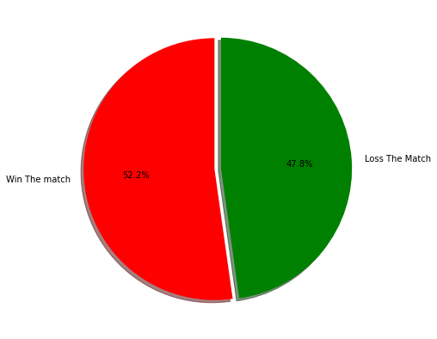

**So let's see for toss decision and winner team:**

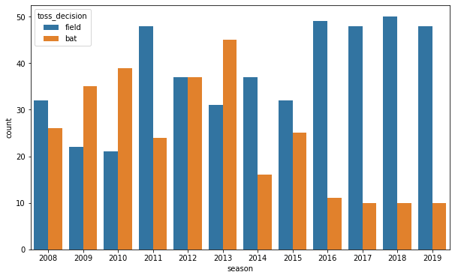

The decision for batting or fielding varies largely across the seasons from 2008 to 2013 some seasons, the probability that toss winners choose for batting is high, while it is not the case in seasons from 2014 to 2019 the majority of toss winners choose for batting.

**Top players**

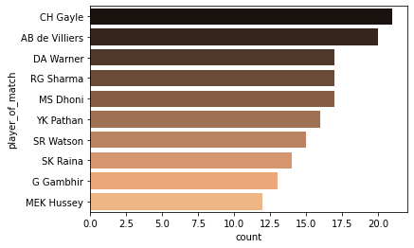

**CH Gayle is the top player of the match awardee in all the seasons of IPL.**

**Top umpires:**

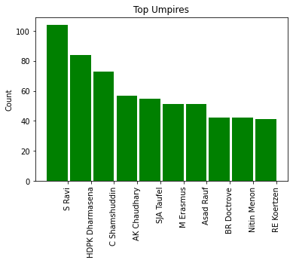

S. Ravi seems to be the most sought-after umpire for IPL matches followed by Dharmasena. Others are fairly close to each other.

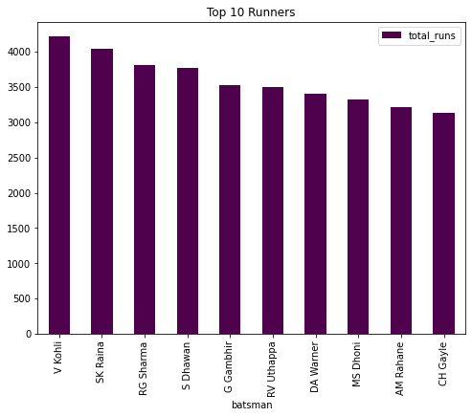Top 10 runner:

**Virat Kohli is the leading batsman according to our analysis followed closely by Raina.**

**Top boundaries:**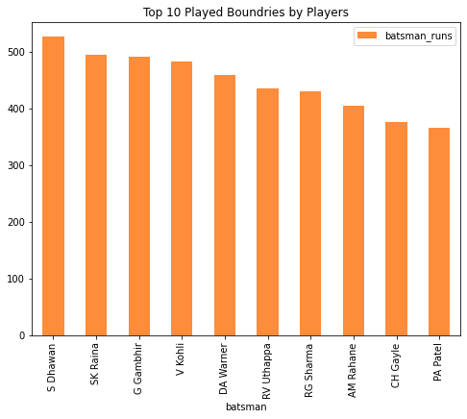

Dhawan & Raina played more boundaries than all other players.

**Most sixers:**

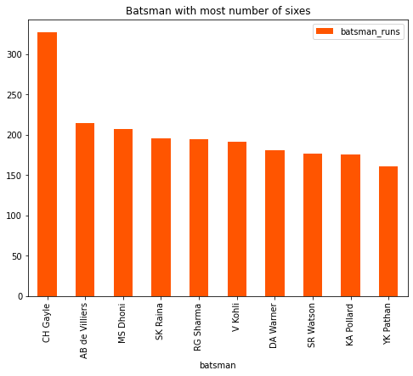

Yes C. Gayle & AB de really played awesome. Both are famous sixers.

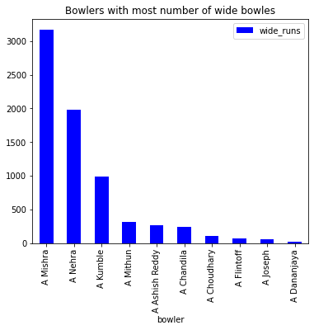**bowlers with most number of wide balls :**

amit misra and nehra has nost number of wide balls during entire season of ipl.

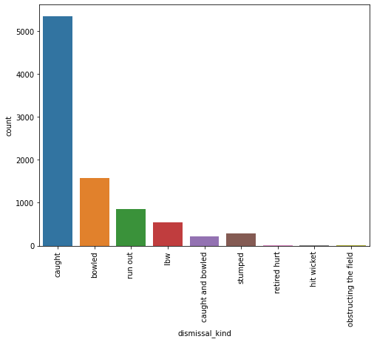

**Caught is the most common dismissal type in IPL followed by Bowled. There are very few instances of hit wicket as well. 'Obstructing the field' is one of the dismissal type as well in IPL.!**

**Lets end this here. It can be go in depth more and more.**

**Here is link to Notebook:**

<https://github.com/dubeysachin752/DataViz-comepetetion/blob/main/DataViz.ipynb>

**Thank You !!**