SQL-Based Data Analysis Using Filtering, Aggregation, and Business Queries
Name: Sneha Dubey
Internship: Celebal Technologies
Assignment: SQL Assignment – Week 2

Objective
Analyze the Superstore dataset using SQL by applying filtering, aggregation, sorting, business queries, and data validation techniques.

Tools Used
- MySQL Server 8.0
- MySQL Workbench
- Superstore Dataset (Kaggle)

Dataset Information
- Dataset Name: Superstore Dataset
- Source: Kaggle
- Records: 9,994
- Columns: 21

Query Results

CREATE DATABASE shopease_db;
USE shopease_db;
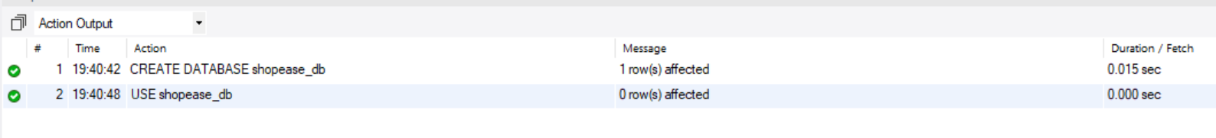

CREATE TABLE customers (
customer_id INT PRIMARY KEY,
first_name VARCHAR(50) NOT NULL,
last_name VARCHAR(50) NOT NULL,
email VARCHAR(100) UNIQUE NOT NULL,
city VARCHAR(50) NOT NULL,
state VARCHAR(50) NOT NULL,
join_date DATE NOT NULL,
is_premium BOOLEAN DEFAULT FALSE
);
-- Index for filtering by city/state
CREATE INDEX idx_customers_city ON customers(city);
CREATE INDEX idx_customers_state ON customers(state);

CREATE TABLE products (
product_id INT PRIMARY KEY,
product_name VARCHAR(100) NOT NULL,
category VARCHAR(50) NOT NULL,
brand VARCHAR(50) NOT NULL,
unit_price DECIMAL(10,2) NOT NULL CHECK (unit_price > 0),
stock_qty INT NOT NULL DEFAULT 0 CHECK (stock_qty >= 0)
);
-- Index for filtering by category
CREATE INDEX idx_products_category ON products(category);

CREATE TABLE orders (
order_id INT PRIMARY KEY,
customer_id INT NOT NULL,
order_date DATE NOT NULL,
status VARCHAR(20) NOT NULL DEFAULT 'Pending'
CHECK (status IN ('Pending','Shipped','Delivered','Cancelled')),
total_amount DECIMAL(12,2) NOT NULL CHECK (total_amount >= 0),
FOREIGN KEY (customer_id) REFERENCES customers(customer_id)
);
-- Index for date-based filtering and sorting
CREATE INDEX idx_orders_date ON orders(order_date);
CREATE INDEX idx_orders_status ON orders(status);

CREATE TABLE order_items (
item_id INT PRIMARY KEY,
order_id INT NOT NULL,
product_id INT NOT NULL,
quantity INT NOT NULL CHECK (quantity > 0),
unit_price DECIMAL(10,2) NOT NULL CHECK (unit_price > 0),
discount_pct DECIMAL(5,2) DEFAULT 0 CHECK (discount_pct BETWEEN 0 AND 100),
FOREIGN KEY (order_id) REFERENCES orders(order_id),
FOREIGN KEY (product_id) REFERENCES products(product_id)
);

-- ========== INSERT: customers ==========
INSERT INTO customers VALUES
(101, 'Aarav', 'Sharma', 'aarav.s@email.com', 'Mumbai', 'Maharashtra', '2024-01-15', TRUE),
(102, 'Priya', 'Patel', 'priya.p@email.com', 'Ahmedabad', 'Gujarat', '2024-02-20', FALSE),
(103, 'Rohan', 'Gupta', 'rohan.g@email.com', 'Delhi', 'Delhi', '2024-03-10', TRUE),
(104, 'Sneha', 'Reddy', 'sneha.r@email.com', 'Hyderabad', 'Telangana', '2024-04-05', FALSE),
(105, 'Vikram', 'Singh', 'vikram.s@email.com', 'Jaipur', 'Rajasthan', '2024-05-12', TRUE),
(106, 'Ananya', 'Iyer', 'ananya.i@email.com', 'Chennai', 'Tamil Nadu', '2024-06-18', FALSE),
(107, 'Karan', 'Mehta', 'karan.m@email.com', 'Pune', 'Maharashtra', '2024-07-22', TRUE),
(108, 'Divya', 'Nair', 'divya.n@email.com', 'Kochi', 'Kerala', '2024-08-30', FALSE);

-- ========== INSERT: products ==========
INSERT INTO products VALUES
(201, 'Wireless Earbuds', 'Electronics', 'BoAt', 1499.00, 250),
(202, 'Cotton T-Shirt', 'Clothing', 'Levis', 799.00, 500),
(203, 'Smart Watch', 'Electronics', 'Noise', 2999.00, 150),
(204, 'Running Shoes', 'Clothing', 'Nike', 4599.00, 120),
(205, 'Bluetooth Speaker', 'Electronics', 'JBL', 3499.00, 200),
(206, 'Bedsheet Set', 'Home', 'Spaces', 1299.00, 300),
(207, 'Laptop Stand', 'Electronics', 'AmazonBasics', 899.00, 180),
(208, 'Cushion Covers (Set)', 'Home', 'HomeCenter', 599.00, 400);

-- ========== INSERT: orders ==========
INSERT INTO orders VALUES
(1001, 101, '2024-08-01', 'Delivered', 4498.00),
(1002, 102, '2024-08-03', 'Delivered', 799.00),
(1003, 103, '2024-08-05', 'Shipped', 7498.00),
(1004, 101, '2024-08-10', 'Delivered', 3499.00),
(1005, 104, '2024-08-12', 'Cancelled', 2999.00),
(1006, 105, '2024-08-15', 'Delivered', 5898.00),
(1007, 106, '2024-08-18', 'Pending', 1299.00),
(1008, 103, '2024-08-20', 'Delivered', 899.00),
(1009, 107, '2024-08-25', 'Shipped', 6098.00),
(1010, 108, '2024-08-28', 'Delivered', 1598.00);

-- ========== INSERT: order_items ==========
INSERT INTO order_items VALUES
(5001, 1001, 201, 2, 1499.00, 0),
(5002, 1001, 207, 1, 899.00, 10),
(5003, 1002, 202, 1, 799.00, 0),
(5004, 1003, 203, 1, 2999.00, 0),
(5005, 1003, 204, 1, 4599.00, 5),
(5006, 1004, 205, 1, 3499.00, 0),
(5007, 1005, 203, 1, 2999.00, 0),
(5008, 1006, 201, 1, 1499.00, 10),
(5009, 1006, 204, 1, 4599.00, 5),
(5010, 1007, 206, 1, 1299.00, 0),
(5011, 1008, 207, 1, 899.00, 0),
(5012, 1009, 205, 1, 3499.00, 0),
(5013, 1009, 208, 2, 599.00, 15),
(5014, 1010, 206, 1, 1299.00, 0),
(5015, 1010, 208, 1, 599.00, 0);

Section A — SQL Basics (SELECT, Constraints, Primary Keys)
-- Q1. Display all columns and rows from the customers table.
SELECT * FROM customers;
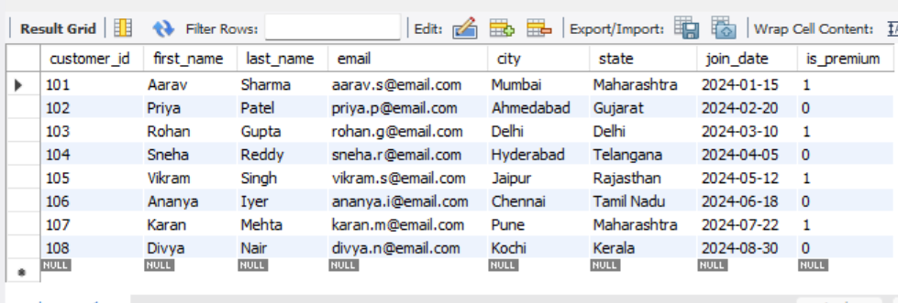

-- Q2. Retrieve only the first_name, last_name, and city of all customers.
SELECT first_name, last_name, city FROM customers;
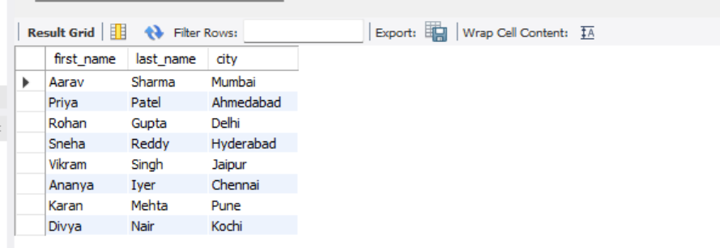

-- Q3. List all unique categories available in the products table.
SELECT DISTINCT category FROM products;
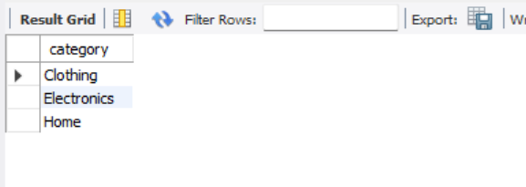

Q4. Identify the Primary Key of each table in the schema. Explain why a Primary Key must be unique and NOT NULL.
Answer:
The Primary Keys of the tables are:
Table | Primary Key
customers | customer_id
products | product_id
orders | order_id
order_items | item_id
A Primary Key is a column (or set of columns) that uniquely identifies each record in a table.
A Primary Key must be:
- Unique: No two rows can have the same Primary Key value. This ensures that each record can be uniquely identified.
- NOT NULL: Every record must have a Primary Key value. A NULL value is not allowed because the database would not be able to uniquely identify that record.
Primary Keys help maintain data integrity and are used to establish relationships between tables through Foreign Keys.

Q5. What constraints are applied to the email column in the customers table? What would happen if you tried to insert a duplicate email?
Answer:
The email column in the customers table has the following constraints:
- UNIQUE – Ensures that every email address is different and no duplicate email values are allowed.
- NOT NULL – Ensures that every customer must have an email address. The email field cannot be left empty.
If we try to insert a duplicate email address, MySQL will reject the insertion and display a Duplicate Entry error because the UNIQUE constraint is violated.
This prevents duplicate customer records and helps maintain data accuracy and consistency in the database.

-- Q6. Try inserting a product with a negative unit_price.
INSERT INTO products (product_id, product_name, category, brand, unit_price, stock_qty) VALUES (209, 'Test Product', 'Electronics', 'TestBrand', -50, 10);
-- Explanation:
-- The INSERT statement fails because the unit_price value (-50)
-- violates the CHECK constraint:
-- CHECK (unit_price > 0)
-- MySQL returns:
-- Error Code: 3819
-- Check constraint 'products_chk_1' is violated.
-- This constraint ensures that only positive product prices
-- can be stored in the database, maintaining data integrity.
Section B — Filtering & Optimization (WHERE, Indexes)
Q7. Retrieve all orders with status = 'Delivered'.
SELECT * FROM orders WHERE status = 'Delivered';
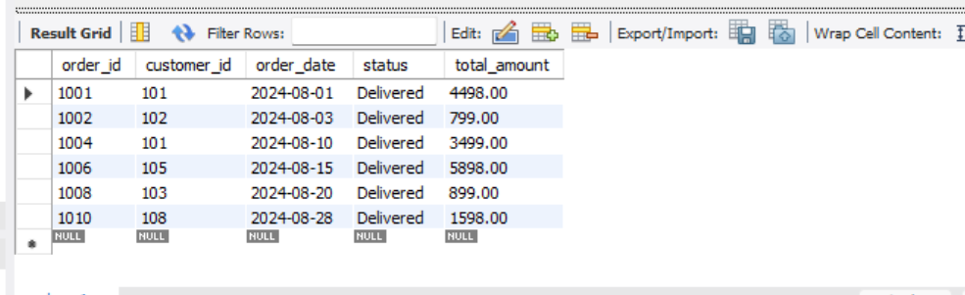

Q8. Find all products in the 'Electronics' category with a unit_price greater than ₹2000.
SELECT * FROM products WHERE category = 'Electronics' AND unit_price > 2000;
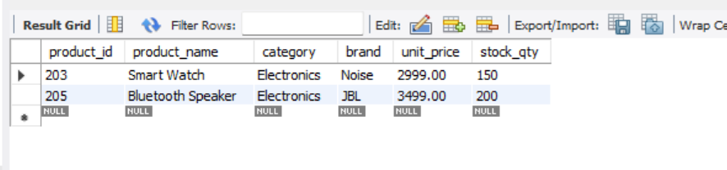

Q9. List all customers who joined in the year 2024 and belong to the state 'Maharashtra'.
SELECT * FROM customers WHERE state = 'Maharashtra' AND join_date BETWEEN '2024-01-01' AND '2024-12-31';
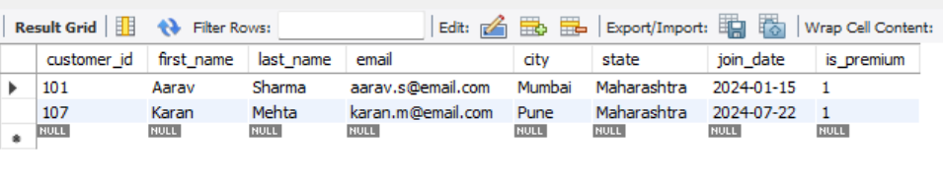
Q10. Find all orders placed between '2024-08-10' and '2024-08-25' (inclusive) that are NOT cancelled.
SELECT * FROM orders WHERE order_date BETWEEN '2024-08-10' AND '2024-08-25' AND status <> 'Cancelled';
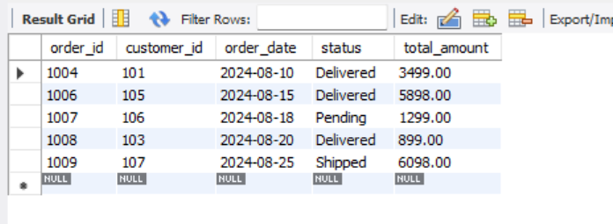
Q11. Explain what the index idx_orders_date does. How would it improve the performance of a query that filters orders by order_date? Write a sample query that would benefit from this index.
-- The index idx_orders_date is created on the order_date column.
-- It speeds up queries that filter or sort records based on order_date
-- by allowing MySQL to quickly locate matching rows instead of scanning
-- the entire table.
-- Example query that benefits from this index:
SELECT * FROM orders WHERE order_date BETWEEN '2024-08-01' AND '2024-08-31';
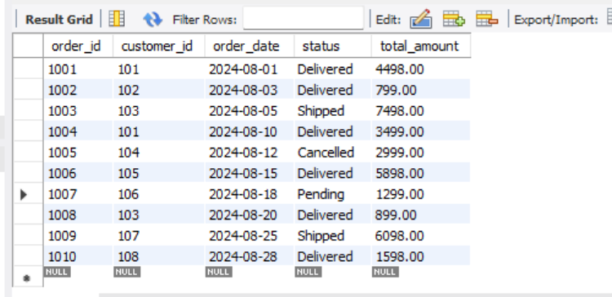
Q12. If you run: SELECT * FROM customers WHERE YEAR(join_date) = 2024; — would the index on join_date be used? Explain why or why not, and rewrite the query to be index-friendly (SARGable).
SELECT * FROM customers WHERE join_date BETWEEN '2024-01-01' AND '2024-12-31';
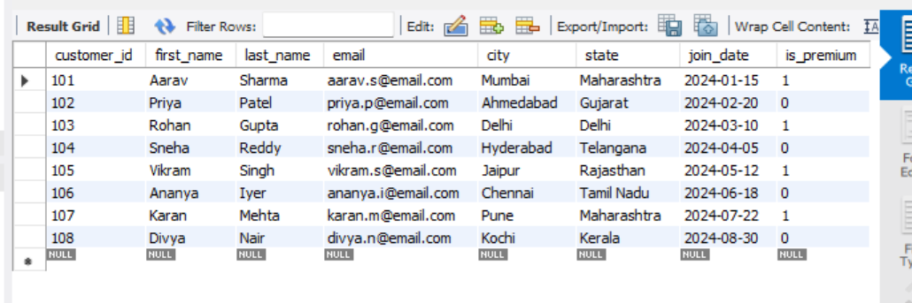

Section C — Aggregation (GROUP BY, SUM, COUNT, AVG, MIN, MAX)
Q13. Count the total number of orders in the orders table.
SELECT COUNT(*) AS Total_Orders FROM orders;
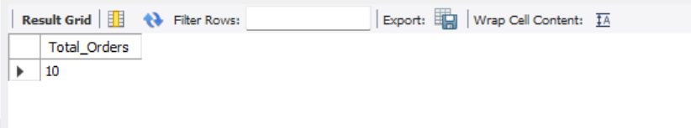
Q14. Find the total revenue (SUM of total_amount) from all 'Delivered' orders.
SELECT SUM(total_amount) AS Total_Revenue FROM orders WHERE status = 'Delivered';
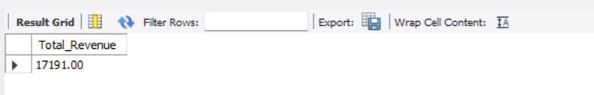
Q15. Calculate the average unit_price of products in each category.
SELECT category, AVG(unit_price) AS Average_Unit_Price
FROM products GROUP BY category;
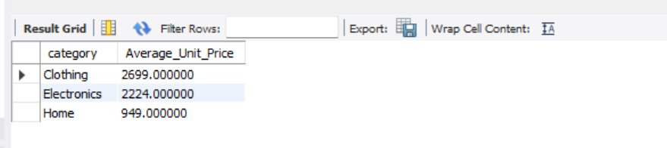
Q16. For each order status, find the count of orders and the total revenue. Sort the result by total revenue in descending order.
SELECT status,
COUNT(*) AS Order_Count,
SUM(total_amount) AS Total_Revenue
FROM orders GROUP BY status ORDER BY Total_Revenue DESC;
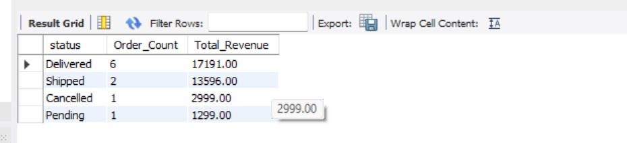

Q17. Find the most expensive (MAX) and cheapest (MIN) product in each category.
SELECT category,
MAX(unit_price) AS Most_Expensive_Product,
MIN(unit_price) AS Cheapest_Product
FROM products GROUP BY category;
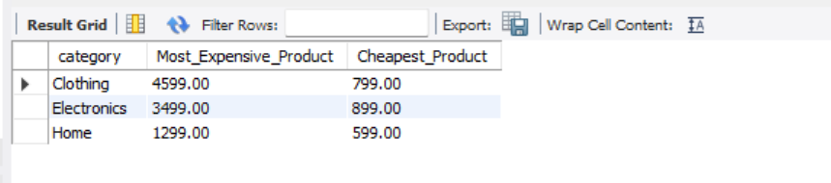

Q18. List all product categories where the average unit_price is greater than ₹2000. (Hint: Use HAVING clause)
SELECT category,
AVG(unit_price) AS Average_Unit_Price
FROM products GROUP BY category HAVING AVG(unit_price) > 2000;
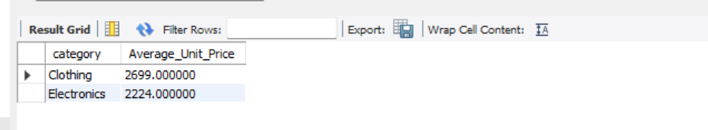

Section D — Joins & Relationships
Q19. Write an INNER JOIN query to display each order along with the customer's first_name and last_name. Show: order_id, order_date, first_name, last_name, total_amount.
SELECT
o.order_id,
o.order_date,
c.first_name,
c.last_name,
o.total_amount
FROM orders o
INNER JOIN customers c
ON o.customer_id = c.customer_id;
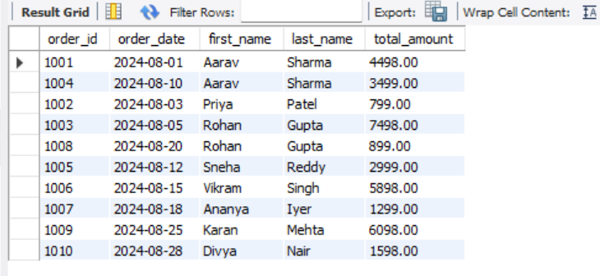

Q20. Using a LEFT JOIN, list ALL customers and their orders (if any). Customers with no orders should still appear with NULL values for order columns.
SELECT
c.customer_id,
c.first_name,
c.last_name,
o.order_id,
o.order_date,
o.status
FROM customers c
LEFT JOIN orders o
ON c.customer_id = o.customer_id;
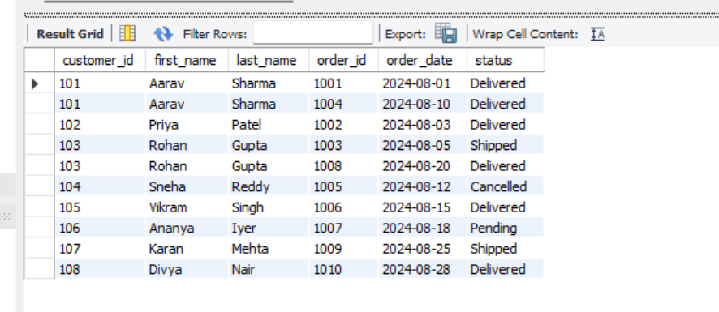
Q21. Write a query using JOINs across three tables (orders → order_items → products) to show: order_id, product_name, quantity, unit_price, and discount_pct for each order item.
SELECT
o.order_id,
p.product_name,
oi.quantity,
oi.unit_price,
oi.discount_pct
FROM orders o
INNER JOIN order_items oi
ON o.order_id = oi.order_id
INNER JOIN products p
ON oi.product_id = p.product_id;
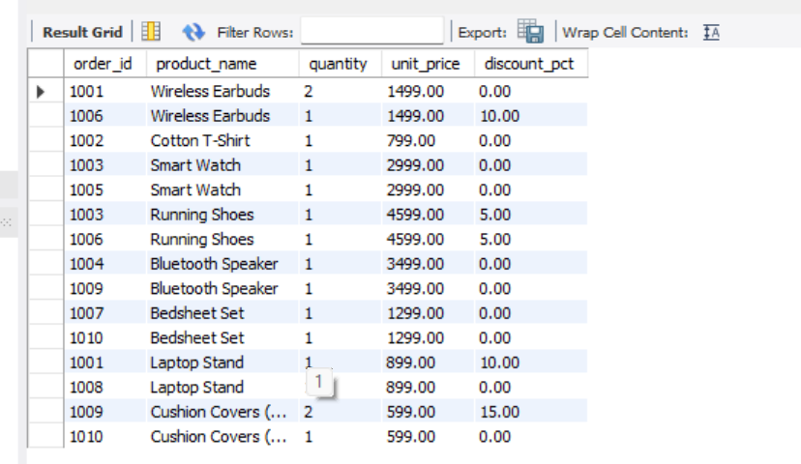

Q22. Explain the difference between LEFT JOIN and RIGHT JOIN with an example from this schema. When would you use a FULL OUTER JOIN?
LEFT JOIN:
A LEFT JOIN returns all records from the left table and the matching records from the right table. If there is no matching record in the right table, the result contains NULL values for the columns of the right table.
Example:
When using customers LEFT JOIN orders, all customers will be displayed. If a customer has not placed any order, the order-related columns will contain NULL.
RIGHT JOIN:
A RIGHT JOIN returns all records from the right table and the matching records from the left table. If there is no matching record in the left table, the result contains NULL values for the columns of the left table.
Example:
When using customers RIGHT JOIN orders, all orders will be displayed. If an order does not have a matching customer (which normally cannot happen in this database because of the foreign key constraint), the customer columns would contain NULL.
FULL OUTER JOIN:
A FULL OUTER JOIN returns all matching records as well as all non-matching records from both tables. If there is no match on either side, the missing columns are filled with NULL.
When to use FULL OUTER JOIN:
A FULL OUTER JOIN is useful when we want to display every record from both tables, regardless of whether a matching record exists. For example, it can be used to show all customers and all orders together, including customers with no orders and orders without matching customers. MySQL does not support FULL OUTER JOIN directly, but it can be achieved by combining a LEFT JOIN and a RIGHT JOIN using the UNION operator.

Q23. Identify all Foreign Key relationships in the schema. Explain what would happen if you tried to insert an order with customer_id = 999 (which doesn't exist in customers).
Foreign Key Relationships
The database contains the following Foreign Key relationships:
- orders.customer_id → customers.customer_id
- order_items.order_id → orders.order_id
- order_items.product_id → products.product_id
These foreign keys establish relationships between the tables and ensure referential integrity, meaning that every foreign key value must correspond to an existing primary key value in the referenced table.
What happens if customer_id = 999 is inserted?
If an order is inserted with customer_id = 999, MySQL will reject the operation because there is no customer with ID 999 in the customers table.
For example:
INSERT INTO orders
(order_id, customer_id, order_date, status, total_amount)
VALUES
(1011, 999, '2024-09-01', 'Pending', 1500.00);
This statement will fail with a Foreign Key Constraint Error because customer_id = 999 does not exist in the parent table (customers).
The foreign key constraint prevents invalid references and ensures that every order is associated with a valid customer, thereby maintaining data consistency and integrity in the database.

Section E — Advanced Concepts (CASE, ACID, Transactions)
Q24. Write a query using CASE to classify products into price tiers:
• 'Budget' → unit_price < 1000
• 'Mid-Range' → unit_price BETWEEN 1000 AND 3000
• 'Premium' → unit_price > 3000
Display: product_name, unit_price, price_tier.
SELECT
product_name,
unit_price,
CASE
WHEN unit_price < 1000 THEN 'Budget'
WHEN unit_price BETWEEN 1000 AND 3000 THEN 'Mid-Range'
ELSE 'Premium'
END AS price_tier FROM products;
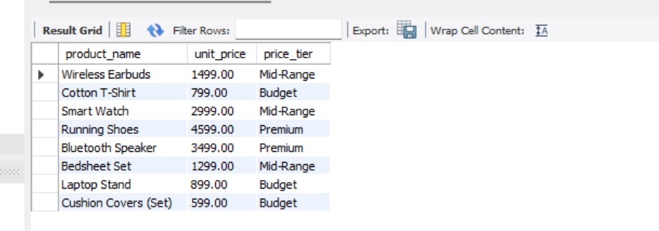
Q25. Using a CASE statement inside an aggregate function, count how many orders are 'Delivered' vs 'Not Delivered' (all other statuses). Display the result in a single row.
SELECT
SUM(CASE WHEN status = 'Delivered' THEN 1 ELSE 0 END) AS Delivered_Orders,
SUM(CASE WHEN status <> 'Delivered' THEN 1 ELSE 0 END) AS Not_Delivered_Orders
FROM orders;
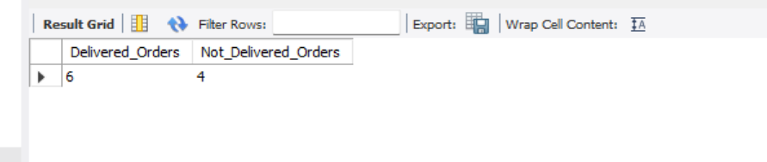
Q26. Explain each letter of ACID:
• A – Atomicity
• C – Consistency
• I – Isolation
• D – Durability
Give a real-world example (e.g., bank transfer) showing why each property is important.
Atomicity (A):
Atomicity ensures that a transaction is completed entirely or not executed at all. If any part of the transaction fails, all changes are rolled back.
Example:
During a bank transfer, if money is deducted from one account but cannot be credited to another account due to an error, the deduction is reversed so that no partial transaction occurs.

Consistency (C):
Consistency ensures that the database remains in a valid state before and after a transaction. All database rules and constraints are maintained.
Example:
A bank account balance cannot become negative if such a rule is defined. Any transaction violating this rule is rejected.

Isolation (I):
Isolation ensures that multiple transactions occurring simultaneously do not interfere with each other.
Example:
If two users try to book the same movie seat at the same time, the database ensures that only one booking succeeds while the other waits or fails.

Durability (D):
Durability ensures that once a transaction is committed, the changes are permanently stored, even if the system crashes immediately afterward.
Example:
After an online payment is marked successful, the transaction remains recorded even if the server shuts down unexpectedly.

Q27. Write a SQL transaction that does the following atomically:
1. Insert a new order (order_id=1011, customer_id=102, today's date, 'Pending', 1598.00)
2. Insert two order items for that order
3. Update the stock_qty of the purchased products
4. If any step fails, ROLLBACK the entire transaction. Otherwise, COMMIT.
Write the complete BEGIN...COMMIT/ROLLBACK block.
START TRANSACTION;
-- Insert a new order
INSERT INTO orders
(order_id, customer_id, order_date, status, total_amount)
VALUES
(1011, 102, CURDATE(), 'Pending', 1598.00);
-- Insert first order item
INSERT INTO order_items
(item_id, order_id, product_id, quantity, unit_price, discount_pct)
VALUES
(5016, 1011, 206, 1, 1299.00, 0);
-- Insert second order item
INSERT INTO order_items
(item_id, order_id, product_id, quantity, unit_price, discount_pct)
VALUES
(5017, 1011, 208, 1, 599.00, 0);
-- Update stock quantity
UPDATE products
SET stock_qty = stock_qty - 1
WHERE product_id = 206;
UPDATE products
SET stock_qty = stock_qty - 1
WHERE product_id = 208;
COMMIT;
