

Lab -2

---------------------------------------------------------------------------------------------

Name – Akhil Dubey

Roll No – 2020UCO1673

Branch – COE -3

Subject - IOT

***Experiment:***

Design a circuit for interfacing the Ultrasonic sensor in Tinkercad framework and plot the capture data using Processing tool.

Solution -:

We are going to design a circuit to interface Ultrasonic sensor with Arduino an check the distance depicted by it.

***Software Name*** -: Tinkercad

***Components Required***

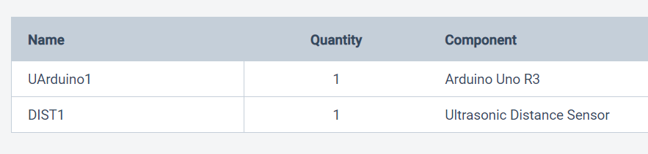

***Circuit Diagram***

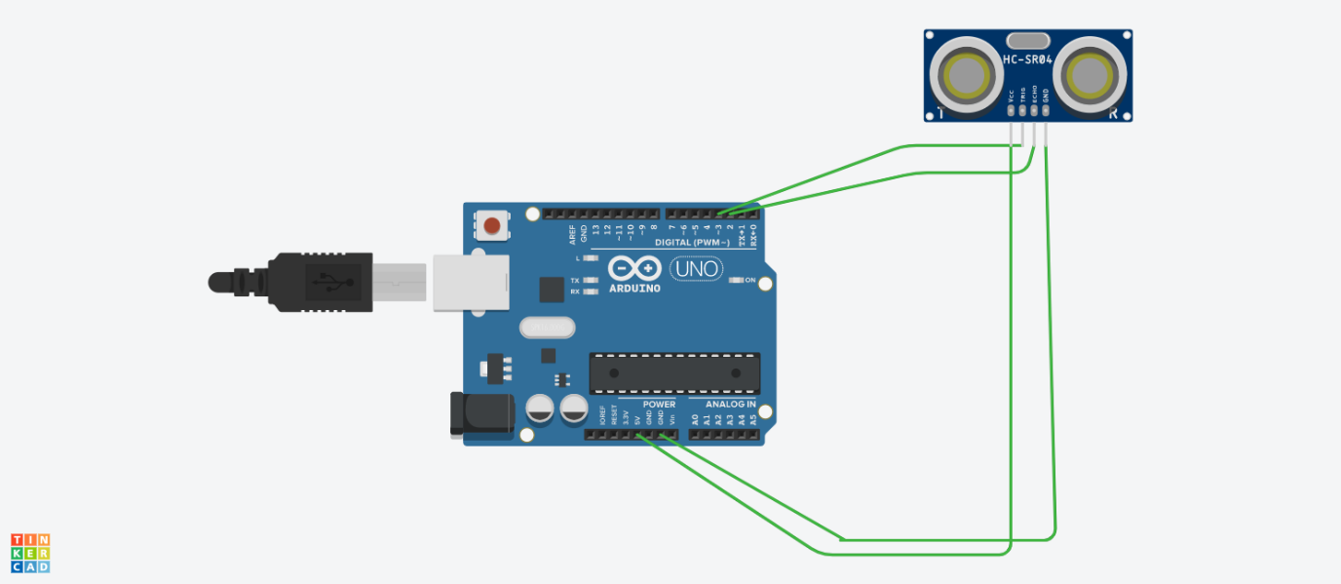

***Schematic View***

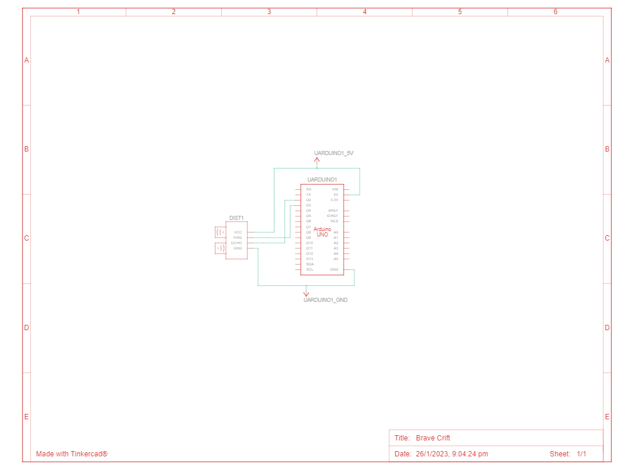

***Code for getting distance based on locus***

#define echo_pin 2

#define trig_pin 3

long duration_0;

int distance_0;

void setup(){

  pinMode(trig_pin, OUTPUT);

  pinMode(echo_pin,INPUT);

  Serial.begin(9600);

  Serial.println("Working....");

}

void loop(){

  digitalWrite(trig_pin,LOW);

  delayMicroseconds(2);

  digitalWrite(trig_pin, LOW);

  duration_0=pulseIn(echo_pin,HIGH);

  distance_0=duration_0 * 0.034/2;

  Serial.print("Distance : ");

  Serial.print(distance_0);

  Serial.println(" cm");

}

Maximum Distance Measured: 35.3 cm

Minimum distance measured: 15.2 cm

**How it is calculating the distance?**

Measures time delay, T, between transmitted signal and signal returned from target at distance d. If velocity of ultrasonic signal given by v (approx. 344 m/sec), distance d = v * T /2 where factor of 2 is to account for round trip distance travelled by signal.

***Difficulty issues***

* Understanding the coding and functions used.

**Knowledge Gain**

* Learned to interface Arduino with sensor.
* Learned C++ function to achieve this.