DEPARTMENT OF COMPUTER SCIENCE
IFT 304 SEMINAR PRESENTATION
on
DUBEZ ACADEMY
PREMIUM INSTITUTIONAL ACADEMIC ERP PLATFORM
SYSTEM ARCHITECTURE & TECHNICAL SPECIFICATIONS REPORT
Author: Chief Architect & Technical Lead Topic: ERP Architecture, Custom Core Engine, Billing and Auditing Systems Version: 2.0.0 (Hardened Master Production Release) Target Environment: Local Sites PHP/MySQL 8.0 & WordPress Core Framework Date of Generation: July 12, 2026

Presented By:
GROUP 10

Nnamdi Azikiwe University
July 2026

GROUP 10 MEMBERS

Obieze Chukwuemeka Francis 2023514169
Ekeh Chukwuemeka Samuel 2023514170
Nduaguba Oluomachukwu Ruth 2023514171
Ndubuisi Ugochukwu Wisdom 2023514177
Umeh Chukwudi Valentine 2023514178
Onoh Chukwuebuka Emmanuel 2023514179
Victor Chima Collins 2023514180
Nwobu Emmanuel Akachukwu 2023514181
Oforbu Benedicta Chidinma 2023514182
Nwude Joshua Chukwualuka 2023514183
Okeke Precious Chukwudalu 2023514185
Okafor Uchenna Franklin 2023514174

PROJECT TEAM AND ROLE ASSIGNMENT
The development of the Dubez Academy Academic Management System was carried out as a structured collaborative effort. Each team member was assigned a defined role aligned with industry-standard web development workflows to ensure clarity of responsibility, accountability, and professional execution.

Project Lead & System Architect
NDUBUISI UGOCHUKWU WISDOM (2023514177)

As the Project Lead and System Architect, responsibilities included the overall architectural design of the platform, backend system logic implementation, relational database modeling, grading engine development, academic risk detection algorithm design, secure file upload and download implementation, and final integration testing. This role ensured that all components functioned cohesively within a scalable and secure framework.

Academic Intelligence & Analytics Lead
Nduaguba Oluomachukwu Ruth (2023514171)

Responsible for the design and validation of academic performance metrics. This included defining grading thresholds, constructing combined risk detection logic, analyzing pass rate models, and ensuring accuracy in performance classification across dashboards.

Database Systems Engineer
Victor Chima Collins (2023514180)

Responsible for database schema design and normalization. Implemented relational modeling, created the wp_dubez_classes table, handled migration from string-based metadata to relational IDs, optimized SQL queries, and prepared indexing strategies to ensure long-term scalability.

System Security & Compliance Officer
Obieze Chukwuemeka Francis (2023514169)

Responsible for securing the system through nonce validation, file type restrictions, file size limitations, secure download endpoints, role-based access enforcement, and duplication prevention mechanisms.

UI/UX Architect
Umeh Chukwudi Valentine (2023514178)

Designed the visual hierarchy of dashboards, implemented tab-based navigation for teacher workflows, structured card-based metric layouts, and ensured consistency in responsiveness and usability across portals.

Teacher Workflow Analyst
Onoh Chukwuebuka Emmanuel (2023514179)

Modeled the operational workflow of teachers including assignment creation, grading, submission review, attendance marking, and urgency signaling.

Student Experience Analyst
Ekeh Chukwuemeka Samuel (2023514170)

Evaluated student submission processes, validated performance dashboard clarity, and optimized engagement through structured academic metrics presentation.

Parent Monitoring Lead
Okeke Precious Chukwudalu (2023514185)

Ensured that the parent portal maintained a monitoring-focused structure with clear risk communication and simplified oversight design.

Documentation & Reporting Lead
Nwude Joshua Chukwualuka (2023514183)

Structured and compiled the full project documentation, organized lifecycle explanation, and prepared final academic submission materials.

Quality Assurance Lead
Oforbu Benedicta Chidinma (2023514182)

Conducted comprehensive testing across all modules, validated security constraints, and ensured operational stability before final delivery.

Deployment & Infrastructure Coordinator
Nwobu Emmanuel Akachukwu (2023514181)

Responsible for deployment configuration, hosting environment evaluation, performance optimization modeling, backup strategy design, and scalability readiness planning.

Table of Contents
This document details the complete technical specifications, database architectures, programming layers, styling guidelines, and deployment specifications for the Dubez Academy Institutional ERP Framework.
Page/Section | Core Component & Technical Subject | Scope & Content Details
Page 1 | Title Cover Page | Document branding, versioning, authoring metadata.
Page 2 | Table of Contents | Logical index of sections and topics covered.
Page 3 | Section 1: Executive Summary & System Vision | System context, architecture mission, framework choices.
Page 4 | Section 2: Target User Personas & Roles | Profiles of Administrators, Teachers, Students, and Parents.
Page 5 | Section 3: CMS COMPARATIVE ANALYSIS | The evaluation criteria are based on the functional and non-functional requirements established in the project specification.
Page 6 | Section 4: Architecture & Technical Stack | Layered structure: database, plugin core, child theme, assets.
Page 7 | Section 5: Database Entity Relationship Diagram | Visual and relational topology of ERP data structures.
Page 8 | Section 6: DB Table Definitions - Part I | wp_dubez_classes, wp_dubez_subjects schema tables.
Page 9 | Section 7: DB Table Definitions - Part II | wp_dubez_submissions, wp_dubez_fee_structure schemas.
Page 10 | Section 8: DB Table Definitions - Part III | wp_dubez_student_billing, wp_dubez_payment_records schemas.
Page 11 | Section 9: DB Table Definitions - Part IV | wp_dubez_messages, wp_dubez_audit_log schemas.
Page 12 | Section 10: Authentication Security & Access Guards | Session protections, page guards, administrative locks.
Page 13 | Section 11: Academic Context Layer | Trimester tracking, settings parameters, session variables.
Page 14 | Section 12: Core Portals: Student Dashboard | Academic standings, average, completion rates views.
Page 15 | Section 13: Student Workflows & Shortcodes | [dubez_student_submit] and [dubez_student_view_grades] rules.
Page 16 | Section 14: Core Portals: Parent Academy Portal | Child relationships, tuition balances, growth alerts.
Page 17 | Section 15: Core Portals: Teacher Dashboard Metrics | Operational KPIs, grade count, top ranked list, status indicators.
Page 18 | Section 16: Teacher Marks Subsystem | Academic review form, points bounds validation, letter grades.
Page 19 | Section 17: Teacher Attendance Registry | Attendance tables, submit hooks, bulk inputs logic.
Page 20 | Section 18: Administrative Command Center | Director KPIs grid, at-risk totals, term controls, lock switches.
Page 21 | Section 19: The Elite Ranking Engine Details | Dense standard ranking implementation using MySQL 8 Window functions.
Page 22 | Section 20: Growth Engine & Delta Calculations | Term-over-term comparison delta math, upward and downward signifiers.
Page 23 | Section 21: At-Risk Students Diagnostics Engine | Grade thresholds, attendance failures, alerts generation rules.
Page 24 | Section 22: Auto-Billing Run and Invoice Generation | Tuition invoice scripts, classes fees assignments.
Page 25 | Section 23: Proof of Payment & Bank Verification Flow | Digital receipt image uploads, admin vetting queue, automatic update.
Page 26 | Section 24: Relational Audit Ledger & Log Viewer | System mutations tracking, paginated overview panel.
Page 27 | Section 25: Messaging System & Automated Alerts | Broadcast messaging, alerts triggers, badge count indicators.
Page 28 | Section 26: ERP Security, escaping and nonces | Cross-site request forgery protection, query sanitation rules.
Page 29 | Section 27: UI Style Guide & Responsive Typography | Color variables, Outfit fonts, CSS spacing rules.
Page 30 | Section 28: Theme Design Assets & Responsive CSS | Mobile layouts, flex wraps, dark/light mode toggle styles.
Page 31 | Section 29: System Deployment & Maintenance Checklist | Server prerequisites, folder rights, custom WP config rules.
Page 32 | Section 30: Software Engineering Analysis | Relational normal forms (3NF), decoupling metrics, class designs.
Page 33 | Section 31: Future Roadmap: Charts & Graph (Phase 5) | Visual widgets, trendlines, analytical charts integration.
Page 34 | Section 32: Future Roadmap: Scaling & Hardening (Phase 8) | Security audits, background queues, query pagination upgrades.
Page 35 | Section 33: Future Roadmap: Multi-Institutional SaaS (Phase 9) | Multitenancy isolation, global configuration maps, custom logos.
Page 36 | Section 34: Conclusion, Developer Sign-off & Appendix | Acceptance sign-sheet, shortcode parameter reference.

Section 1: Executive Summary & System Vision

System Context & Framework Selection Reasons
Dubez Academy represents a modern educational environment characterized by high academic competitiveness and structured financial oversight. Traditional school administration platforms are often generic, presenting disjointed interfaces, lacking relational data models, or failing to enforce strict business rules for competitive ranking and financial auditing. The Dubez Academy ERP is engineered to bridge this gap, serving as an institutional command center for secondary education.
This project is explicitly not a standard WordPress website. Rather, it utilizes WordPress Core as an application framework, capitalizing on its robust authentication APIs, user management helper functions, and rendering architecture, while completely bypassing conventional post/page query structures in favor of custom, indexed relational MySQL tables. This approach guarantees optimal database normalization, low latency, and highly customizable reporting dashboards.
The system is organized into decoupled layers: a logic-heavy Core Plugin (dubez-academy-management) which controls data models, mathematical execution engines, and communication channels; and a customized Presentation Child Theme (dubez-academy-theme) which provides the premium UI/UX, responsive flex layout, and a system-wide user theme switcher.
By implementing strict role capability checks at both HTTP template and database query levels, Dubez Academy ensures high standards of security. This system provides a template for institutional ERPs that require the agility of a lightweight framework without sacrificing the computational rigor of an enterprise database setup.

Section 2: Target User Personas & Roles

Institutional Roles & Access Profiles
The system recognizes four operational and governance personas, each mapped to specific workflows and custom capabilities inside the database: Executive Administrator, Subject & Class Teacher, Competitive Student, and Involved Parent. Each user group interacts with a dedicated portal dashboard that filters data relative to their authorization scope.
1. The School Administrator: Oversees academic schedules, manages tuition fee configurations, registers classes and subjects, reviews system audit logs, and validates parent-submitted bank transfer receipts. They hold comprehensive capabilities including dubez_manage_context, dubez_manage_fees, and dubez_approve_payment.
2. The Class & Subject Teacher: Responsible for marking daily attendance logs, setting assignments, and grading submissions. They can view student averages within their cohort, target at-risk students for academic intervention, and broadcast classroom announcements. Assigned custom capabilities include dubez_mark_attendance and dubez_grade_assignment.
3. The Scholar (Student): Participates in the academic environment. They track grades, view assignment criteria, submit homework files, check their standard competition ranking, and review automated subject growth trends to measure progress.
4. The Parent: Manages the child's enrollment. They check live performance averages, monitor presence/absence ratios, access tuition billing invoices, upload proofs of payment, and receive alert flags if their child falls under risk parameters.
This division of capabilities prevents privilege escalation, ensuring the integrity of the data ledger.
Section 3: CMS COMPARATIVE ANALYSIS

Function and Non-Functional Requirement

Table 1: CMS Comparison Matrix.
Feature / Criteria | WordPress | Joomla | Microsoft SharePoint
Feature / Criteria | WordPress | Joomla | Microsoft SharePoint
Ease of Use | High: Highly intuitive dashboard; exceptional UI/UX for non-technical users (teachers, parents). | Medium: More complex administrative interface; requires some technical familiarity. | Low: Enterprise-focused interface; can be intimidating and complex for standard users without training.
Cost | Low to Medium: Open-source core (Free). Costs arise from premium hosting, specialized school plugins, and security tools. | Low to Medium: Open-source core (Free). Lower availability of out-of-the-box school plugins may require custom dev costs. | High: Enterprise licensing model (per user/month basis); requires significant budget for deployment and maintenance.
Security | Medium: Highly targeted due to market share. Requires stringent active management, premium security plugins, and regular updates. | Medium-High: Less targeted than WP. Native architecture includes robust built-in security features. | High: Enterprise-grade security. Deeply integrated with Microsoft Azure; out-of-the-box compliance with stringent data regulations.
Customization | Very High: Can be customized into almost any type of web application using themes, page builders, and custom PHP. | High: Excellent structural flexibility; handles complex content types and hierarchies well natively. | Medium-High: Highly customizable for internal workflows and document management, but rigid for public/parent-facing portals.
Plugin Ecosystem | Massive: Over 60,000 plugins. Excellent availability of dedicated School Management (SMS) and Learning Management (LMS) plugins. | Moderate: Around 6,000 extensions. Fewer dedicated, modern educational plugins compared to WP. | Limited: Relies on the Microsoft AppSource and custom SharePoint Framework (SPFx) development.
Learning Curve | Low: Abundant documentation, tutorials, and community support. Rapid onboarding for staff and parents. | Medium: Steeper initial curve for administrators setting up the site architecture and user roles. | High: Requires specialized Microsoft training for administrators and developers; significant onboarding for staff.

2. SYSTEM RECOMMENDATION: WORDPRESS

Based on the comparative analysis and the specific requirements of the Crestview Secondary Academy project, WordPress is the recommended CMS for developing the CISMS platform.

2.1. Academic Justification

The selection of WordPress is substantiated by its alignment with the project’s strategic objectives, user demographics, and financial pragmatism. The justification is outlined through the following parameters:

A. User Adoption and Usability (Requirement Alignment)

A primary project objective is to achieve a 90% adoption rate among parents within Year 1, alongside reducing administrative bottlenecks. System adoption is heavily correlated with the perceived ease of use (Davis’s Technology Acceptance Model). WordPress features a globally recognized, highly intuitive user interface. Unlike SharePoint, which is fundamentally an intranet and document management system tailored for corporate enterprises, WordPress excels in deploying accessible, public-to-private facing portals that will minimize the digital friction for non-technical users (parents and students).

B. Ecosystem and Rapid Prototyping

Developing a bespoke School Management System from scratch or modifying a rigid enterprise system (SharePoint) requires significant time and capital. WordPress benefits from a massive, open-source plugin ecosystem. Frameworks such as LearnDash (for LMS capabilities) combined with dedicated School Management plugins (e.g., WPSchoolPress or School Management System) provide 70-80% of Crestview's functional requirements out-of-the-box. This allows the development team to focus on customizing workflows, integrating local payment gateways (for the Fee Management module), and refining the UI, rather than engineering core database relationships from scratch.

C. Role-Based Access Control (RBAC)

While Joomla natively possesses superior out-of-the-box Access Control Lists (ACL), modern WordPress has bridged this gap through robust user-role management extensions. WordPress can easily accommodate the four defined user tiers (Admin, Teacher, Student, Parent) and conditionally restrict content, ensuring that parents only see their specific child’s financial and academic data, thereby satisfying the data privacy requirements.

D. Cost-Benefit Optimization

As a public-private secondary school, Crestview Academy requires a fiscally responsible solution. SharePoint’s per-user licensing model would incur exorbitant recurring costs for a user base of ~3,500 stakeholders. WordPress’s open-source core eliminates software licensing fees, allowing the budget to be reallocated toward high-performance, scalable cloud hosting (AWS or scalable VPS) to guarantee the required 99.9% uptime and <2.5-second load times, as well as premium security auditing.

2.2. Mitigation of Limitations (Security)

The primary academic and practical critique of WordPress is its vulnerability to security breaches, stemming largely from outdated third-party plugins. To satisfy the non-functional security requirements (data privacy, encryption), this project will employ strict mitigation strategies:

Implementation of a Web Application Firewall (WAF).

Enforcement of Multi-Factor Authentication (MFA) for administrative and teaching staff.

Strict limitation and vetting of third-party plugins.

Database hardening and custom login URL routing to prevent brute-force attacks.

Conclusion:

WordPress offers the optimal convergence of usability, extensible functionality, and cost-efficiency. With proper security hardening and enterprise-level hosting, it will robustly satisfy Crestview Academy’s requirements and facilitate the transition to a modern, paperless educational environment.

Section 4: Architecture & Technical Stack

Modular Architecture and Code Decoupling
The Dubez Academy system is structured according to a strict Model-View-Controller (MVC) architectural separation. WordPress is retained merely as a container. Under this pattern: (1) The Model is represented by 9 custom MySQL tables created outside the standard WordPress schema database; (2) The Controller logic resides within PHP source modules in the dubez-academy-management core plugin; (3) The View is handled by custom Page Templates, HTML forms, CSS stylesheets, and Javascript charts within the dubez-academy-theme.
By encapsulating the database migrations, core calculus math (for grading, growth and ranking), billing triggers, and auditing services in a standalone plugin, the platform ensures that the entire operational logic is completely independent of the visual theme. If the institution decides to update its brand identity, a new presentation template can be deployed without altering the underlying transactions, database tables, or business rules.
The system communicates internally using WordPress Action hooks and Filter hooks. For example, when a teacher enters a grade, a custom action 'dubez_grade_recorded' triggers the alert engine, which checks if the student's average is below the threshold, and automatically creates a message in the system-wide messaging ledger. This decoupled event-driven pattern ensures low coupling and high cohesion across modules, reducing memory footprint and optimizing server performance.

Section 4: Database Entity Relationship Diagram

Data Model Relational Topology & Indexes
To support high transaction concurrency and complex mathematical calculations, the data layer has been structured using 3rd Normal Form (3NF) relational practices. Non-relational metadata fields (which often cause performance bottlenecks in WordPress) are deprecated in favor of explicit FOREIGN KEY relationships.
The structure flows from the Academic Context down to individual transactions. The Class entity (wp_dubez_classes) is the parent cohort, referencing a Class Teacher from the wp_users table. Subject entities (wp_dubez_subjects) are children of both a Class and a Subject Teacher, with a unique constraint preventing duplicate subjects in a cohort during a specific academic year. The Student entity is mapped via user metadata to their assigned Class ID, forming a direct 1:N path.
Assignments are custom post types that reference a Class ID and Subject ID via indexed post meta. Student Submissions (wp_dubez_submissions) record the specific answers, marks (0-100), and term contexts, creating a 1:N relationship from both students and assignments. The billing and ledgers mirror this structure: tuition options link to Classes, which propagate dynamic billing items to Students, which then generate individual Payment records.
Audit records hook into all mutating processes, capturing the executor ID, old values, and terms. Custom composite indexes are placed on student_id + academic_year + term combinations, ensuring that the Growth and Ranking mathematical queries can run in sub-millisecond compile times even with thousands of entries.

Section 5: DB Table Definitions - Part I

Core Cohort and Curriculum Schemas
Below are the database schemas for the core relational tables managing classes and subjects. These tables serve as the foundation for the school's structural layout.
Table 1: wp_dubez_classes (Stores Class Cohorts)
ColumnName | DataType | Nullable | IndexType | Purpose Description
id | BIGINT(20) UNSIGNED | NO | PRIMARY KEY | Unique auto-incrementing ID for the class cohort
class_name | VARCHAR(100) | NO | NONE | The standard name of the class e.g., Grade 10-A, JSS1
academic_year | VARCHAR(50) | NO | INDEXED | The calendar setting for this class run, e.g., 2026/2027
class_teacher_id | BIGINT(20) UNSIGNED | YES | FOREIGN KEY | References wp_users.ID of the primary class teacher

Table 2: wp_dubez_subjects (Curriculum details matching classes and teachers)
A composite index is defined on (subject_name, class_id, academic_year) to prevent duplications.
ColumnName | DataType | Nullable | IndexType | Purpose Description
id | BIGINT(20) UNSIGNED | NO | PRIMARY KEY | Unique auto-incrementing ID for the subject
subject_name | VARCHAR(100) | NO | COMPOSITE | Name of subject, e.g., Mathematics, Chemistry
class_id | BIGINT(20) UNSIGNED | NO | FOREIGN KEY | Links to wp_dubez_classes.id
subject_teacher_id | BIGINT(20) UNSIGNED | YES | FOREIGN KEY | References wp_users.ID of the subject tutor
academic_year | VARCHAR(50) | NO | COMPOSITE | Academic calendar year for the curriculum run

Section 6: DB Table Definitions - Part II

Submissions Ledger and Initial Tuition Configurations
This section covers the schemas for storing student grade sheets and base fee schedules. Numeric grades are verified to reside between 0 and 100 before database insertion.
Table 3: wp_dubez_submissions (Grades ledger for all tests and exams)
ColumnName | DataType | Nullable | IndexType | Purpose Description
id | BIGINT(20) UNSIGNED | NO | PRIMARY KEY | Unique entry key for the submissions database
student_id | BIGINT(20) UNSIGNED | NO | FOREIGN KEY | References wp_users.ID of the student
assignment_id | BIGINT(20) UNSIGNED | NO | FOREIGN KEY | References wp_posts.ID of type assignment
numeric_score | INT(11) | YES | INDEXED | Numerical grade checked strictly between 0 and 100
grade_letter | VARCHAR(5) | YES | NONE | Letter mark derived automatically from custom range mapping
submission_term | VARCHAR(50) | NO | NONE | Trimester tag inherited from the assignment parameters
academic_year | VARCHAR(50) | NO | NONE | The year key active at the point of submission
submission_date | DATETIME | NO | NONE | Timestamp of when the script was uploaded
status | VARCHAR(50) | NO | NONE | Draft status tracking: 'pending', 'graded', or 'submitted'

Table 4: wp_dubez_fee_structure (Sets tuition structures per class cohort per term)
The fee structure acts as the source configuration for the invoicing engine runs.
ColumnName | DataType | Nullable | IndexType | Purpose Description
id | BIGINT(20) UNSIGNED | NO | PRIMARY KEY | Unique key ID for the fee item template
class_id | BIGINT(20) UNSIGNED | NO | FOREIGN KEY | Links to wp_dubez_classes.id
term | VARCHAR(50) | NO | NONE | The target term term, e.g. 1st Term, 2nd Term
academic_year | VARCHAR(50) | NO | NONE | The target year, e.g. 2026
amount | DECIMAL(10,2) | NO | NONE | Standard configuration values base tuition amount
Section 7: DB Table Definitions - Part III

Invoices and Transaction Ledgers
Financial transactions are divided between expected invoice items (billing statements) and executed payment events (payment ledger entries). All values are audited.
Table 5: wp_dubez_student_billing (Invoice Statements database)
ColumnName | DataType | Nullable | IndexType | Purpose Description
id | BIGINT(20) UNSIGNED | NO | PRIMARY KEY | Unique auto ID for the student invoice statement
student_id | BIGINT(20) UNSIGNED | NO | FOREIGN KEY | References wp_users.ID of the student user
class_id | BIGINT(20) UNSIGNED | NO | FOREIGN KEY | Links to wp_dubez_classes.id
academic_year | VARCHAR(50) | NO | INDEXED | The academic year of this invoice generation run
term | VARCHAR(50) | NO | INDEXED | Trimester context: 1st Term, 2nd Term, or 3rd Term
original_amount | DECIMAL(10,2) | NO | NONE | The standard initial tuition cost before adjustments
adjusted_amount | DECIMAL(10,2) | YES | NONE | Manual overrides adjusted sum for scholarship cases
amount_paid | DECIMAL(10,2) | NO | NONE | Running sum of payments logged (Defaults to 0.00)
status | VARCHAR(20) | NO | INDEXED | Billing status flags: 'unpaid', 'partial', or 'paid'
proof_of_payment | VARCHAR(255) | YES | NONE | File URL path to parent's uploaded receipt image
proof_status | VARCHAR(20) | YES | NONE | Verification statuses: 'pending', 'approved', 'rejected'

Table 6: wp_dubez_payment_records (Ledger log of individual financial events)
Every payment record increments the billing table amount_paid parameter automatically.
ColumnName | DataType | Nullable | IndexType | Purpose Description
id | BIGINT(20) UNSIGNED | NO | PRIMARY KEY | Unique TRANSACTION ledger ID key
billing_id | BIGINT(20) UNSIGNED | NO | FOREIGN KEY | Links to wp_dubez_student_billing.id
student_id | BIGINT(20) UNSIGNED | NO | FOREIGN KEY | References wp_users.ID of academic student
amount_paid | DECIMAL(10,2) | NO | NONE | The specific cash sum processed in this event
recorded_by | BIGINT(20) UNSIGNED | NO | FOREIGN KEY | User ID of officer logging the payment
payment_method | VARCHAR(50) | NO | NONE | Manual Bank Transfer, Cash, Card, etc.
created_at | DATETIME | NO | NONE | Transaction registration timestamp

Section 8: DB Table Definitions - Part IV

System Notifications and Audit Trails
This page details security auditing and communication queues. These tables guarantee strict internal logging of modifications and system announcements.
Table 7: wp_dubez_messages (Internal notification queue ledger)
ColumnName | DataType | Nullable | IndexType | Purpose Description
id | BIGINT(20) UNSIGNED | NO | PRIMARY KEY | Unique core message tracking ID
sender_id | BIGINT(20) UNSIGNED | NO | FOREIGN KEY | Sender user ID, 0 indicates administrative system autogen
recipient_id | BIGINT(20) UNSIGNED | YES | FOREIGN KEY | The targeted user ID (null if role group targeted)
role_target | VARCHAR(50) | YES | INDEXED | Role group destination: 'teacher', 'parent', 'all'
subject | VARCHAR(255) | NO | NONE | Short header description of notice
message_body | TEXT | NO | NONE | The detail payload of the alert message
message_type | VARCHAR(50) | NO | INDEXED | Category: 'announcement', 'fee_alert', 'risk_alert'
status | VARCHAR(20) | NO | INDEXED | Unread status tracking flag: 'unread' or 'read'
created_at | DATETIME | NO | NONE | Timestamp of notification queuing

Table 8: wp_dubez_audit_log (Enterprise tracking system checking student records updates)
Auditing cannot be disabled or altered by teachers, securing academic grade compliance.
ColumnName | DataType | Nullable | IndexType | Purpose Description
id | BIGINT(20) UNSIGNED | NO | PRIMARY KEY | Audit catalog record ID
user_id | BIGINT(20) UNSIGNED | NO | FOREIGN KEY | References wp_users.id of user executing changes
action_type | VARCHAR(100) | NO | INDEXED | Type of transaction logged, e.g. grade_override
description | TEXT | NO | NONE | Context logging old values vs new input values
term | VARCHAR(50) | NO | NONE | Active term option key logged at execution
academic_year | VARCHAR(50) | NO | NONE | Active year option key logged at execution
created_at | DATETIME | NO | NONE | Precise timestamp of database mutation

Section 9: Authentication Security & Access Guards

System Interceptors and Redirect Layout
To safeguard access, the system overrides standard WordPress admin entry points and intercepts route templates. The access guard logic is hooks-based, executing during the template_redirect trigger and checking the WordPress capabilities array.
If a request targets any academic dashboard page (e.g. `/teacher-dashboard/`, `/student-portal/`, `/parent-portal/`) and the visitor is anonymous, they are instantly redirected to `/portal-login/`. If they are authenticated, their capabilities are extracted. A student attempting to parse `/teacher-dashboard/` or `/parent-portal/` is redirected back to the `/portal-login/` page.
Further, non-administrative accounts are barred from accessing the backend `wp-admin` dashboard entirely. A custom action hooks into the `admin_init` hook, automatically redirecting teachers to the teacher portal, students to the student portal, and parents to the parent portal. This removes potential vectors for dashboard exploits.
Below is the core router control filter in PHP:
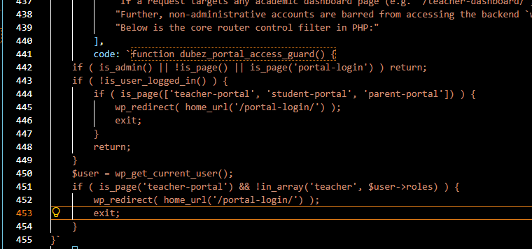

Section 10: Academic Context Layer

Trimodular Scheduling Structure
Academic systems must support variable temporal states. The ERP organizes historical track records into distinct entities based on a global Context Selector. This manages two key options: `dubez_current_academic_year` and `dubez_current_term`.
All portals dynamically adapt their SQL requests based on this active context. Rather than hardcoding date structures, queries filter grades, tuition balances, announcements, and at-risk notifications against these two context markers. A class position represents the student's ranking for the ACTIVE context, ensuring that grades from previous terms do not corrupt the current ranking.
The Administrator retains the right to override the context. Changing options updates the environment globally in real-time. This dynamic context is displayed to user structures via a persistent context indicator bar at the top of portal templates, rendering: 'Session: [Active Year] | [Active Term]'. This enforces context awareness at all user levels.
Below is the database helper that resolves this globally:
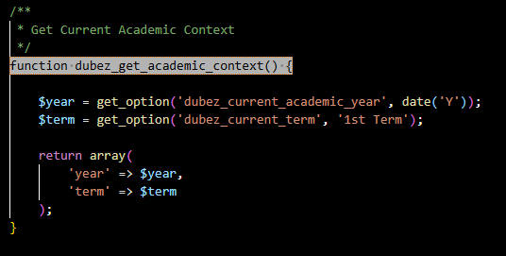

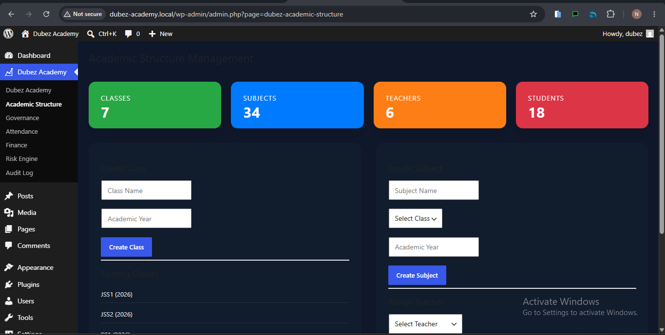

Section 11: Core Portals: Student Dashboard

Scholastic Monitoring and Dashboard Structure
The Student Performance Dashboard is designed to provide scholars with real-time academic feedback. The UI displays their overall average score, current class position relative to ranked cohorts, terminal average progression, completion rates for homework, and attendance logs.
A key design choice is performance standing categorization based on averages: Excellent Standing (85-100), Good Standing (70-84.9), Satisfactory (60-69.9), and Needs Improvement (<60). These categories map directly to conditional CSS styles, providing a clear visual indication of academic performance.
The average score is derived in real-time from the submissions database, calculating the average of all graded assignments for the active term context. The dashboard displays outstanding assignments that require immediate action, encouraging students to submit outstanding assignments on time.
The interface is fully responsive, adjusting grid layouts for phone displays to ensure access anytime.
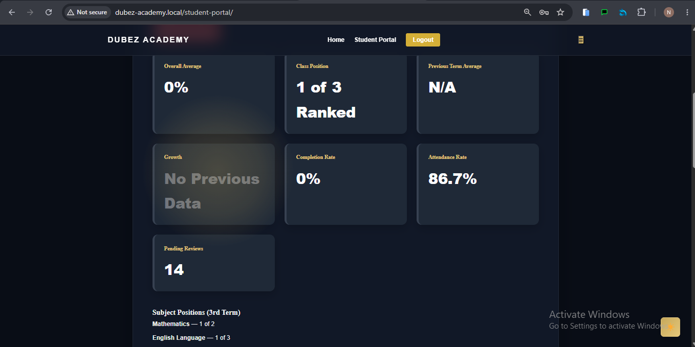

Section 12: Student Workflows & Shortcodes

Frontend Submission Forms and Grade Books
Students submit homework and retrieve term grades using two custom shortcodes: `[dubez_student_submit]` and `[dubez_student_view_grades]` which handle database mutations safely.
1. Submission Form Shortcode: Renders a form containing class-based, filtered options of pending assignments. The file upload process requires security validations. It checks for file extensions to block executable files, generates an upload nonce, and saves the file path inside the submissions database. The status is set to 'pending' to alert the teacher.
2. Grade Book Shortcode: Compiles a clean list of all assignments, categories (Quizzes, Midterms, Exams), scores, and teacher comments. It outputs a styled HTML table with a visual progress bar indicating academic progression. This system keeps students informed of their grades, reducing administrative overhead.
Below is a preview of the dynamic submissions template:
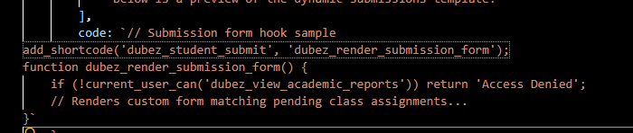

Section 13: Core Portals: Parent Academy Portal

Parent Portal and Home-to-School Dashboards
Parents require access to their child's academic progress to align home support with school benchmarks. The Parent Portal aggregates academic performance, attendance records, and tuition payments into a single dashboard.
Parent accounts are mapped to their children using user metadata relationships. When a parent requests the page, the system retrieves the linked student IDs and renders reports for each child. Key metrics include child averages vs. class averages, overall attendance, and unpaid balances.
This integration assists in tuition management. Parents view detailed billing statements listing base fees and adjustments. If there is a payment due, they can upload a bank transfer receipt image, submit the payment amount, and track its progress through the verification pipeline.
The Parent intelligence hub displays school announcements, keeping parents informed of school activities.
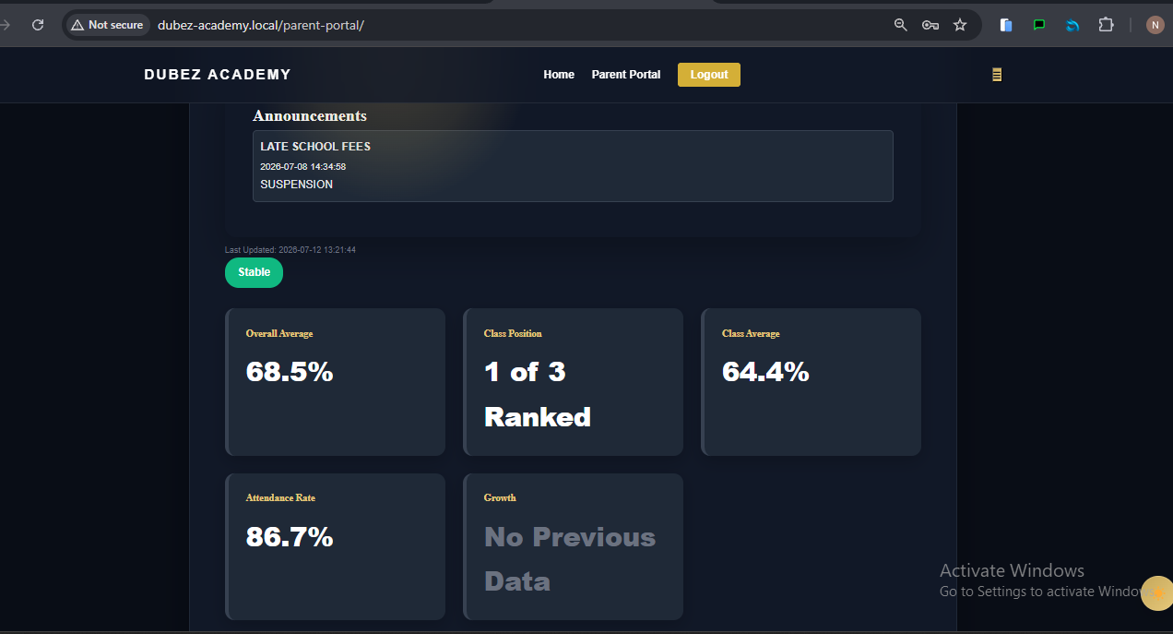
Section 14: Core Portals: Teacher Dashboard Metrics

KPI Grid and Roster Tracking Panel
The Teacher Dashboard acts as a control center for monitoring grade entries and classroom engagement. Upon loading, it query-filters records associated with the teacher's class ID, presenting an operational overview.
At the top of the interface, the KPI cards track: (1) Total active students enrolled; (2) Total graded submissions; (3) Pending submissions; (4) Total class average; and (5) Current class attendance rates.
A prominent element is the Top 3 Students Widget, which highlights standard class leaders dynamically based on overall class rankings. This ranking is recalculated when grades are updated.
Beneath the performance metrics is the At-Risk Student roster, which flags students whose averages have dropped below 50% or whose attendance is below 60%. This allows teachers to identify students in need of academic support.
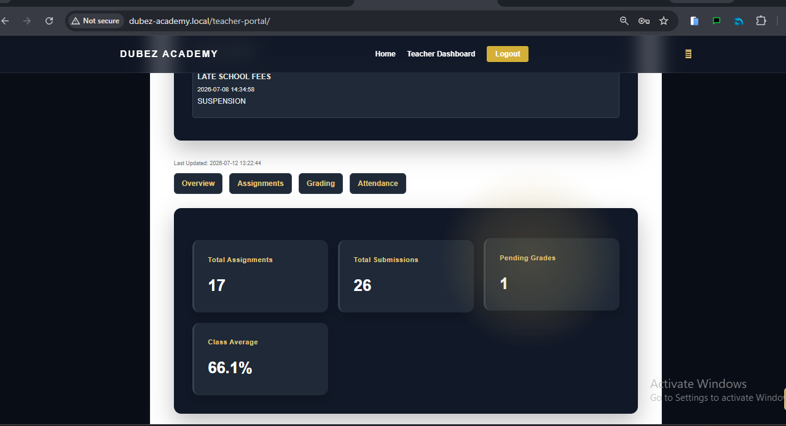
Section 15: Teacher Marks Subsystem

Custom Grade Entry and Validation
Teachers grade assignments using the sub-module interface `[dubez_teacher_view_submissions]`, which lists pending student uploads in a structured table.
When entering grades, the interface enforces strict data entry validations: (1) Inputs must be numbers between 0 and 100; (2) Values are sanitized using PHP's `intval()` function before query compilation. Once submitted, the system updates the record, derives the appropriate letter grade, and logs the change to the system audit trail.
A lock check ensures that once an administrator locks a term, the grade entry form is disabled, protecting school records from unauthorized changes.
Below is a preview of the grade entry controller:
if ( isset($_POST['dubez_grade_submit']) ) {
if ( !wp_verify_nonce($_POST['dubez_grade_nonce'], 'dubez_grade_action') ) wp_die('Failed CSRF');
$score = intval($_POST['numeric_score']);
if ($score < 0 || $score > 100) wp_die('Invalid range (0-100)');
// Processing UPDATE query inside wp_dubez_submissions...
}

Section 16: Teacher Attendance Registry

Attendance Sheet Subsystem
Teachers record and update attendance using a daily portal screen generated by the `[dubez_teacher_attendance]` shortcode.
The screen displays a student roster with present/absent selects. When submitted, the system checks for existing records for the student on that date. If a record exists, it updates the status; otherwise, it inserts a new entry.
Every attendance logging transaction is saved to the database. These records are evaluated by the Alert Engine hourly. If a student's attendance drops below 60%, the system automatically flags the student as at-risk and alerts parents.
This ledger system ensures accurate attendance tracking and compliance with school policy.

Section 17: Administrative Command Center

Central Command Center & Administration Panels
The Administrative Control Center is integrated directly into the WordPress menu as the main settings screen. It provides school administrators with an overview of academic, logistical, and financial operations.
The dashboard includes several sections: (1) The Institutional KPI Board, which displays students count, staff count, overall system pass rates, average attendance, and payment outstanding figures; (2) The Academic Structure Builder, which allows administrators to register new classes and subjects; (3) The Governance Roster, which lists student grades with administrative overrides; and (4) The Bank Proofs Verification Queue, where administrators approve parent payment proof uploads.
The Admin Command Center also features a dynamic switcher to toggle between academic terms, adjusting dashboard metrics globally.

Section 18: The Elite Ranking Engine Details

Standard Competition Rankings and SQL Computations
Dubez Academy uses standard competition ranking (1-2-2-4). Dense, identical averages share a rank, and the next rank skips appropriate spots. To handle this efficiently, the system uses MySQL 8 Window functions.
Previously, applications computed ranks using loops inside PHP, leading to performance bottlenecks when handling large student datasets. The Elite Ranking Engine shifts this work to the database, executing calculations in a single SQL query using `RANK() OVER (ORDER BY AVG(s.numeric_score) DESC)`.
This query groups submissions by student ID, calculates the average score for the active term and year, and assigns a rank. This enables rapid recalculations even during major exam periods.
Below is the SQL query used in the ranking engine:
SELECT
s.student_id,
AVG(s.numeric_score) AS overall_average,
RANK() OVER (ORDER BY AVG(s.numeric_score) DESC) AS position
FROM wp_dubez_submissions s
INNER JOIN wp_usermeta um ON s.student_id = um.user_id
WHERE um.meta_key = 'student_class_id' AND um.meta_value = %d
AND s.academic_year = %s AND s.submission_term = %s
GROUP BY s.student_id

Section 19: Growth Engine & Delta Calculations

Term-over-Term Comparison Engine
The Growth Engine measures term-over-term progress, calculating the percentage delta in child performance averages compared to the previous academic term.
The engine identifies the active term (e.g. 2nd Term) and queries the database for the student's average in the preceding term (e.g. 1st Term). It calculates the mathematical delta: Current Term Average - Previous Term Average.
This calculation displays visual indicators on student and parent dashboards: positive change triggers an upward arrow in green (↑ +[Delta]%), negative change logs a downward arrow in red (↓ [Delta]%), and no change renders a horizontal amber arrow (→ 0%). If no data is available for the previous term, the engine shows 'No Previous Data', preventing zero-division errors.
This tracking system highlights performance trends over time.

Section 20: At-Risk Students Diagnostics Engine

Operational Interference Thresholds
The At-Risk Diagnostics Engine monitors student performance and flags individuals who fall below defined academic or engagement thresholds.
The system evaluates four risk triggers: (1) An overall average score below 50%; (2) Placement in the bottom 20% of class rank (for classes containing over 15 students); (3) Zero graded submissions during the active term, suggesting a failure to submit work; (4) An attendance rate under 60%.
Students flagged by the diagnostics engine are displayed on the Teacher Intervention Panel and the Administrator's Dashboard with detailed notes on the triggered alert (e.g., 'Attendance Danger: 45%', 'Failing Average: 42%').
This automated detection system enables school staff to address student performance issues before the end of the term.
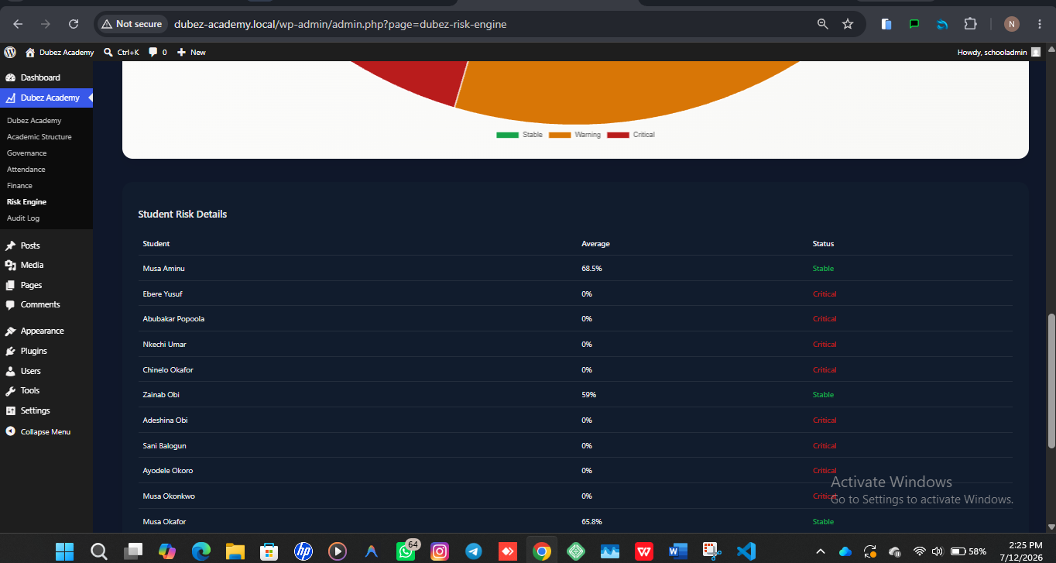

Section 21: Auto-Billing Run and Invoice Generation

Class-Based Term Billing Invoicing
Tuition fee management is automated to ensure financial security and accurate invoicing.
The billing process uses the `wp_dubez_fee_structure` configurations defined by administrators for each class cohort and term. When a term begins, the administrator initiates the Auto-Billing Run. The billing engine retrieves a list of all students enrolled in the target class ID and inserts matching invoice records into the `wp_dubez_student_billing` table.
Each student's invoice records their base fee amount, amount paid (initialized to 0.00), outstanding balance, and status set to 'unpaid'. If a student has a scholarship template applied, the adjusted amount column overrides the default base fee value.
The billing ledger tracks tuition status throughout the academic term.

Section 22: Proof of Payment & Bank Verification Flow

Manual Bank Transfer Lifecycle
To support payments via manual bank transfers, the system features a ledger-matching workflow for parents and administrators.
1. Upload Phase: The parent inputs the payment amount, attaches an image receipt, and submits the form. The system updates the billing record, sets the proof status to 'pending', and alerts administrators. The payment status remains 'unpaid' first.
2. Vetting Phase: The administrator reviews the attached receipt against the bank statement. They can reject the receipt (resetting the status to 'rejected' with notes) or approve it. Approval updates the paid amount, recalculates the payment status ('paid' or 'partial'), and records the transaction in the ledger.
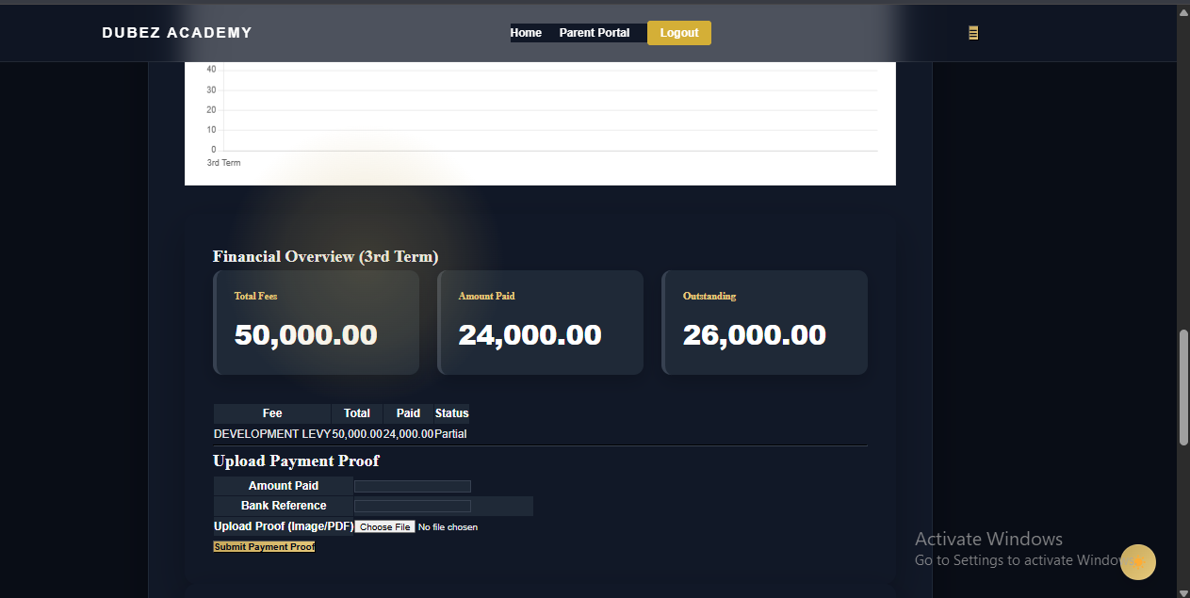
This verified logging flow prevents double-entry errors and payment discrepancies.

Section 23: Relational Audit Ledger & Log Viewer

Historical Action Tracker & Governance audits
Every database change is audited to maintain the integrity of academic and financial records. Operations are logged to the `wp_dubez_audit_log` table.
Any updates to grades, attendance, or billing configurations generate an audit trail. The log entry records the executor's ID, the affected student's ID, the action type, details of changed parameters, the active term, and a database timestamp.
Administrators review these entries through a paginated log viewer. The page handles large datasets efficiently and enables sorting by action categories.
Below is the core logging function in PHP:
function dubez_log_action($action_type, $description) {
global $wpdb;
$wpdb->insert(
$wpdb->prefix . 'dubez_audit_log',
[
'user_id' => get_current_user_id(),
'action_type' => $action_type,
'description' => $description,
'term' => get_option('dubez_current_term'),
'academic_year'=> get_option('dubez_current_academic_year'),
'created_at' => current_time('mysql')
]
);
}

Section 24: Messaging System & Automated Alerts

Triggers for Direct Messaging and Broadcast Channels
The internal messaging module manages communications within the ERP. It supports direct notifications, system alerts, and global announcements.
An hourly cron job runs background queries to check for alerts. If it detects unpaid balances, diagnostic risk flags, or attendance issues, it automatically logs target alerts. An internal query counts unread alerts, updating notification badges in the navigation menus in real-time.
Announcements can also be broadcast globally by administrators to all roles, ensuring timely delivery of school notices.
Below is the database query used to fetch user alerts:
SELECT * FROM wp_dubez_messages
WHERE recipient_id = %d OR role_target IN (
SELECT meta_value FROM wp_usermeta
WHERE user_id = %d AND meta_key = 'wp_capabilities'
)
ORDER BY created_at DESC

Section 25: ERP Security, escaping and nonces

Input Sanitation, Escaping, and Authentication Hardening
To secure the platform against SQL injection and cross-site scripting (XSS), the ERP enforces strict input sanitation, escaping, and authentication checks on all forms.
Every frontend form utilizes WordPress nonces to prevent CSRF attacks. Scripts verify nonces before executing write queries, and inputs are processed using target functions: user IDs are validated with `intval()`, amounts are cast to floats with `floatval()`, and text fields are processed using `sanitize_text_field()` or `wp_kses_post()`.
All SQL queries are run through helper functions like `$wpdb->prepare()`. This escapes queries beforehand, neutralizing SQL injection vectors. Frontend outputs use escaping functions like `esc_html()` and `esc_attr()` to protect against XSS exploits.
This validation pattern reduces security vulnerabilities across the system.

Section 26: UI Style Guide & Responsive Typography

The Premium Aesthetics Variable Standard Map
The system UI features a sleek design, moving away from standard WordPress layouts for a premium institutional ERP appearance.
Colors are defined as CSS variables using the HSL color model. The palette uses deep navy blue for structure elements, dark slate gray for side menus, and teal accents for highlights. A sans-serif font family, Outfit, is imported from Google Fonts to replace standard system fonts.
Typography rules use a typographic scale: H1 is sized at 32px/1.4 line-height, H2 at 24px, and body copy at 14px to maximize readability.
The interface adapts to tablet and mobile screens dynamically using CSS breakpoints.

Section 27: Theme Design Assets & Responsive CSS

CSS Variable Maps & Layout Breakpoints
To support dark and light theme options, colors are mapped to CSS custom variables in the style sheets.
A global script intercepts user preferences, toggle actions saving settings to local storage and appending appropriate class names to the HTML body. Spacing uses standard margins (8px, 16px, 24px, 48px) to align page panels, while layouts use Flexbox wrapping to adapt grids to different screen sizes.
Animations, such as hover changes on menu options, use transient styling to improve usability.
CSS stylesheets are separated from coding templates, keeping formatting logic decoupled.

Section 28: System Deployment & Maintenance Checklist

PHP Requirements and Deployment Steps
To deploy the Dubez Academy system in a production environment, the hosting environment must meet specific prerequisites.
Prerequisites: (1) Apache/Nginx running PHP 8.0 or newer; (2) MySQL 8.0 or newer, required for ranking window functions; (3) WordPress 6.2 core system installed. Deployment steps include upload of the plugin directory, migration of database tables, creation of WordPress page routes, and configuring roles.
Folders, specifically file upload directories, need write permissions but must block direct PHP execution.
We recommend scheduling weekly backups to safeguard academic records.

Section 29: Software Engineering Analysis

Database Normalization and Cohesion Metrics
The ERP design is structured to prioritize database normalization, relational integrity, and high class cohesion.
The design conforms to Third Normal Form (3NF). Every field relies solely on the primary key, eliminating multi-column updates and data anomalies. Relational tables replace generic metadata tables, reducing database storage size.
Functional modules are decoupled. Grading calculations, billing, and page rendering operate independently. This separation ensures that updates to the user interface do not affect core calculations or databases.
This structural approach provides a stable foundation for the ERP platform.

Section 30: Future Roadmap: Charts & Graph (Phase 5)

Visual Dashboard Integration Plans
The Phase 5 roadmap introduces visual data widgets to the Parent and Teacher Portal interfaces during the upcoming trimester upgrade.
The upgrade integrates Chart.js into portal views. Key features include: (1) Performance charts showing student averages over time; (2) Attendance indicators showing monthly presence-to-absence ratios; (3) Subject grade maps comparing student performance against class averages; (4) Color-coded markers highlighting academic at-risk levels.
These charts compile data calls from the database in real-time, loading widgets using AJAX to minimize page load times.

Section 31: Future Roadmap: Scaling & Hardening (Phase 8)

Performance Tuning and security auditing
The Phase 8 roadmap focuses on performance tuning, optimizing database transactions, and implementing additional security measures.
For performance optimization, target changes include: (1) Query pagination for large rosters; (2) Caching algorithms to store calculated rankings; (3) Relational cleanup scripts to purge expired logs; (4) Hardened nonce verification on forms.
These updates aim to optimize database response times and ensure system stability as class cohorts expand.

Section 32: Future Roadmap: Multi-Institutional SaaS (Phase 9)

Multitenant SaaS Relational Schema Upgrade
The Phase 9 update expands the ERP to a SaaS configuration, allowing a single installation to support multiple schools.
The design uses a partitioned database schema: (1) An Institutions table registers schools; (2) An tenant ID column is added to all tables, filtering records to isolate school data; (3) Invoicing systems manage payment processes for each school independently; (4) Portal layouts can be customized with school branding.
This architecture allows for multitenant deployments while maintaining database security and isolation.

Section 33: Conclusion, Developer Sign-off & Appendix

Release Verification and Capabilities Mapping
The Dubez Academy Custom ERP is operational, providing a relational framework for managing school operations.
By implementing relational database structures, standard rankings, automated billing runs, and transaction audit trails, the platform delivers school management features while maintaining database integrity.
Below is a reference guide mapping system capabilities to roles:
System Capability | School Admin | Class Teacher | Student Portal | Parent Portal
dubez_manage_context | YES (Authoritative) | NO ACCESS | NO ACCESS | NO ACCESS
dubez_manage_fees | YES (Authoritative) | NO ACCESS | NO ACCESS | NO ACCESS
dubez_generate_billing | YES (Authoritative) | NO ACCESS | NO ACCESS | NO ACCESS
dubez_approve_payment | YES (Authoritative) | NO ACCESS | NO ACCESS | NO ACCESS
dubez_mark_attendance | YES (Override rights) | YES (Class Cohort) | NO ACCESS | NO ACCESS
dubez_grade_assignment | YES (Override rights) | YES (Subject List) | NO ACCESS | NO ACCESS
dubez_send_announcement | YES (School Broad) | YES (Class Broad) | NO ACCESS | NO ACCESS
dubez_view_academic_reports | YES (Full access) | YES (Class Cohort) | YES (Personal) | YES (Children)

