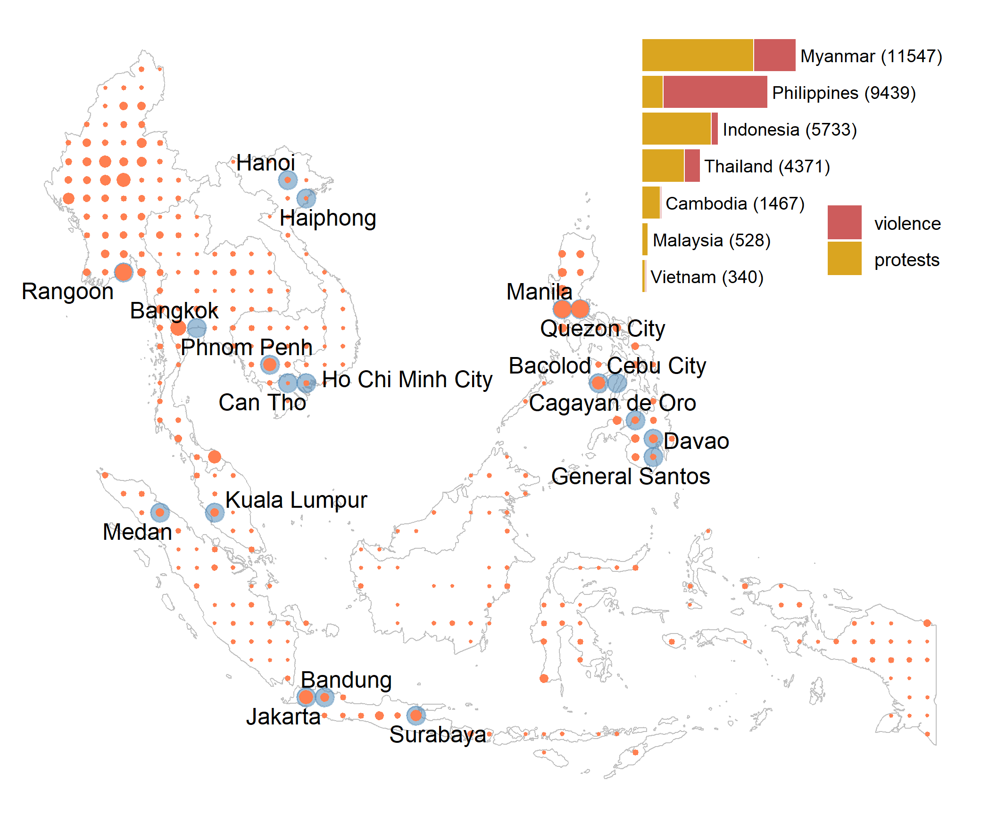

**Figure: Geographic distribution of violence and protests (2010 – 2021) and the major cities**

Note: The conflict data are for Cambodia, Indonesia (2015 – 2021), Malaysia (2018 – 2021), Myanmar, Philippines (2016 – 2021), Thailand, and Vietnam. The presented cities are the largest, in terms of population, of those with geographic centroid within a one-degree cell. When multiple cities fall within a cell, the largest of these cities is presented. Specifically, featured are the cities with population of more than 0.5 million that fall in the grid cell with aggregated city population of more than 2 million. This rule is arbitrary, and is only used for illustrative purposes, that is, to ensure that a manageable number of cities are presented on the map.

**Table 2: The Harvest-Time Violence and Protests Conditional on Battles and Explosions**

|  | **Violence** | **Protests** |
| --- | --- | --- |
| Conflict | 0.199*** | 0.224** |
|  | (0.035) | (0.104) |
| Area × Harvest | 0.007 | -0.091*** |
|  | (0.007) | (0.033) |
| Area × Harvest × Conflict | 0.044*** | 0.025 |
|  | (0.013) | (0.057) |
| Obs. | 37,764 | 37,764 |
| R2 | 0.378 | 0.211 |
| Baseline conflict | 0.35 | 0.54 |
| Area harvested | 0.98 | 0.98 |
| When there are no battles and explosions | | |
| Harvest (%) | 1.9 | -16.4*** |
|  | (2.0) | (6.0) |
| At (historical) average battles and explosions | | |
| Harvest (%) | 7.8*** | -14.2** |
|  | (1.9) | (7.1) |

Note: the outcome variable is a count variable that depicts the number of incidents in a cell during a year-month; the treatment variable is the cropland area (100,000 hectares) interacted with the harvest-season binary variables, which varies across locations (see Figure 2); ‘Conflict’ denotes the sum of incidents recorded as battles and explosions; all regressions include cell and year-month fixed effects; the values in parentheses are standard errors adjusted to clustering at the level of a cell; ***, **, and * denote 0.01, 0.05, and 0.10 statistical significance levels. The magnitudes of the effect, presented in percentage terms, are calculated as: $100\%×\hat{β}×\overline{s}/\overline{c}$ , where $\hat{β}$ is the parameter estimate, $\overline{s}$ is the average cropland area harvested, and $\overline{c}$ is the baseline conflict, which is the monthly average of incidents of a given conflict type.