**Agricultural Shocks and Social Unrest in Southeast Asia[1]**

Justin Hastings[2] David Ubilava[3]

*This Draft: 5 October 2022*

**Abstract**

**1. Introduction**

**2. Background and Data**

*2.1. Conflict*

For social unrest we use the Armed Conflict Location & Event Data (ACLED) compiled by Raleigh et al. (2010) and available at <https://acleddata.com/>. This dataset is highly granular in the sense that: (i) it features any reported conflict regardless of whether the altercation resulted in any casualty; (ii) it groups incidents into six categories, which include *battles*, *strategic developments*, and *explosions/remote violence* that feature two parties, typically the state or state-affiliated militias and the rebels, that dispute the control of a territory, it also includes *violence against civilians* perpetrated by any of the paramilitary groups, as well as *protests* and *riots* that feature different manifestations of public disorder of some sort. The key disadvantage of this dataset is that it covers a relatively short period of time, from 2010 onward for most Southeast Asian countries except for Indonesia (from 2015 onward), Philippines (from 2016 onward), and Malaysia (from 2018 onward). Moreover, there are very few incidents observed in Brunei, Laos, Singapore, and Timor-Leste, and we omit these countries, which leaves Cambodia, Indonesia, Malaysia, Myanmar, Philippines, Thailand, and Vietnam, for the analysis

The study period, that is from 2010 to 2021, thus covers a total of nearly 60 thousand incidents observed across seven countries. This excludes incidents with the geo-precision code 3 in the database (approximately 2.5 percent of the data), as the exact locations of such incidents are unknown and they are arbitrarily attributed to the nearest known site, typically a provincial capital. Figure 1 illustrates the geographical distribution of these incidents aggregated at the one-degree cell level. Together with the conflict incidents, the figure also features a selected set of large cities in the region. The data on cities were obtained from the World Cities Database available at <https://simplemaps.com/data/world-cities>. From this map, it becomes apparent that: (i) conflict, broadly defined, occurs across much of the Southeast Asian region; (ii) within the region, some countries are more conflict-prone than others; (iii) there is a fair bit of spatial dependence in the prevalence of conflict; and (iv) conflict, while generally more prevalent in cities, where most people reside, is not necessarily and exclusively a city phenomenon.

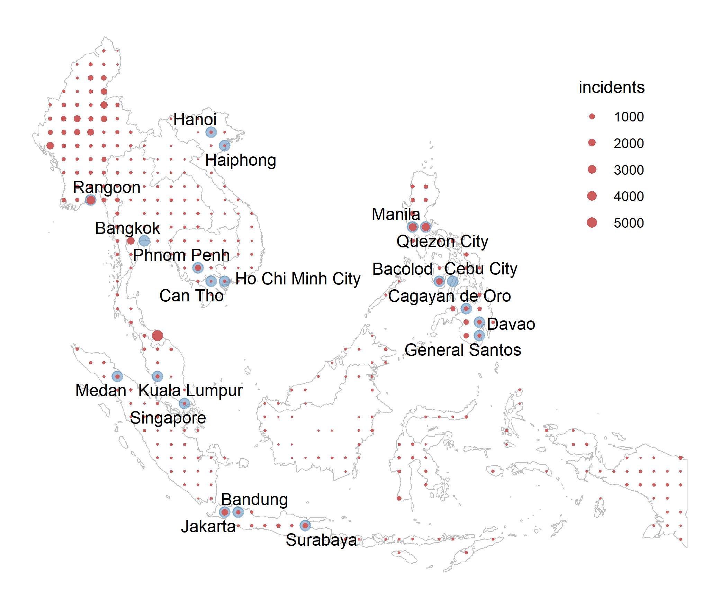

**Figure 1**: Geographic distribution of conflict in 2010-2021 and the major cities of the region.

Note: the presented cities are the largest, in terms of population, of those with geographic centroid within the one-degree grid cell. When multiple cities fall within a grid cell, the largest of these cities is presented. Specifically, featured are the cities with population of more than 0.5 million that fall in the grid cell with aggregated city population of more than 2 million. This rule is arbitrary, and is only used for illustrative purposes, that is, to ensure that a manageable number of cities are presented on the map.

*2.2. Production*

We source the data on cereal grain production and harvest months from Sacks et al. (2010) and Monfreda et al. (2008), available at <https://sage.nelson.wisc.edu/data-and-models/datasets/>. We consider two key cereal grains produced across Southeast Asia: rice and maize. While rice is, by far, the most dominant cereal—both in terms of production as well as consumption—in a select few locations, maize is the more cultivated crop. We obtain the fraction of the cropland dedicated to the major crop—i.e., that occupying the larger fraction of the cropland— within a grid cell. The harvest may extend multiple months. We define the midpoint of the harvest season as the *harvest month*, and months from the harvest start to the harvest end as the *harvest period*. In instances where a crop is grown over two seasons, we use the main season to identify the crop year, however we also record the harvest month and harvest period for the second season. Within a cell, the fraction of cropland as well as the months of the harvest season remain fixed over the study period. In instances where a crop is grown over two seasons, the area fraction of cropland is recorded to be the same in both seasons.

**Figure 2**: Geographic distribution of crop harvest months

Note: the main harvest season on the left, the second harvest season on the right; the size of the dots indicates the cropland area fraction of a cell, ranging from 0.01 (those with smaller values are set to zero for graphing purposes) to 0.58; the radial labels indicate the count of cells that fall within a given harvest month.

*2.3. Descriptive Statistics*

In Table 1 we summarize some of the key features of the data.

Table 1: Descriptive Statistics

|  |  |  |  |  |  |
| --- | --- | --- | --- | --- | --- |
|  | Count | Mean | S.D. | Min | Max |
|  | cell-year-month level variables (2010 – 2021) | | | | |
| Battles | 37764 | 0.297 | 1.827 | 0 | 63 |
| Explosion | 37764 | 0.179 | 1.837 | 0 | 87 |
| Violence | 37764 | 0.344 | 2.880 | 0 | 164 |
| Riots | 37764 | 0.049 | 0.444 | 0 | 42 |
| Protests | 37764 | 0.541 | 3.641 | 0 | 268 |
| Strategic | 37764 | 0.171 | 1.469 | 0 | 67 |
| Combined | 37764 | 1.581 | 7.916 | 0 | 417 |
|  | cell level variables | | | | |
| Cropland area fraction | 359 | 0.062 | 0.087 | 0 | 0.584 |

Note: the data are for Cambodia, Indonesia (2015 – 2021), Malaysia (2018 – 2021), Myanmar, Philippines (2016 – 2021), Thailand, and Vietnam.

**3. Estimation Strategy**

We denote *location*, which is a one-degree cell, with subscript *i*, and *period*, which is a year–month, with subscript *t*. The units of analysis, thus, are location-period covering 378 unique grid cells across Southeast Asia between January 2010 and December 2020. Because we apply monthly rather than yearly data, we opt for the relatively crude level of spatial aggregation—one-degree cells that measure approximately 110×110 km near the equator—as opposed to finer level of spatial aggregation, e.g., 0.5-degree cells, as used by other studies, to ensure there are sufficient number of units with conflict incidents. The current level of aggregation is granular enough to not sabotage the within-country variation in conflict incidents.

Our main econometric specification is as follows:

$y_{it}=βs_{i}d_{it}+μ_{i}+λ_{t}+ε_{it}$ (1)

where $y_{it}$ depicts the number of incidents in cell *i* in period *t*; $s_{i}$ is the time-invariant cropland area fraction in cell *i*; and $d_{it}$ is the cell-specific seasonal dummy variable that take the value of one when the period of observation is the months of harvest, and zero otherwise. $μ_{i}$ is a cell fixed effect, and $λ_{t}$ is a year–month fixed effect. $ε_{it}$ is the error term.

The estimated coefficient $\hat{β}$  reflects the effect of harvest on incidents of social unrest or civil conflict in a hypothetical location with 100 percent cropland. A positive value of the coefficient implies that in the harvest month there is an increase in violence in agricultural cells relative to nonagricultural cells, and that this effect is more pronounced in cells with a higher fraction of cropland. While no cell has the cropland area fraction of 1, there are cells with nearly half or more of the area devoted to crop (namely rice) production. Nonetheless, we scale the estimated coefficient by the expected cropland area fraction when we present the magnitude of the impact.

**4. Results and Discussion**

**Table 2: Regression results**

|  | **Conflict** | **Protests** | **Riots** | **Violence** | **Strategic** | **Explosion** | **Battle** |
| --- | --- | --- | --- | --- | --- | --- | --- |
| ***Unbalanced panel: all countries, all years*** | | | | | | | |
| Area × H | -0.252 | -1.433*** | -0.145* | 0.586** | 0.300*** | 0.112 | 0.327* |
|  | (0.564) | (0.538) | (0.082) | (0.250) | (0.114) | (0.087) | (0.196) |
| Obs. | 40,644 | 40,644 | 40,644 | 40,644 | 40,644 | 40,644 | 40,644 |
| R2 | 0.302 | 0.211 | 0.124 | 0.378 | 0.207 | 0.276 | 0.310 |
| *Magnitude of the effect:* | | | | | | | |
| E(Incidents) | 1.48 | 0.50 | 0.05 | 0.32 | 0.16 | 0.17 | 0.28 |
| Effect (%) | -1.05 | -17.54 | -19.42 | 11.24 | 11.57 | 4.05 | 7.28 |
| ***Balanced panel: all countries, years 2016 onward*** | | | | | | | |
| Area × H | -0.370 | -2.183** | -0.211* | 0.912** | 0.438** | 0.195 | 0.479 |
|  | (0.886) | (0.891) | (0.112) | (0.390) | (0.177) | (0.140) | (0.301) |
| Obs. | 25,848 | 25,848 | 25,848 | 25,848 | 25,848 | 25,848 | 25,848 |
| R2 | 0.292 | 0.223 | 0.122 | 0.377 | 0.168 | 0.168 | 0.315 |
| *Magnitude of the effect:* | | | | | | | |
| E(Incidents) | 1.87 | 0.65 | 0.05 | 0.46 | 0.20 | 0.19 | 0.32 |
| Effect (%) | -1.22 | -20.77 | -24.26 | 12.32 | 13.57 | 6.41 | 9.10 |
| ***Balanced panel: countries excluding Thailand and Philippines, all years*** | | | | | | | |
| Area × H | -0.423 | -1.048* | -0.064 | 0.278 | 0.251* | 0.071 | 0.088 |
|  | (0.484) | (0.604) | (0.077) | (0.186) | (0.144) | (0.122) | (0.144) |
| Obs. | 25,920 | 25,920 | 25,920 | 25,920 | 25,920 | 25,920 | 25,920 |
| R2 | 0.276 | 0.203 | 0.073 | 0.251 | 0.235 | 0.290 | 0.304 |
| *Magnitude of the effect:* | | | | | | | |
| E(Incidents) | 1.51 | 0.53 | 0.03 | 0.18 | 0.21 | 0.25 | 0.32 |
| Effect (%) | -1.80 | -12.80 | -13.45 | 9.94 | 7.57 | 1.85 | 1.79 |

Note: the outcome variable is a count variable that depicts the number of events in a cell during a year-month; the treatment variable is the cropland area fraction in the cell interacted with the harvest-month binary variable; the column headed by ‘Conflict’ combines all event types, the other six columns represent the separate event types; all regressions include cell and year-month fixed effects; the values in parentheses are standard errors adjusted to clustering at the level of a cell and year-month; ***, **, and * denote 0.01, 0.05, and 0.10 statistical significance levels. The effect magnitudes, presented in percent terms, are calculated as: $\hat{β}×\overline{s}/\overline{c}×100\%$ , where $\hat{β}$ is the parameter estimate, $\overline{s}$ is the average cropland area fraction (0.06), and $\overline{c}$ is the unconditional expectation of incidents denoted by E(Incidents) in the table.

**5. Conclusion**

**References**

Monfreda, C., N. Ramankutty, and J. A. Foley (2008), Farming the Planet: 2. Geographic Distribution of Crop Areas, Yields, Physiological Types, and Net Primary Production in the Year 2000, *Global Biogeochemical Cycles 22*, GB1022

Raleigh, C., A. Linke, H. Hegre, and J. Karlsen (2010). Introducing ACLED: An Armed Conflict Location and Event Dataset: Special Data Feature. *Journal of Peace Research 47(5)*, 651–660.

Sacks, W.J., D. Deryng, J.A. Foley, and N. Ramankutty (2010). Crop Planting Dates: An Analysis of Global Patterns. *Global Ecology and Biogeography 19*, 607-620

1. Preliminary and incomplete.
2. Department of Government and International Relations, University of Sydney
3. School of Economics, University of Sydney