**Agricultural Shocks and Social Conflict in Southeast Asia**

**Abstract**

Social conflicts are inevitable, but their occurrence and intensity have varied over time and across locations. In lower-income economies, where employment and income from agriculture are substantial, forms of political violence and social conflict may be linked with this sector. We investigate this linkage using granular conflict data covering a 13-year period across seven Southeast Asian countries. We focus on changes in conflict incidents during the rice harvest season, which is the most produced and consumed cereal crop in the region. We observe an increase in political violence but a decrease in social unrest in rice-producing areas during the harvest season. We investigate different plausible mechanisms that may lead to such effects, by incorporating shocks associated with rice prices and growing season rainfall, and by comparing regions with predominantly irrigated vs predominantly rainfed rice production practices. These findings offer important insights to policymakers as they point to possible temporal and geographic displacements of conflict, which can be linked with locations where a crop is produced and times when it is harvested.

**Keywords**: Agriculture, Conflict, Seasonality, Southeast Asia

**1. Introduction**

In lower–income economies, a small change in people’s well-being may trigger a range of behavioral responses, some of which may be unlawful and possibly violent. While protests, riots, and violence against civilians happen in cities that not only are populous areas but also where the state administration—the key target of protesters—is located (e.g., Smith, 2014; Hendrix and Haggard, 2015), social conflict is not just an urban phenomenon. In rural areas, which often constitute the larger share of territories where the state capacity is limited, changes in income and employment can result in conflict and violence (e.g., McGuirk and Burke, 2020; Ubilava et al, 2022; Guardado and Pennings, 2023). Indeed, mounting empirical evidence points to a strong linkage between crop yields and conflict (Wischnath and Buhaug, 2014; Buhaug et al. 2015; Koren, 2018; Vestby, 2019)—which, in turn, is the most likely mechanism and a manifestation of climate shocks on conflict (e.g., Burke et al., 2009; Hsiang et al., 2013; Dell et al., 2014)—and, somewhat less unequivocally, between commodity price shocks and conflict (Dube and Vargas, 2013; Maystadt and Ecker, 2014; Raleigh et al. 2015; Berman and Couttenier, 2015; Crost and Felter, 2020).

This paper addresses the question of whether agricultural shocks, manifested through seasonal employment and income, lead to conflict. The linkage can be reduced to a couple of theories. One such theory is that of *grievance*, which suggests that people protest the deterioration of their well-being, relative to others or to their own past (e.g., Hendrix and Haggard, 2015; de Winne and Peersman, 2021). A food crisis caused by reduced availability of affordability of food items, for example, can be a factor in such conflict. Another theory is *greed*, which suggests that perpetrators are more likely to engage in conflict when there is more at stake. That is, an increase in farm income, e.g., after a good harvest season, or when the commodity prices are high, increases the value of spoils to be appropriated, which can amplify violence (Koren and Bagozzi, 2017; McGuirk and Burke, 2020).

Both theories, of grievance and greed, explain the conflict that happens not only because there are opportunities to extort wealth or incur damage and thus improve one’s own relative standing—the *predation* or *rapacity* mechanism—but also because the opportunity costs of engaging in such activities are not very high—the *opportunity cost* mechanism. The latter has been primarily portrayed as a person’s choice of the less peaceful ways of generating income, when the lawful alternatives such as farming do not pay enough (e.g., after a bad crop year, or a drop in commodity prices). To that end, the opportunity cost of fighting is seen as an increasing function of income—a negative income shock leading to more violence (Collier and Hoeffler, 1998; Fjelde, 2015). This alludes to a relatively long-term commitment to a conflict, however. A shorter-term manifestation of the opportunity cost mechanism would be instances when people engage in a social conflict, such as protests and riots, when their value of time is relatively low. In the agricultural sector, this would be the period during the year when people are not actively farming (Guardado and Pennings, 2023).

At the heart of the question of the link between agricultural output and conflict is not only the mechanism but also the form of conflict. Political violence aimed at civilians can be linked to the harvest-time positive income shocks, and the relationship is expected to be positive (McGuirk and Burke, 2020). Studies of African data have found seasonal changes in conflict intensity. In crop-producing areas, there is an increase in attacks on civilians during harvest months (Ubilava et al. 2022). In this context, seasonal increases in attacks on civilians in crop-producing areas align with the theory of greed manifested through the rapacity mechanism.

On the other hand, protests and riots are often triggered by negative income shocks. In rural areas they may be linked to agricultural harvest, and if so, the relationship should be negative—i.e., negative agricultural income shocks can drive protests and riots (e.g., Panza and Swee, 2023)—for at least two reasons. First, when people—potential protesters—are busy harvesting, they are unlikely to take part in protests as the opportunity cost of this type of conflict is high. Second, if there is a short period of time, during the calendar year, when people in rural areas are relatively better off, compared to other times of the year or to people in urban areas, it is during or shortly after the harvest season, when the years’ worth of income has been realized. In this context, the seasonal patterns in protests and riots in crop-producing regions can be linked with the theory of grievance and the opportunity cost mechanism.

Finally, incidents linked to larger-scale conflicts, such as battles between incumbents and insurgents to take control of a territory, are unlikely to be driven by or related to agricultural employment income (e.g., Mampilly and Stewart, 2021; Ubilava et al., 2022). And even if they were, the direction of the effect may very well go in the opposite direction. That is, in times of a civil war, for example, people willingly or unwillingly may be involved in the process, at the expense of their usual employment, which in rural societies is often agricultural production.

We study the relationship between agricultural shocks and conflict by examining approximately 80 thousand incidents in Southeast Asia over a 13-year span, with monthly data from 2010 to 2022. We find that changes in conflict in crop-producing areas during the harvest months of rice—the key cereal crop in the region—depend on the type of conflict: protests and riots decrease during rice harvest months, while battles and violence against civilians increase during rice harvest months. This suggests that the mechanisms that primarily drive harvest-time conflict in Southeast Asia varies by their type. In the case of conflict *by* civilians, the opportunity cost of conflict increases during harvest time, which leads to fewer protests and riots. In the case of conflict *against* civilians, harvest time provides rapacious violent groups with an opportunity to appropriate or destroy agricultural surplus.

There are further nuances in the findings. When the rice prices are higher than their historical average, conflict of all types decreases during harvest season. This finding likely suggests that we are unable to disentangle the rapacity mechanisms of conflict associated with grievance and opportunity cost mechanisms of conflict. That civilians are attacked at the time of harvest—when there are spoils to be appropriated—accords with the rapacity mechanism. But if this were to be the only mechanism, then such attacks would have amplified when the price of the crop increases. Instead, the opposite effect is observed, which points to the offsetting effect through the other mechanisms.

We also entertain the idea that forms of conflict that necessarily involve civilians, namely violence against civilians and protests by civilians, can be related—directly or indirectly—to large-scale military events in the region. Incidents of violence against civilians and protests by civilians increase during periods of elevated levels of conflict that typically involves the state and insurgents. We find that while harvest-time reduction in protests happens in times of war and peace, harvest-related seasonal increase in violence happens only in times of war. This accords with the ‘living off the land’ theory (Koren and Bagozzi, 2017), which suggests that co-optation between fighters and farmers—observed in times of relative peace—breaks down during periods of conflict.

We contribute to the literature on the economic roots of conflict (Crost and Felter, 2020; McGuirk and Burke, 2020; Berman et al, 2011; Grasse, 2022). We present empirical evidence for the diverging effects that agricultural employment and income have on different forms of conflict, thus emphasizing benefits and the need of nuanced data analysis. We also contribute to the literature on the seasonality of conflict (Harari & Ferrara, 2018; Ubilava et al., 2022; Guardado & Pennings, 2023). We present empirical evidence for a harvest time increase in violence and a harvest time reduction of protests, and link these effects to the existing theories of conflict that have been previously examined in temporally more aggregate (annual) setting.

**2. Agricultural Origins of Conflict in Southeast Asia**

The geographic focus— Southeast Asia—is suitable for the present analysis for several reasons. First, most of the countries in the region fall into the lower-middle-income economies, with a considerable proportion of people living at or below the national poverty line (World Bank, 2022a, 2022b). The region also has large across-country and within-country variation in governance and institutional capacity levels, as the Philippines, Myanmar, and Indonesia in particular struggle to control their geographic peripheries.

Second, agriculture is a crucial sector for employment and income generation, across much of the region (World Bank, 2022c). While subsistence farming exists in Southeast Asia as in many regions with less developed economies, Southeast Asian countries are often food exporters (unlike many African countries). Thailand, Vietnam, Myanmar, and Cambodia are all in the top ten rice exporting countries globally (FAO, 2023). This means that violence associated with rice-producing areas are especially relevant to income generation for both farmers and the state.

Finally, civil conflict and social unrest have been defining features of the region’s politics (e.g., Crost and Felter, 2020; Crost et al., 2020; Gatti et al., 2021). The Philippines and Myanmar, for example, have seen multiple insurgencies—ideology- or ethnicity-based—for nearly their entire independent existences. The protests and conflicts that were sparked by the Myanmar military’s coup in 2021 have evolved into a full-scale civil war, while the Philippines has high levels of civil conflict. Thailand struggled with a communist insurgency from the 1960s until the early 1980s, and spillover from Myanmar’s insurgencies, while the Thai government continues to fight a low-level ethnic insurgency in southern Thailand. Since Suharto’s fall in 1998, Indonesia has dealt with widespread protests, riots, civil conflict, and Islamist terrorism, as well as ethnic insurgencies in Aceh and West Papua.

We can imagine a number of different actors in Southeast Asian conflict, all of whom could instigate conflict, including civilians, armed rebel groups, state actors, and militias operating on behalf of competing elites. Civilians may instigate protests against government policies, and these protests may turn into riots. Armed rebel groups, state actors, and militias may engage in violence against civilians, either through armed attacks, battles, or explosions. The logic of conflict, agricultural shocks, and seasonality is likely to be different, and in some ways, diametrically opposed, depending on the type of actor (and thus the type of conflict).

Previous work on the connection between conflict and agricultural output in Southeast Asia has come to nuanced conclusions about the types of conflict pursued by different actors, and the potential relationship with agricultural outputs. Gatti et al. (2021) find that decreased agricultural output is associated with an increase in civil conflict in Indonesia, but that irrigation infrastructure specifically mitigates this link. They divide conflict into conflict over natural resources, issues of popular justice, conflicts triggered by government policy, those triggered by group identity, as well as separatist incidents. Their findings suggest that this effect is particularly strong for natural resource conflicts, popular justice, law enforcement actions, and less strong for conflicts driven by ethnic separatism and group identity. While their categorizations do not specifically differentiate civilian protest and rioting from state- and rebel-initiated conflict, in broad strokes, it appears that conflicts that would lead to protests against government policy and over natural resources are more amenable to mitigation through decreasing the effects of negative agricultural shocks than ethnic separatist conflicts, which are more likely to be associated with insurgent activities, particularly in Indonesia, where rebel groups generally have religious or ethnic goals.

*2.1. Harvest-Time Increase in Violence Against Civilians*

In Southeast Asia, both the opportunity cost and rapacity mechanisms are at play, depending on the actor type (Table 1). For attacks on civilians, insurgencies may increase their activities during the harvest season to maximize the damage they do through a number of pathways. First, they may want to expropriate farmers’ income, which is realized during harvest season. Second, for farmers who do not support the insurgency or who are on the sidelines, insurgents may want to harm the farmers’ earning potential in order to minimize threats to the insurgency, or to intimidate the farmers into joining them (Raleigh, 2012; Raleigh and Choi 2017). Third, the insurgents may time their attacks so as to have maximum negative effect on the state, inasmuch as the state is also likely deriving revenues during the harvest season, and state revenue is related to the ability of the state to attack the insurgents (Fearon and Laitin 2003).

By this logic, violence against civilians is likely to be focused on the destruction or appropriation of agricultural outputs. Significant numbers of attacks on civilians in Southeast Asia revolve around the theft of rice or the destruction of rice fields, rice storage units, or rice milling facilities. In December 2013, for instance, the Myanmar military attacked civilian rice paddies in Kachin state during the harvest season.[1]

State forces, political militias, and insurgent groups might choose the harvest season as the time to attack because it would maximize the destruction of their enemies’ resources, or allow them to appropriate that agricultural surplus. In November 2022, a Myanmar military force shot dead three villagers in a raid in Myanmar’s Magway region, two of who were engaged in harvesting rice in paddy fields.[2] During the harvest season, the state may also attack villages that may be aiding rebel groups. In November 2021, for instance, in a clash between the Myanmar military and various People Defense Forces (the armed groups associated with the anti-junta civilian government in internal exile), the military burned harvested rice fields in a village that it (obviously) suspected was loyal to the anti-state groups.[3]

**Table 1. Actors and conflict seasonality: Theoretical expectations**

|  |  |  |  |
| --- | --- | --- | --- |
| **Type of actor** | **Type of conflict** | **Seasonal effect** | **Mechanism** |
| Civilians | Protests, riots | Decrease during harvest times | Opportunity cost |
| Armed actors (State, armed rebel groups, militias) | Violence against civilians, battles and explosions | Increase during harvest times | Rapacity |

Insurgent groups fighting against the state also have an incentive to attack civilians who are providing agricultural outputs to the state, both to intimidate the civilians against supporting the state, and to deny the state food. In November 2022, rebel groups ambushed a military convoy carrying rice in Myanmar in Mon state and killed a soldier.[4] Pro-government militias can engage in similar behavior to degrade the resources available to their enemies and to appropriate resources for themselves. In June 2022, the pro-military junta militia group Pyu Saw Htee killed a rice mill owner in Sagaing and stole large amounts of money (which had been intended to buy more rice milling equipment) as well as mobile phones and a motorcycle.[5]

*2.2. Harvest-Time Decrease in Protests by Civilians*

While riots and protests may be initiated by insurgencies or organized anti-government groups, they may also more generally be indicative of dissatisfaction by civilians, whether organized or not. A decrease in protests and riots during harvest season may come through several pathways. First, those who are directly involved in agriculture may decrease their protest activities during harvest time because they are busy harvesting. This relates to a second pathway, that of a direct opportunity cost mechanism, in which the opportunity cost of protesting increases during harvest time because there is more income to be derived from harvesting. Put another way, the infusion of income from the harvest makes protesting relatively less attractive. This may be because there are actually fewer grievances against the government when would-be protesters are realizing income. It may also be because the ‘income’ from protesting relative to other activities becomes less competitive. In Indonesia, for instance, paid protesting is a longstanding means for political parties and civil society groups to pressure the government or send a message. In many cases, protesters are provided with a packed lunch (‘nasi bungkus’ in Indonesian) and a cash payment (hence the term, the ‘nasi bungkus brigade’), and often have only a tenuous interest in the issue at the center of the protest (Andrews, 2017). Thus, protest campaigns may find fewer supporters (paid or not) during the harvest season.

Protests by farmers in Southeast Asia are often designed to pressure the government to increase (or maintain) the prices they receive for their products. Both Indonesia and the Philippines have seen pressure campaigns from farmers to maintain or increase the price of rice (through price guarantees), or to prevent rice imports (to minimize competition that can undercut the domestic price).[6] In a logic where protests increase as grievances against the state increase, or as the opportunity cost of protesting decreases relative to harvesting, we would expect higher prices or better harvests to be associated with fewer protests and riots.

We would also expect protest and riots to decrease during the harvest season relative to the non-harvest season. In the case of Thailand, for instance, there was a spate of protests against the Thai government by farmers throughout the country in 2014 because of a rice purchasing scheme in which the Thai government was supposed to have paid farmers subsidies for their rice production, but payments were either delayed or non-existent (Mohanty 2012). These protests were largely *not* during rice harvest season (which is December in Thailand), but several months later, when farmer’s grievances increased, and the opportunity cost of protesting was lower relative to harvesting. Of interest here is that the Thai farmers’ grievances were against both the government (for not paying the subsidies) and anti-government groups (for supposedly blocking the government from paying the subsidies).[7] The protests were ultimately followed by a military coup against the civilian government in May 2014.

Finally, fewer protests around the time of harvest, relative to other periods of the crop year, to some extent could be an effect of higher likelihood of civilians’ protest during the growing season (which is also often a season of hunger as supplies from the previous harvest dwindle) as a means of extracting concessions from the government. In Thailand in July 2019, for example, hundreds of farmers blocked a road to force the government to release irrigation water for their rice paddies during a drought.[8]

**3. Data**

We source the data from multiple sources. For social conflict, we use the Armed Conflict Location & Event Data (ACLED) compiled by Raleigh et al. (2010). For rice land cover and harvest calendars we use the data from IFPRI (2019) and from Monfreda et al. (2008). We source the price data from the International Grains Council, and the precipitation data from the ERA5 Copernicus project. In what follows, we describe each dataset in more detail.

*3.1. Conflict*

The ACLED Project (Raleigh et al., 2010) presents highly granular data in the sense that: (i) it features any reported conflict regardless of whether the altercation resulted in any casualty; (ii) it groups incidents into six categories, which include *battles*, *strategic developments*, and *explosions/remote violence* that feature two actors, typically the state or state-affiliated militias and the rebels, that dispute the control of a territory; *violence against civilians* perpetrated by any of the paramilitary groups, as well as *protests* and *riots* that feature different manifestations of public disorder of some sort. The main caveat of this dataset is that it covers a relatively short period of time, from 2010 onward for most Southeast Asian countries except for Indonesia (from 2015 onward), Philippines (from 2016 onward), and Malaysia (from 2018 onward). Moreover, there are very few incidents observed in Brunei, Laos, Singapore, and Timor-Leste, and we omit these countries. This leaves Cambodia, Indonesia, Malaysia, Myanmar, Philippines, Thailand, and Vietnam, for the analysis.

Our study period, which ranges from 2010 to 2022, covers a total of more than 80 thousand incidents observed across the seven countries. This excludes incidents for which exact locations are unknown and they are thus arbitrarily attributed to the nearest known site, typically a provincial capital (such locations are recorded with the geo-precision code 3 in the database). For illustration purposes, we combined explosions/remote violence into the battles category; and we combined protests and riots into unrest category; we retained violence (against civilians) as a category of its own; we excluded strategic developments from the analysis. Figure 1 illustrates the geographical distribution of incidents across three conflict categories aggregated at the level of one-degree cells. The map also features a selected set of large cities in the region.[9]

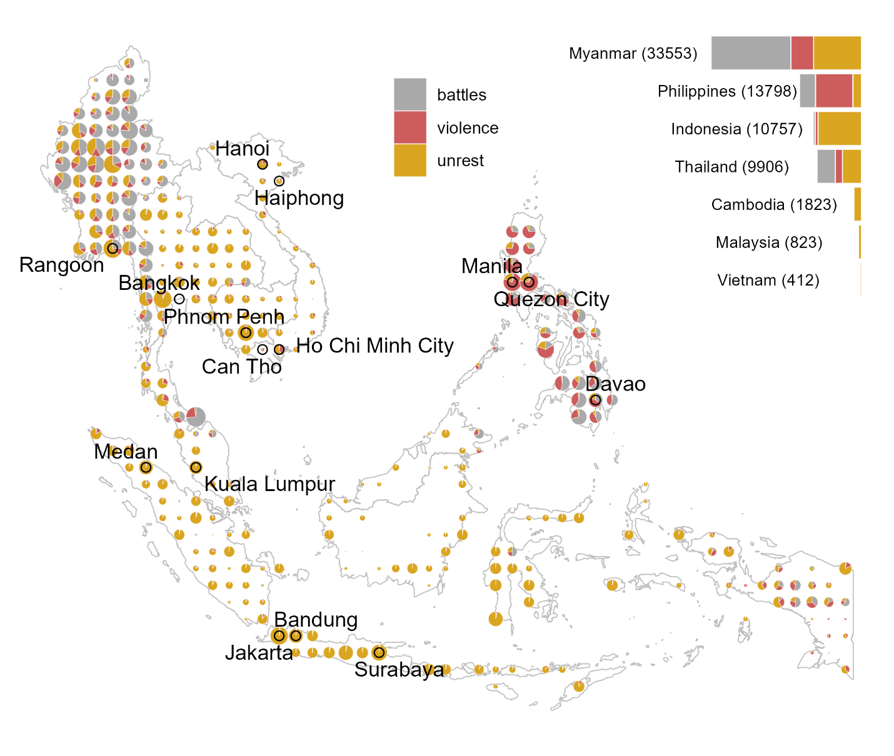

**Figure 1: Geographic distribution of social conflict (2010–2022)**

Note: The data are for Cambodia, Indonesia (2015 – 2022), Malaysia (2018 – 2022), Myanmar, Philippines (2016 – 2022), Thailand, and Vietnam. The size of the dots is proportional to the combined number of incidents in a cell, ranging from 1 to 4749 (the southernmost cell of Thailand). The presented cities are the largest, in terms of population, of those with geographic centroid within a one-degree cell. When multiple cities fall within a cell, the largest of these cities is presented. Specifically, featured are the cities with populations of more than 0.5 million that fall in the grid cell with aggregated city population of more than 2 million. This rule is arbitrary, and is only used for illustrative purposes, that is, to ensure that a manageable number of cities are presented on the map.

From this map, it becomes apparent that: (i) conflict, broadly defined, occurs across much of the Southeast Asian region; (ii) within the region, some countries are more prone to conflict than others; (iii) there is a fair bit of spatial dependence in the prevalence of different types of conflict; and (iv) while generally observed in the cities, where most people reside, conflict not necessarily or exclusively a city phenomenon.

Figure 2 presents the time series of the four considered types of conflict over the study period. Additional features become apparent: (i) there is no apparent trend across conflict types, but there is a notable increase in almost all types of conflict from 2021 onward; (ii) despite a general co-movement among conflict types, there are periods when a rise in one type of conflict is not accompanied by other types of conflict.

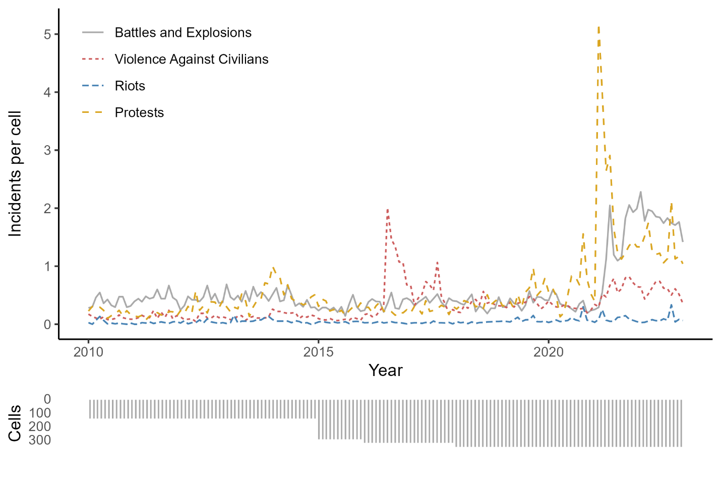

**Figure 2: Dynamics of social conflict by type**

Note: The time series are monthly rates of conflict incidents per cell, across available cells for a given period. The number of cells (the bottom panel) increased progressively as Indonesia (2015), Philippines (2016), and Malaysia (2018) were added to the dataset.

*3.2. Production*

We focus on rice which is, by far, the most dominant cereal—both in terms of production as well as consumption— across Southeast Asia. The harvest may extend multiple months. We define the period from the month when the harvest starts to the month when the harvest ends as the *harvest season*. We define the midpoint of the harvest season as the *harvest month*. In instances where a crop is grown over two seasons, we use the main season to identify the crop year. Within a cell, the area of cropland and the month of the harvest remain fixed over the study period.

Figure 3 aggregates at the level of one-degree cells the geographical distribution of relative cropland area fraction and harvest months. The map also features locations where more than 50 percent of croplands are irrigated. The data on irrigation status are from IFPRI (2019). The histogram of the proportion of irrigated rice in the region is presented in Appendix Figure A1.

From this map, it becomes apparent that: (i) there is a fair bit of variation in the timing of the main harvest season, albeit March being seemingly the most dominant month in that regard; (ii) there is a considerably within-country variation in cropland area fractions, but hardly any within-country variation in the harvest month.

*3.3. Other data*

The price of rice is a crucial determinant of the value of this crop for farmers (or perpetrators, for that matter). We use the data on export price of Thai rice as an indicative price for rice in the region. Following Ubilava et al. (2022), in the analysis we apply year-on-year relative change in prices, obtained by seasonally differencing the log-transformed price series. Such a measure is intuitively sensible, as it approximates the annualized inflation measure, as well as practical, as it tracks closely the general narrative used by policy makers when discussing the price effects.

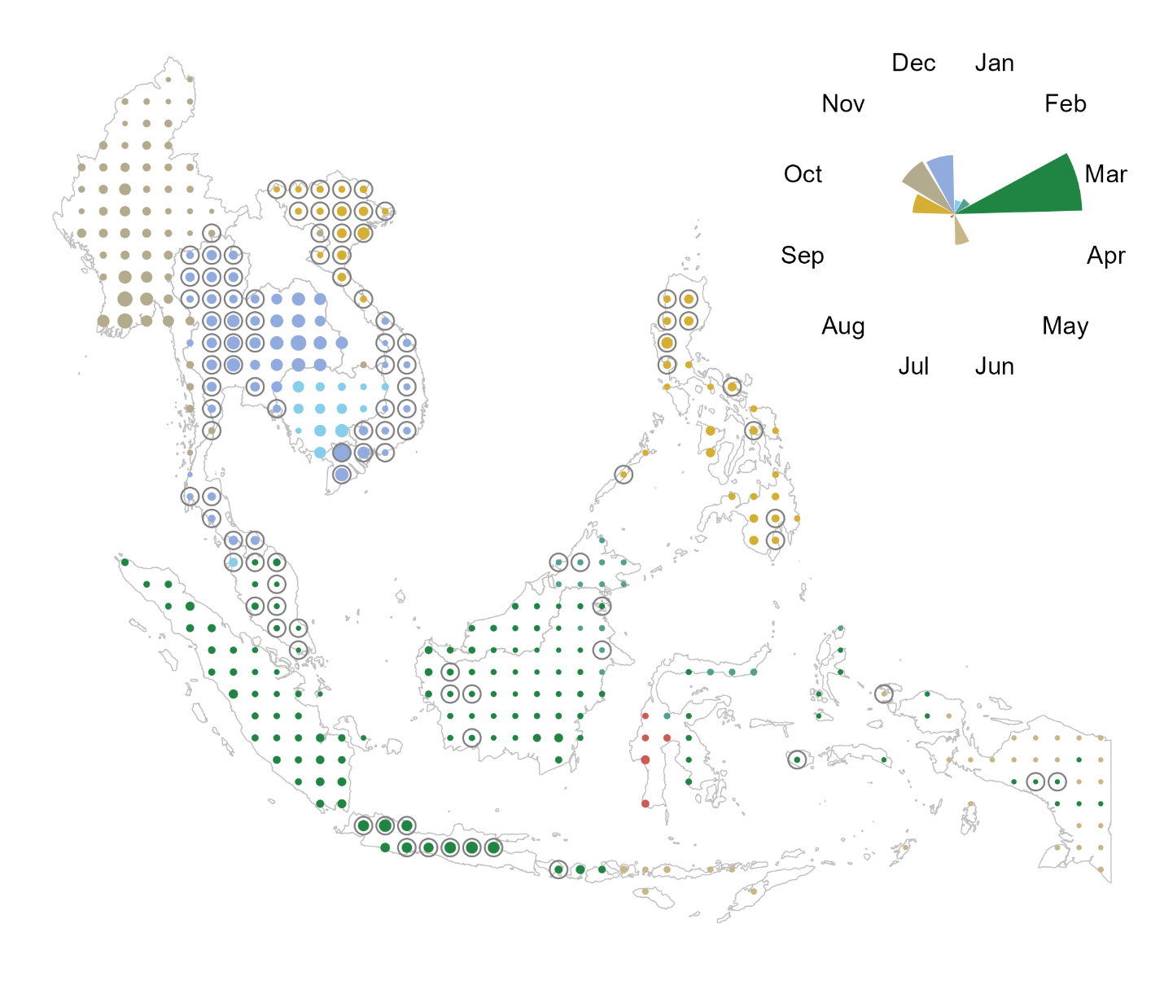

**Figure 2: Geographic distribution of rice harvest months**

Note: The size of the dots is proportional to the area devoted for rice production; the radial bars indicate the count of cells that fall within a given harvest month. The data on the crop area are from IFPRI (2019). The data on harvest calendar are from Monfreda et al. (2008). The countries covered are Cambodia, Indonesia, Malaysia, Myanmar, Philippines, Thailand, and Vietnam.

Rainfall is the most important input in rice production. So, we use it to test the mechanism related to year-to-year change in relative abundance of rice, at harvest time, in rice-producing cells. We obtain ERA5 reanalysis data on gridded total precipitation from the Copernicus Project (Hersbach et al., 2018). Specifically, we obtain monthly average total precipitation, which we aggregate to the one-degree grid cell level—the spatial unit of measurement in the present study. Next, we calculate the measure of total precipitation during the months between the planting and harvesting seasons. For each cell, to obtain the standardized measure of precipitation, we divide the mean-centered precipitation by its standard deviation. Thus, we can interpret the magnitude of the effect as that of a one standard deviation change in precipitation.

*3.4. Descriptive Statistics*

In Table 2 we summarize some of the key features of the data. Violence against civilians and protests represent the two most prevalent types of violent events that typically involve civilians who either are directly targeted (e.g., violent attacks or abduction) or become targets (e.g., intervention against protesters). Battles combined with explosions/remote violence emerge as another important conflict category. The least prevalent category of social conflict is riots, which is a violent version of protests, and share elements of other, more involved types of conflict.

**Table 2: Descriptive Statistics**

|  |  |  |  |  |  |
| --- | --- | --- | --- | --- | --- |
|  | Mean | S.D. | Min | Max | Prop |
|  | *Unit of observation: cell-year-months (42,072)* | | | | |
| All events | 1.957 | 9.261 | 0 | 417 | 0.278 |
| Battles and explosions | 0.619 | 3.872 | 0 | 106 | 0.098 |
| Protests | 0.642 | 3.856 | 0 | 268 | 0.164 |
| Riots | 0.054 | 0.454 | 0 | 42 | 0.034 |
| Violence against civilians | 0.375 | 2.832 | 0 | 164 | 0.094 |
|  | *Unit of observation: cells (359)* | | | | |
| Rice harvested area (100,000 ha) | 0.796 | 1.277 | 0 | 9.087 |  |
| Irrigated | 0.354 | 0.753 | 0 | 7.786 |  |
| Rainfed | 0.442 | 0.874 | 0 | 5.759 |  |

Note: The conflict data are from ACLED Project (Raleigh et al., 2010), and covers the thirteen-year period from *2010 to 2022,* except for Indonesia (2015–2022), Malaysia (2018–2022), and the Philippines (2016–2022). *All events* contain the four presented categories of conflict as well as those labeled as strategic developments (omitted here as well as in the subsequent analysis). *Prop* denotes the proportion of units with at least one conflict incident. The rice harvest data are from IFPRI (2019). Descriptive statistics are obtained across all units of observations.

**4. Estimation, Identification, and Interpretation**

We denote *location*, which is a one-degree cell, with subscript *i*, and *period*, which is a year–month, with subscript *t*. The units of analysis, thus, are location-period covering 359 unique grid cells and, in most instances, 156 periods from January 2010 to December 2022. Because we apply monthly rather than yearly data, we opt for a somewhat coarse level of spatial aggregation—one-degree cells that measure approximately 110×110 km near the equator—as opposed to finer level of spatial aggregation, e.g., 0.5-degree cells, as used by other studies (e.g., McGuirk and Burke, 2020), to ensure there are enough units with conflict incidents. This level of aggregation is granular enough to not sabotage the within-country variation in conflict incidents.

Our main econometric specification is given in a two-way fixed effect setting as follows:

, (1)

where is the dependent variable, which depicts the number of incidents in cell *i* in period *t*; is the treatment variable, which is the product of the time-invariant cropland area fraction in cell *i* and the cell-specific binary variable that takes the value of one when the period of observation is the harvest month, and zero otherwise. is a cell fixed effect, and is a year–month fixed effect. is the error term.

The identifying assumption in Equation (1) rests on the premise that the treatment variable, which is the product of the cropland area fraction and harvest month, is exogenous to conflict observed across locations. To mitigate the issue of potential reverse causality that may be associated with instances when conflict impacts crop production levels or the harvest timing, we use fixed cropland area fractions and harvest months. To address other threats to identification, namely the confounders, we include the fixed effects in the regression. Specifically, cell fixed effects capture any time-invariant determinants of conflict (e.g., distance to roads, cities, or state borders) and year–month fixed effects capture common time-varying events observed in the region (e.g., global financial crises, large-scale climatic shocks, possible changes in the quality of data collection/reporting). Finally, the timing and intensity of harvest may affect conflict through several different channels. We address this issue by working with disaggregated conflict data, thus creating an environment where only a single mechanism is plausibly at play.

The estimated coefficient, , reflects the harvest-time effect on incidents of social conflict in a hypothetical location with the cropland area fraction of one (100 percent cropland). A positive value of the coefficient implies that there is more conflict during the harvest month, compared to other months of the crop year, and that this effect is more pronounced in cells with a higher fraction of cropland. No cell has the cropland area fraction of one. But there are cells with nearly half or more of the area devoted to rice production. To obtain the “representative” magnitude of the impact, we scale the estimated coefficient by the expected cropland area fraction.

**5. Results and Discussion**

In Table 3 we summarize the baseline results of the study. Overall, we observe an increase in conflict and violent attacks against civilians and a decrease in riots and, especially, protests during the harvest season. These effects are relative to the other months of the year, in the rice producing croplands of Southeast Asia.

To obtain the magnitude of the effect, we evaluate the estimated parameters at the average size of the croplands (across all rice-producing locations) relative to the baseline conflict (which is the average number of incidents of each form of conflict in consideration). So, we estimate approximately an eight-percent increase in battles and explosions as well as violence against civilians during the harvest season, and nine-percent decrease in protests during the harvest season. These results are not sensitive to omitting from the sample years prior to 2016, for which we do not have conflict data from Indonesia, Malaysia, and Philippines, or to omitting Indonesia, Malaysia, and Philippines, for which we do not have time series covering the full range of the study period (see Appendix Tables B1 and B2).

**Table 3: The harvest-time conflict in the croplands of Southeast Asia**

|  | **Conflict** | **Battles** | **Violence** | **Riots** | **Protests** |
| --- | --- | --- | --- | --- | --- |
| *Unbalanced panel: all countries, all years* | | | | | |
| Area × Harvest | 0.047 | 0.056** | 0.033*** | -0.003 | -0.061** |
|  | (0.046) | (0.024) | (0.008) | (0.003) | (0.029) |
| Obs. | 42,072 | 42,072 | 42,072 | 42,072 | 42,072 |
| R2 | 0.288 | 0.272 | 0.340 | 0.138 | 0.245 |
| *Average cropland area harvested (100,000 hectares) and the number of incidents (baseline conflict):* | | | | | |
| Baseline conflict | 1.97 | 0.62 | 0.38 | 0.05 | 0.65 |
| Area harvested | 0.96 | 0.96 | 0.96 | 0.96 | 0.96 |
| *Magnitude of the effect evaluated at the average cropland area relative to the baseline conflict:* | | | | | |
| Harvest (%) | 2.3 | 8.6** | 8.4*** | -5.7 | -9.0** |
|  | (2.2) | (3.7) | (2.1) | (5.3) | (4.3) |

Note: the outcome variable is a count variable that depicts the number of incidents in a cell during a year-month; the treatment variable is the cropland area (100,000 hectares) interacted with the harvest-season binary variables, which varies across locations (see Figure 2); the column headed by ‘Conflict’ combines the five event types (all but strategic developments), the column headed by ‘Battles’ combines battles and explosions/remote violence, the remaining three columns represent the separate event types as labeled. All regressions include cell and year-month fixed effects; the values in parentheses are standard errors adjusted to clustering at the level of a cell; ***, **, and * denote 0.01, 0.05, and 0.10 statistical significance levels. The magnitudes of the effect, presented in percentage terms, are calculated as:  , where is the parameter estimate, is the average cropland area harvested, and is the baseline conflict, which is the monthly average of incidents of a given conflict type.

Different mechanisms are presumably at play here. The rapacity mechanism may explain the harvest-time increase in conflict and violence against civilians, which may be a direct effect of perpetrators targeting areas where there are spoils to be appropriated, which accords with the findings of Ubilava et al. (2022), as well as an indirect effect of a collateral damage associated with explosions or other battle related incidents, for example, as more people are out and about during the harvest season. The opportunity mechanism may explain the decrease in protests as people are busy harvesting, meaning that the opportunity cost of participating in protests is high. This echoes the findings of Giuardado and Pennings (2023). In what follows, we further examine these mechanisms.

To begin, we examine years when the *value* of the harvest is higher than expected (due to the annual growth in the price of rice) or when the *volume* of the harvest is higher than expected (due to the rainier crop growing season). We do so by interacting the treatment variable, which is the product of the cropland area and the harvest season binary variable, with the year-on-year price inflation and the growing season rainfall, respectively. The results of these regressions are presented in Tables 4 and 5.

**Table 4: The Effect of a Price Inflation on Harvest-time Conflict in the croplands**

|  | **Conflict** | **Battles** | **Violence** | **Riots** | **Protests** |
| --- | --- | --- | --- | --- | --- |
| *Unbalanced panel: all countries, all years* | | | | | |
| Area × Harvest | 0.052 | 0.057** | 0.034*** | -0.003 | -0.059** |
|  | (0.046) | (0.025) | (0.008) | (0.003) | (0.028) |
| Area × Harvest × Price | -0.160*** | -0.047** | -0.027*** | -0.004** | -0.056** |
|  | (0.059) | (0.021) | (0.010) | (0.002) | (0.023) |
| Obs. | 42,072 | 42,072 | 42,072 | 42,072 | 42,072 |
| R2 | 0.289 | 0.272 | 0.340 | 0.138 | 0.245 |
| *Average cropland area harvested (100,000 hectares) and the number of incidents (baseline conflict):* | | | | | |
| Baseline conflict | 1.97 | 0.62 | 0.38 | 0.05 | 0.65 |
| Area harvested | 0.96 | 0.96 | 0.96 | 0.96 | 0.96 |
| *Magnitude of the effect evaluated at the average cropland area relative to the baseline conflict:* | | | | | |
| Harvest (%) | 2.6 | 8.8** | 8.6*** | -5.5 | -8.8** |
|  | (2.2) | (3.8) | (2.2) | (5.3) | (4.2) |
| Harvest × Price (%) | -5.3* | 1.5 | 1.6 | -12.3* | -17.0*** |
|  | (3.1) | (2.4) | (1.9) | (6.6) | (6.5) |

Note: the outcome variable is a count variable that depicts the number of incidents in a cell during a year-month; the treatment variable is the cropland area (100,000 hectares) interacted with the harvest-season binary variables, which varies across locations (see Figure 2); Price is the standardized measure of the year-on-year inflation of Thai Rice; the column headed by ‘Conflict’ combines the five event types (all but strategic developments), the column headed by ‘Battles’ combines battles and explosions/remote violence, the remaining three columns represent the separate event types as labeled. All regressions include cell and year-month fixed effects; the values in parentheses are standard errors adjusted to clustering at the level of a cell; ***, **, and * denote 0.01, 0.05, and 0.10 statistical significance levels. The magnitudes of the effect, presented in percentage terms, are calculated as:  , where is the parameter estimate, is the average cropland area harvested, and is the baseline conflict, which is the monthly average of incidents of a given conflict type.

**Table 5: The Effect of a Rainy Crop Growing Season on Harvest-Time Conflict**

|  | **Conflict** | **Battles** | **Violence** | **Riots** | **Protests** |
| --- | --- | --- | --- | --- | --- |
| *Unbalanced panel: all countries, all years* | | | | | |
| Area × Harvest | 0.045 | 0.055** | 0.033*** | -0.003 | -0.061** |
|  | (0.045) | (0.023) | (0.008) | (0.003) | (0.029) |
| Area × Harvest × Rain | -0.210** | -0.095*** | -0.034*** | -0.002 | -0.018 |
|  | (0.087) | (0.035) | (0.012) | (0.003) | (0.026) |
| Obs. | 42,072 | 42,072 | 42,072 | 42,072 | 42,072 |
| R2 | 0.289 | 0.272 | 0.340 | 0.138 | 0.245 |
| *Average cropland area harvested (100,000 hectares) and the number of incidents (baseline conflict):* | | | | | |
| Baseline conflict | 1.97 | 0.62 | 0.38 | 0.05 | 0.65 |
| Area harvested | 0.96 | 0.96 | 0.96 | 0.96 | 0.96 |
| *Magnitude of the effect evaluated at the average cropland area relative to the baseline conflict:* | | | | | |
| Harvest (%) | 2.2 | 8.5** | 8.3*** | -5.7 | -9.1** |
|  | (2.2) | (3.6) | (2.0) | (5.3) | (4.3) |
| Harvest × Rain (%) | -8.0*** | -6.2** | -0.4 | -9.1 | -11.8** |
|  | (3.0) | (2.9) | (2.3) | (6.3) | (5.2) |

Note: the outcome variable is a count variable that depicts the number of incidents in a cell during a year-month; the treatment variable is the cropland area (100,000 hectares) interacted with the harvest-season binary variables, which varies across locations (see Figure 2); Rain is the standardized measure of cumulative rainfall during the crop growing season preceding the harvest; the column headed by ‘Conflict’ combines the five event types (all but strategic developments), the column headed by ‘Battles’ combines battles and explosions/remote violence, the remaining three columns represent the separate event types as labeled. All regressions include cell and year-month fixed effects; the values in parentheses are standard errors adjusted to clustering at the level of a cell; ***, **, and * denote 0.01, 0.05, and 0.10 statistical significance levels. The magnitudes of the effect, presented in percentage terms, are calculated as:  , where is the parameter estimate, is the average cropland area harvested, and is the baseline conflict, which is the monthly average of incidents of a given conflict type.

A common pattern that emerges in both tables is that when the value or the volume of the harvest increases, the intensity of all forms of social conflict decreases (or at least do not increase). The most evident is the rather considerable drop in riots and protests when prices of rice raise—the effect more than doubles in magnitude, resulting in 12-percent decrease in riots and 17-percent decrease in protests during harvest months, when year-on-year inflation is one-standard-deviation higher relative to its long-term mean. This strongly supports the suggestive evidence that people do not protest when the opportunity cost of participating in protests is high. In addition, this echoes the grievance theory, as people evidently protest less when they receive a positive income shock related to increase in price of rice.

That we observe less conflict and violence when the value or the volume of the harvest increases weakens the suggested rapacity mechanism but leaves room for a possibility of the opportunity cost mechanism dominating the effect. People—famers in particular—involve in less conflict when their income (from agricultural employment) is high. The estimated impact is for cropland relative to the locations with no cropland—likely the highly urban areas—which suffer from higher prices of rice (and other food items). As a result, a decrease in conflict and violence in the cropland may be explained by less grievance in rural locations relative to urban locations. This suggests the relative spatial displacement of conflict, but the current modeling setting, which is akin to difference-in-differences, doesn’t allow us to examine this hypothesis.

To further investigate the mechanisms, we interact the treatment variable with the proportion of irrigated land in each cell (see Appendix Figure A1 for the histogram of the proportion of irrigated rice in the region). Irrigated rice is the higher-yield and, often, commercially produced rice, as opposed to the rainfed rice, which is lower-yield rice produced at subsistence levels. So, very different types of farmers are likely involved in these two production practices. As before, we assess harvest-time social conflict when the value or the volume of the harvest increases, by interacting the right-hand-side variables with the year-on-year rice price inflation and the growing season rainfall. Results of this exercise are presented in Tables 6 and 7.

Additional features of interest emerge that help clarify some of the earlier findings. Much of the estimated effect is due to changes in conflict and violence at the rainfed rice locations. Put differently, irrigation mitigates much of the harvest-time conflict in Southeast Asia, which accords with Gatti et al. (2021). There are no apparent harvest-time changes in social unrest in parts of the region where irrigated rice is produced, nor any such changes emerge in the wake of price or (presumable) yield increase. By contrast, in rainfed parts of the region, violence against civilians vanishes after the price increase, plausibly driven by reduced grievance.

**Table 6: The Effect of Price Inflation on Harvest-Time Conflict in Irrigated/Rainfed Lands**

|  | **Conflict** | **Battles** | **Violence** | **Riots** | **Protests** |
| --- | --- | --- | --- | --- | --- |
| *Unbalanced panel: all countries, all years* | | | | | |
| Area × Harvest | 0.097 | 0.129*** | 0.055*** | -0.003 | -0.123** |
|  | (0.088) | (0.048) | (0.014) | (0.004) | (0.053) |
| Area × Harvest | -0.103 | -0.165*** | -0.049*** | -0.001 | 0.148** |
| × Irrigated | (0.111) | (0.057) | (0.018) | (0.009) | (0.070) |
| Area × Harvest × Price | -0.269** | -0.101** | -0.046** | 0.001 | -0.059 |
|  | (0.118) | (0.049) | (0.021) | (0.005) | (0.042) |
| Area × Harvest × Price | 0.250 | 0.123 | 0.043 | -0.012 | 0.008 |
| × Irrigated | (0.170) | (0.079) | (0.029) | (0.012) | (0.069) |
| Obs. | 42,072 | 42,072 | 42,072 | 42,072 | 42,072 |
| R2 | 0.289 | 0.272 | 0.340 | 0.138 | 0.245 |
| *Average cropland area harvested (100,000 hectares) and the number of incidents (baseline conflict):* | | | | | |
| Baseline conflict | 1.97 | 0.62 | 0.38 | 0.05 | 0.65 |
| Area harvested | 0.96 | 0.96 | 0.96 | 0.96 | 0.96 |
| *Magnitude of the effect evaluated at the average cropland area relative to the baseline conflict:* | | | | | |
| ***Rainfed*** | | | | | |
| Harvest (%) | 4.7 | 19.9*** | 14.0*** | -4.6 | -18.4** |
|  | (4.3) | (7.4) | (3.6) | (7.8) | (7.8) |
| Harvest × Price (%) | -8.4 | 4.4 | 2.3 | -2.1* | -27.2** |
|  | (6.6) | (7.4) | (4.5) | (11.0) | (11.5) |
| ***Irrigated*** |  |  |  |  |  |
| Harvest (%) | -0.3 | -5.6** | 1.5 | -6.5 | 3.7 |
|  | (2.0) | (2.7) | (2.2) | (11.0) | (4.6) |
| Harvest × Price (%) | -1.3 | -2.2 | 0.7 | -25.4 | -4.0 |
|  | (4.5) | (7.4) | (3.4) | (18.5) | (7.6) |

Note: the outcome variable is a count variable that depicts the number of incidents in a cell during a year-month; the treatment variable is the cropland area (100,000 hectares) interacted with the harvest-season binary variables, which varies across locations (see Figure 2); Price is the standardized measure of the year-on-year inflation of Thai Rice; Irrigated denotes the proportion of irrigated land in a cell; the column headed by ‘Conflict’ combines the five event types (all but strategic developments), the column headed by ‘Battles’ combines battles and explosions/remote violence, the remaining three columns represent the separate event types as labeled. All regressions include cell and year-month fixed effects; the values in parentheses are standard errors adjusted to clustering at the level of a cell; ***, **, and * denote 0.01, 0.05, and 0.10 statistical significance levels. The magnitudes of the effect, presented in percentage terms, are calculated as:  , where is the parameter estimate, is the average cropland area harvested, and is the baseline conflict, which is the monthly average of incidents of a given conflict type.

**Table 7: The Harvest-Time Conflict in Irrigated/Rainfed Lands After a Rainy Season**

|  | **Conflict** | **Battles** | **Violence** | **Riots** | **Protests** |
| --- | --- | --- | --- | --- | --- |
| *Unbalanced panel: all countries, all years* | | | | | |
| Area × Harvest | 0.084 | 0.124*** | 0.053*** | -0.003 | -0.126** |
|  | (0.085) | (0.046) | (0.013) | (0.004) | (0.053) |
| Area × Harvest | -0.093 | -0.160*** | -0.047*** | -0.001 | 0.148** |
| × Irrigated | (0.108) | (0.056) | (0.017) | (0.009) | (0.070) |
| Area × Harvest × Rain | -0.323** | -0.146** | -0.040** | -0.006 | -0.042 |
|  | (0.152) | (0.056) | (0.021) | (0.005) | (0.046) |
| Area × Harvest × Rain | 0.260 | 0.120* | 0.015 | 0.009 | 0.054 |
| × Irrigated | (0.180) | (0.067) | (0.028) | (0.012) | (0.079) |
| Obs. | 42,072 | 42,072 | 42,072 | 42,072 | 42,072 |
| R2 | 0.289 | 0.273 | 0.340 | 0.138 | 0.245 |
| *Average cropland area harvested (100,000 hectares) and the number of incidents (baseline conflict):* | | | | | |
| Baseline conflict | 1.97 | 0.62 | 0.38 | 0.05 | 0.65 |
| Area harvested | 0.96 | 0.96 | 0.96 | 0.96 | 0.96 |
| *Magnitude of the effect evaluated at the average cropland area relative to the baseline conflict:* | | | | | |
| ***Rainfed*** | | | | | |
| Harvest (%) | 4.1 | 19.1*** | 13.5*** | -4.9 | -18.7** |
|  | (4.2) | (7.1) | (3.4) | (7.7) | (7.8) |
| Harvest × Rain (%) | -11.6** | -3.5 | 3.2 | -15.4 | -25.0*** |
|  | (4.7) | (5.4) | (4.3) | (10.4) | (8.4) |
| ***Irrigated*** |  |  |  |  |  |
| Harvest (%) | -0.4 | -5.6** | 1.4 | -6.9 | 3.4 |
|  | (2.0) | (2.7) | (2.2) | (11.2) | (4.6) |
| Harvest × Rain (%) | -3.5 | -9.8** | -5.1 | -1.1 | 5.2 |
|  | (4.4) | (4.4) | (4.4) | (19.3) | (10.3) |

Note: the outcome variable is a count variable that depicts the number of incidents in a cell during a year-month; the treatment variable is the cropland area (100,000 hectares) interacted with the harvest-season binary variables, which varies across locations (see Figure 2); Rain is the standardized measure of cumulative rainfall during the crop growing season preceding the harvest; Irrigated denotes the proportion of irrigated land in the cell; the column headed by ‘Conflict’ combines the five event types (all but strategic developments), the column headed by ‘Battles’ combines battles and explosions/remote violence, the remaining three columns represent the separate event types as labeled. All regressions include cell and year-month fixed effects; the values in parentheses are standard errors adjusted to clustering at the level of a cell; ***, **, and * denote 0.01, 0.05, and 0.10 statistical significance levels. The magnitudes of the effect, presented in percentage terms, are calculated as:  , where is the parameter estimate, is the average cropland area harvested, and is the baseline conflict, which is the monthly average of incidents of a given conflict type.

Finally, to investigate whether the change in lower scale conflict is in any way a byproduct of large-scale military activities in the region, we zoom in on two distinct types of conflict: violence against civilians, which necessarily involves a perpetrator and an unarmed civilian; and protests, which neither involves a military actor as such not is violent per se, and is largely a manifestation of grievance against the state or the de facto government. So, we interact the treatment variable in the baseline equation with the combined number of battles and explosions as defined by the ACLED Project, and re-estimate the regression equations with violence against civilians and protests as the dependent variables. Table 8 presents the results of this exercise.

**Table 8: The Harvest-Time Violence and Protests Conditional on Battles and Explosions**

|  | **Violence** | **Riots** | **Protests** |
| --- | --- | --- | --- |
| *Unbalanced panel: all countries, all years* | | | |
| Battles | 0.218*** | 0.000 | 0.239*** |
|  | (0.028) | (0.001) | (0.088) |
| Area × Harvest | 0.007 | -0.003 | -0.083** |
|  | (0.007) | (0.003) | (0.035) |
| Area × Harvest × Battles | 0.030*** | -0.001 | 0.020 |
|  | (0.009) | (0.000) | (0.036) |
| Obs. | 42,072 | 42,072 | 42,072 |
| R2 | 0.416 | 0.138 | 0.291 |
| *Average cropland area harvested (100,000 hectares) and the number of incidents (baseline conflict):* | | | |
| Baseline conflict | 0.38 | 0.05 | 0.65 |
| Area harvested | 0.96 | 0.96 | 0.96 |
| *Magnitude of the effect evaluated at the average cropland area relative to the baseline conflict:* | | | |
| ***When there are no battles and explosions*** | | | |
| Harvest (%) | 1.7 | -5.2 | -12.4** |
|  | (1.7) | (5.2) | (5.2) |
| ***At (historical) average battles and explosions*** | | | |
| Harvest (%) | 6.4*** | -5.9 | -10.6** |
|  | (1.9) | (5.2) | (5.2) |

Note: the outcome variable is a count variable that depicts the number of incidents in a cell during a year-month; the treatment variable is the cropland area (100,000 hectares) interacted with the harvest-season binary variables, which varies across locations (see Figure 2); Battles denotes the sum of incidents recorded as battles and explosions/remote violence; all regressions include cell and year-month fixed effects; the values in parentheses are standard errors adjusted to clustering at the level of a cell; ***, **, and * denote 0.01, 0.05, and 0.10 statistical significance levels. The magnitudes of the effect, presented in percentage terms, are calculated as:  , where is the parameter estimate, is the average cropland area harvested, and is the baseline conflict, which is the monthly average of incidents of a given conflict type.

These results offer an additional set of insights. First, both violence and protests are more likely when the background conflict level is elevated. This is to be expected—the battles and explosions usually involve, directly or indirectly, the state. As a result, there is less policing elsewhere, which among other things, results in more crime and less order in the region. In the same vein, albeit in different context, Ekhator-Mobayode et al., (2022) found the increasing effect of armed conflict on intimate partner violence in Nigeria. Second, harvest-time increase in violence is only present during the ongoing larger scale conflict, but not otherwise. That is, seasonal violence is squarely a byproduct of broader political conflict. This finding is consistent with the ‘living off the land’ theory (Koren and Bagozzi, 2017), insofar as in times of war, any co-optation between fighters and farmers breaks down, which leads to more violence.

**6. Conclusion**

Can the seasonal nature of employment and income in the agricultural sector lead to temporal changes in social conflict? We address this question by examining more than a decade of granular data on conflict across seven countries in Southeast Asia. We find that during months of the rice harvest, violence against civilians increases but protests and riots decrease. We investigate several likely mechanisms, using additional data on weather, prices, and irrigation, that help explain such seasonal dynamics.

We make several contributions to the literature on conflict and agricultural shocks. To better understand the pathways between harvest-time violence and conflict, we disaggregate conflict into two types of conflict which are often carried out by different groups of people for different reasons – violence against civilians, as well as battles and explosions, usually carried out by the state, allied militias, or anti-state insurgent groups; and protests and riots, often against state policies, by civilians. Instead of resolving the debate over the mechanisms of resource-related conflict on one side or the other, we suggest that different types of conflict (usually instigated by different types of conflict actors) are related to seasonal agricultural output through different mechanisms: conflict *by* civilians is better understood through the opportunity cost mechanism, while conflict *against* civilians is better understood through the rapacity mechanism.

The findings of the study presents important insights for conflict resolution and development policy. The knowledge that political violence and social unrest in rural Southeast Asia can be linked to the rice harvest months can aid the more effective planning by local governments and, particularly, international agencies that are concerned with rural development programs.

**References**

Andrews, S. (2017). Packed Lunch Protesters: Outrage for Hire in Indonesia. *The Diplomat*, 3 February, <https://thediplomat.com/2017/02/packed-lunch-protesters-outrage-for-hire-in-indonesia/>

Berman, E., Callen, M., Felter, J. H., and J. N. Shapiro (2011). Do Working Men Rebel? Insurgency and Unemployment in Afghanistan, Iraq, and the Philippines. *Journal of Conflict Resolution, 55*(4): 496-528.

Berman, N. and M. Couttenier (2015). External Shocks, Internal Shots: The Geography of Civil Conflicts. *The Review of Economics and Statistics 97*(4), 758–776.

Buhaug, H., T. A. Benjaminsen, E. Sjaastad, and O. M. Theisen (2015). Climate Variability, Food Production Shocks, and Violent Conflict in Sub-Saharan Africa. *Environmental Research Letters 10*(12), 125015.

Collier, P. and A. Hoeffler (1998). On Economic Causes of Civil War. *Oxford Economic Papers 50*(4), 563–573.

Crost, B., and J. H. Felter (2020). Export crops and civil conflict. *Journal of the European Economic Association, 18*(3), 1484-1520.

Crost, B., Felter, J. H., Mansour, H., and D. I. Rees (2020). Narrow Incumbent Victories and Post-election Conflict: Evidence From the Philippines. *The World Bank Economic Review, 34*(3), 767-789.

Dube, O. and J. F. Vargas (2013). Commodity Price Shocks and Civil Conflict: Evidence from Colombia. Review of Economic Studies 80(4), 1384–1421.

Ekhator-Mobayode, U. E., Hanmer, L. C., Rubiano-Matulevich, E., and D. J. Arango (2022). The Effect of Armed Conflict on Intimate Partner Violence: Evidence from the Boko Haram Insurgency in Nigeria. *World Development 153*, 105780.

FAO (2023). Food and Agriculture Organisation of the United Nations, https://www.fao.org/faostat/en/#data/QCL

Fearon, J. D., and Laitin, D. D. (2003). Ethnicity, Insurgency, and Civil War. *American Political Science Review, 97*(1), 75-90.

Fjelde, H. (2015). Farming or Fighting? Agricultural Price Shocks and Civil War in Africa. *World Development 67*, 525–534.

Gatti, N., Baylis, K., and B. Crost (2021). Can Irrigation Infrastructure Mitigate the Effect of Rainfall Shocks on Conflict? Evidence From Indonesia. *American Journal of Agricultural Economics, 103*(1), 211-231.

Grasse, D. (2022). Oil Crops and Social Conflict: Evidence from Indonesia. *Journal of Conflict Resolution, 66*(7-8): 1422-1448.

Guardado, J. and S. Pennings (2023). The Seasonality of Conflict. Conflict Management and Peace Science (accepted).

Harari, M. and E. Ferrara (2018). Conflict, Climate, and Cells: A Disaggregated Analysis. *Review of Economics and Statistics 100*(4): 594-608.

Hendrix, C. S., and S. Haggard (2015). Global Food Prices, Regime Type, and Urban Unrest in the Developing World. *Journal of Peace Research 52*(2): 143– 57.

IFPRI (2019). International Food Policy Research Institute. Global Spatially Disaggregated Crop Production Statistics Data for 2010 Version 2.0, https://doi.org/10.7910/DVN/PRFF8V, Harvard Dataverse, V4

Koren, O. (2018). Food Abundance and Violent Conflict in Africa. *American Journal of Agricultural Economics 100*(4), 981–1006.

Koren, O. and B. E. Bagozzi (2017). Living Off the Land: The Connection Between Cropland, Food Security, and Violence Against Civilians. *Journal of Peace Research 54*(3), 351–364.

Mampilly, Z., and Stewart, M. A. (2021). A typology of rebel political institutional arrangements. *Journal of Conflict Resolution, 65*(1), 15-45.

Maystadt, J.-F. and O. Ecker (2014). Extreme Weather and Civil War: Does Drought Fuel Conflict in Somalia Through Livestock Price Shocks? *American Journal of Agricultural Economics 96*(4), 1157–1182.

McGuirk, E. and M. Burke (2020). The Economics Origins of Conflict in Africa. *Journal of Political Economy 128*, 3940–3997.

McGuirk, E. and N. Nunn (2023). Transhumant Pastoralism, Climate Change and Conflict in Africa. *Review of Economics Studies* (accepted).

Mohanty, S. (2012) “Why does everyone hate the Thai rice mortgage scheme?” *Food Navigator Asia*, 13 November. https://www.foodnavigator-asia.com/Article/2012/11/13/Why-does-everyone-hate-the-Thai-rice-mortgage-scheme.

Monfreda, C., N. Ramankutty, and J. A. Foley (2008). Farming the Planet: 2. Geographic Distribution of Crop Areas, Yields, Physiological Types, and Net Primary Production in the Year 2000, *Global Biogeochemical Cycles 22*, GB1022

Raleigh, C., A. Linke, H. Hegre, and J. Karlsen (2010). Introducing ACLED: An Armed Conflict Location and Event Dataset: Special Data Feature. *Journal of Peace Research 47(5)*, 651–660.

Raleigh, C. (2012). Violence Against Civilians: A Disaggregated Analysis. *International Interactions, 38*(4), 462-481.

Raleigh, C., and Choi, H. J. (2017). Conflict Dynamics and Feedback: Explaining Change in Violence against Civilians within Conflicts. *International Interactions, 43*(5), 848-878. doi:10.1080/03050629.2017.1235271

Raleigh, C., Choi, H. J., and Kniveton, D. (2015). The Devil Is In the Details: An Investigation of the Relationships Between Conflict, Food Price and Climate Across Africa. *Global Environmental Change 32*, 187-199.

Sacks, W.J., D. Deryng, J.A. Foley, and N. Ramankutty (2010). Crop Planting Dates: An Analysis of Global Patterns. *Global Ecology and Biogeography 19*, 607-620

Smith, T. G. (2014). Feeding Unrest: Disentangling the Causal Relationship between Food Price Shocks and Sociopolitical Conflict in Urban Africa. *Journal of Peace Research 51*(6), 679– 95.

Ubilava, D., et al. (2022). "Agricultural windfalls and the seasonality of political violence in Africa." *American Journal of Agricultural Economics* (in press).

Vestby, J. (2019). Climate Variability and Individual Motivations for Participating in Political Violence. *Global Environmental Change 56*, 114-123.

de Winne, J. and Peersman, G. (2021) The Impact of Food Prices on Conflict Revisited. *Journal of Business & Economic Statistics 39*(2), 547–560.

Wischnath, G., and Buhaug, H. (2014). Rice or Riots: On Food Production and Conflict Severity Across India. *Political Geography 43*, 6-15.

World Bank (2022a). World Bank Country and Lending Groups. The World Bank Group. https://datahelpdesk.worldbank.org/knowledgebase/articles/906519-world-bank-country-and-lending-groups. Accessed 10 Nov 2022.

World Bank (2022b). World Development Indicators. Poverty headcount ratio at national poverty lines (% of population) [Data file]. https://data.worldbank.org/indicator/SI.POV.NAHC

World Bank (2022c). World Development Indicators. Employment in agriculture (% of total employment) [Data file]. https://data.worldbank.org/indicator/SL.AGR.EMPL.ZS

APPENDICES

APPENDIX A. FIGURES

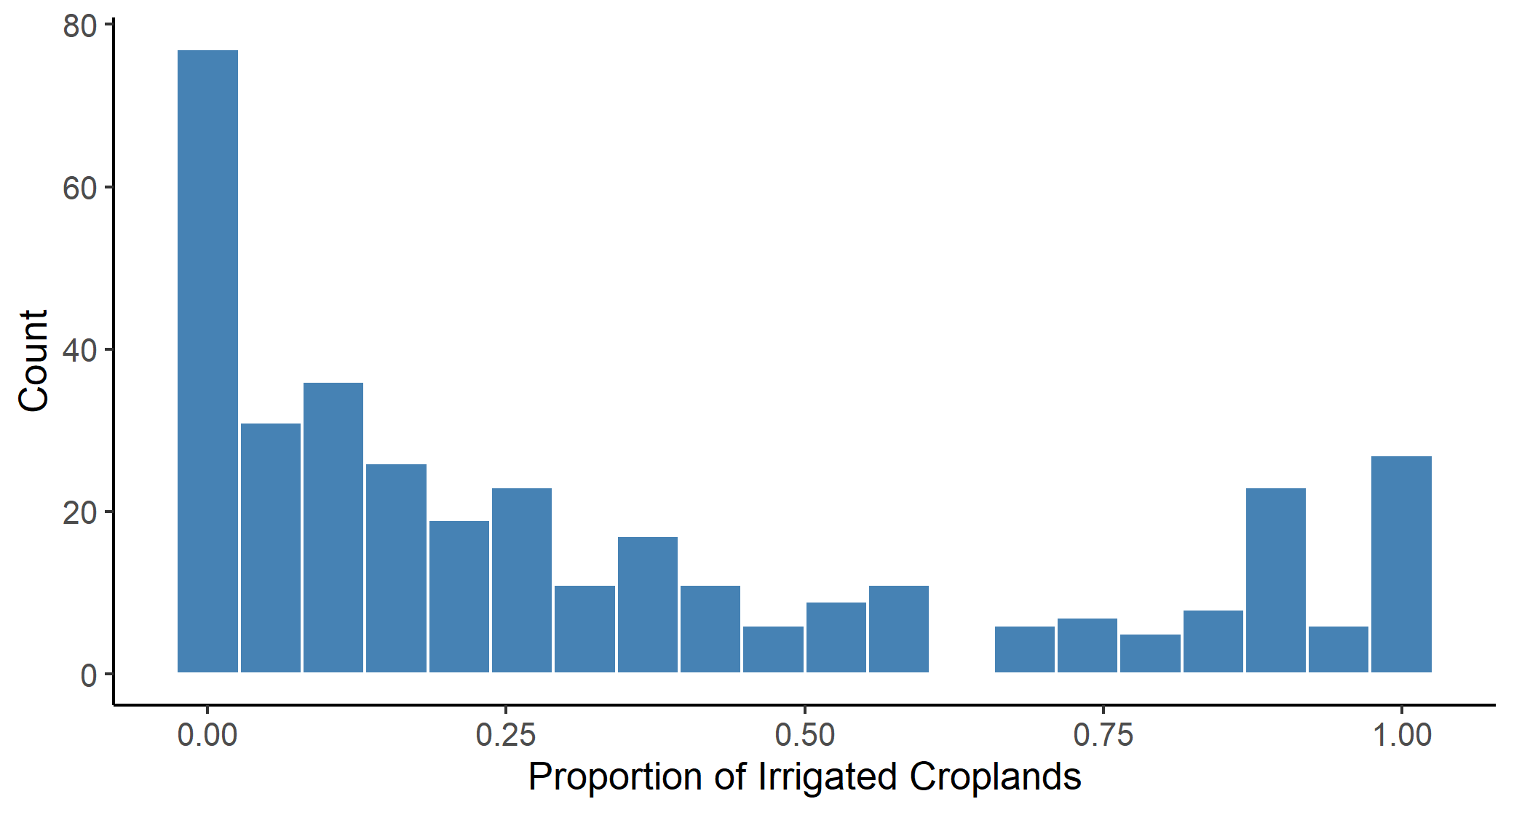

**Figure A1: Distribution of the proportion of irrigated rice croplands**

Note: Data are from IFRPI (2019), and cover Cambodia, Indonesia, Malaysia, Myanmar, Philippines, Thailand, and Vietnam.

APPENDIX B. TABLES

**Table B1: The harvest-time conflict in the croplands of Southeast Asia (subset of years)**

|  | **Conflict** | **Battles** | **Violence** | **Riots** | **Riots** |
| --- | --- | --- | --- | --- | --- |
| *Balanced panel: all countries excluding Malaysia, years 2016-2022* | | | | | |
| Area × Harvest | 0.068 | 0.089** | 0.054*** | -0.005 | -0.106** |
|  | (0.074) | (0.039) | (0.013) | (0.004) | (0.047) |
| Obs. | 27,636 | 27,636 | 27,636 | 27,636 | 27,636 |
| R2 | 0.320 | 0.272 | 0.343 | 0.141 | 0.273 |
| *Average cropland area harvested (100,000 hectares) and the number of incidents (baseline conflict):* | | | | | |
| Baseline conflict | 2.53 | 0.77 | 0.52 | 0.06 | 0.82 |
| Area harvested | 0.87 | 0.87 | 0.87 | 0.87 | 0.87 |
| *Magnitude of the effect evaluated at the average cropland area fraction relative to the baseline conflict:* | | | | | |
| Harvest (%) | 2.3 | 10.1** | 8.9*** | -7.4 | -11.2** |
|  | (2.5) | (4.4) | (2.2) | (6.0) | (4.9) |

Note: the outcome variable is a count variable that depicts the number of incidents in a cell during a year-month; the treatment variable is the cropland area (100,000 hectares) interacted with the harvest-season binary variables, which varies across locations (see Figure 2); the column headed by ‘Conflict’ combines the five event types (all but strategic developments), the column headed by ‘Battles’ combines battles and explosions/remote violence, the remaining three columns represent the separate event types as labeled. All regressions include cell and year-month fixed effects; the values in parentheses are standard errors adjusted to clustering at the level of a cell; ***, **, and * denote 0.01, 0.05, and 0.10 statistical significance levels. The magnitudes of the effect, presented in percentage terms, are calculated as:  , where is the parameter estimate, is the average cropland area harvested, and is the baseline conflict, which is the monthly average of incidents of a given conflict type.

**Table B2: The harvest-time conflict in the croplands of Southeast Asia (subset of countries)**

|  | **Conflict** | **Battles** | **Violence** | **Riots** | **Riots** |
| --- | --- | --- | --- | --- | --- |
| *Balanced panel: all countries excluding Indonesia, Malaysia, and Philippines, all years* | | | | | |
| Area × Harvest | 0.069 | 0.054** | 0.031*** | -0.001 | -0.044* |
|  | (0.044) | (0.024) | (0.008) | (0.002) | (0.026) |
| Obs. | 23,400 | 23,400 | 23,400 | 23,400 | 23,400 |
| R2 | 0.284 | 0.288 | 0.263 | 0.075 | 0.227 |
| *Average cropland area harvested (100,000 hectares) and the number of incidents (baseline conflict):* | | | | | |
| Baseline conflict | 2.38 | 0.94 | 0.29 | 0.03 | 0.69 |
| Area harvested | 1.44 | 1.44 | 1.44 | 1.44 | 1.44 |
| *Magnitude of the effect evaluated at the average cropland area fraction relative to the baseline conflict:* | | | | | |
| Harvest (%) | 4.2 | 8.4** | 15.2*** | -3.3 | -9.2** |
|  | (2.6) | (3.6) | (4.1) | (7.9) | (5.5) |

Note: the outcome variable is a count variable that depicts the number of incidents in a cell during a year-month; the treatment variable is the cropland area (100,000 hectares) interacted with the harvest-season binary variables, which varies across locations (see Figure 2); the column headed by ‘Conflict’ combines the five event types (all but strategic developments), the column headed by ‘Battles’ combines battles and explosions/remote violence, the remaining three columns represent the separate event types as labeled. All regressions include cell and year-month fixed effects; the values in parentheses are standard errors adjusted to clustering at the level of a cell; ***, **, and * denote 0.01, 0.05, and 0.10 statistical significance levels. The magnitudes of the effect, presented in percentage terms, are calculated as:  , where is the parameter estimate, is the average cropland area harvested, and is the baseline conflict, which is the monthly average of incidents of a given conflict type.

1. ACLED # 9785083: “On 9 December 2013, in Mung Ding Pa, Kachin state, the Myanmar army shelled civilian rice fields.”
2. ACLED #9679246: “On 22 November 2022, in Zar Haw village (Gangaw township, Gangaw district, Magway region), the Myanmar military IB-50 shot dead a villager in the head during the raid. The military also shot dead two other villagers who were harvesting rice in the paddy fields for unknown reasons.”
3. ACLED #8807873: “On 4 November 2021, west of Pekon township (Taunggyi district, Shan-South), military troops clashed with the joint forces of Pekon PDF, Moebye PDF, Loikaw PDF, Demoso PDF, the KNDF and the Karenni Army. Military troops fired artillery and torched, looted a nearby village and burned harvested rice in paddy fields according to Pekon PDF. At least 20 military troops were killed and a resistance fighter was injured.”
4. ACLED #9641230: “On 11 November 2022, between Aye Ka Bar and Bay La Maing villages (coded as Aye Ka Bar) (Thanbyuzayat township, Mawlamyine district, Mon state), Mon State Mount Taungnyo People Guerrilla Force ambushed a convoy of three military vehicles carrying rice at about 7 am. One military solider was killed and two others were injured.
5. ACLED #9411619: “On 27 June 2022, in Kyunhla town (Kyunhla township, Kanbalu district, Sagaing region), Pyu Saw Htee members detained and killed a 40-year-old rice mill owner from Pi Tauk Pin village, Kanbalu township when he traveled to the Kyunhla town with a companion to buy equipment for his rice mill. The Pyu Saw Htee members seized 1.5 million Kyats, 2 mobile phones and 1 motorcycle from them. It was reported that the rice mill owner was shot dead as he tried to run away near a quarry outside the town. His companion escaped.”
6. ACLED # 7787765: “On 22 March 2021, dozens of students from the Agricultural Student Coalition (Komar) held a peaceful protest in front of their university in UPN Veteran, Yogyakarta city (Yogyakarta province). They opposed the government plan of importing rice. [size=dozens]”

   ACLED # 9103355: “On 24 September 2018, a group of students held a peaceful protest in Medan City, North Sumatra province, demanding the government to stop importing rice. [size=no report]”

   ACLED # 9225485: “On 22 January 2018, in Sukolilo, hundreds of farmers staged a rally to protest against the government's plan to import rice, stating that it will lower local rice prices.”
7. ACLED # 7908847: “Farmers in the province of Phichit staged a protest against the anti-government movement, blasting its attempt to block the government's efforts to secure funds for the rice pledging program. Hundreds of farmers gathered at a major intersection to express their opposition to the People's Democracy Reform Committee (PDRC), who they believed have been blocking the government's attempt to pay rice farmers for rice pledged under the pledging program.”
8. ACLED: “On 19 July 2019, approximately 150 farmers gathered at a dam in Moo 13, tambon Thep Nakhon, Mueang Kamphaeng Phet of Kamphaeng Phet province, Thailand. They demanded the Irrigation Department release some water into their rice field to ease the effect of the draught. After having waited for a long time to negotiate with an officer, they blocked the road. [size=150]”
9. The data on cities are from the World Cities Database available at <https://simplemaps.com/data/world-cities>.