**Agricultural Shocks and Social Conflict in Southeast Asia**

**Abstract**

Agriculture and conflict are linked. The extent and the sign of the relationship vary by the motives of actors and the forms of conflict. We examine whether harvest-time agricultural shocks, associated with transitory shifts in employment and income, lead to changes in social conflict. Using 13 years of data from eight Southeast Asian countries, we find a seven percent increase in battles, and a 12 percent increase in violence against civilians in the croplands during harvest season compared to the rest of the year. These statistically significant effects plausibly link agricultural harvest with conflict through the rapacity mechanism. We also observe a three percent decrease in protests and riots during the same period, aligning with the opportunity cost mechanism, but these estimates are not statistically significant. The offsetting resentment mechanism may be partly responsible for this, but we also cannot rule out the possibility of the null effect. These findings, which contribute to research on the agroclimatic and economic roots of conflict, offer valuable insights to policymakers by suggesting the temporal displacement of conflict, and specifically of violence against civilians, due to the seasonality of agricultural harvest in rice-producing regions of Southeast Asia.

**Keywords**: Agriculture, Conflict, Seasonality, Southeast Asia

**1. Introduction**

In low- and middle-income countries, a small change in people’s well-being may trigger a range of behavioral responses, some of which may be unlawful as well as violent. While political violence and unrest typically occur in cities, where most people live and the state administration resides (e.g., Smith, 2014; Hendrix and Haggard, 2015), social conflict is not just an urban phenomenon. Rural areas, which typically encompass territories with limited state capacity, can often experience conflict due to changes in income and employment. Indeed, mounting empirical evidence points to a connection between crop yields and conflict (Wischnath and Buhaug, 2014; Buhaug et al. 2015; Koren, 2018; Vestby, 2019; McGuirk and Burke, 2020), wherein crop yields serve as a likely mechanism connecting climate shocks with conflict (e.g., Burke et al., 2009; Hsiang et al., 2013; Dell et al., 2014; Crost et al., 2018; Koubi, 2019).

We ask the question of whether harvest-time agricultural shocks lead to changes in social conflict. The answer to this question is not trivial because of the complex set of mechanisms governing this relationship. Harvest may fuel conflict by presenting opportunities to extort wealth or incur damage on one’s opponents—the *predation* or *rapacity mechanism*. It may amplify or mitigate conflict by changing the absolute as well as relative incomes of groups of individuals between agricultural and non-agricultural locations as well as within agricultural locations—the *resentment mechanism*. And it may reduce conflict because the potential actors of conflict are busy harvesting or the benefits from harvesting outweigh the costs incurred by forgoing this activity in favor of involving in conflict—the *opportunity cost mechanism*.

We can imagine several different actors in Southeast Asian conflict, all of whom could instigate conflict, including civilians, armed rebel groups, state actors, and militias operating on behalf of competing elites. Civilians may instigate protests against government policies, which may turn into riots. Armed rebel groups, state actors, and militias may engage in violence against civilians, either through armed attacks, battles, or explosions. The logic of conflict, agricultural shocks, and seasonality is likely to be different and, in some ways, diametrically opposed, depending on the type of actor (and thus the form of conflict).

We address the research question, and test for the mechanisms, by examining over 70,000 incidents across eight countries of Southeast Asia during the 2010–2022 period. We disentangle the plausible mechanisms by examining different forms of conflict, each form being is more likely to be governed by a specific mechanism. In our most robust finding, we estimate a 12 percent increase in the incidence of violent attacks in rice-producing locations during the harvest season relative to the rest of the year. This finding suggests that the harvest season presents rapacious groups with an opportunity to appropriate or destroy agricultural surplus. We also estimate a three percent decrease in the incidence of protests and riots at harvest time; this effect is not statistically significant. This suggests two possibilities: that either the opportunity cost of social unrest during the harvest season is largely offset by the increase in resentment due to the short-term increase in income inequality in the area, or that neither of these effects is particularly large. A series of mechanisms tests indicate that the former is a more likely scenario.

Finally, we also estimate a seven percent increase in battles at harvest time. We attribute this change to more favorable—for carrying out military activities—weather conditions around the harvest season, which usually coincide with the onset of the dry season. A series of mechanisms tests support this logic even though it is difficult, at least in our empirical setting, to squarely disentangle the weather effect from the harvesting effect.

We contribute to and advance knowledge in three strands of literature. First, we contribute to the literature on climate shocks and conflict (e.g., Burke et al., 2009; Hsiang et al., 2013; Dell et al., 2014; Crost, et al., 2018). We present empirical evidence that emphasizes the effect of growing season precipitation on conflict through its effect on the harvest of the most produced and consumed staple cereal crop in the region. Moreover, we show that climate shocks can have varying effects on different types of conflict that are likely governed by different mechanisms and thus respond differently to seasonal agricultural shocks.

Second, we contribute to the literature on the economic roots of conflict (Berman et al, 2011; Crost and Felter, 2020; McGuirk and Burke, 2020; Grasse, 2022). We show that different types of agriculture-related conflict are likely to have different economic logic, and present empirical evidence for the potentially diverging effects that agricultural windfalls have on different forms of conflict, thus emphasizing the benefits and the need for nuanced data analysis.

Third, we contribute to the emerging literature on the seasonality of conflict (Harari and La Ferrara, 2018; Ubilava et al., 2022; McGuirk and Nunn, 2023; Guardado and Pennings, 2023). We present suggestive evidence of a harvest-time increase in battles and violence and, under certain circumstances, a harvest-time reduction of social unrest, and we link these effects to the existing theories of conflict. Our results also suggest that social conflict related to seasonal agricultural shocks is likely to occur in the context of larger conflicts—the effects of income-related agricultural shocks do not occur in a political and economic vacuum.

The remainder of this paper is organized as follows. In what follows, we present the key background features that make Southeast Asia a suitable region for the analysis, ad outline channels through which harvest manifests into forms of conflict. In the next section, we describe the data. In the subsequent section, we describe the econometric model and the identification strategy. Then, we present the main results, followed by robustness checks, and the mechanism tests. We conclude by summarizing the main findings and discussing their key implications.

**2. Background and Context**

Our geographic focus—Southeast Asia—is suitable for our analysis for several reasons. First, most of the countries in the region fall into lower-middle-income economies, with a significant portion of their population living at or below the national poverty line (World Bank, 2022a, 2022b). The region also has large between- and within-country variations in governance and institutional capacity levels, as the Philippines, Myanmar, and Indonesia in particular struggle to control their geographic peripheries.

Second, agriculture is a crucial sector for employment and income generation, across much of the region (World Bank, 2022c). While subsistence farming exists in Southeast Asia as in many regions with less developed economies, Southeast Asian countries are often food exporters (unlike many African countries). Thailand, Vietnam, Myanmar, and Cambodia are all in the top 10 rice-exporting countries globally (FAO, 2023), meaning that violence associated with rice-producing areas is especially relevant to income generation for both farmers and the state.

Finally, civil conflict and social unrest have been defining features of the region’s politics (e.g., Crost and Felter, 2020; Crost et al., 2020; Gatti et al., 2021). The Philippines and Myanmar, for example, have experienced multiple insurgencies—ideology or ethnicity-based—for nearly their entire period of independence. The protests and conflicts that were sparked by the Myanmar military’s coup in 2021 have evolved into a full-scale civil war, while the Philippines has high levels of civil conflict. Thailand struggled with a communist insurgency from the 1960s until the early 1980s, as well as spillover from Myanmar’s insurgencies, while the Thai government continues to fight a low-level ethnic insurgency in southern Thailand. Since Suharto’s fall in 1998, Indonesia has dealt with widespread protests, riots, civil conflict, and Islamist terrorism as well as ethnic insurgencies in Aceh and West Papua.

*2.1. Motives and Mechanisms of Agricultural Conflict*

The potential relationship between agriculture and social conflict can be reduced to two theories. One is *greed*, which suggests that perpetrators are more likely to engage in conflict when there is more at stake (e.g., McGuirk and Burke, 2020). The other is *grievance*, which suggests that people protest the deterioration of their well-being relative to others or to their own past (e.g., Hendrix and Haggard, 2015; de Winne and Peersman, 2021). Across both theories, we can think of motives by which agricultural shocks might be associated with an increase or decrease in conflict. There may be opportunities to extort wealth or incur damage and thus improve one’s own relative standing. In situations where a group’s adversary experiences relatively more economic success than the group itself (e.g., through differential effects of an agricultural income shock), resentment can be felt, leading to conflict between the two groups (Mitra and Ray, 2014; Panza and Swee, 2023). And there may be situations when a person or a group of people do not need to give up much of other activities to engage in conflict, or when engaging in conflict becomes a preferred way of earning income (Collier and Hoeffler, 1998; Fjelde, 2015).

Sorting out the different channels is theoretically and empirically challenging, particularly since resentment and greed in particular but also opportunity costs are motivations that may not be obvious from looking at the data on what is, after all, the fruits of those motivations rather than the motivations themselves. Differentiating the channels thus requires thinking through who might be engaging in conflict as a result of the motivation derived from the channel, who or what would be the target of conflict or violence as a result of the channel, what form of conflict would logically flow from the channel, and how the conflict would respond to (in this case) seasonal agricultural income shocks based on which channel is relevant. Table 1 summarizes our theoretical conjectures, which we discuss in more detail below.

**Table 1. Actors and conflict seasonality: Theoretical expectations**

|  |  |  |  |
| --- | --- | --- | --- |
| **Forms of conflict** | **Type of actor** | **Likely mechanism** | **Harvest-time effect** |
| Battles and violence against civilians | Armed actors (state forces, rebel groups, militias) | Rapacity | Increase |
| Riots and protests | Civilians | Opportunity cost, resentment | Ambiguous |

At the heart of the question of the link between agricultural output and social conflict is thus both the mechanism and the form of conflict. Different forms of conflict are likely to manifest one mechanism more so than others, thus offering a chance to disentangle the otherwise potentially ambiguous relationship between agricultural shocks and conflict. Panza and Swee (2023), for example, examine three channels for agriculture-related inter-ethnic group conflict: opportunity cost, resentment, and appropriation. They find that, in Mandatory Palestine, rainfall shocks (i.e., bad harvests) that led to an increase in Arab-Jewish income inequality (inasmuch as Arab income was disproportionately affected by bad harvests) were associated with an increase in Arab-initiated conflict between Jews and Arabs. Specifically, Arabs who could not find work in segregated areas due to bad harvests would potentially substitute into violence. They also find that specific types of violence increased during the study period. Instead of targeting looting or asset grabbing, the attacks were focused on resentment-motivated terrorist-type acts and religious places (i.e., attacks that have no positive monetary outcome for the attackers). These findings suggest that the motivation behind the attacks was driven by resentment rather than a desire for appropriation. The authors’ delimitation of violence that could potentially be used to appropriate assets, and violence that could not reasonably be expected to have any positive monetary outcome for the attackers, is a way to conceptually and empirically separate forms of conflict driven by different mechanisms.

*2.2. Harvest-Time Increase in Violence Against Civilians*

In the context of the present analysis, the question becomes what form of conflict is most likely driven by what kind of change at the time of harvest. On the one hand, violence aimed at civilians can be linked to the harvest-time inflow of income, and the relationship is expected to be positive. After a good harvest season, for example, the transitory increase in the spoils to be appropriated or destroyed make farmers a lucrative target, which can amplify violence in croplands relative to non-agricultural areas (Mitra and Ray, 2014; Koren, 2018; McGuirk and Burke, 2020). Such a relationship can also be seasonal. In crop-producing parts of Africa, for example, attacks on civilians increase during harvest months (Ubilava et al., 2022), which aligns with the theory of greed manifested through the rapacity mechanism.

Armed actors (whether state or insurgents) may increase their activities during the harvest season to maximize the damage they do through several pathways. First, they may want to expropriate farmers’ income, which is realized during the harvest season. Second, for farmers who do not support the insurgency or state, or who are on the sidelines, armed actors may want to harm their earning potential to minimize threats to themselves or to intimidate the farmers into joining them (Raleigh, 2012; Raleigh and Choi 2017). Third, insurgents may strategically time their attacks to maximize the negative effect on the state, considering that the state is likely to derive revenues during the harvest season. This revenue is directly related to the state’s ability to attack the insurgents (Fearon and Laitin 2003).

By this logic, violence against civilians is likely to be focused on the destruction or appropriation of agricultural outputs. Significant numbers of attacks on civilians in Southeast Asia revolve around the theft of rice or the destruction of rice fields, rice storage units, or rice milling facilities. In December 2013, for instance, the Myanmar military attacked civilian rice paddies in Kachin state during the harvest season.[1] Battles—violence between armed actors—are likely to have a similar logic: the harvest season is the most strategic time to appropriate or destroy enemy forces’ resources.

State forces, political militias, and insurgent groups might choose the harvest season as the time to attack because it would maximize the destruction of their enemies’ resources or allow them to appropriate the agricultural surplus. In November 2022, a Myanmar military force shot dead three villagers in a raid in the Magway region, two of whom were engaged in harvesting rice in paddy fields.[2] During the harvest season, the state may also attack villages that may be aiding rebel groups. In November 2021, for instance, in a clash between the Myanmar military and various People Defense Forces (the armed groups associated with the anti-junta civilian government in internal exile), the military burned harvested rice fields in a village they (obviously) suspected was loyal to the anti-state groups.[3]

Insurgent groups fighting against the state also have the incentive to attack civilians who are providing agricultural outputs to the state, both to intimidate them against supporting the state and to deny the state food. In November 2022, rebel groups ambushed a military convoy carrying rice in Myanmar in Mon state and killed a soldier.[4] Pro-government militias can engage in similar behavior to degrade the resources available to their enemies and to appropriate resources for themselves. In June 2022, the pro-military junta militia group Pyu Saw Htee killed a rice mill owner in Sagaing and stole large amounts of money (which had been intended to buy more rice milling equipment) as well as mobile phones and a motorcycle.[5]

It is worth noting that even though agricultural production and large-scale conflict can be inherently connected in the long run (e.g., Iyigun, et al., 2017), incidents linked to battles between incumbents and insurgents to take control of a territory, are less likely to be driven by, or related to, harvest-induced short-term and transitory shifts in agricultural employment and income (e.g., Mampilly and Stewart, 2021; Ubilava et al., 2022). And even if it is, the direction of the effect may very well go in the opposite direction. For example, in times of a civil war, people willingly or unwillingly may be involved in the process at the expense of their usual employment, which in rural societies is often agricultural production.

*2.3. Harvest-Time Decrease in Unrest by Civilians*

Social unrest, on the other hand, which is often triggered by negative income shocks, may be linked to agricultural harvest in rural areas. However, the relationship can be negative or positive. The opportunity cost mechanism would lead to fewer protests at harvest time, which can happen for at least two reasons. First, when people—potential protesters—are busy harvesting, they are unlikely to take part in protests as the opportunity cost of this form of conflict is high. Second, if there is a short period of time, during the calendar year, when people in rural areas are relatively better off compared to other times of the year or to people in urban areas, it is during or shortly after the harvest season, when the years’ worth of income has been realized. Therefore, the harvest-time increase in income can mitigate social unrest in croplands relative to the urban, non-agricultural areas. At the same time, there may be a resentment mechanism that could lead to increased unrest: within agricultural areas, the harvest time increase in income inequality—between farmers and non-farmers—may amplify social unrest (e.g., Panza and Swee, 2023). The net effect, manifested through opportunity cost and resentment mechanisms, can be ambiguous.

While riots and protests may be initiated by insurgencies or organized anti-government groups, they may also be more generally indicative of dissatisfaction by civilians either with the government or with other groups. A decrease in protests and riots during the harvest season may occur through an opportunity cost mechanism and come through several pathways. In the first pathway, those who are directly involved in agriculture may decrease their protest activities during harvest time because they are busy harvesting. This relates to a second pathway, that of a direct opportunity cost mechanism, in which the opportunity cost of protesting increases during harvest time due to more income being derived from harvesting. Put another way, the infusion of income from the harvest makes protesting relatively less attractive, perhaps because there are fewer grievances against the government when would-be protesters are realizing income.

A third possible pathway is the “income” from protesting relative to other activities becoming less competitive. In Indonesia, for instance, paid protesting is a long-standing means for political parties and civil society groups to pressure the government or send a message. In many cases, protesters are provided with a packed lunch (“nasi bungkus” in Indonesian) and a cash payment (hence the term “nasi bungkus brigade”) and often have only a tenuous interest in the cause of the protest (Andrews, 2017). Thus, protest campaigns may find fewer supporters (paid or not) during the harvest season.

Protests by farmers in Southeast Asia are often designed to pressure the government to increase (or maintain) the prices they receive for their products. Both Indonesia and the Philippines have seen pressure campaigns from farmers to maintain or increase the price of rice (through price guarantees) or to prevent rice imports (to minimize competition that can undercut the domestic price).[6] In a logic where protests increase as grievances against the state increase, or as the cost of protesting increases relative to harvesting, we would expect protest and riots to decrease during the harvest season relative to the non-harvest season. We would also expect better harvests to be associated with fewer protests and riots.

In the case of Thailand, for instance, there was a spate of protests against the Thai government by farmers throughout the country in 2014 because of a rice purchasing scheme in which the Thai government was supposed to have paid farmers subsidies for their rice production, but the payments were either delayed or non-existent (Mohanty, 2012). These protests were largelynotduring the rice harvest season (which is December in Thailand), but several months later, when farmer’s grievances increased and the opportunity cost of protesting became lower. Of interest here is that the Thai farmers’ grievances were against both the government (for not paying the subsidies) and anti-government groups (for supposedly blocking the government from paying the subsidies).[7]

These protests allude to a potential offsetting mechanism in harvest-time unrest by civilians: resentment. During harvest time, while the grievances of farmers may decrease due to the realization of income, increase in their income relative to others (whether rural non-farmers or urban dwellers) lead to resentment and unrest between different groups (Panza and Swee, 2023).

**3. Data**

Our data come from multiple sources. For social conflict, we use the Armed Conflict Location & Event Data (ACLED) compiled by Raleigh et al. (2010). For rice cropland cover and irrigation, we use data from IFPRI (2019), and for harvest calendars, we use data from Monfreda et al. (2008). For precipitation, we use ERA5 reanalysis data from the Copernicus Project (Hersbach et al., 2018), and for city population, we use data from World Cities Database, better known as SimpleMaps (https://simplemaps.com/data/world-cities). In what follows, we describe these data in more detail.

*3.1. Social Conflict*

The ACLED Project (Raleigh et al., 2010) presents granular data and reports conflicts regardless of casualties. The incidents are categorized into six categories: battles, explosions/remote violence, strategic developments involving two actors (typically the state or state-affiliated militias and the rebels who dispute the control of territory), violence against civilians by armed groups, and protests and riots representing forms of public disorder. In our analysis, we combine battles and explosions/remote violenceinto a single form of conflict and exclude strategic developments as they are not comparable across countries and over time (Raleigh et al., 2010).

The main caveat of this dataset is that it covers a relatively short period of time, from 2010 onward for most Southeast Asian countries except for Indonesia (from 2015 onward), the Philippines (from 2016 onward), and Malaysia (from 2018 onward). The other considered countries are Cambodia, Laos, Myanmar, Thailand, and Vietnam. We exclude Brunei, Singapore, and Timor-Leste because they are small and/or not agriculturally dependent countries and because the ACLED coverage for these three countries is from 2020 onward only.

Our study covers more than 70,000 unique incidents. This excludes incidents for which exact locations are unknown, and they are thus arbitrarily attributed to the nearest known site, typically a provincial capital (such locations are recorded with the geo-precision code 3 in the database). Figure 1 presents the map of incidents across three distinct conflict categories aggregated at the level of one-degree cells. The map also features a selected set of large cities in the region.

From this map, it becomes apparent that conflict occurs across much of the Southeast Asian region. Within the region, some countries are more prone to conflict than others. There is a fair bit of spatial dependence in the prevalence of different types of conflict, and while generally observed in the cities, where most people reside, conflict is not necessarily or exclusively a city phenomenon.

The proportions of types of conflict also vary by country: Myanmar saw high levels of unrest and high numbers of battles, while the Philippines saw little unrest but high levels of violence against civilians. By comparison, Indonesia saw almost no battles or violence against civilians but high levels of unrest, and Thailand was split relatively equally between unrest and battles. Figure 2 presents the time series of the four considered types of conflict.

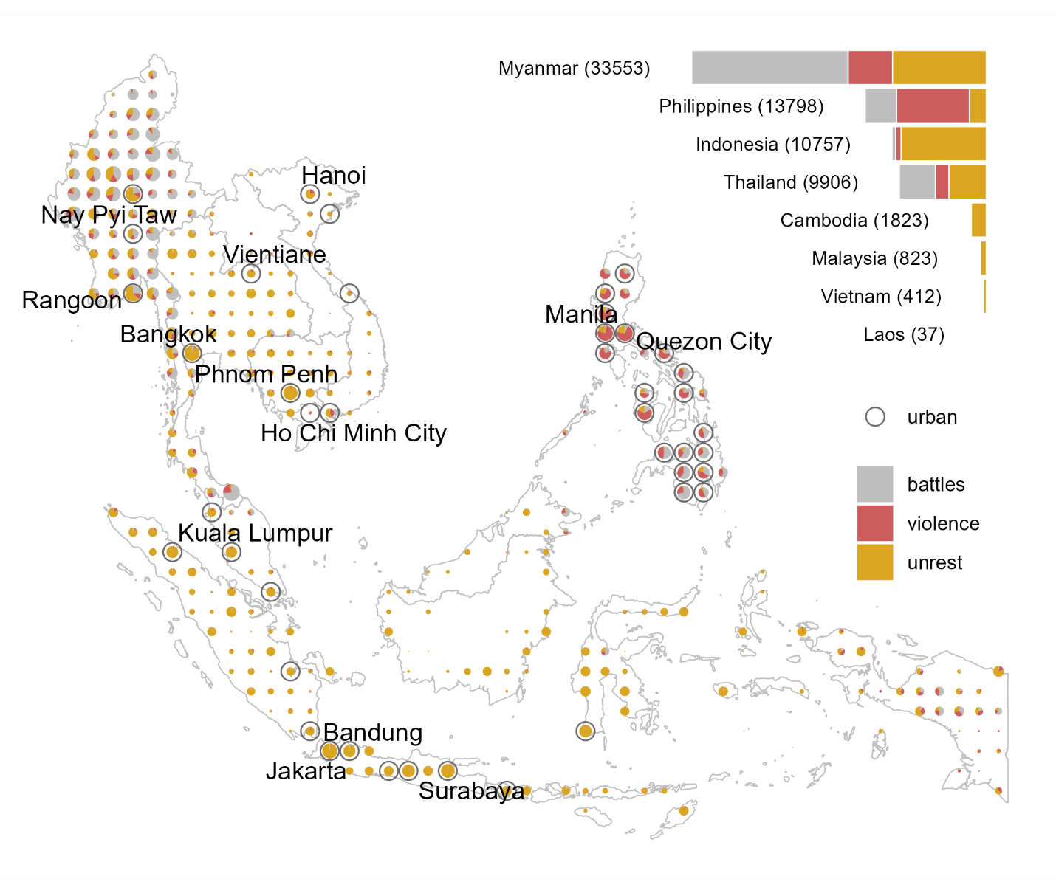

**Figure 1: Geographic distribution of social conflict (2010–2022)**

Note: The data are for Cambodia, Indonesia (2015–2022), Laos, Malaysia (2018–2022), Myanmar, the Philippines (2016–2022), Thailand, and Vietnam. The size of the dots is proportional to the combined number of incidents in a cell. Protests and riots are combined into a single unrest category for illustration purposes. The empty circles that overlay some of the dots identify “urban” cells, defined as those that include a capital city, a city with a population of at least one million, or a total within-cell population of at least two million. The map also includes labels for capital cities and very large cities (with a population of at least 2.5 million).

The figure shows no apparent trend across the forms of conflict, but there is a notable increase in almost all types of conflict from 2021 onward, largely due to the Myanmar civil war. In addition, despite a general co-movement, there are periods when a rise in one form of conflict is not accompanied by other types of conflict, suggesting that the root causes and mechanisms of different forms of conflict vary.

**Figure 2: Dynamics of social conflict by event type**

Note: The time series are monthly rates of conflict incidents per cell, across available cells for a given period. The number of cells (the bottom panel) increased progressively as Indonesia (2015), the Philippines (2016), and Malaysia (2018) were added to the dataset.

*3.2. Rice Harvest Season*

We focus on rice, which is by far the most dominant cereal—both in terms of production and consumption—across Southeast Asia. The harvest season can span several months. We define the period from the month when the harvest starts to the month when the harvest ends as the harvest season. We also define the midpoint of the harvest season as the harvest month. In instances where a crop is grown over two seasons, we use the main season to identify the crop year. To mitigate data limitations and prevent reverse causality from conflict to the size and timing of the harvest, we keep the area of cropland and the harvest months fixed over the study period. We will discuss this in more detail in the next section.

Figure 3 presents the map depicting the geographic prevalence of rice production and the harvest months at the level of one-degree cells. The map also features locations where more than 50% of croplands are irrigated (indicated by empty circles). Appendix Figure A1 presents the histogram of the proportion of irrigated rice across the considered locations in the region.

**Figure 3: Geographic distribution of rice harvest months**

Note: The size of the dots is proportional to the area devoted for rice production, and the radial bars indicate the count of cells that fall within a given harvest month. The data on the crop area and irrigation are from IFPRI (2019), while the data on harvest calendar are from Monfreda et al. (2008).

From this map, it becomes apparent that there is a fair bit of variation in the timing of the main harvest season, albeit March being the most dominant month in that regard. There is also a considerable within-country variation in cropland area fractions but hardly any within-country variation in the harvest month. Finally, locations with larger cropland area fractions are more likely to be irrigated, although the irrigation prevalence can also be viewed as a country-specific phenomenon. Appendix Figure A2 presents the scatterplot of the proportion of irrigated rice against the (natural log of) rice cropland area.

*3.3. Auxiliary Data*

Since rainfall is one of the most crucial factors in rice production, we use it to test the mechanism related to the year-to-year change in the relative abundance of rice, at harvest time, in rice-producing cells. We use monthly average total precipitation, which we aggregate to the one-degree grid cell level—the spatial unit of measurement in our study. Next, we calculate the measure of total precipitation during the months between the planting and harvesting seasons. For each cell, we divide the mean-centered precipitation by its standard deviation to obtain the standardized measure of precipitation. Thus, we can interpret the magnitude of the effect as that of a one-standard-deviation change in precipitation.

We use the information on population size to group cells nominally into urban and rural areas. We consider a cell as urban if it contains the capital city or a large city (with a population size of at least one million), or if the population size within the cell is at least two million. Figure 1 identifies the geographic locations of these cells. In the analysis, we use this information to examine any qualitative disparities in the harvest-time change in conflict between these two groups of locations.

*3.4. Descriptive Statistics*

In Table 2 we summarize some of the data’s key features. Violence and protests represent the two most prevalent forms of conflict that typically involve civilians who either are directly targeted (e.g., violent attacks or abduction) or become targets (e.g., intervention against protesters). Battles combined with explosions/remote violence, labeled as “Battles,” emerge as another important conflict category. The least prevalent event type is riots, which is a violent version of protests that shares elements of other, more violent types of social conflict. The table also presents cell-specific details about croplands. Across the covered 376 cells, the average size of the land used in rice production is approximately 78,000 hectares, which is approximately 6.5% of the cell (as measured near the equator).

**Table 2: Descriptive statistics**

|  |  |  |  |  |  |  |
| --- | --- | --- | --- | --- | --- | --- |
|  | **Sum** | **Mean** | **SD** | **Min** | **Max** | **Incidence** |
|  | *Unit of observation: Cell-year-months (44,724)* | | | | | |
| All events | 71,109 | 1.590 | 7.480 | 0 | 350 | 0.253 |
| Battles | 26,030 | 0.582 | 3.759 | 0 | 106 | 0.092 |
| Violence | 15,803 | 0.353 | 2.748 | 0 | 164 | 0.088 |
| Riots | 2,254 | 0.050 | 0.441 | 0 | 42 | 0.032 |
| Protests | 27,022 | 0.604 | 3.743 | 0 | 268 | 0.155 |
|  | *Unit of observation: Cells (376)* | | | | | |
| Rice cropland area (100,000 ha) |  | 0.781 | 1.255 | 0 | 9.087 |  |
| Irrigated |  | 0.348 | 0.738 | 0 | 7.786 |  |
| Rainfed |  | 0.433 | 0.858 | 0 | 5.759 |  |

Note: The conflict data are from the ACLED Project (Raleigh et al., 2010) and cover eight countries over the 13-year period from 2010 to 2022except for Indonesia (2015–2022), Malaysia (2018–2022), and the Philippines (2016–2022). The other countries are Cambodia, Laos, Myanmar, Thailand, and Vietnam. “All events” contain the four presented categories of conflict, wherein “Battles” combine battles and explosions/remote violence (as defined by the ACLED Project). “Incidence” denotes the proportion of units with at least one conflict incident. The data on rice croplands, which are fixed at levels circa 2010, are from IFPRI (2019).

To better understand the cross-sectional relationship between the size of croplands and conflict prevalence, we plot the latter against the former, both log-transformed for visual convenience (Figure 4). A positive relationship is apparent between the two variables. It appears that predominantly rainfed croplands experience slightly higher levels of conflict compared to irrigated croplands.

**Figure 4: Cross-sectional relationship between cropland area and conflict prevalence**

Note: The conflict data are from the ACLED Project (Raleigh et al., 2010) and cover eight countries over the 13-year period from 2010 to 2022 except for Indonesia (2015–2022), Malaysia (2018–2022), and the Philippines (2016–2022). The other countries are Cambodia, Laos, Myanmar, Thailand, and Vietnam. The cropland data are from IFPRI (2019). Each point represents a cell. Four of the cells have the cropland area equal to zero, and 43 of the cells have the average number of conflict incidents equal to zero. These points appear at the bottom and left edges of the plot. The empty circles that overlay some of the dots identify urban cells, defined as those that include a capital city, a city with population of at least one million, or a total within-cell population of at least two million.

**4. Estimation, Identification, and Interpretation**

We denote location, a one-degree cell, with subscript *i*, country with subscript *c*, year with subscript *t*, andmonth with subscript *m*. Henceforth, we also refer to year-month as the period of observation. The unit of analysis is thus a location—a period covering 376 unique grid cells and, in most cases, 156 year-months from January 2010 to December 2022. The level of spatial aggregation—one-degree cells that measure approximately 110×110 km near the equator—is coarse enough to ensure there are enough units with at least one conflict incident. This level of aggregation is granular enough to not sabotage the within-country variation in conflict incidents.

Our main econometric specification is given in a fixed effects setting as follows:

, (1)

where the outcome variable, , is a binary variable that equals one if the number of conflict incidents in cell *i* in month *m* of year *t*, , exceeds zero and equals zero otherwise. That is, the outcome variable measures the incidence of conflict. The treatment variable, , is the product of the cropland binary variable and the harvest binary variable. *cropland*, which is fixed over time, equals one if more than 10,000 hectares of land is used for rice production in the cell (IFPRI, 2019) and equals zero otherwise. *harvest*, which is cell specific, equals one when the period of observation is the harvest month and equals zero otherwise. is a cell fixed effect, is a country-year fixed effect, and is a year-month fixed effect. is a set of controls—in most specifications just the contemporaneous rainfall—that vary across locations and over time. is the error term.

The identifying assumption in Equation (1) is that the treatment variable is exogenous to conflict. This assumption may seem tenuous because conflict may affect production through factors such as abandoned plots and missed or mistimed harvests and planting seasons. As a result, a lower agricultural output may be the consequence of the change in conflict rather than its cause. However, in our study, we do not apply production data that would vary yearly and instead use cropland area and harvest months, which are location specific and fixed over time. Such an approach, admittedly driven by data limitations, mitigates the issue of reverse causality.

To address other threats to identification, we include the fixed effects and control variables in the regression. Specifically, cell fixed effects capture any time-invariant determinants of conflict (e.g., distance to roads, cities, or state borders), country-year fixed effects control for any country-specific trends in the data (e.g., large-scale political turmoil in election years), and year-month fixed effects capture common time-varying events observed in the region (e.g., global financial crises, large-scale climatic shocks, possible changes in the quality of data collection/reporting). We also include contemporaneous rainfall, which varies over time and across space, in the regression in an attempt to address, at least to an extent, remaining endogeneity issues. This allows us to control for the direct impact of weather on conflict, for example, if excessive rainfall reduces the mobility of troops or makes protests and demonstrations somewhat untenable. Finally, in the robustness checks, we vary the fixed effects to get a better sense of potential threats to our identification strategy.

Under the outlined assumptions, the estimated coefficient, , reflects the harvest-time change in the probability of conflict in the cropland. A positive value of the coefficient, for example, would imply that in croplands there is a higher probability of conflict during the months of harvest compared to the other months of the year. To help interpret the estimated effect, we divide it by the expected number of incidents and multiply by 100. This conversion allows us to express the impact in percentage terms.

**5. Results and Discussion**

Table 3 summarizes the baseline results of the study using all available data. The estimated effects are for croplands (at least 10,000 hectares of land used in rice production) relative to other locations. During the harvest season, we estimate an increase in battles of 0.8 percentage points and an increase in violence against civilians of 1.3 percentage points. These effects, which are statistically significantly different from zero, are of meaningful magnitude. We obtain the magnitude of the effect by evaluating the estimated parameters relative to the baseline conflict incidence, estimating a 7.4% increase in the probability of battles and a 12.6% increase in the probability of violence against civilians during the harvest season. The estimated harvest-time reduction in riots and protests are small—respectively 2.6% and 3.3% reductions in the probabilities—and statistically indistinguishable from zero.

**Table 3: Harvest-time change in conflict incidence in the croplands of Southeast Asia**

|  | **All events** | **Battles** | **Violence** | **Riots** | **Protests** |
| --- | --- | --- | --- | --- | --- |
| *Unbalanced panel: All countries, all years* | | | | | |
| Cropland×Harvest | 0.005 | 0.008** | 0.013*** | -0.001 | -0.006 |
|  | (0.005) | (0.003) | (0.003) | (0.002) | (0.005) |
| Obs. | 44,724 | 44,724 | 44,724 | 44,724 | 44,724 |
| R2 | 0.447 | 0.503 | 0.463 | 0.183 | 0.359 |
| *The magnitude of the estimated effect relative to the baseline conflict incidence (%)* | | | | | |
| *Baseline conflict incidence* | 0.29 | 0.11 | 0.10 | 0.03 | 0.17 |
| Cropland×Harvest | 1.7 | 7.4** | 12.6*** | -2.6 | -3.3 |
|  | (1.8) | (2.9) | (3.1) | (6.8) | (2.7) |

Note: The outcome variable is the indicator for the presence of conflict in a cell in a year-month, and the treatment variable is the indicator for the cropland interacted with the indicator for the harvest season. The “All events” column combines all forms of conflict, and the “Battles” column battles and explosions/remote violence. The remaining columns represent the separate event types as labeled. All regressions include cell, country-year, and year-month fixed effects and control for contemporaneous rainfall. The values in parentheses are standard errors adjusted to clustering at the cell level; ***, **, and * denote 0.01, 0.05, and 0.10 statistical significance levels. The magnitudes of the effect, presented in percentage terms, are calculated as , where is the parameter estimate and is the baseline conflict incidence—the unconditional mean of the outcome variable.

Different mechanisms are presumably at play here. The rapacity mechanism may explain the harvest-time increase in battles and violence against civilians, which likely combines a direct effect of perpetrators targeting areas where there are spoils to be appropriated or destroyed, and an indirect effect of collateral damage associated with explosions or other battle-related incidents during harvest time when more people are out and about. The opportunity cost mechanism may explain the decrease in social unrest when people are busy harvesting. If a farmer—and especially a subsistence farer for whom rice harvest time may be the main and only payday of the year—were to choose one month when they would rather not participate in protests, that would likely be the harvest month. The presence of the offsetting resentment mechanism—linked with the harvest-time change in the relative incomes of farmers and non-farmers—may explain why this decrease is small and statistically indistinguishable from zero.

*5.1 Robustness to Data Subsetting and Alternative Specifications*

Before we proceed any further—because the study covers a relatively small and geographically concentrated area as well as a relatively short period—we check that the results are not sensitive to data subsetting or variations in the outcome and treatment variables as well as controls.

We first re-estimate the baseline model using balanced panels that cover all eight countries but only include the years from 2018 to 2022 and cover all 13 years, excluding Indonesia, Malaysia, and the Philippines. Appendix Tables B1 and B2 present the results of these regressions. The estimates for the harvest-time change in the probability of battles and violence are comparable with those of the main results. The estimates for the harvest-time change in the probability of social unrest is somewhat sensitive to data subsetting, insomuch as when we analyze the panel of countries over the 2018–2022 period, we estimate a statistically significant decrease in protests.

We then re-estimate the baseline model by omitting one country at a time and one year at a time. Appendix Figures A3 and A4 present the estimated parameters, which appear to be largely robust to omitting subsets of data from the analysis. A notable exception is when we omit Myanmar from the data, but that is not surprising since the country accounts for nearly half of all observed conflict incidents.

To ensure that our main results are not driven by our choice of the fixed effects, or that the inference is not affected by our choice of error clustering, we re-estimate the parameters using a set of alternative model specifications. We summarize these results in the specification chart presented in Appendix Figure A5. The results are not sensitive to different combinations of the fixed effects. The key finding that violence against civilians increases at harvest time, while all other forms of conflict either do not change or the change is not statistically significant, stands in most instances except when we cluster the standard errors at country level.

To ensure that the estimated results are not merely coincidental, we next perform a sample randomization exercise. Specifically, we shuffle and randomly re-assign the observed harvest seasons to different locations and re-estimate the baseline regression, repeating this 100 times. On average, we would expect no significant effect here, and Appendix Figure A6 confirms this. Apart from just a few statistically significant estimates of the impact, we observe no substantial impact when the “wrong” harvest seasons are randomly assigned to the croplands.

Finally, we re-estimate the baseline model with the count of conflict incidents, , as the outcome variable. We estimate two sets of regressions using the full sample and its subset that excludes observations for Myanmar in the years 2021–2022. Appendix Tables B3 and B4 present the results. The estimates for violence are particularly robust and comparable with those of the main results, and the estimates for social unrest are sensitive to the presence of the 2021–2022 Myanmar data in the sample. We find a harvest-time decrease in protests (statistically significant) and riots (not statistically significant) in the full sample, but these effects disappear when the sample excludes the Myanmar 2021–2022 data. This result is not entirely unexpected. By transforming the count variable (conflict incidents) to a binary variable (conflict incidence), we mitigate the effect of influential observations manifested through surges in forms of conflict incidents during the Myanmar war. This check boosts our confidence in the model specification of our choice and, within that framework, in the results that pertain to violence against civilians.

It is significant that the Myanmar data are driving a statistically significant reduction in protests and riots during harvest seasons. The country has had an ongoing civil war since 2021, the only nationwide conflict in the region during the period under study. While Southeast Asia is home to many separatist, religious, ideological insurgencies, as well as substantial unrest, nationwide civil war has been uncommon in the post-Cold War period, particularly compared with countries in Africa and the Middle East. Myanmar is thus an outlier in Southeast Asia in terms of the sheer number of all types of social conflict incidents.

Given the impassibility of roads during the wet season (June to October, particularly June and August when rain is heaviest), sustained, mobile military campaigns are difficult in Myanmar during that time, and we would expect that during the rainy season, perpetrators might be able to engage in a relative increase in protests and riots because opposing forces would be less able to bring in personnel to suppress them. Conversely, Myanmar’s rice harvest is generally in November: there may be a decrease in protests and riots during the harvest season both because of the increased opportunity cost of protesting and rioting relative to harvesting and because of an increase in the possibility of violence against civilians relative to protests and riots during the dry season.

Myanmar’s dry season is, loosely, from November to April and may be when state forces and insurgencies find it easiest to engage in battles and violence against civilians given the possibility of the roads. This pattern may not appear in other parts of Southeast Asia because the lack of a nationwide civil war means that governments are not necessarily attempting full-scale military campaigns on their own territory, nor are there nationwide civilian protest movements that operate and adapt to adversary strategies over long periods of time. However, the Myanmar results do suggest that different seasonal conflict dynamics, at least regarding protests and riots, may be operating in countries with nationwide conflict and those without. In this, Myanmar may be more similar to African countries with widespread conflict, where protests and riots arise from grievances created by battles and violence against civilians (Vüllers and Krtsch, 2020) compared to other Southeast Asian countries.

*5.2 Treatment Heterogeneity*

The robustness checks boost our confidence in some of the estimated positive findings as they relate to battles and, especially, violence against civilians. They also reinforce our uncertainty about any effect regarding protests and riots. To the extent that the assumed treatment homogeneity may be camouflaging otherwise heterogenous effects, we examine harvest-time forms of conflict across subgroups of locations sorted by some cell-specific characteristics.

We first interact the treatment variable with an irrigation indicator, denoting cells as irrigated if at least 50% of rice is produced on irrigated land and rainfed otherwise (Figure 3). In general, irrigated rice is higher yield and is often commercially produced, as opposed to rainfed rice, which is lower yield and typically produced at subsistence levels. Therefore, very different types of farmers are likely involved in these two production practices.

Table 4 presents these regression results. Only two forms of conflict, battles and violence against civilians, show statistically significant effects that are also of meaningful magnitudes both in rainfed and irrigated cells. This finding comes as no surprise considering the findings from the main result as well as subsequent robustness checks. But here we also find that harvest-time violence increases at a higher rate, both in absolute and relative terms, in rainfed locations where farms and farmers are less protected. Battles, on the other hand, appear to become relatively more likely to occur at harvest time in irrigated cells. However, this disparity primarily stems from twice-as-large incidences of battles in rainfed locations.

**Table 4: Harvest-time change in conflict incidence in rainfed versus irrigated cells**

|  | **All events** | **Battles** | **Violence** | **Riots** | **Protests** |
| --- | --- | --- | --- | --- | --- |
| *Unbalanced panel: All countries, all years* | | | | | |
| Cropland×Harvest×Rainfed | 0.001 | 0.008** | 0.016*** | -0.003 | -0.010 |
|  | (0.007) | (0.004) | (0.004) | (0.003) | (0.006) |
| Cropland×Harvest×Irrigated | 0.010 | 0.008** | 0.009** | 0.003 | 0.001 |
|  | (0.007) | (0.004) | (0.004) | (0.003) | (0.006) |
| Obs. | 44,724 | 44,724 | 44,724 | 44,724 | 44,724 |
| R2 | 0.447 | 0.503 | 0.463 | 0.183 | 0.359 |
| *The magnitude of the estimated effect relative to the baseline conflict incidence (%)* | | | | | |
| **Rainfed (less than 50% of irrigated rice land)** | | | | | |
| *Baseline conflict incidence* | *0.31* | *0.14* | *0.11* | *0.04* | *0.19* |
| Cropland×Harvest | 0.4 | 6.2** | 14.0*** | -9.1 | -5.4 |
|  | (2.1) | (3.0) | (3.4) | (7.9) | (3.3) |
| **Irrigated (at least 50% of irrigated rice land)** | | | | | |
| *Baseline conflict incidence* | *0.24* | *0.07* | *0.09* | *0.03* | *0.16* |
| Cropland×Harvest | 4.3 | 11.1** | 10.2** | 9.3 | 0.4 |
|  | (2.8) | (5.4) | (4.9) | (9.4) | (3.9) |

Note: The outcome variable is the indicator for the presence of conflict in a cell in a year-month, and the treatment variable is the indicator for the cropland interacted with the indicator for the harvest season. This treatment variable is further interacted with the rainfed and irrigated indicators to obtain a rainfed/irrigated split of the results. The “All events” column combines all forms of conflict, and the “Battles” column combines battles and explosions/remote violence. The remaining three columns represent the separate event types as labeled. All regressions include cell, country-year, and year-month fixed effects and control for the contemporaneous rainfall. The values in parentheses are standard errors adjusted to clustering at the cell level; ***, **, and * denote 0.01, 0.05, and 0.10 statistical significance levels. The magnitudes of the effect, presented in percentage terms, are calculated as , where is the parameter estimate and is the baseline conflict incidence, which is the unconditional mean of the outcome variable.

As alluded above, irrigation quite possibly serves as a catch-all variable for more developed/commercial areas with relatively more stable institutions, which make them less prone to conflict, on average. But even so, there is evidence of harvest-time increase in battles in rainfed and irrigated areas alike. While the time of harvest may be a strategically optimal period for insurgents to take control of territories with agricultural land (e.g., Koren, 2019), it also coincides with the transition from the wet season to the dry season. Consequently, conflict actors who refrained from military activities in the months leading to the harvest become offensive during or shortly after this harvest. In other words, while the estimated increase in harvest-time battles may be inherently linked with the rice harvest, they may also be, at least to an extent, due to the direct weather–conflict link: Myanmar’s “campaign season” for the military is, as discussed above, during the dry season.

We next interact the treatment variable with an indicator that splits the sample into urban and rural cells. Since social conflicts are most prevalent in places with high population densities, we check if there is a qualitatively meaningful discrepancy in the seasonal conflict between urban and rural locations. We define a cell as urban if it contains the capital city or a city with a population size of at least one million, or if the cell’s population size exceeds two million. There are 43 these cells, and more conflict occurs in these cells compared to the rest of the cells. Recall that most of these urban cells also tend to have sizable croplands (Figure 3).

Table 5 presents these regression results, which suggest that harvest-time battles and violence only occur in rural areas. This finding supports the theory that civil conflict and armed violence are more common in peripheries where either state policing is, for all practical purposes, absent or where insurgents are present (e.g., Buhaug and Rød, 2006). We do not observe a harvest-time reduction in protests and riots.

**Table 5: Harvest-time change in conflict incidence in urban versus rural cells**

|  | **All events** | **Battles** | **Violence** | **Riots** | **Protests** |
| --- | --- | --- | --- | --- | --- |
| *Unbalanced panel: All countries, all years* | | | | | |
| Cropland×Harvest×Rural | 0.009 | 0.010*** | 0.014*** | 0.000 | -0.005 |
|  | (0.005) | (0.003) | (0.003) | (0.002) | (0.005) |
| Cropland×Harvest×Urban | -0.017 | -0.003 | 0.006 | -0.007 | -0.011 |
|  | (0.013) | (0.009) | (0.010) | (0.008) | (0.012) |
| Obs. | 44,724 | 44,724 | 44,724 | 44,724 | 44,724 |
| R2 | 0.447 | 0.503 | 0.463 | 0.183 | 0.359 |
| *Magnitude of the estimated effect relative to the baseline conflict incidence (%)* | | | | | |
| **Rural (cells that are not populous or do not contain a large city)** | | | | | |
| *Baseline conflict incidence* | *0.22* | *0.09* | *0.07* | *0.02* | *0.13* |
| Cropland×Harvest | 3.9 | 11.9*** | 21.5*** | 0.8 | -3.7 |
|  | (2.4) | (3.7) | (4.7) | (10.7) | (3.8) |
| **Urban (cells that are populous or contain a large city)** | | | | | |
| *Baseline conflict incidence* | *0.70* | *0.28* | *0.35* | *0.12* | *0.46* |
| Cropland×Harvest | -2.5 | -1.1 | 1.7 | -6.0 | -2.4 |
|  | (1.8) | (3.3) | (2.8) | (6.9) | (2.6) |

Note: The outcome variable is the indicator for the presence of conflict in a cell in a year-month, and the treatment variable is the indicator for the cropland interacted with the indicator for the harvest season. This treatment variable is further interacted with the rural and urban indicators to obtain rural/urban split of the results. The column headed by ‘All events’ combines all forms of conflict, the column headed by ‘Battles’ combines battles and explosions/remote violence, the remaining three columns represent the separate event types as labeled. All regressions include cell, country-year, and year-month fixed effects, and control for contemporaneous rainfall; the values in parentheses are standard errors adjusted to clustering at the level of a cell; ***, **, and * denote 0.01, 0.05, and 0.10 statistical significance levels. The magnitudes of the effect, presented in percentage terms, are calculated as: , where is the parameter estimate, and is the baseline conflict incidence—the unconditional mean of the outcome variable.

*5.3 Testing the Mechanisms*

We perform several tests that will help us examine the suggested mechanisms that link forms of conflict with harvest. We first investigate the dose–response relationship between the size of croplands and harvest-time conflicts. If our conjecture about the rapacity mechanism is valid, we should expect a greater effect in cells where a higher share of land is used in rice production, that is, where there is more rice crop to appropriate or destroy. Likewise, if the opportunity cost mechanism is valid, we should expect a bigger harvest-time reduction in protests as the size of the land used for rice production increases. We introduce a step function that categorizes the croplands into small (10,000–20,000 hectares), medium (20,000–50,000 hectares), and large (greater than 50,000 hectares). Table 6 presents the regression results.

**Table 6: Harvest-time change in conflict incidence by cropland size**

|  | **All events** | **Battles** | **Violence** | **Riots** | **Protests** |
| --- | --- | --- | --- | --- | --- |
| *Unbalanced panel: All countries, all years* | | | | | |
| Cropland×Harvest×Small | -0.021** | -0.001 | 0.001 | 0.000 | -0.020*** |
|  | (0.010) | (0.006) | (0.004) | (0.004) | (0.007) |
| Cropland×Harvest×Medium | 0.002 | 0.001 | 0.012*** | 0.004* | -0.006 |
|  | (0.005) | (0.004) | (0.004) | (0.002) | (0.005) |
| Cropland×Harvest×Large | 0.012* | 0.012*** | 0.013*** | -0.002 | -0.001 |
|  | (0.007) | (0.004) | (0.004) | (0.003) | (0.007) |
| Obs. | 44,724 | 44,724 | 44,724 | 44,724 | 44,724 |
| R2 | 0.447 | 0.503 | 0.463 | 0.183 | 0.359 |
| *Magnitude of the estimated effect relative to the baseline conflict incidence (%)* | | | | | |
| **Small croplands** |  |  |  |  |  |
| *Baseline conflict incidence* | *0.16* | *0.06* | *0.05* | *0.02* | *0.07* |
| Cropland×Harvest | -13.2** | -2.0 | 3.0 | 0.6 | -29.0*** |
|  | (6.1) | (11.2) | (8.8) | (19.4) | (10.6) |
| **Medium Croplands** |  |  |  |  |  |
| *Baseline conflict incidence* | *0.21* | *0.09* | *0.08* | *0.02* | *0.11* |
| Cropland×Harvest | 0.9 | 0.6 | 15.4*** | 18.4* | -5.4 |
|  | (2.5) | (3.9) | (5.0) | (10.0) | (4.4) |
| **Large Croplands** |  |  |  |  |  |
| *Baseline conflict incidence* | *0.33* | *0.10* | *0.11* | *0.05* | *0.24* |
| Cropland×Harvest | 3.5* | 11.4*** | 11.8*** | -4.1 | -0.6 |
|  | (2.1) | (3.6) | (3.6) | (6.8) | (2.8) |

Note: The outcome variable is the indicator for the presence of conflict in a cell in a year-month, and the treatment variable is the indicator for the cropland interacted with the indicator for the harvest season. The croplands are categorized as “small” (between 10,000 and 20,000 hectares), “medium” (between 20,000 and 50,000 hectares), and “large” (above 50,000 hectares). The “All events” column combines all forms of conflict, and the “Battles” column combines battles and explosions/remote violence. The remaining three columns represent the separate event types as labeled. All regressions include cell, country-year, and year-month fixed effects and control for contemporaneous rainfall. The values in parentheses are standard errors adjusted to clustering at the cell level; ***, **, and * denote 0.01, 0.05, and 0.10 statistical significance levels. The magnitudes of the effect, presented in percentage terms, are calculated as , where is the parameter estimate and is the baseline conflict incidence, which is the unconditional mean of the outcome variable.

In the case of violence against civilians, we observe the expected pattern—a bigger effect in larger croplands. We observe a similar pattern in the case of battles, which increase at the time of harvest but only in large croplands. In the case of the other forms of conflict, the patterns vary. Notably, the largest harvest-time decrease in protests occurs in small croplands but not in medium or large ones. This is contrary to our expectations about the opportunity cost mechanism. In subsequent tests for the mechanisms and heterogeneity of the effects, we will provide empirical context to this finding.

We then estimate the effect of the harvest on conflict separately for each month since the harvest-time change in social conflict, and its intensity, may vary during the harvest season. That is, we interact the cropland binary variable with the harvest period monthly binary variables over a five-month period centered on the harvest month. If our proposed rapacity effect is valid, we would expect a more evident increase in violence after the harvest month. Likewise, if our proposed opportunity cost and resentment effects are valid, we would expect a decrease-then-increase in conflict incidence over the harvest window. During the harvest season, the opportunity cost will dominate the effect, thus leading to a dip in protests and riots. Toward the end of the harvest window, resentment will become more prominent, thus resulting in an uptick in social unrest. Table 7 illustrates the estimated effects.

Violence against civilians follows the expected pattern, peaking just after the harvest is realized and subsiding afterward. Battles, like violence, increase just after the harvest month, but they remain elevated (at least within the considered five-month harvest window). Protests also follow the expected pattern—they drop amid the harvest window and start reverting toward pre-harvest levels shortly after. Riots, on the other hand, show a decreasing pattern over the considered harvest window, suggesting that this form of conflict may be triggered by food scarcity rather than by food abundance.

**Table 7: Harvest-time change in conflict incidence across months of the harvest window**

|  | **All events** | **Battles** | **Violence** | **Riots** | **Protests** |
| --- | --- | --- | --- | --- | --- |
| *Unbalanced panel: All countries, all years* | | | | | |
| Cropland×Harvestm-2 | -0.009 | -0.003 | -0.006 | 0.005 | -0.007 |
|  | (0.008) | (0.004) | (0.005) | (0.004) | (0.007) |
| Cropland×Harvestm-1 | 0.005 | 0.000 | 0.010* | -0.001 | -0.002 |
|  | (0.007) | (0.004) | (0.005) | (0.004) | (0.007) |
| Cropland×Harvestm | -0.007 | 0.004 | 0.016*** | -0.006 | -0.027*** |
|  | (0.008) | (0.004) | (0.005) | (0.004) | (0.008) |
| Cropland×Harvestm+1 | 0.005 | 0.020*** | 0.024*** | -0.006 | -0.016** |
|  | (0.008) | (0.006) | (0.006) | (0.004) | (0.007) |
| Cropland×Harvestm+2 | 0.006 | 0.017*** | 0.006 | -0.012*** | -0.012* |
|  | (0.008) | (0.005) | (0.005) | (0.004) | (0.006) |
| Obs. | 43,220 | 43,220 | 43,220 | 43,220 | 43,220 |
| R2 | 0.447 | 0.503 | 0.467 | 0.184 | 0.358 |
| *The magnitude of the estimated effect relative to the baseline conflict incidence (%)* | | | | | |
| *Baseline conflict incidence* | *0.29* | *0.11* | *0.10* | *0.03* | *0.17* |
| Cropland×Harvestm-2 | -3.3 | -2.5 | -5.5 | 15.6 | -4.0 |
|  | (2.6) | (3.8) | (4.6) | (12.0) | (3.9) |
| Cropland×Harvestm-1 | 1.7 | -0.4 | 9.2* | -2.5 | -1.2 |
|  | (2.5) | (3.9) | (4.7) | (11.7) | (4.0) |
| Cropland×Harvestm | -2.6 | 3.6 | 15.6*** | -17.3 | -15.4*** |
|  | (2.7) | (3.9) | (4.6) | (11.2) | (4.4) |
| Cropland×Harvestm+1 | 1.6 | 18.5*** | 23.3*** | -15.8 | -9.1** |
|  | (2.7) | (5.0) | (5.4) | (11.2) | (3.8) |
| Cropland×Harvestm+2 | 2.1 | 15.1*** | 6.1 | -33.2*** | -6.8* |
|  | (2.7) | (4.9) | (4.4) | (10.5) | (3.6) |

Note: The outcome variable is the indicator for the presence of conflict in a cell in a year-month, and the treatment variable is the indicator for the cropland interacted with five monthly binary variables centered on the harvest month. The subscripts denote the lags and leads of months relative to the harvest month. The “All events” column combines all forms of conflict, and the “Battles” column combines battles and explosions/remote violence. The remaining three columns represent the separate event types as labeled. All regressions include cell, country-year, and year-month fixed effects and control for contemporaneous rainfall. The values in parentheses are standard errors adjusted to clustering at the cell level; ***, **, and * denote 0.01, 0.05, and 0.10 statistical significance levels. The magnitudes of the effect, presented in percentage terms, are calculated as , where is the parameter estimate and is the baseline conflict incidence, which is the unconditional mean of the outcome variable.

In the most substantial of the tests, we next compare the changes in conflict incidence across years with crop growing seasons that experience scarce or excessive rain, both plausibly damaging crop yields. We interact the treatment variable with the cell-specific categorical variable that divides the growing seasons into dry (less than one standard deviation of the average rainfall in the cell), normal (within one standard deviation), and wet (greater than one standard deviation) years. If our proposed rapacity mechanism is valid, we would expect a smaller (or no) increase in harvest-time violence in presumably bad crop years compared to the presumably good crop years. Moreover, if our conjecture about the offsetting effects of the opportunity cost and resentment mechanisms is valid, we would expect a reduction in social unrest in presumably bad crop years since farmers will harvest the crop regardless of the year’s quality. Thus, the opportunity cost of protesting during the harvest season would remain largely intact. However lower yields would result in a smaller change in within-cell income inequality between farmers and non-farmers, mitigating the possibility of social unrest associated with resentment.

Table 8 presents the harvest-time effects of growing season rainfall on forms of conflict. The inverted V-shaped effect of the growing season rainfall on violence against civilians well aligns with our expectation regarding the rapacity mechanism. We also observe the general expected pattern in riots and protests, but the estimated harvest-time decrease in these two forms of conflict during presumably bad harvests is not statistically significant.

We also observe a negative relationship between growing season rainfall and harvest battles. This observation suggests the existence of a direct—unrelated to harvest—relationship between weather, particularly rainfall, and conflict. As suggested earlier, actors engage in large-scale military campaigns with relative ease when roads are dry. Thus, the observed changes in harvest-time battles can be a manifestation of intensified civil conflict due to the unusually dry weather conditions during the (main) crop growing season, which tends to be the wet season.

**Table 8: Harvest-time change in conflict incidence by levels of the growing season rainfall**

|  | **All events** | **Battles** | **Violence** | **Riots** | **Protests** |
| --- | --- | --- | --- | --- | --- |
| *Unbalanced panel: All countries, all years* | | | | | |
| Cropland×Harvest×Dry | 0.013 | 0.029** | 0.012 | -0.009 | -0.017 |
|  | (0.016) | (0.013) | (0.013) | (0.006) | (0.014) |
| Cropland×Harvest×Normal | 0.011* | 0.008** | 0.016*** | 0.001 | -0.003 |
|  | (0.006) | (0.004) | (0.004) | (0.003) | (0.006) |
| Cropland×Harvest×Wet | -0.023** | 0.000 | 0.000 | -0.004 | -0.015 |
|  | (0.010) | (0.008) | (0.007) | (0.004) | (0.010) |
| Obs. | 44,724 | 44,724 | 44,724 | 44,724 | 44,724 |
| R2 | 0.447 | 0.503 | 0.463 | 0.183 | 0.359 |
| *The magnitude of the estimated effect relative to the baseline conflict incidence (%)* | | | | | |
| *Baseline conflict incidence* | *0.29* | *0.11* | *0.10* | *0.03* | *0.17* |
| **Growing season rain below one standard deviation of the 1997-2022 average** | | | | | |
| Cropland×Harvest | 4.4 | 25.8** | 11.2 | -25.1 | -9.5 |
|  | (5.5) | (12.0) | (12.4) | (16.4) | (8.0) |
| **Growing season rain within one standard deviation of the 1997-2022 average** | | | | | |
| Cropland×Harvest | 3.7* | 7.3** | 15.7*** | 2.0 | -1.5 |
|  | (2.0) | (3.3) | (3.6) | (8.0) | (3.2) |
| **Growing season rain above one standard deviation of the 1997-2022 average** | | | | | |
| Cropland×Harvest | -8.2 | -0.2 | -0.2 | -12.7 | -8.6 |
|  | (3.6) | (7.2) | (6.5) | (10.5) | (5.5) |

Note: The outcome variable is the indicator for the presence of conflict in a cell in a year-month, and the treatment variable is the indicator for the cropland interacted with the indicator for the harvest season. This treatment variable is further interacted with the growing season rainfall categorical variable that splits the effect into those associated with growing seasons that are unusually dry, within a normal range, and unusually wet. The “All events” column combines all forms of conflict, and the “Battles” column combines battles and explosions/remote violence. The remaining three columns represent the separate event types as labeled. All regressions include cell, country-year, and year-month fixed effects and control for contemporaneous rainfall. The values in parentheses are standard errors adjusted to clustering at the cell level; ***, **, and * denote 0.01, 0.05, and 0.10 statistical significance levels. The magnitudes of the effect, presented in percentage terms, are calculated as , where is the parameter estimate and is the baseline conflict incidence, which is the unconditional mean of the outcome variable.

The results of this last mechanism test allude to findings that can be better examined in conjunction with the preceding mechanism test, that is, when we estimate the changes in conflict in separate months during the harvest period. We therefore substitute the harvest-season binary variable with the harvest months binary variables in the regression model with the treatment variable interacted with the growing season weather variable. Figure 5 presents the estimated effects relative to the baseline conflict incidence in percentage terms (Appendix Table B5 contains the parameter estimates and their standard errors).

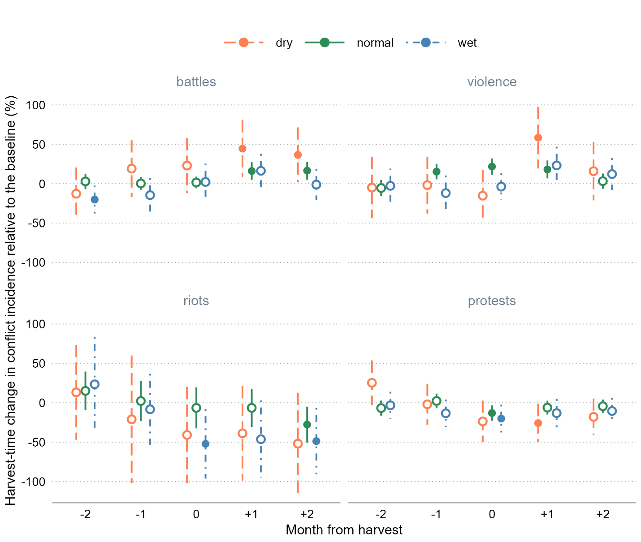

**Figure 5: The impact of the growing season weather on harvest-time dynamics of conflicts**

Note: The point estimates are in percentage terms calculated as , where is the parameter estimate associated with each considered month of the harvest window (a five-month period centered on the harvest month) and each considered growing season weather (dry, normal, and wet, as described in Table 8), and is the baseline conflict incidence (which varies by the form of conflict and is presented in Table 8). The error bars extend , where is the standard error adjusted to clustering at the cell level. Filled circles show the statistically significant point estimates at the 5% level.

This additional test further clarifies the previously presented suggestive evidence regarding the channels through which changes in income during the harvest period may be linked to changes in conflict. It also offers some additional insights. Specifically, while the harvest-time negative relationship between growing season rainfall and battles is maintained across the considered months around harvest, we also observe the unusual spike in violence against civilians during or immediately after it. This suggests that in the wake of unusually dry—and therefore damaging to crop yields—growing season, harvest-time violence becomes largely a byproduct of broader political conflict. This is consistent with the “living off the land” theory of Koren and Bagozzi (2017), who propose that in times of war, any co-optation between fighters and farmers breaks down, which leads to more violence.

The aforementioned findings do not undermine rapacity as the key driver of harvest-time violence against civilians. In line with our previous estimates, we still observe a considerable and statistically significant increase in conflict incidents during the three-month window centered on the harvest. Notably, this increase occurs only in years with presumably rich harvests.

The inverted V-shaped pattern in relation to crop growing season rainfall is maintained across the considered months for both forms of social unrest. As in previous tests, the relative effect is seemingly amplified in the case of riots, primarily owing to its low baseline incidence. More generally, all estimated parameters for this form of conflict are estimated with little precision. The U-shaped pattern in relation to months of the harvest is maintained across the three regimes of crop growing season rainfall. The fact that both forms of social unrest decrease at the time of harvest but do not quickly revert to pre-harvest levels, as expected by the opportunity cost mechanism, or do not increase beyond pre-harvest levels, as anticipated by the resentment mechanism, suggests additional factors driving this pattern.

This pattern mirrors that observed in battles, indicating a potential substitution between these forms of conflict. It suggests that the timing and locations where active battles unfold may not be an opportune time or suitable place for protests and riots. However, Vüllers and Krtsch (2020) argue against this conjecture and present empirical evidence supporting their argument, in the context of African civil wars. They suggest that civilian protests can arise from the grievances of civilians due to battles between the government and rebel groups in their area, including losses from violence and destruction of property and farmland. The relationship, of course, can be context-specific, which we leave for future research to consider.

**7. Conclusion**

Agriculture and conflict are linked. The extent and the sign of the relationship vary by the motives of actors and forms of conflict. To better understand the pathways between harvest-time violence and conflict, we disaggregate conflict into two types that are often carried out by different groups of people for different reasons: violence against civilians and battles and explosions—usually carried out by the state, allied militias, or anti-state insurgent groups—and protests and riots by civilians, often against state policies or other groups. Instead of resolving the debate over the mechanisms of resource-related conflict on one side or the other, we suggest that different types of conflict (usually instigated by different types of conflict actors) are related to seasonal agricultural output through different mechanisms: conflict bycivilians is better understood through the opportunity cost and resentment mechanisms, while conflict againstcivilians is better understood through the rapacity mechanism.

We examine these mechanisms using 13 years of data from eight Southeast Asian countries. During the harvest season, we estimate a seven percent increase in battles and a 12 percent increase in violence against civilians. These effects appear to be primarily driven by rural locations, which see 12 and 22 percent increases in battles and violence against civilians, respectively. We also estimate a decrease in riots and protests, during the harvest season. But these effects are modest and not statistically significant.

In our findings, we present convincing empirical evidence supporting the rapacity mechanism as the key driver of violence against civilians at harvest time. The same mechanism is likely responsible also for the elevated incidence of battles at harvest time, but we also suggest that part of this effect is due to the onset of the dry season that largely coincides with the harvest season. However, the evidence supporting the opportunity cost mechanism, which suggests fewer protests and riots, is weak and sensitive to data subsetting or different mode specifications. The offsetting effect due to the resentment mechanism possibly also plays a role in this result.

The findings of this study offer valuable insights into conflict resolution and development policy. Recognizing that political violence and social unrest in rural Southeast Asia are associated with rice harvest months can greatly assist in enhancing planning efforts by local governments and, particularly, international agencies focused on rural development programs.

**References**

Andrews, S. (2017). Packed Lunch Protesters: Outrage for Hire in Indonesia. *The Diplomat*, 3 February, <https://thediplomat.com/2017/02/packed-lunch-protesters-outrage-for-hire-in-indonesia/>

Berman, E., Callen, M., Felter, J. H., and J. N. Shapiro (2011). Do Working Men Rebel? Insurgency and Unemployment in Afghanistan, Iraq, and the Philippines. *Journal of Conflict Resolution, 55*(4): 496–528.

Buhaug, H., & Rød, J. K. (2006). Local Determinants of African Civil Wars, 1970–2001. *Political Geography 25*(3), 315–335.

Buhaug, H., T. A. Benjaminsen, E. Sjaastad, and O. M. Theisen (2015). Climate Variability, Food Production Shocks, and Violent Conflict in Sub-Saharan Africa. *Environmental Research Letters 10*(12), 125015.

Burke, M. B., Miguel, E., Satyanath, S., Dykema, J. A., and Lobell, D. B. (2009). Warming Increases the Risk of Civil War in Africa. *Proceedings of the National Academy of Sciences, 106*(49), 20670–20674.

Collier, P. and A. Hoeffler (1998). On Economic Causes of Civil War. *Oxford Economic Papers 50*(4), 563–573.

Crost, B., Duquennois, C., Felter, J. H., and Rees, D. I. (2018). Climate Change, Agricultural Production and Civil Conflict: Evidence From the Philippines. *Journal of Environmental Economics and Management, 88*, 379–395.

Crost, B., and J. H. Felter (2020). Export crops and civil conflict. *Journal of the European Economic Association, 18*(3), 1484–1520.

Crost, B., Felter, J. H., Mansour, H., and D. I. Rees (2020). Narrow Incumbent Victories and Post-election Conflict: Evidence From the Philippines. *The World Bank Economic Review, 34*(3), 767–789.

Dell, M., Jones, B. F., and Olken, B. A. (2014). What Do We Learn from the Weather? The New Climate-Economy Literature. *Journal of Economic Literature, 52*(3), 740–798.

FAO (2023). Food and Agriculture Organisation of the United Nations, https://www.fao.org/faostat/en/#data/QCL

Fearon, J. D., and Laitin, D. D. (2003). Ethnicity, Insurgency, and Civil War. *American Political Science Review, 97*(1), 75–90.

Fjelde, H. (2015). Farming or Fighting? Agricultural Price Shocks and Civil War in Africa. *World Development 67*, 525–534.

Gatti, N., Baylis, K., and B. Crost (2021). Can Irrigation Infrastructure Mitigate the Effect of Rainfall Shocks on Conflict? Evidence From Indonesia. *American Journal of Agricultural Economics, 103*(1), 211–231.

Grasse, D. (2022). Oil Crops and Social Conflict: Evidence from Indonesia. *Journal of Conflict Resolution, 66*(7-8): 1422–1448.

Guardado, J. and S. Pennings (2023). The Seasonality of Conflict. Conflict Management and Peace Science (accepted).

Harari, M. and E. La Ferrara (2018). Conflict, Climate, and Cells: A Disaggregated Analysis. *Review of Economics and Statistics 100*(4): 594–608.

Hendrix, C. S., and S. Haggard (2015). Global Food Prices, Regime Type, and Urban Unrest in the Developing World. *Journal of Peace Research 52*(2): 143–57.

Hersbach, H., Bell, B., Berrisford, P., Biavati, G., Horányi, A., Muñoz Sabater, J., Nicolas, J., Peubey, C., Radu, R., Rozum, I., Schepers, D., Simmons, A., Soci, C., Dee, D., Thépaut, J-N. (2023): ERA5 hourly data on single levels from 1940 to present. Copernicus Climate Change Service (C3S) Climate Data Store (CDS), DOI: 10.24381/cds.adbb2d47 (Accessed on 30-03-2023)

Hsiang, S. M., Burke, M., and E., Miguel (2013). Quantifying the Influence of Climate on Human Conflict. *Science, 341*(6151), 1235367.

IFPRI (2019). International Food Policy Research Institute. Global Spatially Disaggregated Crop Production Statistics Data for 2010 Version 2.0, https://doi.org/10.7910/DVN/PRFF8V, Harvard Dataverse, V4

Iyigun, M., Nunn, N., & Qian, N. (2017). The Long-Run Effects of Agricultural Productivity on Conflict, 1400-1900. National Bureau of Economic Research. Working Paper 24066.

Koren, O. (2018). Food Abundance and Violent Conflict in Africa. *American Journal of Agricultural Economics 100*(4), 981–1006.

Koren, O. (2019). Food Resources and Strategic Conflict. *Journal of Conflict Resolution 63*(10), 2236–2261.

Koren, O., and B. E. Bagozzi (2017). Living Off the Land: The Connection Between Cropland, Food Security, and Violence Against Civilians. *Journal of Peace Research 54*(3), 351–364.

Koubi, V. (2019). Climate Change and Conflict. *Annual Review of Political Science, 22*, 343–360.

Mampilly, Z., and Stewart, M. A. (2021). A Typology of Rebel Political Institutional Arrangements. *Journal of Conflict Resolution 65*(1), 15–45.

McGuirk, E. and M. Burke (2020). The Economics Origins of Conflict in Africa. *Journal of Political Economy 128*, 3940–3997.

McGuirk, E. and N. Nunn (2023). Transhumant Pastoralism, Climate Change and Conflict in Africa. *Review of Economics Studies* (accepted).

Mitra, A., and Ray, D. (2014). Implications of an Economic Theory of Conflict: Hindu-Muslim Violence in India. *Journal of Political Economy 122*(4), 719–765.

Mohanty, S. (2012) “Why does everyone hate the Thai rice mortgage scheme?” *Food Navigator Asia*, 13 November. https://www.foodnavigator-asia.com/Article/2012/11/13/Why-does-everyone-hate-the-Thai-rice-mortgage-scheme.

Monfreda, C., N. Ramankutty, and J. A. Foley (2008). Farming the Planet: 2. Geographic Distribution of Crop Areas, Yields, Physiological Types, and Net Primary Production in the Year 2000, *Global Biogeochemical Cycles 22*, GB1022

Panza, L., and E. L. Swee (2023). Fanning the Flames: Rainfall Shocks, Inter‐Ethnic Income Inequality, and Conflict Intensification in Mandate Palestine. *Journal of Economic Behavior & Organization, 206*, 71–94.

Raleigh, C., A. Linke, H. Hegre, and J. Karlsen (2010). Introducing ACLED: An Armed Conflict Location and Event Dataset: Special Data Feature. *Journal of Peace Research 47(5)*, 651–660.

Raleigh, C. (2012). Violence Against Civilians: A Disaggregated Analysis. *International Interactions, 38*(4), 462–481.

Raleigh, C., Choi, H. J., and Kniveton, D. (2015). The Devil Is In the Details: An Investigation of the Relationships Between Conflict, Food Price and Climate Across Africa. *Global Environmental Change 32*, 187–199.

Raleigh, C., and Choi, H. J. (2017). Conflict Dynamics and Feedback: Explaining Change in Violence against Civilians within Conflicts. *International Interactions, 43*(5), 848–878.

Sacks, W.J., D. Deryng, J.A. Foley, and N. Ramankutty (2010). Crop Planting Dates: An Analysis of Global Patterns. *Global Ecology and Biogeography 19*, 607–620

Smith, T. G. (2014). Feeding Unrest: Disentangling the Causal Relationship between Food Price Shocks and Sociopolitical Conflict in Urban Africa. *Journal of Peace Research 51*(6), 679– 95.

Ubilava, D., et al. (2022). "Agricultural windfalls and the seasonality of political violence in Africa." *American Journal of Agricultural Economics* (in press).

Vestby, J. (2019). Climate Variability and Individual Motivations for Participating in Political Violence. *Global Environmental Change 56*, 114–123.

Vüllers, J., & Krtsch, R. (2020). Raise Your Voices! Civilian Protest in Civil Wars. *Political Geography 80*, 102183.

de Winne, J. and Peersman, G. (2021) The Impact of Food Prices on Conflict Revisited. *Journal of Business & Economic Statistics 39*(2), 547–560.

Wischnath, G., and Buhaug, H. (2014). Rice or Riots: On Food Production and Conflict Severity Across India. *Political Geography 43*, 6–15.

World Bank (2022a). World Bank Country and Lending Groups. The World Bank Group. https://datahelpdesk.worldbank.org/knowledgebase/articles/906519-world-bank-country-and-lending-groups. Accessed 10 Nov 2022.

World Bank (2022b). World Development Indicators. Poverty headcount ratio at national poverty lines (% of population) [Data file]. https://data.worldbank.org/indicator/SI.POV.NAHC

World Bank (2022c). World Development Indicators. Employment in agriculture (% of total employment) [Data file]. https://data.worldbank.org/indicator/SL.AGR.EMPL.ZS

APPENDICES

APPENDIX A. FIGURES

**Figure A1: Distribution of the proportion of irrigated rice croplands**

Note: Data are from IFRPI (2019) and cover Cambodia, Indonesia, Laos, Malaysia, Myanmar, the Philippines, Thailand, and Vietnam.

**Figure A2: Proportion of irrigated croplands and the size of cropland areas**

Note: Data are from IFRPI (2019) and cover Cambodia, Indonesia, Laos, Malaysia, Myanmar, the Philippines, Thailand, and Vietnam.

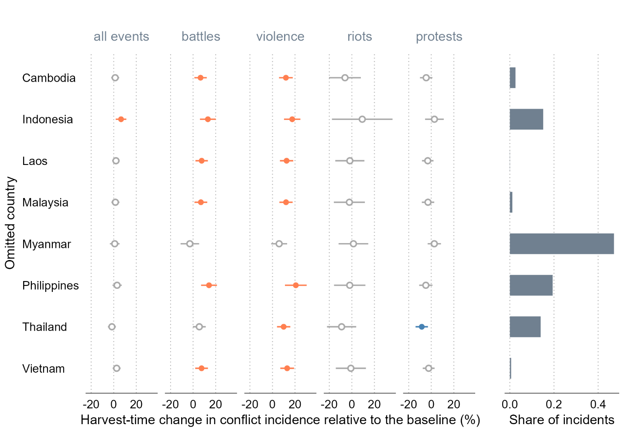

**Figure A3: Sensitivity of the estimates to omitting one country at a time from the dataset**

Note: The dots indicate point estimates, and the error bars show 95% confidence intervals around the point estimates. The confidence intervals are obtained using standard errors adjusted to clustering at the cell level. The colored dots and error bars show the impacts that are statistically significantly positive (orange) or negative (blue) at the 5% level. The impact, presented in percentage terms, is calculated as , where is the parameter estimate and is the baseline conflict incidence.

**Figure A4: Sensitivity of the estimates to omitting one year at a time from the dataset**

Note: The dots indicate point estimates, and the error bars show 95% confidence intervals around the point estimates. The confidence intervals are obtained using standard errors adjusted to clustering at the cell level. The colored dots and error bars show the impacts that are statistically significantly positive (orange) or negative (blue) at the 5% level. The impact, presented in percentage terms, is calculated as , where is the parameter estimate and is the baseline conflict incidence.

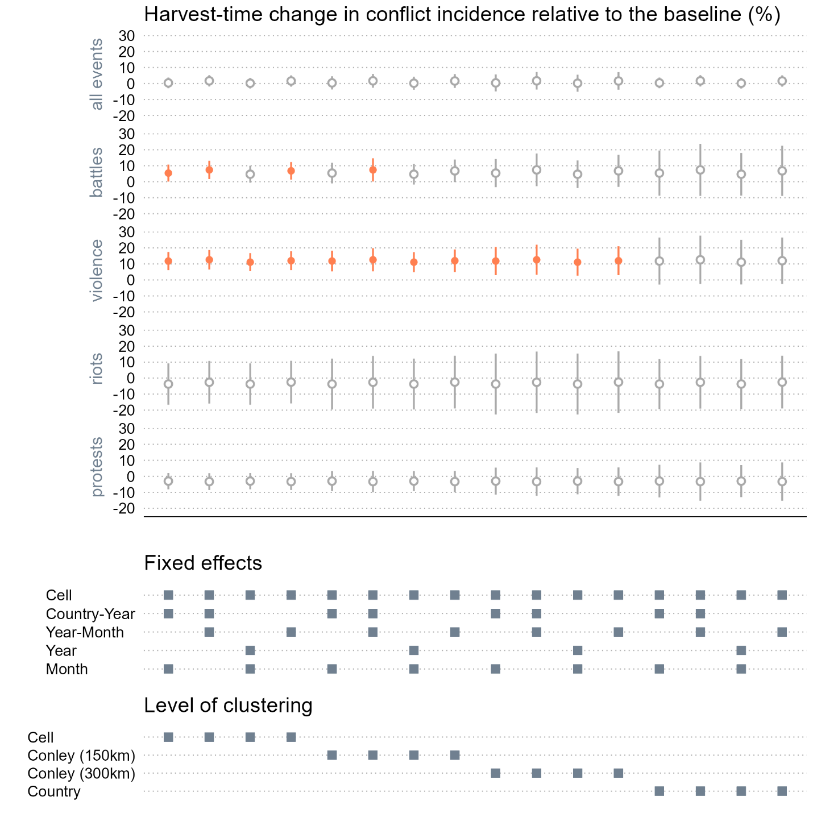

**Figure A5: Specification chart**

Note: In the top panel, the dots indicate point estimates, and the error bars show 95% confidence intervals around the point estimates. The colored dots and error bars show the impacts that are statistically significantly different from zero at the 5% level. The impact, presented in percentage terms, is calculated as , where is the parameter estimate and is the baseline conflict incidence. The bottom panel identifies different combinations of the fixed effects and levels of error clustering.

**Figure A6: Estimated impacts using randomly assigned harvest seasons**

Note: In the top panel, the dots indicate point estimates, and the error bars show 95% confidence intervals around the point estimates. The confidence intervals are obtained using standard errors adjusted to clustering at the cell level. The colored dots and error bars show the impacts that are statistically significantly positive (orange) or negative (blue) at the 5% level. In the bottom panel, the densities are those of the point estimates. The impact, presented in percentage terms, is calculated as , where is the parameter estimate and is the baseline conflict incidence.

APPENDIX B. TABLES

**Table B1: Harvest-time change in conflict incidence in the croplands of Southeast Asia**

|  | **All events** | **Battles** | **Violence** | **Riots** | **Protests** |
| --- | --- | --- | --- | --- | --- |
| *Balanced panel: all countries, years 2018-2022* | | | | | |
| Cropland×Harvest | -0.002 | 0.016*** | 0.016*** | -0.005 | -0.018*** |
|  | (0.007) | (0.004) | (0.005) | (0.003) | (0.007) |
| Obs. | 22,560 | 22,560 | 22,560 | 22,560 | 22,560 |
| R2 | 0.506 | 0.575 | 0.508 | 0.227 | 0.413 |
| *The magnitude of the estimated effect relative to the baseline conflict incidence in the croplands (%)* | | | | | |
| *Baseline conflict incidence* | 0.37 | 0.15 | 0.15 | 0.05 | 0.24 |
| Cropland×Harvest | -0.5 | 10.4*** | 10.6*** | -10.3 | -7.6*** |
|  | (1.9) | (2.9) | (3.4) | (6.8) | (2.7) |

Note: The outcome variable is the indicator for the presence of conflict in a cell in a year-month, and the treatment variable is the indicator for the cropland interacted with the indicator for the harvest season. The “All events” column combines all forms of conflict, and the “Battles” column battles and explosions/remote violence. The remaining columns represent the separate event types as labeled. All regressions include cell, country-year, and year-month fixed effects and control for contemporaneous rainfall. The values in parentheses are standard errors adjusted to clustering at the cell level; ***, **, and * denote 0.01, 0.05, and 0.10 statistical significance levels. The magnitudes of the effect, presented in percentage terms, are calculated as , where is the parameter estimate and is the baseline conflict incidence—the unconditional mean of the outcome variable.

**Table B2: Harvest-time change in conflict incidence in the croplands of Southeast Asia**

|  | **All events** | **Battles** | **Violence** | **Riots** | **Protests** |
| --- | --- | --- | --- | --- | --- |
| *Unbalanced panel: All countries except Indonesia, Malaysia, and the Philippines, all years* | | | | | |
| Cropland×Harvest | 0.019** | 0.020** | 0.022*** | 0.002 | 0.000 |
|  | (0.008) | (0.005) | (0.005) | (0.003) | (0.007) |
| Obs. | 26,052 | 26,052 | 26,052 | 26,052 | 26,052 |
| R2 | 0.399 | 0.485 | 0.389 | 0.125 | 0.309 |
| *The magnitude of the estimated effect relative to the baseline conflict incidence in the croplands (%)* | | | | | |
| *Baseline conflict incidence* | 0.23 | 0.10 | 0.08 | 0.02 | 0.14 |
| Cropland×Harvest | 8.2** | 20.7*** | 28.4*** | 10.8 | 0.0 |
|  | (3.3) | (4.8) | (6.0) | (16.1) | (4.9) |

Note: The outcome variable is the indicator for the presence of conflict in a cell in a year-month, and the treatment variable is the indicator for the cropland interacted with the indicator for the harvest season. The “All events” column combines all forms of conflict, and the “Battles” column battles and explosions/remote violence. The remaining columns represent the separate event types as labeled. All regressions include cell, country-year, and year-month fixed effects and control for contemporaneous rainfall. The values in parentheses are standard errors adjusted to clustering at the cell level; ***, **, and * denote 0.01, 0.05, and 0.10 statistical significance levels. The magnitudes of the effect, presented in percentage terms, are calculated as , where is the parameter estimate and is the baseline conflict incidence—the unconditional mean of the outcome variable.

**Table B3: Harvest-time change in conflict incidents in the croplands of Southeast Asia**

|  | **All events** | **Battles** | **Violence** | **Riots** | **Protests** |
| --- | --- | --- | --- | --- | --- |
| *Unbalanced panel: All countries, all years* | | | | | |
| Cropland×Harvest | 0.004 | 0.112** | 0.109*** | -0.009 | -0.208*** |
|  | (0.083) | (0.047) | (0.033) | (0.007) | (0.062) |
| Obs. | 44,724 | 44,724 | 44,724 | 44,724 | 44,724 |
| R2 | 0.394 | 0.373 | 0.391 | 0.146 | 0.296 |
| *The magnitude of the estimated effect relative to the baseline conflict incidents in the croplands (%)* | | | | | |
| *Baseline conflict incidents* | 2.01 | 0.74 | 0.46 | 0.06 | 0.75 |
| Cropland×Harvest | 0.2 | 15.1** | 24.0*** | -15.3 | -27.7*** |
|  | (4.1) | (6.3) | (7.3) | (11.9) | (8.3) |

Note: The outcome variable is the number of conflict incidents in a cell in a year-month, and the treatment variable is the indicator for the cropland interacted with the indicator for the harvest season. The column headed by ‘All events’ combines all forms of conflict, the column headed by ‘Battles’ combines battles and explosions/remote violence, the remaining columns represent the separate event types as labeled. All regressions include cell, country-year, and year-month fixed effects, and control for contemporaneous rainfall; the values in parentheses are standard errors adjusted to clustering at the level of a cell; ***, **, and * denote 0.01, 0.05, and 0.10 statistical significance levels. The magnitudes of the effect, presented in percentage terms, are calculated as: , where is the parameter estimate, and is the baseline conflict incidence—the unconditional mean of the outcome variable.

**Table B4: Harvest-time change in conflict incidents in the croplands of Southeast Asia**

|  | **All events** | **Battles** | **Violence** | **Riots** | **Protests** |
| --- | --- | --- | --- | --- | --- |
| *Unbalanced panel: All countries, all years, excluding Myanmar 2021-2022* | | | | | |
| Cropland×Harvest | 0.067 | -0.009 | 0.067** | -0.002 | 0.012 |
|  | (0.059) | (0.025) | (0.032) | (0.006) | (0.034) |
| Obs. | 43,308 | 43,308 | 43,308 | 43,308 | 43,308 |
| R2 | 0.506 | 0.459 | 0.408 | 0.181 | 0.458 |
| *The magnitude of the estimated effect relative to the baseline conflict incidents in the croplands (%)* | | | | | |
| *Baseline conflict incidents* | 1.36 | 0.41 | 0.36 | 0.06 | 0.54 |
| Cropland×Harvest | 4.9 | -2.3 | 18.6** | -4.3 | 2.3 |
|  | (4.3) | (6.1) | (8.8) | (10.2) | (6.2) |

Note: The outcome variable is the number of conflict incidents in a cell in a year-month, and the treatment variable is the indicator for the cropland interacted with the indicator for the harvest season. The column headed by ‘All events’ combines all forms of conflict, the column headed by ‘Battles’ combines battles and explosions/remote violence, the remaining columns represent the separate event types as labeled. All regressions include cell, country-year, and year-month fixed effects, and control for contemporaneous rainfall; the values in parentheses are standard errors adjusted to clustering at the level of a cell; ***, **, and * denote 0.01, 0.05, and 0.10 statistical significance levels. The magnitudes of the effect, presented in percentage terms, are calculated as: , where is the parameter estimate, and is the baseline conflict incidence—the unconditional mean of the outcome variable.

**Table B5: Harvest-time change in conflict incidence by levels of the growing season rainfall**

|  | **All events** | **Battles** | **Violence** | **Riots** | **Protests** |
| --- | --- | --- | --- | --- | --- |
| *Unbalanced panel: All countries, all years* | | | | | |
| Cropland×Harvestm-2×Dry | 0.005 | −0.014 | −0.005 | 0.005 | 0.044* |
|  | (0.026) | (0.019) | (0.021) | (0.011) | (0.025) |
| Cropland×Harvestm-2×Normal | −0.012 | 0.003 | −0.006 | 0.005 | −0.012 |
|  | (0.009) | (0.006) | (0.005) | (0.004) | (0.009) |
| Cropland×Harvestm-2×Wet | −0.002 | −0.022** | −0.003 | 0.008 | −0.006 |
|  | (0.017) | (0.010) | (0.012) | (0.011) | (0.015) |
| Cropland×Harvestm-1×Dry | 0.030 | 0.021 | −0.002 | −0.007 | −0.004 |
|  | (0.026) | (0.020) | (0.019) | (0.014) | (0.023) |
| Cropland×Harvestm-1×Normal | 0.013 | 0.000 | 0.016*** | 0.001 | 0.004 |
|  | (0.008) | (0.005) | (0.005) | (0.005) | (0.008) |
| Cropland×Harvestm-1×Wet | −0.037** | −0.016 | −0.012 | −0.003 | −0.023 |
|  | (0.017) | (0.012) | (0.012) | (0.008) | (0.016) |
| Cropland×Harvestm×Dry | −0.013 | 0.025 | −0.016 | −0.014 | −0.041* |
|  | (0.025) | (0.020) | (0.017) | (0.011) | (0.024) |
| Cropland×Harvestm×Normal | 0.001 | 0.002 | 0.023*** | −0.002 | −0.023*** |
|  | (0.009) | (0.004) | (0.005) | (0.005) | (0.009) |
| Cropland×Harvestm×Wet | −0.044*** | 0.002 | −0.004 | −0.018** | −0.035** |
|  | (0.017) | (0.013) | (0.009) | (0.008) | (0.016) |
| Cropland×Harvestm+1×Dry | 0.018 | 0.049** | 0.061*** | −0.014 | −0.045** |
|  | (0.025) | (0.020) | (0.021) | (0.011) | (0.022) |
| Cropland×Harvestm+1×Normal | 0.008 | 0.018*** | 0.019*** | −0.002 | −0.011 |
|  | (0.009) | (0.006) | (0.006) | (0.004) | (0.008) |
| Cropland×Harvestm+1×Wet | −0.020 | 0.018 | 0.024* | −0.016* | −0.023 |
|  | (0.017) | (0.012) | (0.013) | (0.009) | (0.016) |
| Cropland×Harvestm+2×Dry | 0.018 | 0.040** | 0.017 | −0.018 | −0.031 |
|  | (0.023) | (0.020) | (0.020) | (0.011) | (0.021) |
| Cropland×Harvestm+2×Normal | 0.008 | 0.018*** | 0.003 | −0.010** | −0.008 |
|  | (0.009) | (0.006) | (0.005) | (0.004) | (0.008) |
| Cropland×Harvestm+2×Wet | −0.007 | −0.001 | 0.013 | −0.017** | −0.018 |
|  | (0.016) | (0.011) | (0.011) | (0.007) | (0.015) |
| Obs. | 44,724 | 44,724 | 44,724 | 44,724 | 44,724 |
| R2 | 0.447 | 0.503 | 0.463 | 0.183 | 0.359 |

Note: The outcome variable is the indicator for the presence of conflict in a cell in a year-month, and the treatment variable is the indicator for the cropland interacted with the indicator for the harvest season. This treatment variable is further interacted with the growing season rainfall categorical variable that splits the effect into those associated with growing seasons that are unusually dry, within a normal range, and unusually wet. The “All events” column combines all forms of conflict, and the “Battles” column combines battles and explosions/remote violence. The remaining three columns represent the separate event types as labeled. All regressions include cell, country-year, and year-month fixed effects and control for contemporaneous rainfall. The values in parentheses are standard errors adjusted to clustering at the cell level; ***, **, and * denote 0.01, 0.05, and 0.10 statistical significance levels. The magnitudes of the effect, presented in percentage terms, are calculated as , where is the parameter estimate and is the baseline conflict incidence, which is the unconditional mean of the outcome variable.

1. ACLED #9785083: “On 9 December 2013, in Mung Ding Pa, Kachin state, the Myanmar army shelled civilian rice fields.”
2. ACLED #9679246: “On 22 November 2022, in Zar Haw village (Gangaw township, Gangaw district, Magway region), the Myanmar military IB-50 shot dead a villager in the head during the raid. The military also shot dead two other villagers who were harvesting rice in the paddy fields for unknown reasons.”
3. ACLED #8807873: “On 4 November 2021, west of Pekon township (Taunggyi district, Shan-South), military troops clashed with the joint forces of Pekon PDF, Moebye PDF, Loikaw PDF, Demoso PDF, the KNDF and the Karenni Army. Military troops fired artillery and torched, looted a nearby village and burned harvested rice in paddy fields according to Pekon PDF. At least 20 military troops were killed and a resistance fighter was injured.”
4. ACLED #9641230: “On 11 November 2022, between Aye Ka Bar and Bay La Maing villages (coded as Aye Ka Bar) (Thanbyuzayat township, Mawlamyine district, Mon state), Mon State Mount Taungnyo People Guerrilla Force ambushed a convoy of three military vehicles carrying rice at about 7 am. One military solider was killed and two others were injured.
5. ACLED #9411619: “On 27 June 2022, in Kyunhla town (Kyunhla township, Kanbalu district, Sagaing region), Pyu Saw Htee members detained and killed a 40-year-old rice mill owner from Pi Tauk Pin village, Kanbalu township when he traveled to the Kyunhla town with a companion to buy equipment for his rice mill. The Pyu Saw Htee members seized 1.5 million Kyats, 2 mobile phones and 1 motorcycle from them. It was reported that the rice mill owner was shot dead as he tried to run away near a quarry outside the town. His companion escaped.”
6. ACLED #7787765: “On 22 March 2021, dozens of students from the Agricultural Student Coalition (Komar) held a peaceful protest in front of their university in UPN Veteran, Yogyakarta city (Yogyakarta province). They opposed the government plan of importing rice” [size = dozens]. ACLED #9103355: “On 24 September 2018, a group of students held a peaceful protest in Medan City, North Sumatra province, demanding the government to stop importing rice” [size = no report]. ACLED #9225485: “On 22 January 2018, in Sukolilo, hundreds of farmers staged a rally to protest against the government's plan to import rice, stating that it will lower local rice prices.”
7. ACLED #7908847: “Farmers in the province of Phichit staged a protest against the anti-government movement, blasting its attempt to block the government's efforts to secure funds for the rice pledging program. Hundreds of farmers gathered at a major intersection to express their opposition to the People's Democracy Reform Committee (PDRC), who they believed have been blocking the government's attempt to pay rice farmers for rice pledged under the pledging program.”