**Agricultural Shocks and Social Conflict in Southeast Asia**

**Abstract**

Conflicts are common and, to an extent, inevitable. Theories have linked forms of conflict to changes in income, and specifically of one group relative to another. To that end, the harvest season in agrarian societies presents an interesting empirical setting, as farmers in this period experience a short-term increase in income. We study thirteen years of data across eight Southeast Asian countries and focus on changes in different forms of social conflict during the rice harvest season. In this period, compared to the rest of the year, we estimate an increase in violence against civilians in the croplands. This estimate, which is statistically significant, links agricultural harvest with conflict through the rapacity mechanism. In the same period, we estimate a decrease in protests and riots, which would accord with the opportunity cost mechanism, but these estimates are not statistically significant. The offsetting resentment mechanism may be partly responsible for this, but we also cannot rule out the possibility of the null effect. Our findings, which contribute to the research on the agroclimatic and economic roots of conflict, offer valuable insights to policymakers by suggesting temporal displacement of conflict, and specifically of violence against civilians, that we linked with the seasonality of agricultural harvest in rice-producing regions of Southeast Asia.

**Keywords**: Agriculture, Conflict, Seasonality, Southeast Asia

**1. Introduction**

In low– and middle low–income countries, a small change in people’s well-being may trigger a range of behavioral responses, some of which may be unlawful and possibly violent. While protests, riots, and violence against civilians often happen in cities that not only are populous areas but also where the state administration—the key target of protesters—is located (e.g., Smith, 2014; Hendrix and Haggard, 2015), social conflict is not just an urban phenomenon. In rural areas, which often constitute the larger share of territories where the state capacity is limited, changes in income and employment can result in conflict and violence (e.g., McGuirk and Burke, 2020; Ubilava et al, 2022; Guardado and Pennings, 2023). Indeed, mounting empirical evidence points to a linkage between crop yields and conflict (Wischnath and Buhaug, 2014; Buhaug et al. 2015; Koren, 2018; Vestby, 2019)—which is a likely mechanism and a manifestation of climate shocks on conflict (e.g., Burke et al., 2009; Hsiang et al., 2013; Dell et al., 2014; Crost et al., 2018; Koubi, 2019)—and, somewhat less unequivocally, between commodity price shocks and conflict (Dube and Vargas, 2013; Maystadt and Ecker, 2014; Raleigh et al. 2015; Berman and Couttenier, 2015; Crost and Felter, 2020).

This paper addresses the question of whether harvest-time agricultural shocks lead to changes in conflict. The potential relationship between agriculture and conflict can be reduced to a couple of theories. One theory is *grievance*, which suggests that people protest the deterioration of their well-being, relative to others or to their own past (e.g., Hendrix and Haggard, 2015; de Winne and Peersman, 2021). The other theory is *greed*, which suggests that perpetrators are more likely to engage in conflict when there is more at stake.

Both theories explain the conflict that happens not only because there are opportunities to extort wealth or incur damage and thus improve one’s own relative standing, but also because the opportunity costs of engaging in such activities are not very high (Mitra and Ray, 2014). The latter, in particular, has been primarily portrayed in the literature as a person’s choice of the less peaceful ways of generating income, when the lawful alternatives such as farming do not pay enough (e.g., after a bad crop year, or a drop in commodity prices). To that end, the opportunity cost of fighting is seen as an increasing function of income—a negative income shock leading to more violence (Collier and Hoeffler, 1998; Fjelde, 2015). This mechanism typically works through a longer-term commitment to conflict, however. A shorter-term manifestation of the opportunity cost mechanism are instances when people engage in social unrest when their value of time is relatively low. In the agricultural sector, this would be the time of the year when people are not actively farming (Guardado and Pennings, 2023).

At the heart of the question of the link between agricultural output and conflict is not only the mechanism but also the form of conflict. Moreover, different forms of conflict are likely to manifest one mechanism more so than the other, thus offering a chance to disentangle the otherwise potentially ambiguous relationship between agricultural shocks and conflict. On the one hand, violence aimed at civilians can be linked to the harvest-time positive income shocks, and the relationship is expected to be positive. After a good harvest season, for example, the transitory increase in the spoils to be appropriated make farmers a lucrative target, which can amplify violence in croplands relative to non-agricultural areas (Mitra and Ray, 2014; Koren, 2018; McGuirk and Burke, 2020). Such a relationship can also be seasonal. In crop-producing parts of Africa, for example, attacks on civilians increase during harvest months (Ubilava et al. 2022), which aligns with the theory of greed manifested through the rapacity mechanism.

On the other hand, social unrest, often triggered by negative income shocks, may be linked to agricultural harvest in rural areas. The relationship can be negative or positive, however. The opportunity cost mechanism would lead to less protests at harvest time. This can happen for at least two reasons. First, when people—potential protesters—are busy harvesting, they are unlikely to take part in protests as the opportunity cost of this type of conflict is high. Second, if there is a short period of time, during the calendar year, when people in rural areas are relatively better off, compared to other times of the year or to people in urban areas, it is during or shortly after the harvest season, when the years’ worth of income has been realized. So, the harvest-time increase in income can mitigate social unrest in croplands relative to the urban, non-agricultural areas. Within agricultural areas, however, the harvest time increase in income inequality—between farmers and non-farmers—may amplify social unrest (e.g., Panza and Swee, 2023). The net effect, manifested through opportunity cost and resentment mechanisms, can be ambiguous.

Finally, incidents linked to larger-scale conflicts, such as battles between incumbents and insurgents to take control of a territory, are unlikely to be driven by or related to agricultural employment and income (e.g., Mampilly and Stewart, 2021; Ubilava et al., 2022). And even if they were, the direction of the effect may very well go in the opposite direction. That is, in times of a civil war, for example, people willingly or unwillingly may be involved in the process, at the expense of their usual employment, which in rural societies is often agricultural production.

We study the relationship between agricultural shocks and different forms of conflict by examining over 70 thousand incidents across eight countries of Southeast Asia during the 2010–2022 period. We find that violent attacks increase in crop-producing areas during the harvest months of rice—the key cereal crop in the region. This suggests that for conflict *against* civilians, harvest season presents rapacious violent groups with an opportunity to appropriate or destroy agricultural surplus. For conflict *by* civilians, we find that protests decrease at harvest time, which would suggest the opportunity cost dominating the resentment. But there is a caveat.

A series of sensitivity checks suggest the elevated levels of conflict in Myanmar from 2021 onward drive the results. Absent the 2021-2022 data from Myanmar, the estimated increase in harvest-time violence remains, but the harvest-time increase in battles or reduction of protests vanish, at least statistically. Notably, the omitted subset of the data contains a third of observed conflict incidents in the sample. And to the extent that we can only estimate the causes and consequences of conflict where and when conflict happens, these data may contain valuable information. So, while we are more confident about, and in the main analysis rely on estimates from the data subset that excludes Myanmar 2021-2022 observations, we also present estimates from the full sample in the appendix.

We contribute and help advance knowledge in three strands of literature. First, we contribute to the literature on climate shocks and conflict (e.g., Burke et al., 2009; Hsiang et al., 2013; Dell et al., 2014; Crost, et al., 2018). We present empirical evidence that emphasizes the effect of growing-season precipitation on harvest-time conflict. Second, we contribute to the literature on the economic roots of conflict (Berman et al, 2011; Crost and Felter, 2020; McGuirk and Burke, 2020; Grasse, 2022). We present empirical evidence for the potentially diverging effects that agricultural windfalls have on different forms of conflict, thus emphasizing benefits and the need of nuanced data analysis. Third, we contribute to the emerging literature on the seasonality of conflict (Harari and La Ferrara, 2018; Ubilava et al., 2022; McGuirk and Nunn, 2023; Guardado and Pennings, 2023). We present suggestive evidence of harvest-time increase in violence (with high confidence) and a harvest-time reduction of protests (with low confidence), and link these effects to the existing theories of conflict.

**2. Agricultural Origins of Conflict in Southeast Asia**

The geographic focus— Southeast Asia—is suitable for the present analysis for several reasons. First, most of the countries in the region fall into the lower-middle-income economies, with a considerable proportion of people living at or below the national poverty line (World Bank, 2022a, 2022b). The region also has large across-country and within-country variation in governance and institutional capacity levels, as the Philippines, Myanmar, and Indonesia in particular struggle to control their geographic peripheries.

Second, agriculture is a crucial sector for employment and income generation, across much of the region (World Bank, 2022c). While subsistence farming exists in Southeast Asia as in many regions with less developed economies, Southeast Asian countries are often food exporters (unlike many African countries). Thailand, Vietnam, Myanmar, and Cambodia are all in the top ten rice exporting countries globally (FAO, 2023). This means that violence associated with rice-producing areas are especially relevant to income generation for both farmers and the state.

Finally, civil conflict and social unrest have been defining features of the region’s politics (e.g., Crost and Felter, 2020; Crost et al., 2020; Gatti et al., 2021). The Philippines and Myanmar, for example, have seen multiple insurgencies—ideology- or ethnicity-based—for nearly their entire independent existences. The protests and conflicts that were sparked by the Myanmar military’s coup in 2021 have evolved into a full-scale civil war, while the Philippines has high levels of civil conflict. Thailand struggled with a communist insurgency from the 1960s until the early 1980s, and spillover from Myanmar’s insurgencies, while the Thai government continues to fight a low-level ethnic insurgency in southern Thailand. Since Suharto’s fall in 1998, Indonesia has dealt with widespread protests, riots, civil conflict, and Islamist terrorism, as well as ethnic insurgencies in Aceh and West Papua.

We can imagine a number of different actors in Southeast Asian conflict, all of whom could instigate conflict, including civilians, armed rebel groups, state actors, and militias operating on behalf of competing elites. Civilians may instigate protests against government policies, and these protests may turn into riots. Armed rebel groups, state actors, and militias may engage in violence against civilians, either through armed attacks, battles, or explosions. The logic of conflict, agricultural shocks, and seasonality is likely to be different, and in some ways, diametrically opposed, depending on the type of actor (and thus the type of conflict).

Previous work on the connection between conflict and agricultural output in Southeast Asia has come to nuanced conclusions about the types of conflict pursued by different actors, and the potential relationship with agricultural outputs. Gatti et al. (2021) find that decreased agricultural output is associated with an increase in civil conflict in Indonesia, but that irrigation infrastructure specifically mitigates this link. They divide conflict into that over natural resources, issues of popular justice, conflicts triggered by government policy, those triggered by group identity, as well as separatist incidents. Their findings suggest that this effect is particularly strong for natural resource conflicts, popular justice, law enforcement actions, and less strong for conflicts driven by ethnic separatism and group identity. While their categorizations do not specifically differentiate civilian protest and rioting from state- and rebel-initiated conflict, in broad strokes, it appears that conflicts that would lead to protests against government policy and over natural resources are more amenable to mitigation through decreasing the effects of negative agricultural shocks than ethnic separatist conflicts, which are more likely to be associated with insurgent activities, particularly in Indonesia, where rebel groups generally have religious or ethnic goals.

*2.1. Harvest-Time Increase in Violence Against Civilians*

In Southeast Asia, both the opportunity cost and rapacity mechanisms may be at play, depending on the actor type (Table 1). For attacks on civilians, insurgencies may increase their activities during the harvest season to maximize the damage they do through a number of pathways. First, they may want to expropriate farmers’ income, which is realized during harvest season. Second, for farmers who do not support the insurgency or who are on the sidelines, insurgents may want to harm the farmers’ earning potential to minimize threats to the insurgency, or to intimidate the farmers into joining them (Raleigh, 2012; Raleigh and Choi 2017). Third, the insurgents may time their attacks to have maximum negative effect on the state, inasmuch as the state is also likely deriving revenues during the harvest season, and state revenue is related to the ability of the state to attack the insurgents (Fearon and Laitin 2003).

**Table 1. Actors and conflict seasonality: Theoretical expectations**

|  |  |  |  |
| --- | --- | --- | --- |
| **Form of conflict** | **Type of actor** | **Likely mechanism** | **Harvest-time effect** |
| Battles | Armed actors (State forces, rebel groups, militias) | Opportunity cost, Rapacity | Ambiguous |
| Violence | Armed actors (State forces, rebel groups, militias) | Rapacity | Increase |
| Riots | Civilians | Opportunity cost, resentment, rapacity | Ambiguous |
| Protests | Civilians | Opportunity cost, resentment | Ambiguous |

By this logic, violence against civilians is likely to be focused on the destruction or appropriation of agricultural outputs. Significant numbers of attacks on civilians in Southeast Asia revolve around the theft of rice or the destruction of rice fields, rice storage units, or rice milling facilities. In December 2013, for instance, the Myanmar military attacked civilian rice paddies in Kachin state during the harvest season.[1]

State forces, political militias, and insurgent groups might choose the harvest season as the time to attack because it would maximize the destruction of their enemies’ resources or allow them to appropriate that agricultural surplus. In November 2022, a Myanmar military force shot dead three villagers in a raid in Myanmar’s Magway region, two of who were engaged in harvesting rice in paddy fields.[2] During the harvest season, the state may also attack villages that may be aiding rebel groups. In November 2021, for instance, in a clash between the Myanmar military and various People Defense Forces (the armed groups associated with the anti-junta civilian government in internal exile), the military burned harvested rice fields in a village that it (obviously) suspected was loyal to the anti-state groups.[3]

Insurgent groups fighting against the state also have an incentive to attack civilians who are providing agricultural outputs to the state, both to intimidate the civilians against supporting the state, and to deny the state food. In November 2022, rebel groups ambushed a military convoy carrying rice in Myanmar in Mon state and killed a soldier.[4] Pro-government militias can engage in similar behavior to degrade the resources available to their enemies and to appropriate resources for themselves. In June 2022, the pro-military junta militia group Pyu Saw Htee killed a rice mill owner in Sagaing and stole large amounts of money (which had been intended to buy more rice milling equipment) as well as mobile phones and a motorcycle.[5]

*2.2. Harvest-Time Decrease in Unrest by Civilians*

While riots and protests may be initiated by insurgencies or organized anti-government groups, they may also more generally be indicative of dissatisfaction by civilians, whether organized or not. A decrease in protests and riots during harvest season may come through several pathways. First, those who are directly involved in agriculture may decrease their protest activities during harvest time because they are busy harvesting. This relates to a second pathway, that of a direct opportunity cost mechanism, in which the opportunity cost of protesting increases during harvest time because there is more income to be derived from harvesting. Put another way, the infusion of income from the harvest makes protesting relatively less attractive. This may be because there are fewer grievances against the government when would-be protesters are realizing income.

It may also be because the ‘income’ from protesting relative to other activities becomes less competitive. In Indonesia, for instance, paid protesting is a longstanding means for political parties and civil society groups to pressure the government or send a message. In many cases, protesters are provided with a packed lunch (‘nasi bungkus’ in Indonesian) and a cash payment (hence the term, the ‘nasi bungkus brigade’), and often have only a tenuous interest in the issue at the center of the protest (Andrews, 2017). Thus, protest campaigns may find fewer supporters (paid or not) during the harvest season.

Protests by farmers in Southeast Asia are often designed to pressure the government to increase (or maintain) the prices they receive for their products. Both Indonesia and the Philippines have seen pressure campaigns from farmers to maintain or increase the price of rice (through price guarantees), or to prevent rice imports (to minimize competition that can undercut the domestic price).[6] In a logic where protests increase as grievances against the state increase, or as the opportunity cost of protesting decreases relative to harvesting, we would expect protest and riots to decrease during the harvest season relative to the non-harvest season. We would also expect better harvests to be associated with fewer protests and riots.

In the case of Thailand, for instance, there was a spate of protests against the Thai government by farmers throughout the country in 2014 because of a rice purchasing scheme in which the Thai government was supposed to have paid farmers subsidies for their rice production, but payments were either delayed or non-existent (Mohanty 2012). These protests were largely *not* during rice harvest season (which is December in Thailand), but several months later, when farmer’s grievances increased, and the opportunity cost of protesting was lower relative to harvesting. Of interest here is that the Thai farmers’ grievances were against both the government (for not paying the subsidies) and anti-government groups (for supposedly blocking the government from paying the subsidies).[7] The protests were ultimately followed by a military coup against the civilian government in May 2014.

**3. Data**

The goal of the study is to link within-year changes in forms of conflict to agricultural harvest-time changes in employment and income. To achieve this goal, we use data from multiple sources. For social conflict, we use the Armed Conflict Location & Event Data (ACLED) compiled by Raleigh et al. (2010). For rice land cover we use the data from IFPRI (2019). For harvest calendars we use data from Monfreda et al. (2008). In what follows, we describe these data in more detail.

*3.1. Conflict*

The ACLED Project (Raleigh et al., 2010) presents highly granular data in the sense that: (i) it features any reported conflict regardless of whether the altercation resulted in any casualty; (ii) it groups incidents into six categories, which include *battles*, *explosions/remote violence*, and *strategic developments* that feature two actors, typically the state or state-affiliated militias and the rebels who dispute the control of a territory; *violence against civilians* perpetrated by any of the paramilitary groups, as well as *protests* and *riots* that represent manifestations of public disorder of sorts. In our analysis, we combine *battles* and *explosions/remote violence* into a single type of event, and drop *strategic developments* as they are not likely to be comparable across countries and over time as other ACLED event types are (Raleigh et al., 2010).

The main caveat of this dataset is that it covers a relatively short period of time, from 2010 onward for most Southeast Asian countries except for Indonesia (from 2015 onward), Philippines (from 2016 onward), and Malaysia (from 2018 onward). The countries included in the analysis are Cambodia, Indonesia, Laos, Malaysia, Myanmar, Philippines, Thailand, and Vietnam. We exclude from the analysis Brunei, Singapore, and Timor-Leste because they are small and/or not agriculturally dependent countries, and because the ACLED coverage for these three countries is from 2020 onward only.

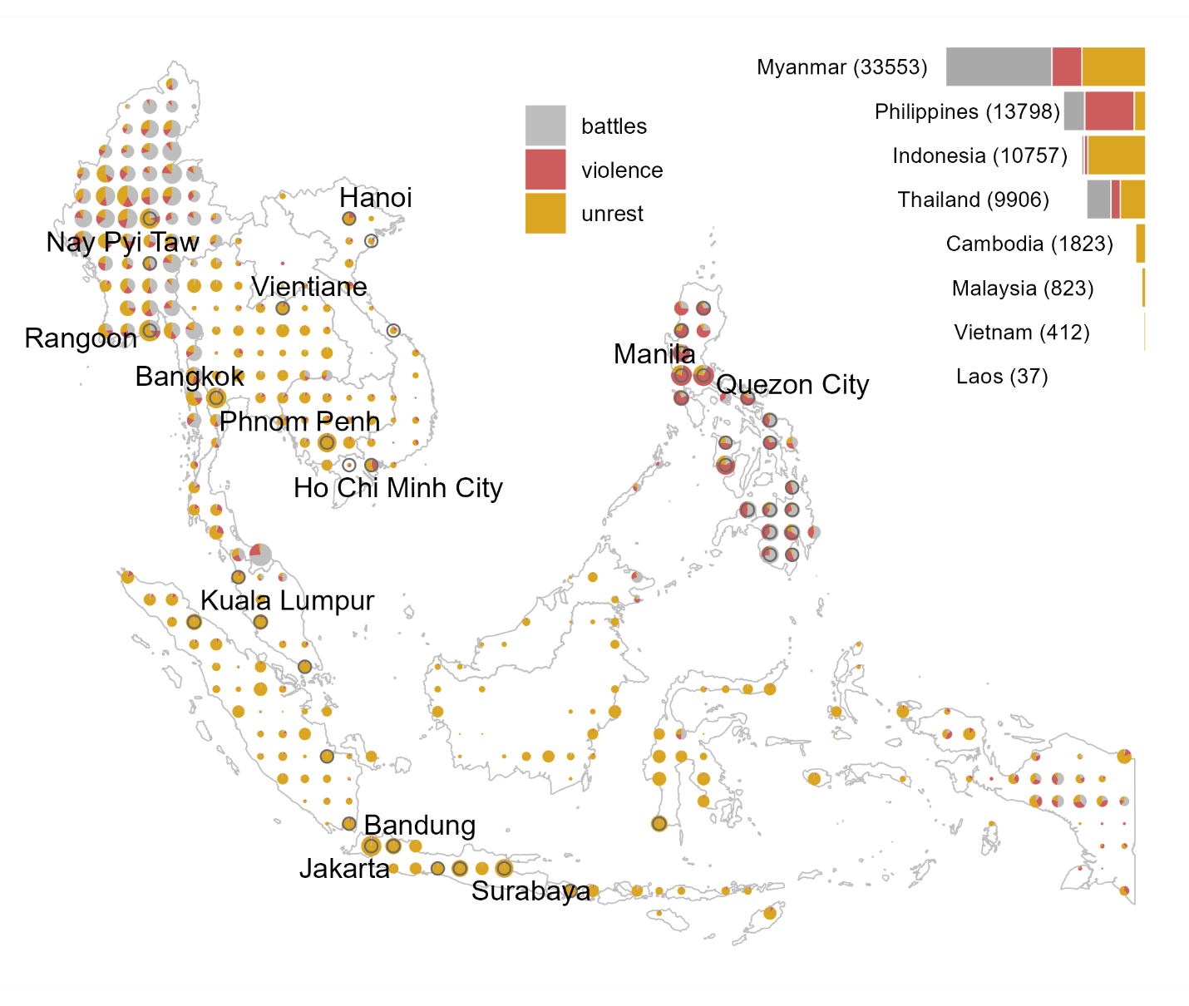

**Figure 1: Geographic distribution of social conflict (2010–2022)**

Note: The data are for Cambodia, Indonesia (2015 – 2022), Laos, Malaysia (2018 – 2022), Myanmar, Philippines (2016 – 2022), Thailand, and Vietnam. The size of the dots is proportional to the combined number of incidents in a cell. The empty circles that overly some of the dots identify ‘urban’ cells, defined as those that include a capital city, or a city with population of at least one million, or the total within-cell population of at least two million. The capital cities and very large cities (with population of at least 2.5 million) are labeled.

Our study period, which ranges from 2010 to 2022, covers a total of more than 70 thousand unique incidents observed across the eight countries. This excludes incidents for which exact locations are unknown and they are thus arbitrarily attributed to the nearest known site, typically a provincial capital (such locations are recorded with the geo-precision code 3 in the database). Figure 1 illustrates the geographical distribution of incidents across three distinct conflict categories (for illustration purposes, we combined protests and riots into a single *unrest* category) aggregated at the level of one-degree cells. The map also features a selected set of large cities in the region. From this map, it becomes apparent that: (i) conflict, broadly defined, occurs across much of the Southeast Asian region; (ii) within the region, some countries are more prone to conflict than others; (iii) there is a fair bit of spatial dependence in the prevalence of different types of conflict; and (iv) while generally observed in the cities, where most people reside, conflict not necessarily or exclusively a city phenomenon.

Figure 2 presents the time series of the four considered types of conflict over the study period. Additional features become apparent. First, there is no apparent trend across conflict types, but there is a notable increase in almost all types of conflict from 2021 onward, largely due to the Myanmar civil war. Second, despite a general co-movement among conflict types, there are periods when a rise in one type of conflict is not accompanied by other types of conflict. This is suggestive that root causes and mechanisms of different forms of conflict vary.

*3.2. Harvest*

We focus on rice which is, by far, the most dominant cereal—both in terms of production as well as consumption— across Southeast Asia. The harvest may extend multiple months. We define the period from the month when the harvest starts to the month when the harvest ends as the *harvest season*. We define the midpoint of the harvest season as the *harvest month*. In instances where a crop is grown over two seasons, we use the main season to identify the crop year. Within a cell, we maintain the area of cropland and the months of the harvest fixed over the study period. We do so not only due to the data limitations, but also to ensure that there is no reverse causality from conflict to the size and the timing of the harvest. We discuss this in more detail in the next section of the paper.

**Figure 2: Dynamics of social conflict by event type**

Note: The time series are monthly rates of conflict incidents per cell, across available cells for a given period. The number of cells (the bottom panel) increased progressively as Indonesia (2015), Philippines (2016), and Malaysia (2018) were added to the dataset.

Figure 3 aggregates at the level of one-degree cells the geographical distribution of relative cropland area fraction and the harvest months. The map also features locations where more than 50 percent of croplands are irrigated (indicated by empty circles). The data on irrigation status are from IFPRI (2019). Appendix Figure A1 presents the histogram of the proportion of irrigated rice across the considered locations in the region.

**Figure 3: Geographic distribution of rice harvest months**

Note: The size of the dots is proportional to the area devoted for rice production; the radial bars indicate the count of cells that fall within a given harvest month. The data on the crop area and irrigation are from IFPRI (2019). The data on harvest calendar are from Monfreda et al. (2008).

From this map, it becomes apparent that: (i) there is a fair bit of variation in the timing of the main harvest season, albeit March being the most dominant month in that regard; (ii) there is a considerable within-country variation in cropland area fractions, but hardly any within-country variation in the harvest month; and (iii) locations with larger cropland area fractions are more likely to be irrigated, although the irrigation prevalence can also be viewed as a country-specific phenomenon. Appendix Figure A2 presents the scatterplot of the proportion of irrigated rice against the (natural log of) rice cropland area.

*3.3. Auxiliary Data*

Rainfall is one of the most crucial factors in rice production. So, we use it to test the mechanism related to year-to-year change in relative abundance of rice, at harvest time, in rice-producing cells. We obtain ERA5 reanalysis data on gridded total precipitation from the Copernicus Project (Hersbach et al., 2018). Specifically, we obtain monthly average total precipitation, which we aggregate to the one-degree grid cell level—the spatial unit of measurement in the present study. Next, we calculate the measure of total precipitation during the months between the planting and harvesting seasons. For each cell, to obtain the standardized measure of precipitation, we divide the mean-centered precipitation by its standard deviation. Thus, we can interpret the magnitude of the effect as that of a one standard deviation change in precipitation.

We use information on cities and population from the World Cities Database, better known as SimpleMaps,[8] to group cells nominally into urban and rural areas. We consider a cell ‘urban’ if it contains the capital city, a large city (with the population size of at least one million), or if the population size within the cell is at least two million. Figure 1 identifies geographic locations of these cells. In the analysis, we use this information to examine any qualitative disparities in harvest-time change in forms of conflict between these two groups of locations.

*3.4. Descriptive Statistics*

In Table 2 we summarize some of the key features of the data. Violence and protests represent the two most prevalent forms of conflict that typically involve civilians who either are directly targeted (e.g., violent attacks or abduction) or become targets (e.g., intervention against protesters). Battles combined with explosions/remote violence, labeled as ‘Battles’ emerge as another important conflict category. The least prevalent event type is riots, which is a violent version of protests that shares elements of other, more violent types of social conflict. The table also presents cell-specific details about croplands. Across the covered 376 cells, the average size of the land used in rice production is approximately 78 thousand hectares, which is approximately 6.5 percent of the cell (as measured near the equator).

**Table 2: Descriptive Statistics**

|  |  |  |  |  |  |  |
| --- | --- | --- | --- | --- | --- | --- |
|  | Sum | Mean | S.D. | Min | Max | Incidence |
|  | *Unit of observation: cell-year-months (44,724)* | | | | | |
| All events | 71,109 | 1.590 | 7.480 | 0 | 350 | 0.253 |
| Battles | 26,030 | 0.582 | 3.759 | 0 | 106 | 0.092 |
| Violence | 15,803 | 0.353 | 2.748 | 0 | 164 | 0.088 |
| Riots | 2,254 | 0.050 | 0.441 | 0 | 42 | 0.032 |
| Protests | 27,022 | 0.604 | 3.743 | 0 | 268 | 0.155 |
|  | *Unit of observation: cells (376)* | | | | | |
| Rice cropland area (100,000 ha) |  | 0.781 | 1.255 | 0 | 9.087 |  |
| Irrigated |  | 0.348 | 0.738 | 0 | 7.786 |  |
| Rainfed |  | 0.433 | 0.858 | 0 | 5.759 |  |

Note: The conflict data are from ACLED Project (Raleigh et al., 2010), and covers eight countries over the period of thirteen years from *2010 to 2022,* except for Indonesia (2015–2022), Malaysia (2018–2022), and the Philippines (2016–2022); the other countries are Cambodia, Laos, Myanmar, Thailand, and Vietnam. *All events* contain the four presented categories of conflict wherein *Battles* combine battles and explosions/remote violence (as defined by ACLED Project). *Incidence* denotes the proportion of units with at least one conflict incident. The data on rice croplands, which are fixed at levels circa 2010, are from IFPRI (2019).

To gauge a better understanding about cross-sectional relationship between the size of croplands and conflict prevalence, we plot the latter against the former, both log-transformed for visual convenience (Figure 4). A positive relationship is apparent between the two variables. There also appears slightly more conflict in predominantly rainfed vis-à-vis irrigated croplands.

**Figure 4: Cross-sectional relationship between cropland area and conflict prevalence**

Note: The conflict data are from ACLED Project (Raleigh et al., 2010), and covers eight countries over the period of thirteen years from 2010 to 2022, except for Indonesia (2015–2022), Malaysia (2018–2022), and the Philippines (2016–2022); the other countries are Cambodia, Laos, Myanmar, Thailand, and Vietnam. The rice cropland data are from IFPRI (2019). Each point represents a cell. Four of the cells have the cropland area equal to zero, and 43 of the cells have the average number of conflict incidents equal to zero. These respective points appear at the bottom and left edges of the plot. The empty circles that overly some of the dots identify ‘urban’ cells, defined as those that include a capital city, or a city with population of at least one million, or the total within-cell population of at least two million.

**4. Estimation, Identification, and Interpretation**

We denote *location*, a one-degree cell, with subscript *i*, *country* with subscript *c*, *year* with subscript *t*, and *month* with subscript *m*. Henceforth, we also refer to year-month as *period*. The unit of analysis, thus, is a location–period covering 376 unique grid cells and, in most cases, 156 year-months from January 2010 to December 2022. The level of spatial aggregation—one-degree cells that measure approximately 110×110 km near the equator—is coarse enough to ensure that there are enough units with at least one conflict incident (Table 2). This level of aggregation, moreover, is granular enough to not sabotage the within-country variation in conflict incidents.

Our main econometric specification is given in a fixed effects setting as follows:

, (1)

where the outcome variable, , is a binary variable that takes the value of one if the number of conflict incidents in cell *i* in month *m* of year *t*, , exceeds zero, and zero otherwise. That is, the outcome variable measures the incidence of conflict. The treatment variable, , is the product of the cropland binary variable and the harvest binary variable. *cropland*, which is fixed over time, takes the value of one if more than 10 thousand hectares of land is used for rice production in the cell (IFPRI, 2019), and zero otherwise. *harvest*, which is cell-specific, takes the value of one when the period of observation is the harvest month, and zero otherwise. is a cell fixed effect, is a country-year fixed effect, and is a year–month fixed effect. is a set of controls—in most specifications just the contemporaneous rainfall—that vary across locations and over time. is the error term.

The identifying assumption in Equation (1) is that the treatment variable is exogenous to conflict. This assumption may seem tenuous, because conflict may affect production via abandoned plots and missed or mistimed harvests and planting seasons. So, a lower agricultural output may be the consequence, rather than the cause, of the change in conflict. But in the present study, we do not apply production data that would vary yearly. Instead, we use cropland area and harvest months, which are location-specific and fixed over time. Such an approach, admittedly driven by data limitations, mitigates the issue of reverse causality.

To address other threats to identification, we include the fixed effects and control variables in the regression. Specifically, cell fixed effects capture any time-invariant determinants of conflict (e.g., distance to roads, cities, or state borders), country-year fixed effects control for any country-specific trends in the data (e.g., large-scale political turmoil in election years), and year–month fixed effects capture common time-varying events observed in the region (e.g., global financial crises, large-scale climatic shocks, possible changes in the quality of data collection/reporting). We also include contemporaneous rainfall, which varies over time and across space, in the regression in an attempt to address, at least to an extent, remaining endogeneity issues. Specifically, this allows us to control for the direct impact of weather on conflict, for example, if excessive rainfall reduces the mobility of troops or makes protests and demonstrations somewhat untenable. Finally, in the robustness checks, we vary the fixed effects to get a better sense of potential threats to our identification strategy.

Under the outlined assumptions, the estimated coefficient, , reflects the harvest-time change in the probability of conflict in the cropland. A positive value of the coefficient, for example, would imply that in croplands, there is higher probability of conflict during the months of harvest, compared to the other months of the year. To aid with the interpretation of the estimated effect, we divide the estimated effect by the expected number of incidents and multiply by 100, to express the impact in percentage terms.

**5. Results and Discussion**

In Table 3 we summarize the baseline results of the study using all available data. The estimated effects are for croplands (at least ten thousand hectares of land used in rice production) relative to other locations. During the harvest season, we estimate increase in battles and violence against civilians. Specifically, the probability of battles increases by 0.8 percentage points and the probability of violence against civilians increases by 1.3 percentage points. These effects, which are statistically significantly different from zero, are of meaningful magnitude. We obtain the magnitude of the effect by evaluating the estimated parameters relative to the baseline conflict incidence. So, we estimate a 7.4 increase in the probability of battles, and a 12.6 percent increase in the probability of violence against civilians during the harvest season. The estimated harvest-time reduction in riots and protests are small—respectively, 2.6 and 3.3 percent reductions in the probabilities—and statistically indistinguishable from zero.

**Table 3: Harvest-time change in conflict incidence in the croplands of Southeast Asia**

|  | **All events** | **Battles** | **Violence** | **Riots** | **Protests** |
| --- | --- | --- | --- | --- | --- |
| *Unbalanced panel: all countries, all years* | | | | | |
| Cropland×Harvest | 0.005 | 0.008** | 0.013*** | -0.001 | -0.006 |
|  | (0.005) | (0.003) | (0.003) | (0.002) | (0.005) |
| Obs. | 44,724 | 44,724 | 44,724 | 44,724 | 44,724 |
| R2 | 0.447 | 0.503 | 0.463 | 0.183 | 0.359 |
| *Baseline conflict incidence:* | 0.29 | 0.11 | 0.10 | 0.03 | 0.17 |
| *Magnitude of the estimated effect relative to the baseline conflict incidence:* | | | | | |
| Cropland×Harvest (%) | 1.7 | 7.4** | 12.6*** | -2.6 | -3.3 |
|  | (1.8) | (2.9) | (3.1) | (6.8) | (2.7) |

Note: The outcome variable is the indicator for the presence of conflict in a cell in a year-month; the treatment variable is the cropland indicator interacted with the harvest-season binary variable; the column headed by ‘All events’ combines all forms of conflict, the column headed by ‘Battles’ combines battles and explosions/remote violence, the remaining columns represent the separate event types as labeled. All regressions include cell, country-year, and year-month fixed effects, and control for contemporaneous rainfall; the values in parentheses are standard errors adjusted to clustering at the level of a cell; ***, **, and * denote 0.01, 0.05, and 0.10 statistical significance levels. The magnitudes of the effect, presented in percentage terms, are calculated as: , where is the parameter estimate, and is the baseline conflict incidence—the unconditional mean of the outcome variable.

Different mechanisms are presumably at play here. The rapacity mechanism may explain the harvest-time increase in conflict and violence against civilians, which likely combines a direct effect of perpetrators targeting areas where there are spoils to be appropriated, and an indirect effect of a collateral damage associated with explosions or other battle-related incidents, for example, as more people are out and about during the harvest season. The opportunity cost mechanism may explain the decrease in social unrest when people are busy harvesting. If a farmer—and especially a subsistence farer for whom rice harvest time may be the main and only payday of the year—were to choose one month when they would rather not participate in protests, that would likely be the month of the harvest. The presence of the offsetting resentment mechanism—linked with the harvest-time change in relative incomes of farmers and non-farmers—may explain why this decrease is small and statistically indistinguishable from zero.

*5.1 Robustness to data subsetting and alternative specifications*

Before we proceed any further—because the study covers a relatively small and geographically concentrated area, as well as a relatively short period—we check that the results are not sensitive to data subsetting or variations in the outcome and treatment variables as well as controls.

First, we re-estimate the baseline model using balanced panels that (i) cover all eight countries but only include years from 2018 to 2022, and (ii) cover all thirteen years but not include Indonesia, Malaysia and Philippines. Appendix Tables B1 and B2 present the results of these regressions. The estimates for the harvest-time change in the probability of battles and violence are comparable with those of the main results of this study. The estimates for the harvest-time change in the probability of social unrest is somewhat sensitive to data subsetting, insomuch as when we analyze the panel of countries over the 2018-2022 period, we estimate statistically significant decrease in protests.

Second, we re-estimate the baseline model by omitting (i) one country at a time, and (ii) one year at a time. Appendix Figures A3 and A4 present the estimated parameters, which appear to be largely robust to omitting subsets of data from the analysis. A notable exception is when we omit Myanmar from the data, but that is not surprising—the country accounts for nearly half of all observed conflict incidents.

Third, to ensure that our main results are not driven by our choice of the fixed effects, or that the inference is not affected by our choice of error clustering, we re-estimate the parameters using a set of alternative model specifications. We summarize these results in the specification chart presented in Appendix Figure A5. The results are not sensitive to different combinations of the fixed effects. The key finding that violence against civilians increases at harvest time, while all other forms of conflict either do not change or the change is not statistically significant, stands in most instances, except when we cluster the standard errors at country level.

Fourth, to ensure that the estimated results are not a mere happenstance, we perform a sample randomization exercise. Specifically, we shuffle and randomly re-assign the observed harvest seasons to different locations and re-estimated the baseline regression. We repeat this 100 times. On average, we would expect no significant effect here. Appendix Figure A6 confirms this. Apart from just a few statistically significant estimates of the impact, we observe no substantial impact when the “wrong” harvest seasons are randomly assigned to the croplands.

Fifth, we re-estimate the baseline model with the count of conflict incidents, that is , as the outcome variable. We estimate two sets of regressions using the full sample, and its subset that excludes observations for Myanmar in years 2021-2022. Appendix Tables B3 and B4 present these results. The estimates for violence are particularly robust and comparable with those of the main results. The estimates for social unrest are sensitive to the presence of Myanmar 2021-2022 data in the sample. We estimate harvest-time decrease in protests (statistically significant) and riots (not statistically significant) in the full sample, but these effects disappear when the sample excludes Myanmar 2021-2022 data. This is not entirely unexpected. By transforming the count variable (conflict incidents) to a binary variable (conflict incidence) we mitigate the effect of influential observations manifested through surges in forms of conflict incidents during the Myanmar war. This check boosts our confidence in the model specification of our choice and, within that framework, in the results that pertain to violence against civilians.

*5.2 Treatment Heterogeneity*

The robustness checks boost our confidence in some of the estimated positive findings as they relate to battles and, especially, violence against civilians. They also reinforce our uncertainty any effect regarding protests and riots. To the extent that the assumed treatment homogeneity may be camouflaging otherwise heterogenous effects, we examine harvest-time forms of conflict across subgroups of locations sorted by some cell-specific characteristics.

First, we interact the treatment variable with an irrigation indicator. We denote cells *irrigated* if at least 50 percent of rice is produced on irrigated land, and *rainfed* otherwise (Figure 3). In general, irrigated rice is the higher-yield and, often, commercially produced, as opposed to rainfed rice, which is lower-yield and typically produced at subsistence levels. So, very different types of farmers are likely involved in these two production practices.

Table 4 presents these regression results. Only two forms of conflict, battles and violence, present statistically significant effects that are, also, of meaningful magnitudes both in rainfed and irrigated cells. This finding comes as no surprise, considering the findings from the main result as well as subsequent robustness checks. But here we also find that harvest-time violence increases at a higher rate, both in absolute as well as relative terms, in rainfed locations where farms and farmers are less protected. Battles, on the other hand, appear to become relatively more likely at harvest time in irrigated cells. Although, this disparity between rainfed and irrigated cells primarily stems from twice-as-large incidence of battles in rainfed locations.

**Table 4: Harvest-time change in conflict incidence in rainfed vs irrigated cells**

|  | **All events** | **Battles** | **Violence** | **Riots** | **Protests** |
| --- | --- | --- | --- | --- | --- |
| *Unbalanced panel: all countries, all years* | | | | | |
| Cropland×Harvest×Rainfed | 0.001 | 0.008** | 0.016*** | -0.003 | -0.010 |
|  | (0.007) | (0.004) | (0.004) | (0.003) | (0.006) |
| Cropland×Harvest×Irrigated | 0.010 | 0.008** | 0.009** | 0.003 | 0.001 |
|  | (0.007) | (0.004) | (0.004) | (0.003) | (0.006) |
| Obs. | 44,724 | 44,724 | 44,724 | 44,724 | 44,724 |
| R2 | 0.447 | 0.503 | 0.463 | 0.183 | 0.359 |
| *Magnitude of the estimated effect relative to the baseline conflict incidence (%):* | | | | | |
| **Rainfed (less than 50% of irrigated rice land)** | | | | | |
| *Baseline conflict incidence:* | *0.31* | *0.14* | *0.11* | *0.04* | *0.19* |
| Cropland×Harvest | 0.4 | 6.2** | 14.0*** | -9.1 | -5.4 |
|  | (2.1) | (3.0) | (3.4) | (7.9) | (3.3) |
| **Irrigated (at least 50% of irrigated rice land)** | | | | | |
| *Baseline conflict incidence:* | *0.24* | *0.07* | *0.09* | *0.03* | *0.16* |
| Cropland×Harvest | 4.3 | 11.1** | 10.2** | 9.3 | 0.4 |
|  | (2.8) | (5.4) | (4.9) | (9.4) | (3.9) |

Note: The outcome variable is the incidence of conflict in a cell during a year-month; the treatment variable is the cropland binary variable interacted with the harvest-season binary variable; this treatment variable is then interacted with the rainfed and irrigated indicators to obtain rainfed/irrigated split of the results. The column headed by ‘All events’ combines all forms of conflict, the column headed by ‘Battles’ combines battles and explosions/remote violence, the remaining three columns represent the separate event types as labeled. All regressions include cell, country-year, and year-month fixed effects, and control for the contemporaneous rainfall; the values in parentheses are standard errors adjusted to clustering at the level of a cell; ***, **, and * denote 0.01, 0.05, and 0.10 statistical significance levels. The magnitudes of the effect, presented in percentage terms, are calculated as: , where is the parameter estimate, and is the baseline conflict incidence, which is the unconditional mean of the outcome variable.

As alluded above, irrigation quite possibly serves as a catch-all variable for more developed/commercial areas with relatively more stable institutions, which make them less prone to conflict, on average. But even so, there is evidence of harvest-time increase in battles in rainfed and irrigated areas alike. While it may be that the time of harvest is a strategically optimal period for insurgents to take control of a territory with agricultural land (e.g., Koren 2019), this period also coincides with the time of the year when the wet season turns into the dry season. So, conflict actors that were holding off of military activities in months leading to harvest, become offensive at or just after harvest. In other words, while the estimated increase in harvest-time battles may be inherently linked with rice harvest, they may also be, at least to an extent, an art-effect of the direct weather–conflict link.

Next, we interact the treatment variable with an indicator that splits the sample into urban and rural cells. Social conflicts are most prevalent in places with high population densities—urban areas, that is. So, we check if there is a qualitatively meaningful discrepancy in the seasonal conflict between urban and rural locations. We define a cell ‘urban’ if it contains the capital city, or a city with the population size of at least one million, or if the cell’s population size exceeds two million. There are 43 such cells. On average, there is more conflict in these cells compared to the rest of the cells. Recall that most of these ‘urban’ cells also tend to have sizeable croplands (Figure 3).

Table 5 presents these regression results, which suggest that harvest-time battles and violence only occur in rural areas. This finding supports the theory that civil conflict and armed violence are more common in peripheries where either state policing is, for all practical purposes, absent or where insurgents are present (e.g., Buhaug and Rød, 2006). We do not observe harvest-time reduction in protests and riots.

**Table 5: Harvest-time change in conflict incidence in urban vs rural cells**

|  | **All events** | **Battles** | **Violence** | **Riots** | **Protests** |
| --- | --- | --- | --- | --- | --- |
| *Unbalanced panel: all countries, all years* | | | | | |
| Cropland×Harvest×Rural | 0.009 | 0.010*** | 0.014*** | 0.000 | -0.005 |
|  | (0.005) | (0.003) | (0.003) | (0.002) | (0.005) |
| Cropland×Harvest×Urban | -0.017 | -0.003 | 0.006 | -0.007 | -0.011 |
|  | (0.013) | (0.009) | (0.010) | (0.008) | (0.012) |
| Obs. | 44,724 | 44,724 | 44,724 | 44,724 | 44,724 |
| R2 | 0.447 | 0.503 | 0.463 | 0.183 | 0.359 |
| *Magnitude of the estimated effect relative to the baseline conflict incidence (%):* | | | | | |
| **Rural (cells that are not populous or do not contain a large city)** | | | | | |
| *Baseline conflict incidence:* | *0.22* | *0.09* | *0.07* | *0.02* | *0.13* |
| Cropland×Harvest | 3.9 | 11.9*** | 21.5*** | 0.8 | -3.7 |
|  | (2.4) | (3.7) | (4.7) | (10.7) | (3.8) |
| **Urban (cells that are populous or contain a large city)** | | | | | |
| *Baseline conflict incidence:* | *0.70* | *0.28* | *0.35* | *0.12* | *0.46* |
| Cropland×Harvest | -2.5 | -1.1 | 1.7 | -6.0 | -2.4 |
|  | (1.8) | (3.3) | (2.8) | (6.9) | (2.6) |

Note: The outcome variable is the incidence of conflict in a cell during a year-month; the treatment variable is the cropland binary variable interacted with the harvest-season binary variable; this treatment variable is then interacted with the rural and urban indicators to obtain rural/urban split of the results. The column headed by ‘All events’ combines all forms of conflict, the column headed by ‘Battles’ combines battles and explosions/remote violence, the remaining three columns represent the separate event types as labeled. All regressions include cell, country-year, and year-month fixed effects, and control for contemporaneous rainfall; the values in parentheses are standard errors adjusted to clustering at the level of a cell; ***, **, and * denote 0.01, 0.05, and 0.10 statistical significance levels. The magnitudes of the effect, presented in percentage terms, are calculated as: , where is the parameter estimate, and is the baseline conflict incidence—the unconditional mean of the outcome variable.

*5.3 Testing the Mechanisms*

We perform several tests that will help us examine the suggested mechanisms that link forms of conflict with harvest. First, we investigate the dose–response relationship between the size of croplands and harvest-time conflicts. If our conjecture about the rapacity mechanism is valid, we should expect a greater effect in cells where a higher share of land is used in rice production. Likewise, if the opportunity cost mechanism is valid, we should expect a bigger harvest-time reduction in protests as the size of the land used for rice production increases. So, we introduce a step function that categorizes the croplands into ‘small’ (between 10,000 and 20,000 hectares), ‘medium’ (between 20,000 and 50,000 hectares), and ‘large’ (above 50,000 hectares).

**Table 6: Harvest-time change in conflict incidence by cropland size**

|  | **All events** | **Battles** | **Violence** | **Riots** | **Protests** |
| --- | --- | --- | --- | --- | --- |
| *Unbalanced panel: all countries, all years* | | | | | |
| Cropland×Harvest×Small | -0.021** | -0.001 | 0.001 | 0.000 | -0.020*** |
|  | (0.010) | (0.006) | (0.004) | (0.004) | (0.007) |
| Cropland×Harvest×Medium | 0.002 | 0.001 | 0.012*** | 0.004* | -0.006 |
|  | (0.005) | (0.004) | (0.004) | (0.002) | (0.005) |
| Cropland×Harvest×Large | 0.012* | 0.012*** | 0.013*** | -0.002 | -0.001 |
|  | (0.007) | (0.004) | (0.004) | (0.003) | (0.007) |
| Obs. | 44,724 | 44,724 | 44,724 | 44,724 | 44,724 |
| R2 | 0.447 | 0.503 | 0.463 | 0.183 | 0.359 |
| *Magnitude of the estimated effect relative to the baseline conflict incidence (%):* | | | | | |
| **Small croplands** |  |  |  |  |  |
| *Baseline conflict incidence:* | *0.16* | *0.06* | *0.05* | *0.02* | *0.07* |
| Cropland×Harvest | -13.2** | -2.0 | 3.0 | 0.6 | -29.0*** |
|  | (6.1) | (11.2) | (8.8) | (19.4) | (10.6) |
| **Medium Croplands** |  |  |  |  |  |
| *Baseline conflict incidence:* | *0.21* | *0.09* | *0.08* | *0.02* | *0.11* |
| Cropland×Harvest | 0.9 | 0.6 | 15.4*** | 18.4* | -5.4 |
|  | (2.5) | (3.9) | (5.0) | (10.0) | (4.4) |
| **Large Croplands** |  |  |  |  |  |
| *Baseline conflict incidence:* | *0.33* | *0.10* | *0.11* | *0.05* | *0.24* |
| Cropland×Harvest | 3.5* | 11.4*** | 11.8*** | -4.1 | -0.6 |
|  | (2.1) | (3.6) | (3.6) | (6.8) | (2.8) |

Note: The outcome variable is the incidence of conflict in a cell during a year-month; the treatment variable is the cropland categorical variable interacted with the harvest-season binary variable. The croplands are categorized as ‘small’ (between 10,000 and 20,000 hectares), ‘medium’ (between 20,000 and 50,000 hectares), and ‘large’ (above 50,000 hectares). The column headed by ‘All events’ combines all forms of conflict, the column headed by ‘Battles’ combines battles and explosions/remote violence, the remaining three columns represent the separate event types as labeled. All regressions include cell, country-year, and year-month fixed effects, and control for contemporaneous rainfall; the values in parentheses are standard errors adjusted to clustering at the level of a cell; ***, **, and * denote 0.01, 0.05, and 0.10 statistical significance levels. The magnitudes of the effect, presented in percentage terms, are calculated as: , where is the parameter estimate, and is the baseline conflict incidence, which is the unconditional mean of the outcome variable.

Table 6 presents the regression results of this exercise. In the case of violence against civilians, we observe the expected pattern—bigger effect in larger croplands. We observe a similar pattern in the case of battles, which increase at the time of harvest, but only in large croplands. In the case of the other forms of conflict, the patterns vary. Notably, the largest harvest-time decrease in protests occurs in small croplands, but doesn’t occur in medium or large croplands. This is contrary to our expectation. In subsequent tests for the mechanisms and heterogeneity of the effects, we will provide empirical context to this finding.

Second, because the harvest time change in social conflict, as well as its intensity, may vary over the duration of the harvest season, which can be as short as two months and as long as five months, we estimate the effect of harvest on conflict separately for each month. That is, we interact the cropland binary variable with the harvest period monthly binary variables over a five-month period centered on the harvest month. If our proposed rapacity effect is valid, we would expect a more evident increase in violence after the harvest month. Likewise, if our proposed opportunity cost and resentment effects are valid, we would expect a decrease-then-increase of conflict incidence over the harvest window: in the midst of the harvest season, the opportunity cost will dominate the effect, thus leading to a dip in protests and riots; toward the end of the harvest window, the resentment will become more prominent, thus resulting in an uptick in social unrest.

Table 7 illustrates the estimated effects. Violence against civilians follows the expected pattern—it peaks just after the harvest is realized and subsides afterward. Battles, like violence, increase just after the harvest month, but they remain elevated (at least within the considered five-month harvest window). Protests also present the expected pattern—they drop amid the harvest window and start reverting toward pre-harvest levels shortly after. Riots, on the other hand, present a decreasing pattern over the considered harvest window, which may suggest that this form of conflict is triggered by food scarcity rather than food abundance.

**Table 7: Harvest-time change in conflict incidence across months of the harvest window**

|  | **All events** | **Battles** | **Violence** | **Riots** | **Protests** |
| --- | --- | --- | --- | --- | --- |
| *Unbalanced panel: all countries, all years* | | | | | |
| Cropland×Harvestm-2 | -0.009 | -0.003 | -0.006 | 0.005 | -0.007 |
|  | (0.008) | (0.004) | (0.005) | (0.004) | (0.007) |
| Cropland×Harvestm-1 | 0.005 | 0.000 | 0.010* | -0.001 | -0.002 |
|  | (0.007) | (0.004) | (0.005) | (0.004) | (0.007) |
| Cropland×Harvestm | -0.007 | 0.004 | 0.016*** | -0.006 | -0.027*** |
|  | (0.008) | (0.004) | (0.005) | (0.004) | (0.008) |
| Cropland×Harvestm+1 | 0.005 | 0.020*** | 0.024*** | -0.006 | -0.016** |
|  | (0.008) | (0.006) | (0.006) | (0.004) | (0.007) |
| Cropland×Harvestm+2 | 0.006 | 0.017*** | 0.006 | -0.012*** | -0.012* |
|  | (0.008) | (0.005) | (0.005) | (0.004) | (0.006) |
| Obs. | 43,220 | 43,220 | 43,220 | 43,220 | 43,220 |
| R2 | 0.447 | 0.503 | 0.467 | 0.184 | 0.358 |
| *Magnitude of the estimated effect relative to the baseline conflict incidence (%):* | | | | | |
| *Baseline conflict incidence:* | *0.29* | *0.11* | *0.10* | *0.03* | *0.17* |
| Cropland×Harvestm-2 | -3.3 | -2.5 | -5.5 | 15.6 | -4.0 |
|  | (2.6) | (3.8) | (4.6) | (12.0) | (3.9) |
| Cropland×Harvestm-1 | 1.7 | -0.4 | 9.2* | -2.5 | -1.2 |
|  | (2.5) | (3.9) | (4.7) | (11.7) | (4.0) |
| Cropland×Harvestm | -2.6 | 3.6 | 15.6*** | -17.3 | -15.4*** |
|  | (2.7) | (3.9) | (4.6) | (11.2) | (4.4) |
| Cropland×Harvestm+1 | 1.6 | 18.5*** | 23.3*** | -15.8 | -9.1** |
|  | (2.7) | (5.0) | (5.4) | (11.2) | (3.8) |
| Cropland×Harvestm+2 | 2.1 | 15.1*** | 6.1 | -33.2*** | -6.8* |
|  | (2.7) | (4.9) | (4.4) | (10.5) | (3.6) |

Note: The outcome variable is the incidence of conflict in a cell during a year-month; the treatment variable is the cropland binary variable interacted with five monthly binary variables centered on the harvest month; the subscripts denote the lags and leads of months relative to the harvest month. The column headed by ‘All events’ combines all forms of conflict, the column headed by ‘Battles’ combines battles and explosions/remote violence, the remaining three columns represent the separate event types as labeled. All regressions include cell, country-year, and year-month fixed effects, and control for contemporaneous rainfall; the values in parentheses are standard errors adjusted to clustering at the level of a cell; ***, **, and * denote 0.01, 0.05, and 0.10 statistical significance levels. The magnitudes of the effect, presented in percentage terms, are calculated as: , where is the parameter estimate, and is the baseline conflict incidence, which is the unconditional mean of the outcome variable.

Third, in the most substantial of the tests, we compare the changes in conflict incidence across years with crop growing seasons that experience scarce or excessive rain, both plausibly damaging crop yields. So, we interact the treatment variable with the cell-specific categorical variable that divides the growing seasons into dry (less than one standard deviation of the average rainfall in the cell), normal (within one standard deviation of the average rainfall in the cell), and wet (greater than one standard deviation of the average rainfall in the cell) years. If our proposed rapacity mechanism is valid, we would expect a smaller (or no) increase in harvest-time violence in presumably bad crop years compared to the presumably good crop years. Moreover, if our conjecture about the offsetting effects of the opportunity cost and resentment mechanisms is valid, we would expect a reduction in social unrest in presumably bad crop years. This is because regardless of how good or bad the year turns out, farmers will harvest the crop. So, the opportunity cost of protesting during the harvest season would remain largely intact. But low yield will result in smaller change in within-cell income inequality between farmers and non-farmers. This will mitigate the possibility of social unrest attributed to resentment.

Table 8 presents the harvest-time effects of growing season rainfall on forms of conflict. The inverted V-shaped effect of growing season rainfall on violence well aligns with our expectation regarding the rapacity effect. We also observe the general expected pattern in riots and protests, but the estimated harvest-time decrease in these two forms of conflict during presumably bad harvests is not statistically significant.

We also observe a negative relationship between growing season rainfall and harvest battles. This may be pointing at the direct—unrelated to harvest—channel that the weather, and rainfall in particular, has on conflict. As suggested earlier, actors engage in large scale military campaigns with relative ease when roads are dry. So, the observed changes in harvest-time battles can be a manifestation of intensified civil conflict due to the unusually dry weather conditions during the (main) crop growing season, which tends to be the wet season.

The results of this last mechanism test allude to findings that can be better examined in conjunction with the preceding mechanism test, that is, when we estimate the changes in conflict in separate months during the harvest period. So, we substitute the harvest season binary variable with the harvest months binary variables in the regression model with the treatment variable interacted with the growing season weather variable. Figure 5 presents the estimated effects relative to the baseline conflict incidence in percent terms (Appendix Table B5 contains the parameter estimates and their standard errors).

**Table 8: Harvest-time change in conflict incidence by levels of rainfall in growing season**

|  | **All events** | **Battles** | **Violence** | **Riots** | **Protests** |
| --- | --- | --- | --- | --- | --- |
| *Unbalanced panel: all countries, all years* | | | | | |
| Cropland×Harvest×Dry | 0.013 | 0.029** | 0.012 | -0.009 | -0.017 |
|  | (0.016) | (0.013) | (0.013) | (0.006) | (0.014) |
| Cropland×Harvest×Normal | 0.011* | 0.008** | 0.016*** | 0.001 | -0.003 |
|  | (0.006) | (0.004) | (0.004) | (0.003) | (0.006) |
| Cropland×Harvest×Wet | -0.023** | 0.000 | 0.000 | -0.004 | -0.015 |
|  | (0.010) | (0.008) | (0.007) | (0.004) | (0.010) |
| Obs. | 44,724 | 44,724 | 44,724 | 44,724 | 44,724 |
| R2 | 0.447 | 0.503 | 0.463 | 0.183 | 0.359 |
| *Magnitude of the estimated effect relative to the baseline conflict incidence (%):* | | | | | |
| *Baseline conflict incidence:* | *0.29* | *0.11* | *0.10* | *0.03* | *0.17* |
| **Growing season rain below one standard deviation of the 1997-2022 average** | | | | | |
| Cropland×Harvest | 4.4 | 25.8** | 11.2 | -25.1 | -9.5 |
|  | (5.5) | (12.0) | (12.4) | (16.4) | (8.0) |
| **Growing season rain within one standard deviation of the 1997-2022 average** | | | | | |
| Cropland×Harvest | 3.7* | 7.3** | 15.7*** | 2.0 | -1.5 |
|  | (2.0) | (3.3) | (3.6) | (8.0) | (3.2) |
| **Growing season rain above one standard deviation of the 1997-2022 average** | | | | | |
| Cropland×Harvest | -8.2 | -0.2 | -0.2 | -12.7 | -8.6 |
|  | (3.6) | (7.2) | (6.5) | (10.5) | (5.5) |

Note: The outcome variable is the incidence of conflict in a cell during a year-month; the treatment variable is the cropland binary variable interacted with the harvest-season binary variable; this treatment variable is further interacted with the growing season rainfall categorical variable that splits the effect into those associated with unusually dry, within a normal range, and unusually wet growing season. The column headed by ‘All events’ combines all forms of conflict, the column headed by ‘Battles’ combines battles and explosions/remote violence, the remaining three columns represent the separate event types as labeled. All regressions include cell, country-year, and year-month fixed effects, and control for contemporaneous rainfall; the values in parentheses are standard errors adjusted to clustering at the level of a cell; ***, **, and * denote 0.01, 0.05, and 0.10 statistical significance levels. The magnitudes of the effect, presented in percentage terms, are calculated as: , where is the parameter estimate, and is the baseline conflict incidence—the unconditional mean of the outcome variable.

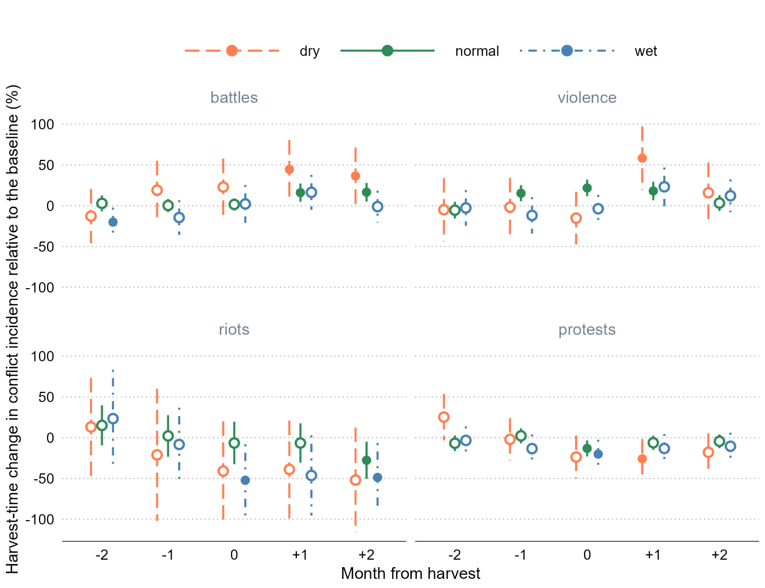

**Figure 5: The impact of the growing season weather on harvest-time dynamics of conflicts**

Note: The point estimates are in percentage terms calculated as: , where is the parameter estimate associated with each considered month of the harvest window (a five-month period centered on the harvest month) and each considered growing season weather (dry, normal, and wet, as described in Table 8), and is the baseline conflict incidence (which vary by conflict type and are presented in Table 8, for example). The error-bars extend , where is the standard error adjusted to clustering at the level of a cell. Filled circles show the statistically significant point estimates at 0.05 level.

This additional test further clarifies the previously presented suggestive evidence regarding the channels through which harvest-time change in income may be responsible for changes in conflict at that period and offers some additional insights. Specifically, while the harvest-time negative relationship between growing season rainfall and battles is maintained across the considered months around harvest, we also observe the unusual spike in violence against civilians at or in the immediate aftermath of harvest. This suggests that in the wake of unusually dry—and, therefore, damaging to crop yields—growing season, harvest-time violence becomes largely a byproduct of broader political conflict. This is consistent with the ‘living off the land’ theory of Koren and Bagozzi (2017), who propose that in times of war, any co-optation between fighters and farmers breaks down, which leads to more violence.

The foregoing does not undermine rapacity as the key driver in the harvest-time violence against civilians: consistent with previous estimates, we still observe considerable and statistically significant increase in this conflict time during the three-month window centered on harvest, which happens only in years with presumably rich harvest.

The inverted V-shaped relationship in relation to crop growing season rainfall is maintained across the considered months for both forms of social unrest. As in previous tests, the relative effect is seemingly amplified in the case of riots, primarily owing to its low baseline incidence. More generally, all estimated parameters for this form of conflict are estimated with little precision. The U-shaped relationship in relation to months of harvest is maintained across the three regimes of the crop growing season rainfall. That both forms of social unrest at the time of harvest but do not quickly revert to pre-harvest levels, which would be consistent with the opportunity cost mechanism, or do not increase beyond pre-harvest levels, which would accord with the resentment mechanism, suggests the possibility of additional factors driving this pattern. That this pattern, in some ways, is a mirror image of that of the battles, indicates that there may be a substitution in these conflict types: when and where active battles unfold may not be an opportune time or suitable place for protests and riots. However, Vüllers and Krtsch (2020) argue against this conjecture and present empirical evidence supporting their argument. The relationship, of course, can be context specific, but we leave this for future research to consider.

**7. Conclusion**

Can the seasonal nature of employment and income in the agricultural sector lead to temporal changes in social conflict? We address this question by examining more than a decade of granular data on different types of conflict across ten countries in Southeast Asia. We find strong empirical support for the rapacity mechanism that leads to more violence against civilians at harvest time. Evidence in support for the opportunity cost mechanism leading to less protests and riots is weak and sensitive to data subsetting or different mode specifications. Using additional data on weather, irrigation, and population density, we examine heterogeneous effects and investigate mechanisms that help explain the seasonal dynamics of conflict.

We make several contributions to the literature on conflict and agricultural shocks. To better understand the pathways between harvest-time violence and conflict, we disaggregate conflict into two types of conflict which are often carried out by different groups of people for different reasons – violence against civilians, as well as battles and explosions, usually carried out by the state, allied militias, or anti-state insurgent groups; and protests and riots, often against state policies, by civilians. Instead of resolving the debate over the mechanisms of resource-related conflict on one side or the other, we suggest that different types of conflict (usually instigated by different types of conflict actors) are related to seasonal agricultural output through different mechanisms: conflict *by* civilians is better understood through the opportunity cost mechanism, while conflict *against* civilians is better understood through the rapacity mechanism.

The findings of the study present important insights for conflict resolution and development policy. The knowledge that political violence and social unrest in rural Southeast Asia can be linked to the rice harvest months can aid the more effective planning by local governments and, particularly, international agencies that are concerned with rural development programs.

**References**

Andrews, S. (2017). Packed Lunch Protesters: Outrage for Hire in Indonesia. *The Diplomat*, 3 February, <https://thediplomat.com/2017/02/packed-lunch-protesters-outrage-for-hire-in-indonesia/>

Berman, E., Callen, M., Felter, J. H., and J. N. Shapiro (2011). Do Working Men Rebel? Insurgency and Unemployment in Afghanistan, Iraq, and the Philippines. *Journal of Conflict Resolution, 55*(4): 496–528.

Berman, N. and M. Couttenier (2015). External Shocks, Internal Shots: The Geography of Civil Conflicts. *The Review of Economics and Statistics 97*(4), 758–776.

Buhaug, H., & Rød, J. K. (2006). Local Determinants of African Civil Wars, 1970–2001. *Political Geography 25*(3), 315–335.

Buhaug, H., T. A. Benjaminsen, E. Sjaastad, and O. M. Theisen (2015). Climate Variability, Food Production Shocks, and Violent Conflict in Sub-Saharan Africa. *Environmental Research Letters 10*(12), 125015.

Burke, M. B., Miguel, E., Satyanath, S., Dykema, J. A., and Lobell, D. B. (2009). Warming Increases the Risk of Civil War in Africa. *Proceedings of the National Academy of Sciences, 106*(49), 20670–20674.

Collier, P. and A. Hoeffler (1998). On Economic Causes of Civil War. *Oxford Economic Papers 50*(4), 563–573.

Crost, B., Duquennois, C., Felter, J. H., and Rees, D. I. (2018). Climate Change, Agricultural Production and Civil Conflict: Evidence From the Philippines. *Journal of Environmental Economics and Management, 88*, 379–395.

Crost, B., and J. H. Felter (2020). Export crops and civil conflict. *Journal of the European Economic Association, 18*(3), 1484–1520.

Crost, B., Felter, J. H., Mansour, H., and D. I. Rees (2020). Narrow Incumbent Victories and Post-election Conflict: Evidence From the Philippines. *The World Bank Economic Review, 34*(3), 767–789.

Dell, M., Jones, B. F., and Olken, B. A. (2014). What Do We Learn from the Weather? The New Climate-Economy Literature. *Journal of Economic Literature, 52*(3), 740–798.

Dube, O. and J. F. Vargas (2013). Commodity Price Shocks and Civil Conflict: Evidence from Colombia. Review of Economic Studies 80(4), 1384–1421.

Ekhator-Mobayode, U. E., Hanmer, L. C., Rubiano-Matulevich, E., and D. J. Arango (2022). The Effect of Armed Conflict on Intimate Partner Violence: Evidence from the Boko Haram Insurgency in Nigeria. *World Development 153*, 105780.

FAO (2023). Food and Agriculture Organisation of the United Nations, https://www.fao.org/faostat/en/#data/QCL

Fearon, J. D., and Laitin, D. D. (2003). Ethnicity, Insurgency, and Civil War. *American Political Science Review, 97*(1), 75–90.

Fjelde, H. (2015). Farming or Fighting? Agricultural Price Shocks and Civil War in Africa. *World Development 67*, 525–534.

Fu, J., Jian, Y., Wang, X., Li, L., Ciais, P., Zscheischler, J., Wang, Y., Tang, Y., Müller, C., Webber, H., Yang, B., Wu, Y., Wang, Q., Cui, X., Huang, W., Liu, Y., Zhao, P., Piao, S., and F. Zhou (2023). Extreme Rainfall Reduces One-Twelfth of China’s Rice Yield Over the Last Two Decades. *Nature Food 4*, 416–426.

Gatti, N., Baylis, K., and B. Crost (2021). Can Irrigation Infrastructure Mitigate the Effect of Rainfall Shocks on Conflict? Evidence From Indonesia. *American Journal of Agricultural Economics, 103*(1), 211–231.

Grasse, D. (2022). Oil Crops and Social Conflict: Evidence from Indonesia. *Journal of Conflict Resolution, 66*(7-8): 1422–1448.

Guardado, J. and S. Pennings (2023). The Seasonality of Conflict. Conflict Management and Peace Science (accepted).

Harari, M. and E. La Ferrara (2018). Conflict, Climate, and Cells: A Disaggregated Analysis. *Review of Economics and Statistics 100*(4): 594–608.

Hendrix, C. S., and S. Haggard (2015). Global Food Prices, Regime Type, and Urban Unrest in the Developing World. *Journal of Peace Research 52*(2): 143–57.

Hsiang, S. M., Burke, M., and E., Miguel (2013). Quantifying the Influence of Climate on Human Conflict. *Science, 341*(6151), 1235367.

IFPRI (2019). International Food Policy Research Institute. Global Spatially Disaggregated Crop Production Statistics Data for 2010 Version 2.0, https://doi.org/10.7910/DVN/PRFF8V, Harvard Dataverse, V4

Koren, O. (2018). Food Abundance and Violent Conflict in Africa. *American Journal of Agricultural Economics 100*(4), 981–1006.

Koren, O. (2019). Food Resources and Strategic Conflict. *Journal of Conflict Resolution 63*(10), 2236–2261.

Koren, O., and B. E. Bagozzi (2017). Living Off the Land: The Connection Between Cropland, Food Security, and Violence Against Civilians. *Journal of Peace Research 54*(3), 351–364.

Koubi, V. (2019). Climate Change and Conflict. *Annual Review of Political Science, 22*, 343–360.

Lansigan, F. P., De Los Santos, W. L., and J. O. Coladilla (2000). Agronomic Impacts of Climate Variability on Rice Production in the Philippines. Agriculture, *Ecosystems & Environment, 82*(1-3), 129–137.

Mampilly, Z., and Stewart, M. A. (2021). A typology of rebel political institutional arrangements. *Journal of Conflict Resolution, 65*(1), 15–45.

Maystadt, J.-F. and O. Ecker (2014). Extreme Weather and Civil War: Does Drought Fuel Conflict in Somalia Through Livestock Price Shocks? *American Journal of Agricultural Economics 96*(4), 1157–1182.

McGuirk, E. and M. Burke (2020). The Economics Origins of Conflict in Africa. *Journal of Political Economy 128*, 3940–3997.

McGuirk, E. and N. Nunn (2023). Transhumant Pastoralism, Climate Change and Conflict in Africa. *Review of Economics Studies* (accepted).

Mitra, A., & Ray, D. (2014). Implications of an Economic Theory of Conflict: Hindu-Muslim Violence in India. *Journal of Political Economy 122*(4), 719–765.

Mohanty, S. (2012) “Why does everyone hate the Thai rice mortgage scheme?” *Food Navigator Asia*, 13 November. https://www.foodnavigator-asia.com/Article/2012/11/13/Why-does-everyone-hate-the-Thai-rice-mortgage-scheme.

Monfreda, C., N. Ramankutty, and J. A. Foley (2008). Farming the Planet: 2. Geographic Distribution of Crop Areas, Yields, Physiological Types, and Net Primary Production in the Year 2000, *Global Biogeochemical Cycles 22*, GB1022

Panza, L., and E. L. Swee (2023). Fanning the Flames: Rainfall Shocks, Inter‐Ethnic Income Inequality, and Conflict Intensification in Mandate Palestine. *Journal of Economic Behavior & Organization, 206*, 71–94.

Raleigh, C., A. Linke, H. Hegre, and J. Karlsen (2010). Introducing ACLED: An Armed Conflict Location and Event Dataset: Special Data Feature. *Journal of Peace Research 47(5)*, 651–660.

Raleigh, C. (2012). Violence Against Civilians: A Disaggregated Analysis. *International Interactions, 38*(4), 462–481.

Raleigh, C., and Choi, H. J. (2017). Conflict Dynamics and Feedback: Explaining Change in Violence against Civilians within Conflicts. *International Interactions, 43*(5), 848–878.

Raleigh, C., Choi, H. J., and Kniveton, D. (2015). The Devil Is In the Details: An Investigation of the Relationships Between Conflict, Food Price and Climate Across Africa. *Global Environmental Change 32*, 187–199.

Sacks, W.J., D. Deryng, J.A. Foley, and N. Ramankutty (2010). Crop Planting Dates: An Analysis of Global Patterns. *Global Ecology and Biogeography 19*, 607–620

Smith, T. G. (2014). Feeding Unrest: Disentangling the Causal Relationship between Food Price Shocks and Sociopolitical Conflict in Urban Africa. *Journal of Peace Research 51*(6), 679– 95.

Ubilava, D., et al. (2022). "Agricultural windfalls and the seasonality of political violence in Africa." *American Journal of Agricultural Economics* (in press).

Vestby, J. (2019). Climate Variability and Individual Motivations for Participating in Political Violence. *Global Environmental Change 56*, 114–123.

Vüllers, J., & Krtsch, R. (2020). Raise Your Voices! Civilian Protest in Civil Wars. *Political Geography 80*, 102183.

de Winne, J. and Peersman, G. (2021) The Impact of Food Prices on Conflict Revisited. *Journal of Business & Economic Statistics 39*(2), 547–560.

Wischnath, G., and Buhaug, H. (2014). Rice or Riots: On Food Production and Conflict Severity Across India. *Political Geography 43*, 6–15.

World Bank (2022a). World Bank Country and Lending Groups. The World Bank Group. https://datahelpdesk.worldbank.org/knowledgebase/articles/906519-world-bank-country-and-lending-groups. Accessed 10 Nov 2022.

World Bank (2022b). World Development Indicators. Poverty headcount ratio at national poverty lines (% of population) [Data file]. https://data.worldbank.org/indicator/SI.POV.NAHC

World Bank (2022c). World Development Indicators. Employment in agriculture (% of total employment) [Data file]. https://data.worldbank.org/indicator/SL.AGR.EMPL.ZS

APPENDICES

APPENDIX A. FIGURES

**Figure A1: Distribution of the proportion of irrigated rice croplands**

Note: Data are from IFRPI (2019), and cover Cambodia, Indonesia, Laos, Malaysia, Myanmar, Philippines, Thailand, and Vietnam.

**Figure A2: The proportion of irrigated croplands and the size of cropland areas**

Note: Data are from IFRPI (2019), and cover Cambodia, Indonesia, Laos, Malaysia, Myanmar, Philippines, Thailand, and Vietnam.

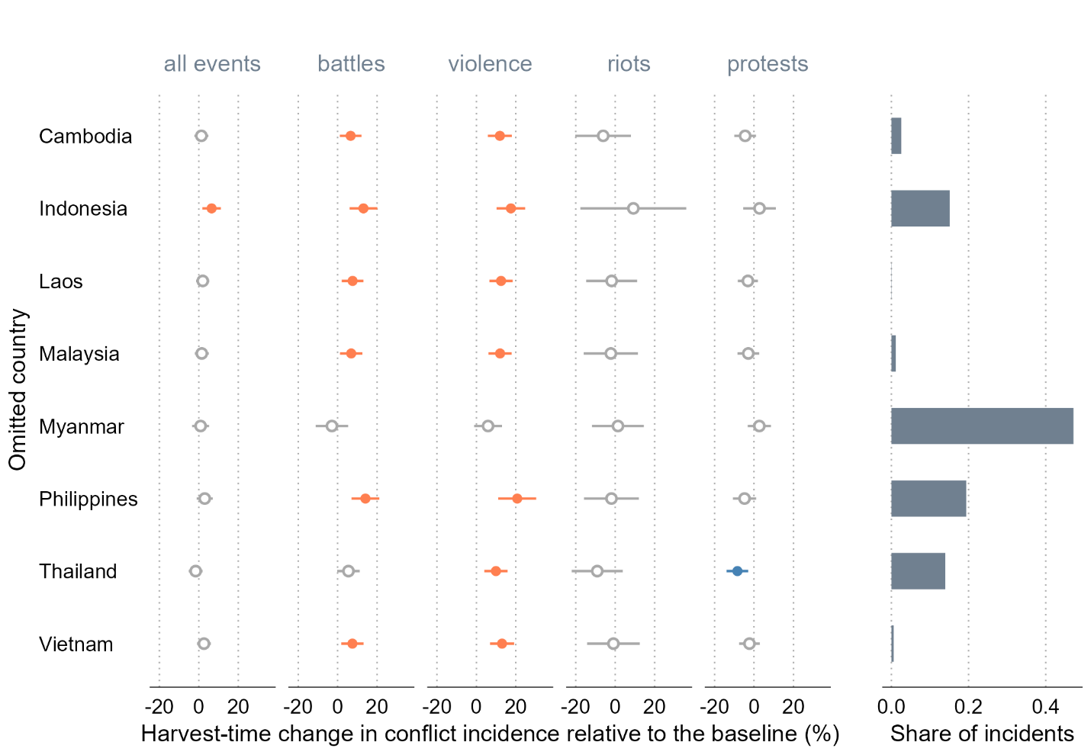

**Figure A3: Sensitivity of the estimates to omitting one country at a time from the dataset**

Note: The dots indicate point estimates, and the error bars show 95% confidence intervals around the point estimates; the confidence intervals are obtained using standard errors adjusted to clustering at the level of a cell. The colored dots and error bars show the impacts that are statistically significantly positive (orange) or negative (blue) at 5% level. The impact, presented in percentage terms, is calculated as: , where is the parameter estimate, and is the baseline conflict incidence.

**Figure A4: Sensitivity of the estimates to omitting one year at a time from the dataset**

Note: The dots indicate point estimates, and the error bars show 95% confidence intervals around the point estimates; the confidence intervals are obtained using standard errors adjusted to clustering at the level of a cell. The colored dots and error bars show the impacts that are statistically significantly positive (orange) or negative (blue) at 5% level. The impact, presented in percentage terms, is calculated as: , where is the parameter estimate, and is the baseline conflict incidence.

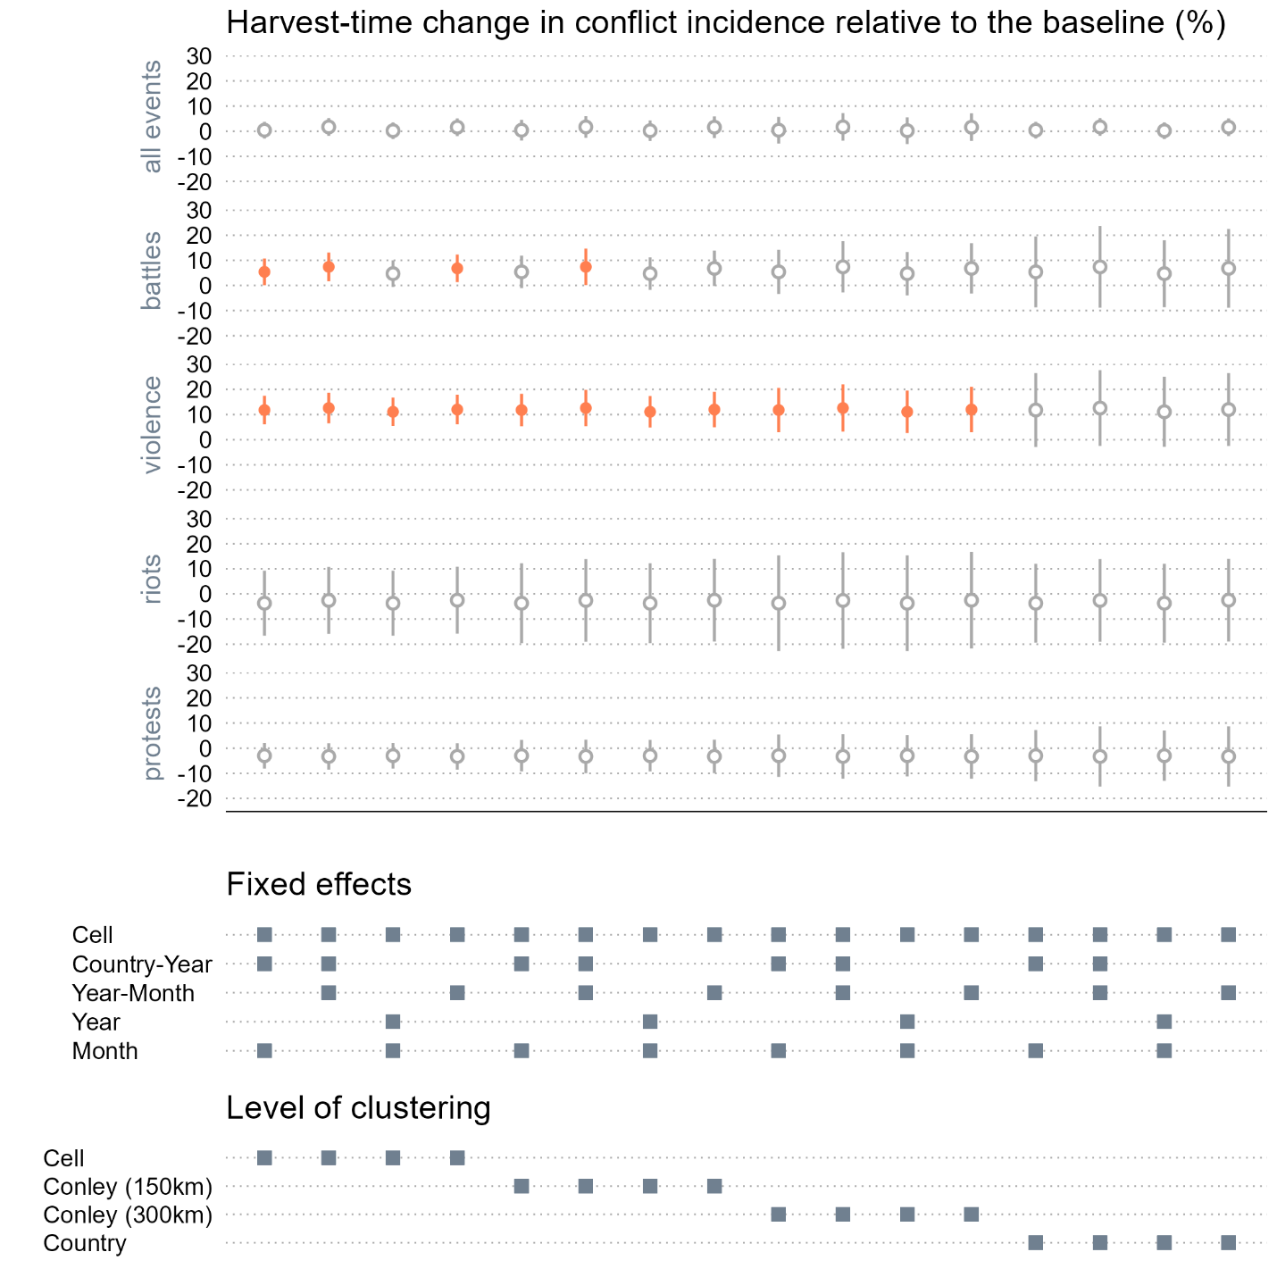

**Figure A5: Specification chart**

Note: In the top panel, the dots indicate point estimates, and the error bars show 95% confidence intervals around the point estimates. The colored dots and error bars show the impacts that are statistically significantly different from zero at 5% level. The impact, presented in percentage terms, is calculated as: , where is the parameter estimate, and is the baseline conflict incidence. The bottom panel identifies different combinations of the fixed effects and levels of error clustering.

**Figure A6: The estimated impacts using randomly assigned harvest seasons**

Note: In the top panel, the dots indicate point estimates, and the error bars show 95% confidence intervals around the point estimates; the confidence intervals are obtained using standard errors adjusted to clustering at the level of a cell. The colored dots and error bars show the impacts that are statistically significantly positive (orange) or negative (blue) at 5% level. In the bottom panel, the densities are those of the point estimates. The impact, presented in percentage terms, is calculated as: , where is the parameter estimate, and is the baseline conflict incidence.

APPENDIX B. TABLES

**Table B1: The harvest-time change in conflict incidence in the croplands of Southeast Asia**

|  | **All events** | **Battles** | **Violence** | **Riots** | **Protests** |
| --- | --- | --- | --- | --- | --- |
| *Balanced panel: all countries, years 2018-2022* | | | | | |
| Cropland×Harvest | -0.002 | 0.016*** | 0.016*** | -0.005 | -0.018*** |
|  | (0.007) | (0.004) | (0.005) | (0.003) | (0.007) |
| Obs. | 22,560 | 22,560 | 22,560 | 22,560 | 22,560 |
| R2 | 0.506 | 0.575 | 0.508 | 0.227 | 0.413 |
| *Magnitude of the estimated effect relative to the baseline conflict incidence in the croplands (%):* | | | | | |
| *Baseline conflict incidence:* | 0.37 | 0.15 | 0.15 | 0.05 | 0.24 |
| Cropland×Harvest | -0.5 | 10.4*** | 10.6*** | -10.3 | -7.6*** |
|  | (1.9) | (2.9) | (3.4) | (6.8) | (2.7) |

Note: The outcome variable is the indicator for the presence of conflict in a cell in a year-month; the treatment variable is the cropland indicator interacted with the harvest-season binary variable; the column headed by ‘All events’ combines all forms of conflict, the column headed by ‘Battles’ combines battles and explosions/remote violence, the remaining columns represent the separate event types as labeled. All regressions include cell, country-year, and year-month fixed effects, and control for contemporaneous rainfall; the values in parentheses are standard errors adjusted to clustering at the level of a cell; ***, **, and * denote 0.01, 0.05, and 0.10 statistical significance levels. The magnitudes of the effect, presented in percentage terms, are calculated as: , where is the parameter estimate, and is the baseline conflict incidence—the unconditional mean of the outcome variable.

**Table B2: The harvest-time change in conflict incidence in the croplands of Southeast Asia**

|  | **All events** | **Battles** | **Violence** | **Riots** | **Protests** |
| --- | --- | --- | --- | --- | --- |
| *Unbalanced panel: all countries except Indonesia, Malaysia, and Philippines, all years* | | | | | |
| Cropland×Harvest | 0.019** | 0.020** | 0.022*** | 0.002 | 0.000 |
|  | (0.008) | (0.005) | (0.005) | (0.003) | (0.007) |
| Obs. | 26,052 | 26,052 | 26,052 | 26,052 | 26,052 |
| R2 | 0.399 | 0.485 | 0.389 | 0.125 | 0.309 |
| *Magnitude of the estimated effect relative to the baseline conflict incidence in the croplands (%):* | | | | | |
| *Baseline conflict incidence:* | 0.23 | 0.10 | 0.08 | 0.02 | 0.14 |
| Cropland×Harvest | 8.2** | 20.7*** | 28.4*** | 10.8 | 0.0 |
|  | (3.3) | (4.8) | (6.0) | (16.1) | (4.9) |

Note: The outcome variable is the indicator for the presence of conflict in a cell in a year-month; the treatment variable is the cropland indicator interacted with the harvest-season binary variable; the column headed by ‘All events’ combines all forms of conflict, the column headed by ‘Battles’ combines battles and explosions/remote violence, the remaining columns represent the separate event types as labeled. All regressions include cell, country-year, and year-month fixed effects, and control for contemporaneous rainfall; the values in parentheses are standard errors adjusted to clustering at the level of a cell; ***, **, and * denote 0.01, 0.05, and 0.10 statistical significance levels. The magnitudes of the effect, presented in percentage terms, are calculated as: , where is the parameter estimate, and is the baseline conflict incidence—the unconditional mean of the outcome variable.

**Table B3: The harvest-time change in conflict incidents in the croplands of Southeast Asia**

|  | **All events** | **Battles** | **Violence** | **Riots** | **Protests** |
| --- | --- | --- | --- | --- | --- |
| *Unbalanced panel: all countries, all years* | | | | | |
| Cropland×Harvest | 0.004 | 0.112** | 0.109*** | -0.009 | -0.208*** |
|  | (0.083) | (0.047) | (0.033) | (0.007) | (0.062) |
| Obs. | 44,724 | 44,724 | 44,724 | 44,724 | 44,724 |
| R2 | 0.394 | 0.373 | 0.391 | 0.146 | 0.296 |
| *Magnitude of the estimated effect relative to the baseline conflict incidents in the croplands (%):* | | | | | |
| *Baseline conflict incidents:* | 2.01 | 0.74 | 0.46 | 0.06 | 0.75 |
| Cropland×Harvest | 0.2 | 15.1** | 24.0*** | -15.3 | -27.7*** |
|  | (4.1) | (6.3) | (7.3) | (11.9) | (8.3) |

Note: The outcome variable is the indicator for the presence of conflict in a cell in a year-month; the treatment variable is the cropland indicator interacted with the harvest-season binary variable; the column headed by ‘All events’ combines all forms of conflict, the column headed by ‘Battles’ combines battles and explosions/remote violence, the remaining columns represent the separate event types as labeled. All regressions include cell, country-year, and year-month fixed effects, and control for contemporaneous rainfall; the values in parentheses are standard errors adjusted to clustering at the level of a cell; ***, **, and * denote 0.01, 0.05, and 0.10 statistical significance levels. The magnitudes of the effect, presented in percentage terms, are calculated as: , where is the parameter estimate, and is the baseline conflict incidence—the unconditional mean of the outcome variable.

**Table B4: The harvest-time change in conflict incidents in the croplands of Southeast Asia**

|  | **All events** | **Battles** | **Violence** | **Riots** | **Protests** |
| --- | --- | --- | --- | --- | --- |
| *Unbalanced panel: all countries, all years, excluding Myanmar 2021-2022* | | | | | |
| Cropland×Harvest | 0.067 | -0.009 | 0.067** | -0.002 | 0.012 |
|  | (0.059) | (0.025) | (0.032) | (0.006) | (0.034) |
| Obs. | 43,308 | 43,308 | 43,308 | 43,308 | 43,308 |
| R2 | 0.506 | 0.459 | 0.408 | 0.181 | 0.458 |
| *Magnitude of the estimated effect relative to the baseline conflict incidents in the croplands (%):* | | | | | |
| *Baseline conflict incidents:* | 1.36 | 0.41 | 0.36 | 0.06 | 0.54 |
| Cropland×Harvest | 4.9 | -2.3 | 18.6** | -4.3 | 2.3 |
|  | (4.3) | (6.1) | (8.8) | (10.2) | (6.2) |

Note: The outcome variable is the indicator for the presence of conflict in a cell in a year-month; the treatment variable is the cropland indicator interacted with the harvest-season binary variable; the column headed by ‘All events’ combines all forms of conflict, the column headed by ‘Battles’ combines battles and explosions/remote violence, the remaining columns represent the separate event types as labeled. All regressions include cell, country-year, and year-month fixed effects, and control for contemporaneous rainfall; the values in parentheses are standard errors adjusted to clustering at the level of a cell; ***, **, and * denote 0.01, 0.05, and 0.10 statistical significance levels. The magnitudes of the effect, presented in percentage terms, are calculated as: , where is the parameter estimate, and is the baseline conflict incidence—the unconditional mean of the outcome variable.

**Table B5: Harvest-time change in conflict incidence by levels of rainfall in growing season**

|  | **All events** | **Battles** | **Violence** | **Riots** | **Protests** |
| --- | --- | --- | --- | --- | --- |
| *Unbalanced panel: all countries, all years* | | | | | |
| Cropland×Harvestm-2×Dry | 0.005 | −0.014 | −0.005 | 0.005 | 0.044* |
|  | (0.026) | (0.019) | (0.021) | (0.011) | (0.025) |
| Cropland×Harvestm-2×Normal | −0.012 | 0.003 | −0.006 | 0.005 | −0.012 |
|  | (0.009) | (0.006) | (0.005) | (0.004) | (0.009) |
| Cropland×Harvestm-2×Wet | −0.002 | −0.022** | −0.003 | 0.008 | −0.006 |
|  | (0.017) | (0.010) | (0.012) | (0.011) | (0.015) |
| Cropland×Harvestm-1×Dry | 0.030 | 0.021 | −0.002 | −0.007 | −0.004 |
|  | (0.026) | (0.020) | (0.019) | (0.014) | (0.023) |
| Cropland×Harvestm-1×Normal | 0.013 | 0.000 | 0.016*** | 0.001 | 0.004 |
|  | (0.008) | (0.005) | (0.005) | (0.005) | (0.008) |
| Cropland×Harvestm-1×Wet | −0.037** | −0.016 | −0.012 | −0.003 | −0.023 |
|  | (0.017) | (0.012) | (0.012) | (0.008) | (0.016) |
| Cropland×Harvestm×Dry | −0.013 | 0.025 | −0.016 | −0.014 | −0.041* |
|  | (0.025) | (0.020) | (0.017) | (0.011) | (0.024) |
| Cropland×Harvestm×Normal | 0.001 | 0.002 | 0.023*** | −0.002 | −0.023*** |
|  | (0.009) | (0.004) | (0.005) | (0.005) | (0.009) |
| Cropland×Harvestm×Wet | −0.044*** | 0.002 | −0.004 | −0.018** | −0.035** |
|  | (0.017) | (0.013) | (0.009) | (0.008) | (0.016) |
| Cropland×Harvestm+1×Dry | 0.018 | 0.049** | 0.061*** | −0.014 | −0.045** |
|  | (0.025) | (0.020) | (0.021) | (0.011) | (0.022) |
| Cropland×Harvestm+1×Normal | 0.008 | 0.018*** | 0.019*** | −0.002 | −0.011 |
|  | (0.009) | (0.006) | (0.006) | (0.004) | (0.008) |
| Cropland×Harvestm+1×Wet | −0.020 | 0.018 | 0.024* | −0.016* | −0.023 |
|  | (0.017) | (0.012) | (0.013) | (0.009) | (0.016) |
| Cropland×Harvestm+2×Dry | 0.018 | 0.040** | 0.017 | −0.018 | −0.031 |
|  | (0.023) | (0.020) | (0.020) | (0.011) | (0.021) |
| Cropland×Harvestm+2×Normal | 0.008 | 0.018*** | 0.003 | −0.010** | −0.008 |
|  | (0.009) | (0.006) | (0.005) | (0.004) | (0.008) |
| Cropland×Harvestm+2×Wet | −0.007 | −0.001 | 0.013 | −0.017** | −0.018 |
|  | (0.016) | (0.011) | (0.011) | (0.007) | (0.015) |
| Obs. | 44,724 | 44,724 | 44,724 | 44,724 | 44,724 |
| R2 | 0.447 | 0.503 | 0.463 | 0.183 | 0.359 |

Note: The outcome variable is the incidence of conflict in a cell during a year-month; the treatment variable is the cropland binary variable interacted with the harvest-season binary variable; this treatment variable is further interacted with the growing season rainfall categorical variable that splits the effect into those associated with unusually dry, within a normal range, and unusually wet growing season. The column headed by ‘All events’ combines all forms of conflict, the column headed by ‘Battles’ combines battles and explosions/remote violence, the remaining three columns represent the separate event types as labeled. All regressions include cell, country-year, and year-month fixed effects, and control for contemporaneous rainfall; the values in parentheses are standard errors adjusted to clustering at the level of a cell; ***, **, and * denote 0.01, 0.05, and 0.10 statistical significance levels. The magnitudes of the effect, presented in percentage terms, are calculated as: , where is the parameter estimate, and is the baseline conflict incidence—the unconditional mean of the outcome variable.

1. ACLED # 9785083: “On 9 December 2013, in Mung Ding Pa, Kachin state, the Myanmar army shelled civilian rice fields.”
2. ACLED #9679246: “On 22 November 2022, in Zar Haw village (Gangaw township, Gangaw district, Magway region), the Myanmar military IB-50 shot dead a villager in the head during the raid. The military also shot dead two other villagers who were harvesting rice in the paddy fields for unknown reasons.”
3. ACLED #8807873: “On 4 November 2021, west of Pekon township (Taunggyi district, Shan-South), military troops clashed with the joint forces of Pekon PDF, Moebye PDF, Loikaw PDF, Demoso PDF, the KNDF and the Karenni Army. Military troops fired artillery and torched, looted a nearby village and burned harvested rice in paddy fields according to Pekon PDF. At least 20 military troops were killed and a resistance fighter was injured.”
4. ACLED #9641230: “On 11 November 2022, between Aye Ka Bar and Bay La Maing villages (coded as Aye Ka Bar) (Thanbyuzayat township, Mawlamyine district, Mon state), Mon State Mount Taungnyo People Guerrilla Force ambushed a convoy of three military vehicles carrying rice at about 7 am. One military solider was killed and two others were injured.
5. ACLED #9411619: “On 27 June 2022, in Kyunhla town (Kyunhla township, Kanbalu district, Sagaing region), Pyu Saw Htee members detained and killed a 40-year-old rice mill owner from Pi Tauk Pin village, Kanbalu township when he traveled to the Kyunhla town with a companion to buy equipment for his rice mill. The Pyu Saw Htee members seized 1.5 million Kyats, 2 mobile phones and 1 motorcycle from them. It was reported that the rice mill owner was shot dead as he tried to run away near a quarry outside the town. His companion escaped.”
6. ACLED # 7787765: “On 22 March 2021, dozens of students from the Agricultural Student Coalition (Komar) held a peaceful protest in front of their university in UPN Veteran, Yogyakarta city (Yogyakarta province). They opposed the government plan of importing rice. [size=dozens]”

   ACLED # 9103355: “On 24 September 2018, a group of students held a peaceful protest in Medan City, North Sumatra province, demanding the government to stop importing rice. [size=no report]”

   ACLED # 9225485: “On 22 January 2018, in Sukolilo, hundreds of farmers staged a rally to protest against the government's plan to import rice, stating that it will lower local rice prices.”
7. ACLED # 7908847: “Farmers in the province of Phichit staged a protest against the anti-government movement, blasting its attempt to block the government's efforts to secure funds for the rice pledging program. Hundreds of farmers gathered at a major intersection to express their opposition to the People's Democracy Reform Committee (PDRC), who they believed have been blocking the government's attempt to pay rice farmers for rice pledged under the pledging program.”
8. Available at https://simplemaps.com/data/world-cities