Manual for the use of LIMS functions of nmrshiftdb2:
(Stand 15-12-2014):

This is a “how to” with instructions how to submit a sample and download data for processed jobs (submission for orders in automation, self-service and operator mode, download of data). The following instructions are were designed for the instruments of the NMR core facility at the Department of Chemistry, University of Cologne. Thus, spectrometer specifications refer to the local installation which in use at University of Cologne (details on instrumentation can be found in the “Experimental and Methods” section of this paper). Nmrshiftdb2’s LIMS at the University of Cologne is based on three different user profiles, which are described in the two chapters of this handout. To get an impression of Nmrshiftdb2’s optional LIMS functionality, a demo installation for the LIMS is accessible via its web surface at http://www.nmrshiftdb.org (www installation at Cologne University).

1. Functions available for users of the NMR facility

This chapter describes the functionalities which nmrshiftdb2’s LIMS provides for students and scientific users of the NMR lab. The sections give details on the use of the LIMS for spectrometers that run in automation (with or without sample changer), for spectrometers which are operated by NMR facility staff and for trained users, that operate spectrometers in expert mode. Also, the order processing (self-processing option) and data download are explained.

1.1 Submitting an order for the sample changers (DPX300, AV300ac or DPX200) or the AV300oc

• After login with username and password at http://laplace.nmr.uni-koeln.de/ , the “NMR lab administration” menu opens, where the order submission form appears. This is where you have to submit an order for your sample.

• If you want to submit an order to the DPX300, you do not need to change the default options in the fields below “submit a new order”, which are set to „dpx 300“ and “process by automation”; this means that your sample will be submitted for the robot in lab 116 Organic Chemistry. For automated or semi-automated measurements, the option “process on spectrometer” can also be changed to “av300” (robot in lab 212A Inorganic Chemistry), “dpx200” (robot in lab 212A Inorganic Chemistry) or “av300oc” (spectrometer in lab 115 in Organic Chemistry). In all cases, the “automation” option needs to be checked, if you are not an advanced user.

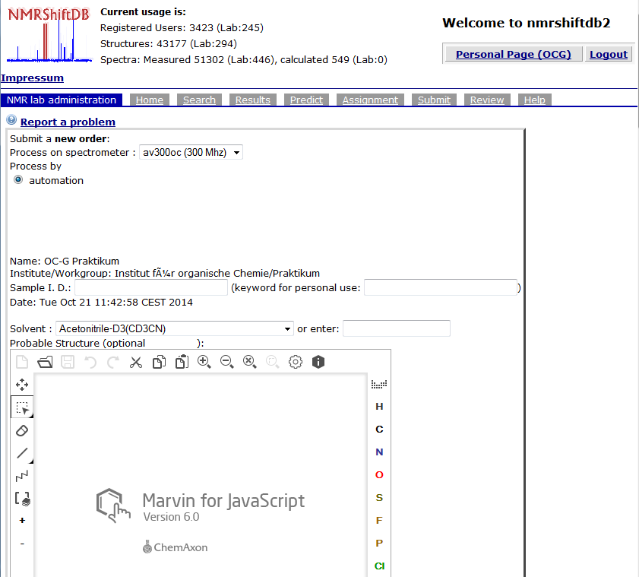

• Please enter the name for your sample in the next field (“sample I.D.”), where only tokens with letters and/or numbers are accepted. Special characters/dashes/spaces etc. are not accepted – please check for the nomenclature on our homepage, http://www.oc.uni-koeln.de/nmr/en_auftrag.html). This name needs to be identical with the name entered on the screen of the ICONNMR software in the field “name”.

• The deuterated solvent has to be entered in the next field – either by hand or by scrolling down and selecting from the solvent list on the right panel.

• Next, if possible enter the assumed structure of the compound with the help of the Marvin editor. Instead, you can also upload a file (accepted format MDL Molfiles), paste a structure after copying as SMILES or select a file from your user „structure history“. You do not have to save the structure after drawing, just continue.

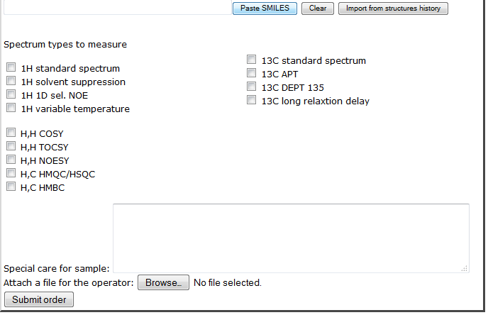

• Enter the desired NMR experiment(s) either by checking one or several of the existing options. Or type the experiment after „Special care for sample“, if the list does not contain it. Also, in case that your sample should be stored in a fridge/freezer, is sensitive to light etc., please enter your remarks in the space „Special care...“. An additional function allows you to send accompanying material (e.g. information for operators, like spectra specifically labelled by the user for NOE experiments etc.).

• Once you click „Submit Order“, your order is activated and scheduled. The software opens a new, empty order form for you. You can either fill this in for the submission of another sample or click on the icon “Logout” in the upper right corner to leave the user area.

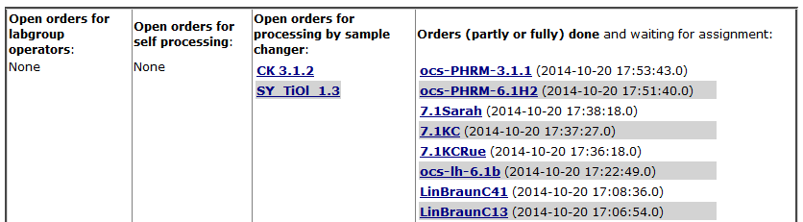

• Once the order submission is completed, the sample I.D. will appear in the column „open orders for processing by sample changer“ of the “order handling” overview. You now have take your sample to the sample changer / AV 300oc and enter the sample I.D. and experiment information on the spectrometer workstation or process the experiment at the AV 300oc as guided by the software. Once the sample changer has processed your order or you have completed your measurement at the AV 300oc, file(s) will be moved to the spectra server, and the order will appear in the column “The following orders have been...done” of the “order handling” overview. It then can be downloaded, processed and assigned as described in the next section.

• Important: Wrongly or erroneously submitted orders can be deleted by checking the box („confirm deletion by checking“) under the structure editor and clicking on „delete order“!

1.2 Downloading spectra files after completed measurement

• Once a measurement is completed you can directly download the corresponding spectra file(s). Also, you can check in between the progress of your orders. To do so, you have to log in at the homepage of the NMRshiftDB (http://laplace.nmr.uni-koeln.de/) as described above. In the „NMR lab administration“ window, you see below the „order handling“ bar four columns: „...open orders for lab group operators“ (= orders which will be processed by NMR facility staff), „...open orders for self processing“ (= orders which you have to measure for yourself, if you are and advanced user), „...orders for processing by sample changer“ (= orders for sample changer) and „...orders … done“ (= completed orders) in the fourth column.
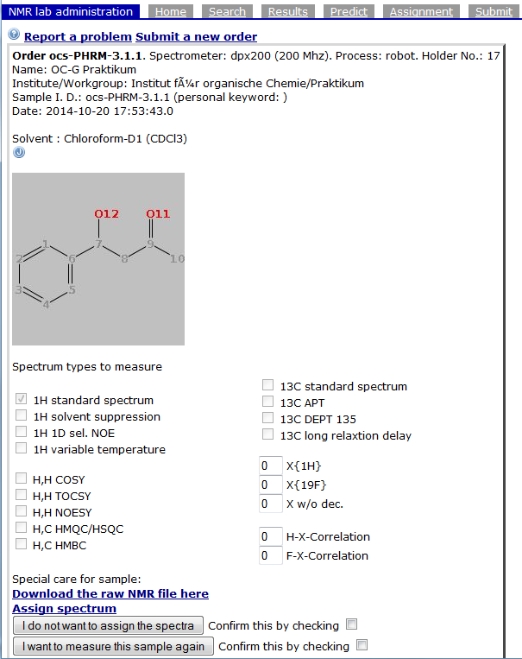
• Orders which appear in the latter column can be downloaded after clicking on the highlighted file name. After clicking, you will be presented with the assumed structure of the compound. Directly underneath the structure window you find the link „Download the raw NMR file here“, which allows you to download your file(s) in zip format.

• Download and extract your spectra and open them e.g. with SpinWorks or TopSpin.

• Now you can assign your spectra, if they served as a full characterisation (meaning 1D and 2D) of your compound and not only for reaction control purposes, or if the compound has been assigned electronically already. For this purpose, move on to the assignment handout. If you would like to do the assignment later, you can log out now without deleting the order, which allows you to return back at any time and continue with the next step. If you do not want to perform an assignment of your spectrum and have saved your data, you can delete the order: Check the box “confirm deletion…” and click in “Delete order”.

1.3 Order submission form for service measurements (experiments performed by an NMR lab operator)

• After login, in “NMR lab administration” the order submission form window appears. You should select the desired, staff-operated spectrometer (AV 400, DRX 500 or AV 600) and keep the option „I want this order to be processed by a lab operator“, which means that a staff member of the NMR facility will record spectra for you.

• Please enter the name for your sample in the next field (“sample I.D.”) where only tokens with letters and/or numbers are accepted. Special characters/dashes/spaces etc. are not accepted – please check for the nomenclature on our homepage, http://www.oc.uni-koeln.de/nmr/en_auftrag.html).

• The deuterated solvent has to be entered in the next field – either by typing or by scrolling down and selecting from the solvent list on the right panel.

• Next, enter the assumed structure of the compound with the help of the Marvin editor. Instead, you can also upload a file (accepted format MDL Molfiles), paste a structure after copying as SMILES or select a file from your user „structure history“ (however, this contains only the history of the current session). You do not have to save the structure after drawing, just continue.

• Enter the desired NMR experiments either by checking one or several of the existing options. In case that your sample should be picked up and/or stored in a fridge/freezer, is sensitive to light and so on, please enter your remarks in the space „Special care...“. An additional function allows you to send accompanying material (information for operators, e.g. spectra specifically labelled by the user for NOE experiments etc.).

• Once you click „Submit Order“, your order is activated and scheduled. The software opens a new, empty order form for you. You can either fill this in for the submission of another sample or click on the icon “Logout” in the upper right corner to leave the user area.

1.4 Processing an order if you record your spectra yourself (“Self processing”, only advanced users – to be used e.g. on the DPX 300)

• Complete the order form as described in the previous sections (make sure that you mark „myself“ for the option „I want this order to be processed by...“) and submit it. Now, the order is listed in the “order handling” category „open orders for self-processing“.

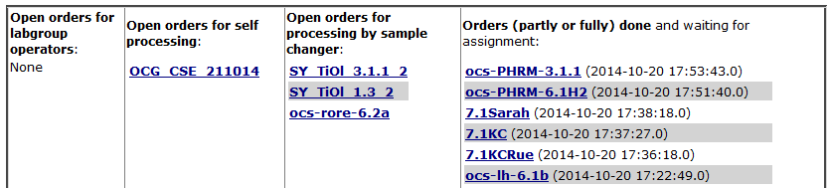

• Once you have recorded your spectra at the spectrometer and would like to pick them up for processing, connect to the database again (http://laplace.nmr.uni-koeln.de/) and log in. In the “NMR lab administration” window, click on the corresponding order name in the column „open orders for self processing“.
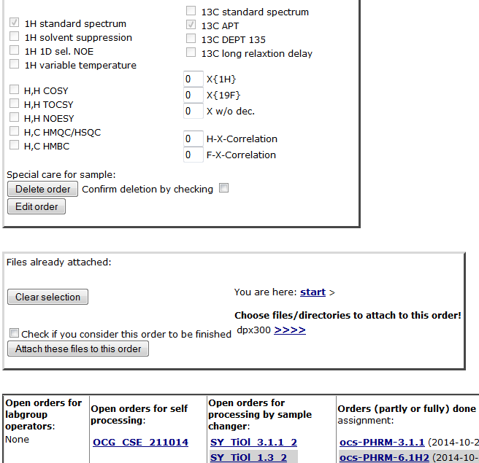
• Below the (now opening) structure editor and below the icon for „Faces Scheduling System“, the spectrometer which you selected for the order (dpx300, …) is presented after the request „Choose files/directories you want...“. Click on the arrows („>>>>“) behind the spectrometer that you used for the experiments. Now, a list of spectra available from this spectrometer becomes visible. For uploading the desired spectrum, click in the file name (not on the arrows „>>>>“ behind it!!!) to select the file. You can click on several names, if you would like to transfer more than one file. Once you have selected the desired files, activate the checkbox below the selection field („Check if you consider this order...“). Click in the icon „Attach these files...“. The files now appear in the „order handling“ category as completed and can be downloaded, processed and assigned as described in section 1.2.

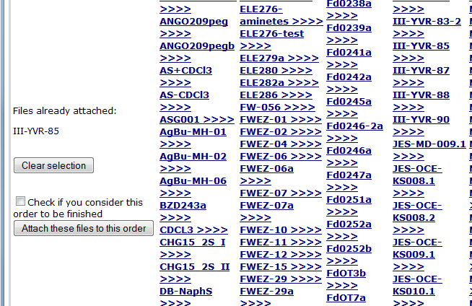

2. LIMS functions available for NMR staff and the facility administrator

In the following, the staff and administrator profiles available in nmrshiftdb2’s LIMS are described. The corresponding sections give details on the use of the LIMS for the processing of orders, the statistics function for accounting, and adjusting the software environment for specific needs (spectrometer operation modes, available experiments etc.).

2.1 Processing of orders

• After logging in with username and password at http://laplace.nmr.uni-koeln.de/, the “NMR lab administration” menu opens, showing in the upper section of the page an overview (table) of existing spectrometers at the NMR facility. Active orders submitted to be processed by NMR facility staff are listed as active links in the columns below the corresponding spectrometers. If the spectrometers are connected to internet and a web browser is available, the entire procedure from opening of the order description through recording of experiments and completing the order by attaching the desired spectral data can be carried out “on site”.

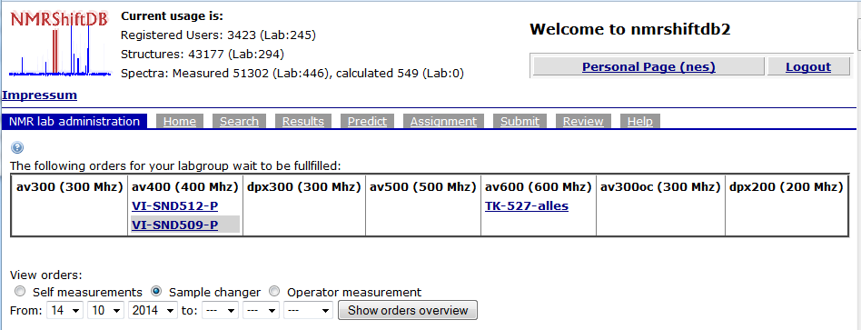

• If a staff member wants to process an active order, the contents of the order become visible after clicking on the link. Besides solvent and structure (if a structure needs to be placed on the order can be selected by the administrator), the desired experiments are visible. Also, if a user wishes to submit specific, additional information (sensitivity of sample, notes to the staff members, attached files with extra information) will be shown in the order form. At this point, the staff member will execute the required NMR experiments, and after completion, transfer the data to the spectra server (local database) with a simple macro. Instead, a fully automated data transfer would be also possible, if desired.

• Now, in the opened order form, the staff member can choose from the list of spectrometer directories shown on the right side of the page (“Choose files/directories...“) the spectrometer, on which the experiment was actually recorded. By clicking on the link (“>>>>“), all the available spectra directories for that instrument will be visible. The one which should be attached to the order is selected by simply clicking on the name link. Now, in the middle of the form (“Files already attached:“), the name of the spectra folder is listed, and, if no further data need to be attached, the order can be completed by checking the box beneath (“Check if you consider this order to be finished“) and clicking on the icon “Attach these files to this order“. Depending on the size of the folder, this might take a few seconds, since the directory will be packed before it becomes available to the user.
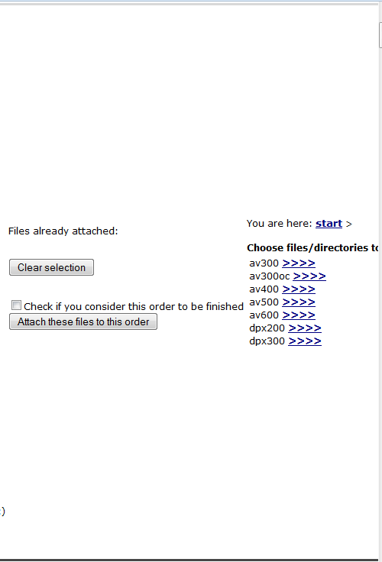
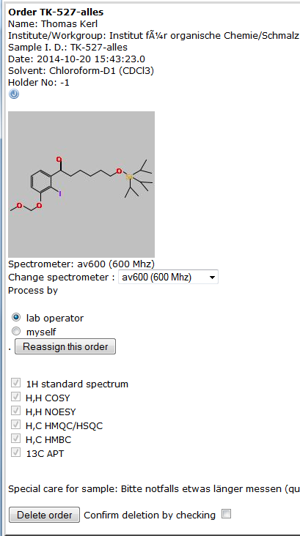

• Once an order has been completed in that manner, it will no longer be visible in the table on top of the page. However, as described in the next paragraph, such orders that were already processed can be brought back when you are looking for them.

2.2 Overseeing of completed orders

• The “NMR lab administration” menu of the operator account also offers an option to control, which experiments were submitted by which user on which spectrometer. In the section of the page just below the overview table (“View orders”), one of the three modes for order submission can be selected at a time, if applicable (“Self measurements”, “Sample changer” or “Operator measurement”). Then, the time frame for the overview needs to be defined, followed by clicking on the “Show orders overview” icon. If nothing is changed in the time frame fields, an overview will be shown for the week until the current date. The result is presented as order lists sorted by spectrometer. Each order can be inspected by simply clicking on the name link to see details.

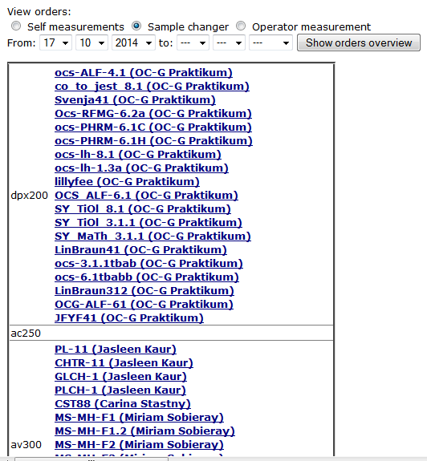

2.3 Handling user accounts

• To be able to utilize the functionalities of nmrshiftdb2’s LIMS, each user needs to register before the “NMR lab administration” menu can be accessed. Users cannot activate their accounts individually upon entering their information in the registration fields – this is to avoid abuse of the free registration menu. Instead, only the facility administrator can grant access for new users by activating their account profile.

• Once a new user has entered and submitted his registration data, the future user profile will be visible for all NMR staff in the center table of the “NMR lab administration” menu. The latter contains besides username and real names of users also their email, affiliation and date of registration (a function that can be helpful to determine inactive user accounts). Only if the facility administrator has activated an account, the field “is member accepted?” will show “yes” as confirmation. Accounts may be deleted after checking the box and clicking on the icon “Check and click to delete…”.

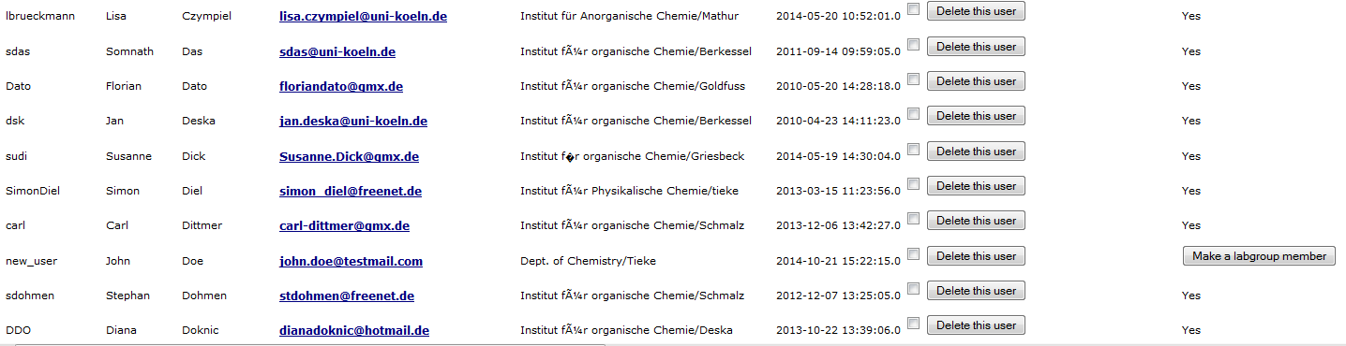

2.4 Adjusting spectrometer operations

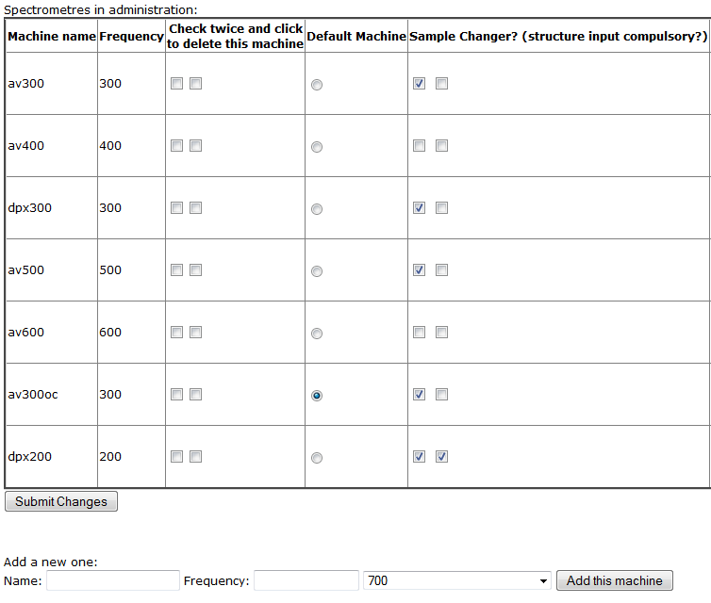
• The spectrometers of the facility can be administrated through the following menu functions: First of all, spectrometers under administration can be defined in the section “spectrometers in administration”. New spectrometers can be defined through the “Add a new one” option below the spectrometer table, where initially only the name/token referring to the instrument, as well as the operating frequency for proton are required. Once the “Add this machine” icon was clicked, the new spectrometer appears in the table and several parameters can be adjusted. If a spectrometer is no longer part of the administrated lab, it can be deleted by checking both (!) boxes in the third column from the left (“Check twice and click…”).

• In the fourth column from the left, the spectrometer which should appear as default instrument in the scroll-down list for orders, can be selected. In the next (fifth) column, the first box needs to be checked if the spectrometer can operate a sample changer, while the second box allows the NMR staff to define, if users have to submit a molecular structure with the order form of the corresponding spectrometer. In the sixth column from the left, the option to have the spectrometer operated by staff for service measurements can be selected when checking the first box, the second one, again, defines if users have to submit a molecular structure with the order form.

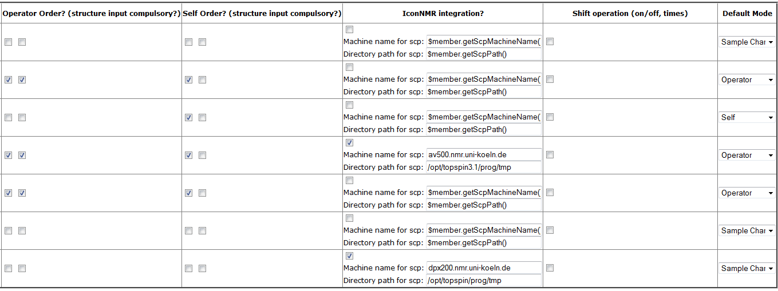

The next column (seventh from the left), a so-called self-order mode may be allowed for a spectrometer. This means, that users might access the spectrometer outside automation in manual mode (e.g. trained or advanced users). This type of users might want to select, which of their spectral data they want to transfer to the server and when they want to attach them to their order form. Therefore, this account type allows access to spectra directories for a specific spectrometer; orders might be completed by users in a similar manner as described for the order processing by staff in section 2.1. In the column “IconNMR integration”, a spectrometer can be marked as ready for integration of the entire process from order submission through activating experiments on a sample changer in automation to attaching spectra to completed orders exclusively by nmrshiftdb2’s LIMS. This means, users will only need to access the web interface of nmrshiftdb2 to submit and start orders in automation, no interaction with the manufacturer’s software is required for them. If spectrometers are operated in time shifts (e.g. peak times and after hours etc.), these can be specified, once the box in the second column from the right (“Shift operation”) is active. The last column serves to determine, which of the possibly selectable modes of operation will be marked as the default mode in the order form visible for NMR users.

2.5 Defining NMR experiments available for orders

• The NMR experiments, which are available in the lab can be defined in the section “spectrometers in administration”. “New” experiments can be created through the option “Add a new one” underneath the table “Experiments possible”. Initially, for the setup of a new experiment, only the name that will be visible in the order form needs to be entered and accepted by clicking the icon “Add this experiment”. Now, the new option appears in the table and several parameters can be adjusted. If an experiment is no longer available in the administrated lab, it can be deleted by checking both (!) boxes in the third column from the left (“Check twice and click…”). The experiments that are defined in this table form the pool, from which can be selected when defining the individual spectrometer option later (section 2.6).

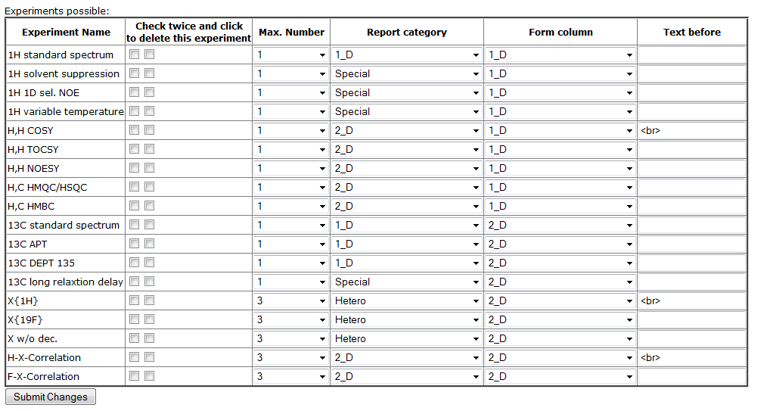

• Currently, there exists an option to limit the maximum number of experiments of each type which might be requested per order (third column). Also, for accounting purposes, a “report category” needs to be defined in the next column (currently available are 1D, 2D, heteronuclear and “special”). The second and the last column from the right allow layout options for the order form visible to users.

2.6 Selecting NMR experiments available for specific spectrometers

• For each spectrometer, when selected by a user in the order form, specific NMR experiments can be assigned. If a routine instrument is supposed to only operate for 1D experiments, then, in the corresponding order form, only 1D experiments will be eligible etc. To define, which type of experiments are visible for which spectrometer, the experiments that were defined in the previous paragraph (section 2.5) can be linked with the spectrometers defined in section 2.4 by completing the table in the section “machine/experiment combinations” of the “NMR lab administration” menu.

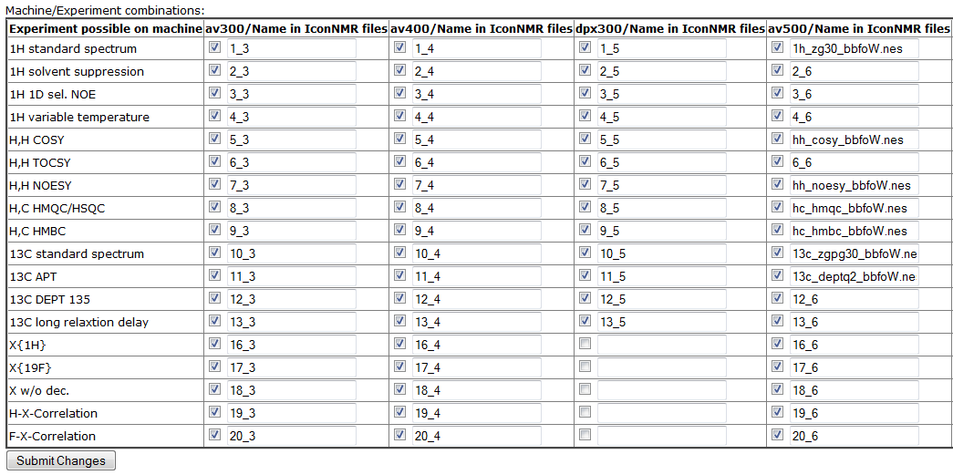

• The table consists of columns for each spectrometer under administration, while each line contains the pre-defined experiments. By checking the box, an experiment becomes visible in the order form of the corresponding spectrometer. The text field behind the box allows to define, which parameter set should be used by spectrometers operating in automation, to prepare the text file which is required for external setup of the automation software.

2.7 Defining solvent tables for spectrometers in automation mode

• If the software that controls spectrometer operation in automated mode is controlled by nmrshiftdb’s LIMS, usually, the deuterated solvent needs to be specified as defined by the spectrometer manufacturer or instrument-internal solvent sheet. To give this information to the spectrometer’s automation software through an external setup file, the table “solvents for orders” needs to be completed for those instruments that can be run in automation mode. Thus, for each column (corresponding to one spectrometer), at the bottom exists a scroll-down list of pre-defined solvents. However, if the desired solvent is not available there, or the notation is different from what is required by the spectrometer software, the free text field below that list might be used to enter the correct specification. Then, by clicking on the icon “Add solvent”, the solvent is transferred into the list of available solvents for the spectrometer.

• To delete a solvent from the list, the two (!) boxes in front of an entry need to be checked and the icon at the bottom of the column has to be activated (“Remove/order solvents…”). If solvent should appear in the scroll-down list visible for users in a certain order, the position can be selected from field behind the solvent entry and defined by clicking the icon “Remove/order solvents…”.
2.8 Using the statistics function for accounting

• At the bottom of the “NMR lab administration” menu, there are two options to derive a summary/résumé of user/staff activities either in a monthly or a yearly presentation. In each of these, the time frame can be selected, and also, currently two types of report are available: In a report of type 1, the experiments are listed in the order of the institutions (e.g. department, subdivided into institutes/divisions, subdivided into research groups). For each lab, then, the number of experiments for each of the instruments, which were used, is listed, divided by the four categories which are currently available (see section 2.5). Currently, no direct connection of the experiments with a corresponding time demand is available, since nmrshiftdb2’s scheduling system is not yet ready for use. In a report of type 2, a more compressed information is derived by only summarizing the instruments plus the number and type of experiments, run in the requested time period.

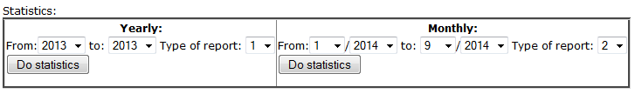

nmrhiftdb2 is developed by Stefan Kuhn and the NMR facility at University of Cologne. The precursor, NMRshiftDB, was the developed by the Steinbeck lab (EBI Cambridge). Further informations are available on the general homepage http://www.nmrshiftdb.org.

