

Quick Check Tutorial

An nmrshiftdb2 account is useful, but not compulsory (registration at www.nmrshiftdb.org)

Visit nmrshiftdb2
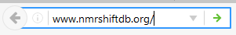
Visit the public version of nmrshiftdb2 using an internet browser of your choice at https://www.nmrshiftdb.org or https://nmrshiftdb.uni-koeln.de.

Login (optional)
Login is optional, but recommended to be able to recall data, and needed for a submit.
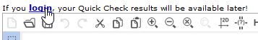

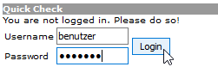
If you login with your user name, you can save Quick Checks you have done and recall them later. A later submit is only possible with a login

Choose the Quick Check tab

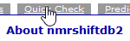
Chose the QuickCheck using the appropriate tab.

Load a file or enter your molecule
The easiest way to import data into the QuickCheck is the import of a file in one of the following formats:
- NMReDATA (imports structure and spectra)
- CMC-SE results (a zip file of the Topsin folder is needed, imports structure and all spectra)
- MNova mol or sd file (imports structure and all spectra)
- Mol file with atom labels (imports structure only)
For doing so, chose the file using „Choose File“ for the right type below the structure editor. The file name appears next to the button. Then hit „Transfer“. The data are loaded and checked. You can progress to item 14 directly.
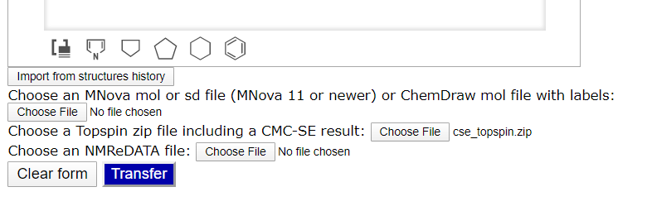
If you want to enter data manually instead of uploading a file, start with entering the structure:
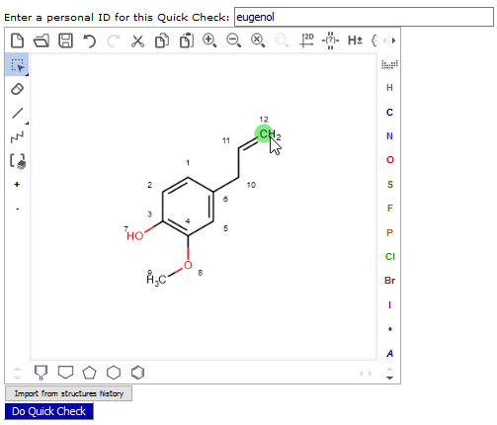
Draw the structure in the editor. Alternatively you can paste SMILES or InChI strings (or various other formats) by the Folder button or by ctrl+v. A copy & paste from ChemDraw is possible via the „copy as SMILES“ option of ChemDraw. You can enter an ID („personal ID“) for the QuickCheck here.

Hit „Transfer“ (optional)
This shows the accurate number of Shift fields. If you are logged in and assigned a „personal ID“, the structure is saved.

Enter the chemical shifts of the structure

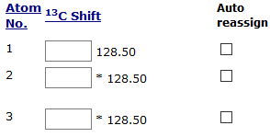
Enter the ¹H and ¹³C shifts in the respective text fields. The suggested value is the result of the nmrshiftdb2 prediction, * indicates a symmetric atom (those are filled automatically if left empty). For CH₂ groups two fields are provided. If you leave the second field empty, the value from the first field is assumed for both protons.

OR

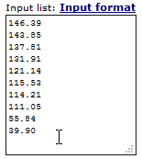
Enter a shift list in the large test field. The QuickCheck tool will suggest an assignment. Unused shifts will be shown in the text field.

Hit „Transfer“

The QuickCheck tool compares your inputs with the prediction and scores the assignments using a traffic light system.
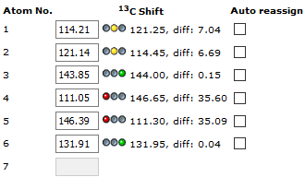

Hetero atom bound protons are not scored due to low prediction reliability. Their assignment can be entered for sake of completeness, though. 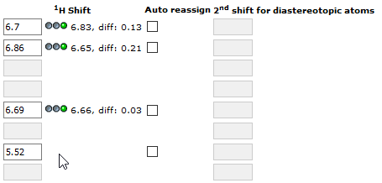
By hitting the headers of the columns you can sort by atom number or prediction vaue.

Correct individual assignments

Enter the corrected shifts in the respective fields and hit „Transfer“ again.

ODER

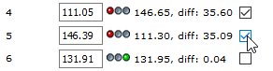
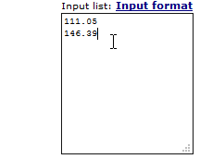
Enter the new shifts in the large text field und choose „Auto reassign“ near the positions, which should be reassigned by the Quick Check. Again, unused shifts will stay in the text field. Hit „Transfer“ again.

Enter 2D correlations (optional)
If you do not have 2D correlations, you can directly proceed to item 13.
Choose the tab „2D Spectra“. There are two tables for entering correlations. The expected correlations are marked in green:
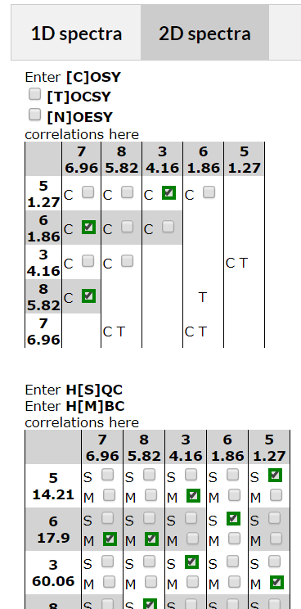

Activate additional spectrum types
By default COSY, HSQC, and HMBC correlations can be entered. TOCSY und NOESY correlations can be added by clicking the relevant checkboxes. 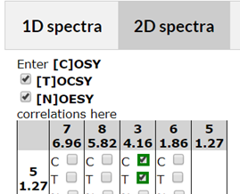

Choose correlations from your spectra
For each spectrum type, you can selected the correlations from the spectra. On the axes of the tables the shifts of the relevant nucleus and the numbers of the assigned atom are shown. For symmetric spectra, the symmetric correlations are added automatically.

Hit „Transfer“

This evaluates the theoretical correlations and compares them to the entered ones.

Check the quality of the data
Ideally all shifts should be scored as green and for 2D spectra the green correlations should be selected. The overall score should be „accept“ for 1D and 2D spectra. The „Show full report“ links next to the scores link to PDF reports for the spectra. The „Show overall report“ link below the 1D spectra links to a report for all spectra. If you are sure that your data are correct (which may be the case with a not optimal score) you have finished the Quick Check..

Submit of finished inputs
If the 13C or the 1H data or both are assigned, those can be written to the database. This is done via the link „Submit 13C/1H“ below the shift list.

Recall saved Quick Checks
You can work on your data over several sessions. For this, you must be logged in and have assigned a „Personal ID“. Past QuickChecks then get saved and are listed below the structure editor:
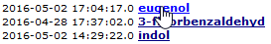
Click on a name to recall a dataset.
QuickChecks can be deleted using the „Delete“ button next to the link.

