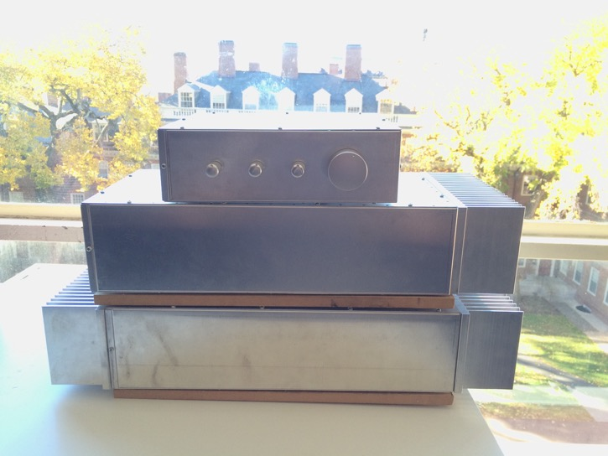

**100 Watt Audio System**

Preamplifier, Subwoofer Amplifier, Stereo Amplifier

MTM Stereo Speakers

10” Ported Subwoofer

Frank DuBose

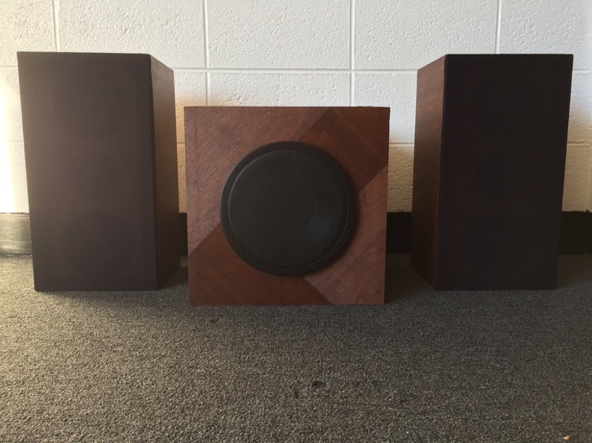

|  |  |  |
| --- | --- | --- |
|  | Stereo Speakers | Subwoofer |
| Primary Material | ¾” Medium Density Fiberboard (MDF) | ¾” MDF |
| Configuration | Mid-Tweeter-Mid (MTM) | Ported |
| Driver Dimensions | 5.5” Midwoofer, 1” Tweeter | Driver: 10”  Port: 3” Dia., 10” Length |
| Stuffing/Lining | Stuffed with batting | Lined with carpet liner |
| Terminals | Binding Posts | Binding Posts |
| Finish Type | Stained Veneer | Stained Veneer |
| Crossover | Passive Linkwitz-Riley | Active Variable Linkwitz-Riley (in preamp) |

|  |  |  |  |
| --- | --- | --- | --- |
|  | Preamplifier | Stereo Amp | Sub Amp |
| Chassis | 1/16” Aluminum (Omni-Chassis) | 1/16” Aluminum (Omni-Chassis) | 1/16” Aluminum (Omni-Chassis) |
| # PCBs or Perf-Boards | 6 | 3 | 2 |
| Transformer | N/A (purchased DC supply) | 400VA Toroid | 200VA Toroid |
| PSU Capacitance | 4,400uF/rail | 40,000uF/rail | 20,000uF/rail |
| Custom PCB? | No | Yes | Yes |
| Amplifier Chip | N/A | Tex. Inst. LM3886 (BR100 setup) x2 | Tex. Inst. LM3886 (BR100 Setup) |

**Before The Project**

The idea of building speakers first came to mind early in college when I was tasked with replacing the surrounds on an old pair of speakers from our basement (surround: a ring of material, often foam, that runs the circumference of a speaker cone, connecting it to the metal frame). As I tried to find more information about surround repair, I discovered that not only do people routinely fix the surrounds themselves, but people also frequently build their own speakers from scratch. After learning the very basics of how a speaker driver works while repairing the surround, I became very interested in the idea of DIY speakers but knew I would need lots of time to tackle such a project.

During my junior spring of college, some promising summer internship opportunities fell through and left me without a solid plan for the summer. I decided I would use the time to build a pair of speakers, giving myself engineering experience while building something interesting to me. When some preliminary digging revealed that two speaker cabinets (my initial plan) wouldn’t be a sufficient summer project, I added a subwoofer, then amplifiers. Ahead of me were 6 items to build, none of which I had built before and none of which I knew more than what a few days of internet searches could tell me. As spring semester ended, I began the first of what would become weeks of internet research and faculty consultations.

**The Amplifiers**

Despite initially researching speaker cabinets, I had to focus almost exclusively on the design of the amplifiers for the first two months of summer. I hadn’t yet taken a transistor course and was puzzled when article after article on amplifier design mentioned transistors and vacuum tubes. To help ensure I wouldn’t be so stumped that I never actually built an amplifier, I decided to forego the idea of a transistor-based amplifier and instead use a popular “chip amp,” the Texas Instruments LM3886 integrated circuit (originally produced by National Semiconductor), which operates as an op-amp. Using this option had the added benefit of an application note, **AN 1192**, produced by Texas Instruments which goes into detail on how to configure and implement the LM3886. This document was immensely helpful and can be easily found with a Google search.

After deciding to use a chip amp, I faced the task of configuring it effectively on a PCB. Thankfully, I was able to use tips from someone else’s documentation of their DIY amplifier online and based my PCB off of his layout ([**http://www.shine7.com/audio/pa100.htm**](http://www.shine7.com/audio/pa100.htm), by alexw88. I knew his website backward and forward by the end of this project). I had never made a PCB before, but between watching tutorials for Eagle and having alexw88’s PCB template to copy I learned a lot in a short period.

While drafting my LM3886 circuit, I began working on solutions for volume control and mono subwoofer output from a stereo input. I found a fantastic website, Elliott Sound Products ([**http://sound.whsites.net/index2.html**](http://sound.whsites.net/index2.html)), that is run by a Mr. Rod Elliott and which offers pages and pages of audio system information. I learned much perusing his site, but also purchased some PCBs from him as he offers tens of PCBs for various audio circuits. My preamplifier ended up consisting of a Power Supply circuit (that provided a regulated 5V supply from a purchased DC wall converter), Volume/Tone Control circuit, and two Variable Crossover circuits that all came from ESP. I used one of his crossovers on each channel (L and R) to separate them into highs and lows, then summed the lows together to make a mono subwoofer output and kept the highs as the stereo output. The subwoofer summing circuit, which I designed and constructed on perfboard, included independent volume control capable of complete attenuation and ~12dB of gain.

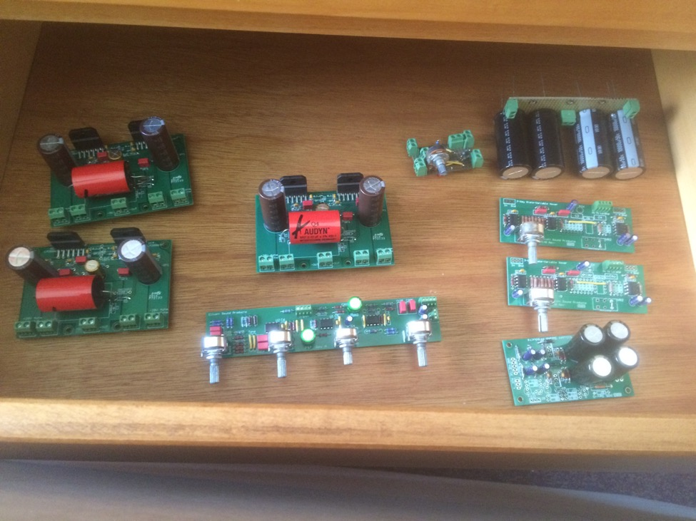*Counterclockwise from top-right: Capacitor bank for subwoofer amplifier, 2 active crossovers, ESP power supply circuit for preamplifier, tone/volume control circuit for preamplifier, 3 LM3886 circuits, and subwoofer summing/volume control circuit.*

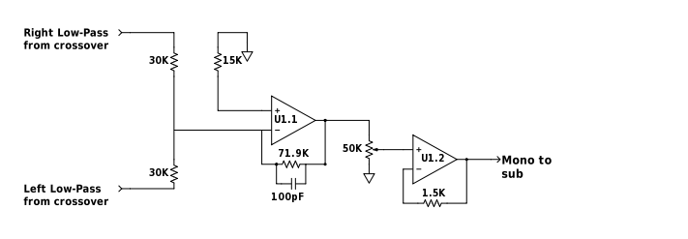

*Subwoofer summing/volume control schematic*

After designing or purchasing and soldering the circuits involved in the signal path, I had to figure out the power supplies. My subwoofer amplifier used two LM3886 chips in a bridged configuration to achieve a single 100W output, and my stereo amplifier required one of those circuits per channel (four LM3886 chips total). Reading articles online and relevant sections of two books, *The Art of Electronics* and *Practical Electronics for Inventors*, were enlightening, but none seemed to present a formula or exact method to power supply design. I gradually pieced together, with the help of some faculty who were happy to lend their expertise, that I wanted a linear power supply, that it should be full-wave rectified, that my transformers needed to be big, that the current draw of my capacitors would be high but for short periods of time, and other tidbits of information. I settled on a 400VA toroidal transformer with 40,000uF/rail for my stereo amplifier and a 200VA toroidal transformer with 20,000uF/rail for my subwoofer amplifier. I configured everything in an unregulated linear power supply, meaning my AC fed to my toroid, which went to the rectifier, which went to the capacitance bank and power rails (there was no regulator involved in the path).

At this point I had finalized my amplifier PCBs, power supplies, and preamplifier circuits and moved on to the physical layout and assembly of the amplifiers. I considered both wooden and metal chasses, looking first at surplus supply stores to see if I could repurpose a container or appliance being sold there. After unsuccessful searches for assembled chasses, I eventually purchased aluminum plates that could be screwed together to form full boxes, called Omni Chassis ([**http://lmbheeger.com/omnichassiskit.aspx**](http://lmbheeger.com/omnichassiskit.aspx)). The one caveat to this solution is that the weight of my transformers would easily bend such thin aluminum if not supported, so I cut and attached panels of MDF to the bottom of both amplifiers to bear all of the weight (this can be seen in later photos).

In all three pieces, I sought to separate wires carrying the power supply from wires carrying the music signal as much as possible to avoid potential interference. I also optimized the amount of surface area behind the LM3886 chips so that I could maximize heat transfer to the external heat sinks, which are mounted directly behind the chips. Below are as photos showing plans of the amplifier layouts and what they looked like after assembly.

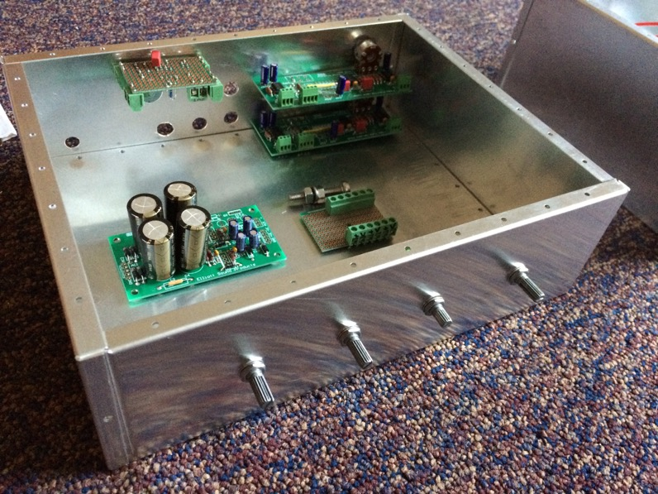*Planning the layout of the preamplifier. The two crossovers are in the back-right, the sub summer is in the top left, the power supply is on the left side of the base, the tone and volume control is attached to the front face with the potentiometers, and the small piece on the right side of the base is a power rail extension.*

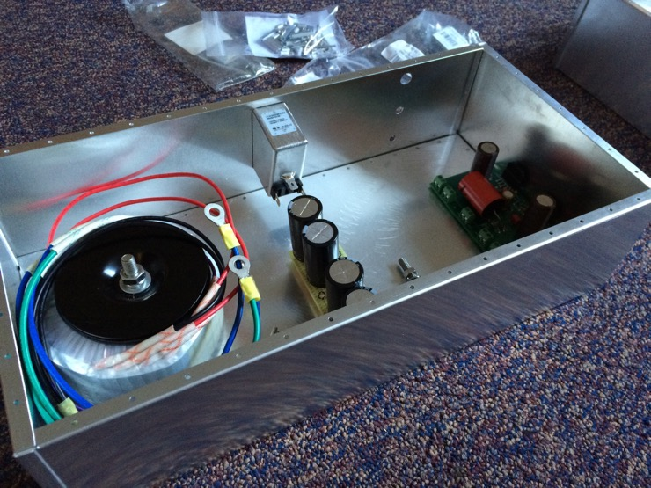*The subwoofer amplifier had the transformer on one side, as far as possible from the LM3886 circuitry, and the power supply capacitors in the middle.*

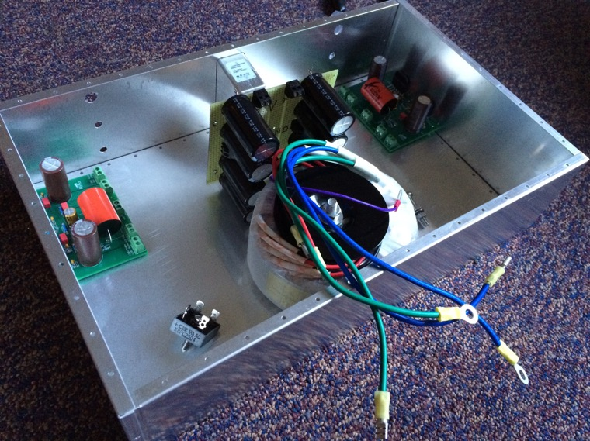

*The stereo amplifier has one LM3886 circuit on each end with the transformer and power supply capacitors in the middle. The rectifier can be seen in the bottom left.*

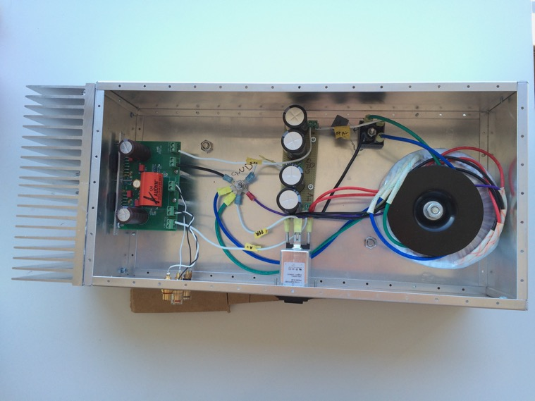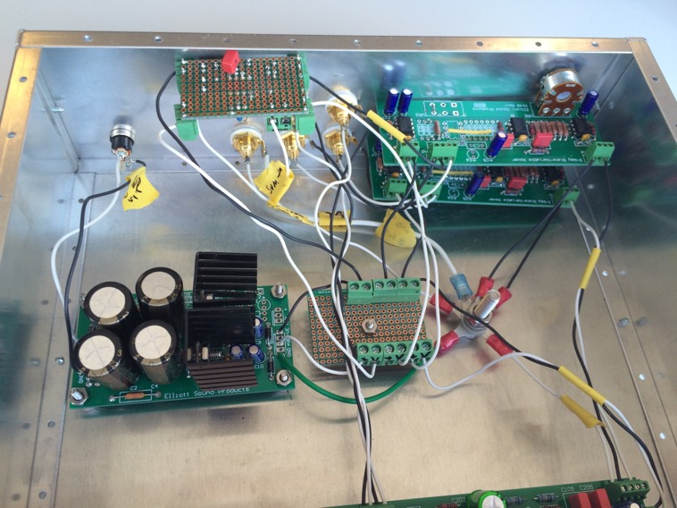*The completed preamplifier. The wiring is horrendously ugly and was a product of diminishing time and funds, which prevented me from finding multiple colors of wire or neat methods of containing the wire. The connections above are all labeled on the yellow pieces of tape, however, and function as intended.*

*The wired sub amp. A piece of the MDF base can be seen in the top-right.*

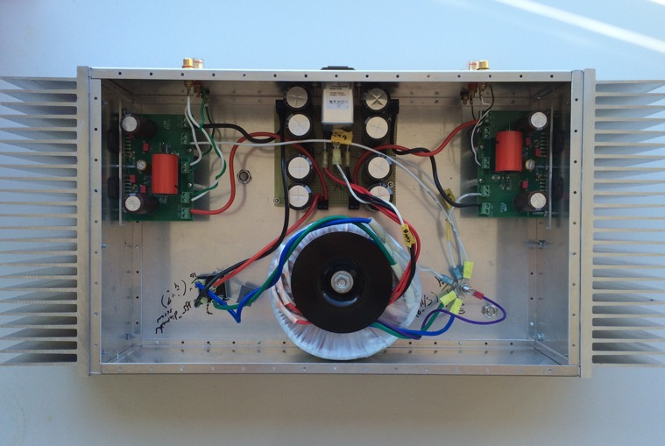*The completed stereo amplifier.*

When I had drilled all holes, attached all pieces to the chassis, and prepared all internal circuitry, I tested each amplifier bit by bit with a VariAC (variable AC power supply), oscilloscope, and waveform generator. The VariAC was used to evaluate the power supplies, slowly increasing the voltage to minimize the risk of damage if part of the power supply circuit was incorrectly wired (and to prevent capacitors from exploding). First I examined the transformer to see if the voltage was properly altered, then I connected the rectifier to see if I was creating rectified voltage, then I plugged in the capacitance bank to see if the voltage was adequately smooth after the capacitors. When all of this proved successful, I ran power to my LM3886 PCBs and fed a sinusoidal signal to the board, measuring its amplification.

The preamplifier underwent a similar process. I tested the power supply circuit, then the tone and volume control PCB, then the crossovers, and then the subwoofer summing circuit.

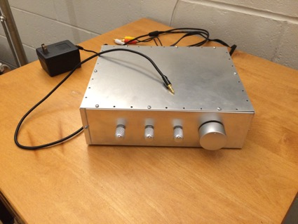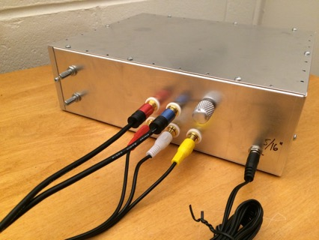

*Preamplifier*

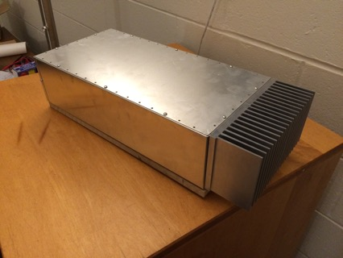

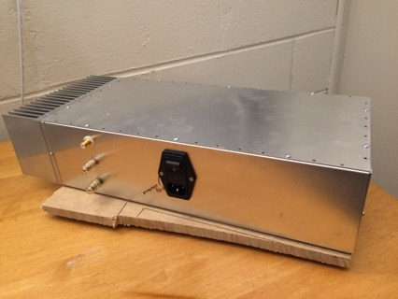

*Subwoofer Amplifier*

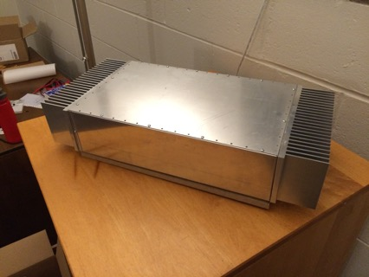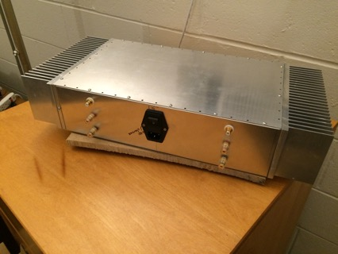

*Stereo Amplifier*

**The Cabinets**

I built the cabinets at home with the help of a family friend and his woodshop. Nearly every online article I found listed MDF (medium density fiberboard) as a quality option for speaker cabinets, so I used ¾” MDF in my design. With a little bit of luck in how I happened to design the cabinets, I was able to cut all pieces I needed from a single 8’ x 4’ board.

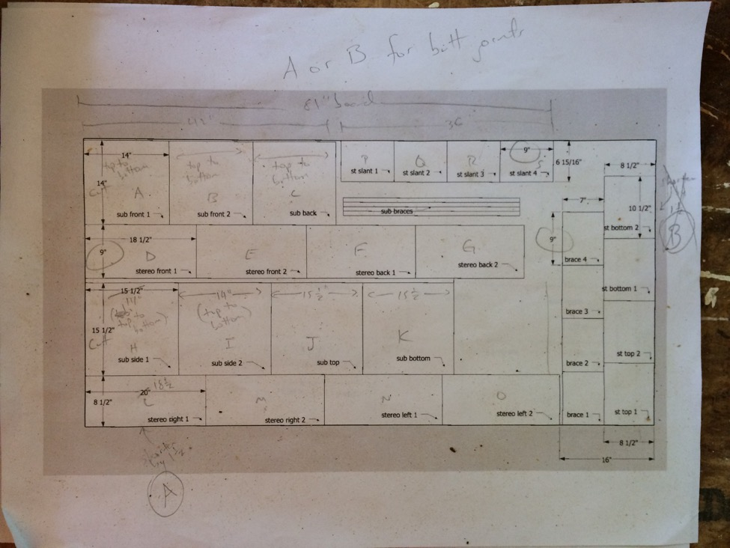*The cut-sheet I made to figure out how to divide my 8’ x 4’ sheet of MDF.*

**Stereo**

I decided to pursue an MTM design for my stereo cabinets, which denotes a linear arrangement of speaker drivers with two woofer (or **M**idrange) drivers sandwiching a **T**weeter driver. While some people pursue this for performance reasons, I sought this design mostly for aesthetics. It also offered me some extra flexibility in terms of matching my tweeter and midrange drivers—I could wire two 4Ω woofers in series and pair them with an 8Ω tweeter, or I could wire two 8Ω woofers in parallel and pair them with a 4Ω tweeter. Had I wanted to use only 1 woofer in each cabinet, I would need a 4Ω tweeter with a 4Ω woofer or an 8Ω tweeter with an 8Ω woofer, and I found few such pairings that fell in my price point (I didn’t shop around much—my drivers all came from <http://www.parts-express.com/>). Below are the parameters of my woofers and tweeter.

|  |  |  |
| --- | --- | --- |
|  | Woofer | Tweeter |
| Model | HP-5210 5-1/4" Poly Cone Rubber Surround Woofer 8 Ohm | Peerless by Tymphany DX25TG59-04 1" Fabric Dome Tweeter |
| Impedance | 8Ω (wired in parallel) | 4Ω |
| Power Handling RMS | 50W | 100W |
| Sensitivity | 89 dB 1W/1m | 89.8 dB 1W/1m |
| Frequency Response | 35Hz – 5,000Hz | 2,500Hz – 20,000Hz |

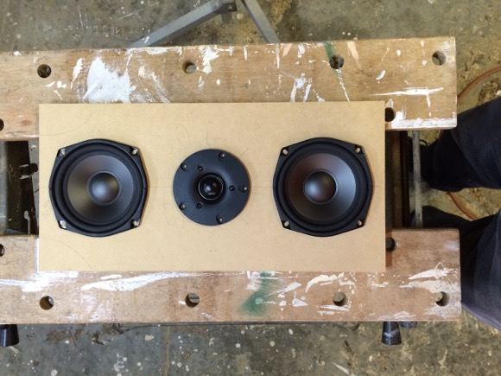

*The face of my MTM stereo cabinet design.*

I selected these drivers because the impedances and power handling matched up when two woofers were wired in parallel, the sensitivity favored the woofers when they are wired in parallel (which, if I remember correctly, is sometimes beneficial in helping to reduce shrill highs), and the frequency responses offer enough overlap to safely cross well above the tweeter’s resonant frequency (Fs = 640Hz). And they were also inexpensive.

After picking my drivers, I began designing the cabinets. Tweeters are typically sealed and therefore not affected by the cabinet dimensions, but I had to carefully design the compartments for my two midrange woofers in each cabinet to make sure there were no standing waves created in my cabinets. (A quick aside: when I say the tweeter is sealed, I mean the tweeter has an airtight seal behind its vibrating dome and therefore can’t send sound waves backward. This is important because woofers, which are not sealed, do send sound waves backward. These backward-sent waves can grow stronger if there are parallel surfaces for them to reverberate between and if their wavelength is a multiple of the distance between those surfaces.) I first attempted to dimension small internal compartments for my woofers according to the “Golden Ratio” of 1:1.6:2.6 that I found in many online sources, but this gave me aesthetically displeasing proportions for the overall cabinet. Instead, I created a cabinet face that I liked and gave the walls of the woofer compartments slants and slopes so they would not be parallel. After all, the purpose of the Golden Ratio is to reduce standing waves, but non-parallel surfaces and adequate stuffing can achieve the same goal. The only woofer parameter I ended up using for the compartment design was the “optimum cabinet size” value, given on Parts Express. I purchased simple hobby batting from Walmart to fill the compartments. There were plenty of opinions and options online about what type of filling is best, but at this point I was far over budget and running out of time before having to return to school so I settled for an inexpensive and local option.

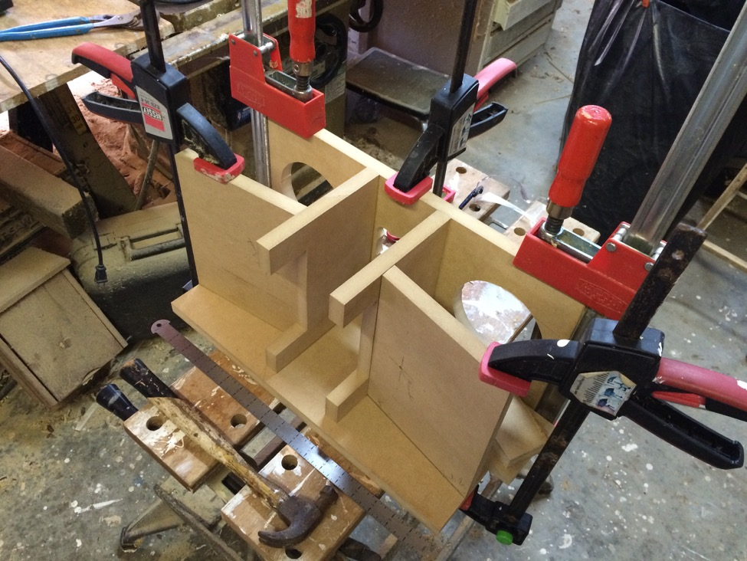*The slanted rear panels of my midrange woofer compartments can be seen in this mockup. I added angled wedges to the left and right sides of each compartment as well to further reduce parallel surface area.*

An additional feature I built into my cabinets was a removable rear plate that granted access to the inside. On the internal face of this plate I mounted the crossover components so that if I ever want to modify the crossover I can easily retrieve it without disassembling anything. Press-fit speaker grill connectors were used to hold the plate to the speaker cabinet, and I attached a simple drawer handle to it for ease of use.

For my crossovers, I decided to cross the drivers at 4kHz and determined the proper components with an online Linkwitz-Riley calculator. It seemed this was a popular option for crossovers and it has served my purposes well.

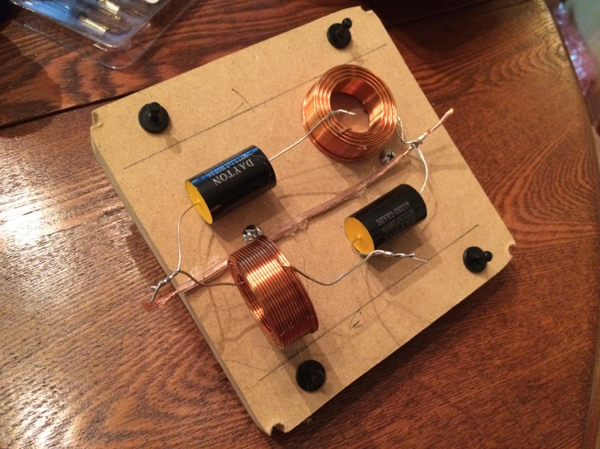*The removable plate and crossover components.*

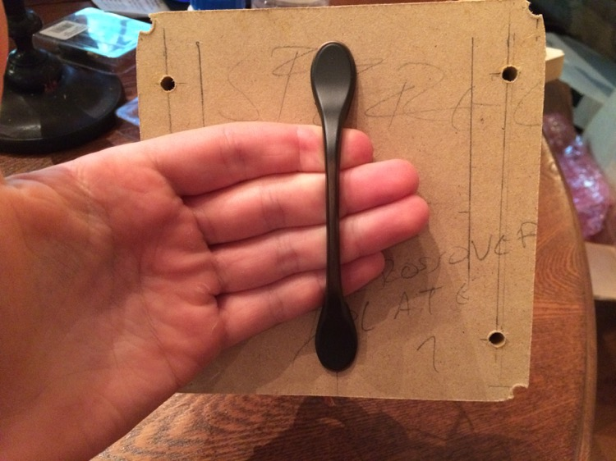*The handle for removal.*

*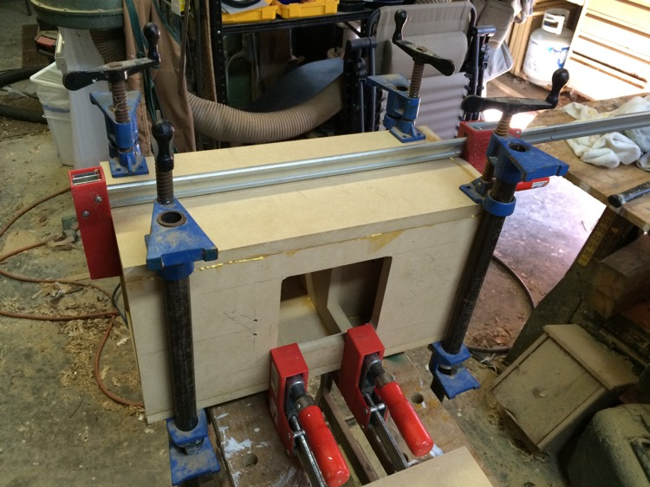The hole where the removable plate attaches to the cabinets.*

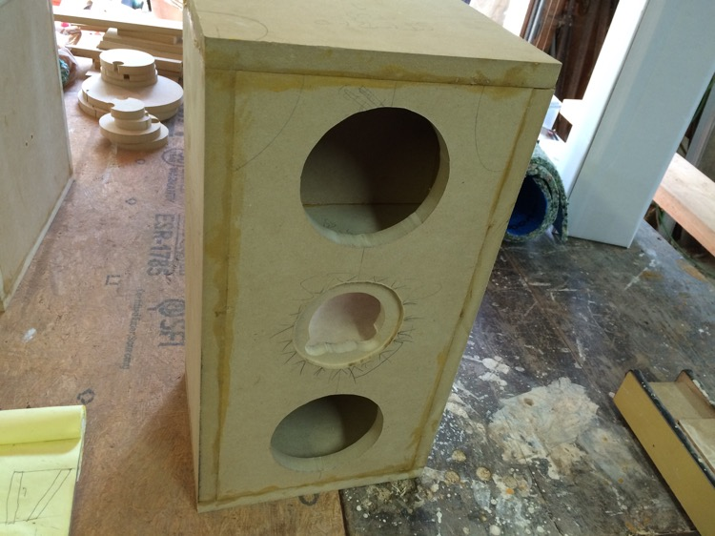*A structurally sound speaker cabinet skeleton.*

**Subwoofer**

|  |  |
| --- | --- |
|  | Subwoofer Parameters |
| Diameter | 10” |
| Power Handling (RMS) | 120W |
| Impedance | 4Ω |
| Frequency Response | 34Hz–800Hz |

The subwoofer was a more straightforward design and fabrication. Again using the “optimum cabinet size” value on Parts Express for the subwoofer I selected (a 10” 4Ω GRS driver), I designed a 15” cube to give it the recommended ported volume. I had read that ported subwoofers can get louder with the same power than sealed subwoofers, although sealed often have “tighter” sound, and decided to go with the more efficient ported design. Using some online calculators that ended up corroborating the information given on the subwoofer product page, I selected a 3” diameter flared port tube measuring 10” in length that would tune the subwoofer to 32­–35Hz (I don’t remember exactly).

*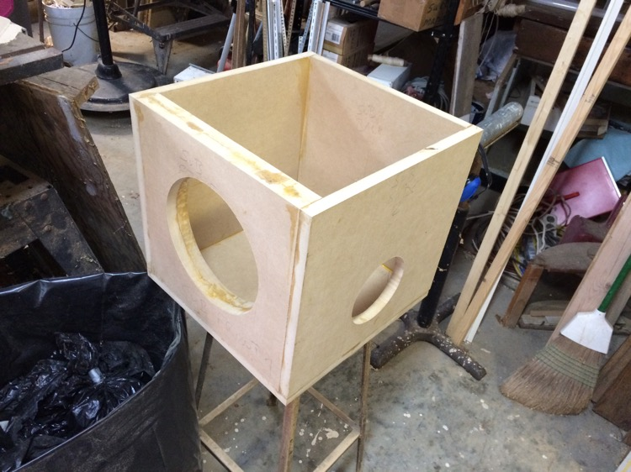The beginnings of the subwoofer cabinet.*

I read that standing waves are less of an issue with the frequencies played by a subwoofer since low-frequency notes have such long wavelengths, so I was not concerned when designing my sub as a cube. I used two layers of MDF on the face that holds the driver and placed internal dowels between opposite internal walls to help reduce cabinet vibrations. Following in the spirit of my inexpensive internet-recommended batting fill for my stereo cabinets, I purchased carpet padding to line the interior walls of my subwoofer cabinet. I chose to pad the subwoofer instead of fill it after reading a few sources that recommended doing this; it seemed, however, that this was another point of contention in the audio world and that there was no clear best answer.

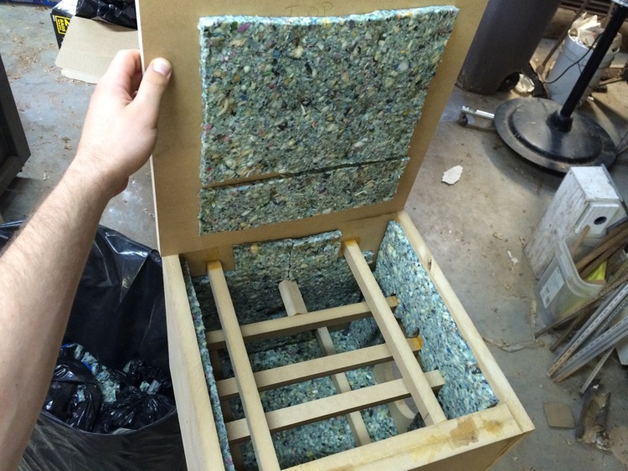*The dowels and carpet padding inside the subwoofer cabinet.*

**Veneer**

The final touches for my cabinets were to apply and stain veneer. Given the amount of information I gleaned from Parts Express, I continued to shop there and purchased *Band-It Cherry Veneer 24" x 96" Paper-Backed*. This selection was superb; it was not fragile when handled with moderate care, it looked good, and it was easy to cut and manipulate. I cycled through a number of new X-ACTO blades while cutting the veneer because I thought a pristine blade was needed for a good cut, but I later tried using a quality pair of scissors and had just as high of results (and saved a lot of time).

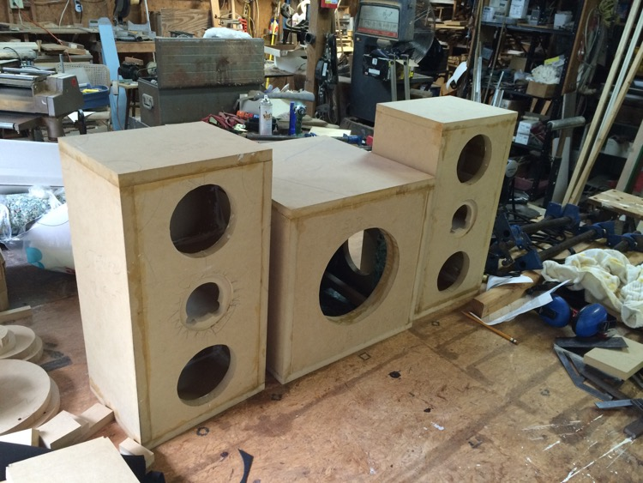*All three cabinets before applying veneer.*

Just as I had mapped the many pieces of MDF to a single 4’ x 8’ sheet, I now mapped the strips of veneer to this 2’ x 8’ sheet. I planned to use a single sheet of veneer on the front, top, and both sides of all three cabinets (except the stereo faces) but found I would be one strip short no matter how I tried to divide the veneer. To address this, I found four thinner strips that could be pieced together over the front of the subwoofer, since the surface area of the subwoofer driver itself reduced the amount of veneer needed on that face. I’ve placed a picture of this a bit further down.

The veneer required contact cement to adhere to the MDF, so after I cut all of my pieces I had to spread the cement over the back of the veneer and over the MDF face. The cement’s container instructed that one should wait 10-20 minutes after application or until the cement felt dry before attaching anything, so I was able to line up a few pieces of veneer at the same time before going back and attaching the first strip. A tip I found to test if the cement is sufficiently dry is to place my arm down on the cemented surface and see if my arm hair is tugged as I lift my arm up. When I didn’t feel a tug, I went on and attached the two cement-covered surfaces.

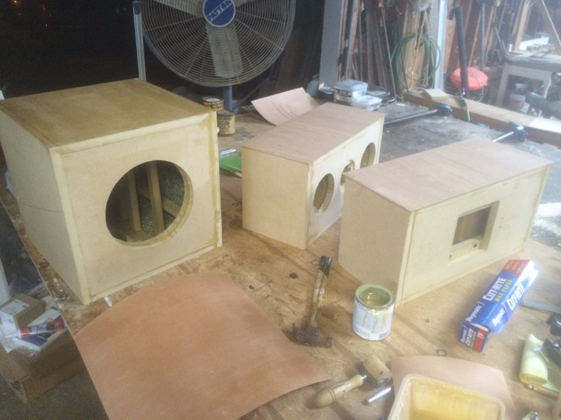*Applying the first pieces of veneer. I cemented three surfaces at a time, one on each cabinet, and then went back and adhered the veneer. The overhanging edges can be seen on the stereo cabinets if one looks closely.*

Placing the veneer on the cabinets needed to be done with care, as the contact area was large and it was easy to accidentally misalign the veneer. To address this, multiple online sources recommended placing wax paper over the cemented cabinet surface, placing the veneer on top of the paper, aligning the veneer and cabinet, and then carefully pulling the wax paper out from one side while the veneer is pressed down from the other side. This process was significantly aided by cutting the veneer strips with an extra half-inch on each side (an extra inch in each dimension) so that they didn’t need to be aligned perfectly with the cabinet. As long as there was veneer hanging past every side of the cabinet when placed on the wax paper, I could start pulling the paper out and pressing the veneer down.

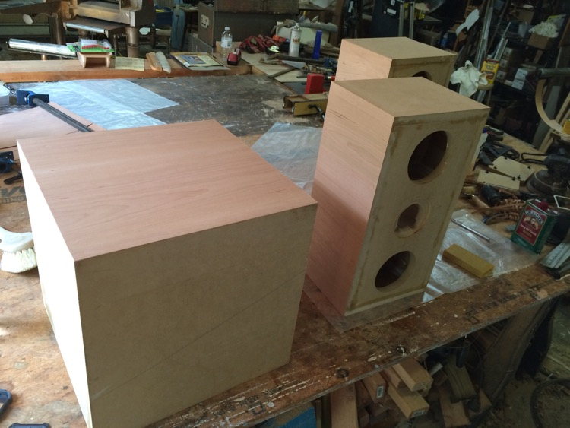*Almost done with the veneer.*

Cutting the veneer strips with extra length meant that they had to be trimmed once attached. This process did necessitate the use of X-ACTO blades (as opposed to scissors) and required that I carefully pull the blade as close to the cabinet as possible to trim the excess veneer. I found that it was easier to trim when I was cutting across the grain of the wood than with the grain; when doing the latter, my blade would sometimes follow patterns in the wood and veer off track, making me come back for another trim.

After all veneer was applied, I used a Red Oak stain and Tung Oil as a finisher. The friend helping me to build the cabinets is a big fan of Tung Oil, which hardens and protects the wood by soaking into it instead of resting on top as polyurethane protectants do, and I figured he knew better than I. I also lacked any sort of preference, having never worked with wood finishers before.

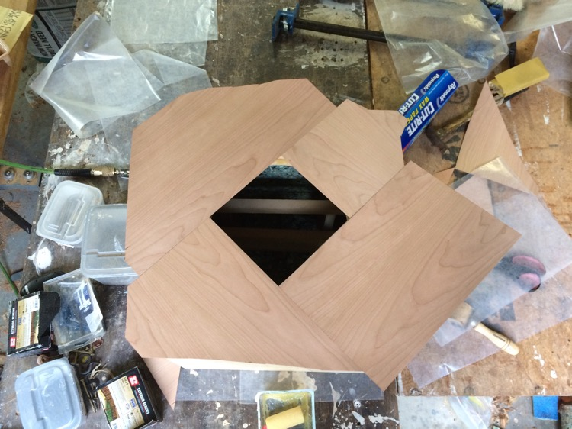*The four pieces of veneer, before trimming, needed to cover the front face of the subwoofer.*

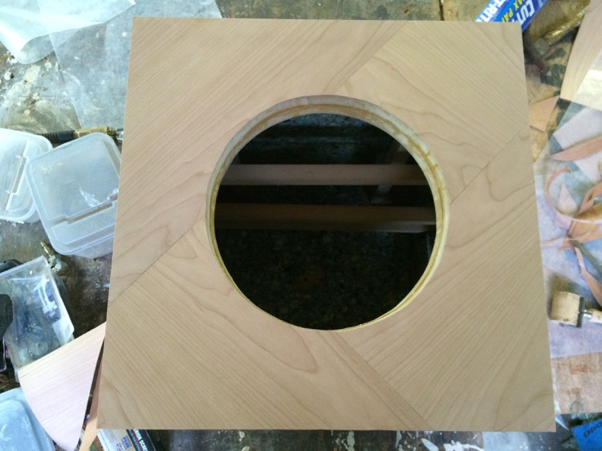*The front of the subwoofer after trimming the veneer.*

*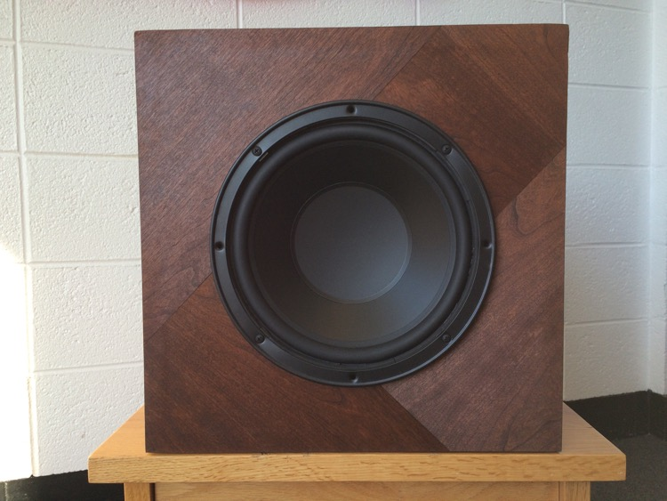Stained, assembled subwoofer (port, unseen, on the right side).*

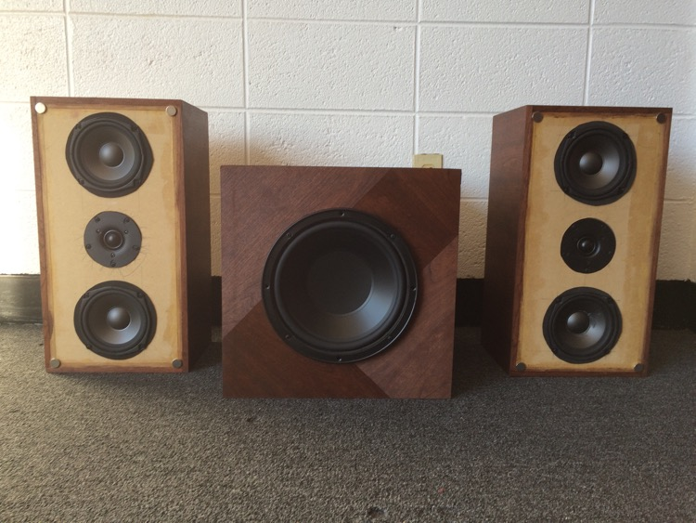

*Stereo speakers, without grills, and subwoofer.*

**Miscellaneous Details**

**Woofer Gaskets**

I purchased sheets of craft foam from Wal-Mart to make gaskets for my woofers and subwoofer. I cut rings from the foam (which I made sure was a non-porous type) to fit between my cabinet faces and my woofer frames to help ensure no air escaped due to a non-flush contact between the two. I did not bother cutting exact circles, so some of the edges of the foam can be seen in the photos above.

**Flush Tweeter Mount**

My woodworking friend helped me to route a space for my tweeters in my cabinet faces so that they would mount flush with the surface. I chose to do this after reading certain sources online about phase alignment of the drivers being related to their physical alignment but was not clear if this was a necessary step. I took it mostly out of precaution.

**Ground Bolts**

In each amplifier and preamp, I connected a bolt to the metal chassis and made that connection my ground connection. The purpose was twofold: first, it was a safety measure to ensure that the chassis was never charged and would always have a voltage of 0; and second, it was an attempt to create a “star ground” where all ground connections from the various circuits in the amplifier are joined at a single point, which is said to reduce the potential for hum or buzz in your speakers. I was not able to achieve a totally noise-free setup and hear a quiet-but-audible buzz in my left speaker channel in particular, but I don’t know if this is due to faulty grounding or to other sources of interference.

**Heatsinks**

I followed a guide in one of my sources to calculate the necessary heatsinks for my LM3886 circuits and purchased the heatsinks seen in my photos from Heatsinks USA ([**http://www.heatsinkusa.com/**)](http://www.heatsinkusa.com/)). I later saw there were heatsink recommendations in the AN 1992 document that I failed to take into account, and that the recommended heatsinks are smaller than those that I selected. Obviously I prefer to have too large than too small of heatsinks and don’t mind.

**Suppliers**

I purchased the vast majority of my circuit supplies – resistors, capacitors, potentiometers, and op-amps – from Mouser ([**http://www.mouser.com/**)](http://www.mouser.com/)). It was confusing to look through their immense selection of products at first, but became second-nature after learning enough relevant vocabulary (radial versus axial leads, ceramic vs film, through-hole versus surface mount). All speaker and amplifier accessories – knobs, grill clothe, binding posts, RCA jacks – came from Parts Express.