**Midterm Design Project**

ES-173

Frank DuBose

Sunday, October 30, 2016

Collaborators: Alina Acosta, Daniel Galindo-Navarro

Instructor: Evelyn Hu

The details of my photodetector device are as follows:

1. The material is Silicon
2. The device is P-doped to a concentration of 1015/cm3
3. The device is a 1cm x 1cm square that has a winding path of 8 turns etched into it. The path is of equal width along its entirety (1/9 of a cm) and is approximately 9 cm in length with a cross-sectional area of 1.17 x 10-5 cm2. See figure below for details (figure also submitted as separate document).

I have assumed that the values given in the midterm writeup are appropriate to use (although some are not for 400K), I have assumed 100% quantum efficiency in the absorption of light, and I have assumed that the etching process removes a negligible amount of silicon and that the surface area is still 1 square centimeter.

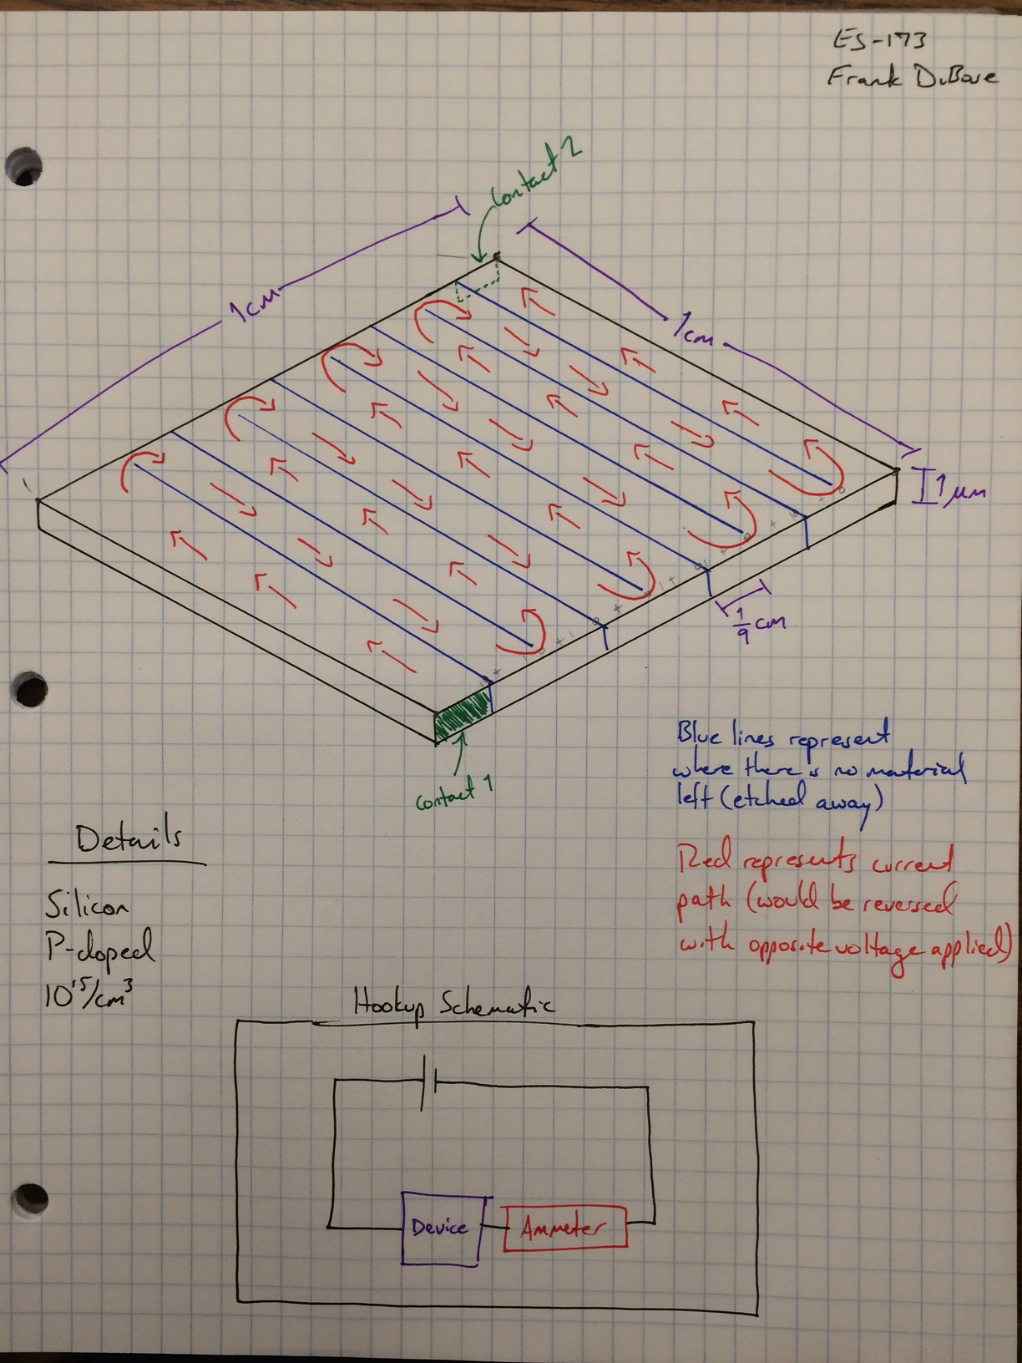

These specifications were not my initial plans for the device, but were shown to be the best after doing many calculations for each of the materials and their different doping options.

I began the design process by trying to reason why different features would benefit or hinder the performance of this device. The characteristics I examined include:

* **Carrier Mobility**: A higher carrier mobility means more current flow. If this were my only criteria, I would have selected GaAs due to its electron mobility of 8500 cm2/V*s (higher than Ge or Si). I initially predicted n-type doping would be most effective since all three materials have higher electron mobility than hole mobility, but making the electrons the minority carriers ended up allowing for a larger change in current in lit conditions. This will be discussed more later.
* **Conductivity**: This is a function of mobility and carrier concentrations. I was not given conductivity data (I had to calculate it) so did not have a preferred candidate in terms of conductivity, but it was something I was aware of from the beginning and thought would play a big role.
* **Carrier Lifetime**: A faster/shorter carrier lifetime means the electron-hole pair exists for a shorter period of time and is therefore less influential on the current of the device. I want a material with a longer carrier lifetime, like Ge or Si with lifetimes of 10-6 seconds.
* **Absorption Coefficient**: A higher absorption coefficient means the material can absorb more of the incident light and therefore become more excited by light. Ge had the highest absorption coefficient at 5*104/cm.
* **Intrinsic Carrier Concentrations**: This plays a big role in how the dopant affects the material. If ni is higher than or approximately equal to the dopant concentration, the material’s behavior will not change significantly due to the dopant. Due to this hypothesis, I considered Ge doped to 1015/cm3 to be a poor choice from the beginning since its intrinsic concentration at 400K is already higher than 1015/cm3 (however, I later found Ge doped to 1015/cm3 was not the worst material and out-performed GaAs).
* **Dopant Concentrations**: Because mobility decreases with increased dopant concentrations, I assumed a lower concentration (i.e. 1015/cm3) would allow for higher conductivity. I didn’t rule out the possibility of higher dopant concentration improving performance elsewhere to counteract the lower mobility it would cause, but considered it unlikely that this would happen.

**Goals**

The main performance characteristics I was aiming to achieve were 1) the given requirement of a 10MΩ dark resistance, and 2) as large as possible of a difference between the dark current and the lit current so as to maximize the signal-to-noise ratio of the device.

**Analysis**

As seen in the list of parameters above that I considered important prior to conducting any numerical analysis, there is no one material that is best in every category. This led to a surprise when I calculated the lit current as a percentage of dark current, which gave me the results below.

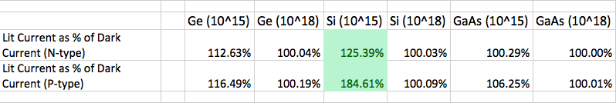

Silicon doped to 1015/cm3 has a higher increase in current from dark conditions to lit conditions than either other material, both when doped n-type and when doped p-type. It showed a 25% increase in current when n-doped and an 84% increase in current when p-doped. In considering how silicon that is p-doped to a concentration of 1015/cm3 ended up as the best option, I concluded a number of different reasons all play a part.

1. My intuition regarding dopant concentration is supported by the data above, as every material has a higher increase in current when doped to 1015/cm3 than when doped to 1018/cm3. Higher dopant concentration lowers mobility.
2. Doping with p-type, while initially not my preferred dopant, is effective because it allows for a greater *increase* in current when the material is illuminated. This effect has multiple facets that make it work. The first is that, for maximum effect, electrons must be the minority carrier for maximum effect (although n-type silicon is still second only to p-type silicon). The second is that the minority carrier concentration be lower than the excess carrier concentration. The third is that the minority carrier concentration be significantly lower than the majority carrier concentration when dark. When these conditions are met, the following happens: in darkness, there is large contribution to current by the majority carrier and little contribution to current by the minority carrier, but when lit, the minority carrier is suddenly much more prevalent than before and contributes a lot more to the current. In silicon, for instance, electron concentration changes from 1010/cm3 to 1014/cm3, meaning there are 10,000 more electrons in the substance when it is illuminated than when dark. Then, when this increase in carriers is particularly an increase in high-mobility carriers, those carriers’ impact on current is further amplified.
3. Gallium arsenide in particular has a very fast recombination lifetime, meaning its electron-hole pairs don’t “live” for very long once excited by light before they recombine. This is shown analytically in the equation for excess carrier concentration, which states $δ_{n}=δ_{p}=g_{op}τ_{n}$. If the lifetime is very fast, the excess carrier concentration will diminish. Because GaAs has a lifetime 100 times faster than Ge or Si, it has significantly fewer excess carriers when illuminated and hence a lower increase in current under illumination.
4. Ge appears to be a good candidate until the final calculations are made. It absorbs more light than Si and has lower resistivity than Si, but it has an intrinsic carrier concentration of 1015. This limits the current increase when excess carriers are added to the substance because the intrinsic concentration is already of a higher order of magnitude than the excess carrier concentration.

It was very surprising to find Si to be the best option for this device, given its low absorption of light, high resistivity, and mediocre electron and hole mobility, but obviously these features all come together to create a material very well-suited for photodetection.

To answer the questions at the end of the midterm:

1) **Why is a large value of dark resistance important for your device operation? Why did the description given in Section 4.1 suggest that you would need to use a folded or zig-zag pattern?**

A large dark resistance is important mainly to help ensure a high signal-to-noise ratio. For example, if the device increased in current by 1 amp when illuminated, it would be much easier to see that 1 amp increase if the change was from 0 amps to 1 amp than from 10 amps to 11 amps.

A zig-zag pattern is necessary to achieve a long current path (and subsequently a small path cross-sectional area) in a small footprint — 1 square centimeter in our problem.

2) **What are the metrics of your device?**

Quiescent current – the amount of current through the device when not illuminated.

Illuminated current – the amount of current through the device when illuminated.

Current increase – the amount of increase from quiescent current to illuminated current.

Absorption efficiency – the proportion of incident light collected by the material.

Quantum efficiency – the proportion of photons that are absorbed that cause an electron-hole pair.