**Using Reflective Surfaces To Reduce Minimum Thickness Of Planar p-n Solar Cells**

Frank DuBose

ES-173: Introduction to Electronic and Photonic Devices

Evelyn Hu

ABSTRACT: The effectiveness of solar cells is a function of, among other things, the sheer number of photons the semiconductor material is capable of absorbing. Light that is reflected off of or transmitted through the semiconductor material is lost energy. To reduce the amount of light reflected or transmitted, anti-reflective coating is often implemented and solar cells are made thicker than the absorption or penetration depth of the light that is to be absorbed. We would like to conduct research into the potential for a reduction in the thickness of solar cells by placing a reflective layer (which might also double as the rear electrode) behind the cell such that any light transmitted through the semiconductor would be reflected back. This would allow for two opportunities for any transmitted photons to be collected by the material. We predict that the largest contribution of this research to the state of the art will be a method of reducing the thickness of solar cells. This could lead to new applications where a sleek form-factor is a requirement and could transform existing applications into more attractive options.

I. INTRODUCTION

The technology surrounding solar cells has been improving in leaps and bounds over the past 20 years. Much of the research that has taken place in this time has explored new semiconductors to use, new geometries and structures to try, and new methods of growing the materials. These have been hugely beneficial to the state of the art and have led to exciting possibilities. However, many of the most impressive options are expensive and difficult to build, meaning they are not taking hold in general industry use and are not yet having a significant effect on the use of solar technology by the public.

Instead, simple planar p-n junction silicon solar cells remain the most common form of solar cell seen today. This cell can achieve 15-30% power conversion and generates around 0.6V[1].

While the research that has already been conducted in the field will certainly produce lasting long-term results as it continues to develop, the research we hope to conduct, if shown to be fruitful, will introduce a design that can be used to improve solar panel effectiveness almost immediately.

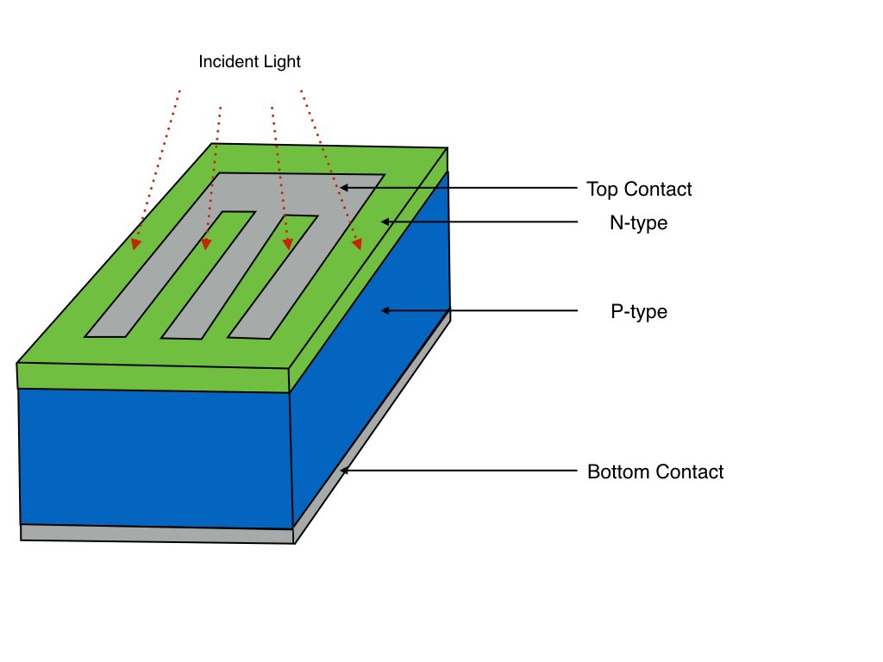 The crux of our idea relies on the notion of reducing the amount of incident light that is transmitted through the semiconductor without being collected. The typical method for reducing transmitted photons is to make the thickness of the cell substantially greater than the absorption depth of the light being collected. We intend to research the possibilities for placing a mirrored surface behind the semiconductor so that any light that is transmitted through the semiconductor will be reflected back into the material and will have another opportunity to be absorbed. If proven effective, this would allow for a reduction in thickness of the cells. Additionally, we hope to make this reflective surface conductive so that it may serve as the rear electrode for our device. Doing so would allow for both conduction and reflection to benefit from the entire surface area of the rear of the cell.

*Figure 1: Typical design of a p-n junction silicon solar cell.*

Our research will hopefully result in thinner and more efficient solar panels that can be produced with little change to the current manufacturing processes used for planar silicon p-n cells. Thinner cells might then inspire new uses for or placement of solar technology, contributing to an overall growth in the usage of photovoltaic devices. A smaller form factor might allow for solar panels to be placed in more diverse areas, as opposed to the current norm of rooftops and freestanding structures in open space. Integration into urban landscapes could be easier than before, or into technologies with surfaces not traditionally occupied by solar cells (such as the surfaces of vehicles, or of laptops, or of street/shop signs, for example). Our overall goal is to allow for production of smaller solar cells with no reduction in efficiency and for little to no increase in price.

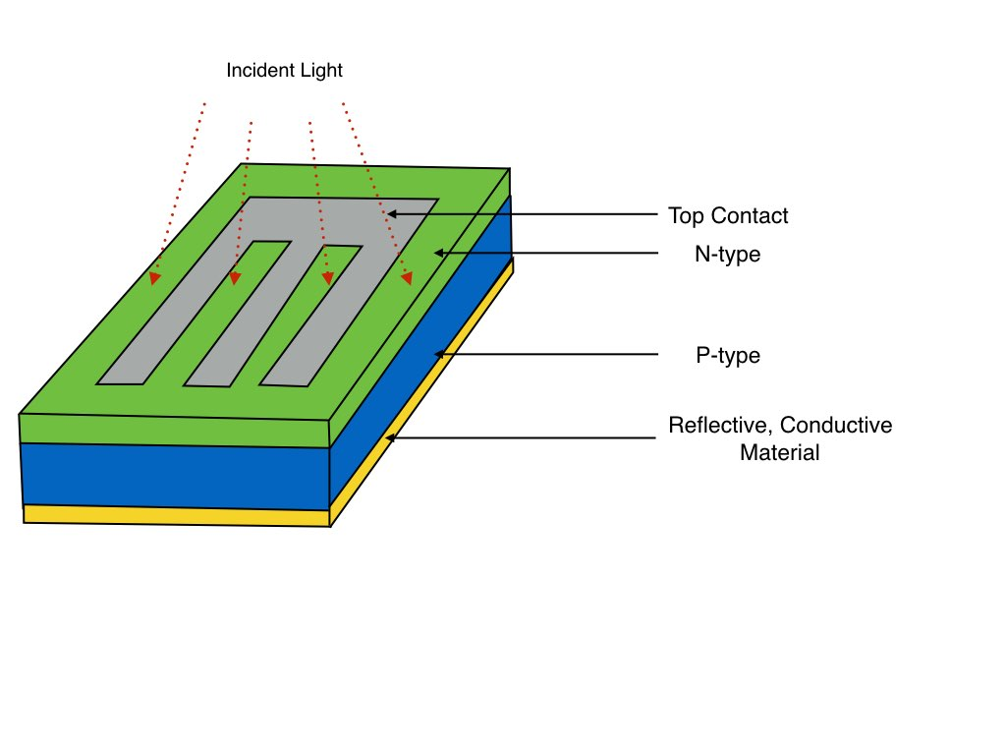

*Figure 2: Improved, thinner design for silicon solar cell using a reflective bottom layer that doubles as the rear electrode.*

II. METHOD AND BUDGET

We plan to split the funds being pursued by this proposal between salaries and software licenses for programs such as COMSOL. Before attempting physical experiments with our device, we need to conduct simulations to gain insight into the feasibility and expected results of such a design.

Once we have the necessary software, we plan to extensively explore the effect of different cell depths on absorption and transmission of light. We know that high-energy light is absorbed more readily than low-energy light, and that the intensity of light passing through a semiconductor decreases exponentially with distance traveled in the material. That is,

[1]

where α is the absorption coefficient of the material and 1/α is the absorption depth. The absorption depth is a significant determinant of cell thickness, as the cell must be substantially thicker than 1/α in order to capture most of the photons. We hope that by using our method of photon reflection we can simulate a thickness double that of the actual cell and therefore minimize the actual thickness required.

Further research will also be conducted into ideal materials to use or combine for the bottom reflective layer and electrode. One option that has already been identified is to deposit indium tin oxide (ITO), a well-known transparent conductive material, over a reflective surface made of a different material. Ideally, however, the layer will be composed of a single material that will both reflect light and conduct electricity. This would allow for fewer materials and a simpler fabrication process.

III. MEASUREMENTS

In characterizing our device, we plan to measure a number of specific metrics.

The first stage to tackle will be identification of a suitable reflective surface. This will require evaluation of the reflectivity of various materials at various thicknesses and consideration of how they would be implemented in our solution – whether applied as a liquid and allowed to cool, applied as a thin wafer, or applied in some other manner.

Next, we would have to examine the conductivity of the reflective materials we have investigated. If we are able to find a material that can reflect and conduct, we will move forward with that option. However, if none of our reflective choices are sufficiently conductive, we will move on to examine transparent conductive materials that can be added as a clear layer between the p-type semiconductor and the reflective surface. We will simulate voltage across these materials and measure their current in order to explore conductivity of the various materials we choose to consider.

After exploring options for the reflective surface and rear electrode, we will evaluate the transmission of photons through the semiconductor material with the goal of reducing thickness. As previously stated, thickness of cells is often dependent upon the absorption depth, so we will manipulate the thickness while comparing it to the absorption depth. We will look at the amount of light transmitted through on the “first pass” through the cell, as well as the amount of light transmitted through on the “second pass” after reflecting off of the rear layer.

The final element we will research is methods of fabrication for our device, although this will be dependent upon the nature of the results we achieve. If our research into the behavior of our device does not look promising, any investigation into fabrication would be a lost cause.

IV. SUMMARY

In summary, we hope to improve upon the current design of planar p-n junction solar cells by placing a reflective electrode at the rear of the device, allowing for transmitted photons to be reflected back into the semiconductor a second time. This will hopefully achieve comparable absorption to a typical p-n solar cell while boasting a substantially diminished thickness. We believe that investigating reflective materials, the conductivity of those materials, transparent conductive materials (if necessary), transmission of photons through the semiconductor, and fabrication costs are the most critical aspects of determining the feasibility of our device and the scale of its hypothesized improvement over current designs.

Aside from fabrication considerations, COMSOL is capable of all of the simulations that we plan to carry out. We therefore anticipate little to no need for further funding in this stage of research if we receive the grant sought with this proposal. If our preliminary simulations prove to be fruitful, we will seek additional funding to conduct research using hardware and experimenting with physical prototypes of our device. If our device performs as hypothesized, we envision it leading to a wave of new applications and increase in the prevalence of solar technology.

V. REFERENCES

Hu, C. C., (2010). PN and Metal-

Semiconductor Junctions. *Modern Semiconductor Devices for Integrated Circuits* (89-156). Prentice Hall.