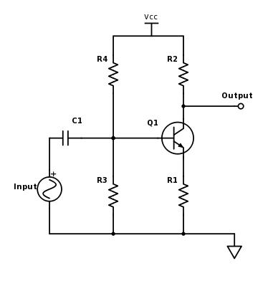Class-A amps are the simplest type of transistor-based amplifier, as they involve only a single transistor. One example of a class-A amp using a BJT is shown below.

The input signal feeds to the base of the transistor, controlling the collector current and the voltage at the output. As the input voltage drops, the collector current decreases and the output voltage increases. As the input voltage increases, the collector current increases and the output voltage drops. Due to this behavior, a class-A amplifier of this topology is inverting.

Class-B Amplifiers

Class-B amps are more complex and more efficient than class-A amps. Two transistors are used instead of just one, and each transistor is responsible for amplifying only part of the input signal.

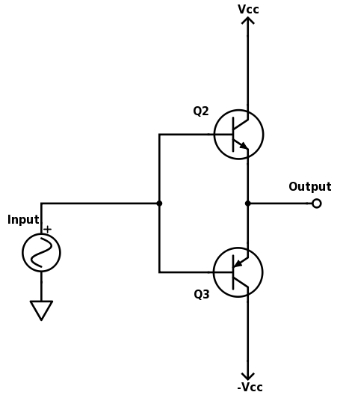

In this design, an NPN (Q2) and a PNP (Q3) are used together. When the input signal is positive, Q2 turns on and conducts but Q3 does not. The positive current is “pushed” to the output, representing the positive input. When the input goes negative, Q2 does not conduct but Q3 does, which “pulls” current from the output to the negative terminal at the collector of Q3. This represents the amplification of the negative input.

The drawback of class-B amplifiers is that neither transistor will conduct when the input is zero volts. In fact, when the input is within -0.7 to 0.7V, neither transistor will have a sufficiently high base-emitter voltage to conduct and so no current will flow to or from the output.