Software Requirement Specification

TMSO-SRS-001

Version 1.5

**Revision History**

| Date | Version | Description | Author | Revised by |
| --- | --- | --- | --- | --- |
| 13/06/2021 | 1.0 | First version | Phan Duc, Le Liem | Phan Duc |
| 17/06/2021 | 1.1 | Update component share screen | Phan Duc, Le Liem | Phan Duc |
| 18/06/2021 | 1.2 | Add View chart | Phan Duc, Le Liem | Phan Duc |
| 20/06/2021 | 1.3 | Update tabBarItems | Phan Duc, Le Liem | Phan Duc |
| 20/06/2021 | 1.4 | Update content and images for Home screen | Ho Si Hung, Ho Viet Long | Ho Si Hung |
| 22/06/2021 | 1.5 | Update content and images for Detail News screen  Update content and images for Categories screen  Update content and images for Bookmark screen  Add content and images for Category News List screen | Ho Si Hung, Ho Viet Long | Ho Si Hung |

Table of Contents

**1.1** **Overview** 4

**1.2** **Scope** 4

**1.** **Functional Requirements** 5

**2.1** **Feature/Component #1: Launch screen** 5

2.1.1 User Interfaces 6

2.1.2 Functional Requirements 6

**2.2** **Feature/Component #2:Recents screen** 6

2.2.1 User Interfaces 7

2.2.2 Functional Requirements 7

**2.3** **Feature/Component #3: Detail News Screen** 8

2.3.1 User Interfaces 9

2.3.2 Functional Requirements 9

**2.4** **Feature/Component #4: Categories screen** 9

2.4.1 User Interfaces 10

2.4.2 Functional Requirements 11

**2.5** **Feature/Component #5: Bookmarks Screen** 12

2.5.1 User Interfaces 13

2.5.2 Functional Requirements 14

**2.6** **Feature/Component #6: Share Screen** 16

2.6.1 User Interfaces 16

2.6.2 Functional Requirements 16

**2.7** **Feature/Component #7: Download list Screen** 17

2.7.1 User Interfaces 18

2.7.2 Functional Requirements 19

**2.8** **Feature/Component #8: Heath/Science/Entertainment/Technology News list Screen** 20

2.8.1 User Interfaces 20

2.8.2 Functional Requirements 21

**2.9** **Feature/Component #12: Getting News Screen** 23

2.9.1 User Interfaces 23

2.9.2 Functional Requirements 23

**2.10** **Feature/Component #7: View chart Screen** 23

2.10.1 User Interfaces 24

2.10.2 Functional Requirements 24

**Introduction**

## **Overview**

This application allows users to read, bookmark and share the latest international news via API.

Users can also download news, store them inside their devices, and read them anytime they want.

Our application will get all latest news which then divided into 4 categories: Health, Technology, Entertainment, Science news. User can select a category to see news in that field.

This app also supports View chart for each category, users can select this function to see which categories they most usually visited.

Framework which we use in this project include:

* UIKit - UserInterface framework
* Core Data - To store Bookmarks in disk
* Swift Standard Library (Codable) - To parse JSON objects
* Charts

Library which we use in this project include:

* SDWebImage: to load image asynchronously
* SVProgressHUD: to display HUD screen with various status: loading/ processing/ success, …

## **Scope**

IOS OS version:

14.0

14.1

14.2

14.3

14.4

14.5

* Iphone test devices:
* iphone 8
* iphone 8 plus
* iphone X
* iphone Xs
* iphone Xs Max
* iphone Xr

Iphone screen resolutions:

750 x 1334 Pixels (iphone 8)

1920 x 1080 Pixels (iphone 8 plus)

2436x1125 Pixels (iphone X, iphone Xs)

2688 x 1242 Pixels (iphone Xs Max)

1792 × 828 Pixels (iphone Xr)

Support screen orientation in portrait mode only.

# **Functional Requirements**

## **Feature/Component #1: Launch screen**

### User Interfaces

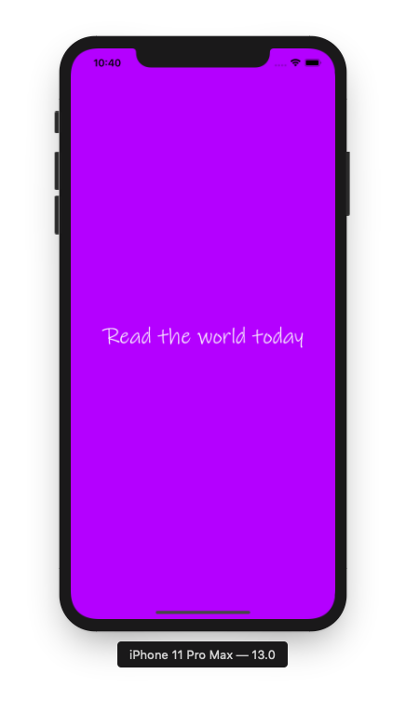

*Image 1: Launch screen*

### Functional Requirements

|  |  |  |  |
| --- | --- | --- | --- |
| **Item** | **Description** | **Action** | **Response** |
| **Launch screen** | * Launch screen has a title: Read the world today * Text color: White * Background color: Violet | N/A | N/A |

## **Feature/Component #2: Home screen**

### User Interfaces

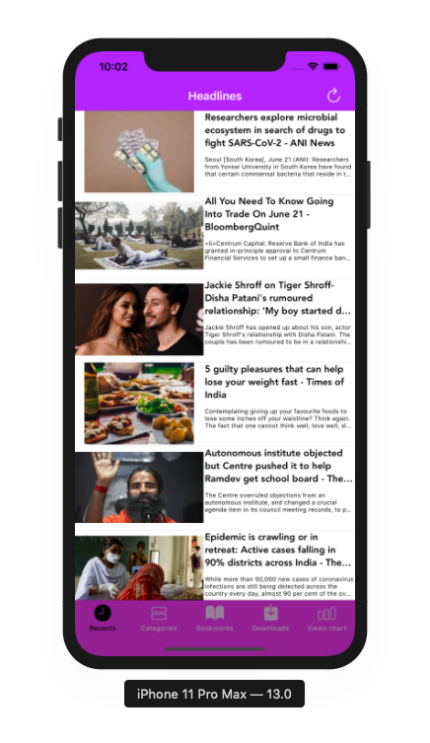

*Image 2: Home screen*

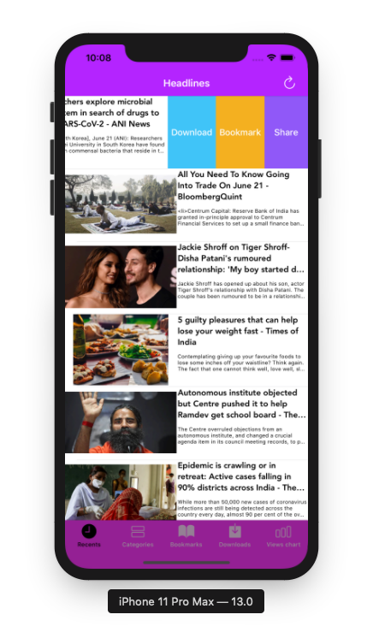

*Image 3: Home screen with Swipe Actions Download, Bookmark and Share*

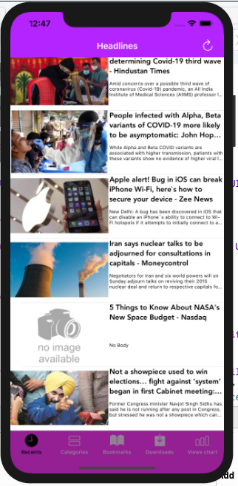

*Image 4: Home screen with an example of news*

*with error when loading image and content*

### Functional Requirements

|  |  |  |  |
| --- | --- | --- | --- |
| **Item** | **Description** | **Action** | **Response** |
| **Home screen** | Home screen has 1 tabBarController, 5 tabBarItems,1 button, 1 navigationBar, and 20 view cells to display news data include images, title and body of that news:   * Navigation bar contain button refresh and title “Headlines: * View cell News contains these components: * News images * News Title * News Body * Download Swipe Action * Mark Swipe Action * Share Swipe Action * TabBarController contains 5 tabBarItems: * Recents TabBarItems * Categories TabBarItems * Bookmark TabBarItems * Download TabBarItems * View chart TabBarItems | N/A | N/A |
| **Navigation Bar** | Navigation bar contains a title of screen: “Headlines” and a refresh button | N/A | N/A |
| **Button refresh list news** | A button to refresh list news from api | Tap on the button | Reload all news |
| **View cell News** | - Using to display news details  - View cell contains following components:   * Image news (if image can’t be loaded succesfully, no image availabe will be used to display) * Title news (if title can’t be loaded succesfully, “Not Found” will be used to display) * News summary (if title can’t be loaded succesfully, “No body” will be used to display) | Tap on the view cell | Display news details |
| **View cell News when swipe from right to left** | - Using to display news details and other options with this news  - View cell contains following components:   * Title news * News summary * Download Swipe Action * Mark Swipe Action * Share Swipe Action | Swipe from right to left | Display 3 Swipe Actions: Download, Bookmark and Share |
| **Download Swipe Action** | - Using to add news to download list  - The download button is on the left of the mark Swipe action  - The download Swipe action has a blue background and white text color | Tap on the **Download** Swipe Action | Add selected news to download list |
| **Bookmark Swipe Action** | - Using to add news to bookmark list  - The bookmark swipe action is on the left of the share swipe action  - The bookmark swipe action has an orange background and white text color | Tap on the **Bookmark** Swipe Action | Add selected news to bookmark list |
| **Share Swipe Action** | - Using to display a list of social network options for sharing  - The Bookmark Swipe Action  is on the left of the share button  - The share Swipe Action has a violet background and white text color | Tap on the **Share** Swipe Action | Display a list of social network options for sharing |
| **TabBarController** | TabBarController contains 5 tabBarItems:   * Recents TabBarItems * Categories TabBarItems * Bookmark TabBarItems * Download TabBarItems * View chart TabBarItems | N/A | N/A |
| **Recents TabBarItems** | -Using to display 20 latest news | Tap on the **Recents TabBarItem** | Display a list of 20 latest news |
| **Categories TabBarItems** | - Using to display category options  - Categories:   * Heath * Science * Entertainment * Technology | Tap on **Categories TabBarItems** | Display categories screen |
| **Bookmark TabBarItems** | - Using to display the list of bookmarks news on device | Tap on **Bookmark TabBarItems** | Display screen contians a list of bookmark news |
| **Download TabBarItems** | - Using to display the list of download news on the smartphone | Tap on **Download TabBarItems** | Display screen contians a list of download news |
| **View chart TabBarItems** | * Using to show a chart of user View for each category | Tap on **View chart TabBarItems** | Show a screen display a chart of user View for each category |

## **Feature/Component #3: Detail News Screen**

### User Interfaces

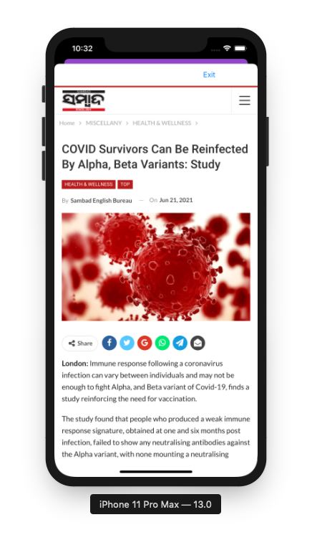

*Image 5: Detail News*

### Functional Requirements

|  |  |  |  |
| --- | --- | --- | --- |
| **Item** | **Description** | **Action** | **Response** |
| **Detail News Screen** | Detail News Screen has 1 UIView contains an Exit button and an URL label.  It also contains a webkitview to display data of detail of news. | N/A | N/A |
| **UIView titleBarView** | UIView titleBarView has a constraint width equal to 320. | N/A | N/A |
| **Label URL** | Label URL has a gradient background, from purple on the left to pink on the right | N/A | N/A |
| **Exit button** | Using to exit screen detail news back to Home/Technology/Science/Entertainment/Heath screen | Tap on **Exit button** | Return to to Home/Technology/Science/Entertainment/Heath screen |
| **WebkitView Detail News** | Using to show detail of selected news | N/A | N/A |

## **Feature/Component #4: Categories screen**

### User Interfaces

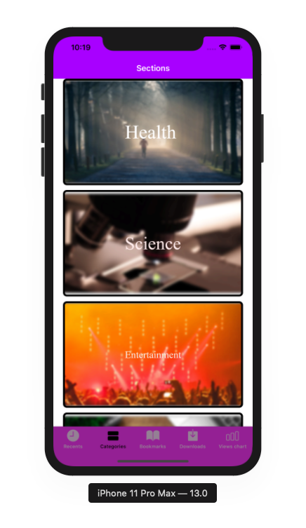

*Image 6: Categories screen*

### Functional Requirements

|  |  |  |  |
| --- | --- | --- | --- |
| **Item** | **Description** | **Action** | **Response** |
| **Categories screen** | Screen has a navigationBar, 1 tabBarController, 5 tabBarItems, 1 CollectionView contains 4 CollectionViewcell:   * Navigation bar contains title “Sections” * TabBarController contains 5 tabBarItems: * Recents TabBarItems * Categories TabBarItems * Bookmark TabBarItems * Download TabBarItems * View chart TabBarItems * CollectionViewCell contains 2 UIImageView: background and categoryTitle | N/A | N/A |
| **Navigation Bar** | Navigation bar contains a title of screen: “Sections” | N/A | N/A |
| **TabBarController** | TabBarController contains 5 tabBarItems:   * Recents TabBarItems * Categories TabBarItems * Bookmark TabBarItems * Download TabBarItems * View chart TabBarItems | N/A | N/A |
| **Recents TabBarItems** | -Using to display 20 latest news | Tap on the **Recents TabBarItem** | Display a list of 20 latest news |
| **Categories TabBarItems** | - Using to display category options  - Categories:   * Heath * Science * Entertainment * Technology | Tap on **Categories TabBarItems** | Display categories screen |
| **Bookmark TabBarItems** | - Using to display the list of bookmarks news on device | Tap on **Bookmark TabBarItems** | Display screen contians a list of bookmark news |
| **Download TabBarItems** | - Using to display the list of download news on the smartphone | Tap on **Download TabBarItems** | Display screen contians a list of download news |
| **View chart TabBarItems** | Using to show a chart of user View for each category | Tap on **View chart TabBarItems** | Show a screen display a chart of user View for each category |
| **CollectionView Categories** | Using to show a list of 4 categories news: Health, Science, Entertainment, Technology | N/A | N/A |
| **CollectionViewCell Category** | Using to show detail of a category | Tap on **CollectionViewCell Category** | Show selected Category **News list Screen** |
| **UIImageView background Category** | Using to show image of a category | N/A | N/A |
| **UIImageView title Category** | Using to show title image of a category | N/A | N/A |

## **Feature/Component #2: Category News List screen**

### User Interfaces

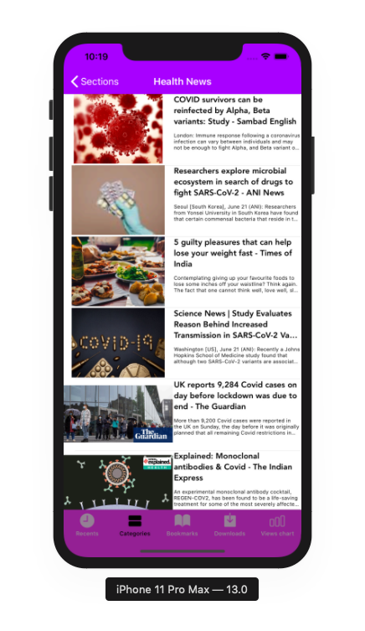

*Image 7: Categories News List screen*

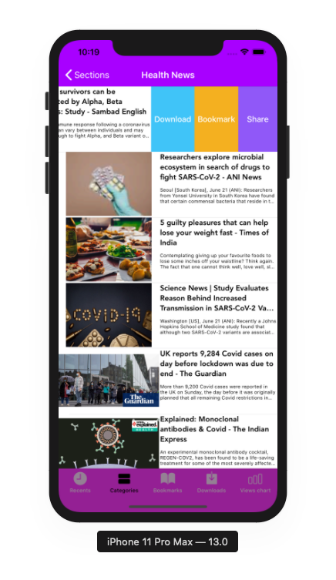

*Image 8: Categories News List screen with Swipe Actions Download, Bookmark and Share*

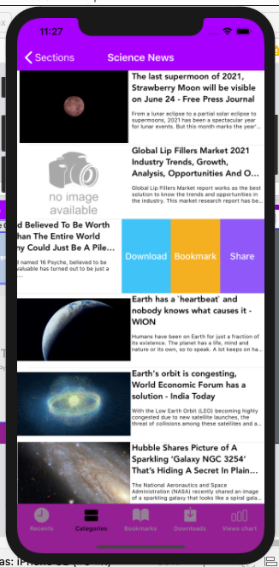

*Image 9: Categories News List screen with an example of news*

*with error when loading image and content*

### Functional Requirements

|  |  |  |  |
| --- | --- | --- | --- |
| **Item** | **Description** | **Action** | **Response** |
| **Categories News List screen** | Categories News List screenhas 1 tabBarController, 5 tabBarItems,1 navigationBarItem, 1 navigationBar, and 20 view cells to display news data include images, title and body of that news:   * Navigation bar contain a navigationBar backToSections and title of selected category * View cell News contains these components: * News images * News Title * News Body * Download Swipe Action * Mark Swipe Action * Share Swipe Action * TabBarController contains 5 tabBarItems: * Recents TabBarItems * Categories TabBarItems * Bookmark TabBarItems * Download TabBarItems * View chart TabBarItems | N/A | N/A |
| **Navigation Bar** | Navigation bar contains a title of selected category and 1 navigationBarItem backToSections | N/A | N/A |
| **NavigationBarItem backToSections** | An **NavigationBarItem** to back to categories Screen | Tap on **NavigationBarItem backToSections** | Back to categories Screen |
| **View cell News** | - Using to display news details  - View cell contains following components:   * Image news (if image can’t be loaded succesfully, no image availabe will be used to display) * Title news (if title can’t be loaded succesfully, “Not Found” will be used to display) * News summary (if title can’t be loaded succesfully, “No body” will be used to display) | Tap on the view cell | Display news details |
| **View cell News when swipe from right to left** | - Using to display news details and other options with this news  - View cell contains following components:   * Title news * News summary * Download Swipe Action * Mark Swipe Action * Share Swipe Action | Swipe from right to left | Display 3 Swipe Actions: Download, Bookmark and Share |
| **Download Swipe Action** | - Using to add news to download list  - The download button is on the left of the mark Swipe action  - The download Swipe action has a blue background and white text color | Tap on the **Download** Swipe Action | Add selected news to download list |
| **Bookmark Swipe Action** | - Using to add news to bookmark list  - The bookmark swipe action is on the left of the share swipe action  - The bookmark swipe action has an orange background and white text color | Tap on the **Bookmark** Swipe Action | Add selected news to bookmark list |
| **Share Swipe Action** | - Using to display a list of social network options for sharing  - The Bookmark Swipe Action  is on the left of the share button  - The share Swipe Action has a violet background and white text color | Tap on the **Share** Swipe Action | Display a list of social network options for sharing |
| **TabBarController** | TabBarController contains 5 tabBarItems:   * Recents TabBarItems * Categories TabBarItems * Bookmark TabBarItems * Download TabBarItems * View chart TabBarItems | N/A | N/A |
| **Recents TabBarItems** | -Using to display 20 latest news | Tap on the **Recents TabBarItem** | Display a list of 20 latest news |
| **Categories TabBarItems** | - Using to display category options  - Categories:   * Heath * Science * Entertainment * Technology | Tap on **Categories TabBarItems** | Display categories screen |
| **Bookmark TabBarItems** | - Using to display the list of bookmarks news on device | Tap on **Bookmark TabBarItems** | Display screen contians a list of bookmark news |
| **Download TabBarItems** | - Using to display the list of download news on the smartphone | Tap on **Download TabBarItems** | Display screen contians a list of download news |
| **View chart TabBarItems** | * Using to show a chart of user View for each category | Tap on **View chart TabBarItems** | Show a screen display a chart of user View for each category |

## **Feature/Component #5: Bookmarks Screen**

### User Interfaces

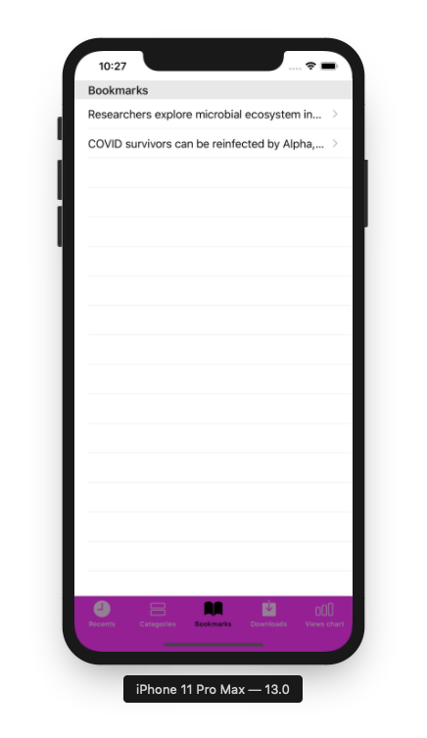

*Image 10: Bookmark screen*

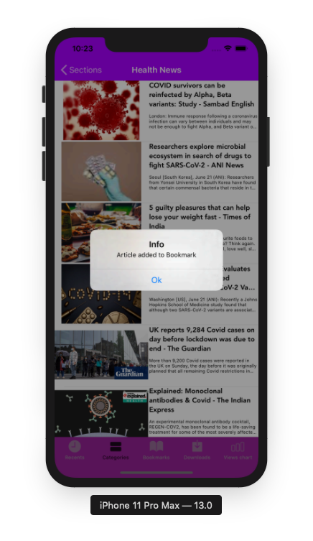

*Image 11: Notification when bookmarked successfully*

*at Categories News List screen*

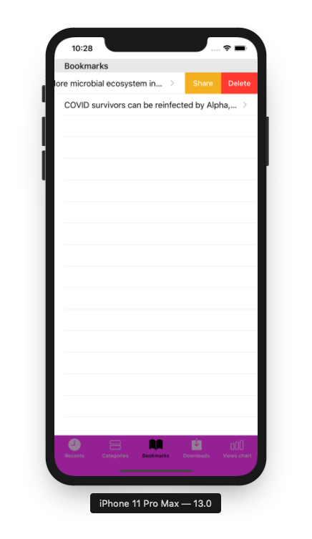

*Image 12: Bookmark Screen with Swipe Actions*

### Functional Requirements

|  |  |  |  |
| --- | --- | --- | --- |
| **Item** | **Description** | **Action** | **Response** |
| **Bookmark Screen** | Bookmark screenhas 1 tabBarController, 5 tabBarItem and 1 UITableView to display a list of bookmarked news:   * UITableView has a title for header: “Bookmarks” * UITableViewCell News contains these components: * News title label * Share Swipe Action * Delete Swipe Action * TabBarController contains 5 tabBarItems: * Recents TabBarItems * Categories TabBarItems * Bookmark TabBarItems * Download TabBarItems * View chart TabBarItems | N/A | N/A |
| **UITableView Bookmark news** | **UITableView Bookmark news**  contains a title “Bookmarks” | N/A | N/A |
| **UITableView cell Bookmark News** | - Using to display news details  - View cell contains News Title labels | Tap on the view cell | Display news details |
| **View cell News when swipe from right to left** | - Using to display news details and other options with this news  - View cell contains following components:   * Title news labels * Share Swipe Action * Delete Swipe Action | Swipe from right to left | Display 2 Swipe Actions: Delete and Share |
| **Delete Swipe Action** | - Using to delete news from Bookmark news list  - The download button is on the right of Share Swipe action  - The download Swipe action has a red background and white text color | Tap on the **Delete** Swipe Action | Delete selected news from Bookmark list |
| **Share Swipe Action** | - Using to display a list of social network options for sharing  - TheShareSwipe Action  is on the right of the right of title label  - The share Swipe Action has an orange background and white text color | Tap on the **Share** Swipe Action | Display a list of social network options for sharing |
| **TabBarController** | TabBarController contains 5 tabBarItems:   * Recents TabBarItems * Categories TabBarItems * Bookmark TabBarItems * Download TabBarItems * View chart TabBarItems | N/A | N/A |
| **Recents TabBarItems** | -Using to display 20 latest news | Tap on the **Recents TabBarItem** | Display a list of 20 latest news |
| **Categories TabBarItems** | - Using to display category options  - Categories:   * Heath * Science * Entertainment   Technology | Tap on **Categories TabBarItems** | Display categories screen |
| **Bookmark TabBarItems** | - Using to display the list of bookmarks news on device | Tap on **Bookmark TabBarItems** | Display screen contians a list of bookmark news |
| **Download TabBarItems** | - Using to display the list of download news on the smartphone | Tap on **Download TabBarItems** | Display screen contians a list of download news |
| **View chart TabBarItems** | Using to show a chart of user View for each category | Tap on **View chart TabBarItems** | Show a screen display a chart of user View for each category |

## **Feature/Component #6: Share Screen**

### User Interfaces

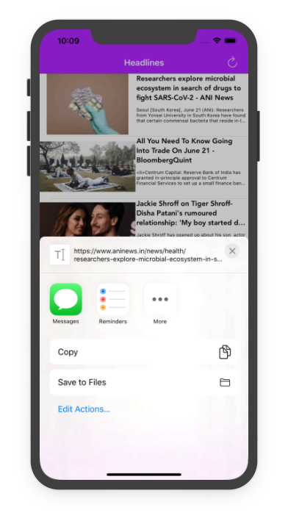

*Image 13: Share list screen*

### Functional Requirements

|  |  |  |  |
| --- | --- | --- | --- |
| **Item** | **Description** | **Action** | **Response** |
| **Share Screen** | Share Screen has 7 buttons and a title   * Reminder button * Copy button * Save to Files button * Edit Actions button * Close button * More button * Title: URL news | N/A | N/A |
| **Reminder button** | -Using to record reminders to the user's phone | Tap on button | Record reminders to the user's phone |
| **Copy button** | -Using to copy the news link to the clipboard on the user's phone | Tap on button | Copy the news link to the clipboard on the user's phone |
| **Save to files button** | -Using to store information into a file and then add it to the user's phone memory | Tap on button | Store information into a file and then add it to the user's phone memory |
| **Edit action** **button** | -Using to edit action | Tap on button | Edit action |
| **Close button** | -Using to close share screen | Tap on button | Close share screen |
| **More button** | -Using to show options | Tap on button | Show options |
| **URL Title news** | -URL news | N/A | N/A |

## **Feature/Component #7: Download list Screen**

### User Interfaces

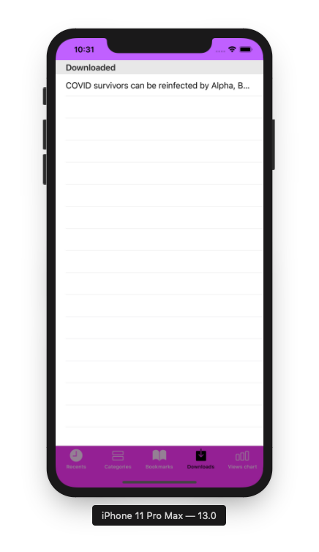

*Image 14: Download list screen*

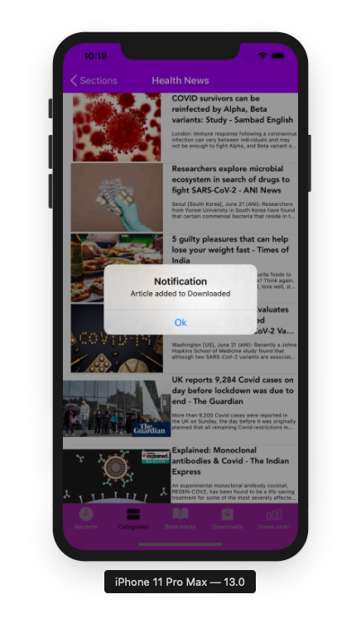

*Image 15: Notification when downloaded news successfully*

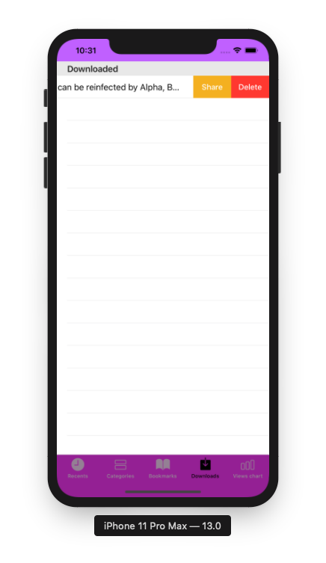

*Image 16: Download Screen with Swipe Action*

### Functional Requirements

|  |  |  |  |
| --- | --- | --- | --- |
| **Item** | **Description** | **Action** | **Response** |
| **Download Screen** | Download screenhas 1 tabBarController, 5 tabBarItem and 1 UITableView to display a list of bookmarked news:   * UITableView has a title for header: “Downloaded” * UITableViewCell News contains these components: * News title label * Share Swipe Action * Delete Swipe Action * TabBarController contains 5 tabBarItems: * Recents TabBarItems * Categories TabBarItems * Bookmark TabBarItems * Download TabBarItems * View chart TabBarItems | N/A | N/A |
| **UITableView Bookmark news** | **UITableView Bookmark news**  contains a title “Downloaded” | N/A | N/A |
| **UITableView cell Bookmark News** | - Using to display news details  - View cell contains News Title labels | Tap on the view cell | Display news details |
| **View cell News when swipe from right to left** | - Using to display news details and other options with this news  - View cell contains following components:   * Title news labels * Share Swipe Action * Delete Swipe Action | Swipe from right to left | Display 2 Swipe Actions: Delete and Share |
| **Delete Swipe Action** | - Using to delete news from Bookmark news list  - The download button is on the right of Share Swipe action  - The download Swipe action has a red background and white text color | Tap on the **Delete** Swipe Action | Delete selected news from Bookmark list |
| **Share Swipe Action** | - Using to display a list of social network options for sharing  - TheShareSwipe Action  is on the right of the right of title label  - The share Swipe Action has an orange background and white text color | Tap on the **Share** Swipe Action | Display a list of social network options for sharing |
| **TabBarController** | TabBarController contains 5 tabBarItems:   * Recents TabBarItems * Categories TabBarItems * Bookmark TabBarItems * Download TabBarItems * View chart TabBarItems | N/A | N/A |
| **Recents TabBarItems** | -Using to display 20 latest news | Tap on the **Recents TabBarItem** | Display a list of 20 latest news |
| **Categories TabBarItems** | - Using to display category options  - Categories:   * Heath * Science * Entertainment   Technology | Tap on **Categories TabBarItems** | Display categories screen |
| **Bookmark TabBarItems** | - Using to display the list of bookmarks news on device | Tap on **Bookmark TabBarItems** | Display screen contians a list of bookmark news |
| **Download TabBarItems** | - Using to display the list of download news on the smartphone | Tap on **Download TabBarItems** | Display screen contians a list of download news |
| **View chart TabBarItems** | Using to show a chart of user View for each category | Tap on **View chart TabBarItems** | Show a screen display a chart of user View for each category |

## **Feature/Component #12: Getting News Screen**

### User Interfaces

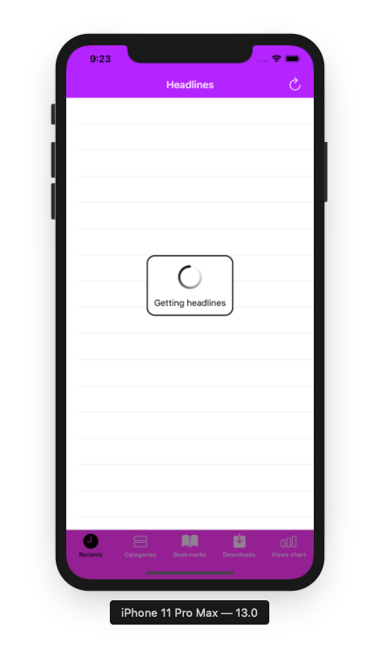

*Image 17: Getting News screen*

### Functional Requirements

|  |  |  |  |
| --- | --- | --- | --- |
| **Item** | **Description** | **Action** | **Response** |
| **Getting News screen** | Getting News screen has:   * Title: Getting news * Icon: Loading * Text: Black * Background: Light blue | N/A | N/A |

## **Feature/Component #7: View chart Screen**

### User Interfaces

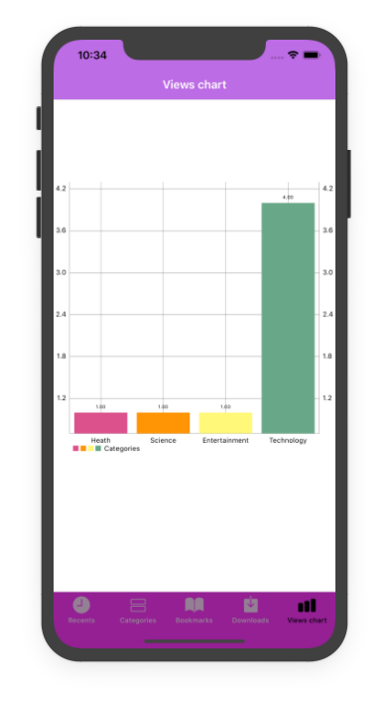

*Image 15: View chart screen*

### Functional Requirements

|  |  |  |  |
| --- | --- | --- | --- |
| **Item** | **Description** | **Action** | **Response** |
| **Chart Screen** | Chart screenhas 1 tabBarController, 5 tabBarItem and 1 chart:   * TabBarController contains 5 tabBarItems: * Recents TabBarItems * Categories TabBarItems * Bookmark TabBarItems * Download TabBarItems * View chart TabBarItems * Categories views chart | N/A | N/A |
| **Categories View chart** | -Using to display a chart of Views for each category | N/A | N/A |
| **TabBarController** | TabBarController contains 5 tabBarItems:   * Recents TabBarItems * Categories TabBarItems * Bookmark TabBarItems * Download TabBarItems * View chart TabBarItems | N/A | N/A |
| **Recents TabBarItems** | -Using to display 20 latest news | Tap on the **Recents TabBarItem** | Display a list of 20 latest news |
| **Categories TabBarItems** | - Using to display category options  - Categories:   * Heath * Science * Entertainment   Technology | Tap on **Categories TabBarItems** | Display categories screen |
| **Bookmark TabBarItems** | - Using to display the list of bookmarks news on device | Tap on **Bookmark TabBarItems** | Display screen contians a list of bookmark news |
| **Download TabBarItems** | - Using to display the list of download news on the smartphone | Tap on **Download TabBarItems** | Display screen contians a list of download news |
| **View chart TabBarItems** | Using to show a chart of user View for each category | Tap on **View chart TabBarItems** | Show a screen display a chart of user View for each category |

***---------- End of Document ----------***