Ex1.

* Boolean is a value that is either TRUE or FALSE.
* 1 == 2 -> False
* 3 > 2 -> True
* 1 == 1 -> True

Ex2.

* A **flowchart** is a type of diagram that represents an algorithm, workflow or process, showing the steps as boxes of various kinds, and their order by connecting them with arrows.
* 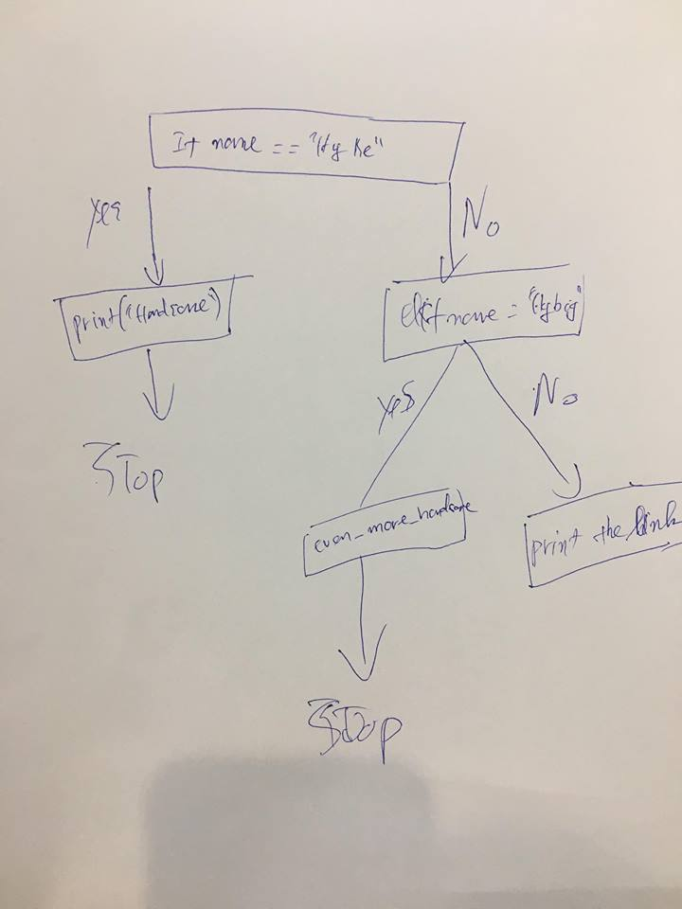

Ex3.

* “Nested conditionals statements means that you can use one if or else if statement inside another if or else if statement(s).
* Eg:
* var = 100
* if var < 200:
* print "Expression value is less than 200"
* if var == 150:
* print "Which is 150"
* elif var == 100:
* print "Which is 100"
* elif var == 50:
* print "Which is 50"
* elif var < 50:
* print "Expression value is less than 50"
* else:
* print "Could not find true expression"
* print "Good bye!"