Bùi Đức Anh_1150080126
Lớp 11_THMT
lab3
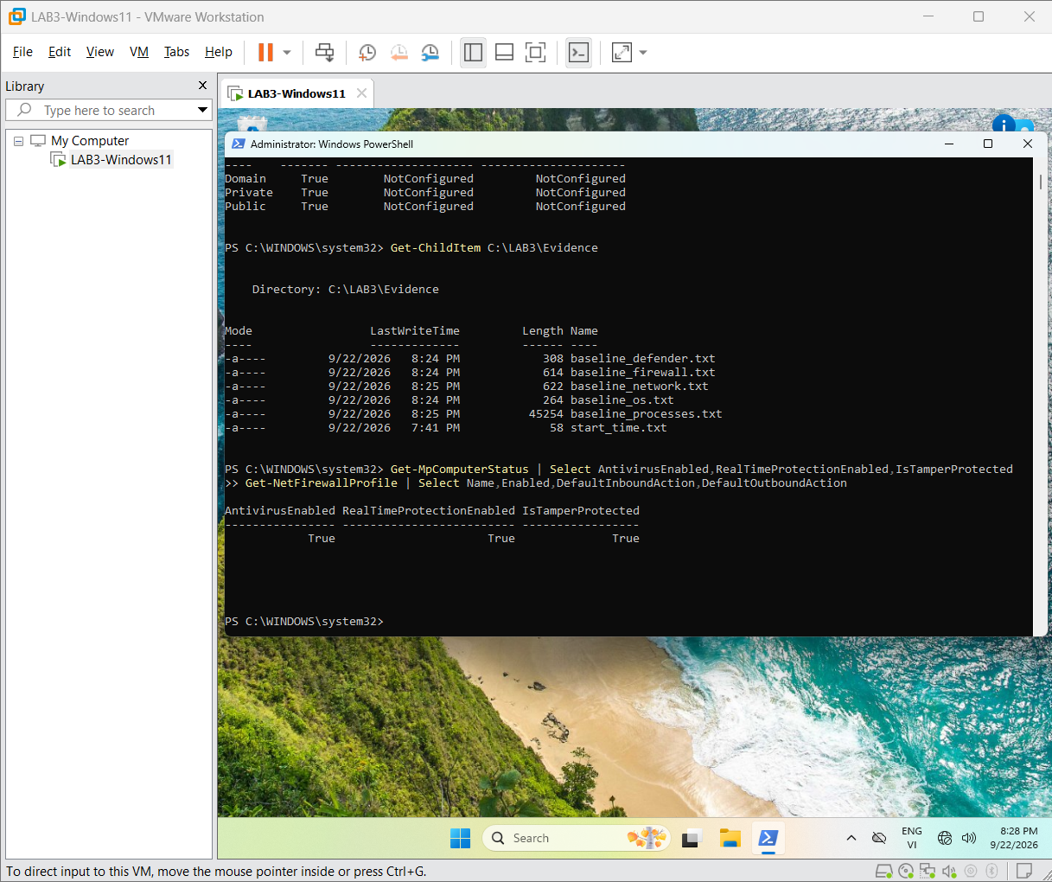

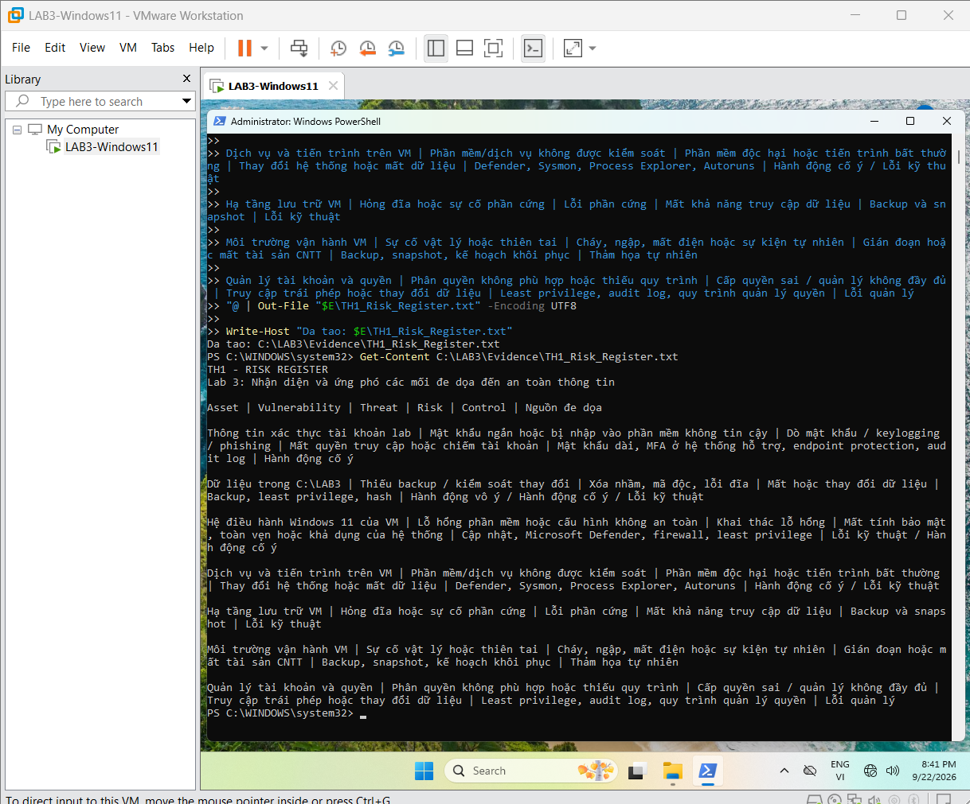
H_TH1_Risk_Register.png

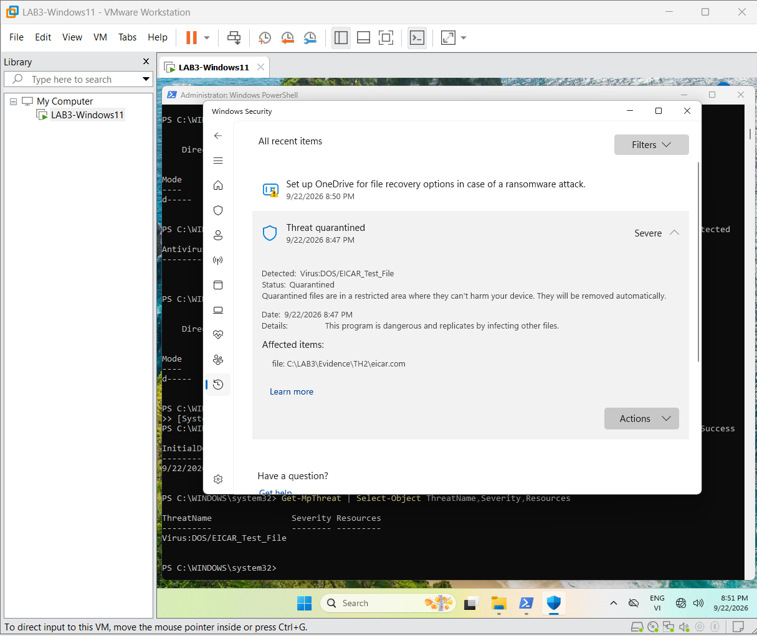
H4_ProtectionHistory_EICAR.png

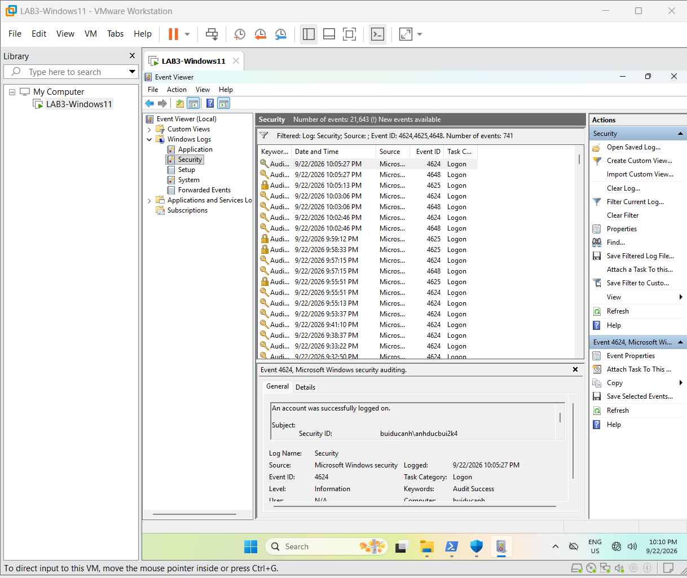

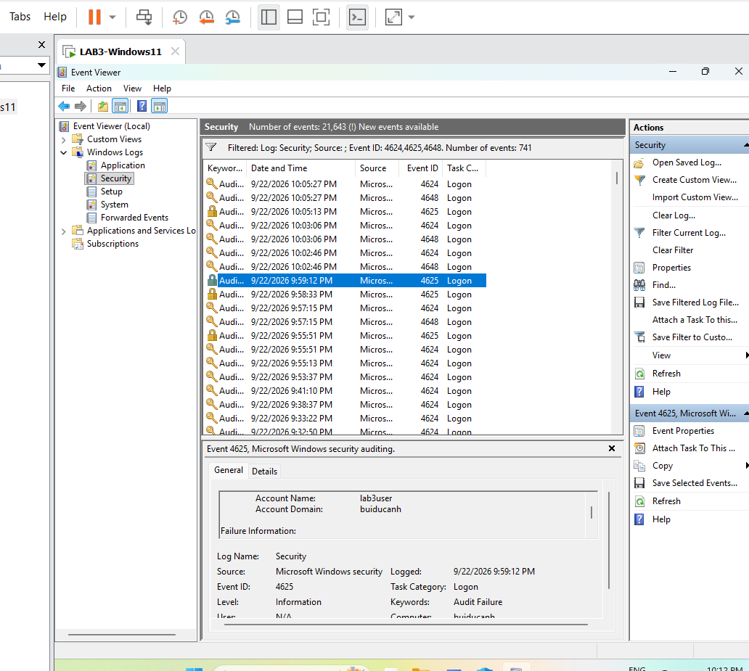
H5_Event4625.png

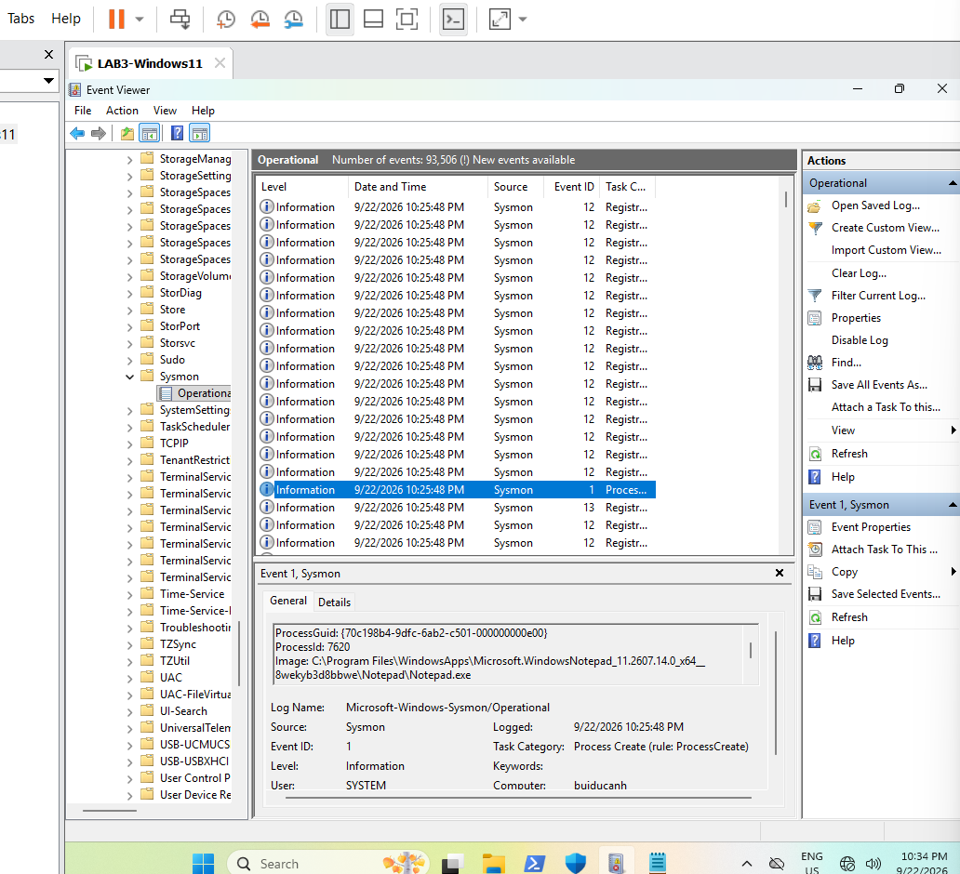
H6_Sysmon_Event1.png

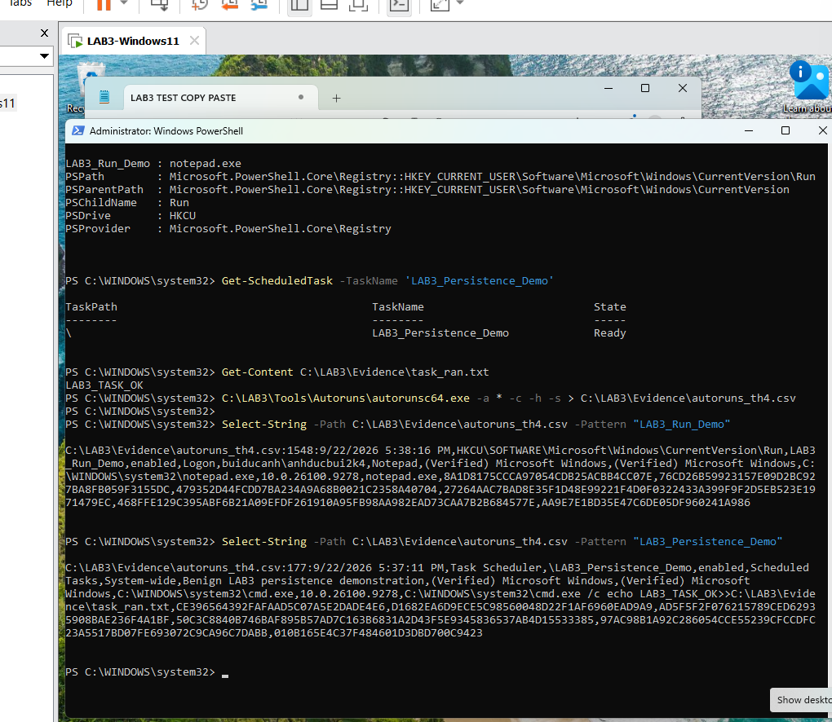
H7_Autoruns_Persistence.png

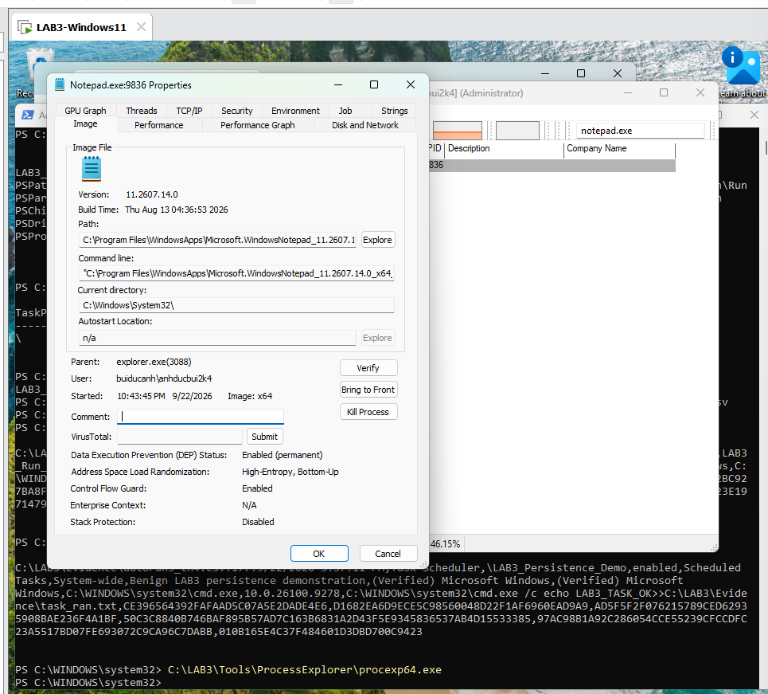
H8_ProcessExplorer_Notepad.png

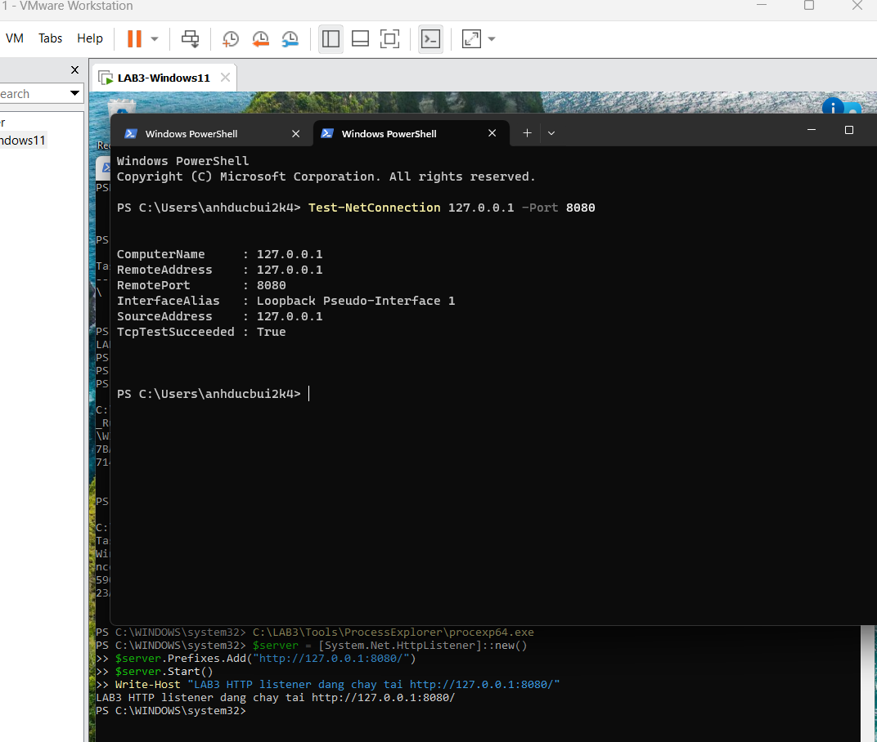
H9_Localhost_8080.png

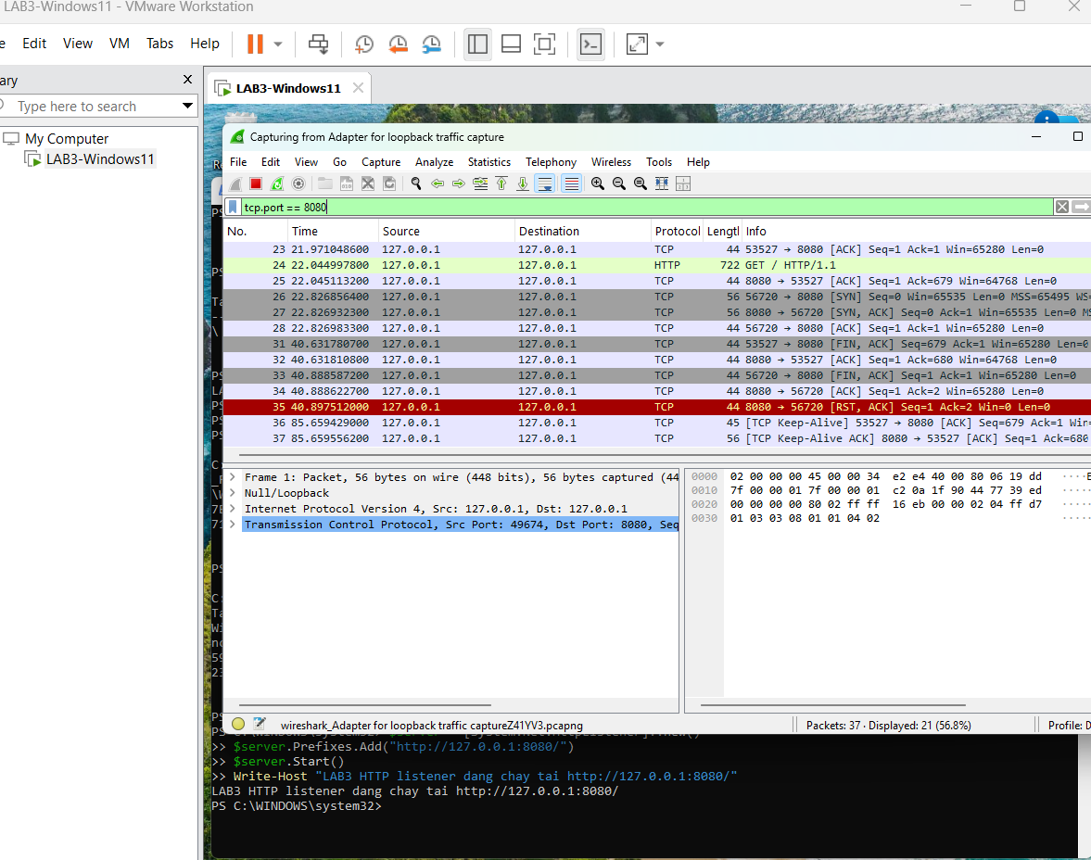
H10_Wireshark_Localhost.png

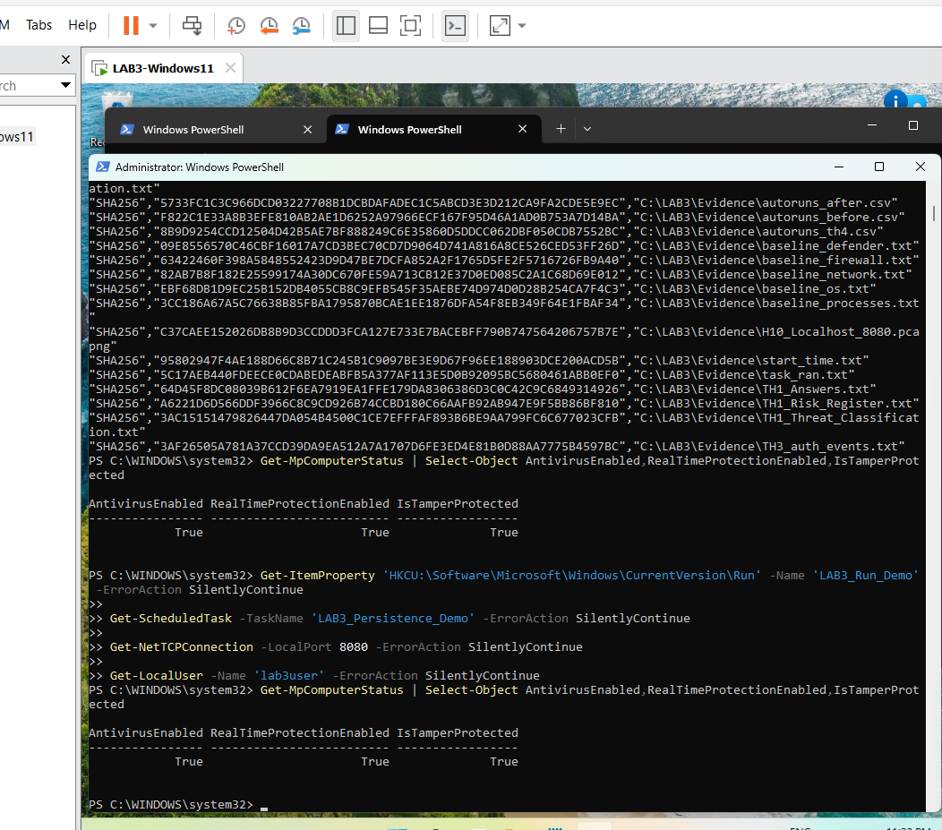
H11_Recovery_Verification.png

