

WORKSHEET: Human Research Determination
The purpose of this worksheet is to help individuals determine whether an activity constitutes Human Research. It does not need to be completed or retained.
Some potential use cases:
- Doctor of Nursing Practice (DNP) candidates and faculty who are healthcare practitioners seeking to determine whether their activities are Human Research or Quality Improvement Initiatives/Practice Changes.
- Doctoral candidates completing their projects in their work environment, seeking to enhance a program/process/delivery change to established standards/best practices
- Those who are unsure whether their efforts meet the definition of research.
Checklist
Use this checklist to determine whether a proposal meets the DHHS definition of research (45 CFR 46.102).

Section 1 — Indicators the Project is NOT Research (Quality Improvement / Practice Change)
- Intent: Improve care, workflow, or outcomes within one local practice site.
- Intervention: Implemented for all applicable patients as part of routine practice.
  - No change to the standard of care solely for the sake of data collection
- Project
  - Does not use randomization or a control group.
  - Would be implemented even without data collection, because the practice change is inherently beneficial.
- Data: Collected only to guide or evaluate the local practice change, not to test a hypothesis.
- Findings: Not intended to be generalizable beyond the local site.
- Dissemination (poster, manuscript, abstract): Presents the work as quality improvement rather than as generalizable research.

Section 2 — Indicators the Project IS Research
- The activity is designed as a systematic investigation intended to answer a research question or test a hypothesis.
- The intent is to produce generalizable knowledge beyond the local site.
- The project includes comparison groups, controlled study designs, or random assignment.
- Data is collected specifically to draw conclusions that extend beyond local improvement.
- The intervention is introduced only to collect data for the study, not as a standard practice change.
- There is a plan to publish the results as research rather than quality improvement.
- Participants may receive different levels of risk or benefit compared to standard care because of the project.
Comparison Table
 | Human Research | Quality Improvement/Practice Change
Primary Intent | - Develop/contribute to generalizable knowledge  - Test hypothesis  - Answer research questions | - Improve local care  - Enhance workflow  - Improve a program/delivery of care with consideration of established standards
Methodolody | - Systematic investigation  - Random assignment  - Controlled study design | - Routine practice for all  - No control group  - No randomization  - Adaptive/iterative
Scope and Data | - More likely to be externally funded  - Controlled study design | - Single center (generally)  - Not externally funded  - Guide local changes
Analysis | - Prove/disprove the hypothesis  - Qualitative/quantitative analysis | - Compare program/process/delivery change to established standards/best practices
Results | - Intent to contribute to generalizable knowledge | - Intent to utilize results locally
Dissemination | - Published/presented as research | - Insights may be shared as quality improvement learnings

Human Research Determination
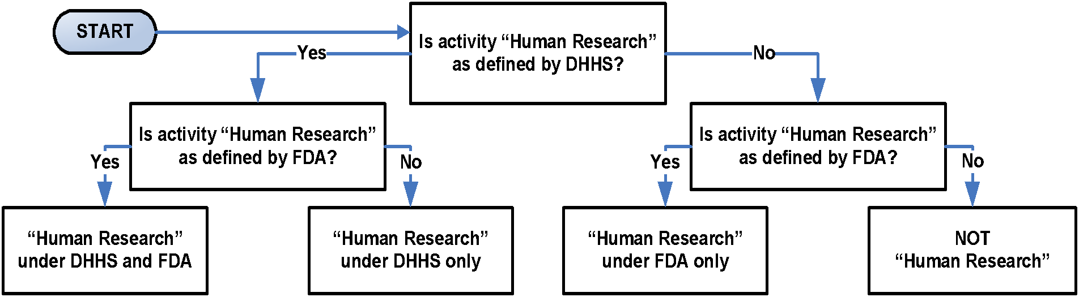
Image from Purdue IRB HRP-310

- Research as Defined by DHHS Regulations (Check if “Yes”)
- Is the activity an investigation?
Investigation: a searching inquiry for facts; detailed or careful examination.
- Is the investigation systematic?
Systematic: having or involving a system, method, or plan.
- Is the systematic investigation designed to develop or contribute to knowledge?
Designed: observable behaviors used to develop or contribute to knowledge.
Develop: to form the basis for a future contribution.
Contribute: to result in. Knowledge: truths, facts, information.)
- Is the knowledge the systematic investigation is designed to develop or contribute generalizable?
Generalizable: universally or widely applicable.

- Human Subject Under DHHS Regulations (Check if “Yes”)
- Is the investigator conducting the Research gathering information or biospecimens about living individuals?

- Human Subject Under DHHS Regulations (Check if “Yes”)
- Will the investigator use, study, or analyze information or biospecimens obtained through either of the following mechanisms? Specify which mechanism(s) apply, if yes:
- Physical procedures or manipulations of those individuals or their environment for Research purposes (“Intervention”).
- Communication or interpersonal contact with the individuals. ("Interaction”).

- Human Subject Under DHHS Regulations (Check if “Yes”)
- Will the investigator gather data that is either? Specify which category(s) apply if yes:
  - The data are about behavior that occurs in a context in which an individual can reasonably expect that no observation or recording is taking place (i.e. “Private information”).
  - Individuals have provided the data for specific purposes in which the individuals can reasonably expect that it will NOT be made public, such as a medical record (i.e. “Private information”).
- Can the individuals’ identities be readily ascertained or associated with the information by the investigator (i.e. “Identifiable Private Information”)?

- Human Subject Under DHHS Regulations (Check if “Yes”)
- Will the investigator gather biospecimens?
- Can the individuals’ identities be readily ascertained or associated with the biospecimens by the investigator (i.e. “Identifiable Biospecimen”)?
If all items are checked under 1, 2, and 3 or 1, 2, 4 and/or 5, the activity is Human Research under DHHS regulations.

- Human Research Under DHHS Regulations (Check if “Yes”)
- Has a department or agency head, covered by the Common Rule, retained final judgment (consistent with the ethical principles of the Belmont Report) that the activity is Human Research under DHHS regulations?
If checked, the activity is Human Research under DHHS regulations.
- Human Research Under FDA Regulations (Check if “Yes”)
- Does the activity involve any of the following? (Check all that apply)
  - In the United States: The use of a drug in one or more persons other than use of an approved drug in the course of medical practice .
  - In the United States: The use of a device in one or more persons that evaluates the safety or effectiveness of that device.
  - Data regarding subjects or control subjects submitted to or held for inspection by FDA .
  - Data regarding the use of a device on human specimens (identified or unidentified) submitted to or held for inspection by FDA .
If “Yes”, the activity is Human Research under FDA regulations.

- Human Research under Organizational Policy
If the activity is Human Research under DHHS regulations or under FDA regulations, it is Human Research under organizational policy.

- Engagement (Complete if the activity is Human Research. (Check if “Yes”)
- The organization is engaged in Human Research. Use IRB 311 WORKSHEET - Engagement Determination.

The term ‘‘drug’’ means: - articles recognized in the official United States Pharmacopoeia, official Homoeopathic Pharmacopoeia of the United States, or official National Formulary, or any supplement to any of them; and - articles intended for use in the diagnosis, cure, mitigation, treatment, or prevention of disease in man or other animals; and - articles (other than food and dietary supplements) intended to affect the structure or any function of the body of man or other animals; and - articles intended for use as a component of any article specified in clause (A), (B), or (C).
“Other than the use of an approved drug in the course of medical practice” refers to a practitioner providing an approved drug to a patient because the practitioner believes the drug to be in the best interests of the patient. If the protocol specifies the use of the drug, it is not in the course of medical practice unless use of the drug is completely up to the discretion of the practitioner.
The term ‘‘device’’ means an instrument, apparatus, implement, machine, contrivance, implant, in vitro reagent, or other similar or related article, including any component, part, or accessory, which is: - recognized in the official National Formulary, or the United States Pharmacopeia, or any supplement to them, - intended for use in the diagnosis of disease or other conditions, or in the cure, mitigation, treatment, or prevention of disease, in man or other animals, or intended to affect the structure or any function of the body of man or other animals, and which does not achieve its primary intended purposes through chemical action within or on the body of man or other animals and which is not dependent upon being metabolized for the achievement of its primary intended purposes.
This is specific to submissions that are part of an application for a research or marketing permit. However, unless otherwise indicated, assume all submissions to FDA meet this requirement.
This is specific to submissions that are part of an application for a research or marketing permit. However, unless otherwise indicated, assume all submissions to FDA meet this requirement.

