Job Aid: Submitting the PG IRB Application Form and Uploading Confirmation

Purpose
This job aid explains how to submit your final IRB application packet through the PG IRB Application Form and how to upload your submission confirmation email to the IRB Submission Confirmation Dropbox.
Submitting the form confirms that your IRB application has been sent for review. It does not mean IRB approval has been granted. You may not begin recruitment, consent, data collection, or access research records until official PG IRB approval has been received.

Before You Begin
Before completing the PG IRB Application Form, confirm that you have:
- Approval or explicit clearance to proceed.
- Your finalized IRB application packet.
- The correct official pathway protocol form.
- Consent form or information sheet, when applicable.
- Recruitment materials.
- Data-collection instruments.
- Current CITI training certificate.
- Signed site permission form, when applicable.
- Any additional supporting documents required for your pathway.

Step 1: Open the PG IRB Application Form
Open the PG IRB Application Form using the link provided in the course.

Step 2: Complete the Candidate Information Section
Enter your candidate information carefully.
Complete all required fields marked with an asterisk. The form asks for information such as candidate name, candidate email, Student ID number, Purdue Global affiliation, affiliated school, and degree program. Internal candidates should use their PG email address.
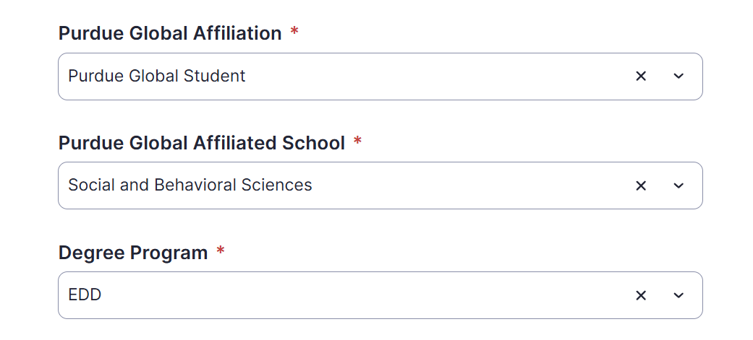

Step 3: Select Your Faculty/Supervisor
Select or enter your Research Project Coordinator’s name.
Please make sure this is accurate to ensure proper routing or it will be delayed

Step 4: Confirm the Correct Review Pathway
Review the submission requirements by pathway before uploading documents.
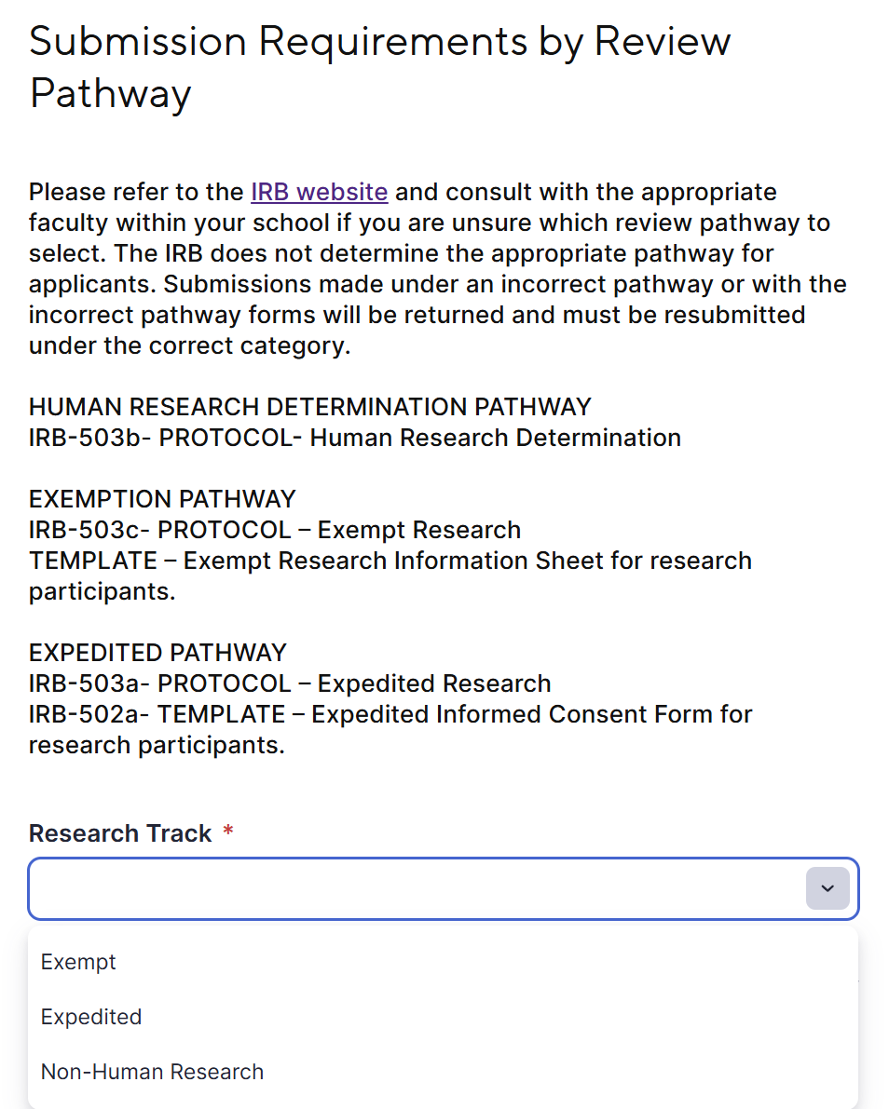

Step 5: Upload Required Documents
Upload all required documents in the designated sections of the PG IRB Application Form.
Use clear file names, such as:
- LastName_IRBApplication_2026.pdf
- LastName_CITI_2026.pdf
- LastName_SitePermission.pdf
- LastName_RecruitmentEmail.pdf
- LastName_InterviewProtocol.pdf
Before moving forward, confirm that every required document is attached and that each file opens correctly.

Step 6: Check “Send Me a Copy of My Responses”
Before clicking Submit, check the box that says:
Send me a copy of my responses

This step is required for ED825 because the copy of your responses will generate the confirmation email you need for the course dropbox. The screenshot of the PG IRB Application Form shows this checkbox near the bottom of the form before submission.

Step 7: Submit the PG IRB Application Form
After all required fields are complete and all required documents are uploaded, click Submit.
Once submitted, save the confirmation email generated from the “Send me a copy of my responses” option.

Step 8: Upload Confirmation to the IRB Submission Confirmation Dropbox
Upload your PG IRB submission confirmation email to the IRB Submission Confirmation Dropbox.
Name your file clearly:
LastName_IRBSubmissionConfirmation.pdf
This confirmation email is required for grading and verification. Your instructor will use it to confirm that you submitted the official IRB application through the PG IRB Application Form.

What Happens After Submission?
After review, the IRB may take one of the following actions:
- Approve the protocol as submitted.
- Request revisions or additional information.
- Request resubmission under a different review pathway.
If revisions are requested, work with your RPC to address the requested changes. If the protocol is approved, you will receive an email notification from the IRB confirming approval.

Important Reminders
Submitting the PG IRB Application Form is not the same as receiving IRB approval.
Uploading the confirmation email to the IRB Submission Confirmation Dropbox verifies course submission, not IRB approval.
You may not begin recruitment, consent, data collection, interviews, surveys, observations, or access to research records until official PG IRB approval has been received.

