CCT College Dublin

Assessment Cover Page

Module Title: | Algorithms & Constructs  Software Development Fundamentals
Assessment Title: | System Modelling & Build
Lecturer Name: | Ken Healy / Taufique Ahmed
Student Full Name: | Qizhen Guo
Student Number: | 2025748
Assessment Due Date: | Saturday 23rd May 2026
Date of Submission: | Saturday 23rd May 2026

Declaration

By submitting this assessment, I confirm that I have read the CCT policy on Academic Misconduct and understand the implications of submitting work that is not my own or does not appropriately reference material taken from a third party or other source. I declare it to be my own work and that all material from third parties has been appropriately referenced. I further confirm that this work has not previously been submitted for assessment by myself or someone else in CCT College Dublin or any other higher education institution.

CA2 Integrated Assignment Report

Bank Employee Management System

1. Introduction
This report presents the design and development of a Bank Employee Management System created for the CA2 Integrated Assignment. The system is a Java command-line application that allows users to manage applicant and employee records for a bank organisation.

The system reads applicant data from a text file, sorts applicants alphabetically using recursive Merge Sort, searches for applicants using recursive Binary Search, allows new employee records to be added with input validation, and represents employee records in a binary tree using level-order insertion.

The selected organisation type is a bank because it naturally contains departments, managers and employees. This structure supports the assignment requirements for manager types, department types, employee records and binary tree hierarchy representation.

2. Chosen Organisation
The chosen organisation is a bank. The bank contains several departments such as Loans, Customer Service, Human Resources, Information Technology and Foreign Exchange. Employees are assigned to departments and are also associated with a manager type.

The system includes three manager types:
- Branch Manager
- Assistant Manager
- Team Lead

The system includes five department types:
- Loans
- Customer Service
- Human Resources
- Information Technology
- Foreign Exchange

3. Functional Requirements
FR1: The system shall load applicant records from a text file named Applicants_Form.txt.

FR2: The system shall sort applicant records alphabetically by full name using a recursive sorting algorithm.

FR3: The system shall display the first 20 sorted applicant names after sorting.

FR4: The system shall allow the user to search for an applicant by full name using recursive Binary Search.

FR5: The system shall display the applicant’s name, manager type and department when a search is successful.

FR6: The system shall allow the user to add a new employee record by entering first name, last name, manager type and department.

FR7: The system shall validate user input for employee names, manager type and department.

FR8: The system shall create a binary tree using at least 20 employee records.

FR9: The system shall insert employees into the binary tree using level-order insertion.

FR10: The system shall display the binary tree using level-order traversal and show the tree height and total node count.

4. Non-Functional Requirements
NFR1: The system shall be implemented as a Java command-line application without using GUI frameworks such as JavaFX or Swing.

NFR2: The system shall be organised using clear Java classes and package naming under the package CA_2.

NFR3: The system shall be easy to run in NetBeans as a Maven project.

NFR4: The system shall provide clear console messages so that users understand each menu option and system response.

NFR5: The system shall handle invalid user input without crashing.

NFR6: The system shall use GitHub version control with multiple meaningful commits during development.

NFR7: The system shall use efficient recursive algorithms for sorting and searching.

NFR8: The system shall maintain readable and maintainable code through appropriate class separation and comments.

5. Use Cases

Use Case 1 — Sort Applicants

Description:
This use case allows the user to sort all applicants alphabetically by full name using recursive Merge Sort.

Preconditions:
Applicant data must already be loaded from the text file.

Main Flow:
1. The user selects the “Sort Applicants” menu option.
2. The system retrieves all applicant records.
3. The system applies recursive Merge Sort.
4. The system displays the first 20 sorted applicant names.

Postconditions:

The applicant list is sorted alphabetically.

Use Case 2 — Search Applicant

Description:
This use case allows the user to search for an applicant by entering a full name.

Preconditions:
Applicant data has been loaded and sorted, or the system can sort the applicant list before searching.

Main Flow:
1. The user selects the “Search Applicant” menu option.
2. The system asks the user to enter a full name.
3. The user enters the applicant name.
4. The system performs recursive Binary Search.
5. The system displays the applicant information if found.

Alternative Flow:
If the applicant does not exist, the system displays “Applicant not found.”

Postconditions:
The search result is displayed to the user.

Use Case 3 — Add Employee

Description:
This use case allows the user to add a new employee record to the system.

Preconditions:
The system must be running.

Main Flow:
1. The user selects “Add Employee”.
2. The system asks for first name and last name.
3. The system asks the user to select a manager type.
4. The system asks the user to select a department.
5. The system validates all input.
6. The system creates a new employee record.
7. The system confirms successful insertion.

Alternative Flow:
If invalid input is entered, the system asks the user to re-enter the value.

Postconditions:
A new employee is added to the employee list.

Use Case 4 — Create Binary Tree

Description:
This use case creates an employee binary tree using level-order insertion.

Preconditions:
At least 20 employee records must exist.

Main Flow:
1. The user selects “Create Binary Tree”.
2. The system creates a new binary tree.
3. The system inserts employees using level-order insertion.
4. The system confirms successful tree creation.

Postconditions:
The binary tree is successfully created.

Use Case 5 — Display Binary Tree

Description:
This use case displays all employees stored in the binary tree.

Preconditions:
The binary tree must already exist.

Main Flow:
1. The user selects “Display Tree”.
2. The system performs level-order traversal.
3. The system displays all employee nodes.
4. The system displays tree height.
5. The system displays total node count.

Alternative Flow:
If the tree has not been created, the system displays an error message.

Postconditions:
The tree information is displayed to the user.

6. Use Case Diagram
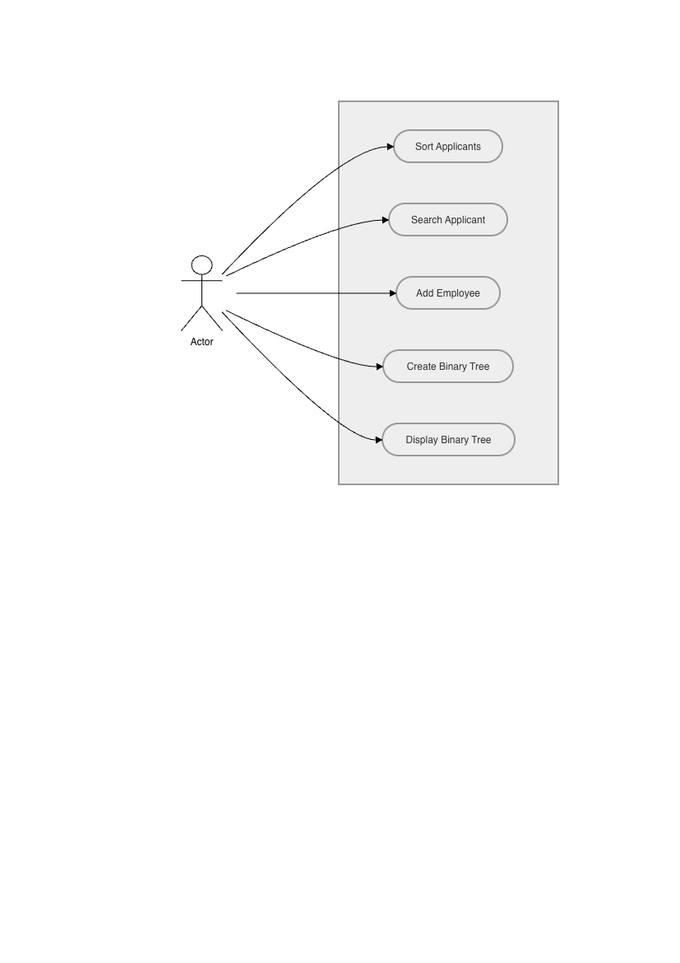

7. UML Diagrams

UML Diagram 1 — Class Diagram
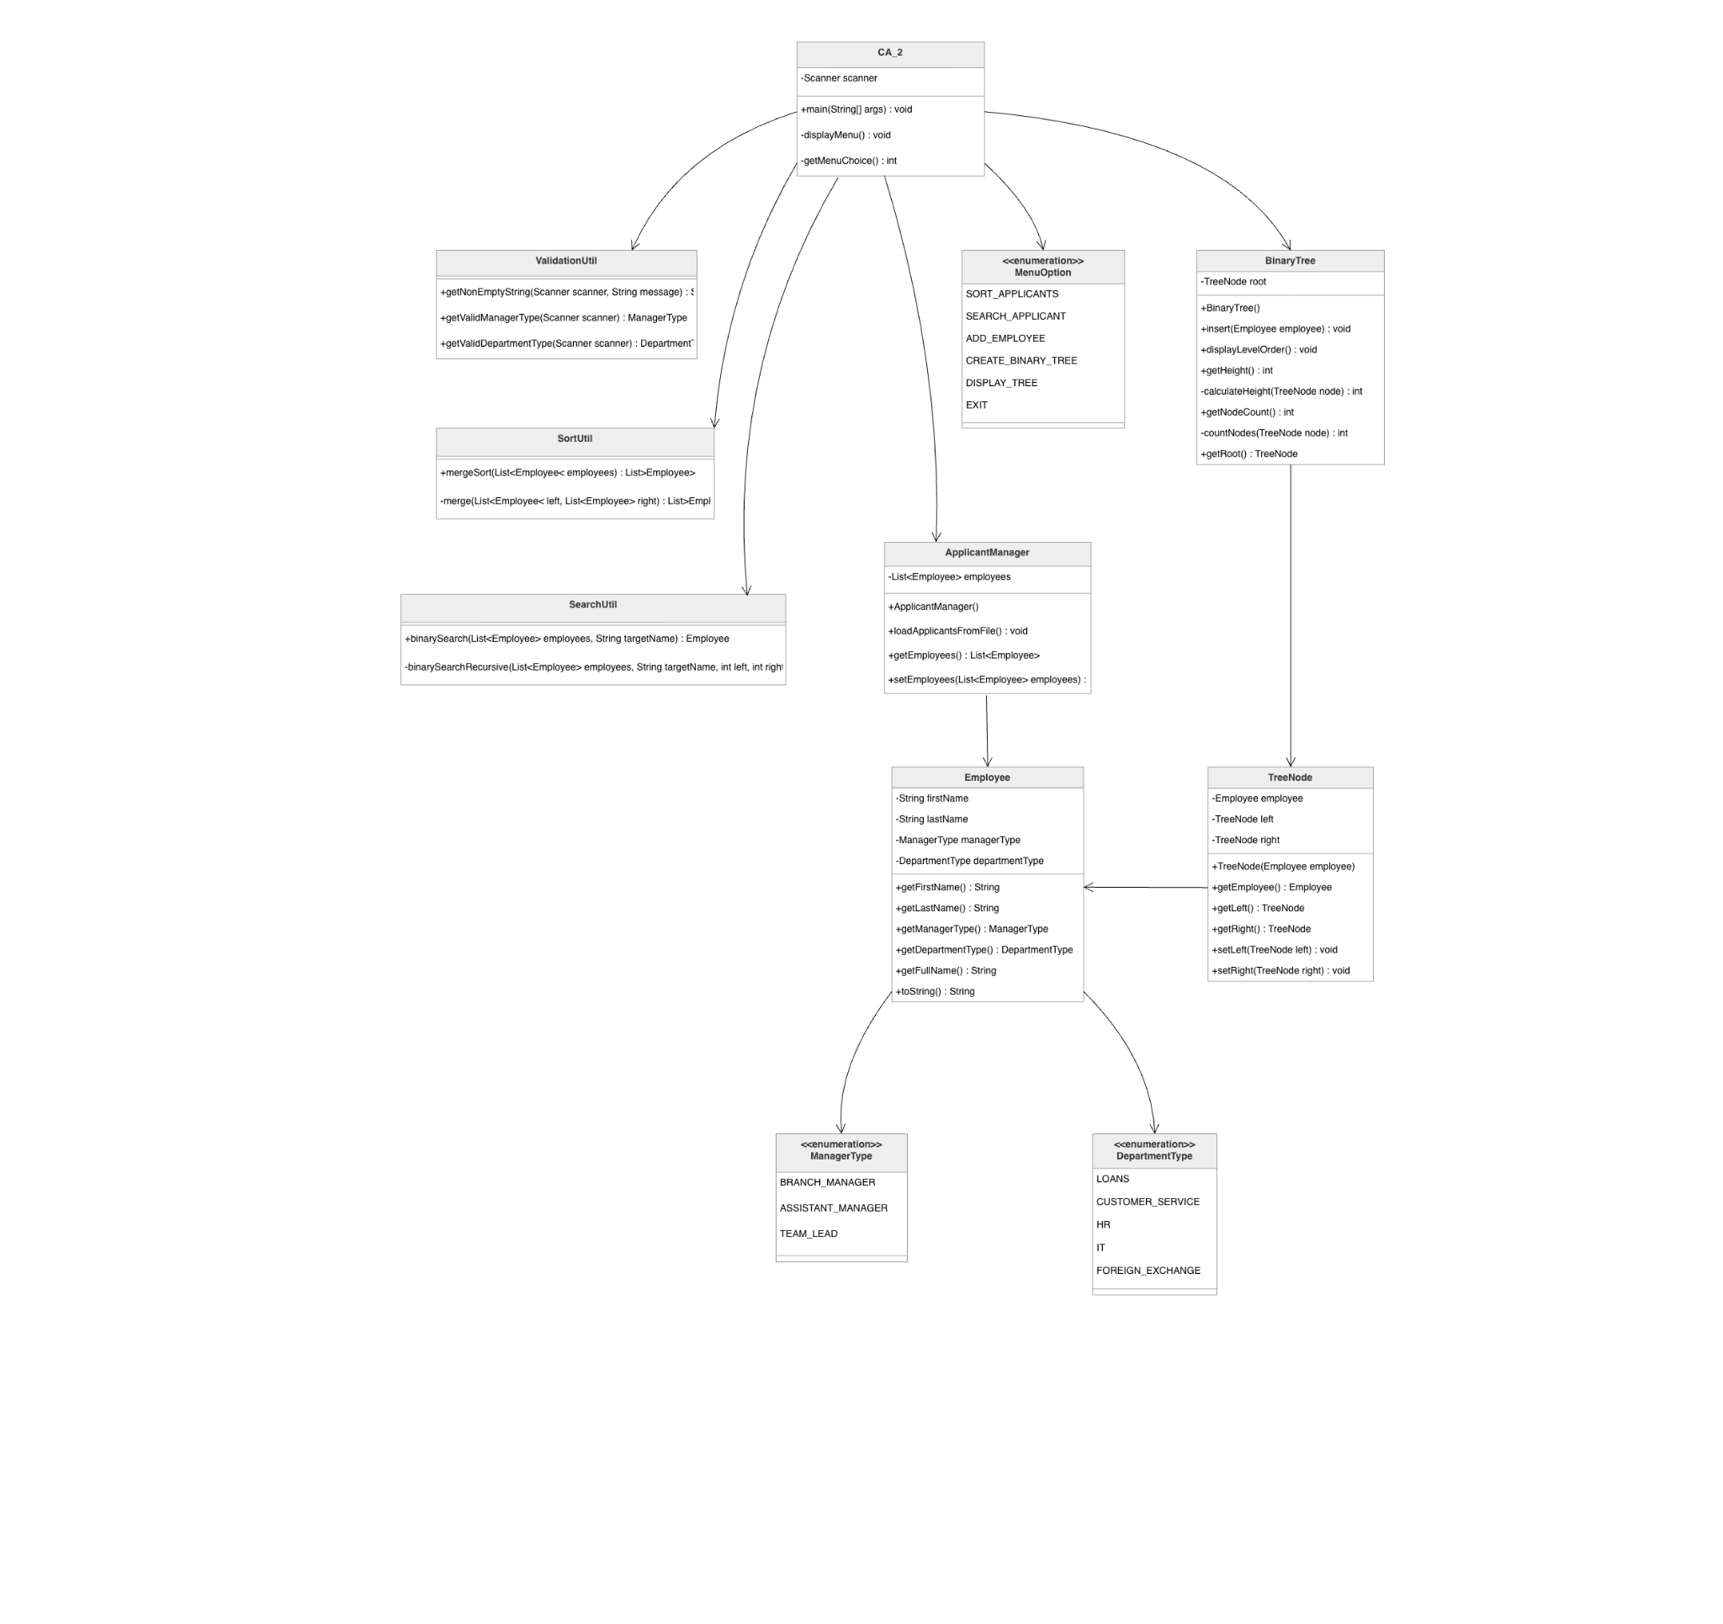

UML Diagram 2 — Activity Diagram
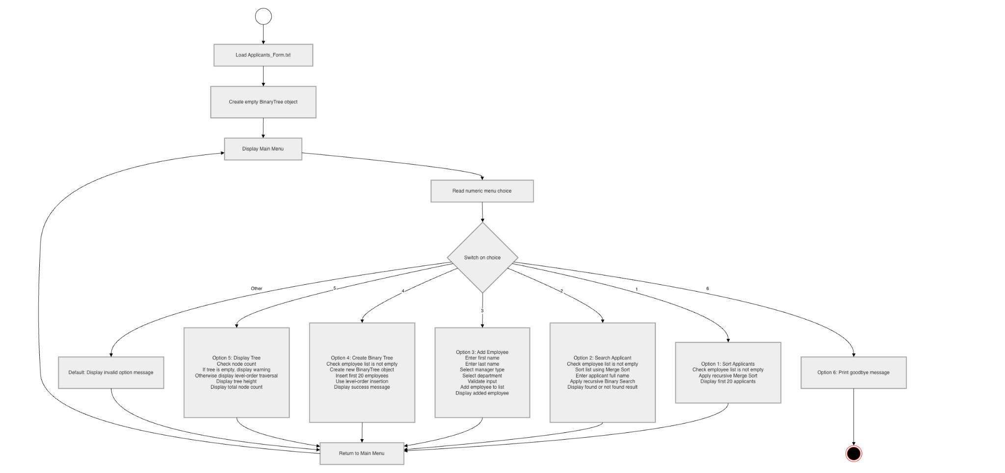

8. User Stories and Acceptance Criteria

User Story 1 — Sort Applicants
As a user, I want to sort all applicants alphabetically so that I can view the applicant list in an organised order.

Acceptance Criteria
AC1: Given that applicant records have been loaded, when the user selects the Sort Applicants option, then the system shall sort the applicant list alphabetically by full name.

AC2: Given that the applicant list has been sorted, when sorting is complete, then the system shall display the first 20 applicant names.

AC3: Given that the applicant list is empty, when the user selects the Sort Applicants option, then the system shall display a message explaining that no applicants are available to sort.

User Story 2 — Search Applicant
As a user, I want to search for an applicant by full name so that I can quickly find the applicant’s manager type and department.

Acceptance Criteria
AC1: Given that applicant records have been loaded, when the user enters a valid applicant full name, then the system shall search the sorted list using recursive Binary Search.

AC2: Given that the applicant exists, when the search is successful, then the system shall display the applicant’s full name, manager type and department.

AC3: Given that the applicant does not exist, when the search is completed, then the system shall display an “Applicant not found” message.

AC4: Given that the user enters an empty name, when the input is submitted, then the system shall request a non-empty value.

User Story 3 — Add Employee
As a user, I want to add a new employee record so that the system can store newly hired staff members.

Acceptance Criteria
AC1: Given that the system is running, when the user selects the Add Employee option, then the system shall request the employee’s first name and last name.

AC2: Given that the user enters an empty first name or last name, when the input is submitted, then the system shall reject the input and ask the user to enter a valid value.

AC3: Given that the user is adding an employee, when the manager type is requested, then the system shall only accept one of the available manager type options.

AC4: Given that the user is adding an employee, when the department is requested, then the system shall only accept one of the available department options.

AC5: Given that all input values are valid, when the employee is created, then the system shall add the employee to the list and display a success message.

User Story 4 — Create Binary Tree
As a user, I want to create a binary tree of employee records so that the organisation can display a simple employee hierarchy structure.

Acceptance Criteria
AC1: Given that employee records exist, when the user selects the Create Binary Tree option, then the system shall create a new binary tree.

AC2: Given that the binary tree is being created, when employee records are inserted, then the system shall insert the first 20 employees using level-order insertion.

AC3: Given that the binary tree has been created, when insertion is complete, then the system shall display a message confirming that the tree was created successfully.

AC4: Given that no employee records exist, when the user selects the Create Binary Tree option, then the system shall display an appropriate warning message.

User Story 5 — Display Binary Tree
As a user, I want to display the binary tree so that I can view the employee hierarchy, tree height and total number of nodes.

Acceptance Criteria
AC1: Given that the binary tree has been created, when the user selects the Display Tree option, then the system shall display employees using level-order traversal.

AC2: Given that the binary tree has been created, when the tree is displayed, then the system shall display the tree height.

AC3: Given that the binary tree has been created, when the tree is displayed, then the system shall display the total node count.

AC4: Given that the binary tree has not been created, when the user selects the Display Tree option, then the system shall display a message asking the user to create the tree first.

9. Unit Test Documentation

Unit Test 1 — Sort Applicants

Field | Description
Test ID | UT01
Test Name | Sort Applicants Alphabetically
Feature Tested | Recursive Merge Sort
Related Requirement | FR2, FR3
Test Objective | To verify that the system sorts applicant records alphabetically by full name and displays the first 20 sorted applicants.
Preconditions | Applicants_Form.txt exists in src/main/resources and applicant data has been loaded successfully.
Test Data | Applicant list loaded from Applicants_Form.txt
Test Steps | 1. Run the program. 2. Select menu option 1 - Sort Applicants.
Expected Result | The system sorts applicants alphabetically and displays the first 20 applicant names. The first displayed applicant should be alphabetically earlier than the following names.
Actual Result | The system displayed the first 20 sorted applicants, starting with names such as Alex Turner, Amelia King, and Benjamin Hill.
Status | Pass

Evidence / Observation:
Applicants sorted alphabetically.
First 20 applicants:
1. Alex Turner
2. Amelia King
3. Benjamin Hill
4. Chris Evans
5. Daniel Gray
...

Conclusion：
The recursive Merge Sort function worked correctly. The applicant list was sorted alphabetically and the first 20 records were displayed as required.

Unit Test 2 — Search Applicant

Field | Description
Test ID | UT02
Test Name | Search Existing Applicant
Feature Tested | Recursive Binary Search
Related Requirement | FR4, FR5
Test Objective | To verify that the system can search for an existing applicant by full name using recursive Binary Search.
Preconditions | Applicant data has been loaded and the system is running.
Test Data | Search name: Alex Turner
Test Steps | 1. Run the program. 2. Select menu option 2 - Search Applicant. 3. Enter Alex Turner.
Expected Result | The system finds the applicant and displays the applicant’s full name, manager type and department.
Actual Result | The system displayed Applicant found and showed the applicant details.
Status | Pass

Evidence / Observation:
Enter applicant full name to search: Alex Turner

Applicant found:
Employee Name: Alex Turner
Manager Type: ASSISTANT_MANAGER
Department: LOANS

Conclusion：
The recursive Binary Search function worked correctly for an existing applicant. The system returned the correct applicant name and displayed associated manager and department information.

Unit Test 3 — Add Employee with Valid Input

Field | Description
Test ID | UT03
Test Name | Add New Employee
Feature Tested | Employee insertion and input validation
Related Requirement | FR6, FR7
Test Objective | To verify that the system allows the user to add a new employee record when all input values are valid.
Preconditions | The system is running and the main menu is displayed.
Test Data | First name: San; Last name: Zhang; Manager Type: BRANCH_MANAGER; Department: LOANS
Test Steps | 1. Select menu option 3 - Add Employee. 2. Enter first name San. 3. Enter last name Zhang. 4. Select manager type option 1. 5. Select department option 1.
Expected Result | The system creates the employee record and displays a success message with the employee details.
Actual Result | The system added the employee and displayed the new employee record successfully.
Status | Pass

Evidence / Observation:
Employee added successfully:
Employee Name: San Zhang
Manager Type: BRANCH_MANAGER
Department: LOANS

Conclusion：
The system successfully validated the user input and added a new employee record to the employee list.

Unit Test 4 — Create and Display Binary Tree

Field | Description
Test ID | UT04
Test Name | Create and Display Employee Binary Tree
Feature Tested | Binary tree level-order insertion, traversal, height and node count
Related Requirement | FR8, FR9, FR10
Test Objective | To verify that the system creates a binary tree using employee records and displays the tree information correctly.
Preconditions | Applicant or employee records have been loaded into the system.
Test Data | First 20 employee records from the employee list
Test Steps | 1. Select menu option 4 - Create Binary Tree. 2. Select menu option 5 - Display Tree.
Expected Result | The system inserts 20 employees into the binary tree using level-order insertion. It then displays the tree using level-order traversal, followed by the tree height and total node count.
Actual Result | The system created the tree, displayed 20 employee nodes, showed tree height as 5, and total nodes as 20.
Status | Pass

Evidence / Observation:
Binary tree created successfully.
20 employees inserted using level-order insertion.

Tree Height: 5
Total Nodes: 20

Conclusion：
The binary tree feature worked correctly. The system inserted employees using level-order insertion and displayed the required tree traversal and statistics.

10. Sorting and Searching Algorithm Choices
The system uses recursive Merge Sort to sort applicant records alphabetically by full name. Merge Sort was selected because it is naturally recursive and follows a divide-and-conquer approach. The applicant list is divided into smaller sublists, each sublist is sorted recursively, and the sorted results are merged back together. This makes it suitable for the assignment requirement because the sorting algorithm must use recursion.

Merge Sort is also appropriate for this project because applicant records are stored in a list after being loaded from Applicants_Form.txt. The system needs to organise these records alphabetically before displaying the first 20 applicants. Merge Sort has a time complexity of O(n log n), which is more efficient and reliable than simple algorithms such as Bubble Sort or Selection Sort, especially as the number of records increases.

For searching, the system uses recursive Binary Search. Binary Search was selected because the applicant list is sorted before searching. The algorithm compares the user’s target name with the middle record in the list. If the target is smaller, it recursively searches the left half. If the target is larger, it recursively searches the right half. This process continues until the applicant is found or the search range becomes empty.

Recursive Binary Search is suitable because it avoids checking every applicant one by one. Its time complexity is O(log n), making it more efficient than Linear Search for sorted data. It also works well with Merge Sort because Merge Sort prepares the data into the correct order required by Binary Search. Together, these two algorithms meet the assignment requirement for recursive sorting and recursive searching while keeping the system efficient and logical.

11. Conclusion
The Bank Employee Management System was developed as a Java command-line application for the CA2 Integrated Assignment. The system successfully loads applicant data from a text file, sorts applicant records alphabetically using recursive Merge Sort, searches for applicants using recursive Binary Search, allows new employee records to be added with input validation, and creates an employee binary tree using level-order insertion.

The selected organisation was a bank because it provides a clear structure involving departments, managers and employees. The system includes manager types, department types and employee records, which makes it suitable for representing an organisational structure.

The project also demonstrates software development planning through functional requirements, non-functional requirements, use cases, UML diagrams, user stories, acceptance criteria and unit test documentation. These design elements helped define the expected behaviour of the system before and during implementation.

Overall, the completed system meets the main technical and design requirements of the assignment. It demonstrates recursive algorithms, validated user input, file reading, binary tree operations and structured software documentation.

12. GitHub Repository Link
GitHub Repository:
https://github.com/ducatione/CA_2

13. References
Oracle. (n.d.). Java Documentation. Available at: https://docs.oracle.com/en/java/

Apache Maven. (n.d.). Maven Documentation. Available at: https://maven.apache.org/guides/

GitHub Docs. (n.d.). GitHub Documentation. Available at: https://docs.github.com/

diagrams.net. (n.d.). diagrams.net Documentation. Available at: https://www.diagrams.net/doc/

