Thiết kế xây dựng phần mềm

Đề tài: Xây dựng ứng dụng thuê xe EcoBikeRental

1. Cấp độ thiết kế:

* Architechtures/Framework
* OOD Pattern
* OOD Principle
* Specified Data Structure
* General + OOD Concepts

1. Design Concepts: Gồm Cohesion và Coupling

Cohesion (Liên kết form, cấu trúc)

- The most common reason to put elements – data and behaviour – together is to form an ADT

- The common design objective of separation of concerns suggests a module should address a single set of concerns

- Cohesion refers to the degree to which the elements of a module belong together. Cohesion is a measure of how strongly-related or focused the responsibilities of a single module are

Coupling (Liên kết logic, mạch lạc)

- How are modules dependent on one another?

+ Statically? Dynamically? And more?

+ Ideally, split design into parts that don’t interact much

+ An artist’s redition – to really assess coupling one needs to know what the arrows are, etc.

- Coupling or Dependency is the degree to which each program module relies on each one of the other modules

1. Phạm vi của Cohesion

- Functional: Every essential element to a single compulation is contained in the conponent.

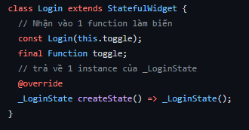

- Information: Module performs a number of actions, each with its own entry point, with independent code for each action, all performed on the same data.

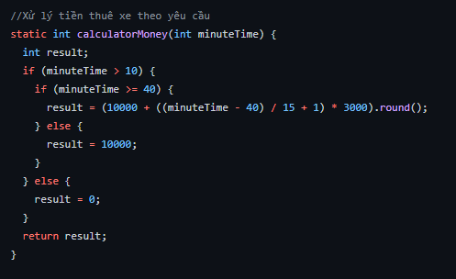

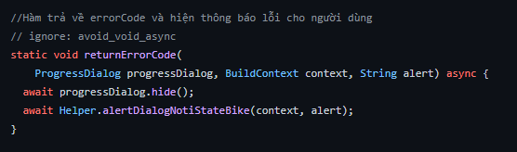

- Sequential: The ouput of one component is the input to another.

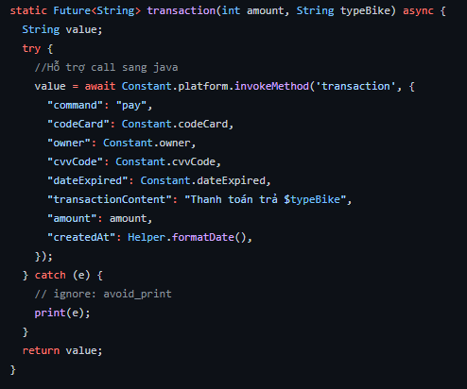

- Communicational: Module performs a series of actions related by a sequence of steps to be followed by the product and all actions are performed on the same data.

- Procedural: Elements of a component are related only to ensure a particular order of execution.

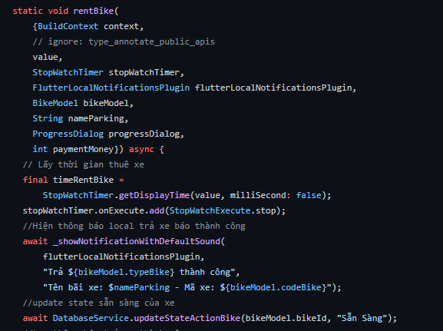

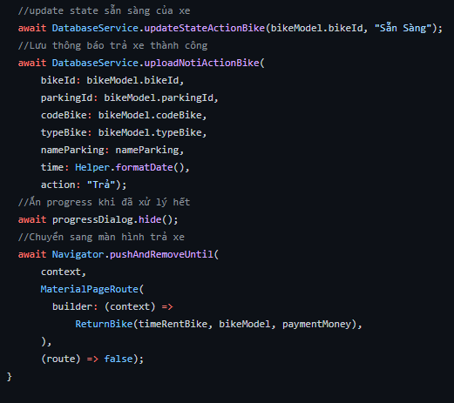

- Temporal: Elements of a component are related by timing. Vi phạm

- Logical: Elements of component are related logically and not functionally. Vi phạm

- Coincidental: Elements of the component are only related by their location in source code.

1. Phạm vi của Coupling

- Content: One component references contents of another.

- Common: Serveral modules share an externally imposed data format, communication protocol, or device interface.

- Control: Component passes control parameters to coupled components.

- Stamp: Data are passed by parameters using a data structure containing fields which may or may not be used.

- Data: Two components are data coupled if there are homogeneous data items.

- Uncoupled