ITE-5332-0NB – J2EE

Instructor: Shahdad Shariatmadari

Project - 01

Student Name: Kien Tran, Chi Bui

Student ID: N01260692

**Project- Part 1:** This is part 1 of the Project which should be in a group of two in the class.

* *You should collaborate together to complete this part of the project during the class and submit it by the end of the class today.*
* *You are allowed to use any material from the internet, but those materials should be relevant to our course and you should be able to answer any question about what you submit at the end.*
* *You can do brainstorming with other groups, but any form of sharing work/code is strictly avoided.*

**Project description**: You are working as J2EE developer at ABC Company. You are asked to design a web application using J2EE/JSP/MySQL for the Customer Service department which fulfills the following functionalities:

1. When users buy any product from the company, they should register the product in the company website. For doing this, the user should
   1. Create an account in the site. User should enter username, password, the Cellphone no and email along with the name/address. The login information should be stored in the database table.
   2. To register a product, Users should enter login-id (username) along with “product name”  and “serial no” and “purchase date” of the product. This data should be stored in the  database table
      * How to validate the product_name?
2. The company asks you to add the following security feature to the program:
   1. If the user doesn’t have a valid user account, the user can’t register the product
   2. Add proper form validation feature to the webform
3. The company asks you to provide the following functionalities for the Web site Administrator. When the Admin user logged in into the web application, the admin user can perform the followings:
   1. Can see all user accounts or do SEARCH to find a specific user account
   2. Can see all registered products by the user or do SEARCH to find a specific product
   3. Admin user can enter/update list of available products in the website. The product info are stored in the database-table, this table may have some columns like product-name, color, …. This information will be used when a user wants to register a product. When a user wants to register a product, the user should select the “product-name” which exists in the database.

**Question 1)** Based on the abovementioned description, develop a plan and divide the work between group members.

**Question 2)** Design the database in MySQL WorkBench You can use your creativity to design the database tables which match with the above-mentioned requirements

**Question 3)** Design Webforms. You can use your creativity to design it.

**Question 4)** Develop JSP coding using JSTL.

**Question 5)** Deploy the J2EE web application

**Submission:**

1. The document which shows how you plan the work (WorkFlow and DataFlow, UI & DB design) and how you divide the work, screenshots of the output
2. All source codes
3. Exported database
4. Ready to deploy a version of the web application

NOTE: you need to submit everything that you implement by the end of class, even if it is not working properly.

**My expectation**

* I understand completing this project in 1:30 hours is super challenging, but try your best to divide the work into a small chunk, assemble blocks and finalize it.
  + If you couldn’t complete the whole steps, it is absolutely fine. But try to have something tangible at the end to submit.
* Use your creativity in order to design this program using different structures/concepts that we have learned so far.
* **Be professional in programming:**
  + **Try to use comments wherever required**.
  + **Use proper names for DatabaseName, TableName, TableColumnName, variables and functions**
  + **Use proper/meaningful messages in order to interact with user**
  + **Apply proper error management/handling (on user inputs, data processing, …) and display proper error messages accordingly**

Happy Coding! & enjoy the project!

Question 01

1. User (user) - Chi
   1. Login
   2. Register
2. Product (Admin)
   1. Create/update/detete/serach product - Kien
   2. Registried User List – Display - Chi
   3. Product registration List and searrach - Kien
3. Product registration (user) - Kien
   1. Registry product
      1. Only registry when login
      2. Display list product
      3. insert

Question 02:

Add Products

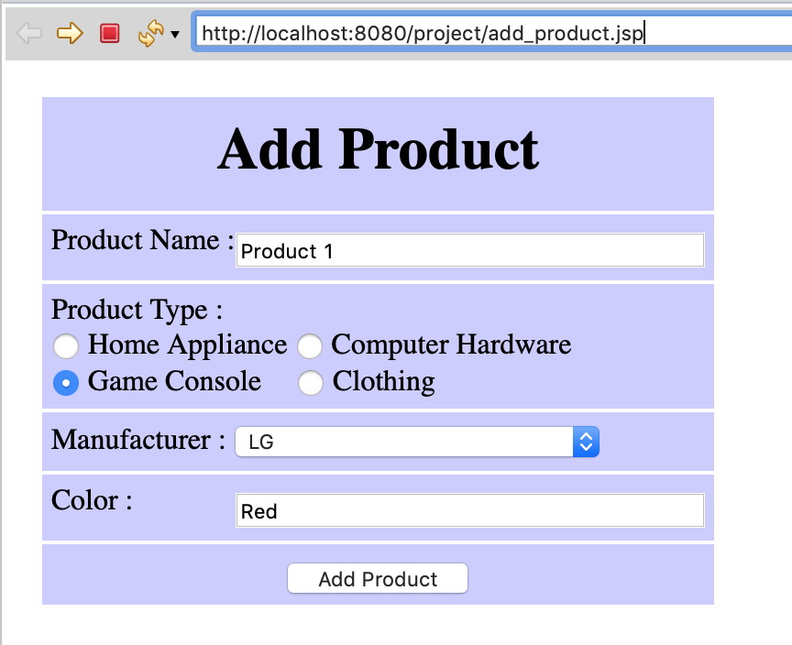

Product List

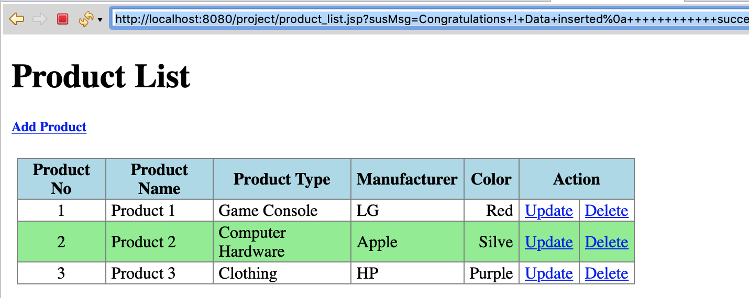

Product Registration

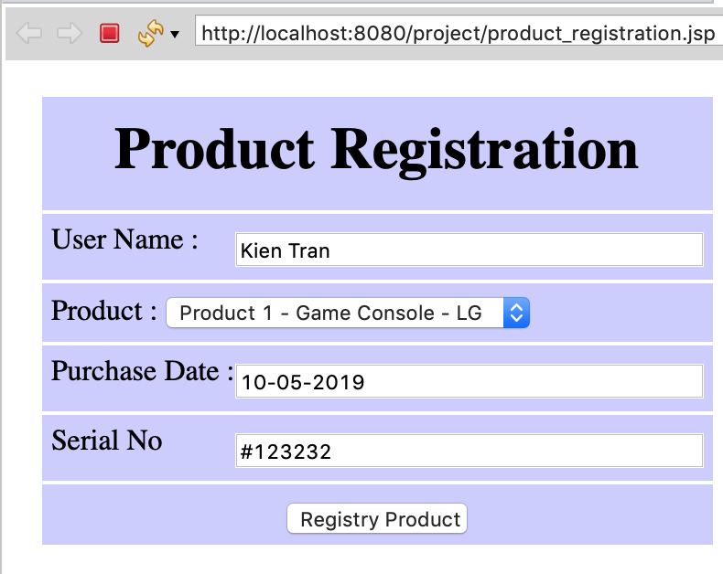

Product Registration List

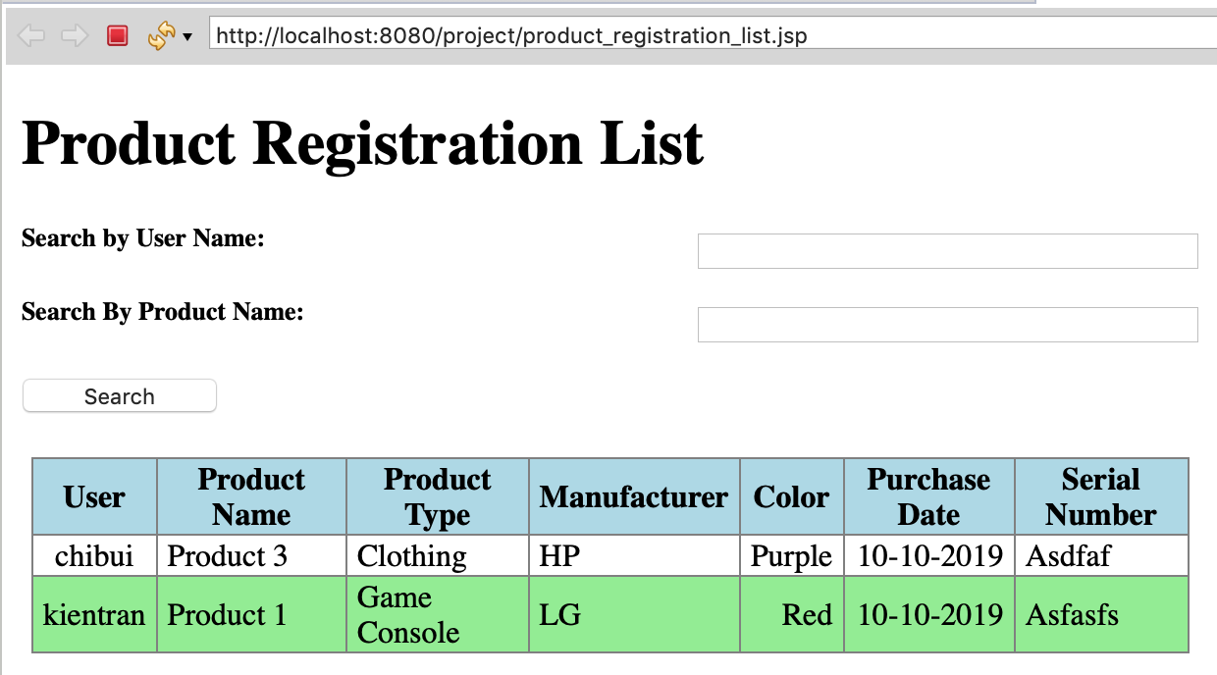

User List

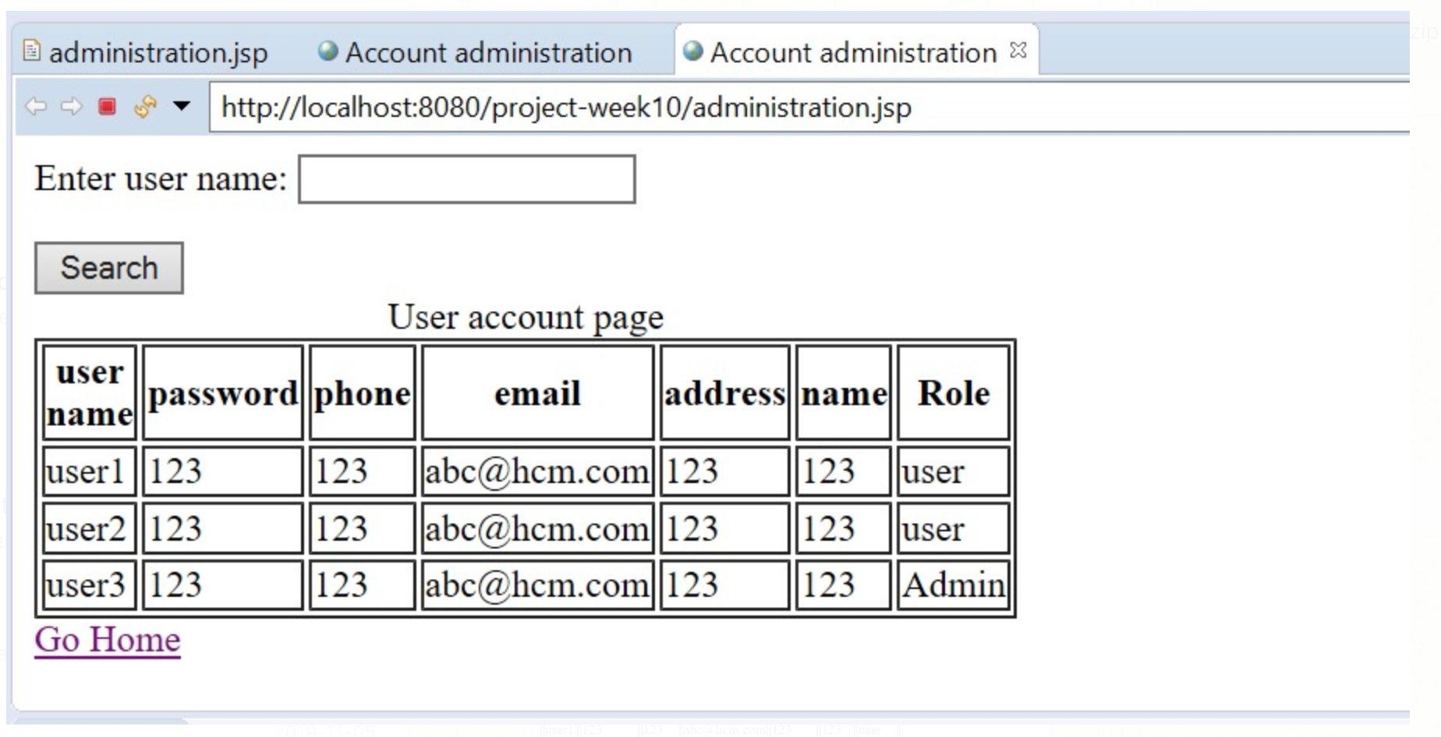

User Login

