Activity 1

How to add the destroy method?

Add an Override destroy() method in HelloWorld class. Method will be called and Message will be displayed in the console when we stop the server.

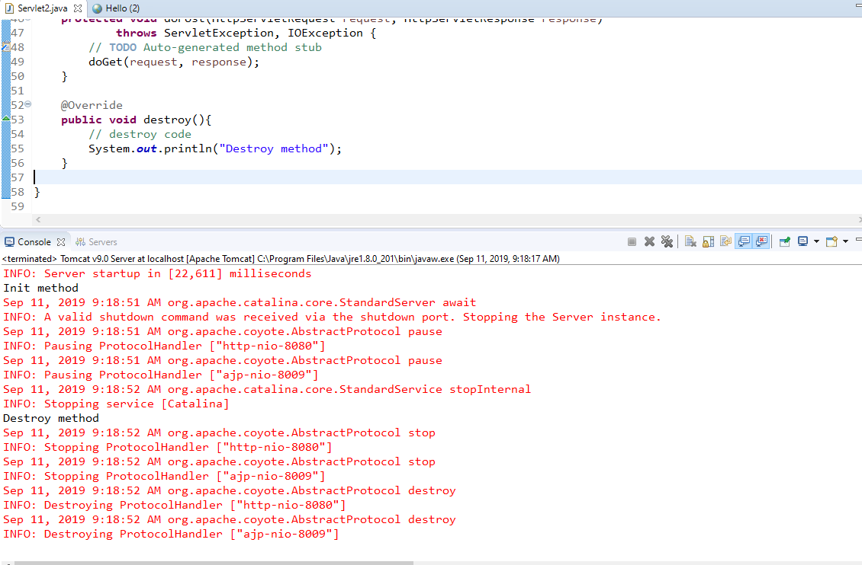

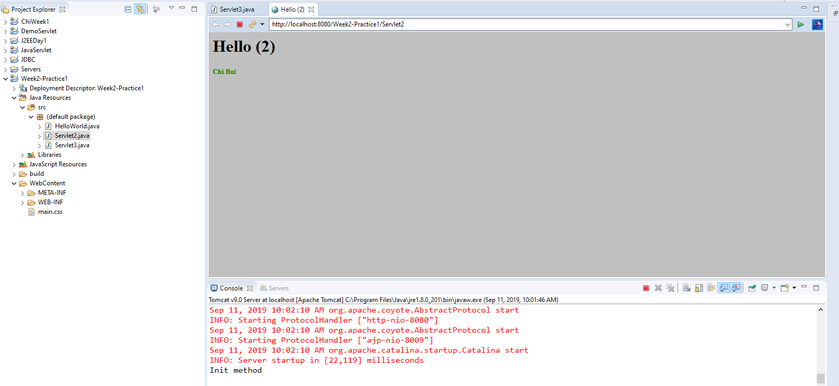

Activity 2

Explain how Servlet3 works:

The init() method will be run first to initialization the value of modTime and create the random number for element in numbers array with 10 elements from 0 to 9 using the randomNum() function

The randomNum() function will return a random integer number for 0 to 99

modTime value will be used in the getLastModified method already explained

the init() method only run once that is why the output data look the same after running for several times.

Then the service will be called by run the doGet() function which create a HTTP page object by using response HttpServletResponse object

The page html page with title declared by variable String title and will print all the element of numbers array which is 10 elements.

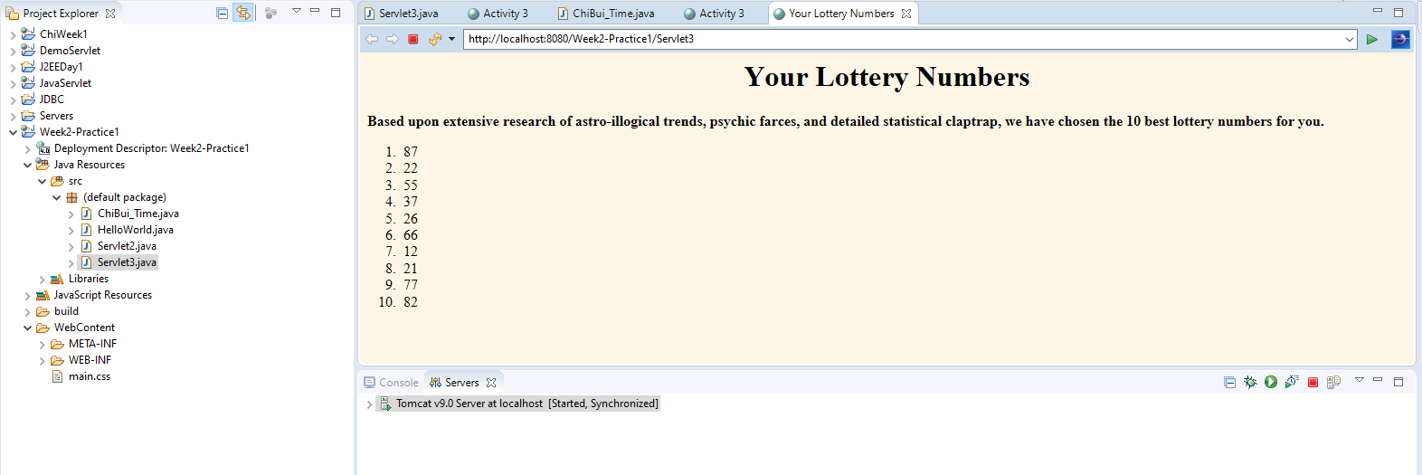

Activity 3

