# I.Esp32

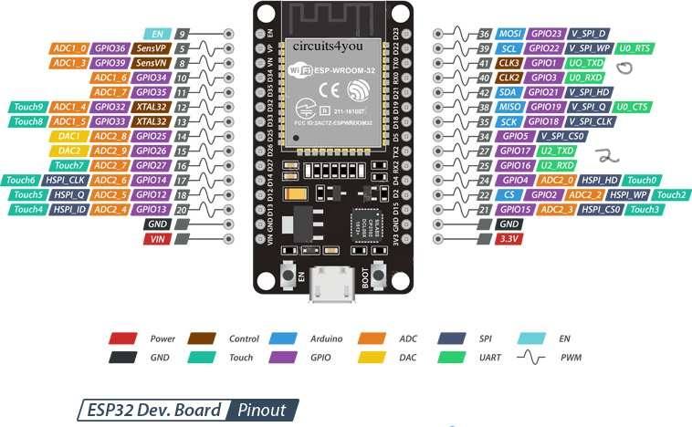

Image 1. Esp32 port and pin

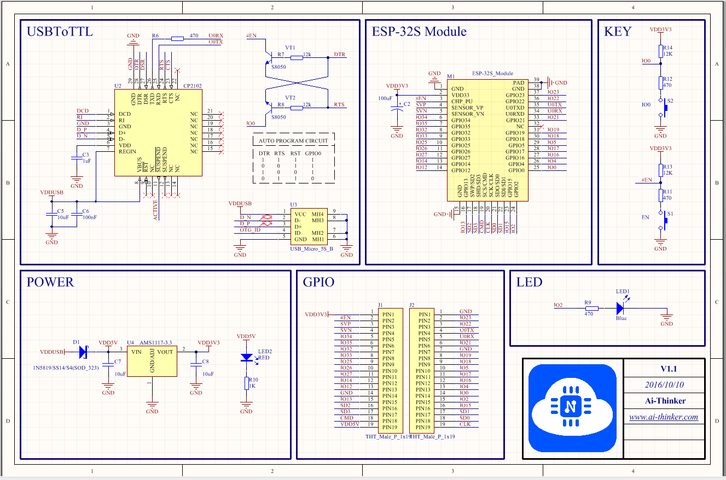

Image 1. Esp32 devkit schematic

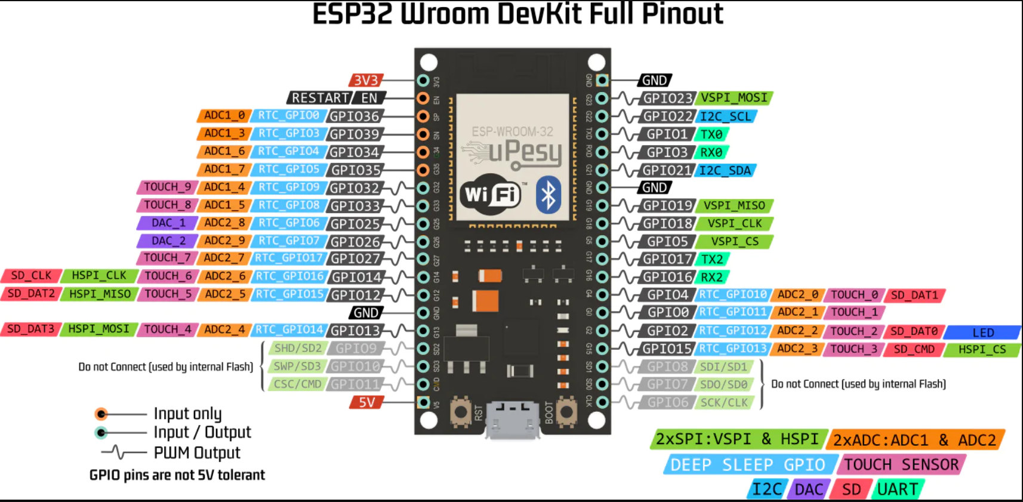

Image 1. Esp32 many pin more

II.Esp-Idf

