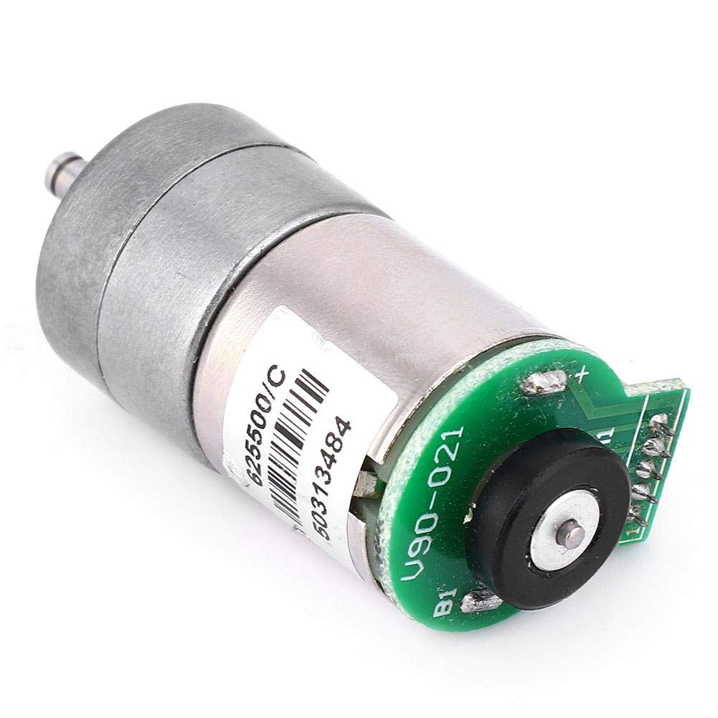

**625500/C Metal Gear DC 12V Reduction Motor with Encoder for RC Car Robot**

**Model :** 625500/C

**Description**DC geared motor with encoder

Rated voltage: DC 12V

No-load current: 50mA

Stall current: 1A

No-load speed: 64 rpm

Suitable voltage: 6-12V (32-64 rpm)

Reduction ratio: 1:110

Weight: 74 grams

The output shaft of the geared motor rotates 220 turns to output 220 complete pulses.

Pin definition:

1, Hall power input (external DC3-12V);

2, Hall signal output (external 10K pull-up resistor can be read directly from the microcontroller);

3. Hall ground line (external power supply ground);

4-5 motor line (powered by external motor)

Size Chart: Approx. 44x25mm ,

Encoder Length = 19mm