**Pinout:**

|  |  |
| --- | --- |
| **Pin Name** | **Description** |
| CS | Chip Select |
| SCK | Clock |
| MISO | Master In Slave Out |
| MOSI | Master Out Slave In |

**Interfacing Diagram**

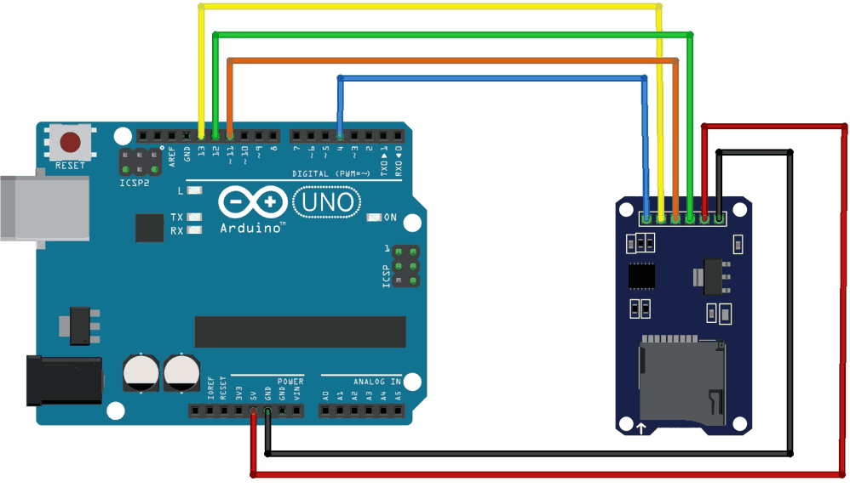

**Interfacing Diagram**

The diagram shows the detail connections of SD module with Arduino.

1. MOSI - pin 11
2. MISO - pin 12
3. CLK - pin 13
4. CS - pin 4

***Note*** You can connect VCC of the module to either 5v or 3.3v.