# I.Esp32

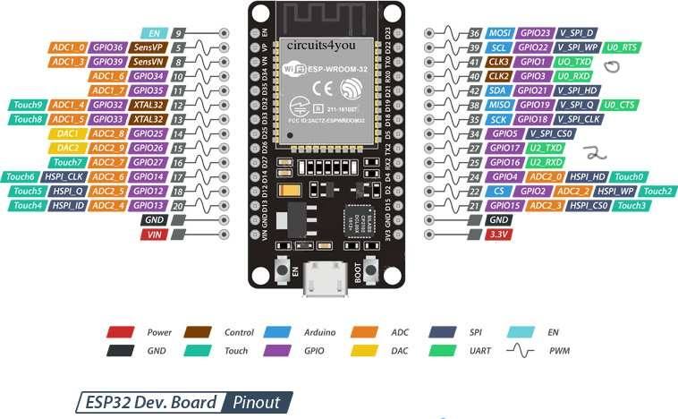

Image 1. 1 Esp32 port and pin

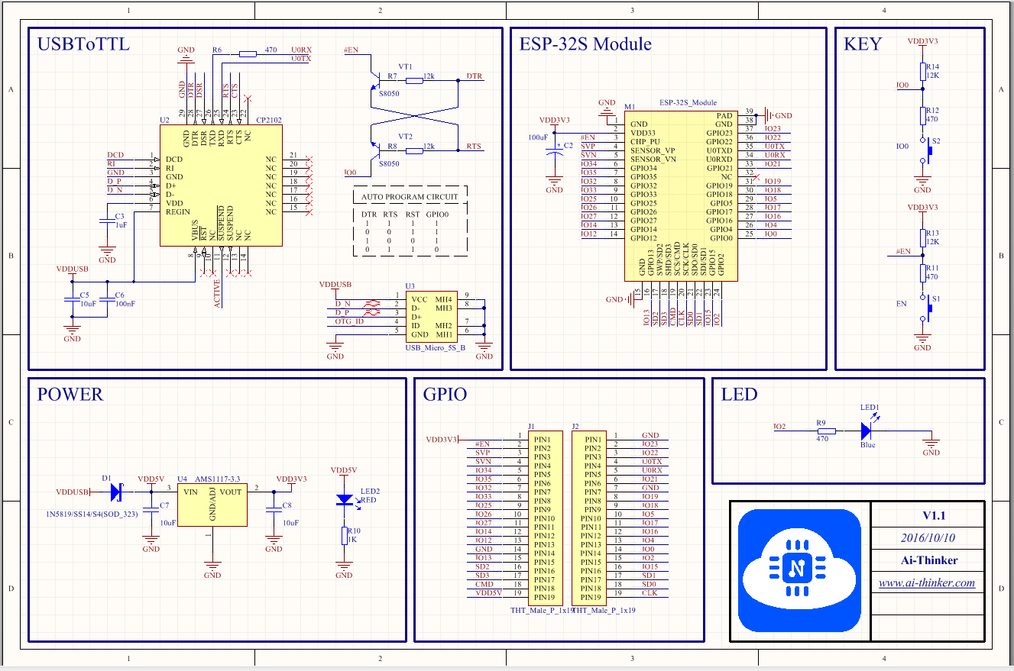

Image 1. 2 Esp32 devkit schematic

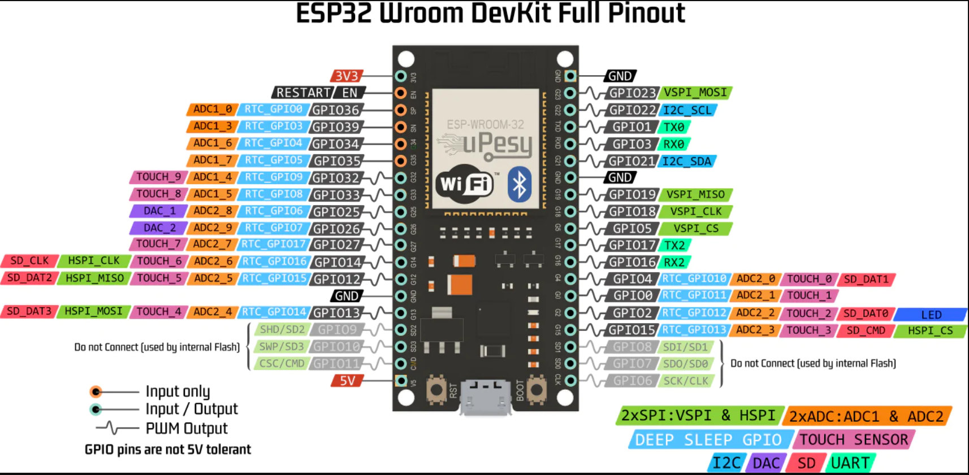

Image 1. 3 Esp32 many pin more

II.Esp-Idf

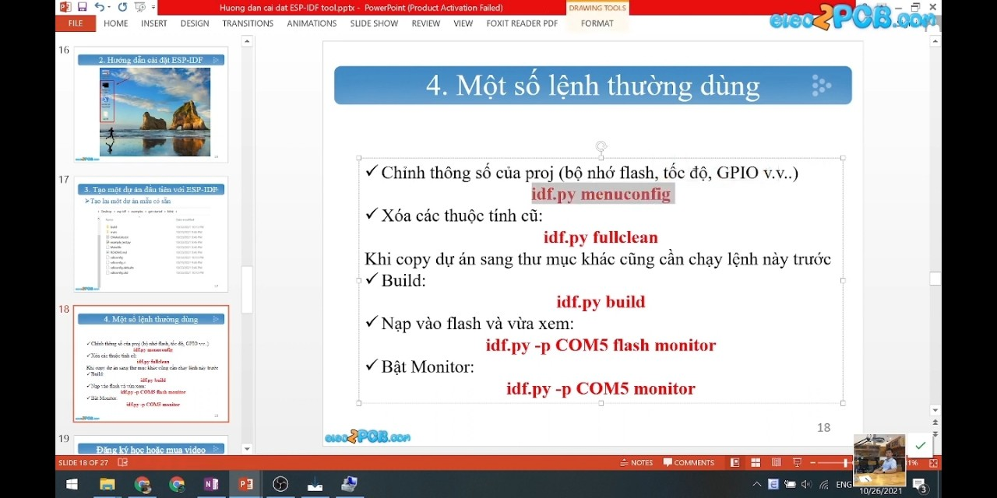

# III.Esp8266