**Name: PHẠM ĐỨC ĐẠT**

**ID STUDENT: ITITIU20184**

**LAB 01 - Lesson 1: Kotlin basics**

# LESSON 01: Get started

## 2. [Install the Java Development Kit (JDK)](https://developer.android.com/codelabs/android-development-kotlin-1.1?continue=https%3A%2F%2Fdeveloper.android.com%2Fcourses%2Fpathways%2Fandroid-development-with-kotlin-1%23codelab-https%3A%2F%2Fdeveloper.android.com%2Fcodelabs%2Fandroid-development-kotlin-1.1#1)

## 3. [Install IntelliJ IDEA](https://developer.android.com/codelabs/android-development-kotlin-1.1?continue=https%3A%2F%2Fdeveloper.android.com%2Fcourses%2Fpathways%2Fandroid-development-with-kotlin-1%23codelab-https%3A%2F%2Fdeveloper.android.com%2Fcodelabs%2Fandroid-development-kotlin-1.1#2)

## 4. [Create Hello Kotlin](https://developer.android.com/codelabs/android-development-kotlin-1.1?continue=https%3A%2F%2Fdeveloper.android.com%2Fcourses%2Fpathways%2Fandroid-development-with-kotlin-1%23codelab-https%3A%2F%2Fdeveloper.android.com%2Fcodelabs%2Fandroid-development-kotlin-1.1#3)

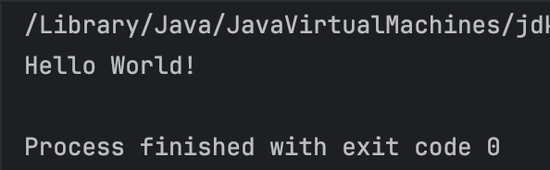

# LESSON 01: Kotlin basics

## 2. [Learn about operators and types](https://developer.android.com/codelabs/android-development-kotlin-1.2?continue=https%3A%2F%2Fdeveloper.android.com%2Fcourses%2Fpathways%2Fandroid-development-with-kotlin-1%23codelab-https%3A%2F%2Fdeveloper.android.com%2Fcodelabs%2Fandroid-development-kotlin-1.2#1)

1. Step 2: Practice using types

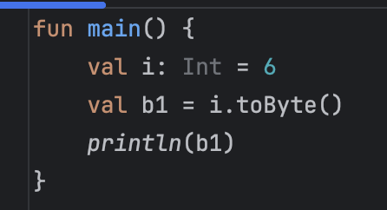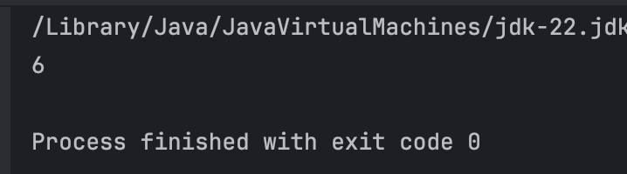

## 3. [Compare conditions and booleans](https://developer.android.com/codelabs/android-development-kotlin-1.2?continue=https%3A%2F%2Fdeveloper.android.com%2Fcourses%2Fpathways%2Fandroid-development-with-kotlin-1%23codelab-https%3A%2F%2Fdeveloper.android.com%2Fcodelabs%2Fandroid-development-kotlin-1.2#2)

1. Write an if/else statement.

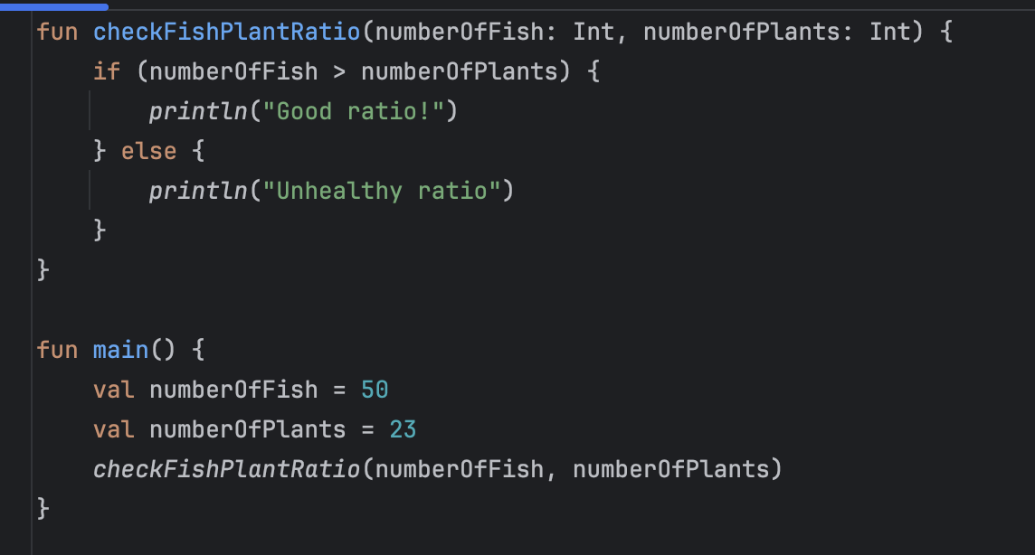



1. Try using a range in an if statement.

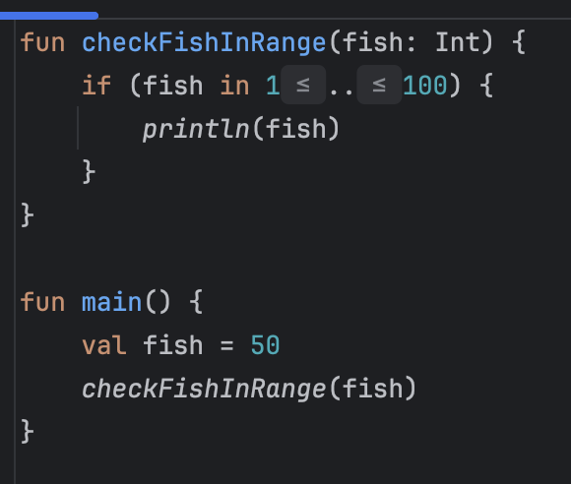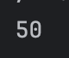

1. Write an if with multiple cases.

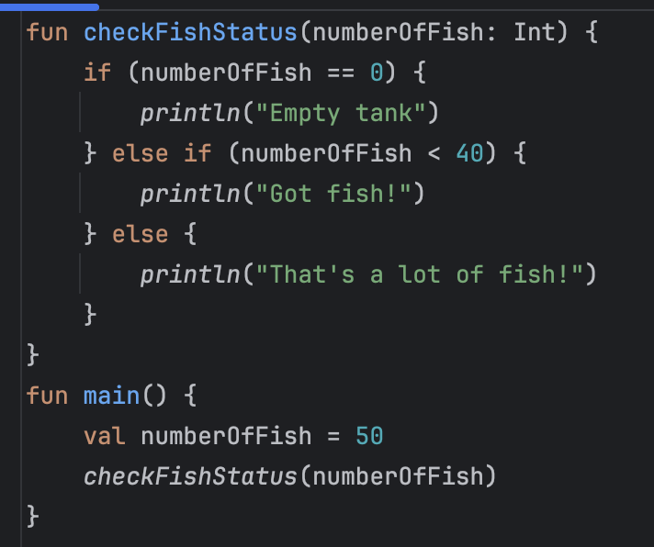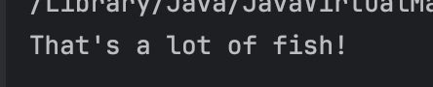

1. Try out a when statement

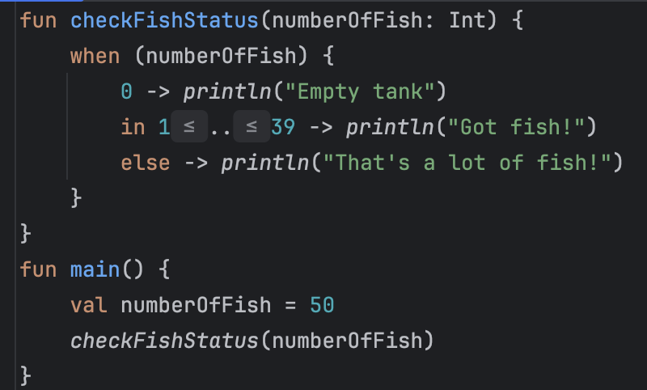

# LESSION 01: Quiz

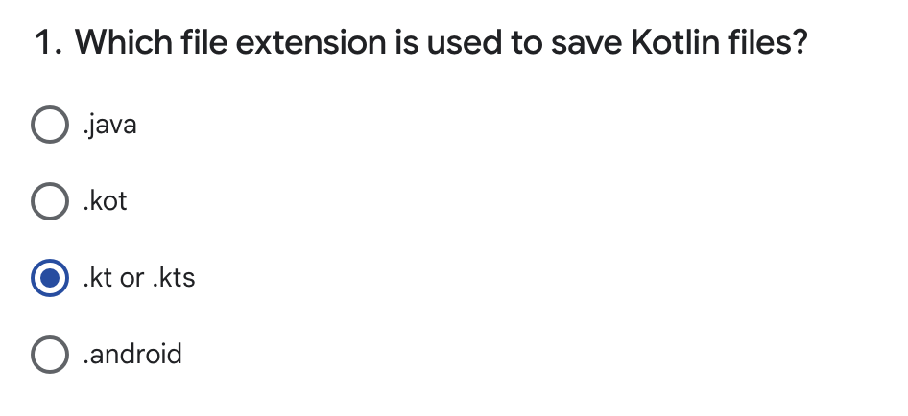

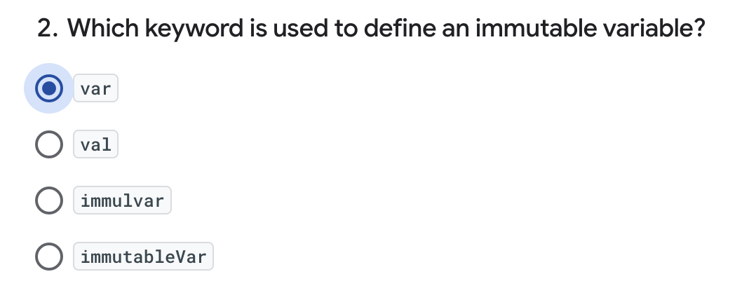

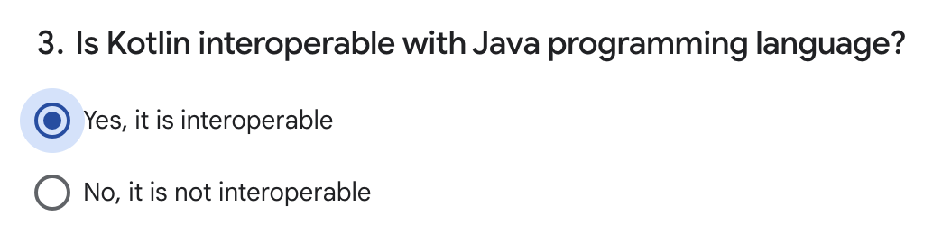

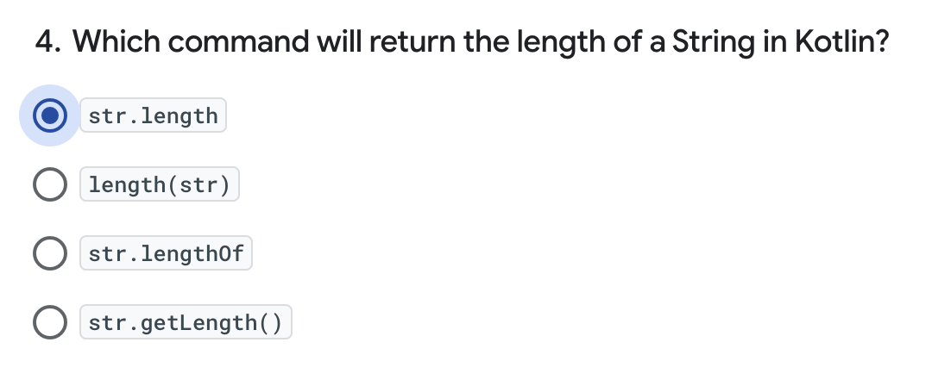

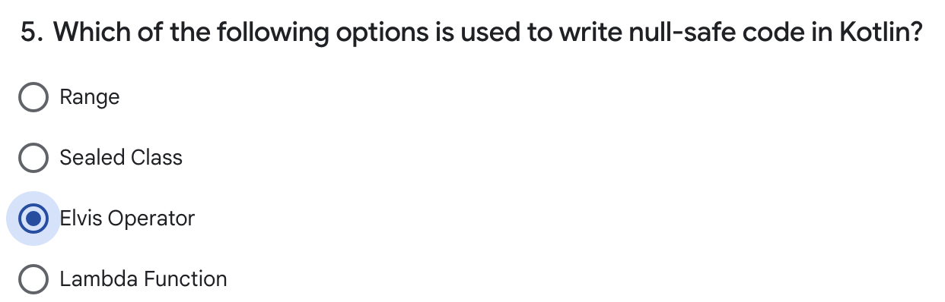

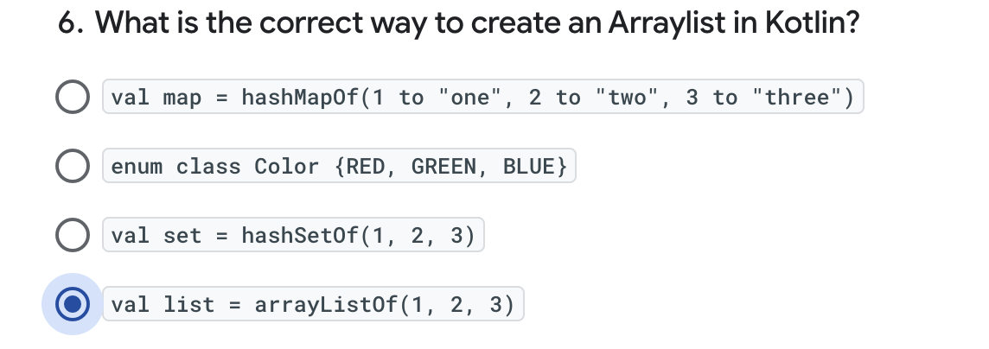

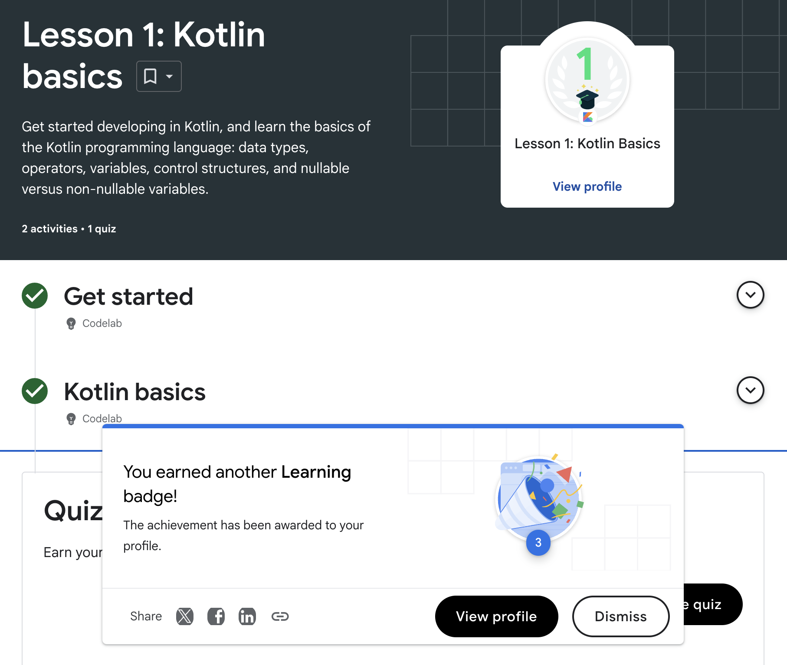

# LESON 02: FUNCTION

## 3. [Learn more about functions](https://developer.android.com/codelabs/android-development-kotlin-2.1?continue=https%3A%2F%2Fdeveloper.android.com%2Fcourses%2Fpathways%2Fandroid-development-with-kotlin-2%23codelab-https%3A%2F%2Fdeveloper.android.com%2Fcodelabs%2Fandroid-development-kotlin-2.1#2)

## 4. [Explore default values and compact functions](https://developer.android.com/codelabs/android-development-kotlin-2.1?continue=https%3A%2F%2Fdeveloper.android.com%2Fcourses%2Fpathways%2Fandroid-development-with-kotlin-2%23codelab-https%3A%2F%2Fdeveloper.android.com%2Fcodelabs%2Fandroid-development-kotlin-2.1#3)

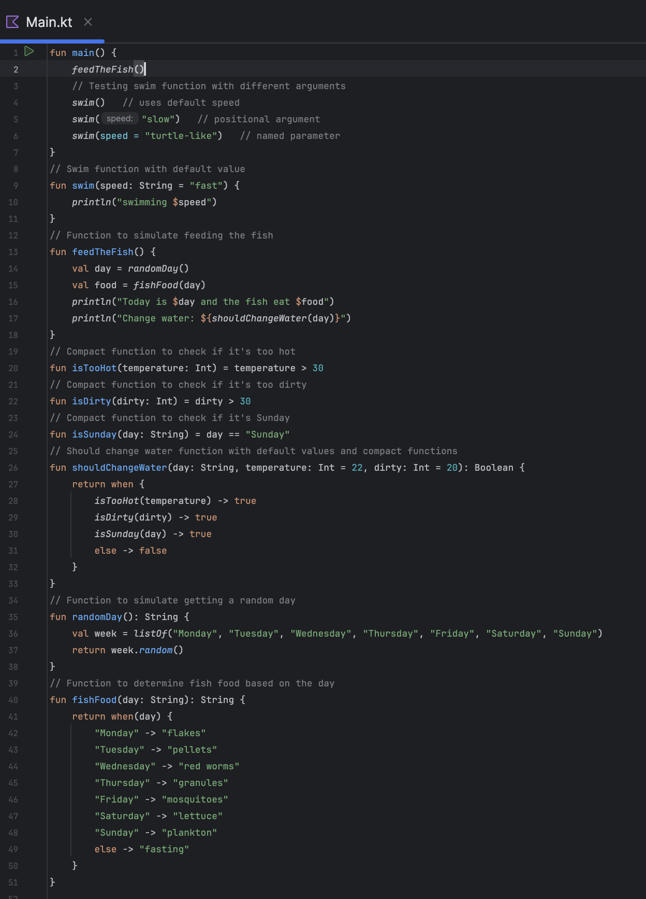

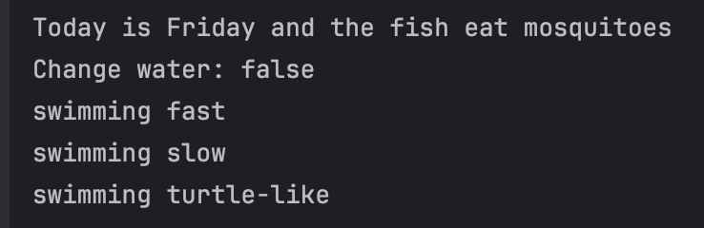

## 5.[Get started with filters](https://developer.android.com/codelabs/android-development-kotlin-2.1?continue=https%3A%2F%2Fdeveloper.android.com%2Fcourses%2Fpathways%2Fandroid-development-with-kotlin-2%23codelab-https%3A%2F%2Fdeveloper.android.com%2Fcodelabs%2Fandroid-development-kotlin-2.1#4)

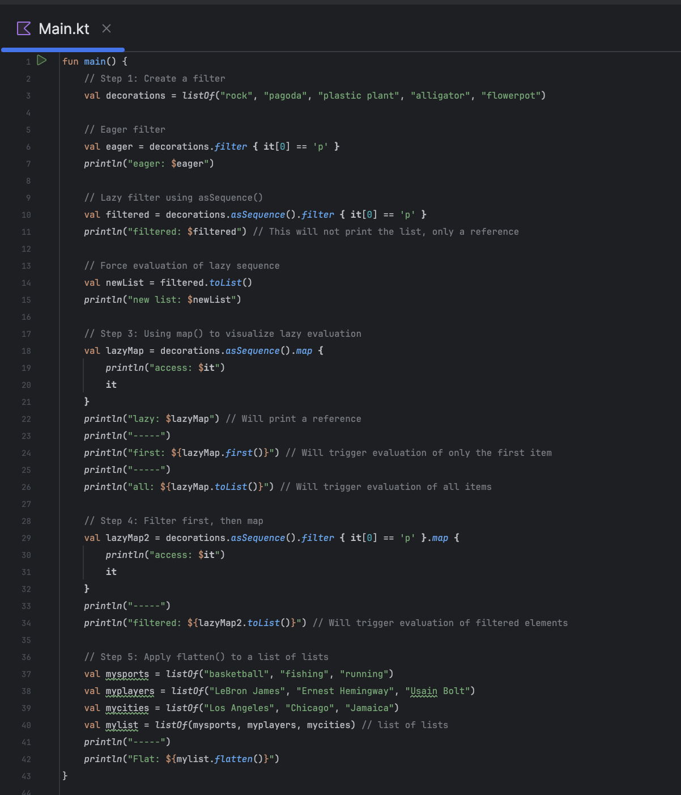

## 

6. [Get started with lambdas and higher-order functions](https://developer.android.com/codelabs/android-development-kotlin-2.1?continue=https%3A%2F%2Fdeveloper.android.com%2Fcourses%2Fpathways%2Fandroid-development-with-kotlin-2%23codelab-https%3A%2F%2Fdeveloper.android.com%2Fcodelabs%2Fandroid-development-kotlin-2.1#5)

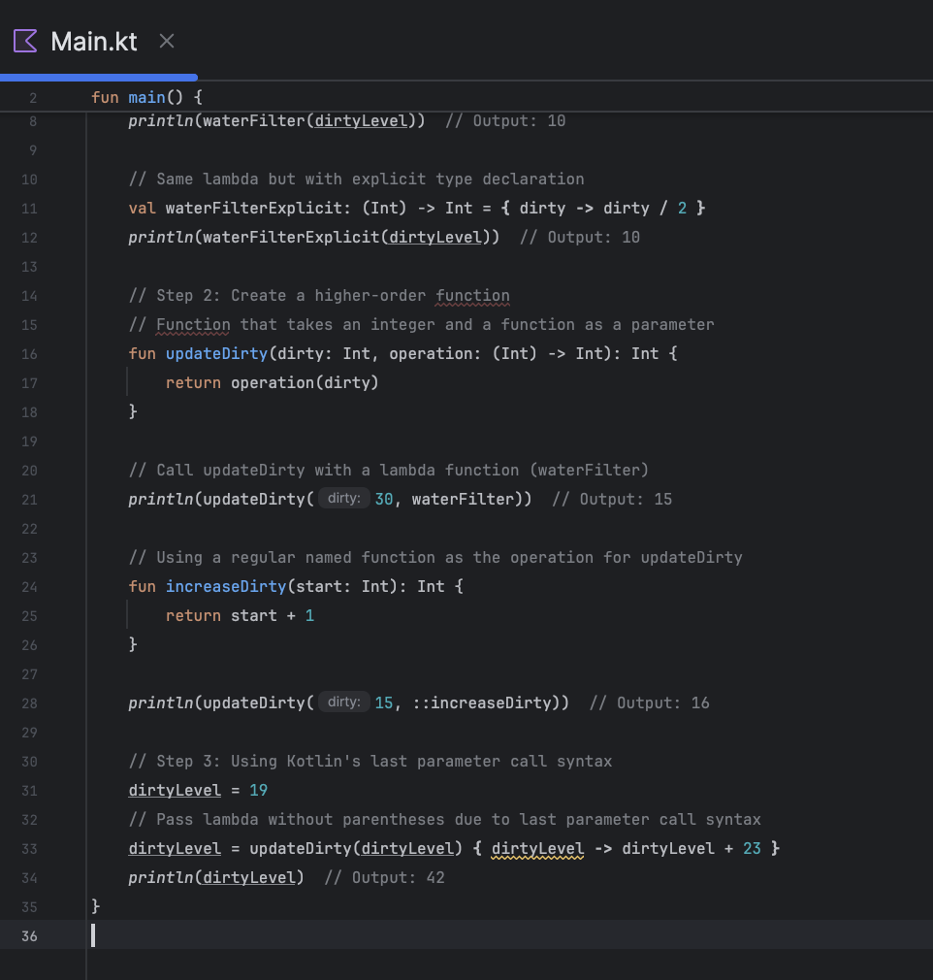

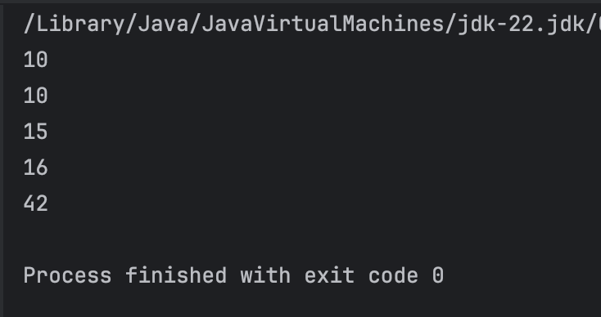

## LESSON 2: QUIZ

