**Name: PHẠM ĐỨC ĐẠT**

**ID STUDENT: ITITIU20184**

**LAB 02 - Lesson 3: Classes and Objects**

# Using Classes and Objects in Kotlin

## [2. Create a class](https://developer.android.com/codelabs/android-development-kotlin-3.1?continue=https%3A%2F%2Fdeveloper.android.com%2Fcourses%2Fpathways%2Fandroid-development-with-kotlin-3%23codelab-https%3A%2F%2Fdeveloper.android.com%2Fcodelabs%2Fandroid-development-kotlin-3.1#1)

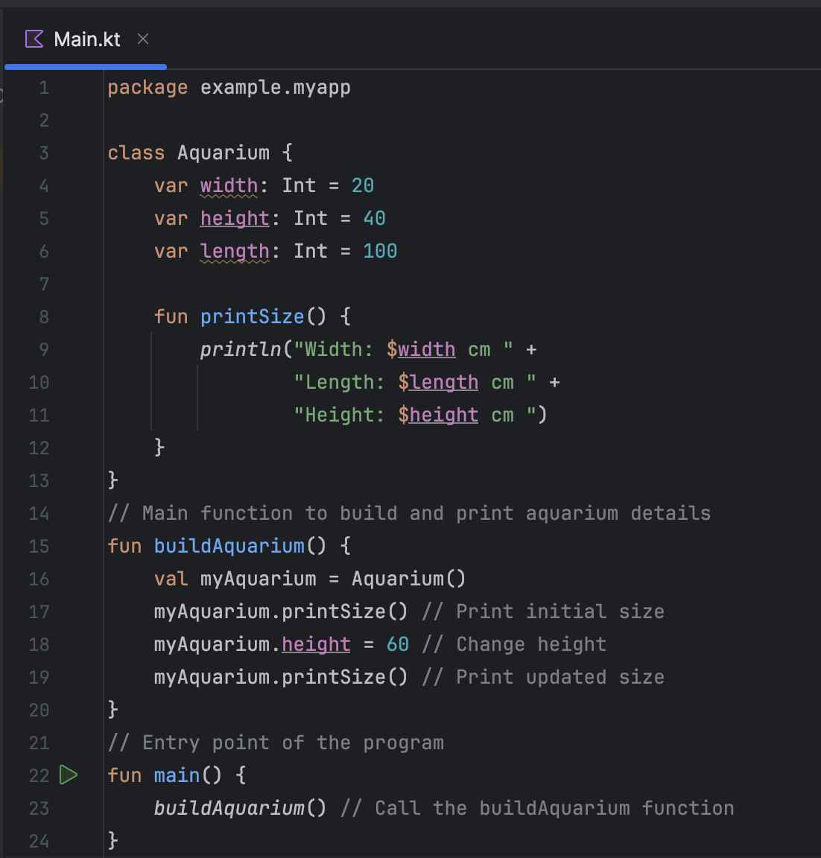

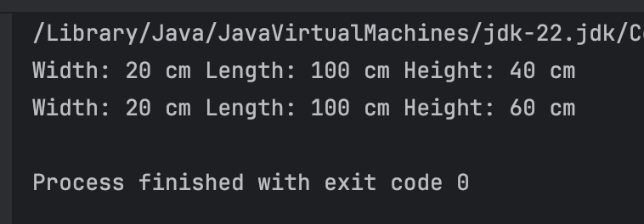

## [3. Add class constructors](https://developer.android.com/codelabs/android-development-kotlin-3.1?continue=https%3A%2F%2Fdeveloper.android.com%2Fcourses%2Fpathways%2Fandroid-development-with-kotlin-3%23codelab-https%3A%2F%2Fdeveloper.android.com%2Fcodelabs%2Fandroid-development-kotlin-3.1#2)

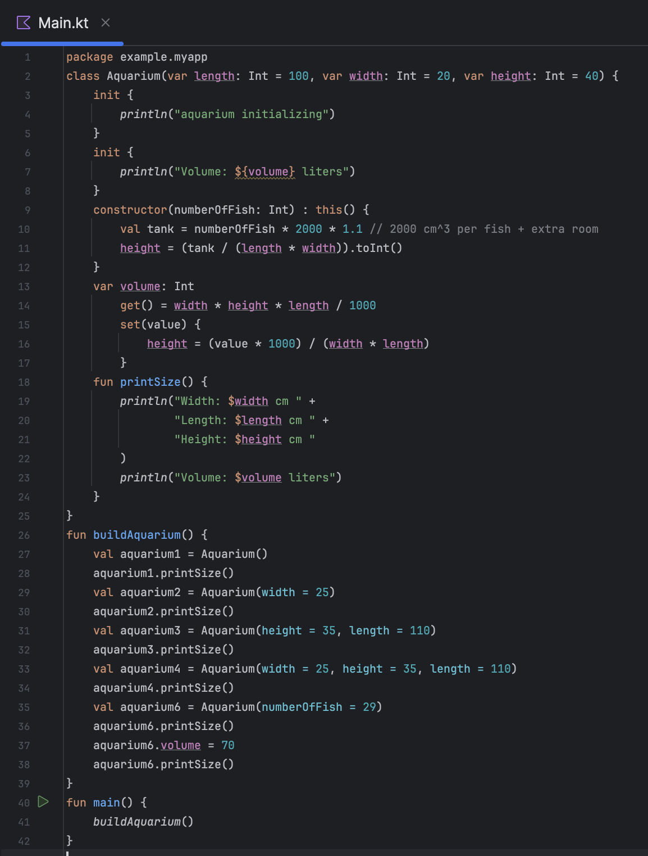

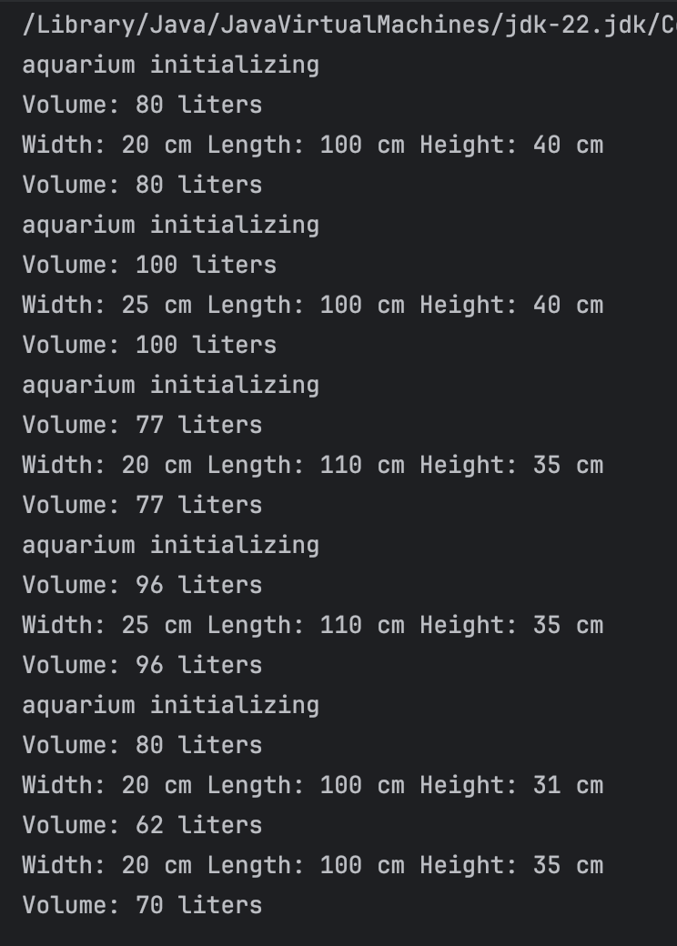

## [4. Learn about visibility modifiers](https://developer.android.com/codelabs/android-development-kotlin-3.1?continue=https%3A%2F%2Fdeveloper.android.com%2Fcourses%2Fpathways%2Fandroid-development-with-kotlin-3%23codelab-https%3A%2F%2Fdeveloper.android.com%2Fcodelabs%2Fandroid-development-kotlin-3.1#3)

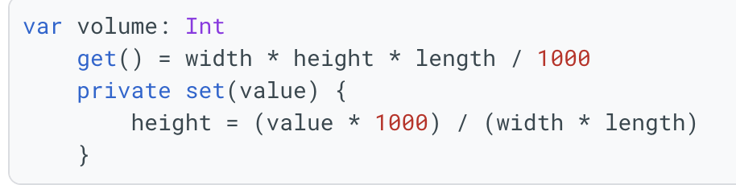

## [5. Learn about subclasses and inheritance](https://developer.android.com/codelabs/android-development-kotlin-3.1?continue=https%3A%2F%2Fdeveloper.android.com%2Fcourses%2Fpathways%2Fandroid-development-with-kotlin-3%23codelab-https%3A%2F%2Fdeveloper.android.com%2Fcodelabs%2Fandroid-development-kotlin-3.1#4)

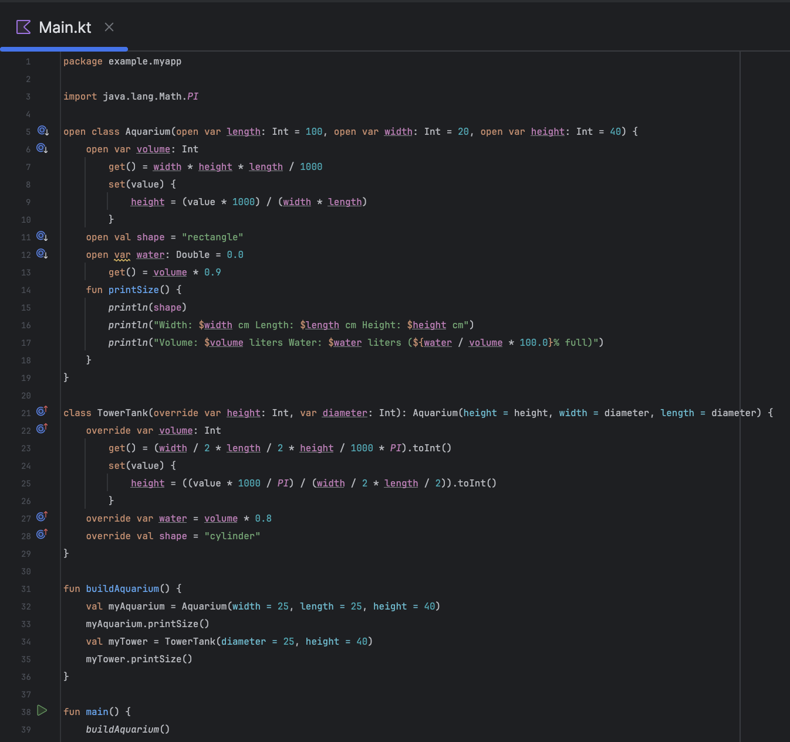

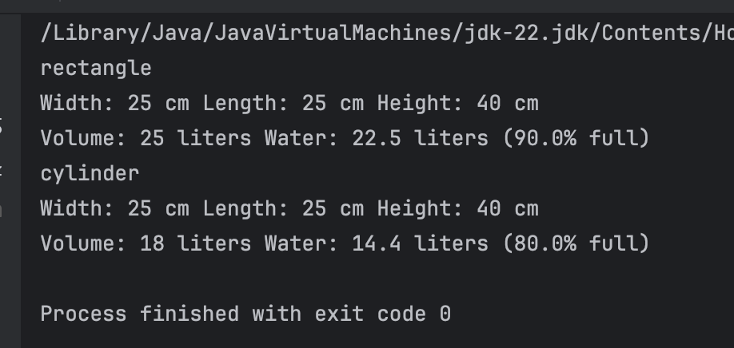

## 

## 

## [6. Compare abstract classes and interfaces](https://developer.android.com/codelabs/android-development-kotlin-3.1?continue=https%3A%2F%2Fdeveloper.android.com%2Fcourses%2Fpathways%2Fandroid-development-with-kotlin-3%23codelab-https%3A%2F%2Fdeveloper.android.com%2Fcodelabs%2Fandroid-development-kotlin-3.1#5)

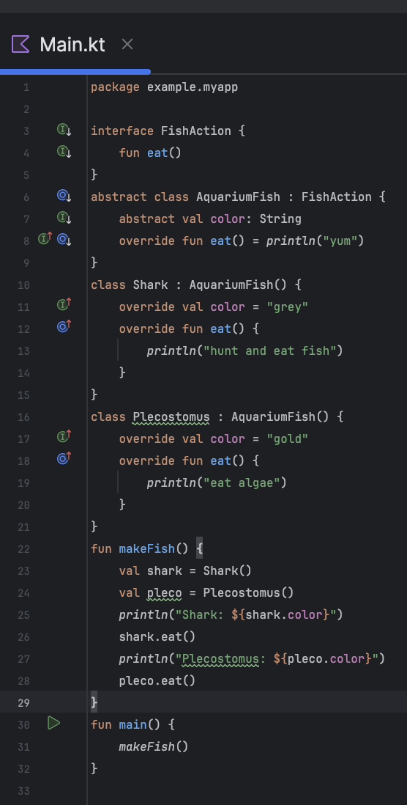

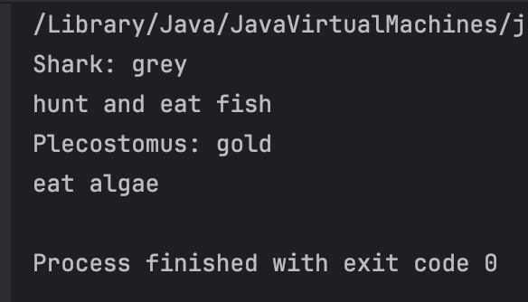

## [7. Use interface delegation](https://developer.android.com/codelabs/android-development-kotlin-3.1?continue=https%3A%2F%2Fdeveloper.android.com%2Fcourses%2Fpathways%2Fandroid-development-with-kotlin-3%23codelab-https%3A%2F%2Fdeveloper.android.com%2Fcodelabs%2Fandroid-development-kotlin-3.1#6)

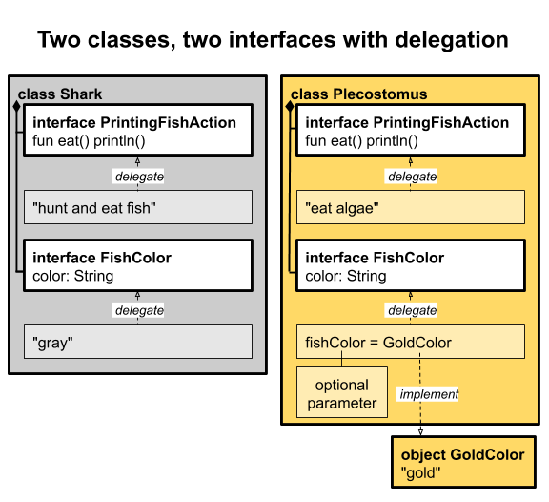

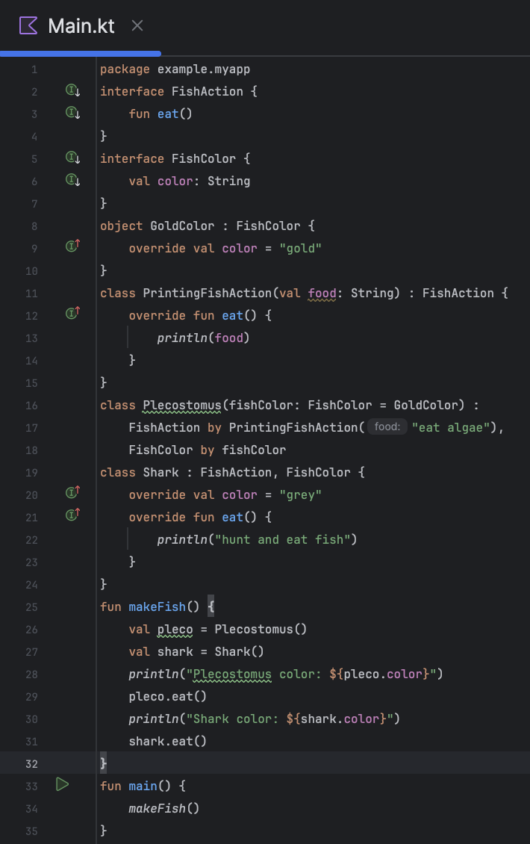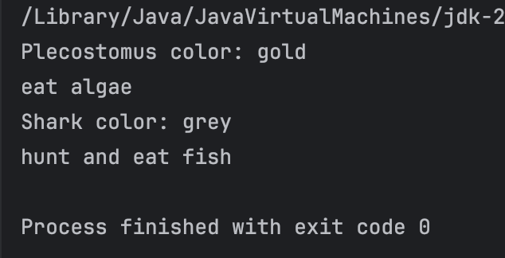

## [8. Create a data class](https://developer.android.com/codelabs/android-development-kotlin-3.1?continue=https%3A%2F%2Fdeveloper.android.com%2Fcourses%2Fpathways%2Fandroid-development-with-kotlin-3%23codelab-https%3A%2F%2Fdeveloper.android.com%2Fcodelabs%2Fandroid-development-kotlin-3.1#7)

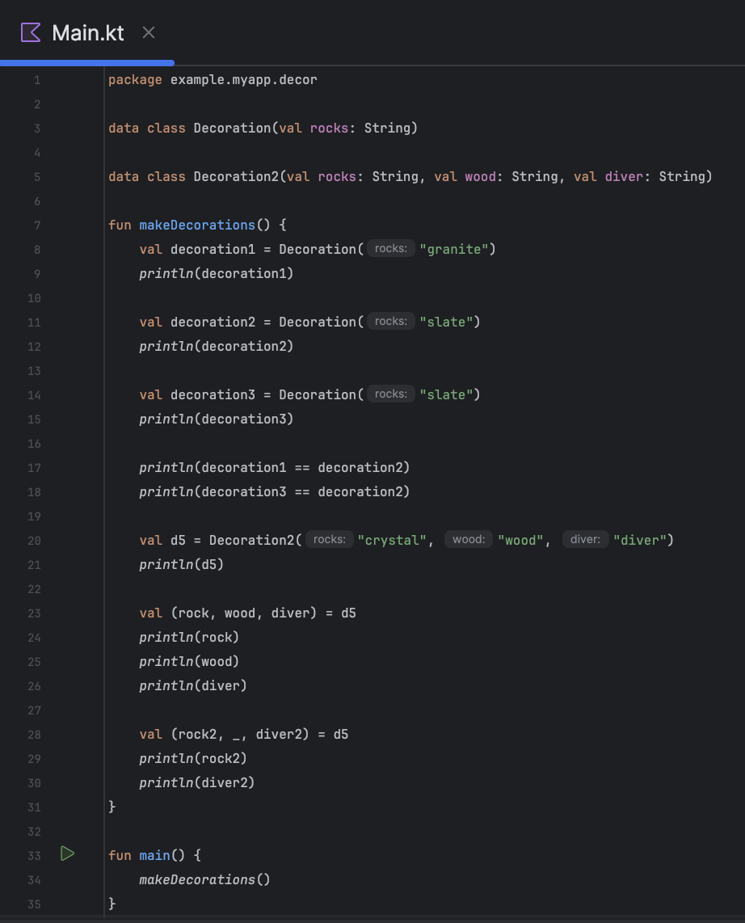

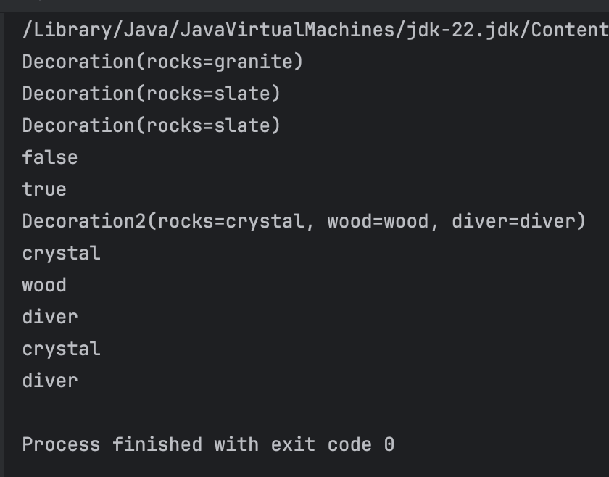

## [9. Learn about singletons and enums](https://developer.android.com/codelabs/android-development-kotlin-3.1?continue=https%3A%2F%2Fdeveloper.android.com%2Fcourses%2Fpathways%2Fandroid-development-with-kotlin-3%23codelab-https%3A%2F%2Fdeveloper.android.com%2Fcodelabs%2Fandroid-development-kotlin-3.1#8)

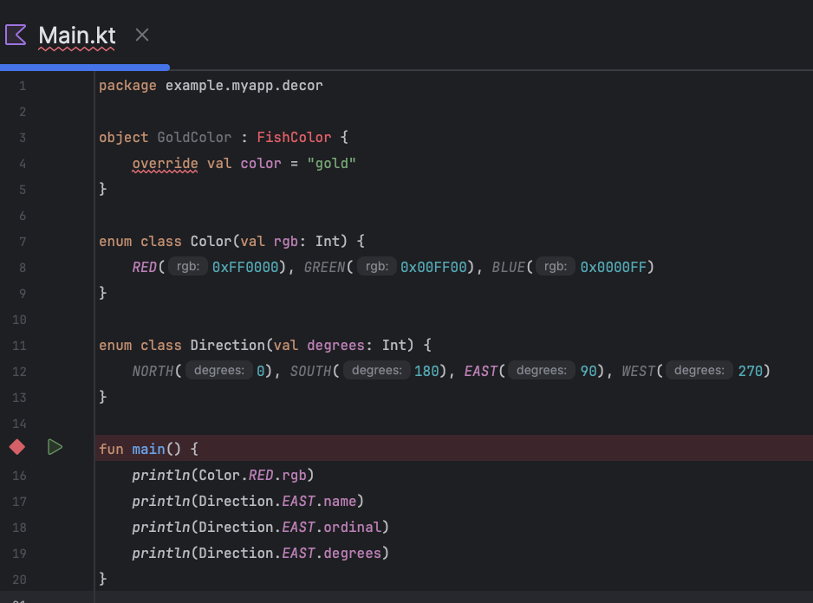

# Pairs/triples, collections, constants, and writing extension functions

## [1. Create a Companion Object](https://developer.android.com/codelabs/android-development-kotlin-3.2?continue=https%3A%2F%2Fdeveloper.android.com%2Fcourses%2Fpathways%2Fandroid-development-with-kotlin-3%23codelab-https%3A%2F%2Fdeveloper.android.com%2Fcodelabs%2Fandroid-development-kotlin-3.2#0)

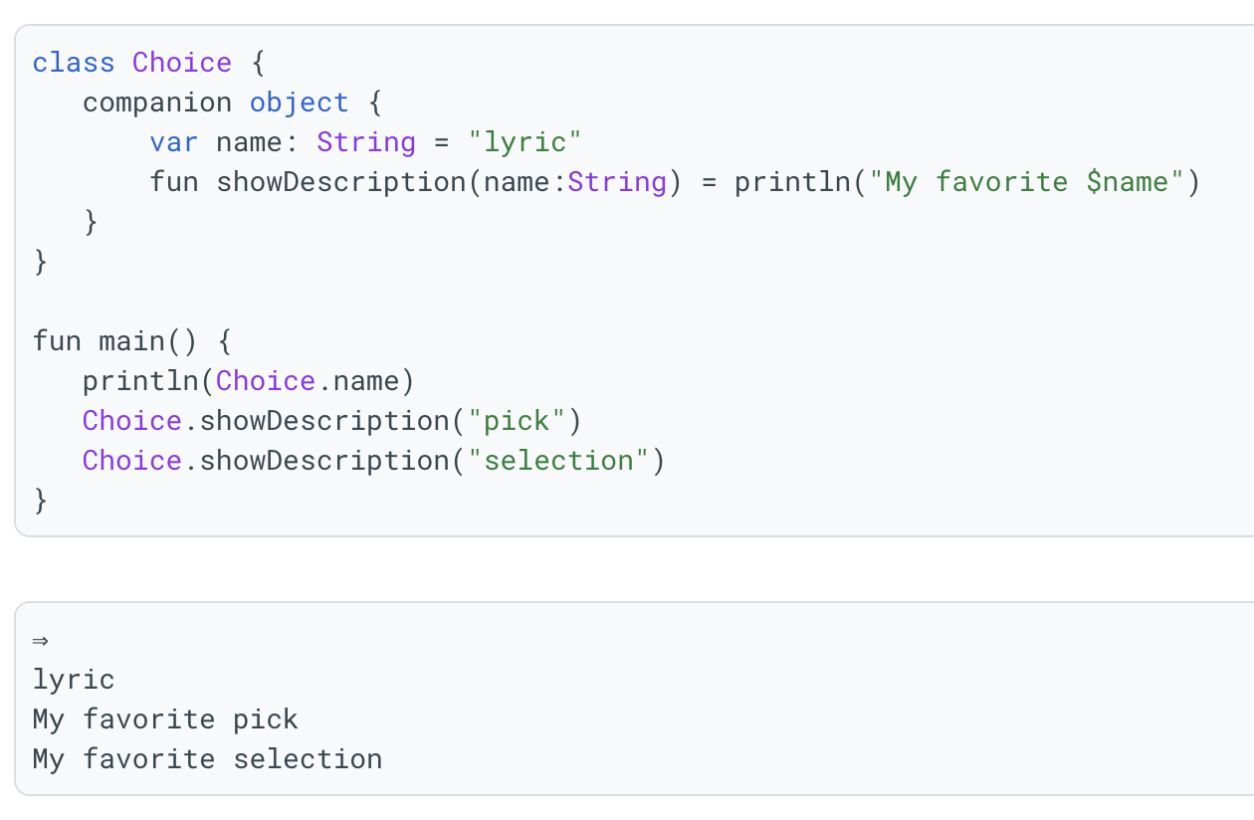

## 

## [2. Learn about pairs and triples](https://developer.android.com/codelabs/android-development-kotlin-3.2?continue=https%3A%2F%2Fdeveloper.android.com%2Fcourses%2Fpathways%2Fandroid-development-with-kotlin-3%23codelab-https%3A%2F%2Fdeveloper.android.com%2Fcodelabs%2Fandroid-development-kotlin-3.2#1)

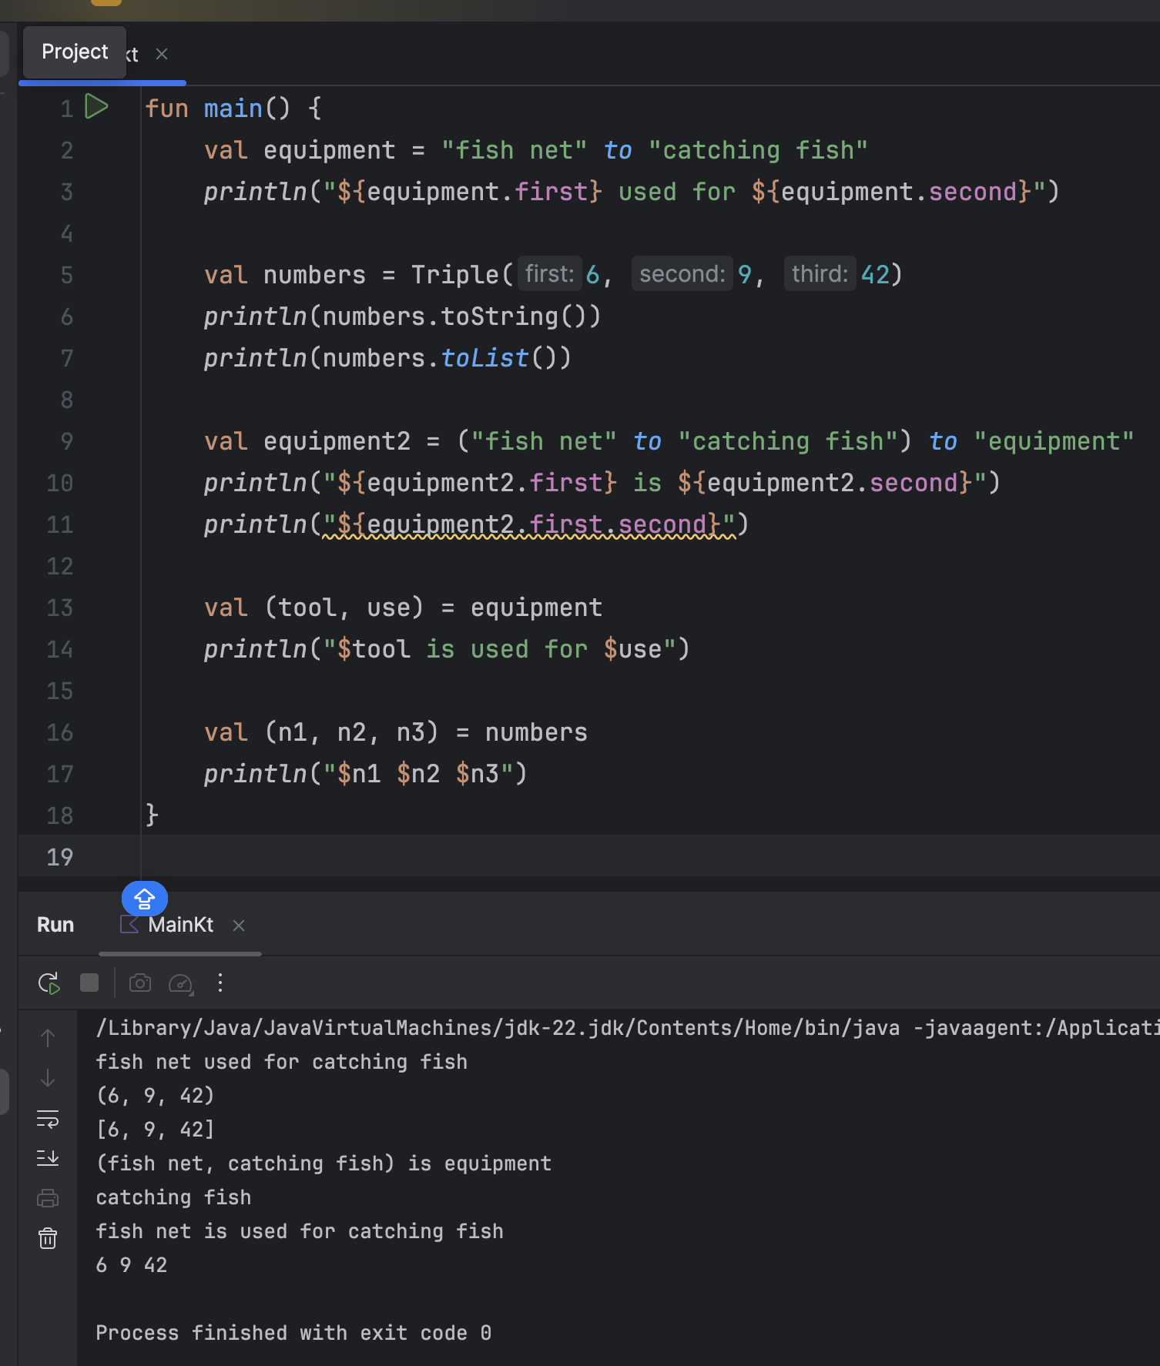

## 

## 

## 

## 

## 

## [3. Learn more about collections](https://developer.android.com/codelabs/android-development-kotlin-3.2?continue=https%3A%2F%2Fdeveloper.android.com%2Fcourses%2Fpathways%2Fandroid-development-with-kotlin-3%23codelab-https%3A%2F%2Fdeveloper.android.com%2Fcodelabs%2Fandroid-development-kotlin-3.2#2)

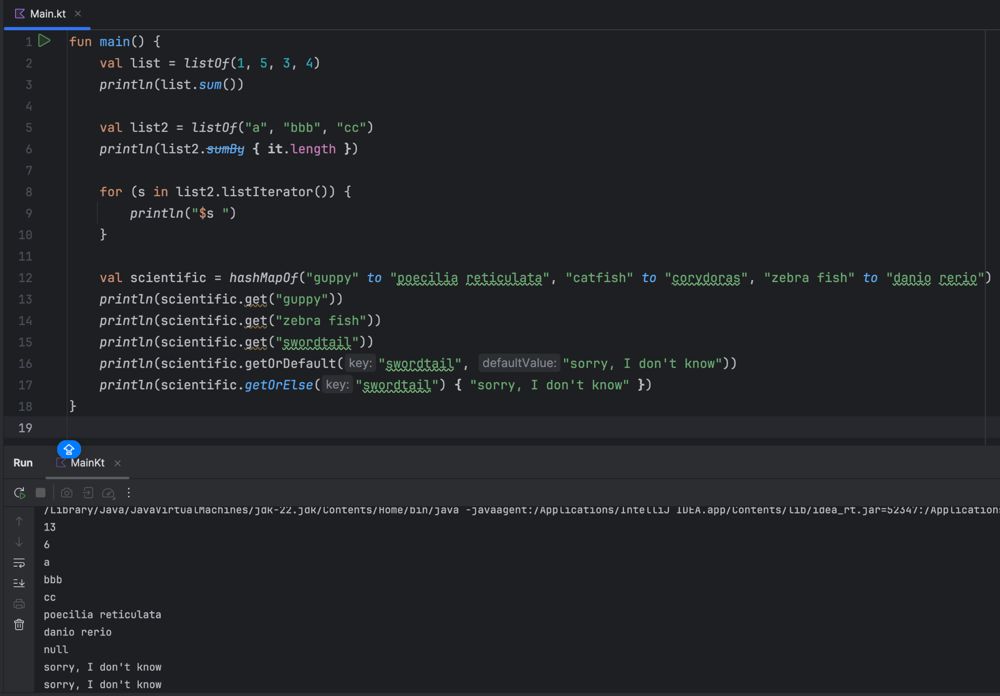

## [4. Organize and define constants](https://developer.android.com/codelabs/android-development-kotlin-3.2?continue=https%3A%2F%2Fdeveloper.android.com%2Fcourses%2Fpathways%2Fandroid-development-with-kotlin-3%23codelab-https%3A%2F%2Fdeveloper.android.com%2Fcodelabs%2Fandroid-development-kotlin-3.2#3)

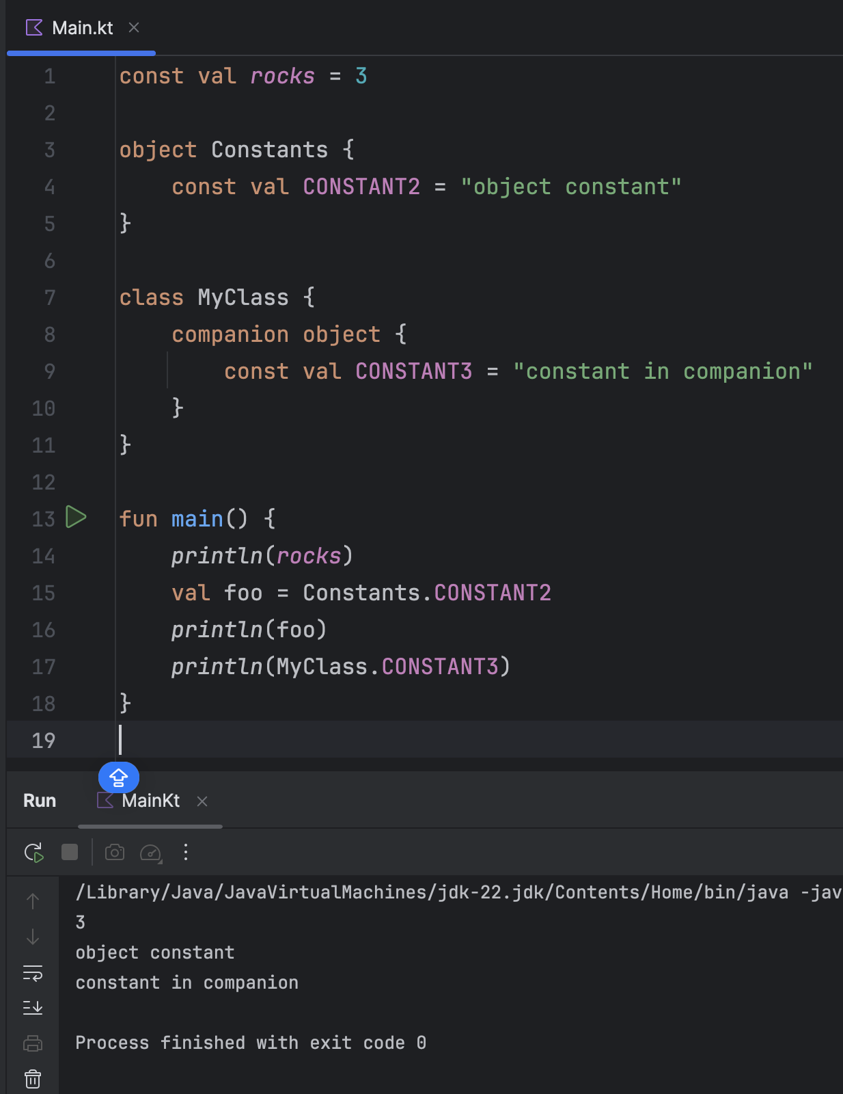

## [5. Understand extension functions](https://developer.android.com/codelabs/android-development-kotlin-3.2?continue=https%3A%2F%2Fdeveloper.android.com%2Fcourses%2Fpathways%2Fandroid-development-with-kotlin-3%23codelab-https%3A%2F%2Fdeveloper.android.com%2Fcodelabs%2Fandroid-development-kotlin-3.2#4)

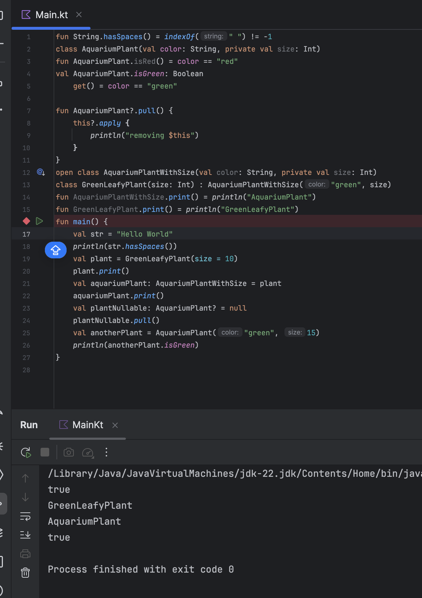

# QUIZ

