**Question 1 (30pts): List 03 main reasons for an interactive visualization? And describe an example for each.**

1. Facilitating Data Exploration and Discovery

- Interactive visualizations enable users to explore and manipulate data to uncover patterns, trends, and insights that might not be immediately apparent in static charts or reports. Users can drill down into specific data points, adjust parameters, and filter results to focus on particular aspects of the data.

- Example: A geographic information system (GIS) map that allows users to zoom in and out, select specific regions, and display various layers of information such as population density, climate data, or traffic patterns. This can help urban planners identify areas of high congestion and plan infrastructure projects accordingly.

1. Enhancing User Engagement and Understanding

- By involving users in the data exploration process through interactive elements, visualizations can increase engagement and improve comprehension. Users are more likely to understand and remember information when they can interact with it, as this involvement creates a more engaging and memorable experience.

- Example: An interactive timeline of historical events where users can click on specific time periods to learn more about significant occurrences, view related multimedia content, and understand the context of these events within a broader historical framework. This can be particularly useful in educational settings to enhance learning.

1. Supporting Customized Analysis and Personalization

- Interactive visualizations allow users to tailor the presentation of data to their specific interests or needs, making the analysis more relevant and personal. Users can select which data sets to view, choose visualization types, and set their parameters, enabling a more personalized interaction with the data.

- Example: A customizable dashboard for financial data where investors can select which stocks or indices to track, compare performance over different time frames, and use sliders to simulate various investment scenarios. This personalization helps users make more informed decisions based on their investment strategies and risk tolerance.

**Question 2 (30pts): The following charts are not good. Analyze why they are not good and redesign them**

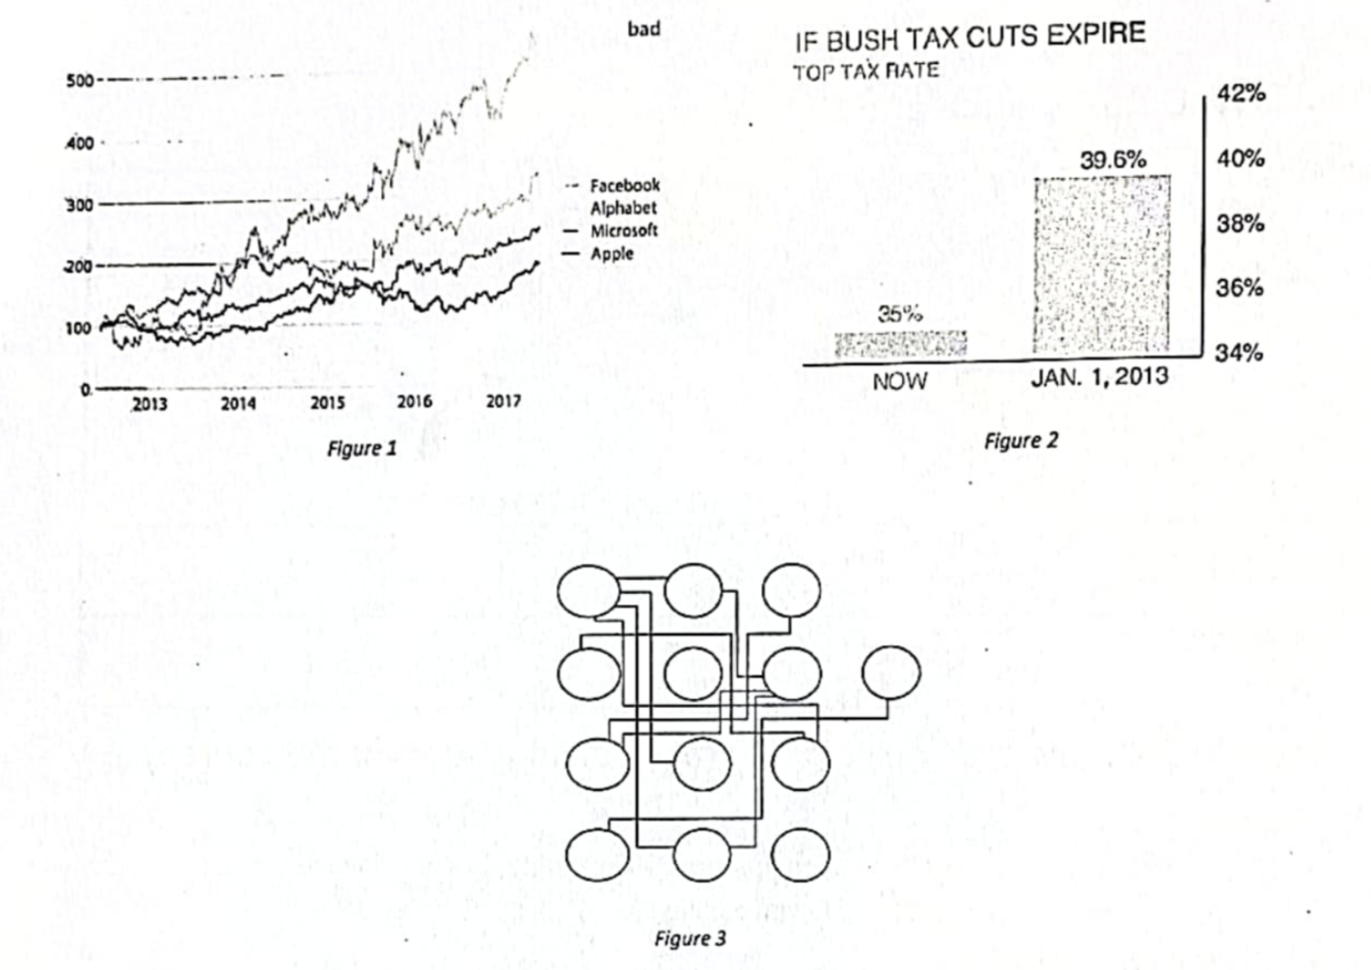

1. Line chart:

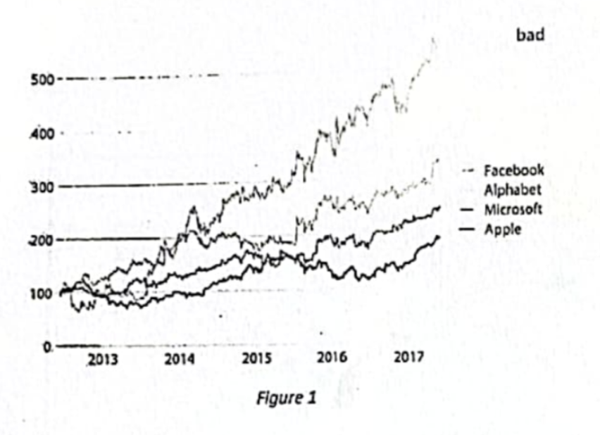

**Some aspects could improved:**

- Resolution and Clarity: The chart is quite pixelated and blurry, making it difficult to read the text and distinguish between the data lines clearly.

- Color and Line Style: The lines appear to be in grayscale, which can be difficult to distinguish. There is also an overlap of the lines, which may cause confusion.

- Lack of Context: The y-axis is labeled, but there's no indication of what the numbers represent – are they stock prices, performance indices, or something else? Additionally, there is no label for the x-axis, although it seems to represent years.

- Data Labels: The legend that indicates which line corresponds to which company is not directly next to the lines themselves, which requires the reader to shift attention back and forth to match the company with the data.

- Title and Labeling: The word "bad" in the top right corner is ambiguous. It's unclear whether it refers to the quality of the chart or the performance of the companies. The chart lacks a descriptive title that explains what the figure is depicting.

**Redesign it:**

**-** Use high-quality, clear graphics so that all text and lines are legible.

- Apply color to differentiate between the companies more clearly.

- Label both axes with appropriate units of measurement and time intervals.

- Position the legend closer to the corresponding lines or use interactive elements that allow hovering over a line to see the company name.

- Add a descriptive title that clearly states what the chart is displaying.

- Incorporate grid lines for easier reading of values from the chart.

- Provide annotations or a brief description if any significant events or points of interest correspond to changes in the data.

1. Bar chart:

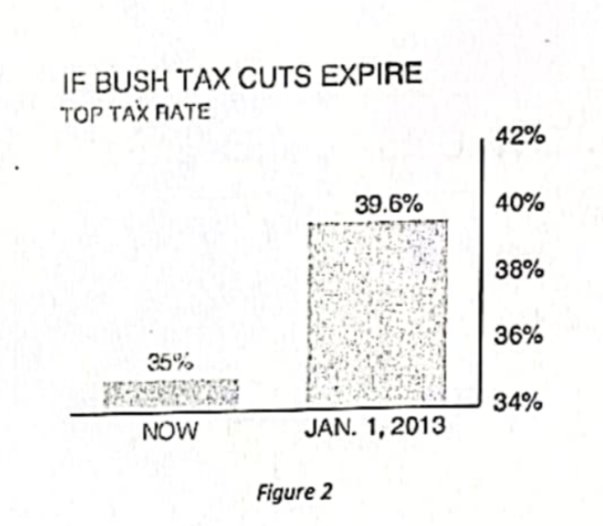

**Some aspects could improved:**

**-** Proportional Representation: The visual representation of the tax rates does not seem to be proportionate to the actual percentages. For instance, the increase from 25% to 39.6% looks significantly larger than it should be when compared to the scale on the right.

- Scale and Axes: The y-axis is not clearly labeled, and it's not clear what the numbers on the right side represent. The chart also lacks a clear x-axis.

- Design and Clarity: The use of a shaded box to represent the future tax rate is unconventional and may be confusing. The percentage inside the box is difficult to read due to the shading.

- Misleading Visuals: The size of the shaded area could be misinterpreted as a much more substantial increase than what the percentage indicates.

- Contextual Information: There is no context provided about what the current rate applies to or how the new rate would compare in a broader economic context.

**Redesign it:**

- Use a simple bar chart with two bars to clearly represent the 'now' and 'January 1, 2013' tax rates, ensuring that the height of each bar is proportional to the tax rate it represents.

- Clearly label the y-axis to indicate that it represents the percentage of the tax rate and ensure that the axis is scaled appropriately.

- Provide a legend or note to explain what the tax rates represent and any relevant information about the Bush tax cuts for context.

- Use clearer typography to ensure that all text is legible and that percentage values are easily readable.

- Avoid using shading that can obscure text and use solid fill colors instead.

1. Schematic

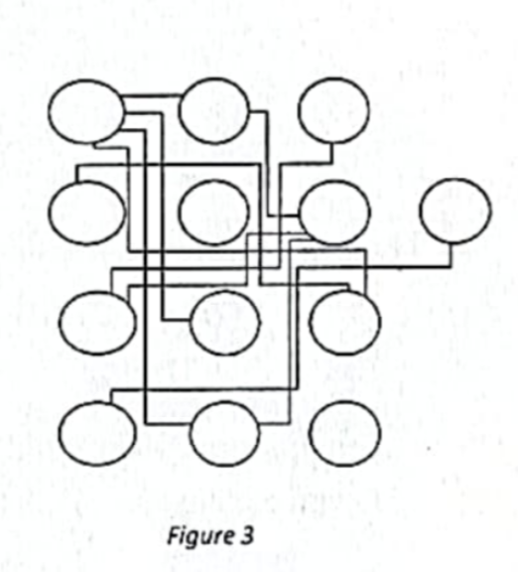

**Some aspects could improved:**

- Clarity: The lines and connections between the nodes are quite cluttered, which can make it difficult to follow the paths and understand the connections.

- Resolution: The image is blurry, which further complicates the interpretation of the diagram.

- Labels: There are no labels or identifiers for the nodes (circles) or the lines connecting them. Without these, it is hard to determine what each node represents or the nature of their connections.

- Key or Legend: There is no legend or key to explain the meaning of different shapes or line types, if they have specific meanings.

- Purpose and Context: There is no context provided for what this diagram represents. Without knowing the purpose of the diagram, it is hard to determine if it is conveying the necessary information effectively.

**Redesign it:**

- Ensure a higher resolution so that all elements are crisp and clear.

- Introduce labels for the different nodes and connections.

- Simplify the layout to reduce clutter and improve readability.

- Provide a legend or key if different elements have specific meanings.

- Include a title or caption that explains the context and purpose of the diagram.

**Question 3: (40pts) Design a visualization**

**In a university, the curriculum of a program is updated each year such as**

**- Add new courses**

**- Remove existing courses**

**- Move a course from one semester to another**

**- Add a new connection between two courses**

**- Remove an existing connection between two courses**

**The update is to adopt new knowledge and technology, but people need to track the differences between versions.**

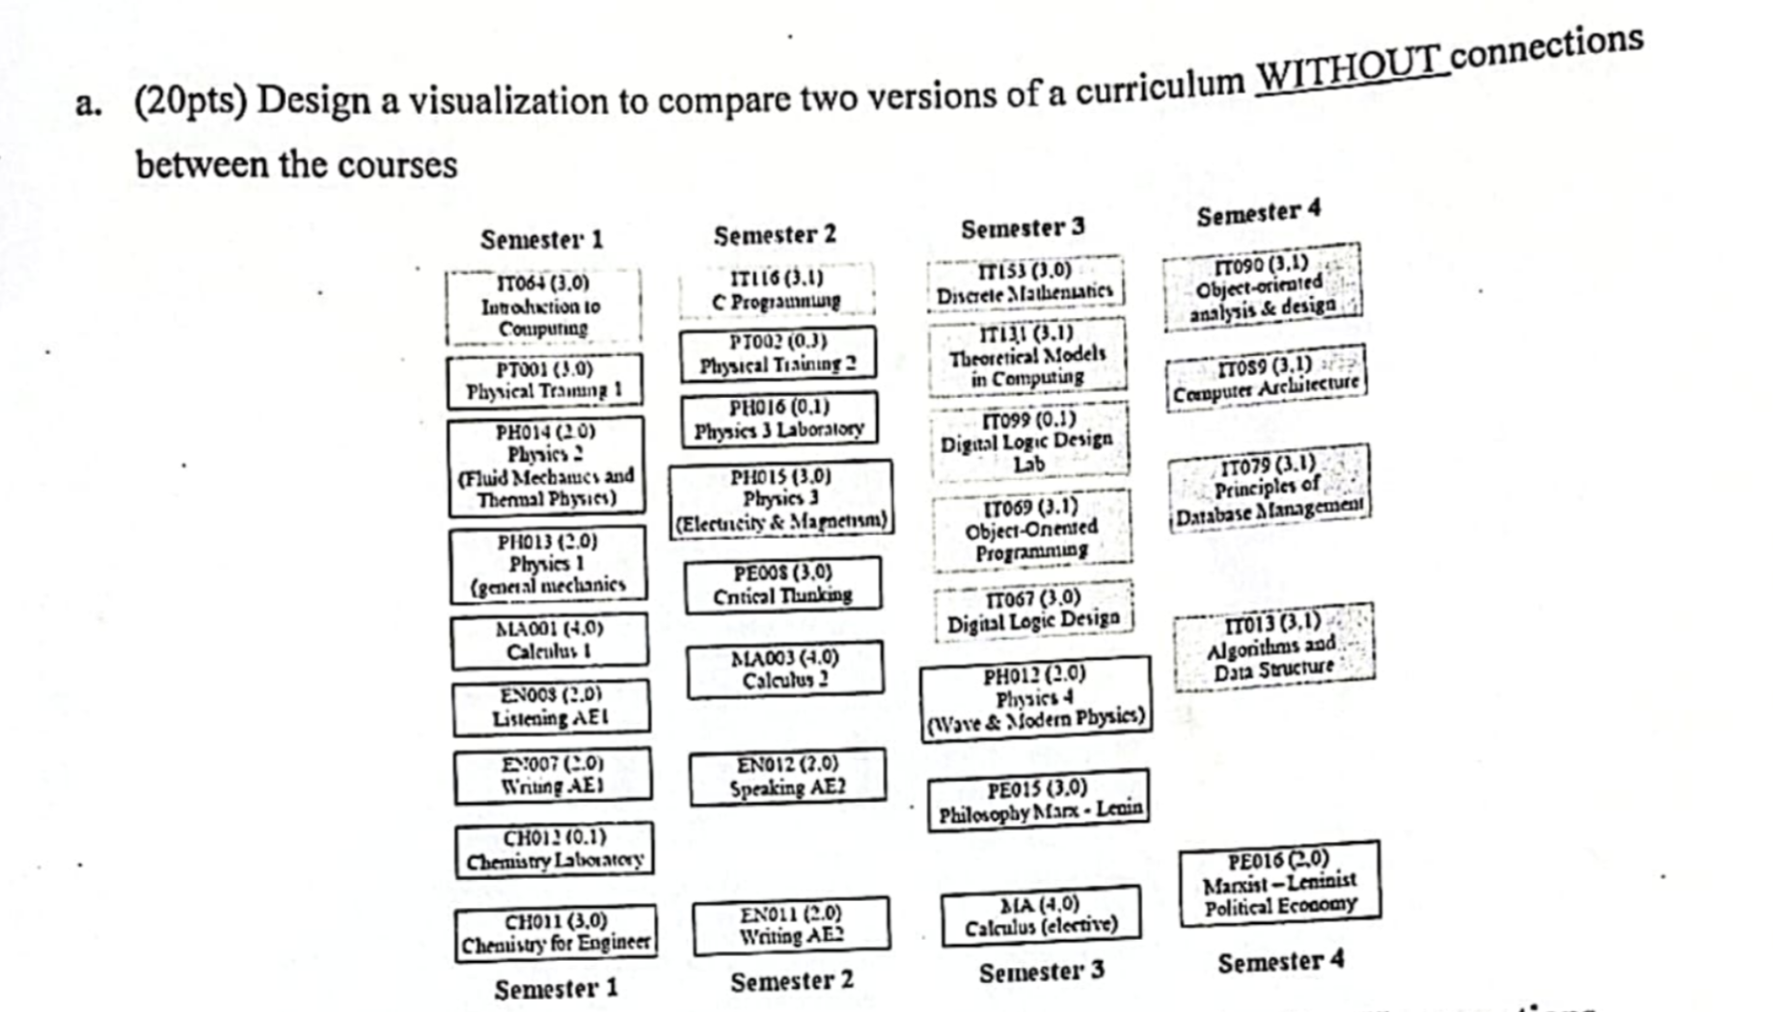

- Two-Column Layout: Create a two-column layout, where the left column represents the old curriculum and the right column represents the updated curriculum.

- Semester Headings: Each column should be divided into rows, with each row representing a semester. Label each row with "Semester 1," "Semester 2," and so on.

- Course Blocks: Within each semester row, list the courses as blocks or cells, with the course code and name. You could use different colors to represent different statuses of the courses (e.g., green for new courses, red for removed courses, blue for moved courses).

- Alignment for Comparison: Ensure that the corresponding semesters are aligned horizontally across the two columns to facilitate easy comparison.

- Legend: Include a legend to explain what each color or symbol means (e.g., a "+" for new courses, a "-" for removed courses, an arrow for moved courses).

- Interactivity (Optional): If the visualization is digital, you can add interactive elements such as hover text that provides more details about changes to each course or filters to show only added, removed, or moved courses.

- Consistent Course Formatting: Use consistent formatting for course codes and names to help viewers quickly spot differences.

- Summary of Changes: Below the side-by-side comparison, provide a summary section that lists the total number of new, removed, moved courses, and any other pertinent information.

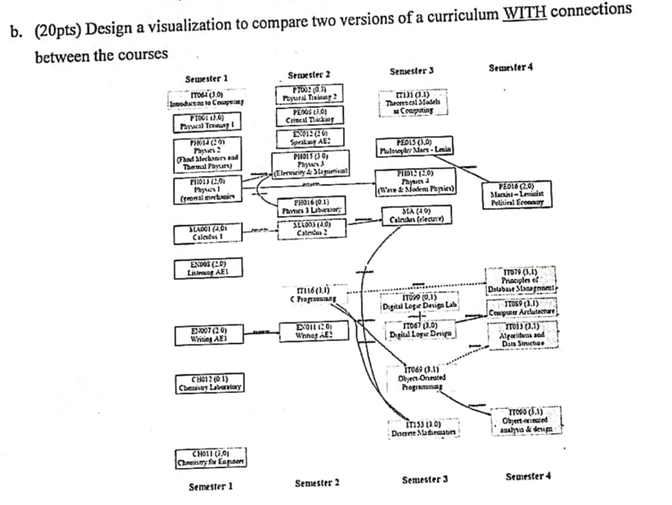

- Flowchart with Parallel Columns: Use a flowchart format with two parallel columns, one for each version of the curriculum. Each column should be divided into segments representing semesters.

- Course Nodes: Within each semester segment, represent each course as a node (a box or circle). Use color-coding or different shapes to indicate the status of the course (new, removed, unchanged).

- Connecting Lines: Draw lines between courses to indicate connections, such as prerequisites or corequisites. Use arrows to show the direction of the connection.

- Color-Coded Lines: Use different colors or styles of lines to represent different types of connections (new, removed, strengthened, weakened).

- Alignment for Comparison: Align the courses vertically across the two columns where possible, to make it easy to compare the presence and connections of the courses across the two versions.

- Legend: Include a legend or key to explain the meanings of different node and line colors and styles.

- Interactive Elements (Optional): If the visualization will be used in a digital format, consider adding interactive elements such as the ability to click on a course to see more information or to highlight all connections for a selected course.

- Summary: Provide a summary box or area that outlines the key changes in the curriculum and the overall structure of the connections.