Overview:
About

Part I: Ideas, Implements and Result.

Part II: Tutorial.
How to use ?

Part III: Evaluation system.

About
This project allows student use the knowledge in the

Part I: Ideas, Implements and Achievements.
a, Ideas:
The main problem of this project is to create a client – server system which can allow client side store and download the file they want. In this project, we simulate the operation of ADSL model which can increase the speed for downloading process. Normally, when we upload and download from only one server the speed is always limited , but with ADSL protocol we can increase the speed by using multiple server to provide file for user side.
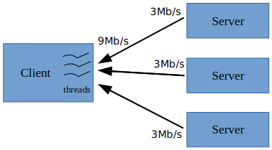

The system need 3 major blocks
Client block: Through this block, user can interact with system by choosing the upload or download mode, choosing the file to upload and download.
Registration block: This block store all the information of server data node because it is remote object so client can easy get the list of all exist servers.
Server block (or data node): In the server block we need to add the name of host and the port of each server in the remote object that is served by registration part.
(1) Download
(2) Upload
(3) Add server list
(4) Get server list

Server side
Data node
Data node
Data node
Name node
Client

(1)
(3)
(2)
Registration side Client side
(1)
(2)
(1)
(2)
(3)
(3)
(4)

Host class

b, Implements
b.1, Server block and registration block
First we create the server block and the registration block, we connect two blocks for register process in which the name node can get the information of each data node. The serializable class host is created to get and set the information of each data node.

To connect server block to registration block we need create interfaces which offer the method to to remote machine interact.

Name node
Data node
Name node
(1)
(1)
Naming.bind
Naming.lookup
Naming.lookup
(2)
Interface
Registration
Consulation
(2)

(1) Client Look up function
(2) Server bind and exec the function if it exists.

Function in this block:

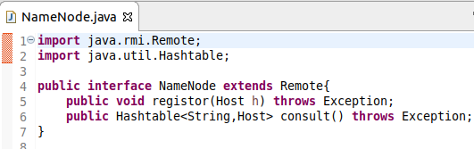

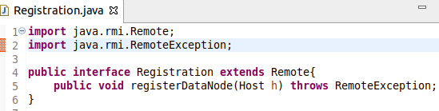

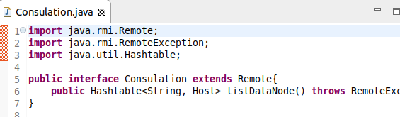

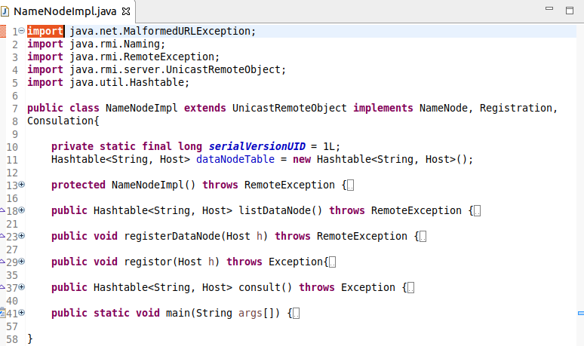

b.2, Client block
Second we create a simple client block to give the user permission to download and upload the file.
This block use the manage file interface to manage the download and store(upload) function.

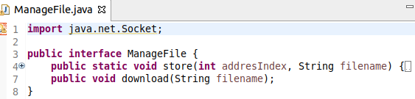

Simple client can download in parallel and upload to more than one data node at the same moment so we need the thread to handle this process. To create a thread we have to create a class which extends(inherit) the thread class here we create two classes “uploadThread” and “downloadThread”.

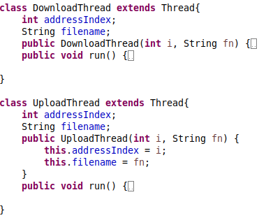

c, Result
My simple application allows client upload a large file into the data store, through the locally test it shows that the application can up 2,2 gigabyte file to three data nodes with quite faster speed.

