| **Executive Summary (0.25) & Conclusion (0.25)** | **0.5 points** |
| --- | --- |
| **I. Business Requirements** | **1.0 points** |
| **II. System Requirements Analysis (each sub item is 1pts)** | **3.0 points** |
| **III. System Requirements Analysis (each sub item is 1pts)** | **3.0 points** |
| **IV .System Requirements Implementation** | **2.0 points** |
| **V. System Testing, Deployment and Demo** | **1.5 points** |
| **(*include* *Visio/PowerDesign/Drawing source* + *source code*)** |  |
| **Total** | **11 points** |

**Real-Time Continuous**

**Glucose Monitoring**

**Requirements Analysis & Design (RAD)**

**By Students:**

1. **StudentID1 : 518H0611 - Bùi Đức Dũng**
2. **StudentID2 : 519H0027 - Võ Nguyên Long**

| **Reference:** | **Team_02_RAD_Requirements_Modelling_v0.1** | | |
| --- | --- | --- | --- |
| **Audience:** | **Mr. Pham Thai Ky Trung** | **Document Version:** | **April 04, 2018** |
| **Outcome:** | **Video Rental System** | | |
| **Abstract:** | This document provides an in-depth analysis of a real-time continuous Glucose monitoring system, the requirements modelled utilizing the UML framework. The document is a collaboration between the members of Team 02. | | |
|  | | | |

# **Intellectual Property**

The following documentation, the content therein and/or the presentation of its information is proprietary to and embodies the confidential processes, designs, technologies and otherwise of Team 02. All copyright, trademarks, trade names, patents, industrial designs, and other intellectual property rights contained herein are, unless otherwise specified, the exclusive property of Team 02.

The ideas, concepts and/or their application, embodied within this documentation remain and constitute items of intellectual property which nevertheless belong to Team 02.

The information (including, but by no means limited to, data, drawings, specification, documentation, software listings, source and/or object code) shall not be disclosed, manipulated, disseminated or otherwise in any manner inconsistent with the nature and/or conditions under which this documentation has been issued.

The information contained herein is believed to be accurate and reliable. Team 02 accepts no responsibility for its use in any way whatsoever. Team 02 shall not be liable for any expenses, damages and/or related costs which may result from the use of the information contained herein.

The information contained herein is subject to change without notice.

All Rights Reserved. Copyright herein is expressly protected at common law, statute and under various International and Multi-National Treatises (including, but by no means limited to, the Berne Convention for the Protection of Literary and Artistic Works).

# Table of Contents

**Intellectual Property** **3**

Table of Contents **3**

**Executive Summary (0.25 point)** **5**

Business Requirements (1 point) **6**

**Organization Chart** **7**

**Business Modelling** **7**

**List of Requirements** **9**

System Requirements Analysis (3.0 points) **9**

Translate from Business Use Case **10**

System Narrative 10

Users and their goals 11

List of Events 13

List of Actors 14

List of Use Cases 15

Use Case Diagram 16

Domain Class Model Diagram 17

Use Case Descriptions **18**

Use Case: Patient Enter Notes 18

Use Case: Alert 22

Use Case: Receive Data from server 24

Use Case: Sent Data from server 26

Verifying use cases for Actor **28**

Verifying uses cases: Enter Note for Patient 28

Verifying uses cases for Alert 29

System Requirements Design (3.0 points) **30**

**Design Class for Use Case 1** **30**

3.1.1 Design Classes in Detailed Design 30

3.1.2 Design Class Diagram 32

Domain Design Class 32

Design Class 33

Design Class for Use Case 2 **34**

Design Class 34

System Requirements Implementation (2pts) **35**

Implementation **36**

UI design 36

SQL Code 37

**Conclusions/ Recommendations (0.25 point)** **39**

# 

# **Executive Summary (0.25 point)**

In this project, we will introduce to you how a Real-Time Continuous Glucose Monitoring (RTCGM) can be built from scratch. From what the system requirements and how to meet them, to declaring all the use cases and its actors. Represent contents through use case diagrams, activity diagrams, sequence diagrams,.... We also build an assumption of all the UI that the system needs.

# **Business Requirements (1 point)**

# **Organization Chart**

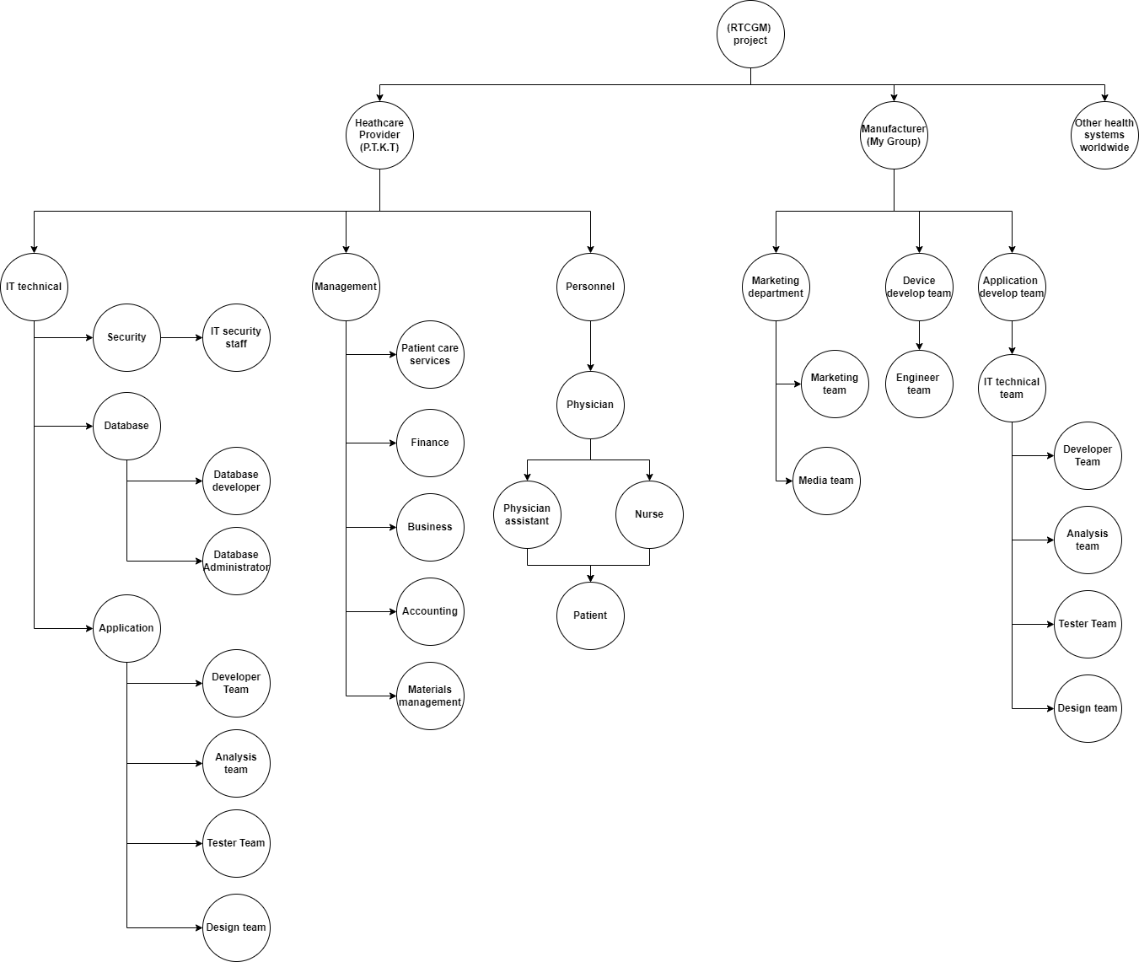

**Figure 1: Org Chart**

# **Business Modelling**

Business Narrative

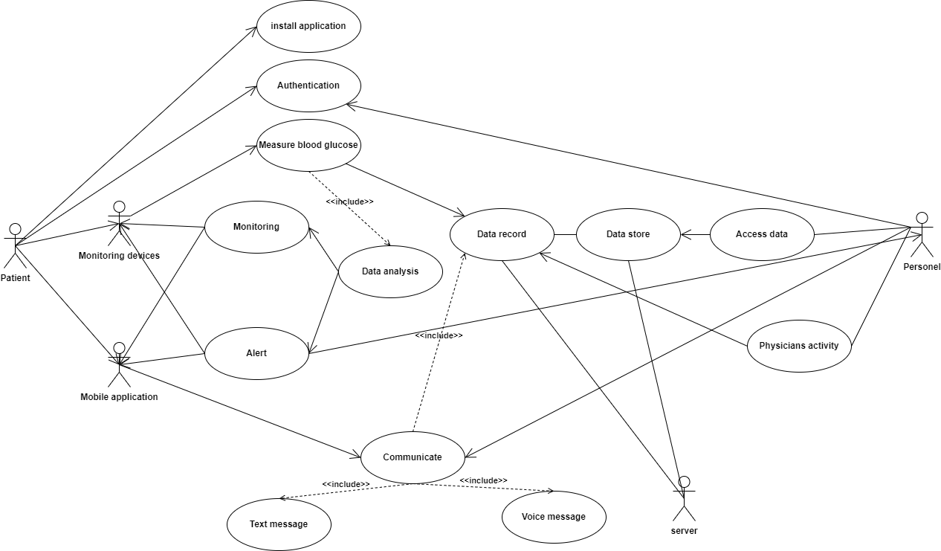

**Figure 2 : Business use case**

# **List of Requirements**

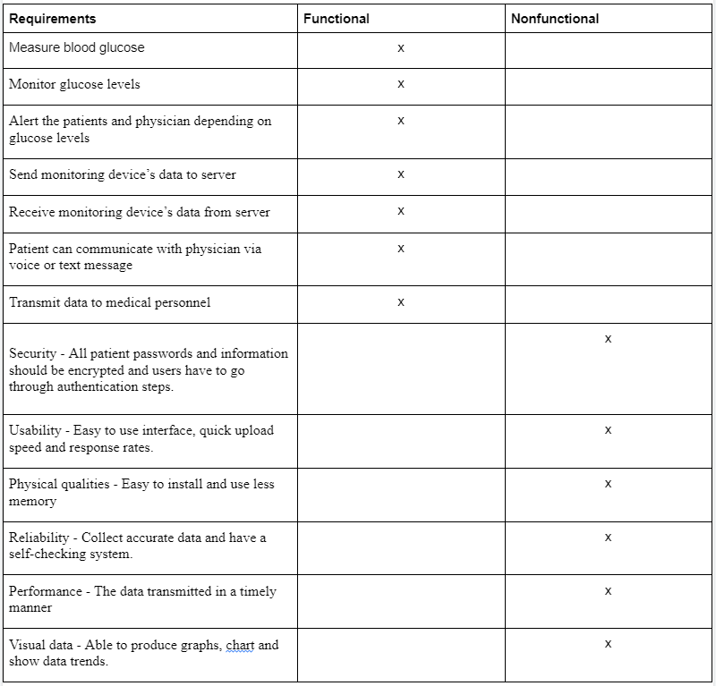

# **System Requirements Analysis (3.0 points)**

# **Translate from Business Use Case**

## ***System Narrative***

RTGM system:

* A patient will receive a wristband(monitoring device) and install a mobile application of the RTGM system.
* Patient has to create an account through authentication of medical personnel. That medical personnel will be the one who will communicate and give guidance for the Patient. They can communicate by voice or text message.
* Patients will be able to see their glucose level measurement and alert in the wristband or the mobile app. The data shown can be presented in graphical form or text form.
* Medical Personnel can access data to see the glucose level of the patient for further analysis and guidance.
* All data will be stored in the Server and can be accessed by Patient or Medical Personnel.

## ***Users and their goals***

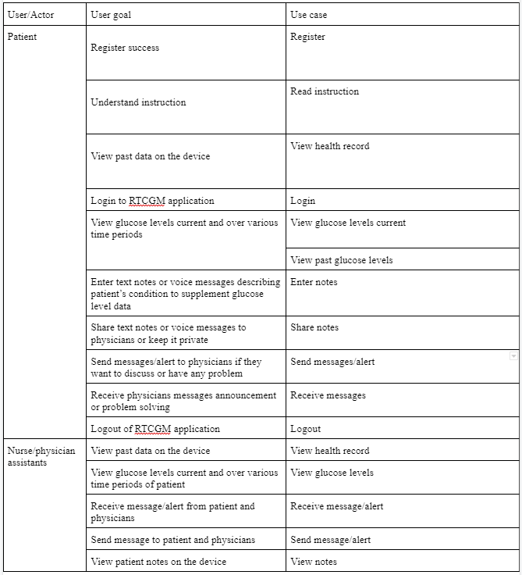

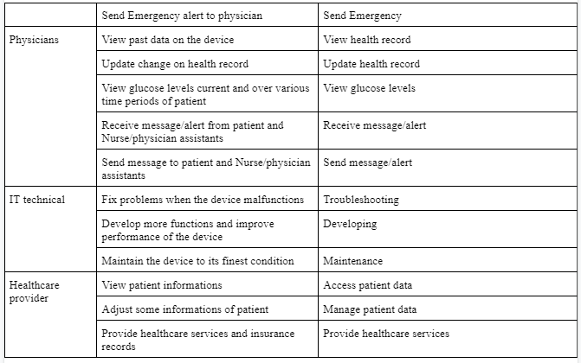

## ***List of Events***

List of events and its use case

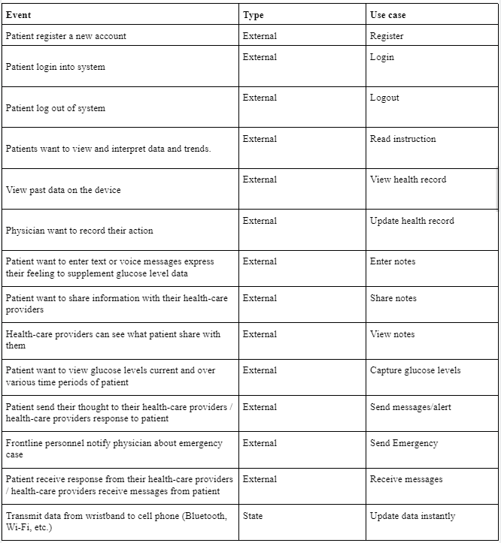

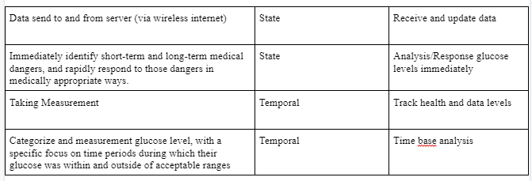

## ***List of Actors***

* **Patient:** is who interacts with the system to monitor their glucose level
* **Medical Personnel:** is who will also see the Patient glucose level to be able to guide them. There are three types of Medical Personnel.
  + **Physician:** is the one in charge of emergency situations when the Patient is in high or low glucose level.
  + **Physician assistant:** is the one giving specialized guidance for the Patient and also provide needed information for Patient.
  + **Nurse:** is the one who mostly communicates with Patient to guide them to take care of their health, and also provide needed information for Patient.
* **IT technician:** is who has to maintain the wristband or the mobile application to their finest performance
* **Healthcare provider:** is who manages the data of the Patient and also gives them the service.
* **Server**: is where all data will be stored and accessed.

## ***List of Use Cases***

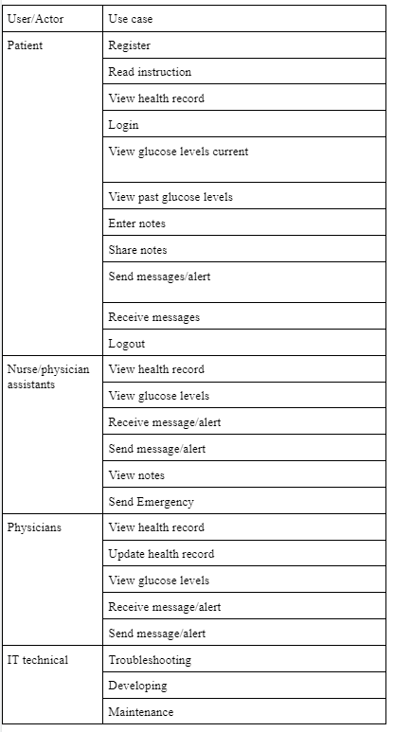

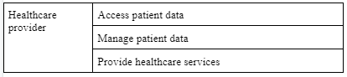

## ***Use Case Diagram***

The use case diagram of RTGM System can be draw-able as the following :

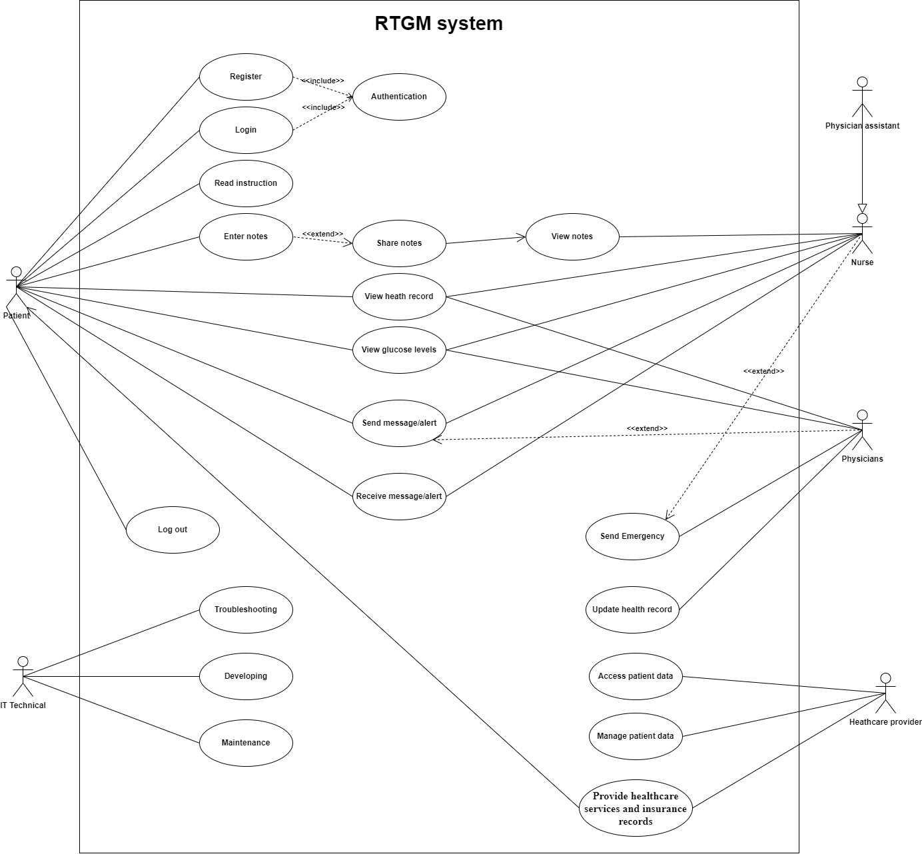

**Figure 3: RTGM system use case diagram**

## ***Domain Class Model Diagram***

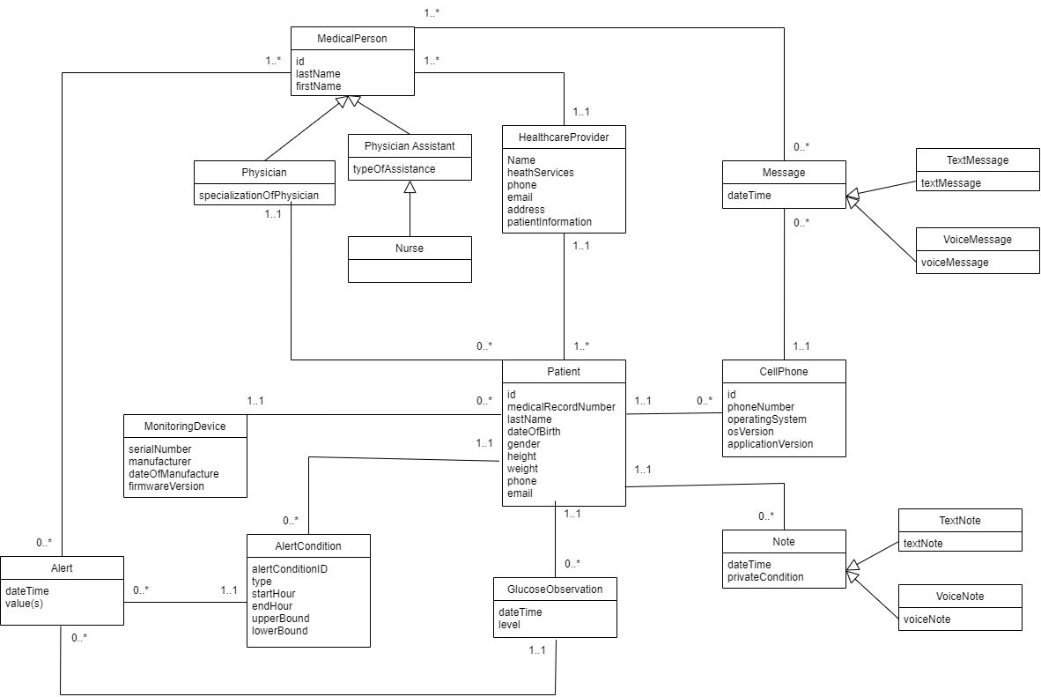

***Figure 4:*** *RTCGM Domain Model Class Diagram*

# **Use Case Descriptions**

## ***Use Case:*** Patient Enter Notes

1. Use case : name 1 full description

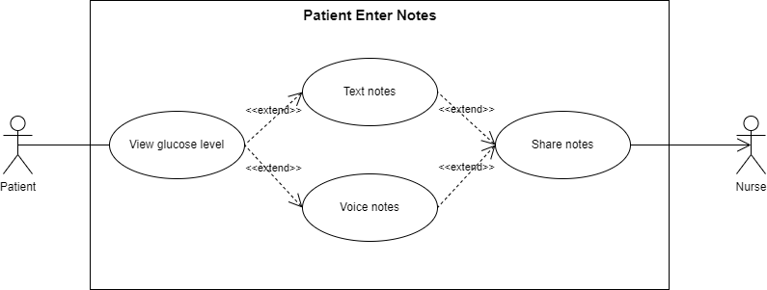

**Figure 5: Patient Enter Notes Use Case diagram**

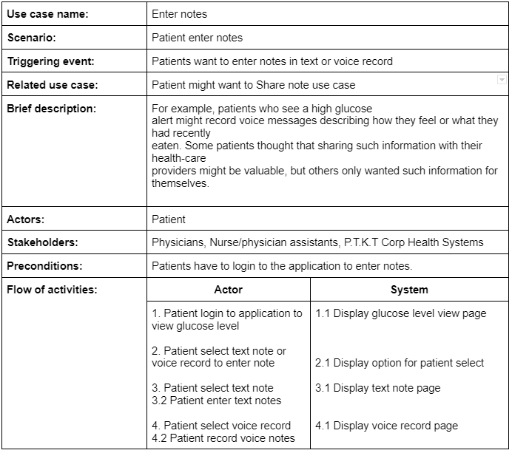

1. Activity diagram for Use Case: Patient Enter Notes

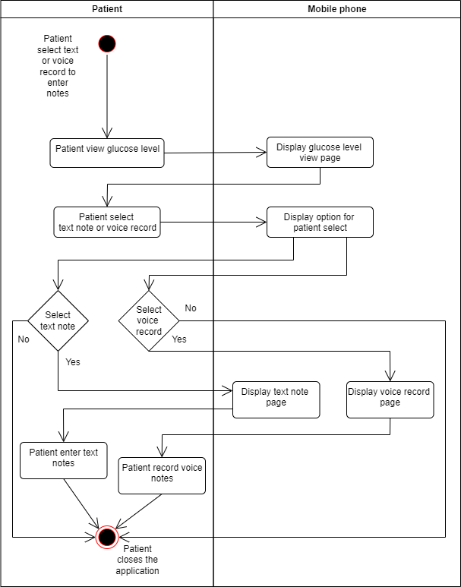

**Figure 6: Patient Enter Note Activity diagram**

1. System sequence diagram for Use Case: Patient Enter Notes

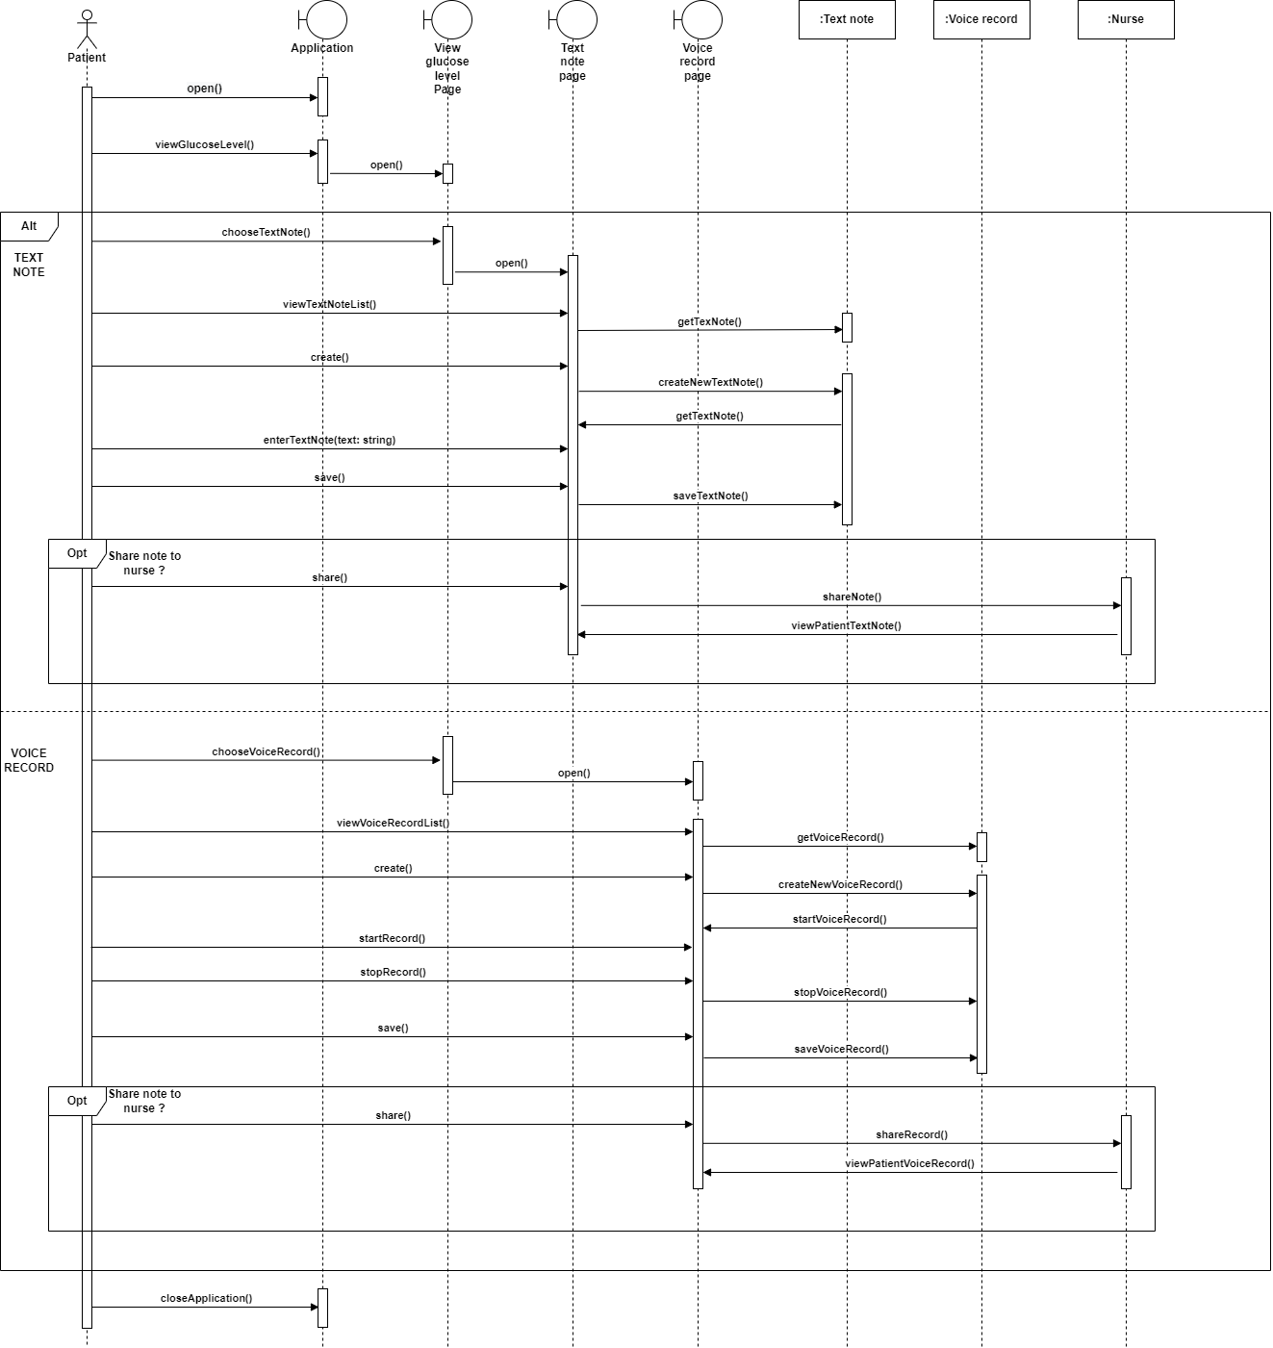

**Figure 7: Patient Enter Note SSD**

## ***Use Case:*** Alert

1. Use case : Alert fully description

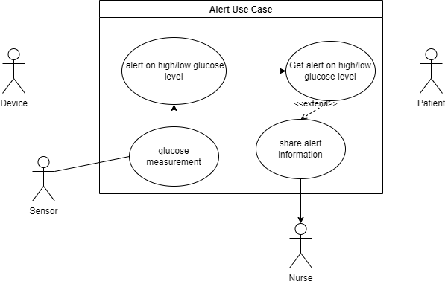

**Figure 8: Alert Use Case Diagram**

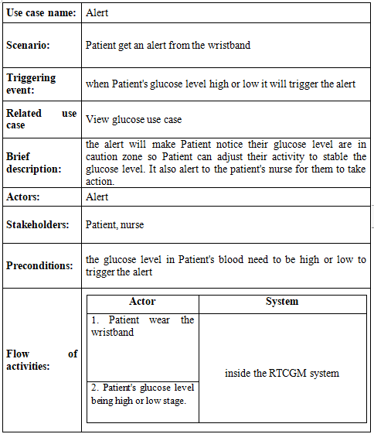

1. Activity diagram for Use Case: Alert

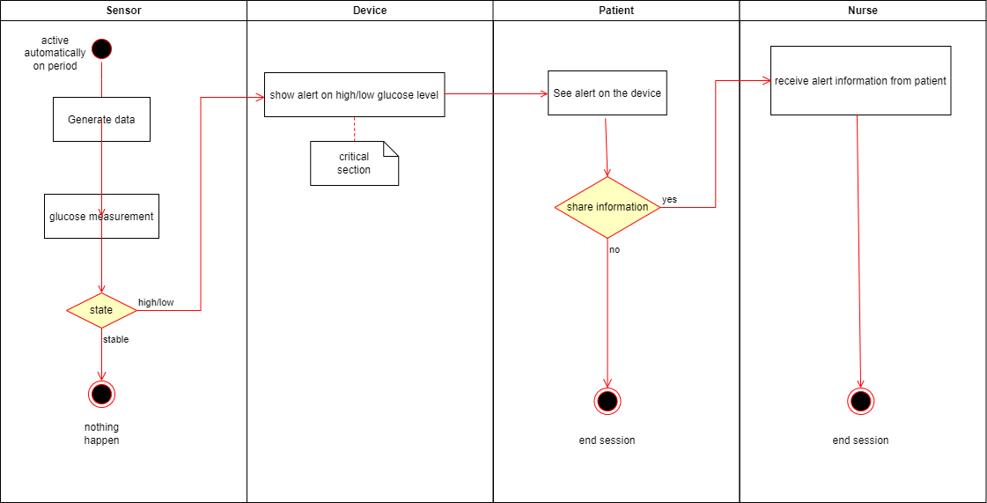

**Figure 9: Alert Use Case Activity Diagram**

1. System sequence diagram for Use Case: Alert

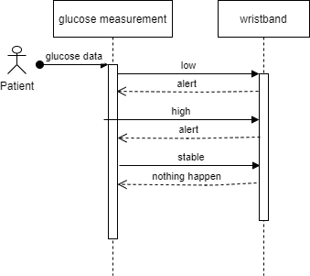

**Figure 10: Alert Use Case SSD**

## Use Case: Receive Data from server

i. Use case : Receive Data fully description

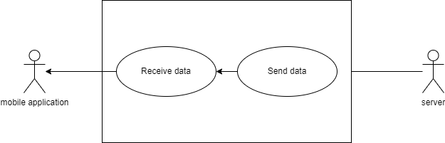

**Figure 11: Receive Data from server use case diagram**

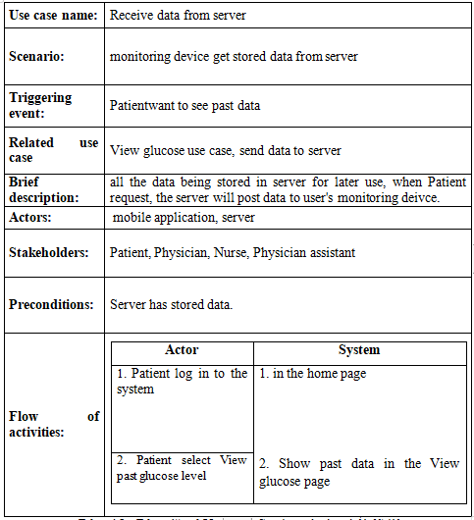

ii. Activity diagram for Use Case: Receive Data

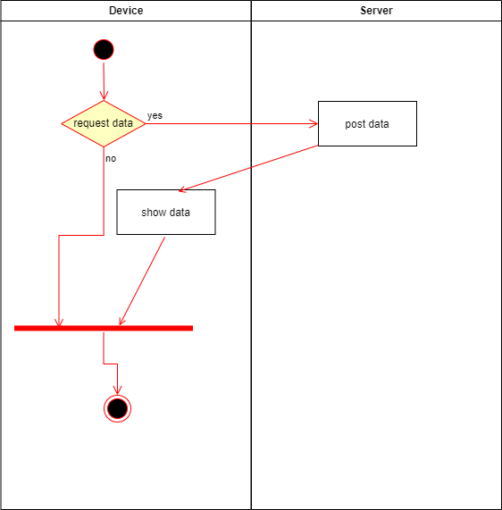

**Figure 12: Receive Data from server use case Activity Diagram**

iii. System sequence diagram for Use Case: Receive Data

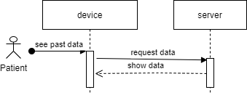

**Figure 13: Receive Data from server use case SSD**

## Use Case: Sent Data from server

i. Use case : Receive Data fully description

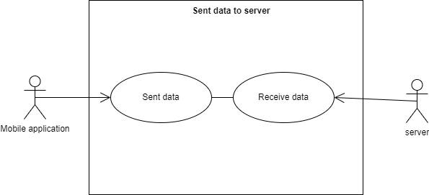

**Figure 14: Send Data from server use case Diagram**

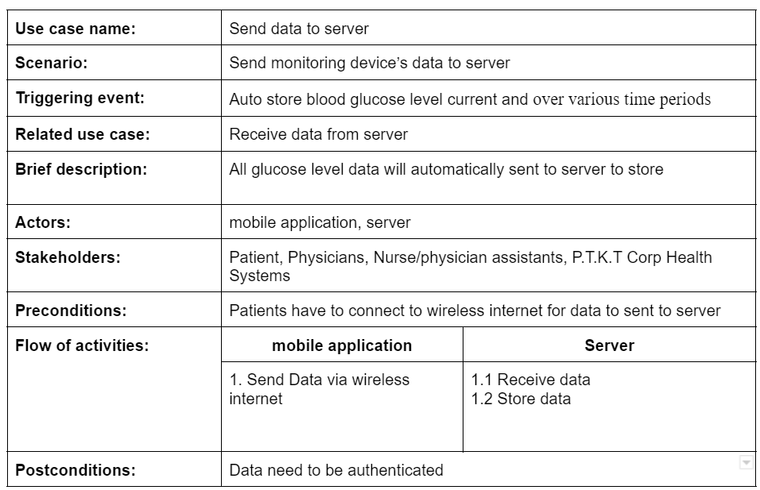

ii. Activity diagram for Use Case: Receive Data

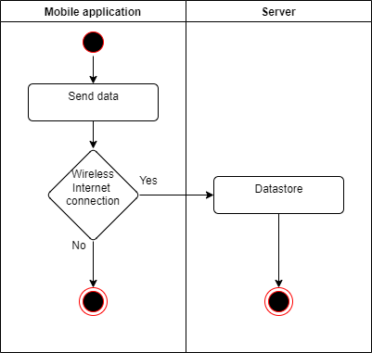

**Figure 15: Send Data from server use case Activity Diagram**

iii. System sequence diagram for Use Case: Receive Data

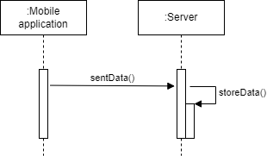

**Figure 15: Send Data from server use case SSD**

# **Verifying use cases for Actor**

## ***Verifying uses cases:*** Enter Note ***for*** Patient

| **Data entity/domain class** | **C R U D** | **Verified use case** |
| --- | --- | --- |
| Patient | Create | Create new text note  Create new voice record  Share note to medical personnel (Add)  Share voice recordings to medical personnel (Add)  Add note to highlight list  Add voice record to highlight list |
|  | Read/report | View list of notes  View list of highlight notes  View note  View list of voice records  View list of voice records  Hear voice records |
|  | Update | Save text note  Save voice record |
|  | Delete | Delete text note  Delete voice record |
| Nurse | Read/report | Receive patient note |

## ***Verifying uses cases for*** Alert

| **Data entity/domain class** | **C R U D** | **Verified use case** |
| --- | --- | --- |
| Patient | Create | Create new alert  Share alert to medical personnel |
|  | Read/report | View alert |
|  | Update | Update alert |
|  | Delete |  |
| Nurse | Read/report | Receive patient alert  Send feedback to patient |

# **System Requirements Design (3.0 points)**

# **Design Class for Use Case 1**

## 3.1.1 *Design Classes in Detailed Design*

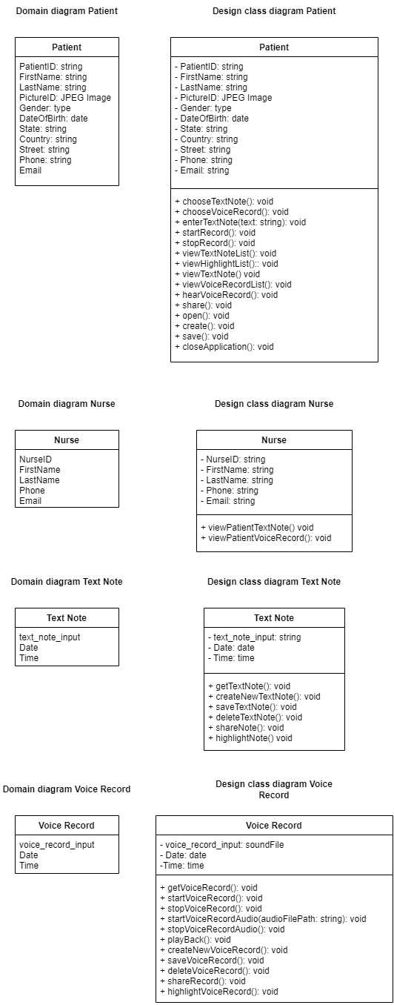

## 3.1.2 ***Design Class Diagram***

## *Domain Design Class*

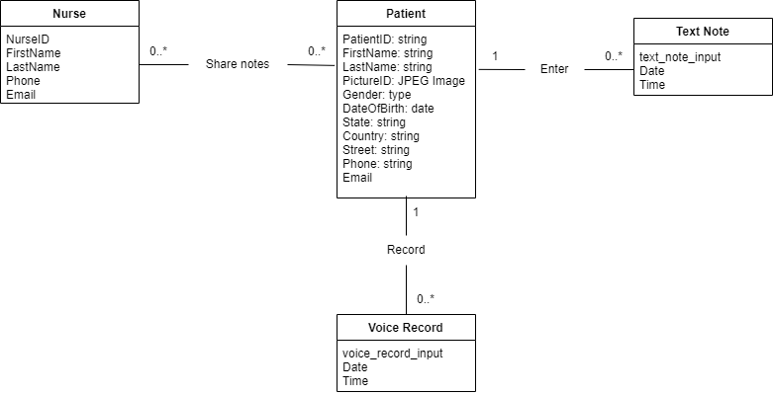

## 

## ***Design Class***

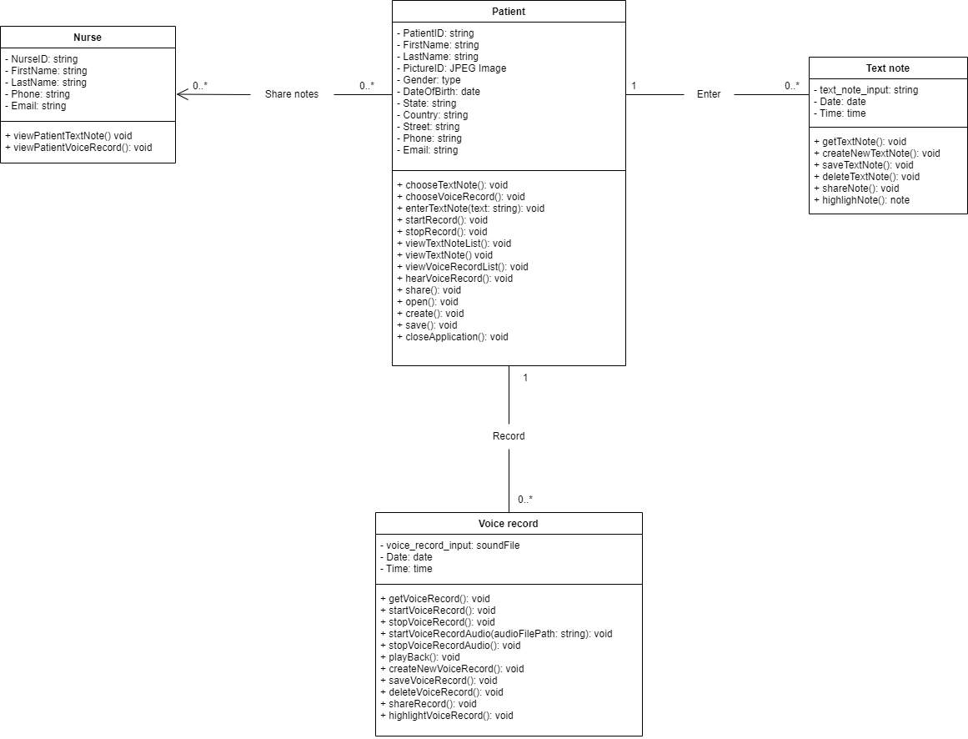

# **Design Class for Use Case 2**

## *Design Class*

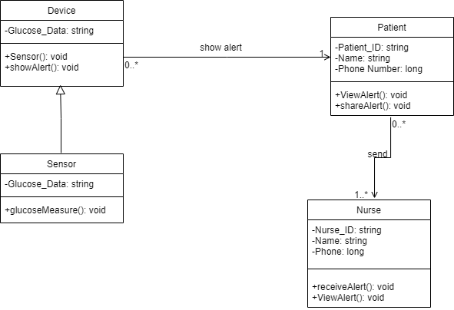

# **System Requirements Implementation (2pts)**

# **Implementation**

## ***UI design***

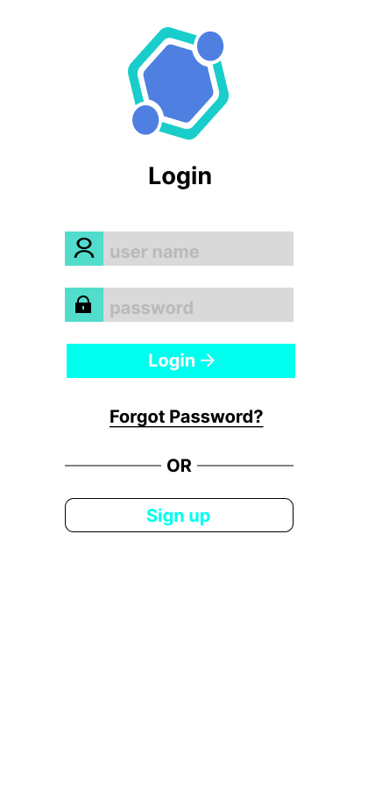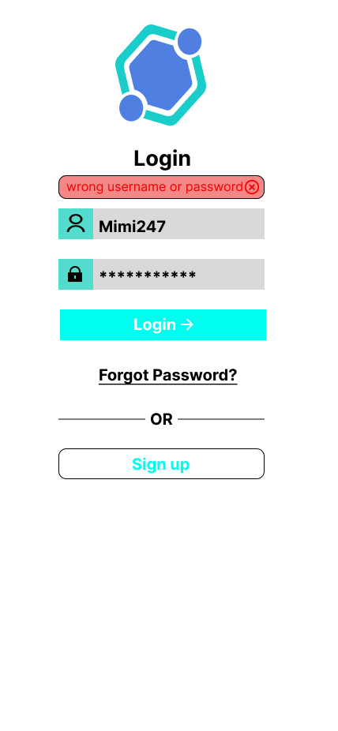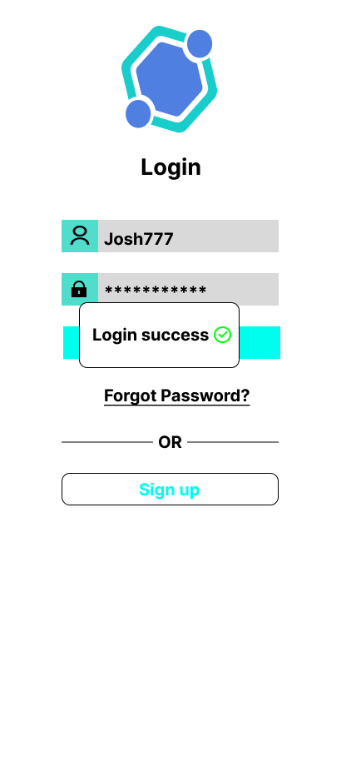

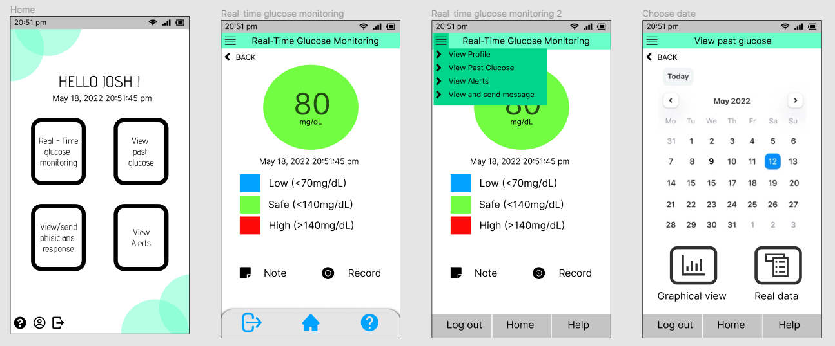

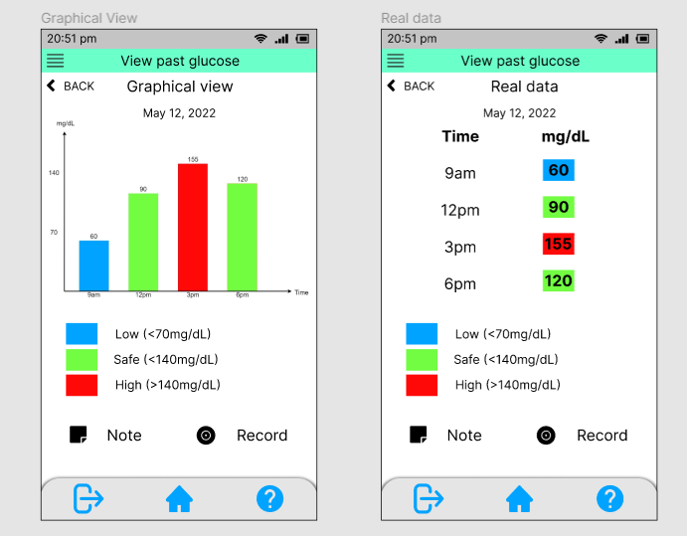

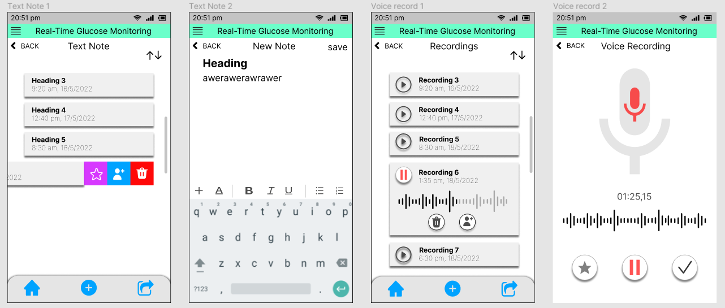

## ***SQL Code***

1. Create Database



1. Create Table

# 

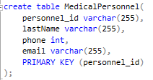

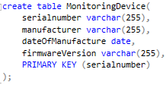

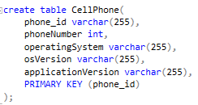

# 

# 

# 

# **Conclusions/ Recommendations (0.25 point)**

All the Contents we have included in this project make a big step in building a complete RTCGM system. Although there are still missing parts we didn’t accomplish, what was there were all fulfilled. We hope you see this project as a reference to the requirements analysis and design article.