QUADCOPTER CONTROL AND SIMULATION IN MATLAB
  - Dinh Duc Duy-22134001
  - Department of Mechatronics, HCMC University of Technology and Education , HCMC, Viet Nam
  - Subject: Autonomous Vehicles and Mobile Robot, Lecturer:Dr. Ha Le Nhu Ngoc Thanh

Abstract
The control of a quadcopter’s position and attitude presents several challenges that can be effectively addressed through a Proportional-Derivative (P) control approach. This method is applied to manage the UAV's altitude, position, and orientation. The process begins with developing a mathematical model of the quadcopter, followed by the implementation of an outer-loop P controller for precise position control. At the same time, an inner-loop P controller is utilized to maintain stable attitude angles, even in the presence of external disturbances. This setup results in a dual-loop control system, where both position and attitude are actively controlled. The performance and robustness of this control strategy are validated through simulations, demonstrating its effectiveness in accurately tracking both position and attitude for the quadcopter.

I. Introduction
A quadrotor, or quadcopter, is a type of helicopter that features four rotors arranged in a square pattern, evenly spaced from each other around the vehicle’s center of mass, with upward-facing orientations. The rotors are powered by electric motors, and their rotational speeds are adjusted to control the movement of the vehicle. The quadcopter’s straightforward design makes it a popular choice for small unmanned aerial vehicles (UAVs), widely used in applications such as construction inspections, search and rescue operations, surveillance, and more. Many different models of quadrotor dynamics and control algorithms have been developed, with techniques like the virtual control method commonly used to calculate the desired pitch and roll angles. Due to its nonlinear dynamics, underactuation, and inherent instability, the quadcopter presents unique challenges that must be addressed when designing control algorithms. Various control methods, including the widely used PID controller, have been implemented to tackle these challenges in the literature [3] [4].
The complex dynamics of quadcopters have garnered significant attention from researchers, leading to various areas of study. Central to these investigations is the development of the fundamental dynamical model, with deeper exploration into more complex aerodynamic characteristics [1, 2]. A wide range of control strategies have been explored, including PID controllers [3, 4, 5, 6], back-stepping control [7, 8], nonlinear control methods [9], LQR controllers [6], and nonlinear controllers with nested saturations [10, 11]. For these control strategies to function effectively, accurate position and attitude data are essential. This data is typically acquired through sensors such as gyroscopes, accelerometers, and other tools like GPS, sonar, and laser senor [12, 13].
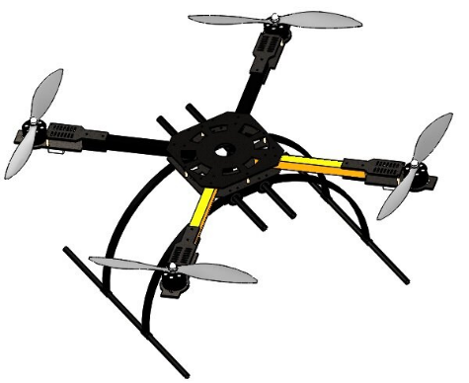
Figure 1 Quadcopter Structure
This report aims to lay the groundwork for future research in quadcopter modeling and control. The primary goals are to explore the mathematical models of quadcopter kinematics and dynamics, and to develop effective stabilization and trajectory control strategies. Although the quadcopter has six degrees of freedom but only four control inputs, presenting a challenge, the report covers the entire process, including mathematical modeling, controller design, and simulation validation, before drawing conclusions.

II. Mathemactic Modeling Quadcopter dynamics

1. CONFIGURATION
The popularity of quadcopters can be attributed to their simple design and ease of operation. As shown in Figure 1, they feature four rotors placed at the ends of extended arms, with two rotating clockwise and the other two counterclockwise. This symmetrical arrangement allows for stable and precise hovering, ensuring consistent flight stability.
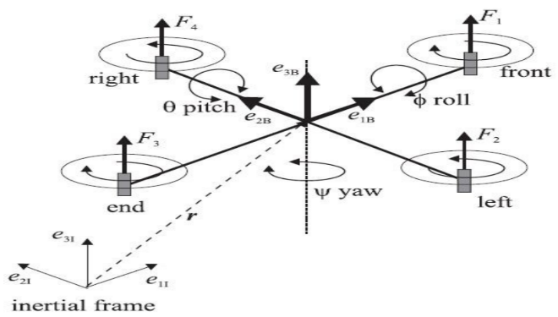
Figure 2. Configuration of an underactuated quadcopter, the lift forces $f_{i}={bω}_{i}$ with i= 1, 2, 3, 4 produced by four motor
Quadcopters are valued for their versatility and use in various fields, especially in confined spaces due to their VTOL capability. Their stability makes them ideal for tasks like aerial photography and inspections.
This section presents a brief mathematical model of the underactuated quadcopter. The key reference frames are the Earth frame (E) and the body frame (B). Vertical momentum is generated by the lift from the propellers, while horizontal momentum is controlled through roll, pitch, and yaw angles. Let φ, θ, and ψ represent the roll, pitch, and yaw angles, respectively, and x, y, z denote the vehicle’s position.
1.1 Body dynamics
When the quadcopter moves, it undergoes rotations in the Roll, Pitch, and Yaw angles. Using transformation equations, we can determine how the current state relates to the previous state.
Euler angles
Let assumes that frame {V} at origin O, and {V} $≡$ {E}
- Yaw angle: $R_{V}^{V_{1}}$ = Rot(z, $ψ$), rotate from frame {V} to frame {$V_{1}\}$
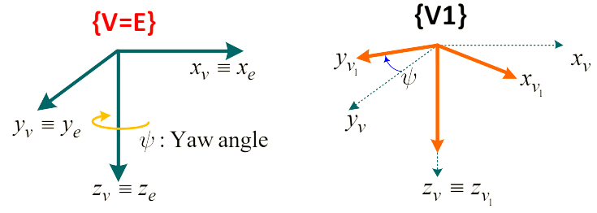
$$R_{V}^{V_{1}}= \left[\begin{matrix}cosψ & sinψ & 0 \\ -sinψ & cosψ & 0 \\ 0 & 0 & 1\end{matrix}\right]$$
- Pitch angle: $R_{V_{1}}^{V_{2}}$ = Rot(y, $θ$), rotate from frame {$V_{1}$} to frame {$V_{2}\}$
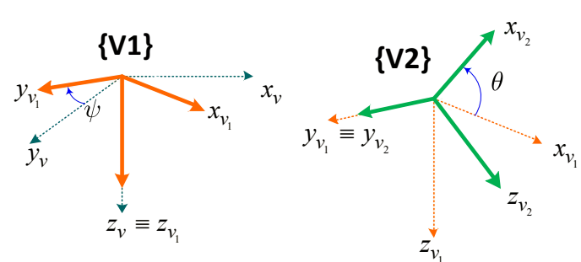
$$R_{V_{1}}^{V_{2}}= \left[\begin{matrix}cosθ & 0 & -sinθ \\ 0 & 1 & 0 \\ sinθ & 0 & cosθ\end{matrix}\right]$$
- Roll angle: $R_{V_{2}}^{B}$ = Rot(x, $ϕ$), rotate from frame {$V_{2}$} to frame {$B\}$
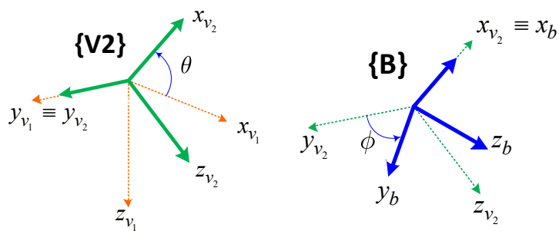
$$R_{V_{2}}^{B}= \left[\begin{matrix}1 & 0 & 0 \\ 0 & cosϕ & sinϕ \\ 0 & -sinϕ & cosϕ\end{matrix}\right]$$
- Transformation matrix from frame {V} to {B} (Roll $→$ Pitch $→$ Yaw)
${R_{E}^{B}= R}_{V}^{B}= R_{V_{2}}^{B}R_{V_{1}}^{V_{2}}R_{V}^{V_{1}}$
= $\left[\begin{matrix}cθcψ & cθsψ & -sθ \\ sϕsθcψ-sψ & sϕsθsψ+cϕcψ & sϕcθ \\ cϕsθcψ & cϕsθsψ-sϕcψ & cϕcθ\end{matrix}\right]$
If point P($x_{P}$, $y_{P}$, $z_{P}$) $∈\left\{V\right\}$, the point P in frame {B} is computed:
$\left[\begin{aligned}\begin{matrix}x_{P} \\ y_{P}\end{matrix} \\ z_{P}\end{aligned}\right]$_{B} = $R_{E}^{B}\left[\begin{aligned}\begin{matrix}x_{P} \\ y_{P}\end{matrix} \\ z_{P}\end{aligned}\right]$_{E}

System parameters | Description | Value
$$I_{xx} \left(kgm^{2}\right)$$ | Moment of Inerita along axis x in Earth reference frame | 0.032276
$$I_{yy} \left(kgm^{2}\right)$$ | Moment of Inerita along axis y in Earth reference frame | 0.031124
$$I_{zz} \left(kgm^{2}\right)$$ | Moment of Inerita along axis z in Earth reference frame | 0.035229
$m \left(kg\right)$ | Total mass | 1.3620
$$l \left(m\right)$$ | Arm length of quadcopter | 0.211
$$b\left(Ns^{2}\right)$$ | Thrust coefficent | 1,3122.${10}^{-5}$
$$d\left(Nms^{2}\right)$$ | Drag coefficient | 1.2181.${10}^{-5}$
$$ω_{0}\left(rad\right)$$ | The rotation velocity when the device balancing | 504.5398
{E} | fixed coordinate defining a HOME location
{V} | attached on the vehicle, origin at the center of the vehicle, and aligned with axes of the Earth frame in initiation
{B} | Body fixed system
Table 1: System parameter

2. KINEMATIC OF QUADCOPTER
The position of the quadcopter be defined as $ξ= {\left(x_{e}, y_{e}, -h\right)}^{T}$ and its orientation vector described by Euler angle ${\left(ϕ , θ, ψ\right)}^{T}$ in terms of roll, pitch and yaw angles. Transformation matrix from frame {V} to {B} (Roll $→$ Pitch $→$ Yaw).
$\frac{d}{dt}\left(\begin{aligned}x_{e} \\ y_{e} \\ -h\end{aligned}\right)= R_{b}^{e}\left(\begin{aligned}u \\ v \\ w\end{aligned}\right)$ = $\left(\begin{matrix}cθcψ & sϕsθcψ-cϕsψ & cϕsθcψ+sϕsψ \\ cθsψ & sϕsθsψ+cϕcψ & cϕsθsψ-sϕcψ \\ -sθ & sϕcθ & cϕcθ\end{matrix}\right)$  $$\left(\begin{aligned}u \\ v \\ w\end{aligned}\right)$$ | (1)
equation (1) can be simplified as: $\dot{ξ}=R_{B}^{E}Θv$
- Angular rate of rotational motion:
$$ω_{b}=ω_{b}^{\text{yaw }}+ω_{b}^{\text{pitch }}+ω_{b}^{\text{roll }}$$ | (2)
where $ω_{b}$ be measured from Gyroscope around Body frame $\{B\}:ω_{b}=(p,q,{r)}^{T}$
$$ω_{b}^{\text{yaw }}=R_{v_{1}}^{b}ω_{v_{1}}=R_{v_{1}}^{b}{\left(\begin{matrix}0 \\ 0 \\ \overset{˙}{ψ}\end{matrix}\right)}_{v_{1}}=R_{v_{2}}^{b}\left(ϕ\right)R_{v_{1}}^{v_{2}}\left(θ\right){\left(\begin{matrix}0 \\ 0 \\ \overset{˙}{ψ}\end{matrix}\right)}_{v_{1}}$$
$ω_{b}^{\text{pitch }}=R_{v_{2}}^{b}ω_{v_{2}}=R_{v_{2}}^{b}{\left(\begin{matrix}0 \\ \overset{˙}{θ} \\ 0\end{matrix}\right)}_{v_{2}}=R_{v_{2}}^{b}\left(ϕ\right){\left(\begin{matrix}0 \\ \overset{˙}{θ} \\ 0\end{matrix}\right)}_{v_{2}}$
$ω_{b}^{\text{roll }}={\left(\begin{matrix}\overset{˙}{ϕ} \\ 0 \\ 0\end{matrix}\right)}_{b}$
From (2):
$$\left(\begin{matrix}p \\ q \\ r\end{matrix}\right)=R_{v_{2}}^{b} \left(ϕ\right)R_{v_{1}}^{v_{2}} \left(θ\right){\left(\begin{matrix}0 \\ 0 \\ \overset{˙}{ψ}\end{matrix}\right)}_{v_{1}}+R_{v_{2}}^{b} \left(ϕ\right){\left(\begin{matrix}0 \\ \overset{˙}{θ} \\ 0\end{matrix}\right)}_{v_{2}}+{\left(\begin{matrix}\overset{˙}{ϕ} \\ 0 \\ 0\end{matrix}\right)}_{b}$$
$$⇔\left(\begin{matrix}p \\ q \\ r\end{matrix}\right)=\left(\begin{matrix}1 & 0 & -sθ \\ 0 & cϕ & sϕcθ \\ 0 & -sϕ & cϕcθ\end{matrix}\right)\left(\begin{matrix}\overset{˙}{ϕ} \\ \overset{˙}{θ} \\ \overset{˙}{ψ}\end{matrix}\right)$$
Finally, we can obtain
$$\frac{d}{dt}\left(\begin{matrix}ϕ \\ θ \\ ψ\end{matrix}\right)=W_{B}^{E}\left(\begin{matrix}p \\ q \\ r\end{matrix}\right) \left(3\right)$$
Where $W_{B}^{E}$ is an angular velocity transformation matrix that converts the quadcopter's attitude and angular speed of the quadcopter from {B} frame to {E} frame.
$$W_{B}^{E}=\left(\begin{matrix}1 & \sin\left(ϕ\right)\tan\left(θ\right) & \cos\left(ϕ\right)\tan\left(θ\right) \\ 0 & \cos\left(ϕ\right) & -\sin\left(ϕ\right) \\ 0 & \frac{\sin\left(ϕ\right)}{\cos\left(θ\right)} & \frac{\cos\left(ϕ\right)}{\cos\left(θ\right)}\end{matrix}\right)$$

3. DYNAMIC OF QUADCOPTER
The performance of a quadcopter is based on the Thrust Force (F) and Drag moment (M)
$$F_{i}=bΩ_{i}^{2}$$
$$M_{i}=dΩ_{i}^{2}$$
Where $i=\left(1,2,3,4\right)$ is external force provided by motor $i$, $b$ is thrust coefficient, $d$ is drag coefficient.
Movements of an UAVs include:
- Translational Dynamics
- Rotational Dynamics
Translational motion: The translational motion of the vehicle is derived using Newton's second law in the inertial frame of reference.
$f_{b}=m{\overset{˙}{V}}_{B}, {with V}_{B}$ is general velocity of UAV in $\left\{B\right\}$
$⇒f_{b}=m\left(\left(\frac{dv}{dt}\right)+ω_{b}×v\right)$,
where $ω_{b}=(p,q,{r)}^{T},v=(u,v,{w)}^{T}$
Finally get:
$$f_{b}=m\left(\left(\begin{matrix}\overset{˙}{u} \\ \overset{˙}{v} \\ \overset{˙}{w}\end{matrix}\right)+ω_{b}×v\right)$$ | (4)

On body frame $\left\{B\right\}$
$$\begin{matrix} & f_{b}={\left(\begin{matrix}f_{x} \\ f_{y} \\ f_{z}\end{matrix}\right)}_{b}=f_{b\text{ Gravity }}+f_{b\text{ Aeros }} \\ & =R_{e}^{b}f_{e_{\text{Gravity }}}+f_{b\text{ Aeros }} \\ & =R_{e}^{b}{\left(\begin{matrix}0 \\ 0 \\ mg\end{matrix}\right)}_{e}+{\left(\begin{matrix}0 \\ 0 \\ -\sum{ }F_{i}\end{matrix}\right)}_{b} \\ & \end{matrix}$$
Finally :
$$f_{b}=R_{e}^{b}{\left(\begin{matrix}0 \\ 0 \\ mg\end{matrix}\right)}_{e}+{\left(\begin{matrix}0 \\ 0 \\ -\sum{F_{i}}\end{matrix}\right)}_{b}$$ | (5)
where $F_{i}=bΩ_{i}^{2},i=1,…,4$ and $b$ is thrust coeficient.
From (4) and (5):
$$\left(\begin{matrix}\overset{˙}{u} \\ \overset{˙}{v} \\ \overset{˙}{w}\end{matrix}\right)=\left(\begin{matrix}-\operatorname{gsin}{θ} \\ \operatorname{gsin}{ϕ\cos{θ}} \\ \operatorname{gcos}{ϕ\cos{θ}}\end{matrix}\right)+\frac{1}{m}\left(\begin{matrix}0 \\ 0 \\ -\sum{ }F_{i}\end{matrix}\right)-ω_{b}×v$$ | (6)
Rotation motion of the vehicle: Applying Euler's equation in the body frame of the vehicle, compute the momentum at O′O' resulting from external forces and torques.
$T=J{\overset{˙}{ω}}_{b}+ω_{b}×{Jω}_{b}$
$\text{where }T={\left[τ_{ϕ},τ_{θ},τ_{v}\right]}^{T},$ $J=\left(\begin{matrix}J_{x} & 0 & 0 \\ 0 & J_{y} & 0 \\ 0 & 0 & J_{z}\end{matrix}\right),$
$⇒{\overset{˙}{ω}}_{b}=\frac{1}{J}\left(\left(\begin{matrix}τ_{ϕ} \\ τ_{θ} \\ τ_{ψ}\end{matrix}\right)-ω_{b}×Jω_{b}\right)$ | (7)
Simplified mathematics model
From $f_{b}=R_{e}^{b}{\left(\begin{matrix}0 \\ 0 \\ mg\end{matrix}\right)}_{e}+{\left(\begin{matrix}0 \\ 0 \\ -∑F_{i}\end{matrix}\right)}_{b}$,
$⇒f_{e}={\left(\begin{matrix}F_{x} \\ F_{y} \\ F_{z}\end{matrix}\right)}_{e}=R_{b}^{e}f_{b}$,
$${⇒f}_{b}=R_{e}^{b}{\left(\begin{aligned}0 \\ 0 \\ mg\end{aligned}\right)}_{e}+{\left(\begin{aligned}0 \\ 0 \\ -∑F_{i}\end{aligned}\right)}_{b}$$
where $U_{1}$ is thrust force, $U_{1}={\sum{}}_{i=1}^{4} F_{i}={\sum{}}_{i=1}^{4} bΩ_{i}^{2},b$ is thrust coefficient.
Other hand: $f_{e}=m\overset{¨}{ξ}$, where $\overset{¨}{ξ}=(\overset{¨}{x},\overset{¨}{y},\overset{¨}{z})^{T},x,y,z$ are the global position of the vehicle
$$m\overset{¨}{ξ}={\left(\begin{matrix}0 \\ 0 \\ mg\end{matrix}\right)}_{e}+R_{b}^{e}\left(\begin{matrix}0 \\ 0 \\ -U_{1}\end{matrix}\right)$$
$$⇔\left(\begin{matrix}\overset{¨}{x} \\ \overset{¨}{y} \\ \overset{¨}{z}\end{matrix}\right)=\left(\begin{matrix}-\frac{U_{1}\cos{ϕ\sin{θ\cos{ψ}}}+\sin{ϕ\sin{ψ}}}{m} \\ -\frac{U_{1}\cos{ϕ\sin{θ\sin{ψ}}}-\sin{ϕ\cos{ψ}}}{m} \\ g-\frac{U_{1}\cos{ϕ\cos{θ}}}{m}\end{matrix}\right)$$
$$\text{From: }\left(\begin{matrix}τ_{ϕ} \\ τ_{θ} \\ τ_{ψ}\end{matrix}\right)=J{\overset{˙}{ω}}_{b}+ω_{b}×Jω_{b}\text{, }$$
$$\text{where, }ω_{b}=p,q,r^{T}$$
$$J{\overset{˙}{ω}}_{b}=\left(\begin{matrix}J_{x} & 0 & 0 \\ 0 & J_{y} & 0 \\ 0 & 0 & J_{z}\end{matrix}\right)\left(\begin{matrix}\overset{˙}{p} \\ \overset{˙}{q} \\ \overset{˙}{r}\end{matrix}\right)=\left(\begin{matrix}J_{x}\overset{˙}{p} \\ J_{y}\overset{˙}{q} \\ J_{z}\overset{˙}{r}\end{matrix}\right)$$
$ω_{b}×J_{b}=\left(\begin{matrix}p \\ q \\ r\end{matrix}\right)×\left(\begin{matrix}J_{x} & 0 & 0 \\ 0 & J_{y} & 0 \\ 0 & 0 & J_{z}\end{matrix}\right)\left(\begin{matrix}p \\ q \\ r\end{matrix}\right)$
= $\left(\begin{matrix}qr\left(J_{z}-J_{y})\right. \\ pr\left(J_{x}-J_{z}\right.) \\ pq\left(J_{y}-J_{x}\right.)\end{matrix}\right)$
With small angles movement:
$$\left(\begin{matrix}\overset{¨}{ϕ} \\ \overset{¨}{θ} \\ \overset{¨}{ψ}\end{matrix}\right)=\left(\begin{matrix}\frac{τ_{ϕ}}{J_{x}} \\ \frac{τ_{θ}}{J_{y}} \\ \frac{τ_{ψ}}{J_{z}}\end{matrix}\right)+\left(\begin{matrix}\frac{\overset{˙}{θ}\overset{˙}{ψ}J_{y}-J_{z}}{J_{x}} \\ \frac{\overset{˙}{ϕ}\overset{˙}{ψ}J_{z}-J_{x}}{J_{y}} \\ \frac{\overset{˙}{ϕ}\overset{˙}{θ}\left(J_{x}-J_{y}\right)}{J_{z}}\end{matrix}\right)$$
Finally:
$$\left(\begin{aligned}\ddot{x} \\ \ddot{y} \\ \ddot{z} \\ \ddot{ϕ} \\ \ddot{θ} \\ \ddot{ψ}\end{aligned}\right)=\left(\begin{aligned}-\frac{U_{1}\left(\cos{ϕ\sin{θ\cos{ψ}}}+\sin{ϕ\sin{ψ}}\right)}{m} \\ -\frac{U_{1}\left(cosϕsinθsinψ-sinϕcosψ\right)}{m} \\ g-\frac{U_{1}cosϕ\cos{θ}}{m} \\ \frac{1}{I_{x}}U_{2}+\frac{I_{y}-I_{z}}{I_{x}}\dot{θ}\dot{ψ} \\ \frac{1}{I_{y}}U_{3}+\frac{I_{z}-I_{x}}{I_{y}}\dot{ϕ}\dot{ψ} \\ \frac{1}{I_{z}}U_{4}+\frac{I_{x}-I_{y}}{I_{z}}\dot{ϕ}\dot{θ}\end{aligned}\right),$$
where $τ_{ϕ}= U_{2} \left(Nm\right):Roll moment$
$τ_{θ}$ = $U_{3} \left(Nm\right):Pitch moment$
$τ_{ψ}$ = $U_{4} \left(Nm\right):Yaw moment$

4. AERODYNAMICS OF QUADCOPTER
In aerodynamics, the lift force and moment are assumed to be proportional to the square of the propeller's rotational speed.
$$F_{i}=bΩ_{i}^{2}$$
$$M_{i}=dΩ_{i}^{2}$$
Where $i=\left(1,2,3,4\right)$ is external force provided by motor $i$, $b$ is thrust coefficient, $d$ is drag coefficient.
Calculating aerodynamics for a quadcopter involves understanding the forces acting on it during flight. While the detailed calculations are complex and often involve computational simulations.
$$f_{b\text{ Aero }}\left[N\right]=\left[\begin{matrix}0 \\ 0 \\ -\sum{ }F_{i}\end{matrix}\right]=\left[\begin{matrix}0 \\ 0 \\ -b\left(Ω_{1}^{2}+Ω_{2}^{2}+Ω_{3}^{2}+Ω_{4}^{2}\right)\end{matrix}\right]$$
$$\begin{matrix} & T\left[N.m\right]=\left(\begin{matrix}τ_{ϕ} \\ τ_{θ} \\ τ_{ψ}\end{matrix}\right)=\left(\begin{matrix}lF_{4}-lF_{2} \\ lF_{1}-lF_{3} \\ -M_{1}+M_{2}-M_{3}+M_{4}\end{matrix}\right) \\ & =\left(\begin{matrix}lb{(Ω}_{4}^{2}-Ω_{2}^{2}) \\ lb\left(Ω_{1}^{2}-Ω_{3}^{2}\right) \\ d\left({-Ω}_{1}^{2}+Ω_{2}^{2}-Ω_{3}^{2}+Ω_{4}^{2}\right)\end{matrix}\right) \\ & \end{matrix}$$
So we can represent the aerodynamics matrix is:
$$\left[\begin{matrix}U1 \\ U2 \\ U3 \\ U4\end{matrix}\right]=\left[\begin{matrix}-b\left(Ω_{1}^{2}+Ω_{2}^{2}+Ω_{3}^{2}+Ω_{4}^{2}\right) \\ lb{(Ω}_{4}^{2}-Ω_{2}^{2}) \\ lb{(Ω}_{1}^{2}-Ω_{3}^{2}) \\ d\left(Ω_{1}^{2}+Ω_{2}^{2}-Ω_{3}^{2}+Ω_{4}^{2}\right)\end{matrix}\right] \left(8\right)$$
where $U_{1}\left[N\right]$: Thrust Force, $τ_{ϕ}=U_{2}\left[N.m\right]$: Roll moment, $τ_{θ}=U_{3}\left[N.m\right]$: Pitch moment, $τ_{ψ}=U_{4}\left[N.m\right]$: Yaw moment.

5. MOTOR DYNAMIC
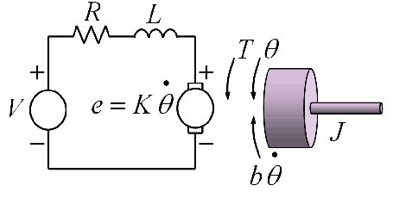
Figure 3 .Simple motor dynamics model
Before go to the calculation, there is some parameters for the motor dynamic:
System parameters | Description | Value
$$J_{m}\left(kgm^{2}\right)$$ | Moment of inertia a motor | $$12.{10}^{-6}$$
$$R_{a}$$ | Resistant of motor | 0.128
$$L_{a}$$ | Inductor of coil | Ignore
$$K_{t}$$ | Torque constant | 0.005
$$K_{e}$$ | Emf constant | 0.005
Table 2. Motor parameters

Electrical performance: Using Kirchhoffs Law we have:
$$v_{a}-v_{R}-v_{L_{a}}-v_{emf}=0$$  $$\begin{matrix} \\ v_{a}-i_{a}R_{a}-L_{a}\frac{di_{a}}{dt}-v_{emf}=0\end{matrix}$$ | (9)
Mechanical performance: Using Newton’s law we have:
$$T_{m}-Drag=J_{m}{\overset{¨}{θ}}_{m}$$ | (10)

From (10) we have:
$$T_{m}=K_{t}i_{a}$$ | (11)

Finally, from (9) and (11) we got motor dynamics equation:
$$K_{t}\left(\frac{v_{a}-K_{e}ω_{m}}{R_{a}}\right)-Drag=J_{m}\frac{dω_{m}}{dt}$$
$$v_{a}=K_{e}ω_{design}+\frac{dω_{design}^{2}R_{a}}{K_{t}}$$

III. Controller desgin
The primary goal of the control algorithm presented in this study is to ensure that the quadcopter accurately follows a predefined trajectory, represented by $ζ=[x,y,z]^{T}$, while also maintaining a specified yaw angle, $ψ_{d}$​. In the quadcopter system, the rotational dynamics (roll, pitch, and yaw) and their time derivatives are independent of the translational components (position), while the position is dependent on the orientation angles. As a result, the system can be thought of as consisting of two distinct subsystems: one for the linear translational motion and another for the angular rotational motion.
To control these subsystems effectively, separate controllers are designed for each. In the translational subsystem, a proportional (P) controller is used to calculate the control law $U_{1}$​ and determine the desired roll $ϕ_{d}$and pitch $θ_{d}$ angles. This ensures that the quadcopter precisely follows the desired trajectory, while the controller also helps to maintain stability and minimize errors in height control, especially under external disturbances. The desired angles, $η_{d}={\left(ϕ_{d},θ_{d},ψ_{d}\right)}^{T}$, are thus derived from this control process.
For the rotational subsystem, a similar P controller is implemented to determine the control laws $U_{2},U_{3},U_{4}$​, which ensure that the quadcopter’s orientation aligns with the desired attitude angles $η_{d}={\left(ϕ_{d},θ_{d},ψ_{d}\right)}^{T}$. By employing this strategy, the system’s attitude is stabilized and adjusted to meet the predefined yaw and rotational goals. The entire control approach, which involves managing both translation and rotation independently using P controllers, is visually summarized in Figure 4.

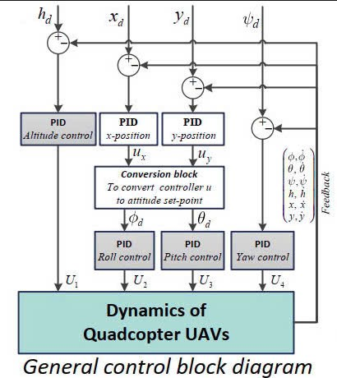
Figure 4. Design diagram

1. Control Allocation
Let $u_{1}, u_{2}, u_{3}, u_{4}$ are controller input.
Let $δ_{roll},δ_{pitch},δ_{yaw},δ_{thrust}$control signal of Roll, Pitch, Yaw, Thrust controller :
$$\left[\begin{aligned}u_{1} \\ u_{2} \\ u_{3} \\ u_{4}\end{aligned}\right]=\left[\begin{aligned}u_{0} \\ u_{0} \\ u_{0} \\ u_{0}\end{aligned}\right]+\left[\begin{matrix}\begin{matrix}1 & 0 \\ 1 & -1\end{matrix} & \begin{matrix}1 & -1 \\ 0 & 1\end{matrix} \\ \begin{matrix}1 & 0 \\ 1 & 1\end{matrix} & \begin{matrix}-1 & -1 \\ 0 & 1\end{matrix}\end{matrix}\right]\left[\begin{aligned}δ_{\text{thrust }} \\ δ_{\text{roll }} \\ δ_{\text{pitch }} \\ δ_{\text{yaw }}\end{aligned}\right]$$

2. Attitude (roll, pitch, yaw)

$$\left\{\begin{matrix}\overset{¨}{ϕ}=\frac{U_{2}}{I_{x}}=\frac{2K_{th}L}{I_{x}}δ_{\text{roll }} \\ \overset{¨}{θ}=\frac{U_{3}}{I_{y}}=\frac{2K_{th}L}{I_{y}}δ_{\text{pitch }} \\ \overset{¨}{ψ}=\frac{U_{4}}{I_{z}}=\frac{4dλ}{I_{z}}δ_{yaw}\end{matrix}\right.$$
Roll design
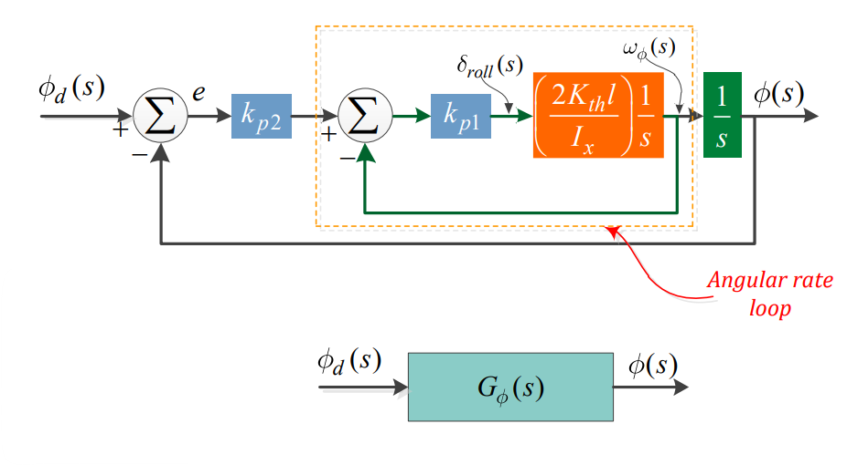
Figure 3 .Roll Double P controller diagram
From Dynamics of roll sub-system:
$$\ddot{ϕ}=\frac{2K_{th}l}{I_{x}}δ_{\text{roll} }→G\left(s\right)= \frac{1}{s}⋅\frac{2K_{th}l}{I_{x}s}$$
Apply P controller:
$$δ_{ϕ}\left(t\right)=k_{p_{1}}\left[k_{p_{2}}\left(ϕ_{d}\left(t\right)-ϕ\left(t\right)\right)-\dot{ϕ}\left(t\right)\right]$$

$$→\ddot{ϕ}=\frac{2K_{th}l}{I_{x}}k_{p1}\left[k_{p_{2}}\left(ϕ_{d}\left(t\right)-ϕ\left(t\right)\right)-\dot{ϕ}\left(t\right)\right]$$

$$→\ddot{ϕ}+\frac{2K_{th}l}{I_{x}}k_{p1}k_{p_{2}}ϕ\left(t\right)+\frac{2K_{th}l}{I_{x}}k_{p1}\dot{ϕ}\left(t\right)=\frac{2K_{th}l}{I_{x}}k_{p1}k_{p_{2}}ϕ_{d}\left(t\right)$$

Apply Laplace transformation to both sides
$$s^{2}ϕ\left(s\right)+\frac{2K_{th}l}{I_{x}}k_{p1}k_{p_{2}}ϕ\left(s\right)+\frac{2K_{th}l}{I_{x}}k_{p1}sϕ\left(s\right)=\frac{2K_{th}l}{I_{x}}k_{p1}k_{p_{2}}ϕ_{d}\left(s\right)$$

$$⇔ϕ\left(s\right)\left(s^{2}+\frac{2K_{th}l}{I_{x}}k_{p1}k_{p_{2}}+\frac{2K_{th}l}{I_{x}}k_{p1}s\right)=\left(\frac{2K_{th}l}{I_{x}}k_{p1}k_{p_{2}}\right)ϕ_{d}\left(s\right)$$

$$→\frac{ϕ\left(s\right)}{ϕ_{d}\left(s\right)}=\frac{\frac{2K_{th}l}{I_{x}}k_{p1}k_{p_{2}}}{s^{2}+\frac{2K_{th}l}{I_{x}}k_{p1}s+\frac{2K_{th}l}{I_{x}}k_{p1}k_{p_{2}}}$$

$$→\left\{\begin{matrix}\frac{2K_{th}l}{I_{x}}k_{p1}=2ζω_{n} \\ \frac{2K_{th}l}{I_{x}}k_{p1}k_{p_{2}}=ω_{n}^{2}\end{matrix}\right.$$
$$→\left\{\begin{matrix}k_{p_{1}}=\frac{ζω_{n}}{K_{th}l}I_{x} \\ k_{p_{2}}=\frac{ω_{n}^{2}}{2K_{th}l.k_{p_{1}}}I_{x}=\frac{ω_{n}^{2}}{2ζω_{n}}=\frac{ω_{n}}{2ζ}\end{matrix}\right.$$

Pitch design
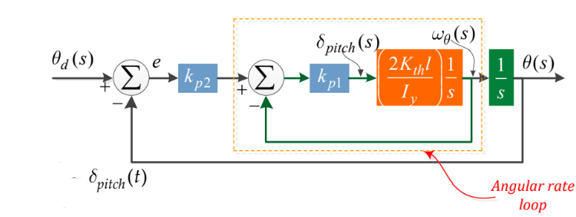
Figure 4 .Pitch Double P controller diagram
We have:
$$\ddot{θ}=\frac{2K_{th}l}{I_{y}}δ_{\text{pitch }}→G\left(s\right)= \frac{1}{s}⋅\frac{2K_{th}l}{I_{y}s}$$
Similar to the calculation process in the previous section.
$$δ_{θ}\left(t\right)=k_{p_{1}}\left[k_{p_{2}}\left(θ_{d}\left(t\right)-θ\left(t\right)\right)-\dot{θ}\left(t\right)\right]$$
$$→\ddot{θ}=\frac{2K_{th}l}{I_{y}}k_{p1}\left[k_{p_{2}}\left(θ_{d}\left(t\right)-θ\left(t\right)\right)-\dot{θ}\left(t\right)\right]$$
Apply Laplace transformation
$$\frac{θ\left(s\right)}{θ_{d}\left(s\right)}=\frac{\frac{2K_{th}l}{I_{y}}k_{p1}k_{p_{2}}}{s^{2}+\frac{2K_{th}l}{I_{y}}k_{p1}s+\frac{2K_{th}l}{I_{y}}k_{p1}k_{p_{2}}}$$

$$→\left\{\begin{matrix}\frac{2K_{th}l}{I_{y}}k_{p1}=2ζω_{n} \\ \frac{2K_{th}l}{I_{y}}k_{p1}k_{p_{2}}=ω_{n}^{2}\end{matrix}\right.$$

$$→\left\{\begin{matrix}k_{p_{1}}=\frac{ζω_{n}}{K_{th}l}I_{y} \\ k_{p_{2}}=\frac{ω_{n}^{2}}{2K_{th}l.k_{p_{1}}}I_{y}=\frac{ω_{n}^{2}}{2ζω_{n}}=\frac{ω_{n}}{2ζ}\end{matrix}\right.$$

Yaw design
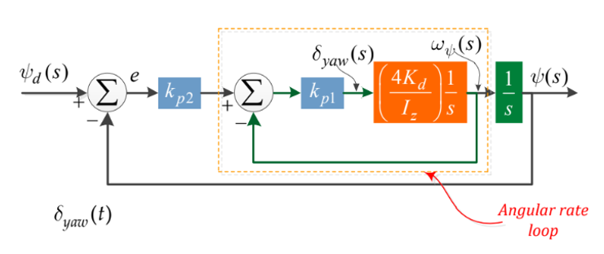
Figure 5 .Yaw Double P controller diagram
We have:
$\ddot{ψ}= \frac{4ⅆK_{th}}{bI_{z}}⋅δ_{yaw}$ $→$G(s) = $\frac{ψ\left(s\right)}{δ_{yaw}\left(s\right)}$ = $\frac{1}{s}⋅\frac{4K_{th}d}{I_{z}bs}$
Similar to the calculation process in the previous section.
$$δ_{ψ}\left(t\right)=k_{p_{1}}\left[k_{p_{2}}\left(ψ_{d}\left(t\right)-ψ\left(t\right)\right)-\dot{ψ}\left(t\right)\right]$$
$$→\ddot{ψ}=\frac{4K_{th}d}{I_{z}b}k_{p1}\left[k_{p_{2}}\left(ψ_{d}\left(t\right)-ψ\left(t\right)\right)-\dot{ψ}\left(t\right)\right]$$
$$→\frac{ψ\left(s\right)}{ψ_{d}\left(s\right)}=\frac{\frac{4K_{th}d}{I_{z}b}k_{p1}k_{p_{2}}}{s^{2}+\frac{4K_{th}d}{I_{z}b}k_{p1}s+\frac{4K_{th}d}{I_{z}b}k_{p1}k_{p_{2}}}$$

$$→\left\{\begin{matrix}\frac{4K_{th}d}{I_{z}b}k_{p1}=2ζω_{n} \\ \frac{4K_{th}d}{I_{z}b}k_{p1}k_{p_{2}}=ω_{n}^{2}\end{matrix}\right.$$
$$→\left\{\begin{matrix}k_{p_{1}}=\frac{ζω_{n}}{{2K}_{th}d}I_{z}b \\ k_{p_{2}}=\frac{ω_{n}^{2}}{4K_{th}d.k_{p_{1}}}I_{z}b=\frac{ω_{n}^{2}}{2ζω_{n}}=\frac{ω_{n}}{2ζ}\end{matrix}\right.$$

3. Altitude (height)
Mathematics model of Attitude motion:
$$\ddot{z}=g-\frac{U_{1}\cos\left(ϕ\right)\cos\left(θ\right)}{m}$$
Note that the direction of $z$ is towarding to the ground, so the $\dot{h}=-\dot{z}$.
$$\overset{¨}{h}=-g+\frac{U_{1}^{ }}{m}\left(cosϕcosθ\right) \left(h\text{ is upward direction}\right)$$

$$=-g+\frac{\sum_{i=1}^{4}{ } F_{i}}{m}\left(cosϕcosθ\right)$$

$$= -g+\frac{4K_{th}}{m}\underset{u_{0}+δ_{th}^{'}}{\underbrace{\left(u_{0}+δ_{th}\right)\left(cosϕcosθ\right)}}$$

With
$$\left(u_{0}+δ_{th}\right)cosϕcosθ=u_{0}+δ_{th}^{'}$$
$$⇔δ_{th}=\frac{u_{0}+δ_{th}^{'}}{cosϕcosθ}-u_{0}$$
So:
$$\overset{¨}{h}=\frac{1}{m}\underset{\text{Hover }→≈0}{\underbrace{\left(-mg+4K_{th}u_{0}\right)}}+\frac{4K_{th}}{m}\left(δ_{th}^{'}\right)$$
$$\ddot{h}=\frac{4K_{th}\left(δ_{th}^{'}\right)}{m}$$

Similar to attitude (roll, pitch, yaw) controller we can design altitude controller as:
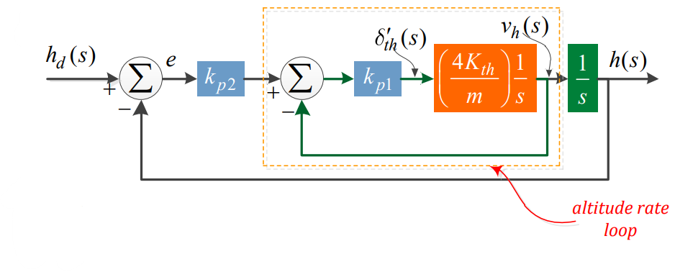
Figure 6 .Attitude controller diagram
From the block diagram:
$$δ_{th}^{'}=k_{p_{1}}\left[k_{p_{2}}\left(h_{d}-h\right)-\dot{h}\right]$$
Apply Laplace transformation to both sides and convert it into a second-order transfer function).
$$\frac{h\left(s\right)}{h_{d}\left(s\right)}=\frac{\frac{2K_{th}}{m}k_{p1}k_{p_{2}}}{s^{2}+\frac{4K_{th}}{m}k_{p1}s+\frac{4K_{th}}{m}k_{p1}k_{p_{2}}}$$
$$→\left\{\begin{matrix}\frac{4K_{th}}{m}k_{p1}s=2ζω_{n} \\ \frac{2K_{th}}{m}k_{p1}k_{p_{2}}=ω_{n}^{2}\end{matrix}\right.→\left\{\begin{matrix}k_{p_{1}}=\frac{ζω_{n}}{K_{th}}m \\ k_{p_{2}}=\frac{ω_{n}^{2}}{4K_{th}k_{p_{1}}}m\end{matrix}\right.$$

4. Position (x, y)
Mathematics model of Position motion:
$$\ddot{x}=-\frac{U_{1}}{m}u_{x}$$
$$\ddot{y}= -\frac{U_{1}}{m}u_{y}$$
where $u_{x}=\cos\left(ϕ\right)\sin\left(θ\right)\cos\left(ψ\right)+sin\left(ϕ\right)\sin\left(ψ\right),$
$$u_{y}=\cos\left(ϕ\right)\sin\left(θ\right)\sin\left(ψ\right)-sin\left(ϕ\right)\cos\left(ψ\right)$$
From the dynamic model of position system, the attitude angle (roll, pitch) is computed through the controller $u_{x}$ and $u_{y}$.
$$ϕ_{d}=\sin^{-1}\left(u_{x}\sin\left(ψ_{d}\right)-u_{y}\cos\left(ψ_{d}\right)\right)$$
$$θ_{d}=\sin^{-1}\left(\frac{u_{x}\cos\left(ψ_{d}\right)+u_{y}\sin\left(ψ_{d}\right)}{\cos\left(ϕ_{d}\right)} \right)$$
For x position we have:
$$\ddot{x}= -\frac{U_{1}\left(\cos{ϕ\sin{θ\cos{ψ}}}+\sin{ϕ\sin{ψ}}\right)}{m}$$
$$→ \ddot{x}= - \frac{\sum_{i=1}^{4}{ } F_{i}}{m}\left(\cos{ϕ\sin{θ\cos{ψ}}}+\sin{ϕ\sin{ψ}}\right)$$
$$= - \frac{4K_{th}}{m}{(u}_{0}+δ_{th})(\cos{ϕ\sin{θ\cos{ψ}}}+\sin{ϕ\sin{ψ}})$$
$$= \frac{4K_{th}}{m}δ_{x}$$
where
$δ_{x}= -{(u}_{0}+δ_{th})(\cos{ϕ\sin{θ\cos{ψ}}}+\sin{ϕ\sin{ψ}})$
Transfer function: $G_{h}\left(s\right)= \frac{h\left(s\right)}{δ_{x}\left(s\right)} =\frac{1}{s}. \frac{4K_{th}}{ms}$
For design controller, with $δ_{x}=k_{p1}\left(k_{p2}\left(h_{d}-x\right)-\overset{˙}{x}\right)$ and $\overset{¨}{x}$ is calculated above:
$$→\overset{¨}{x}+\frac{4K_{th}k_{p1}}{m}\overset{˙}{x}+\frac{4K_{th}k_{p1}k_{p2}}{m}x=\frac{4K_{th}k_{p1}k_{p2}}{m}x_{d}$$
$$→\left(s^{2}+\frac{4K_{th}k_{p1}}{m}s+\frac{4K_{th}k_{p1}k_{p2}}{m}\right)x\left(s\right)=\frac{4K_{th}k_{p1}k_{p2}}{m}x_{d}\left(s\right)$$
$$⇒G_{h}\left(s\right)=\frac{x\left(s\right)}{x_{d}\left(s\right)}=\frac{\frac{4K_{th}k_{p1}k_{p2}}{m}}{s^{2}+\underset{2ζω_{n}}{\underbrace{\frac{4K_{th}k_{p1}}{m}}}s+\underset{ω_{m}}{\underbrace{\frac{4K_{th}k_{p1}k_{p2}}{m}}}}$$
$$⇒ k_{p1}=\frac{ξω_{n}m}{2K_{th}},k_{p2}=\frac{ω_{n}^{2}m}{4K_{th}k_{p1}}$$

For y position we also have:
$$\ddot{y}= -\frac{U_{1}\left(cosϕsinθsinψ-sinϕcosψ\right)}{m}$$
$$→ \ddot{y}= - \frac{\sum_{i=1}^{4}{ } F_{i}}{m}\left(cosϕsinθsinψ-sinϕcosψ\right)$$
$$= - \frac{4K_{th}}{m}{(u}_{0}+δ_{th}\left(cosϕsinθsinψ-sinϕcosψ\right)$$
$$= \frac{4K_{th}}{m}δ_{y}$$
where
$δ_{y}= -{(u}_{0}+δ_{th})(cosϕsinθsinψ-sinϕcosψ)$
Transfer function: $G_{h}\left(s\right)= \frac{h\left(s\right)}{δ_{y}\left(s\right)} =\frac{1}{s}. \frac{4K_{th}}{ms}$
For design controller, with $δ_{y}=k_{p1}\left(k_{p2}\left(h_{d}-y\right)-\overset{˙}{y}\right)$ and $\overset{¨}{x}$ is calculated above:
$$→\overset{¨}{y}+\frac{4K_{th}k_{p1}}{m}\overset{˙}{y}+\frac{4K_{th}k_{p1}k_{p2}}{m}y=\frac{4K_{th}k_{p1}k_{p2}}{m}y_{d}$$
$$→\left(s^{2}+\frac{4K_{th}k_{p1}}{m}s+\frac{4K_{th}k_{p1}k_{p2}}{m}\right)y\left(s\right)=\frac{4K_{th}k_{p1}k_{p2}}{m}y_{d}\left(s\right)$$
$$⇒G_{h}\left(s\right)=\frac{y\left(s\right)}{y_{d}\left(s\right)}=\frac{\frac{4K_{th}k_{p1}k_{p2}}{m}}{s^{2}+\underset{2ζω_{n}}{\underbrace{\frac{4K_{th}k_{p1}}{m}}}s+\underset{ω_{m}}{\underbrace{\frac{4K_{th}k_{p1}k_{p2}}{m}}}}$$
$$⇒ k_{p1}=\frac{ξω_{n}m}{2K_{th}},k_{p2}=\frac{ω_{n}^{2}m}{4K_{th}k_{p1}}$$
So we see for x and y position the $k_{p1} and k_{p2}$ is the same.
$$k_{p1}=\frac{ξω_{n}m}{2K_{th}},k_{p2}=\frac{ω_{n}^{2}m}{4K_{th}k_{p1}}$$

IV. Simulation results
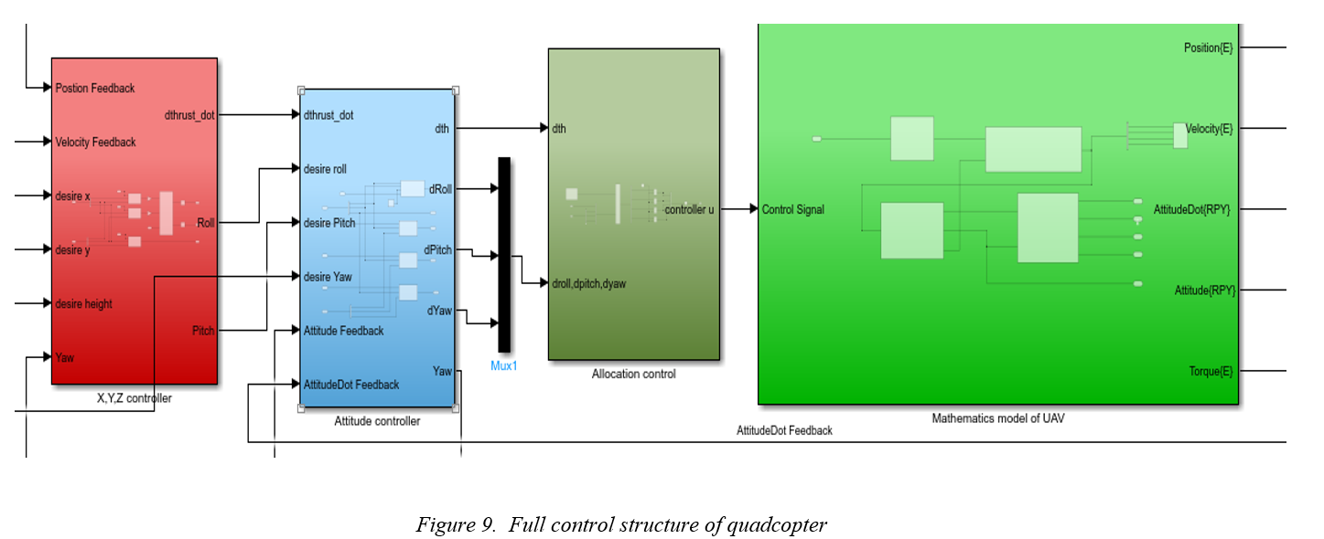
The pipepline of simulink code Matlab for UAV simulation in Figure 9. Contain 4 subsystem: Controller X,Y,Z; Attitude controller; Allocation control; Mathematics of UAV.

In theory, the performance of the controller is carried out on the quadcopter system. The quadcopter parameters and controller parameters are summarised in Table 1 and Table 2.

Parameters | Values
Length arm [m]: L | 0.211
I = diag([$I_{x}, I_{y}, I_{z}])$ | diag([0.032276, 0.031124, 0.035229])
Mass [kg]: m | 1.362
g [m/$s^{2}]$ | 9.81
Thrust coefficient: b | 1.312186e-5
Drag coefficient: d | 1.2181e-7
Initial value for omega, attitude, velocity, position | [0; 0; 0]
Force of each motor [N]: $F_{o}$ | $$\frac{m*g}{4}$$
$$J_{m}$$ | 12.${10}^{-6}$
Motor resistance (Ohm): $R_{a}$ | 0.128
Motor constant [V/(rad/s)]: $K_{t}$ | 0.005
Initial motor speed | 0
RPM at hover position: $w_{o}$ | 4818
$$u_{o}$$ | ($w_{o}-1075)/7525$
Table 3. Quadcopter parameters

Controller | parameters | Value
Roll | $$ζ$$ | 0.7
 | $$ω_{n}$$ | 6
Pitch | $$ζ$$ | 0.7
 | $$ω_{n}$$ | 6
Yaw | $$ζ$$ | 0.8
 | $$ω_{n}$$ | 6
H | $$ζ$$ | 6
 | $$ω_{n}$$ | 4
X | $$ζ$$ | 1
 | $$ω_{n}$$ | 1
Y | $$ζ$$ | 1
 | $$ω_{n}$$ | 1
Table 4. Control parameters

In this experiment, quadcopter designed to reach the point [10, 20, 10] and yaw angle is equal to 0. The result as show from Figure 10 to Figure 14.
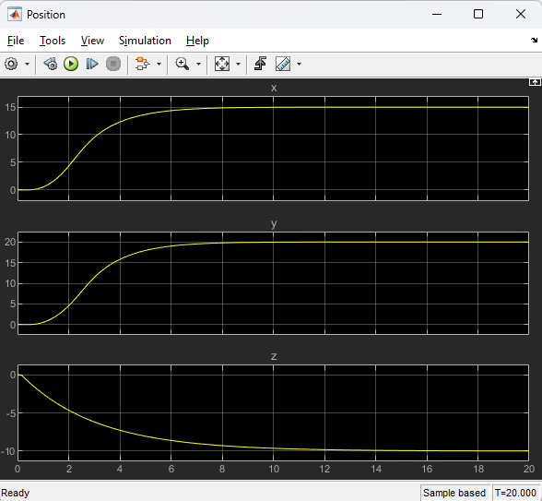
Figure 10. Position of quadcopter

The simulation results demonstrate the UAV's position tracking performance over a 20-second time frame for the x, y, and z axes. For the x-axis, the position shows a smooth rise from the initial state to a steady-state value of approximately 15 units, with minimal overshoot, achieving steady-state stability after about 8 seconds. The y-axis position follows a similar pattern, transitioning smoothly to a steady-state value of around 20 units. This response is steady and well-damped, with no oscillations observed. For the z-axis, the position starts at 0 units and smoothly transitions to -10 units. The descent is well-controlled, without overshoot or oscillations, and the system reaches stability within approximately 8 seconds. Overall, the UAV exhibits effective position control across all axes, with smooth transitions and stable convergence to the desired setpoints.

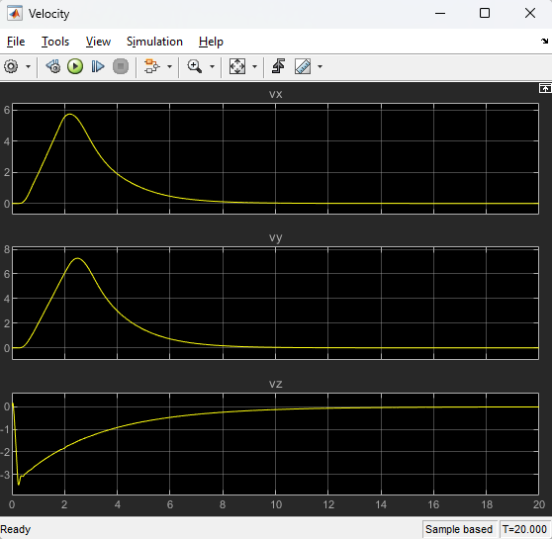
Figure 11. Velocity of quadcopter

The velocity responses for the UAV along the x, y, and z axes are analyzed as follows: For the x-axis (VX), the velocity exhibits an initial peak of approximately 6 units, representing a rapid acceleration at the start. It then decreases smoothly to zero, indicating that the UAV has reached its desired position along the x-axis. The response shows no oscillations, highlighting good damping and stability. Similarly, for the y-axis (VY), the velocity initially peaks at around 8 units before decreasing steadily to zero. The decay is well-controlled, ensuring stable convergence to the desired position along the y-axis without oscillations. Finally, for the z-axis (VZ), the velocity begins with a smooth rise from 0 units to approximately -3 units before stabilizing. The lack of oscillations in all axes indicates effective control of the UAV's movement and velocity throughout the simulation.

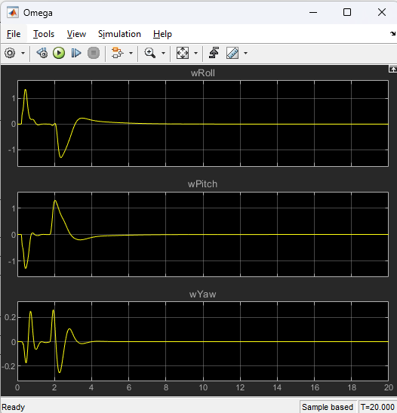
Figure 12. Rate of change of attitudes

The angular velocities (rate of change of attitudes) along the roll, pitch, and yaw axes are analyzed as follows: For the roll axis (wRoll), the response shows a damped oscillatory behavior in the initial phase, with peaks around ±1 rad/s. These oscillations decay smoothly, and the angular velocity converges to zero, indicating stabilization of the roll angle after approximately 6 seconds. Similarly, for the pitch axis (wPitch), the angular velocity exhibits damped oscillations with initial peaks around ±1 rad/s. The oscillations gradually decay to zero, stabilizing the pitch angle after about 6 seconds. For the yaw axis (wYaw), the angular velocity shows smaller initial oscillations compared to roll and pitch, with a maximum deviation of approximately ±0.2 rad/s. The response stabilizes quickly, achieving near-zero angular velocity within 6 seconds. Overall, the UAV demonstrates effective damping of angular velocity, with all axes stabilizing smoothly without excessive oscillations.

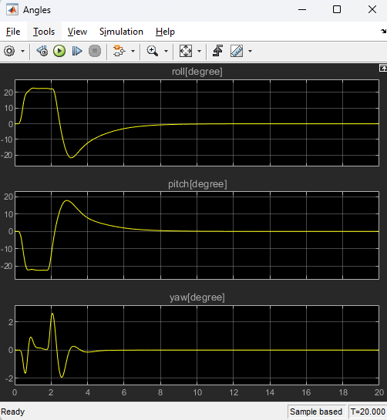
Figure 13. Angle during movement

The angles for roll, pitch, and yaw during the UAV's movement are analyzed as follows: For the roll angle, it starts with a peak of approximately +20° before rapidly decreasing to a minimum of -20°. The roll angle exhibits damped oscillations, effectively reducing oscillations and stabilizing at approximately 0° within 8 seconds. For the pitch angle, it initially drops to about -20°, then increases sharply to approximately 20°. Similar to the roll angle, it undergoes damped oscillations and stabilizes at around 0° after approximately 8 seconds. For the yaw angle, the oscillations are smaller compared to roll and pitch, with a maximum deviation of approximately ±2°. The yaw angle quickly stabilizes near 0°, with oscillations diminishing within 6 seconds. Overall, the UAV demonstrates effective attitude control, with all three angles (roll, pitch, and yaw) exhibiting smooth transitions and stabilizing without excessive oscillations.

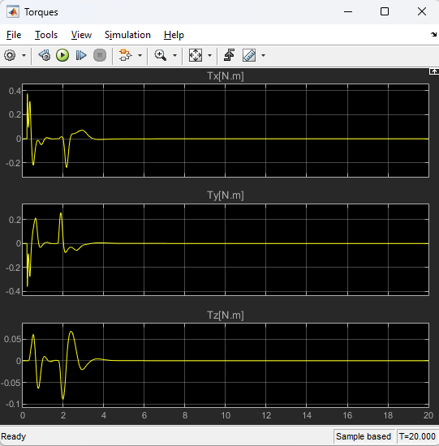
Figure 14. Torque for each dimension

The torques along the x, y, and z axes during the UAV's movement are analyzed as follows: For the x-axis torque (Tx), the torque initially oscillates with a peak near ±0.2 Nm. These oscillations decay rapidly within 4 seconds, and the torque stabilizes close to zero, indicating effective damping and stabilization along the roll axis. The torque along the y-axis (Ty) exhibits similar behavior, with initial oscillations around ±0.2 Nm. These oscillations decay smoothly within approximately 4 seconds, and the torque stabilizes near zero, ensuring control stability for pitch movements. For the z-axis torque (Tz), the oscillations are smaller compared to the x and y axes, with a maximum deviation of approximately ±0.05 Nm. The torque stabilizes quickly within 3 seconds, highlighting effective yaw control. Overall, the torque responses suggest that the UAV's control system efficiently manages torque fluctuations across all axes, leading to stable and well-damped attitude control during the flight.

The simulation 3D of UAV from [0;0;0] to [10;20;10]
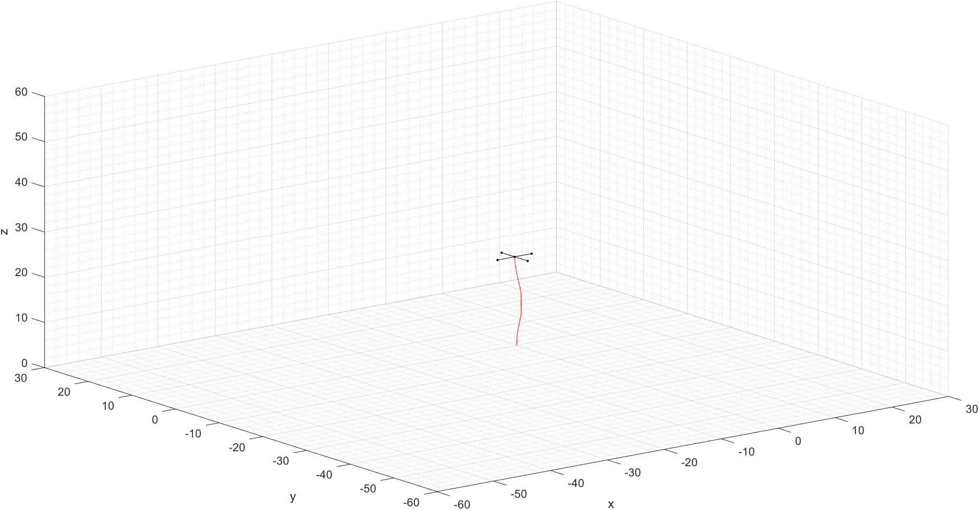
Figure 15. Matlab simulation for UAVs
The 3D simulation provides a visual representation of the UAV's trajectory during flight. Key observations include that the UAV starts from an initial position in 3D space and follows a controlled trajectory, represented by the red path in the figure. The simulation highlights the UAV's ability to adjust its position and orientation dynamically while maintaining stability, as evidenced by the smoothness of the trajectory. Additionally, the model visually depicts the UAV's physical structure, offering a clear understanding of its orientation in the 3D environment. This is essential for analyzing attitude control and evaluating how effectively the UAV maintains its desired position and orientation during flight. Overall, the 3D simulation confirms the UAV’s stable trajectory and effective control system performance.

V. Conclusion
In conclusion, this project explored the use of a multiple proportional (P) controller to manage the position, altitude, and attitude (roll, pitch, yaw) of a quadcopter in MATLAB. The results showed that the multiple P controller effectively stabilizes the quadcopter’s position and orientation, offering a simple and implementable solution for certain applications.
However, while the P controller ensures stability, it may not provide optimal performance in the presence of disturbances or dynamic changes in the system. Future research could focus on more advanced control methods, such as PID, LQR, or MPC, to enhance the UAV's robustness and responsiveness.
Overall, the project demonstrated the feasibility of using a P controller for quadcopter control, laying the groundwork for further exploration of more sophisticated control strategies tailored to specific operational needs.

Reference
[1] Hoffmann, G., Huang, H., Waslander, S., & Tomlin, C. (2007, August). Quadrotor helicopter flight dynamics and control: Theory and experiment. In AIAA guidance, navigation and control conference and exhibit (p. 6461).
[2] Tayebi, A., & McGilvray, S. (2004, December). Attitude stabilization of a four-rotor aerial robot. In 2004 43rd IEEE conference on decision and control (CDC)(IEEE Cat. No. 04CH37601) (Vol. 2, pp. 1216-1221). Ieee.
[3] Huang, H., Hoffmann, G. M., Waslander, S. L., & Tomlin, C. J. (2009, May). Aerodynamics and control of autonomous quadrotor helicopters in aggressive maneuvering. In 2009 IEEE international conference on robotics and automation (pp. 3277-3282). IEEE.
[4] Tayebi, A., & McGilvray, S. (2004, December). Attitude stabilization of a four-rotor aerial robot. In 2004 43rd IEEE conference on decision and control (CDC)(IEEE Cat. No. 04CH37601) (Vol. 2, pp. 1216-1221). Ieee.
[5] Dikmen, İ. C., Arisoy, A., & Temeltas, H. (2009, June). Attitude control of a quadrotor. In 2009 4th International Conference on Recent Advances in Space Technologies (pp. 722-727). Ieee.
[6] Madani, T., & Benallegue, A. (2006, October). Backstepping control for a quadrotor helicopter. In 2006 IEEE/RSJ International Conference on Intelligent Robots and Systems (pp. 3255-3260). IEEE.
[7] Zemalache, K. M., Beji, L., & Marref, H. (2005, July). Control of an under-actuated system: application a four rotors rotorcraft. In 2005 IEEE International Conference on Robotics and Biomimetics-ROBIO (pp. 404-409). IEEE.
[8] Raffo, G. V., Ortega, M. G., & Rubio, F. R. (2010). An integral predictive/nonlinear H∞ control structure for a quadrotor helicopter. Automatica, 46(1), 29-39.
[9] Castillo, P., Lozano, R., & Dzul, A. (2005). Stabilization of a mini rotorcraft with four rotors. IEEE control systems magazine, 25(6), 45-55.
[11] Escareno, J., Salazar-Cruz, S., & Lozano, R. (2006, June). Embedded control of a four-rotor UAV. In 2006 American Control Conference (pp. 6-pp). IEEE.
[10] Martin, P., & Salaün, E. (2010, May). The true role of accelerometer feedback in quadrotor control. In 2010 IEEE international conference on robotics and automation (pp. 1623-1629). IEEE.
[11] He, R., Prentice, S., & Roy, N. (2008, May). Planning in information space for a quadrotor helicopter in a GPS-denied environment. In 2008 IEEE International conference on Robotics and Automation (pp. 1814-1820). IEEE.

