Nhóm 10

Vũ Minh Phong

Lê Đức Hải

Trần Duy Bim

Cao Thị Thảo

Nguyễn Thị Tuyết Mai

VI, Biểu đồ trình tự hệ thống

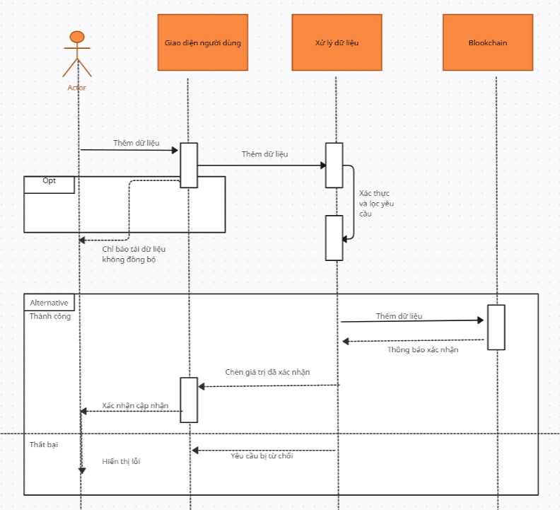

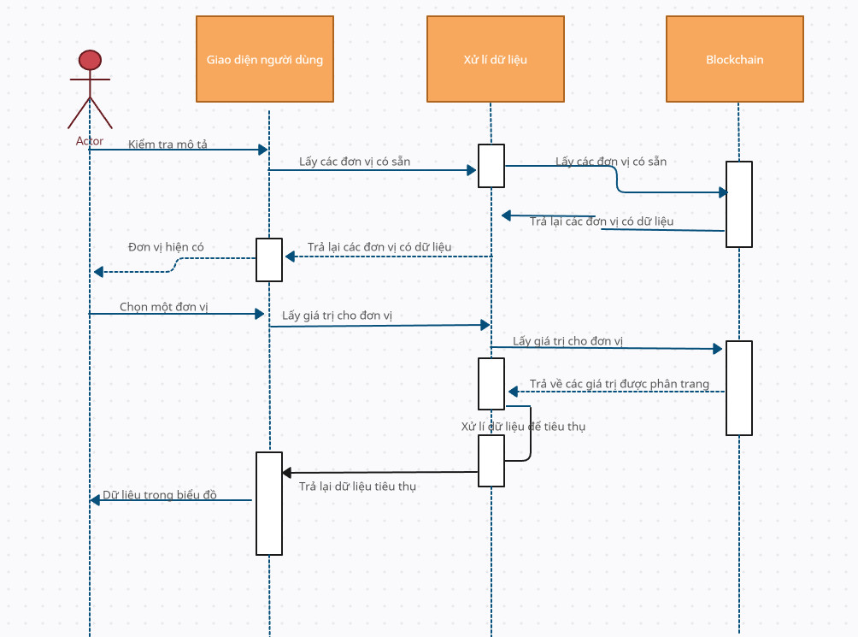

VII,

|  |  |  |  |
| --- | --- | --- | --- |
| Actor Classification |  |  |  |
| Actor Name | Description | Complexity | Weight |
| User/Frontend(FE) | The user is interacting with a graphical user interface during account log in, account creation, data entry, and viewing their results (visual and text-based) | Hyper- Complex | 4 |
| Blockchain | Database system interacting with the server via smart contracts | Average | 2 |

|  |  |  |  |
| --- | --- | --- | --- |
| Use Case Classification |  |  |  |
| User Case | Description | Category | Weight |
| Đăng nhập (UC-1) | Giao diện người dùng vừa phải.  6 bước cho kịch bản thành công.  4 tác nhân tham gia (FE, Máy chủ, Hợp đồng thông minh, Chuỗi khối) | Average | 10 |
| Đăng ký (UC-2) |  | Complex | 15 |
| Xem lịch sử đơn hàng (UC-3) | Complex user interface.  8 steps for success scenario.  4 participating actors (FE, Server, Smart Contracts, Blockchain) | Complex | 15 |
| Giao tiếp(UC-4) | Complex user interface.  13 steps for success scenario.  4 participating actors (FE, Server, Smart Contracts, Blockchain) | Complex | 15 |
| DisplayVisual Analytics (UC-5) | Complex user interface.  13 steps for success scenario.  4 participating actors (FE, Server, Smart Contracts, Blockchain) | Complex | 15 |

