Non-Invasive Adaptive Hand Prosthetics

C. Castellini¹, E. Gruppioni², A. E. Fiorilla³, P. van der Smagt⁴, A. Davalli² and G. Sandini³

¹ LIRA-Lab, University of Genova, Italy
² INAIL Centro Protesi, Budrio, Italy
³ Italian Institute of Technology, Genova, Italy
⁴ DLR - German Aerospace Research Center, Oberpfaffenhofen, Germany

Abstract

We propose hereby a technique to dramatically improve the feed-forward control of dexterous hand prostheses by amputees, namely machine learning methods applied to a non-invasive technique, surface electro-myography (EMG).
Advancement wrt the state-of-the-art. EMG (both surface and invasive) has been used extensively to drive myoelectric prostheses since the Sixties; in all cases, trained physiatrists were needed to find the best placement for the electrodes on the patient’s stump, and even so the control obtained was rough: the patient had to learn to associate wrist flexion/extension to hand opening/closing, since there was no systematic procedure for detecting the subject’s intentions from the EMG signal, and only one or, at best, two DOFs could be controlled in a standard prosthesis.
Using supervised machine learning, during a rather quick training phase we let the system learn to associate EMG electrical patterns to desired grasping postures (e.g., pinch grip, flat grip, hand stretching or power grasp) and to the desired amount of force involved in the grasp. No medical assistence is required. A prototype of the system, working on-line with no special computational needs, has been tested on a healthy subject with a non-prosthetic, highly dexterous mechatronic hand, namely the DLR-II Hand (dial http://people.liralab.it/drwho/NINAPRO_DLR.avi). Just by using the EMG signal, the hand is controlled both in position and in force. [1,2]
The system has also been extensively tested on a pool of 10 healthy subjects and in non-controlled conditions: the subjects involved in this experiment, equipped with wireless EMG electrodes, were left free to walk, sit down, stand up and move their upper arms while the system was being trained. This was done in order to check whether the system could be used in daily life activities, and applied to any person. The results indicate that the answer is positive to both questions. [3,4]
Lastly, we have applied the technique to three amputees who volunteered to collaborate at INAIL Centro Protesi. The main question here, that is, are amputees able to produce discernible EMG signals when asked to imagine complex grasp postures and forces?, has been answered, again, positively. Our system, applied to their data, obtains again an excellent performance, notwithstanding two of them have been amputated some 40 years ago – one of them is even left with as little as 9cm. of his forearm (see the Figure below). [5,6,7]

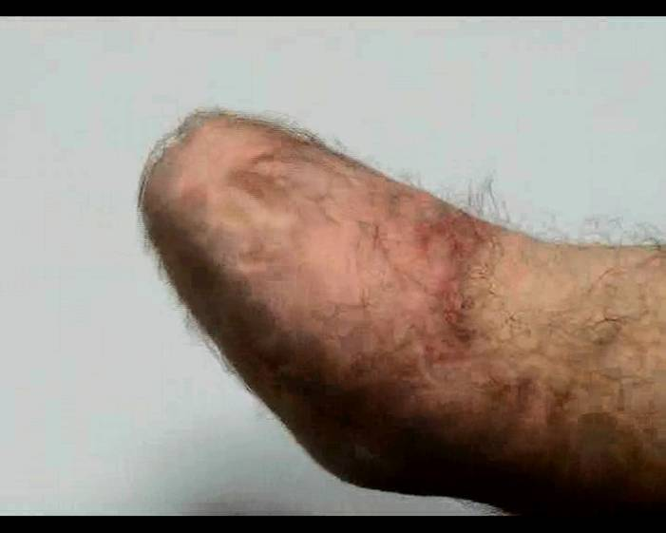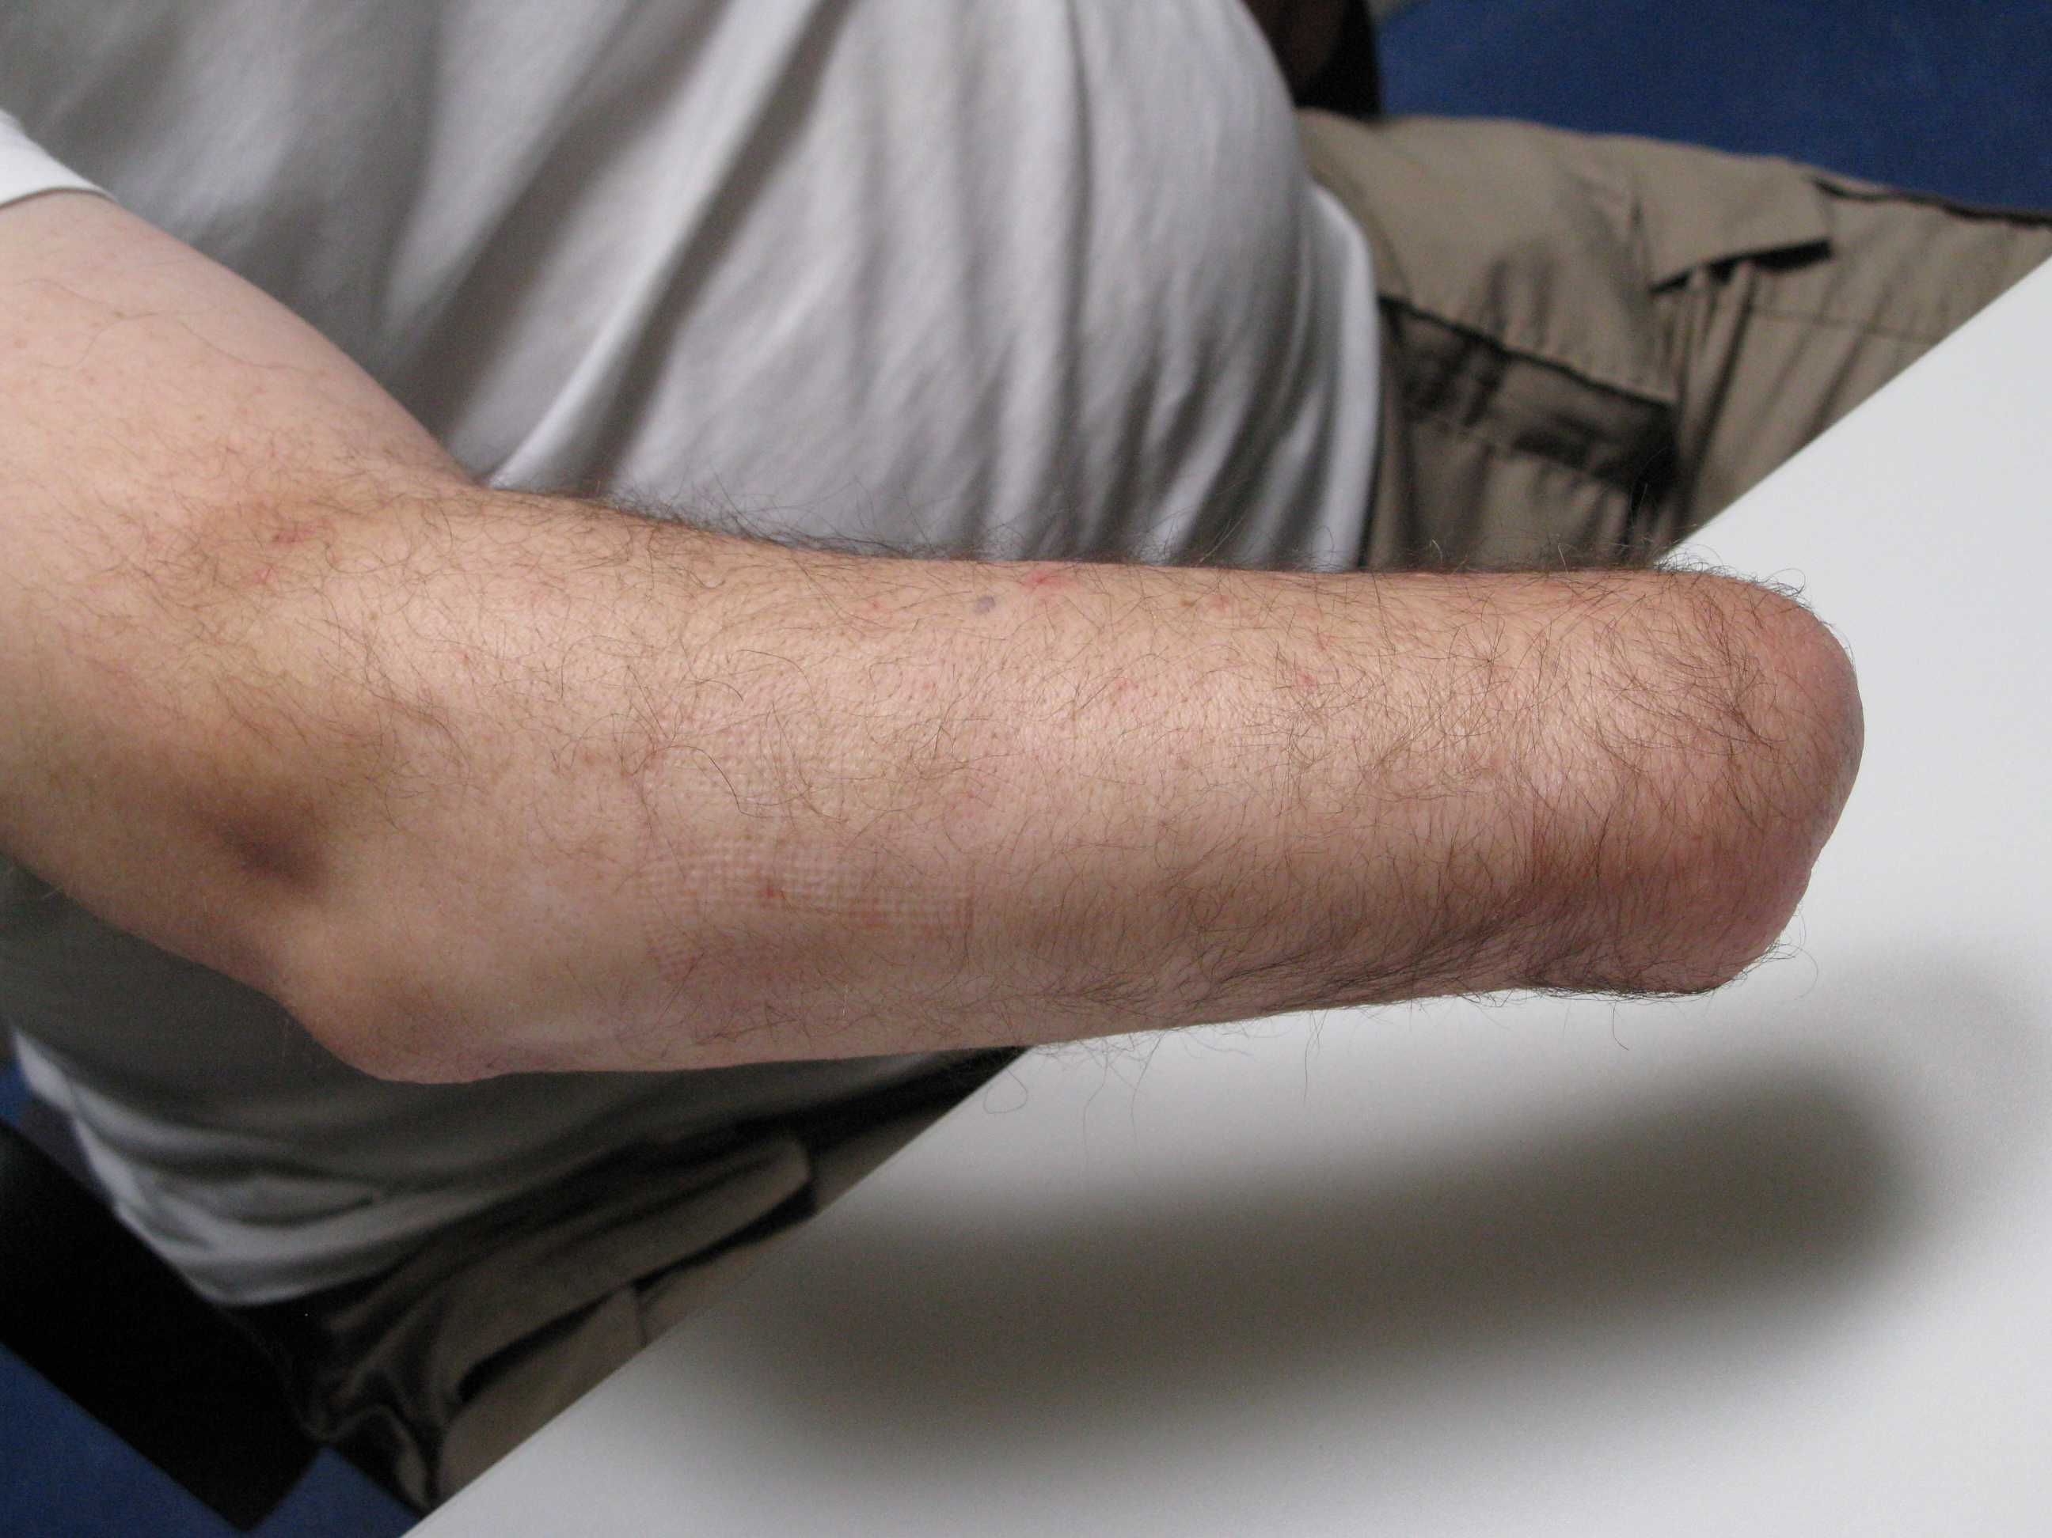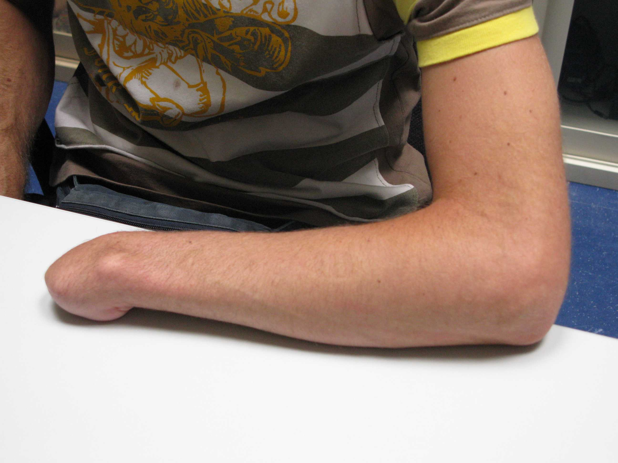

Experiment results. Although from a robotics point of view our first experiment is the most interesting, since we show that a dexterous hand can actually be controlled using our system both in position and force, the third one is the most interesting as far as the near future is concerned; as well, it is the final mathematical proof-of-concept that the approach is feasible for amputees, which is in turn the main aim of this project. Patients were aged 63 (trans-radial one-third proximal amputation operated in 1963), 56 (trans-radial one-third distal, amputated in 1972) and 25 (trans-carpal, amputated in 2007). They present a rather wide variety of operations and conditions – in particular, subject 1 has about 9cm left of his forearm, subject 2 has some 20cm and subject 3 still has the whole forearm plus some of the carpus. Using a simple dimensionality reduction technique, one can see that the samples produced by the patients are remarkably distinct from one another, and produce rather neat “clusters”:
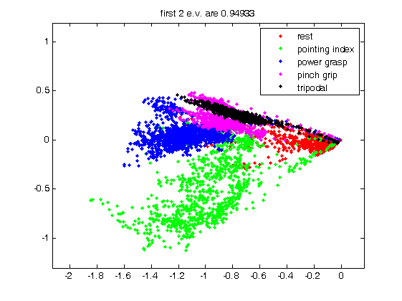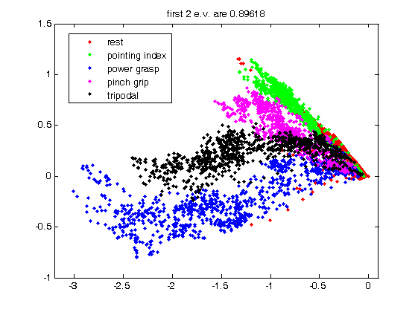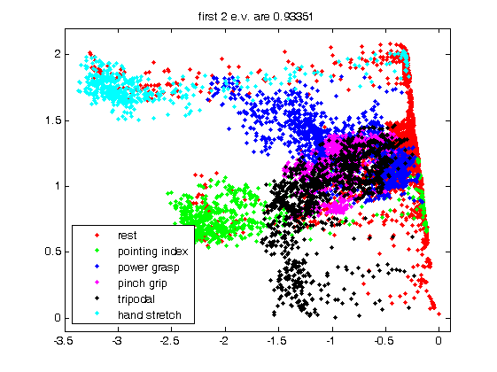
In the Figure above, colours correspond to different ways of grasping: for instance, the blue dots are samples obtained while the subject was imagining doing a power grasp (according to one of the previously illustrated modalities) whereas the magenta ones are pinch grips.
In the first place, it is remarkable that long-term amputees such as subjects 1 and 2 can produce such distinct signals after 40 years without having their hands. Secondly, our machine works well on such signals, and in fact the results are excellent, as the Table below sketches:
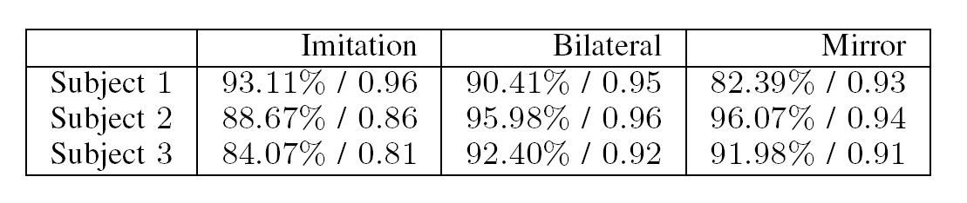
(Imitation, Bilateral and Mirror refer to different training modalities we tested – see the Bibliography for more details). All in all, our results confirm the feasibility of the approach.
Future work. The system we propose can be applied to commercially available hand prostheses as well as to more sophisticated academic prototypes, to improve feed-forward control of the hand, both as far as position of the joints and applied force are concerned. A better way of controlling dexterous hand prostheses would indeed lead to a better way of life for amputees; moreover, (a) the system is easy to implant and “configure” according to the patient’s type of amputation and needs; (b) it is effective and can work in real-time in an embedded architecture; (c) it is economically sustainable – in the ideal scenario, it does not cost too much more than the currently available solutions. We expect the technique to be applied in at least two or three amputation hospitals and potentially, in the future, to become the standard in myoelectric non-invasive hand prosthetics.

References to our own related work

[1] C. Castellini, P. van der Smagt, G. Sandini and G. Hirzinger, Surface EMG for Force Control of Mechanical Hands, proceedings of ICRA-08
[2] C. Castellini and P. van der Smagt, Surface EMG in Advanced Hand Prosthetics, Biological Cybernetics, to appear (2009)
[3] C. Castellini, E. Fiorilla and G. Sandini, Multi-subject/DLA analysis of surface EMG control of mechanical hands, poster at the I GNB congress (Pisa, Italy, 2008)
[4] C. Castellini, E. Fiorilla and G. Sandini, Multi-subject / Daily-Life Activity EMG-based control of mechanical hands, submitted to the Journal of Neuroengineering and Rehabilitation
[5] C. Castellini, E. Gruppioni, A. Davalli and G. Sandini, Surface EMG for hand prostheses: can an amputee really do it?, poster at the I neuro-robotics symposium (Freiburg-im-Breisgau, Germany, 2008)
[6] C. Castellini, E. Gruppioni, A. Davalli and G. Sandini, EMG-driven hand prosthetics: initial results on a patient, submitted to the Journal of Neuroengineering and Rehabilitation
[7] C. Castellini, E. Gruppioni, A. Davalli and G. Sandini, Towards Adaptive Hand Prosthetics, submitted to the IEEE Transactions on Robotics, special issue on Rehabilitation Medicine

Web links

http://people.liralab.it/drwho/NINAPRO_DLR.avi – a movie showing control of the DLR-II mechanical hand via surface EMG, shot at DLR in late 2007.

