1. Boolean is a value. A Boolean value is either true or false  
 Ex:

>>> 5 + 3 == 6

False

>>> 5 != 6  
 True  
 >>> 7 > 8   
 False

2. A flowchart is a type of [diagram](https://en.wikipedia.org/wiki/Diagram) that represents an [algorithm](https://en.wikipedia.org/wiki/Algorithm), [workflow](https://en.wikipedia.org/wiki/Workflow) or process, showing the steps as boxes of various kinds, and their order by connecting them with arrows.

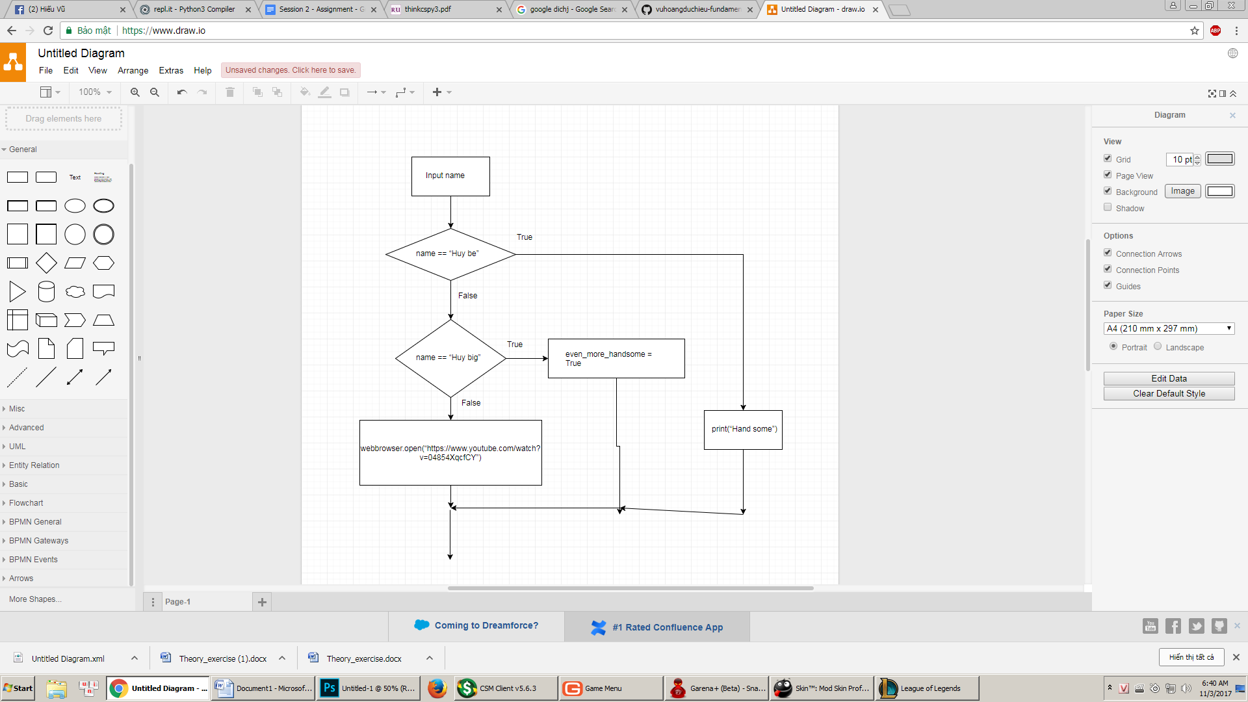  
  
3.Nested Conditionals is a conditional has another conditional in that. They are linked together.

if a.lower() == "c4e":

print("Password")

if b.lower() == "123456" :  
 print("Welcome User")

else :

print("Incorect Password")

else:  
 print("User does not exist")