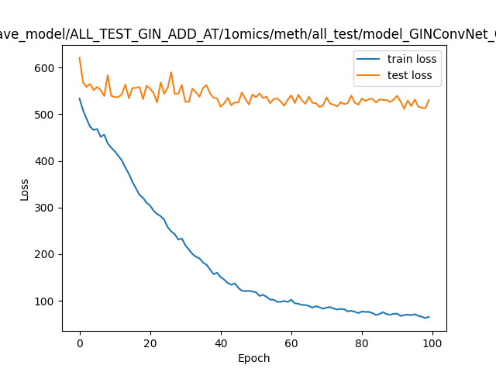

ave_model/ALL_TEST_GIN_ADD_AT/1omics/meth/all_test/model_GINConvNet

600

train loss test loss

Ilraturun

ummmmmmm

**SS07**

©

20

40

60

80

100

Epoch