**INTRODUCE**

*This is our Car Rental system. In system, customer can rent a car based on model name and branch location which is nearest to them. Our system provides customer to have 3 branch locations to pick-up or drop-off. Customer who have membership will be given 5-10% discount from us. You can see detail more below.*

* Part 1 – Develop ER diagram

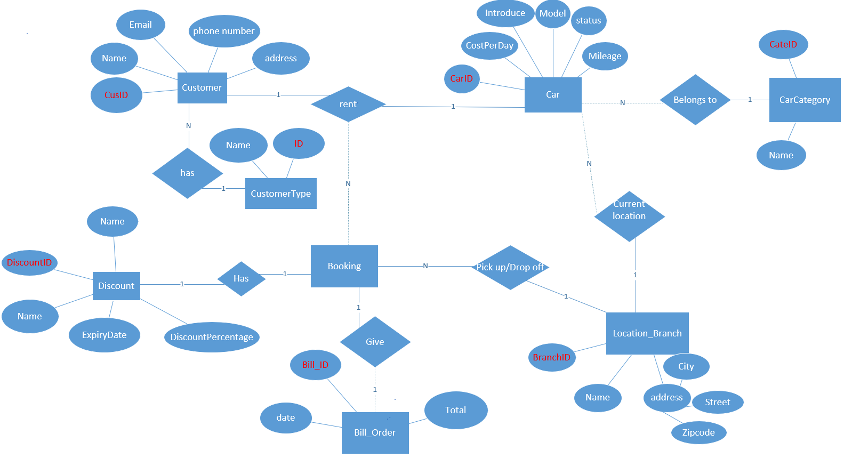

* Part 2 - Develop and document database design

1. Customer:

Customer who can visit the Car Rental website for reserving. They will have mebership id. Customer entity will store details like their name, address, phone number, email, date of birth.

|  |  |  |  |  |
| --- | --- | --- | --- | --- |
| Customer | Field | Data type | Width | Properties |
| Location | CusID | Auto |  | Nut null  Primary key |
| NameCus | Nvarchar | 50 | Not null |
| Address | Nvarchar | 200 | Not null |
| PhoneNum | Nvarchar | 11 | Not null |
| Email | Varchar | 50 | Not null |
| Dob | Date time |  | Not null |

|  |  |  |  |  |
| --- | --- | --- | --- | --- |
| CustomerType | Field | Data type | Width | Properties |
| Location | CusTypeID | Auto |  | Nut null  Primary key |
| NameCusT | Nvarchar | 50 | Not null |
|  |  |  |  |

1. Car Category

Every car has a car category. It will be have attributes like id, name

|  |  |  |  |  |
| --- | --- | --- | --- | --- |
| CarCategory | Field | Data type | Width | Properties |
| Location | CateID | Auto |  | Nut null  Primary key |
| CateName | Nvarchar | 50 | Not null |
|  |  |  |  |

1. Car

Car entity will have list of cars available on website. Each car will be associated with a car category and attributes like name, mileage, status, detail, cost per day.

|  |  |  |  |  |
| --- | --- | --- | --- | --- |
| Car | Field | Data type | Width | Properties |
| Location | CarID | Auto |  | Nut null  Primary key |
| Name | Nvarchar | 50 | Not null |
| Status | Nvarchar | 50 | Not null |
| Mileage | Int | 32 | Not null |
| Detail | Narchar | 500 | Not null |
| Picturer | Varchar | 500 | Not null |
| costPerDay | Double | 18,0 | Not null |

1. Discount

Customer can apply discount code when pay. Each discount code has different discount percentage. It will be have attributes like id, name, expiry and discount percentage.

|  |  |  |  |  |
| --- | --- | --- | --- | --- |
| Discount | Field | Data type | Width | Properties |
| Location | DiscountID | auto |  | Nut null  Primary key |
| Name | Nvarchar | 50 | Not null |
| ExpriDate | Date time |  | Not null |
| DiscountPercentage | Nvarchar | 11 | Not null |

1. Bill order

When customer book a car, bill order has attributes like id, date, total money

|  |  |  |  |  |
| --- | --- | --- | --- | --- |
| Bill_Order | Field | Data type | Width | Properties |
| Location | Bill_ID | Auto |  | Nut null  Primary key |
| Date | Date time |  | Not null |
| Total | Double | 18,0 | Not null |

1. Location branch

Customer can pick a for rent form 3 locations. Location branch entity has attributes like id, address, phone, email to contact with customer.

|  |  |  |  |  |
| --- | --- | --- | --- | --- |
| Location_Branch | Field | Data type | Width | Properties |
| Location | BranchID |  |  | Nut null  Primary key |
| Name | Nvarchar | 50 | Not null |
| Address | Nvarchar | 50 | Not null |
| PhoneNum | varchar | 11 | Not null |
| Email | Varchar | 20 | Not null |

