About this bag, we can not do, because it's heat sealed version. if change the outer material to sewing version, we can make it. like below the picture.
the MOQ is 500pcs/.
sample fee $80, 7days.

this bag size 37*26.5*31cm
Time for sample: _7___ days
Time for Production: __45__ days

Unit Price (300 pcs): U$S __32.5___ FOB ____ningbo_____ (port)
Unit Price (1000 pcs): U$S _31.5____ FOB __ningbo_______ (port)
Qty per outer box: __1___ pcs/ctn
Size of outer ctn box: ___40___ x ____28___ x __34____ cm
Gross weight ctn: _1.9___kg
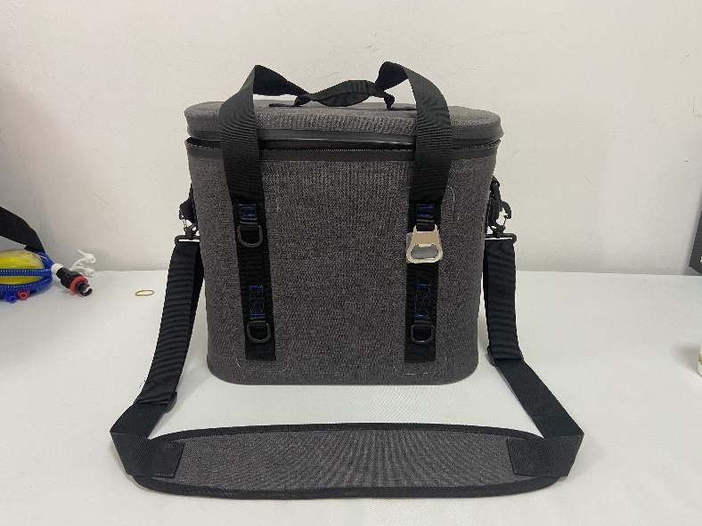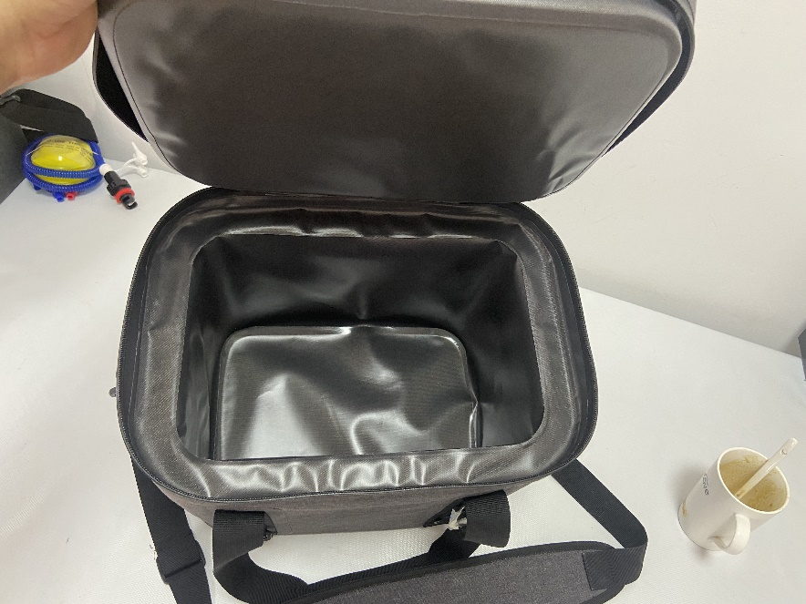

Best Regards
James

Yiwu Better Culture Co.,Ltd.
Office: 9 Floor, Unit 2, Building 2, Hongxiang Wantit Plaza, Yiwu, Zhejiang, China 322000
Factory: No. 5 Chengbei Road Houzhai Stationery and Sports Industrial Zone Yiwu Zhejiang China
P: 0086-579-85173061 F: 0086-579-85173062
WhatsApp/Viber/Wechat/M:0086-13626696200 Skype:james418206
W: www.toppromotion.cn E: sales08@toppromotion.cn

