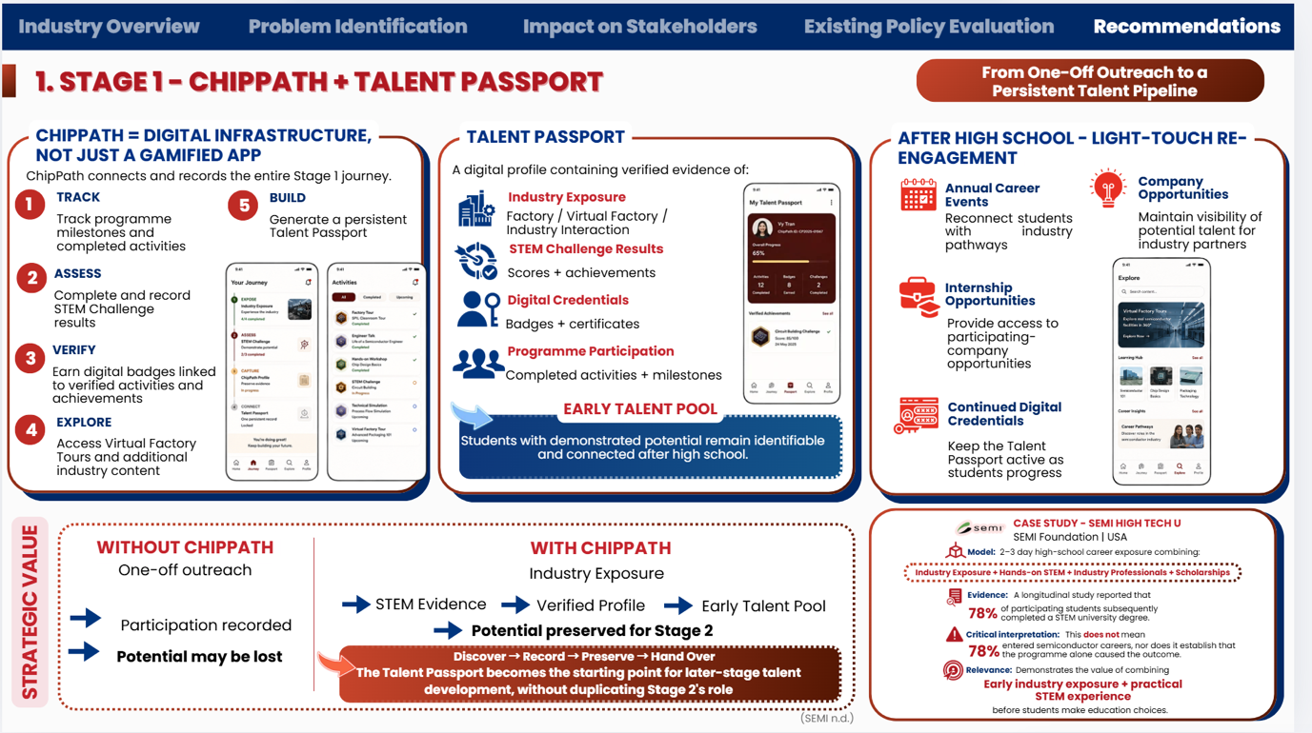
Design a modern, professional mobile app prototype called ChipPath — a digital talent pipeline platform for high-school students exploring careers in the electronics and semiconductor industry.

Core concept
ChipPath is not a gamified learning app. It is a digital infrastructure that connects, records, verifies and preserves a student's entire early-talent journey, eventually creating a persistent Talent Passport that can be carried forward into later-stage talent development.
The experience should feel like a combination of:
- Career exploration platform
- STEM challenge portfolio
- Digital credential wallet
- Talent profile / passport
- Industry opportunity platform

Main navigation
Use a clean bottom navigation with 5 sections:
Home | Explore | Challenges | Passport | Opportunities

1. HOME — “Your Talent Journey”
Create a dashboard showing the student's current progress through the ChipPath journey.
Include:
- Welcome message: “Continue your journey into the semiconductor industry.”
- Journey progress tracker:
Discover → Experience → Challenge → Verify → Build
- Programme milestones completed
- Upcoming activities
- Latest achievement / badge
- Recommended next action
- Progress toward completing the Talent Passport
Example cards:
- “Virtual Factory Tour — Completed”
- “STEM Challenge — Result: 87/100”
- “Industry Interaction — Completed”
- “2 milestones remaining”
The interface should visually communicate that every activity contributes to a long-term verified profile.

2. EXPLORE — “Discover the Industry”
Create an industry exploration hub.
Include:
- Virtual Factory Tours
- Company / industry visits
- Engineer & industry professional interactions
- Semiconductor career pathways
- STEM resources
- Upcoming industry events
Each activity should show:
- Activity title
- Company / organiser
- Short description
- Duration
- Skills or evidence gained
- “Start” / “View activity” button
Example:
Virtual Semiconductor Factory Tour
“Explore how semiconductor components move from design to manufacturing.”
→ View Tour
→ Add to Journey

3. CHALLENGES — “Prove Your Potential”
Create a STEM Challenge section where students can participate in practical challenges.
Include:
- Available challenges
- Completed challenges
- Challenge difficulty
- Assessment criteria
- Results and scores
- Achievements earned
Example challenge:
Smart Factory Challenge
“Design a simple solution to improve efficiency in a semiconductor manufacturing process.”
After completion, show:
- Technical Aptitude Score
- Engagement Score
- Demonstrated Interest
- Overall result
- Earned credential / badge
The purpose is to record evidence of potential, rather than simply award points.

4. PASSPORT — “Your Verified Talent Passport”
This is the most important screen.
Create a polished digital profile containing verified evidence of the student's journey.
Header:
Talent Passport
“Your verified record of industry exposure, achievements and potential.”
Include sections:
Industry Exposure
- Factory visits
- Virtual factory tours
- Industry interactions
STEM Challenge Results
- Scores
- Completed challenges
- Achievements
Digital Credentials
- Verified badges
- Certificates
- Skills / competencies
Programme Participation
- Completed activities
- Milestones
- Participation history
Include a visual verification indicator:
✓ Verified by ChipPath
The profile should look like a professional digital talent record, not a gaming profile.

5. OPPORTUNITIES — “Stay Connected”
Create an early-talent opportunity section designed for students after high school.
Include:
- Annual career events
- Internship opportunities
- Participating company opportunities
- Industry engagement opportunities
- New credentials / milestones
Example:
Annual Semiconductor Career Day
“Reconnect with industry and discover university-to-career pathways.”
Internship Opportunity
“Early Talent Internship — Manufacturing Engineering”
→ View Opportunity
This section demonstrates the “light-touch re-engagement” concept: students remain connected to industry without requiring intensive engagement during university.

Key user flow
Show the core journey clearly:
Discover
↓
Industry Exposure
↓
STEM Challenge
↓
Verified Evidence
↓
Talent Passport
↓
Early Talent Pool
↓
Stage 2 Development

Visual style
Use a professional consulting / corporate technology aesthetic rather than a children's education app.
- Clean white / light background
- Navy and deep blue as primary colours
- Red accent used selectively
- Rounded cards
- Minimal but meaningful icons
- Clear hierarchy
- Modern sans-serif typography
- Professional data visualisation
- Subtle semiconductor / technology visual elements
- Avoid excessive gamification, cartoon characters or childish illustrations
The overall impression should be:
“A professional digital talent infrastructure for discovering and preserving future semiconductor talent.”

Prototype screens to prioritise
Create these 6 high-fidelity screens:
- Home — Talent Journey Dashboard
- Explore — Virtual Factory / Industry Exposure
- Challenge — STEM Challenge
- Challenge Result — Verified Evidence
- Talent Passport — Digital Profile
- Opportunities — Early Talent Pool
The prototype should make the strategic value immediately understandable:
ChipPath does not replace Stage 2. It creates the verified talent record that allows potential discovered in Stage 1 to be preserved and handed over to Stage 2.

