5090209351 杜溪

Task 1
(a)TCP/FTP
(b)

0.2 | 0.4 | 0.6 | 0.8 | 1
tcp: 389660  cbr: 107000  total: 496660  tcp ratio: 0.7846  cbr ratio: 0.2154 | tcp: 308040  cbr: 226000  total: 534040  tcp ratio: 0.5768  cbr ratio: 0.4232 | tcp: 183300  cbr: 342500  total: 525800  tcp ratio: 0.3486  cbr ratio: 0.6514 | tcp: 183300  cbr: 405000  total: 588300  tcp ratio: 0.3116  cbr ratio: 0.6884 | tcp: 9280  cbr: 586500  total: 595780  tcp ratio: 0.0156  cbr ratio: 0.9844
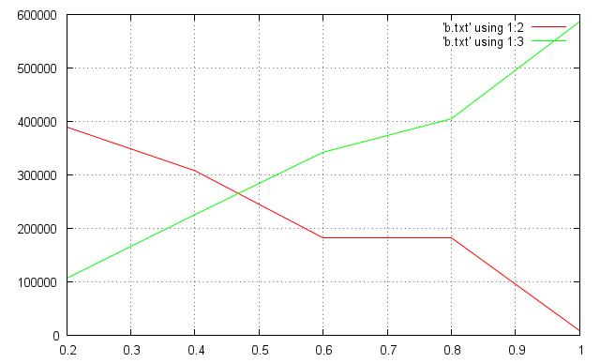
TCP uses more bandwidth at first, but UDP gradually uses more bandwidth as its sending rate increases and its traffic dominates the bottleneck at 1Mbps. The UDP traffic is favored because it has no flow control.
(c)
tcp: 9280
cbr flow 1: 478500
cbr flow 2: 108000
total: 595780
tcp ratio: 0.0156
cbr flow 1 ratio: 0.8031
cbr flow 2 ratio: 0.1813
The UDP/CBR flow generated by node 2 is favored because it's sent at a higher rate.
(d)
10ms | 15ms | 20ms | 25ms | 30ms | 35ms | 40ms
tcp1: 301880  tcp2: 247980  total: 549860  tcp1 ratio: 0.5490  tcp2 ratio: 0.4510 | tcp1: 272620  tcp2: 261840  total: 534460  tcp1 ratio: 0.5101  tcp2 ratio: 0.4899 | tcp1: 300340  tcp2: 231040  total: 531380  tcp1 ratio: 0.5652  tcp2 ratio: 0.4348 | tcp1: 247980  tcp2: 264920  total: 512900  tcp1 ratio: 0.4835  tcp2 ratio: 0.5165 | tcp1: 280320  tcp2: 229500  total: 509820  tcp1 ratio: 0.5498  tcp2 ratio: 0.4502 | tcp1: 264920  tcp2: 224880  total: 489800  tcp1 ratio: 0.5409  tcp2 ratio: 0.4591 | tcp1: 280320  tcp2: 184840  total: 465160  tcp1 ratio: 0.6026  tcp2 ratio: 0.3974

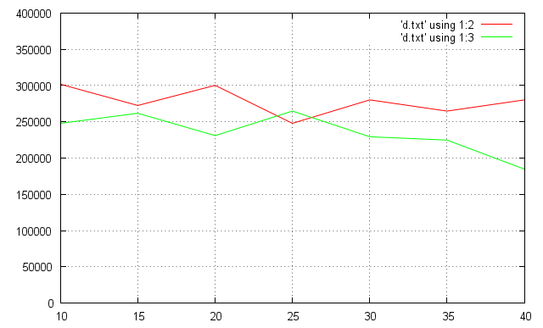
The two connections both get approximately half of the bandwidth because of the TCP flow control.

Task 2
(A)
1.Yes, some packets were dropped at node2 at about 5.5 sec.
2.(0.15+0.25-0.08)/0.08 = 4:1 (bandwidth of the 40ms-RTT flow vs. that of the 200ms-RTT one)
3.Because packets in the 200ms RTT TCP flow are more likely to time out, which causes the flow control algorithm to decide to send at a lower rate.
4.By modifying the flow control algorithm to allow for a larger timeout.
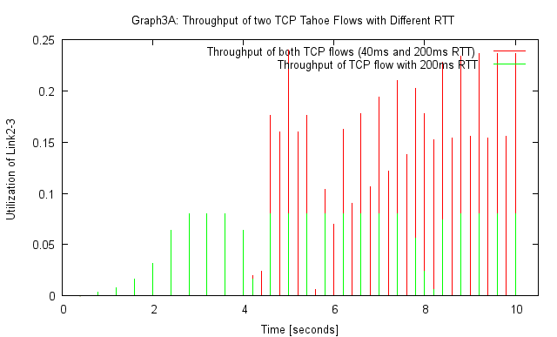
(B)

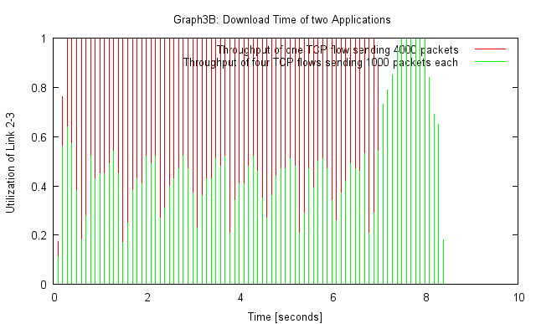
1. The 4-connection application performs poorer than the single-connection one.
2. The 4-connection one takes about 40% of the bandwidth of Link 2-3.
3. It's not unfair.

